Environmental Public Health and

Emergency Response

2006 - 2007

Environmental Public Health Leadership Institute Fellow:

Bryant J Wilke, R.S.
Director, Environmental Health Services
Saginaw County Department of Public Health
1600 N. Michigan
Saginaw, Mi. 48602
989-758-3684
bwilke@saginawcounty.com

Mentor:

Brian Hubbard, M.P.H.
Environmental Health Scientist
Centers for Disease Control and Prevention
National Center for Environmental Health
4770 Buford Highway, NE
Mail Stop F-28
Atlanta, GA 30341-3724

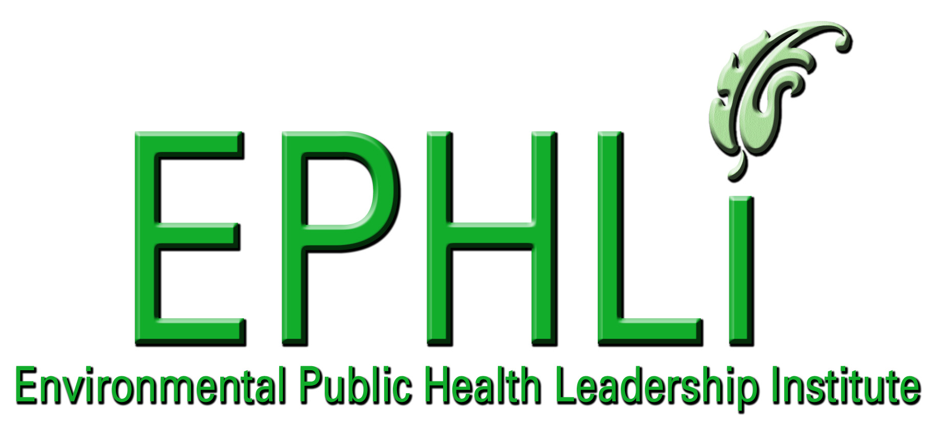

EXECUTIVE SUMMARY:
Building a competent workforce for environmental public health is necessary for all local health departments. Integrated training that reflects all hazard plans must include knowledge of incident command and first responder-critical/crisis thinking to enhance environmental public health practice. These additional training requirements compete with program demands that are oftentimes unfunded. A well-trained environmental health workforce that administers emergency response procedures and provides services according to health department emergency response plans is necessary to fulfill the public health mission. Skills developed in daily environmental public health activities are the same as those required in an emergency response. Developing training to accompany the all hazards plan is necessary to build a competent workforce, to improve staff confidence and to minimize health threats during a public health emergency.

INTRODUCTION/BACKGROUND:
Public health agencies have a major role in providing disease surveillance and intervention. The threat of biological terrorism and potently radioactive type explosive devices has escalated the need for public health agencies to prepare for emergency situations beyond the normal agency responsibilities and possibly beyond jurisdictional borders. Government agencies have downsized limiting staffing levels over the years; and staffing levels are currently at minimums making efforts to enhance emergency management training a problematic issue. Local public health departments must maintain their required or mandated programs and maintain a balance between mandated programs, staffing levels, as well as the income or funding ratio in maintaining required services. Realizing the need for emergency preparedness and successful readiness, the environmental public health workforce roles must be determined along with specific emergency response training to successfully respond in any type of emergency.

A comprehensive training plan that complements the all hazards plan must provide a clear vision, anticipate responsibilities, and assure that resources are available to perform duties during an emergency response. Training programs should include clear, all hazard emergency procedural plans with well-described procedural steps. Training must also reinforce the idea that expertise developed in daily work activities is applicable in emergency situations. Developing a competent environmental public health workforce is essential in meeting the essential public health services.

Feedback from environmental health staff surveys and after action reports from emergency preparedness exercises revealed several concerns, including poor knowledge of proper procedures and communication channels when handling situations beyond the normal daily operations. Individuals placed into emergency operations had difficulty in determining appropriate courses of action due to a lack of confidence when applying their expertise and knowledge within an emergency operation. Understanding expectations in advance allows staff to realize their role in emergency response activities. Staff requested that follow-up training occur soon after drills so that “lessons learned” are retained. Ongoing training is necessary to improve the knowledge, skills, and abilities of the environmental public health workforce for emergency response. An effective ongoing training program will emphasize weak skill areas identified during staff needs assessment and task analysis phases of training development.

Behavior over Time Graph:

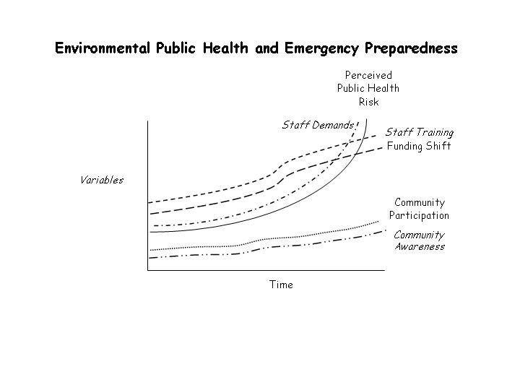

Loop Diagrams and applicable archetypes: Limits to Success and Shifting the Burden

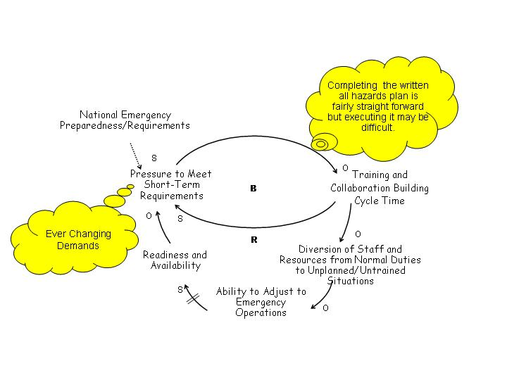
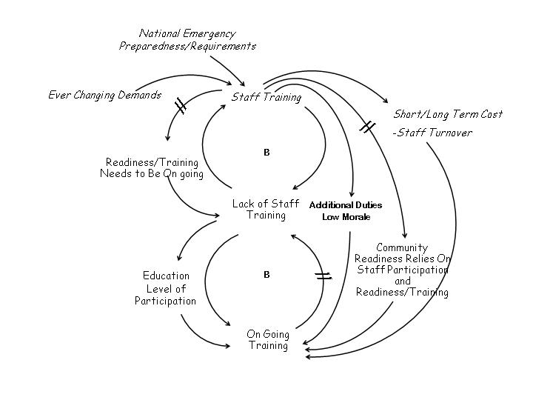

10 Essential Environmental Health Services:

This project emphasizes the need to develop a competent workforce which is number 8 on the list of 10 Essential Environmental Health Services list. How a competent workforce is developed and further maintained can overlap into other Essential Services areas as illustrated on the Chart preceding this page¹. The 10 Essential Environmental Health Services can overlap and be specifically defined in fulfilling an essential service.

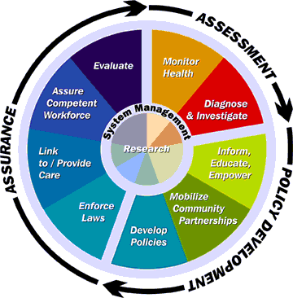

TEN ESSENTIAL ENIRONMENTAL HEALTH SERVICES
Essential Services | Project Activities
1. Monitor health status to identify EH problems. | - Track complaints and illness reports through Epi Team.  - Solicit feedback from Epi Team members on EH responsible areas in need of attention.
2. Diagnose and investigate EH problems and hazards in the community. | - Conduct environmental assessments on all relative complaints.  - Review EH complaint logs weekly and share with Epi team in tracking potential illness trends.
3. Inform, educate and empower people about EH | - Provide on-site trainings for community emergency response as well as individual home emergency awareness for employees families well being.  - Community outreach events, participate at health fairs and home builders shows.
4. Mobilize community partnerships to identify and solve EH problems | - Collaborate, make presentations to community groups.  - Participate on committees such as emergency preparedness – LEPC, Solid Waste Authority, and Storm Water Authority.
5. Develop policies and plans that support EH efforts. | - Develop internal policies and plans addressing staff training, certification requirements as well as continue education.  - Offer trainings associated with required certifications.  - Assist outside organizations in implementing emergency plans.
6.Enforce laws and regulation that protect EH | - Increase compliance with safety regulations, meet standards.  - Offer safety trainings and reviews.  - Reinforce laws and regulations covering emergency issues.
7. Link people to needed EH services. | - Seek partnerships with municipalities and local leaders.
8. Assure a competent EH workforce. | - Maintain monthly Epi-Team meetings.  - Provide in-service trainings and financial support for off-site trainings.
9. Evaluate the effectiveness, accessibility and quality of EH services. | - Survey customers yearly.  - Survey collaborative partners on yearly basis.  - Survey staff with an internal survey on yearly basis.
10. Research for new insights and innovative solutions to EH problems. | - Research national EH emergency management trends.  - Consult w/other EH services for specific solutions to problematic issues.

National Goals Supported
1. Describe how your project seeks to support one or more of the CDC Health Protection Goals http://www.cdc.gov/about/goals/default.htm or meets one or more of the Healthy People 2010 Objectives http://www.cdc.gov/nchs/about/otheract/hpdata2010/abouthp.htm².

This project supports the CDC Health Protection Goals and Healthy People 2010 by establishing a procedure in preparing not only the public health staff but educating the community in emergency preparedness. By establishing internal departmental procedures and providing advance training in emergency response, the department will be supporting these goals by addressing response time, response procedures and activation strategies in response to prevention strategies, infectious disease outbreaks, terrorism threats and natural disasters.

2. Describe how your project supports any or all of these national goals or initiatives.
National Strategy to Revitalize Environmental Public Health Services http://www.cdc.gov/nceh/ehs/Docs/nationalstrategy2003.pdf ³.

This project supports the national goals by facilitating the advance training of environmental public health practitioners to develop a competent workforce. The threat of emerging infectious diseases and terrorist events require today’s environmental public health practitioner to be knowledgeable in nontraditional areas of expertise.

As reported to the President and Congress stated:

“The potential consequences of an inadequately staffed and trained workforce are worrisome. Few national resources are committed to preparing future environmental public health and protection professionals; training opportunities for members of the existing workforce are limited: and opportunities for local workers to upgrade their environmental public health knowledge are not readily available. Thus, the number of graduates from accredited programs in environmental public health and training opportunities for current environmental public health professionals, particularly at the local level, both need to be increased.” (CDC, September 2003)

Activities

Resources/Inputs

Short & Long Term Outcomes, Impacts.

Outputs

Learning
- Increased capacity of Public Health response capabilities
- Improved delivery emergency services
- Increased community knowledge
- Increased collaboration between partners/other agencies
- Improved integration of public health into collaborations
- Emergency response capabilities increased

Results
- More efficient and effective public health system
- Limiting health issues during an emergency incident.

- Level of community response as a whole – Collaborative information
- Partner participation level assessment
- Training curriculum
- Event calendar and participants

- # individual assessments
- # persons trained
- diversity of persons trained
- #, scope, and focus of trainings
- # off site based trainings
- # evaluations/facilitator interest

Behavior
- Increased leadership
knowledge and capacity of PH leaders
- Behavior changes in community
- Accepted response activities
- Determine involvement in collaborative projects
- Determine number of training events
implemented
- Project receives feedback on
collaboration efforts

Project Logic Model - Environmental Public Health Emergency Preparedness Logic Model
Goal: Improve Saginaw County’s ability to respond to a community emergency by assuring competent/well trained staff.
Learning
- Increased partnerships between PH leaders and community
- Increase in projects addressing needs of unprepared communities and/or populations

Learning
- Public health employees increase knowledge and confidence
- Department becomes confident and self reliant

Funding/Partners
- CDC/EPA
- State
- Local
- Foundations

- Staff
- Faculty
- Advisory Committees
Program Design and Development
- Set calendar of events
- Establish training for current health department employees
- Establish health department emergency response plans in compliance with federal mandates and establish staff roles in implementing plans.
Partners
- Lead Individuals
- Executive Managers
- Law Enforcement
- Fire Department
- LEPC Staff
Training
- Conduct EH staff pre-training assessments - Survey
- Conduct onsite training sessions
NIMS – 100, 200, 700, 800
Respirator training (fit testing)
- Conduct off-site training if needed
HAZWOPER - 40 hr training
- Public health staff training
Expand training to include other public health employees associated with emergency response activities
Epi-Team, Executive Staff

Learning
- Public health employees increase knowledge and confidence
- Department becomes confident and self reliant
Learning
- Increased partnerships between PH leaders and community
- Increase in projects addressing needs of unprepared communities and/or populations
- Lower overall risk of communities: This needs explanation and may actually be better if stated as an impact indicator of disease and injury reduction.

Teamwork and Collaborative Projects
- Develop potential partner list
- Contact partners with collaboration
- Department present concepts to partners
- Conduct table top exercises involving community members

PROJECT OBJECTIVES / DESCRIPTION / DELIVERABLES:

Program Goal:

To create a confident, well-trained, and highly skilled Public Health Emergency Response Team integrated from all disciplines within the health department’s staff that is capable of responding to both natural and technological/man-made emergencies and disasters.

Health Problem:
Inadequate public health emergency preparedness and response may increase the risk of disease and injury to vulnerable communities and populations during emergencies and disasters.

Outcome Objective

To improve the health department’s capabilities during an emergency response activity through education, training, emergency drills and exercises.

Determinant:

An ineffective response to a community emergency may increase the risk of disease and injury to vulnerable populations during emergency situations and natural disasters.

Impact Objective:

Create a confident, well-trained, and highly skilled public health staff capable of responding to environmental public health impacts associated with emergencies and disasters.

Contributing Factors:

● Lack of specific emergency response education and training for local public health employees.
● Department-wide support to integrate emergency preparedness into daily operations
● Lack of public awareness on the importance of being individually prepared for emergencies and disasters.
● Increased overhead cost due to training requirements.

Process Objectives:

● Create an epidemiological team (Epi-Team) from multiple disciplines within the health department by March 1, 2007.
● Conduct a tabletop exercise on April 10, 2007 that includes similar elements proposed in the full scale MBS Airport exercise scheduled for May 23, 2007
● Include Health Department participation on the exercise design team for the MBS Airport full scale drill scheduled for May 23, 2007. Include a pandemic flu scenario to exercise a Point of Distribution (POD) for mass prophylaxis.
● Conduct joint exercise with the main Saginaw Post Office – mini dispensing site drill September 19, 2007
● Public Health Response Team to host an in county-wide 800 megahertz radio exercise, October 1, 2007
● Conduct Incident Command System training for all health department employees utilizing FEMA programs, NIMS 100, 200, 700 and 800 core courses by September 1, 2007.
● Train and certify all health department staff on proper respirator protection (fit testing) by June 1, 2007.
● Create an illness monitoring procedure so that community illness and incidents are reviewed weekly by the Community Disease Nurse and Lead Environmental Health Specialist – surveillance.

METHODOLOGY:

This project started with the vision that responding to domestic or natural disasters inherently includes the multi-disciplines of environmental public health. Environmental Public Health practitioners in Saginaw County, Michigan have little or no formal training in incident command or emergency operations. This realization stressed the importance of assessing our current capabilities and to develop training opportunities that include emergency management procedural methods. Initially, environmental health staff was surveyed to determine their level of expertise in managing emergency operations and the incident command system. Eventually, all department staff was surveyed utilizing the identical survey tool to determine the entire department’s level of readiness. A simple fifteen question survey was developed to measure the confidence, current training needs, as well as staff’s emergency management interest level.

Survey results indicated low personal confidence level as well as the need for emergency management training sessions. Confidence levels ranged from 7 to 21%. The majority of staff indicated “not confident” to “low confidence” to describe their abilities when working in any type of emergency operation.

NEXT STEPS and CONCLUSIONS:

Professional development and continuing education help professionals to maintain professional skills and to expand capabilities. As stated earlier, terrorist acts or natural disasters rely on the multi-disciplinary approaches and skills of environmental public health during responses. Determining a department’s current readiness level is a primary responsibility of all local, state and national agencies.

When assessing an agency’s readiness, it is necessary to identify strengths and weaknesses, and available resources. A survey is one possible method in determining an agency’s readiness. Actual participation in tabletop drills and full scale drills also allows for direct observations when determining agency readiness level. Participation in tabletop drills and full-scale exercises allows for real-time assessments as well as constructive input from drill observers. However, preparation will not always lead to successful opportunities. In this case an on-going training program is essential to prepare environmental public health staff to respond to the ever-changing demands of emergency management

Next steps in the department will integrate emergency management practices and future training into daily operations. An example would be to foster the development of the Epi-Teams to function as a local surveillance group for illness reports. Future activities will also expand the department’s internal staff-readiness level as well as create the needed collaborations to build community readiness for acts of terrorism or natural disasters. Next steps include the following:

INTERNAL STEPS:

- Epi-Team meets monthly for surveillance activities.
- Epi-Team meets as needed to determine course of actions on food borne and/or communicable disease outbreaks.
- Epi-Team shares in the responsibility in report development by utilizing the multi disciplines in final outcome reports.
- Provide the initial respirator training and fit testing by June 1, 2007 and continue every year thereafter.
- Continue training sessions for all new employees.
- Continue annual training sessions for existing employees.
- Participate in County, State and Federal emergency management drills.
- Conduct internal survey by October 1, 2007 to assess staff levels of familiarity and confidence in emergency response activities.
- Complete funding analysis and seek additional training funds if necessary by September 30, 2007.

EXTERNAL STEPS:

- FDSA – March 1, 2007 thru April 1, 2007 Environmental Health Services Food Service Staff to Participation in the Food Defense Surveillance Assignment with FDA.
- On February 22, 2007 hosting a Tri-County Pandemic Influenza School Symposium
- Continue to develop collaborations by attending the Fire Chiefs Association Monthly meetings beginning March 2007.
- Conduct two half day strategic planning events that include emergency management discussion topics.

The future internal and external steps establish a course of action for the health department to integrate emergency management into our everyday operations. These steps will also build staff experience through participation in drills and other daily activities. To evaluate whether the department is successful in fostering staff development, it will be key to reevaluate and/or survey staff to determine their awareness-level as well as their confidence-level when participating in emergency response operations. The integration of emergency management processes and management techniques is an attempt to build familiarity so that the health department’s staff is confident in handling nontraditional emergency response activities.

LEADERSHIP DEVELOPMENT OPPORTUNITIES:

Bryant J Wilke

First, I would be remiss if I fail to thank Misti Frenzke for nominating me to the institute and for my department’s support of my professional and personal growth. Participating in the institute is, so far, a capstone in my career.

As I stated in my application to the institute “I can only imagine that this experience would be life long.” I really did not know how right I was at the time, but I can testify today how correct my prediction was. The leadership institute is exactly what the environmental public health profession has needed. As professionals, our technical expertise is unwavering; however, leadership in environmental public health oftentimes is lacking. The Environmental Public Health Leadership Institute has helped fine-tune qualities that enhance our professional leadership skills. The institute has brought together experts with a willingness to share their leadership knowledge with participants. It has been difficult to select one aspect of the program that stands out as being the core or essential feature of the program. The Environmental Public Health Leadership Institute not only developed leadership skills, but concentrated on environmental public health leadership skills. I have been thinking about the past year, the travelling adventures, class time, presentations and the whole concept of providing me with leadership tools that I will undoubtedly use the rest of my life. I feel very thankful to all those that made arrangements, presented and supported the program.

Finally, I was a little reluctant about the mentoring process initially and I contribute this reluctance to the lack of exposure of having to share ideas and thoughts on my personal/professional development. Brian Hubbard with CDC was my team mentor, and I must say, he is a wonderful individual to work with. You know learning to accept criticism can be hard but Brian is able to deliver feedback in a way that allows you to grow professionally and accept his input without being personally offended. Brian always went the extra mile to assist us by providing information to no end. I have learned that the mentoring process can be very rewarding and found it to be a truly great experience. As for the rest of the faculty and mentors my cohorts have expressed the exact same sentiments. Thank You for this great experience!

ABOUT THE EPHLI FELLOW(s)

Brant J Wilke, R.S.

Bryant Wilke received his Bachelor of Science Degree in Environmental Health from Ferris State University and a graduate certificate in Hazardous Materials Management from Wayne State University. Currently, Bryant is the Environmental Health Services Director for the Saginaw County Department of Public Health, Saginaw, Michigan. He is one of seven division directors within this health organization.

The division serves the community through many traditional environmental health programs such as food service protection, onsite wastewater, onsite water supply, nuisance complaints, and swimming pool operations. Non-traditional programs include solid waste compliance and hazardous materials collection programs, lead poisoning surveillance, and lead abatement. In addition to 19 years of experience working in the public health sector, Bryant has 3 years of full-time environmental health consulting experience.

REFERENCES

- U.S. Department of Health & Human Services, Office of Disease Prevention & Human
Services. Healthy People 2010. World Wide Web: http://www.healthypeople.gov.
- Centers for Disease Control. A National Strategy to Revitalize Environmental Public Health Services. Atlanta, GA: Department of Health and Human Services. Centers for Disease Control: September 2003.
- Osaki, C. Essential Services of Environmental Health. Northwest Center for Public Health Practice, University of Washington School of Public Health and Community Medicine, Seattle, WA. July 2004.

