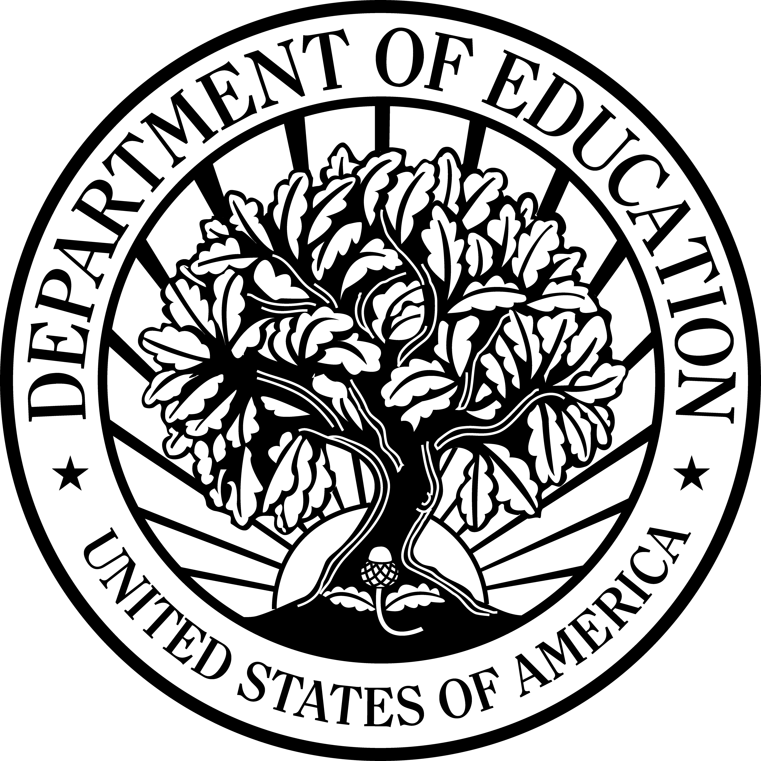


U.S. Department of Education

Office of Vocational and Adult Education
Fact Sheet Series

Adult Basic and Literacy Education

Ready for College: Adult Education Transitions Program

The OVAE Fact Sheet Series highlights efforts currently underway at the Office of Vocational and Adult Education (OVAE) to support the principles of the President’s No Child Left Behind Act of 2001. The principle(s) supported by this effort are checked.

- Increase Accountability and Academic Achievement
- Increase Options and Involvement for Parents and Students
- Increase Flexibility and Reduce Bureaucracy
- Focus on What Works

Background

The President’s American Competitiveness Initiative recognizes that a high school diploma or equivalency diploma is no longer adequate for 21st century workforce demands. Some form of postsecondary education and training is critical to succeed in the new global economy. This program supports State and local efforts to increase the rate at which young adults successfully transition to postsecondary education.

Overview

The Office of Vocational and Adult Education (OVAE) awarded four grants to implement projects focused on improving the quality of ASE so that out-of-school youth could successfully transition to postsecondary education. The four grantees include the: Colorado Community College System Foundation, Essex County College (NJ), North Carolina Community College System, and Kansas Board of Education.

During the 24 month project period, grantees will identify and document educational practices of State and local agencies. These projects will enhance curricula; provide professional development for instructional staff; and identify effective student support strategies.

Outcomes and Products

- Increase the percentage of participating out-of-school youth, aged 18 to 24, who can transition to postsecondary education.
- Develop replicable models for dissemination.
- Produce final reports that summarize and document effective strategies.

Timeline

- October 2007– September 2009

Contact

Christopher.Coro@ed.gov

