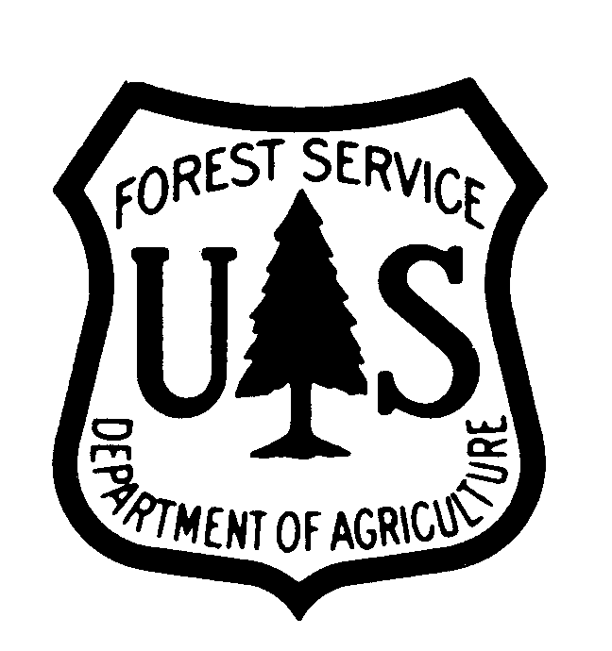 | News  Release | Gallatin National Forest  Hebgen Lake Ranger District  PO Box 520  West Yellowstone, MT 59758  406-823-6961  www.fs.fed.us/r1/gallatin

For Immediate Release Contact: Joanne Girvin
Date: February 10, 2005 (406) 823-6965

Grand Opening of Rendezvous Ski Trailhead Facility

And Free Day of Skiing

West Yellowstone, MT – The community of West Yellowstone and the Forest Service are celebrating the grand opening of the new Rendezvous Ski trailhead facility with a ribbon-cutting ceremony and a free day of skiing on Saturday, February 19, 2005.
The ribbon-cutting ceremony will be hosted by West Yellowstone Mayor
Mary Phillips at 10:30 a.m. at the new facility, which is located on the south edge of West Yellowstone at the entrance to the Rendezvous Ski Trails at the intersection of Geyser and Obsidian Streets.
Built by the Town of West Yellowstone, the new building will serve as a location for trail users to relax, warm up, wax their skis, and use the restrooms. It will also be used as meeting space for non-profit organizations.
The new trailhead facility is funded, in part, by a Rural Community Assistance Grant from the U.S. Forest Service. Other partners include the West Yellowstone Ski Education Foundation and the West Yellowstone Chamber of Commerce.
-MORE-

Page 2 - Grand Opening of Rendezvous Ski Trailhead Facility and Free Day of Skiing

At Rendezvous Ski Trails, skiers can select from over 30 km of trails that are professionally groomed daily for skating and classic skiing. The high elevation of the area allows for plenty of snow, and the trails range from easiest to most difficult. Skiers are normally charged $5 for a day pass or $25 for an individual season pass.
-FS-

