Dyersburg High School Dyersburg, TN
“Excellence through Commitment”
Dyersburg High School
Dyersburg, TN

886 students, 9-12

White 71%
African American 28%
Hispanic 1%
Students receiving free/ reduced price lunch 42%
Students receiving SPED services 10%
Student teacher ratio 16:1
Student turnover rate 11%
Teacher turnover rate 5%
Dyersburg High School is located in northwest Tennessee—close to the borders of Missouri, Kentucky, and Arkansas—75 miles north of Memphis. The community is very proud of the school and its tradition, still focused on “Excellence through Commitment.” Of the 21 school systems in Tennessee’s northwest region, Dyersburg High School is recognized as one of the best.
Dyersburg High School’s student enrollment of 886 students in grades 9-12 mirrors the community population of 17,406 with about three-quarters White and one-quarter African American residents. Just over 40% of the students are eligible for free-and-reduced lunch. The community used to have a textile plant, but it closed several years ago and some 900 jobs were lost. Many other manufacturing plants in the area have also closed or scaled back and the community is still adjusting.
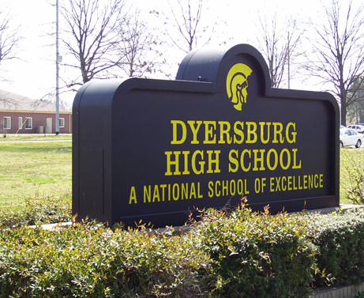
Even in the face of the declines and economic changes, Dyersburg High School continues to achieve excellent results, building on its 1991 recognition as a National Blue Ribbon School.
Dyersburg is near the Mississippi River, and tornadoes are quite common. On April 2, 2006, a series of tornadoes rushed through the Dyersburg area, destroying many homes and buildings and killing nine people in the neighboring town of Newbern. In May 2003 the high school, which was built on a 40-acre site in 1971, sustained significant tornado damage. Since rebuilt and refurbished, the building today includes a large sports complex and other space designed for co-curricular activities.

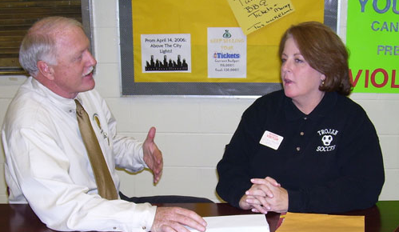
Dyersburg High School’s commitment to high performance is characterized, say school leaders, by the school’s vision and motto. “Excellence through Commitment” applies to all people connected to the school—students, faculty, parents, and the community. Because the administration handles all discipline issue, teachers can concentrate on teaching. All students have the same homeroom teachers and classmates throughout their four years.
Hard Work, Discipline, Respect
The district superintendent describes the local culture this way: “This is a very good district that has great support from the school board. Every grade level tested in every tested subject made positive gains on state assessments. Not many schools can say that. The board has a vision that says it’s all about people. They want to celebrate people and they demand good schools.”
Curriculum Mapping and Alignment: Always a Work in Progress

The school is committed to curriculum mapping and alignment with state standards. Principal Sam Miles explains the program is successful because 1) it is a priority of school leadership, 2) it is led by a strong person, the “Teaching and Learning Facilitator,” 3) it supports both content and pedagogy (including professional development), 4) it offers a structure that encourages teachers to take an interdisciplinary approach to essential skills, 5) it uses assessment to hold students accountable for mastery of objectives, and 6) it helps teachers use assessment data to guide instruction.
The Teaching and Learning Facilitator also teaches two math courses and spends three periods working with other teachers. Her major job is to lead the curriculum mapping and work closely with teachers. Her ongoing teaching assignment solidifies the respect and cooperation of the rest of the faculty who work with her.
Curriculum maps for every subject are organized by month, topic, essential questions, content objectives, and skills aligned with state standards and assessments. According to the Teaching and Learning Facilitator, “Curriculum mapping and alignment is a part of our culture. …It just keeps rolling. The process never finishes. The main challenge is to get teachers to all work together.” Depending on the results of student assessments, the maps are adjusted daily, weekly, or every nine weeks.
The school is guided by Heidi Hayes Jacobs’ Mapping the Big Picture and Lisa Carter’s work in curriculum alignment. Over the past nine years all curriculum areas—English, Math, Science, Social Studies, Vocational Education, Fine Arts, Foreign Language, and Physical Education—have been mapped to align with state and national standards. Curricula continue to be updated to reflect essential questions, types of assessments, skills, and objectives. The faculty is practicing what they designed and getting data that both indicate successes and identify areas of concern.
An Enhanced Calendar’ Provides Extended Opportunities to Support Learning

In 2000, the Dyersburg City School District adopted an enhanced school calendar to maximize learning opportunities for all students. Each quarter of the school year is organized into nine weeks of school followed by two weeks of vacation or “intersession” coursework. An assortment of individual intervention and enrichment programs during the intersession period provide help to students who need additional assistance or opportunities to work ahead.
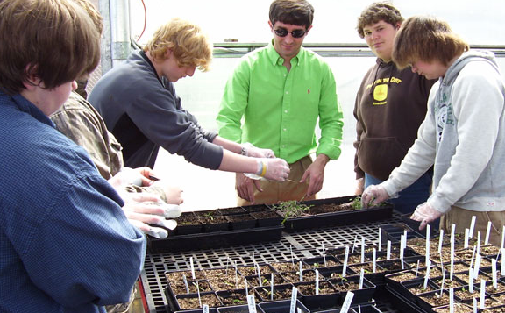
Teachers identify potential student participants based on assessments of objectives missed during the nine weeks. Students receive “quality points” for participating. More than 100 students participated in the spring English and Math intercession. The school also included history and science class intercessions this year. Teachers who are new to the system (within first 3 years) are required to teach one intercession class.
The strength of the enhanced calendar seems to result from the use of benchmark assessment data to individualize the intervention efforts and to encourage advanced students to go deeper or further through enrichment courses and activities. Both school counselors work during intersession.
Teachers strongly support the enhanced school calendar, as well as the longer 60-minute periods. Students like the enhanced schedule and the intercessions too, welcoming the regular breaks “when you think you can’t stand school any more.” They admit that it does take away a bit from the summer vacation and can limit summer jobs, but the community has adjusted to the schedule. One parent said, “The schedule does great things for families and it provides a nice break for the teachers as well.”
Interscholastic sports continue during the intersession periods. Parents reported that they love the schedule but added that it affects students involved in sports because of schedule conflicts with other school districts that follow a more traditional calendar.
The school counselors also operate the ‘Make Up, Catch Up’ (MUCU) program. Teachers identify students who miss or do not complete assignments or who fail a course, and during the regular nine-week quarters these students are required to attend one-hour MUCU sessions before or after school to complete their missing assignments. Teachers have the option of giving partial credit for the completed work. Students who fail to complete assignments in the MUCU are given in-school suspensions.
Tutoring is available to all students through Students Opt for Success (SOS), a program of teacher-led tutoring sessions from 7:00 to 7:55 a.m. and from 3:10-4:00 p.m., Mondays through Thursdays. Students who have been chosen for the National Honor Society also volunteer to tutor students who want extra help.
“Algebra for All” Establishes a Firm Foundation for Mathematics Instruction

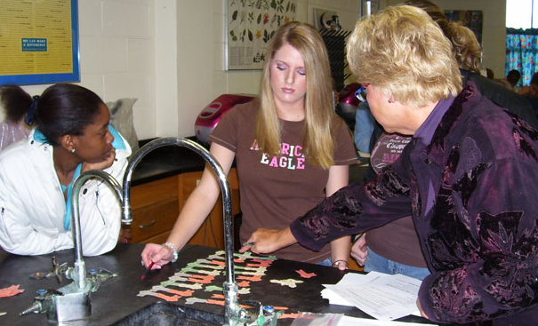
Another cornerstone of Dyersburg High School’s success has been its commitment to provide every student with a solid base for high school mathematics. Some years ago, one of the school’s math teachers learned about an Algebra I program used in Arkansas that put the responsibility for learning back on the students. Dyersburg adopted “Algebra for All,” a competency-based, spiraling curriculum, which the school and developer aligned with Tennessee standards.
Algebra for All incorporates higher order thinking skills. Each module is divided into smaller segments whose objectives are aligned to the segment’s content. Students must complete all homework assignments before they can be assessed; they have three opportunities during the nine-week quarter to take each assessment. Scores must exceed the 80th percentile to move on to the next quarter’s module. In this way, no student fails the whole year, and instead reviews or repeats sections as needed. Teachers know where each student is in the learning curve at all times. The assignment of students and teachers is adjusted every nine weeks depending on student progress during the quarter.
The Algebra teacher attributes a ripple effect to “Algebra for All” and sees students taking more responsibility for their learning and work. “This program has had a positive effect throughout the school. The best thing about teaching is watching kids learning. And the best thing about this school is that hard work is appreciated. The general trend of the staff is to go the extra mile for the students.”
“9th Grade EOC” English Program Mirrors the Success of “Algebra for All”
The success of Algebra for All’s precise teaching, assessments, and spiraling curriculum led Dyersburg to develop a comparable program for freshman English. School leaders knew a problem with student reading existed: the failure rate for the end of course exams the previous year was 25%.
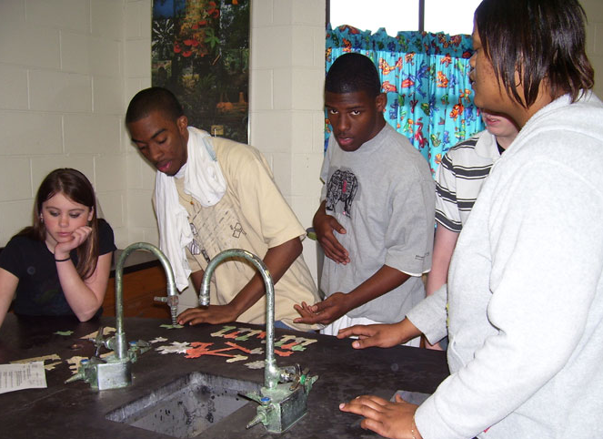
In the 2004-05 school year the school adapted the Algebra for All approach to 9th grade English, organizing the state English standards to address a set number of standards every nine weeks. Staff members developed their own assessments and re-assessments, and located supplemental materials that aligned with standards. There are usually three assessments for every four English objectives; special assessments may be developed to review objectives.
“It’s a constant monitoring process,” said one 9th grade English teacher. “You know what you’re supposed to teach. You know what objectives you have to cover and when.” Teachers analyze student errors on assessments and identify the reasoning behind student responses. They then re-teach and retest the content, using new passages and questions. Each teacher uses a locally developed Excel spreadsheet to monitor student progress. The student progress data allow teachers to be flexible and to adapt their teaching strategies constantly.
The teachers place higher priority on student mastery of the state English standards than on other English curriculum topics, which means that there is not enough time to cover every subject teachers would like to teach. But the focus on helping all incoming freshmen master the content related to the Tennessee standards is reflected in the school’s very high assessment results.

Over time Dyersburg’s culture of high expectations and has been matched by parent and community support. “This school has the support of the community,” a parent explains, “And the community has high expectations for the school. We’re all stakeholders here because our kids go here.” The community and parents feel welcome and included in the life of the school. Many of the parents attended Dyersburg themselves and have a special relationship with the school.
High Expectations and Community Support

Parents and students alike report that the faculty and staff are committed to continuing the school’s historic excellence. “Traditions are important,” a parent says. “Every child can find something to participate in at this school.” Parents agree that teachers care and are dedicated to the students, and feel comfortable calling teachers whenever a child has a problem. Students call teachers at home if they have difficulty with homework. A parent pointed out, “Teachers foster love of subject. They challenge students and once students are successful, it’s contagious.” The parents were also impressed that teachers are involved in so many before and after school activities.
One student felt the size of the school was perfect, describing it as “a small school with lots of opportunities,” adding that “The teachers care about the whole student, not just academics.” Another student added, “Academics are harder here than in other local schools and teachers expect you to do your best.”
Community support for the school takes many forms. For example, the parents raised $32,000 in donations and prizes for the substance-free all-night Project Graduation celebration.
School administrators attend the student after-school activities, which communicates volumes to the students and parents. A very active Parent Advisory Committee (PAC) stays in touch with what the school is trying to do and provides ongoing feedback, meeting four times a year and serving as a go between with the community.
Dyersburg High School nurtures parent and community support. Home-school communication takes many forms, from one-on-one discussions, e-mail, letters, phone conferences, a mid-term report, faxes, the school website, and prime time TV spots on a local cable channel. At the beginning of each school year a Parent Orientation Night familiarizes parents with the main learning emphases of the year, announces any new rule changes, sets out expectations for student behavior, identifies student opportunities for financial aid and scholarships, distributes written explanations of how teachers evaluate student work, and discusses student achievement and the school’s performance in recent years.
Pride and Participation in Strong Arts, Athletics and Co-curricular Programs


Students, faculty and parents are quick to point out the essential role that the many extra-curricular programs play in Dyersburg’s overall success. The programs and activities are used to encourage and leverage improved student performance in academics, and student participation is high. The school has classes in drama, art, choir, and band.
The drama department produces three plays each year and participation is open to all students, not just drama students. Students take the lead in all aspects of the productions: set design and construction, costumes, and direction. The drama teacher points out, “Participation in drama translates into teamwork skills and leadership skills. But to do that you have to involve a lot of kids on the stage and backstage as well.” The program has strong support from both the administration and the community.
Sports also play a strong role at Dyersburg High: student participation is high and the community attends school sporting events in large numbers. One coach summed it up: “Sports are good for life. You have good interactions between students of all races, plus a real varied socioeconomic mix. At Dyersburg sports are a ‘tie-in’ thing, just like clubs and other activities. So it’s a good setting for kids. This school provides a balance with academics, sports, and social activities.”
Celebrating Success

One night every spring Dyersburg students enjoy one of the school’s most cherished traditions. Anticipated all year, the annual Honors Banquet takes place in the Commons Dining Area, miraculously transformed by the faculty into an elegant banquet setting for 600-700 students and their parents. “We try to outdo ourselves every year—it’s sort of our gift to the students,” a teacher explains. Everyone eagerly anticipates which graduate from ten years before will return to speak to the students about how Dyersburg High School prepared him or her for the real world. Many plaques and prizes are awarded to cap off the evening.
Numerous other programs, both large and small, recognize student accomplishments of all kinds and encourage students to make their best effort in all that they do. At academic success parties students receive awards, just as they do at sports banquets. The guidance counselors work closely with the Academic Booster Club to plan these events. The main bulletin board in the school lobby features “Trojans of the Week”—students who have demonstrated good citizenship and behavior.
Professional Development Center is a Valuable Resource in District
Three years ago the Dyersburg City School District saw a chance to improve learning opportunities for the district’s teachers and students, and took it. The State Department of Education was looking to develop regional teacher professional development centers in counties throughout the state. Dyersburg had recently closed a junior high school building and offered to host the region’s Professional Development Center. Funded with local and state funds, the Center also uses federal Title I and II money. Its board meets regularly and routinely gathers data from teacher and parent surveys.
The Center has increased coordination across districts and enabled participating districts to pool resources and tap some outstanding national and state presenters and staff development offerings. Staff development programs have become more attuned to staff needs and have helped teachers review their classroom instruction and adopt best practices. The Center has also helped teachers meet state and federal requirements to become highly qualified in their subject areas. Dyersburg High School works closely with the Center to maximize time for staff development in the school.
Strong Traditions, Effective Innovations
Dyersburg High School has successfully married strong traditions and a history of high expectations to a number of effective innovations that encourage and inspire student achievement. As one student put it, “Dyersburg is a small town and people expect you to be polite and to succeed. All of the teachers and our administrators have very high standards and they help us meet them.” This sentiment is captured by scene after scene of orderly, well mannered students and visibly very caring faculty and staff members. That students would want to do their best makes perfect sense.
Dyersburg High School: Gateway Proficiency Results
Algebra % Proficient
 | 2002 | 2003 | 2004
All | 99 | 99 | >95
Low income | 98 | 96 | >95
African American | 98 | 96 | >95
English % Proficient
 | 2002 | 2003 | 2004
All | NA | 99 | 97
Low income | NA | 97 | 95
State average | NA | 97 | 93

