California Academy of Mathematics and Science Los Angeles, CA

California Academy of Mathematics and Science
Los Angeles, CA

615 students, grades 9-12

Students qualifying for free or reduced price meals 40%

Student ethnicity:
Hispanic 31%
Asian 26%
African American 13%
White 15%
Filipino 14%
Other 1%
Planning for the Future
The high-tech economy of southern California depends on a steady stream of employees with strong science and math skills. Faced with high student drop-out rates, and large numbers of female and minority students who were alienated from math and science, a group of education, business, and community leaders took matters into their own hands. They created a new high school, based on the premise that, given support and rich opportunities, female and minority students can excel in science and math.
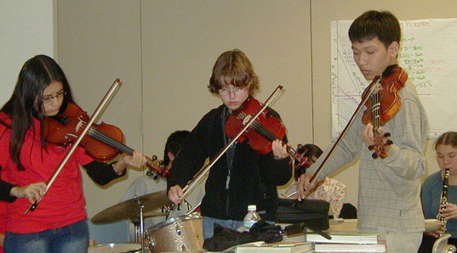
The California Academy of Mathematics and Science (CAMS) opened on the California State University at Dominquez Hills (CSUDH) campus in 1990, the product of partnerships among CSUDH, the California State University’s Chancellor’s Office, a consortium of eleven local school districts, and high tech and aerospace industries. Long Beach Unified School District serves as the managing school district fiscal agent. Offering an intensive, math- and science-rich college preparatory education to motivated students, CAMS is bearing out its founders’ premise. Today CAMS ranks in the top ten schools in California on the NCLB Academic Performance Index; its students score well above state and national averages on the math and verbal SATs. Average student daily attendance in 2003-04 was 98%. Attrition is less than 5% for all reasons, as opposed to a 50% drop-out rate in some local high schools, and 95% of CAMS students go on to four-year colleges and universities, including the most selective and prestigious in the nation. (Approximately 5% attend community colleges.)
Entrance to the school is by application. CAMS faculty and students canvass all area middle schools, talk to students and parents, and invite qualified candidates and families to the school for Saturday interviews. Applicants must have scored above the 65th percentile in math and science, although English scores may be lower. Successful applicants have shown a keen interest in math and science, as evidenced in interviews (including parent interviews), teacher recommendations, and student projects.
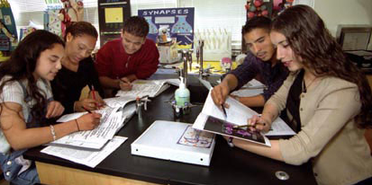
Although CAMS winnows about 165 students from approximately 850 9th grade applicants each year, CAMS does not rank its applicants for acceptance, but accepts students from each of its 75 feeder schools including predominately inner-city middle schools. Its mission is to “defy the odds” and prove that students, especially those from academically deprived environments, can excel in math and science, given a setting that features integrated curriculum, teamwork, and real world applications of learning. Faculty refer to CAMS as a “talent development program.”
Some call CAMS exceptional, charging that it has the luxuries of being a small high school, selecting its students, and co-existing with a university. Class size is relatively large, between 30-35 students. The school receives about $5,500 per student annually, placing CAMS is on par with the state average for high schools. (CAMS’s base funding is $4,400 per student; private donations and special legislative funding make up the rest.) Many features that the school’s founders and current administrators deem essential to its success are replicable.
A New Vision of Female and Minority Students
For Dr. Kathleen Clark, CAMS principal since its inception, a successful school has a vision. The CAMS vision was to empower minority and female students—both underrepresented in the science and engineering fields that power the area’s growth—with science and math skills. With funding from a California Specialized Secondary Schools Program and private foundations, a task force of educators and business leaders outlined a rigorous curriculum. They articulated a philosophy of student-faculty teamwork, developed an admissions policy for a math and science specialty public high school. Agreements were signed with local school districts for staffing and fiscal support. A board of representatives from school districts, higher education, and the private sector governs CAMS. A corporate advisory group advises the board on technology issues, work force trends, and access to philanthropic support. With both public and private support, CAMS’s new buildings on the CSUDH campus were completed in 2001. Construction on another building is due to begin February 2006.
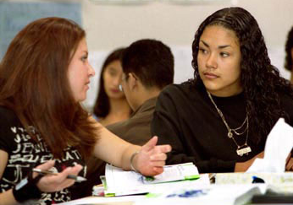
Designed to expose students to science and math less as a subject than as a way of thinking, the CAMS curriculum prescribes four years of math and six of science. They include a 9th grade engineering science survey class that, as intended, often motivates female students to continue their engineering studies. All students must pass calculus by the end of 12th grade, often a stumbling block for minority and female students who wish to take college level math and science courses. Accelerated English, social sciences, computer science, and two years of required languages (with recommended third and fourth years) complete the core curriculum. They must be ready to negotiate an open campus, accomplish three to four hours of homework a night, and often ride by bus more than an hour each way.
Rooted in interdisciplinary work and real world application, the curriculum is based on state, district, and national association standards, exceeding district expectations for curricular development. For instance, the math program is based on the problem-based, recently published Interactive Math Program (Key Curriculum Press). Students justify their math solutions both in writing and orally before their peers. Students often study the same phenomenon from multiple perspectives, such as comparing systems in a car to systems in the body. Science classes use robotics and construction projects to explore theories. English and social studies teachers pose questions at the beginning of class for students to ponder as they read and discuss the day’s content. In tenth grade English, each student publishes a 100-page novel based on A Hero’s Journey, by Joseph Campbell.
Students and Teachers Access the University
Because CAMS is on the CSUDH campus, juniors and seniors may enroll in university courses (and some CAMS teachers teach at CSUDH). CAMS students may graduate with as many as 20 college credits—an advantage for students applying to selective colleges and/or advancing to early college graduation. Many of these students receive generous scholarship awards to help them afford higher education costs.
The school oversees numerous internship and summer programs with business partners, matching students with professionals from an industry of the student’s choice. Mentors from local industry help bridge the gap between the classroom and the “real world,” inspiring students to think beyond high school. One mentor who is still in contact with students he mentored over the years said, “I am most tough on time management, which I think helped them be successful in their studies.”
Building Strong Bonds
Teachers work in teams. The same four or five teachers teach all core subjects to a grade level; a counselor is also assigned to each grade level team. Teachers have at least an hour and half each week to meet as a grade level team to plan interdisciplinary lessons and discuss student progress. Mid-semester progress reports and semester tests identify struggling students, and an Academic Review Committee counsels parents and students when a student’s grade falls below a C. Struggling students can request peer tutoring or be assigned to an academic support class during elective periods, an option five to 10 percent of students take, particularly in writing and oral skills. Students, parents, and faculty all said, “No one falls through the cracks.”
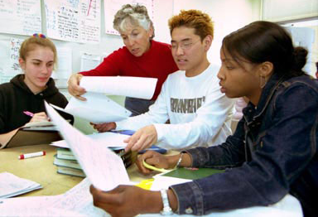
CAMS teachers are chosen for their ability to work in teams, their background in their curriculum area(s), and interest in an innovative, interdisciplinary curriculum. A “peer collaboration process” supports new teachers and lets accomplished teachers share their skills. Teachers described the peer collaborative as empowering, opening “conversations that we never had before.” CAMS teachers retain tenure from their home districts through “detached service leave.”
Students belong to a cohort, a group, of about 35 ethnically and geographically diverse students, and take all core classes with that group for the entire academic year. Within the cohorts, teachers assign group projects, carefully moving students among these groups to balance their strengths and needs. Visitors to classrooms note a lot of conversation and small group work. In a focus group, a student said, “We build this unbreakable bond. We help each other. We do not want to let our cohort down. I have personal connections across cultural groups that I would not have at my local high school.” Another student felt safe with his teachers: “I know I can go to my teachers. Teachers make you feel comfortable to ask questions. Teachers encourage questions.” A parent described the bond among students: “If the boat makes it, they all make it.”
CAMS teachers do not grade “on a curve,” eliminating, the principal said, some traditional competition. Freshmen attend a required four-day orientation the summer before entering CAMS, initiating the student bonding experience. Parents need to support their children’s hard work at CAMS. The teaching method at CAMS is foreign to most families; however, one parent described, “CAMS faculty won’t let a child drop off. All doors are open.”
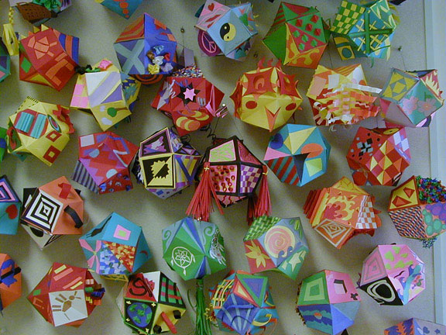
Apart from academics, freshmen and sophomores take 200 minutes a week of physical education, and electives such as team sports, art, chorus, orchestra, robotics, engineering, key club, and theater are offered. Extracurricular opportunities, such as cultural clubs, a dance ensemble group, and a multicultural fair are student-initiated and supported by faculty members. Recently, a CAMS student wrote and directed a school musical. As members of a small learning community, students feel they can do “anything” and take leadership roles.
Experiential Learning
“Chief Justice, honored judges, teachers, students, family and friends, we of the law firm SMART would like to call your attention to the pertinent facts of the case of ….” The four-person SMART law firm and the four students representing the state of California are CAMS tenth graders arguing their legal cases, the culmination of their “Halls of Justice” interdisciplinary project (IDP). This interdisciplinary project challenges student teams to integrate content and skills from all core subjects into a written and multi-media presentation with real-world application. For example, for the Halls of Justice project, the 10th grade faculty listed as many as 30 polemical science and math topics, such as human cloning, the use of embryonic stem cells, ownership of space, and water rights. Students choose their top three, and are assigned to eight person teams: half represent the petitioner and half the respondent. Each team organizes its inquiry, does research, and formulates arguments, sharing briefs or documents via digital files.
Each teacher directs three or four student teams, detailing requirements for student work in each core subject area. For example, in science, “the mechanical, physical, and chemical component of the argument must be . . . factually accurate. . . using technical terms, taking into consideration the audience.” In history, students “compare the present with the past, evaluating the consequences of at least four past events.” Student teams receive rubrics so they know how they will be graded. Each team designs a team charter which serves as both a work contract and a peer-grading guide at the end of the project. Student teams delegate roles, set budgets, outline tasks, and develop timelines. Since the work may require evening and weekend time and transportation, parents sign off on student participation. At their “day in court,” each student presents one aspect of the oral argument.
IDPs enrich the educational experience for students, teachers, and community members. Many teachers find that “The students teach us.” Interdisciplinary projects strengthen students’ abilities to collaborate, evaluate, synthesize, and form opinions, all skills valued by the world at large. Other current grade level projects are: create a time machine (freshmen, within the first two months of school), explore changes in the Los Angeles basin (juniors, following semester break), and develop business plans (seniors, second semester).
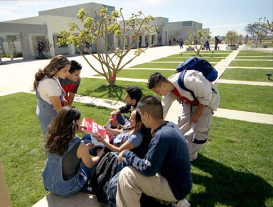
Many features of CAMS that the administration believes other schools can replicate— academic focus, partnerships, teams, integrated content, building a positive school climate, real world application—appear in the National Association of Secondary School Principals’ Breaking Ranks II: Strategies for Leading High School Reform (2004). The planning time core teachers share is an important part of CAMS’s academic program that many visitors to CAMS believe could be replicated in other schools. The focus on curriculum and partnerships could also be implemented in other schools.

