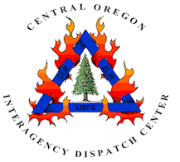
Central Oregon Interagency Dispatch Center
4550 SW Airport Way
Prineville, OR 97754

FIRE NEWS--Central Oregon Interagency Dispatch Center
For Immediate Release: September 17, 2008 – 12:30 p.m.
Contact: Media Desk, 541/416-6811 www.fs.fed.us/r6/centraloregon/fire

Media Alert: Royce Butte Fire – Community Meeting

There will be a community meeting this evening to update evacuees and community members on the status of the Royce Butte Fire. The community meeting will be held at 6 p.m. tonight at Gilchrist High School, 201 Mountain View Drive, in the music room.

# # #

