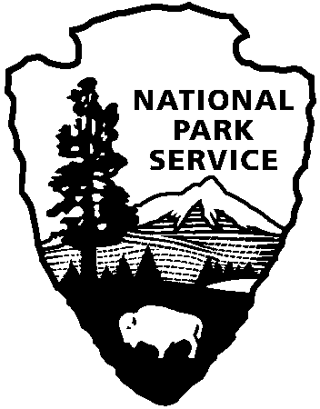
Release date:
Contact(s):
Phone number:
Date:
Harpers Ferry NHP News Release

Harpers Ferry National Historical Park
P.O. Box 65
Harpers Ferry, WV

304-535-6748 phone
304-535-6244 fax
EXPERIENCE YOUR AMERICA
The National Park Service cares for special places saved by the American people so that all may experience our heritage.

™
Immediately
Marsha B. Wassel
304-535-6748
August 12, 2008

National Park Service
U.S. Department of the Interior

Remembering the Niagara Movement: A Pilgrimage to John Brown’s Fort

On Sunday, August 24 at 8:30 a.m. Harpers Ferry National Historical Park invites the public to retrace the 1906 footsteps of the men and women of the Niagara Movement during a commemorative walk to the 1906 site of the John Brown Fort. The ceremony will include music, historic readings and a memorial roll call of the members of the Niagara Movement.
Following the pilgrimage, a non-denominational memorial service will be held at 10:00 a.m. at the Curtis Freewill Baptist Church in Harpers Ferry.
Those wishing to participate should drive directly to the Murphy Farm and then to the church.
For further information, call Harpers Ferry National Historical Park at 304-535-6029.

page 2

