UNITED STATES DEPARTMENT OF EDUCATION
OFFICE OF INSPECTOR GENERAL

Audit Services
New York Audit Region

May 19, 2008

Control Number
ED-OIG/A02H0007

Dr. James Melville
President & Chief Executive Officer
Technical Career Institutes, Inc.
320 West 31st Street
New York, NY 10001-2789

Dear Dr. Melville:

This Final Audit Report, entitled Technical Career Institutes, Inc.’s Administration of the Federal Pell Grant and Federal Family Education Loan Programs, presents the results of our audit. The purpose of the audit was to determine whether Technical Career Institutes, Inc. (TCI) administered the Pell Grant and Federal Family Education Loan (FFEL) programs in accordance with the Higher Education Act of 1965, as amended (HEA), and applicable Federal regulations. Specifically, we examined (1) institutional and program eligibility (excluding the 90/10 rule), (2) student eligibility, (3) award calculations and disbursements, and (4) return of Title IV funds. Our review covered the period from July 1, 2005, through June 30, 2006.

BACKGROUND

TCI, located at 320 West 31st Street in New York City, is a proprietary, single-campus college that provides higher education and technical education services. In 1909, TCI opened as the Marconi Institute. In 1974, the name of the college was changed to TCI. On June 30, 2005, TCI was acquired by EVCI Career Colleges Holding Corporation, which also owns Interboro Institute and Pennsylvania School of Business.

TCI is accredited by the Middle States Commission on Higher Education and currently offers associate degrees in the following areas: (1) Business and New Media Technology, (2) Computer and Electronics Technology, and (3) Climate Control Technology. TCI also offers certificates for shorter programs. Educational programs are provided on a standard-term calendar measured in semester credit hours. TCI’s academic calendar consists of three 15-week semesters: fall, spring, and summer. The enrollment in each of the semesters is about 3,000 students.

TCI participates in the following Title IV, HEA, programs: Pell Grant, Federal Supplemental Educational Opportunity Grant, FFEL, William D. Ford Federal Direct Loan (Direct Loan), Federal Perkins Loan, and Federal Work-Study. During the period of July 1, 2005, through June 30, 2006, TCI received a total of $20,541,317 in Title IV funding, which included $10,572,764 in Pell Grants and $8,881,954 in FFEL.

AUDIT RESULTS

We determined that TCI met requirements in the HEA and regulations for institutional (excluding the 90/10 rule), program, and student eligibility and for award calculations. However, our review disclosed that (1) TCI improperly paid $440,487 to FFEL lenders to pay off its students’ loans and prevent their default; and (2) TCI had internal control deficiencies in the administration of Title IV programs during the period under review.

In its comments on the draft report, TCI did not concur with our Finding No. 1 or its recommendations. TCI did not concur with most of Finding No. 2 and its recommendations: it concurred with two exceptions identified in the finding. TCI’s comments are summarized at the end of each finding.

Except for personally identifiable information (that is, information protected under the Privacy Act of 1974, 5 U.S.C. § 552a), the entire narrative of TCI’s comments is included as an Attachment to this report. Because of the voluminous nature of and the inclusion of personally identifiable information in the attachments to the College’s comments, we have not included them with the Attachment. Copies of the attachments to TCI’s comments, less the personally identifiable information, are available on request.

FINDING NO. 1 – TCI Improperly Paid Lenders to Reduce Its Cohort Default Rates.

TCI improperly paid $440,487 to FFEL lenders to pay off its students’ loans and to prevent their default. TCI’s FFEL and Direct Loan Programs Default Reduction Measures (default prevention policy), implemented at TCI as of October 2005, states that for—

First term Title IV withdrawals with loans
- A federal refund is calculated at the time of withdrawal
- Timely refunds are made to federal programs in the order regulated by the Department of Education
- If the student fails to return to school the following term, TCI fully refunds all FFELP/FDSLP [FFEL and Direct Loan programs] loan funds that remain on the student’s account (spring withdrawals are reviewed in the fall)
- Students with balances due on account are sent notification to complete payments plans with the school
- Students not completing payment plans with the school are sent to an outside collection agency approximately 150 days from the end date of their last term

TCI paid the lenders $440,487 to pay off the FFEL loans received by 301 students who withdrew during their first semester at TCI. For 5 of the 13 students in our random sample of withdrawn students, TCI paid the lenders $6,889 to pay off the FFEL amounts earned by these students. TCI then attempted to collect the loan amounts from its students by entering into repayment plans scheduled to begin 150 days after the end of the students’ last semester at TCI. None of the five students in our sample made payments within 150 days. TCI marked the students’ accounts as delinquent and sent the debts to an outside collection agency.

Pursuant to 34 C.F.R. § 668.22(e)(2), a borrower is entitled to the applicable percentage of loan funds earned prior to his or her withdrawal:

The percentage of title IV grant or loan assistance that has been earned by the student is—
(i) Equal to the percentage of the payment period or period of enrollment that the student completed . . . as of the student's withdrawal date, if this date occurs on or before completion of 60 percent of the . . . [p]ayment period or period of enrollment for a program that is measured in credit hours; or
. . . . . . .

(ii) 100 percent, if the student's withdrawal date occurs after completion of 60 percent of the . . . [p]ayment period or period of enrollment for a program that is measured in credit hours . . . .

In addition to denying an entitlement to students, by making payments on loans to prevent students’ defaults, TCI’s default prevention policy results in loans that must be considered in default for purposes of calculating TCI’s cohort default rate:

- Pursuant to Section 435(m)(2)(B) of the HEA, “A loan on which a payment is made by the school, such school’s owner, agent, contractor, employee, or any other entity or individual affiliated with such school, in order to avoid default by the borrower, is considered as in default for purposes of this subsection.”

- Pursuant to 34 C.F.R. § 668.183(c)(1)(iii), “[A] borrower in a cohort for a fiscal year is considered to be in default if . . . [b]efore the end of the following fiscal year, you or your owner, agent, contractor, employee, or any other affiliated entity or individual make a payment to prevent a borrower’s default on a loan that is used to include the borrower in that cohort.”
According to TCI officials, TCI implemented its default prevention policy because it had problems with its cohort default rates in prior years, and it wanted to reduce its cohort default rates to maintain its Title IV eligibility. For fiscal years (FYs) 1992 through 1995, TCI’s cohort default rates exceeded 25 percent. Based on these rates, TCI would have lost its eligibility to participate in the FFEL and Direct Loan programs if it had not prevailed in its appeals. TCI instituted its default prevention policy in November 1994.

As a result of TCI’s payments on its student’s loans, TCI’s students were denied access to the FFEL loan funds to which they were entitled. This could have harmed the students by damaging their credit (when their outstanding balances were referred to outside collection agencies) and by denying the students access to the terms of FFEL Program loans, including grace periods, low-cost repayment plans, deferments, forbearances, cancellations, and other benefits.

TCI’s payments on its students’ loans may have made its cohort default rate calculations incorrect for all fiscal years after FY 1994, and TCI may have retained its eligibility for Title IV programs improperly. We found the calculation of TCI’s FY 2005 official cohort default rate was incorrect, because the borrowers for whom TCI made loan payments to prevent defaults, as per 34 C.F.R. § 668.183 (c)(1)(iii), should have been considered to be in default for purposes of TCI’s cohort default rates calculation. However, the student borrowers were not included in the numerator of TCI’s cohort default rate calculation based on these loans, and only two of these borrowers were included in the denominator of the calculation.

Recommendations

We recommend that the Acting Chief Operating Officer for Federal Student Aid (FSA) require TCI to―

- Stop making payments to lenders on students’ loans for the purpose of preventing their default;

- Identify all of the students for whom it made such payments on or after July 1, 2005;

- Rescind all collection agency referrals for the affected students;

- Direct the collection agencies to retract any negative reports made to credit agencies concerning the affected students; and

- Inform the affected students of its improper practice and of their rights and recourses under the HEA and all applicable consumer laws.

We recommend that the Acting Chief Operating Officer for FSA―

- Recalculate TCI’s cohort default rate for FY 2005, including the borrowers for whom TCI made payments as defaulted for the purposes of the calculation, and take appropriate action under 34 C.F.R. Part 668, Subpart M;

- In TCI’s cohort default rate calculations for FYs 2006 and 2007, include as defaulted the borrowers for whom TCI made such payments; and

- Consider limiting, suspending, or terminating TCI’s participation in the Title IV, HEA programs, under 34 C.F.R. Part 668, Subpart G, based on TCI’s practice of making payments on its students’ FFEL Program loans.

TCI Comments

TCI did not concur with our finding or recommendations. TCI disagreed with our finding for the following reasons:

- TCI’s payments cannot be considered improper because they do not meet the criteria in 34 C.F.R. § 668.183(c)(1)(iii): they were not payments made “to prevent a borrower’s default on a loan that is used to include the borrower in [a] cohort.” For a loan to be included in a cohort, the loan must have entered repayment during the cohort year (34 C.F.R. § 668.183(b)(1)). A FFEL Stafford loan enters repayment on the date following the end of its grace period, which is never less than six months after the borrower stops attending (34 C.F.R. §§ 682.200(b) and 682.209(a)(3)(i)). All of TCI’s payments were made less than six months after students stopped attending, so the loans did not enter repayment, and TCI’s payments on the loans did not affect TCI’s cohort default rate calculation.

- TCI’s students were not denied FFEL funds to which they were entitled. Disbursements of FFEL loans were made to the students before they withdrew, and as such, the disbursements complied with requirements in 34 C.F.R. § 668.22(e). Each student in the OIG sample “was disbursed the Title IV aid that he or she had earned during the period of enrollment and each student knowingly and voluntarily acknowledged and consented to TCI’s default prevention policy.”

- TCI’s default prevention practices were no more harmful to students than defaulting on a FFEL loan. For example, students are charged fixed or variable rates of interest on their FFEL loans, but TCI did not charge interest. TCI does refer delinquent accounts to a collection agency after 150 days have passed and in-house collection has not been productive, but the collection agencies used by TCI are “not authorized to send reports of any sort to credit reporting bureaus.” The only time that a student might be subject to a negative credit report would be when a seriously delinquent account is referred to a third-party collection agency for litigation and a judgment is obtained. Such a referral does not cause more harm to the student than he or she would suffer after default on a FFEL loan, and “TCI does not believe that any such reports have been made since July 1, 2005.” The report cites no evidence that any student suffered any harm, so its findings are purely speculative.
- According to Chapter 2.1 of the Department’s Cohort Default Rate Guide, loans that are fully refunded or cancelled within 120 days of disbursement are not included in a school’s cohort default rate calculation. Regardless of whether the loans meet the criteria 34 C.F.R. § 668.183(c)(1), loans for three of the five students in the report’s sample were returned within 120 days and, as such, would not be included in TCI’s cohort default rate calculation.

- If the loans on which TCI made payments were included in its cohort default rates, the change to the rates would not cause a loss of eligibility. According to its calculations, TCI’s cohort default rates for FYs 2002 through 2005 would not have exceeded the 25 percent threshold if those loans were included as defaulted, and TCI did not expect its cohort default rates for FYs 2006 or 2007 would exceed 25 percent.

- TCI’s default prevention plan was properly implemented, administered, and sanctioned by the Department and TCI’s guaranty agency, New York Higher Education Services Corporation (HESC). During an April 1999 program review, the Department analyzed TCI’s default prevention policy and did not communicate any concerns. HESC reviewed TCI’s default prevention plan in 1996, 1998, and 1999, and consistently found that it complied with the Department’s cohort default rate regulations.

TCI disagreed with our recommendations for this finding, but stated that it has suspended making payments to FFEL lenders as part of its default prevention policy and that it has ceased referring students’ accounts to collection agencies or for litigation. TCI acted in “good faith and substantial reliance” on guidance provided by the Department and HESC, and stated that it would be inappropriate to take any adverse action against TCI, as provided in Recommendation 1.8.

OIG Response

We have considered TCI’s comments, but have not revised our finding or recommendations. Our responses to each of TCI’s comments are below:

- For cohort default rate purposes, the definition of “repayment” cited by TCI is not applicable to loans that are repaid in full before the borrower would have otherwise entered repayment. Pursuant to 34 C.F.R. § 668.182(f)(3), the loans that TCI repaid in full are considered to have entered repayment on the dates that TCI made the payments for the borrowers:

For the purposes of this subpart, a loan is considered to enter repayment on the date that a borrower repays it in full, if the loan is paid in full before the loan enters repayment under paragraphs (f)(1) or (f)(2) of this section.

As such, there is no exception to the requirements in Section 435(m)(2)(B) of the HEA or 34 C.F.R. § 668.183(c)(1)(iii), quoted in our finding, for schools that pay off a student’s loan fully within 180 days of the student’s last date of attendance.

- TCI misses the point when it responds that it made initial FFEL disbursements to students during the term and that those funds were earned by students. TCI denied students FFEL funds when it revoked those disbursements by repaying the students’ loans in full: its students were not allowed to use funds that they had earned and to which they were entitled, under 34 C.F.R. § 668.22, to pay for their educational expenses. Pursuant to 34 C.F.R. § 682.101(b)—

Institutions of higher education, including most colleges, universities, graduate and professional schools, and many vocational, technical schools may participate as schools, enabling an eligible student or his or her parents to obtain a loan to pay for the student’s cost of education.

TCI compounded the denial when it employed collection agencies to collect charges from students that had previously been satisfied with FFEL funds.

TCI claims that its students “knowingly and voluntarily acknowledged and consented to TCI’s default prevention policy,” but TCI’s comments provide no evidence that it allowed any student to receive a FFEL loan without authorizing TCI to return the loan funds. Our audit did not identify any such students. Further, the authorizations TCI’s students were required to sign did not provide a method for students to refuse to authorize TCI’s return of their loan funds, and TCI’s written default reduction measures did not include any procedures for cases in which students refused to sign an authorization.

- TCI’s terms of repayment were not as generous as those for repayment of a FFEL loan. As the most substantive example, under TCI’s terms of repayment, a borrower was considered to be in default if he or she did not begin making payments within 150 days after he or she ended attendance. It takes about 600 days for a borrower to default on a FFEL loan after the student ends attendance. All of the students in our sample defaulted on their obligations under TCI’s loan terms; it is much less likely that they would have defaulted under the terms for FFEL program loans.

TCI’s assertion that its collection agencies were not authorized to report to credit reporting bureaus until an account was referred for litigation and a judgment was obtained is not confirmed by the attachments it provides with its comments. Of the six agreements that TCI provided, only one limited reporting to a credit bureau in the manner described by TCI in its comments. Regardless, our Recommendation 1.4 would not require any action by TCI for borrowers who were not subject to negative credit reporting: if no borrowers were referred to credit bureaus, TCI would not need to take any action under that recommendation.

- The Department’s Cohort Default Rate Guide does not support TCI’s assertion that the loans it repaid in full within 120 days of disbursement must be considered as cancelled and excluded from the cohort default rate calculation. The Cohort Default Rate Guide provides separate instructions for the treatment of loans that were repaid in full, without reference to the date that the loans were repaid (they are included in the calculation), and for loans that were cancelled within 120 days of the disbursement date (they are excluded from the calculation). The agreement for repaying a FFEL loan (the promissory note) is an agreement between the borrower and the lender. Unless the school determines that its certification of the student’s eligibility is incorrect (or a return to Title IV calculation is required under 34 C.F.R. § 668.22), it does not have any standing to cancel the loan: only the student or the lender can cancel the loan because they are the only parties to the agreement. Since TCI has provided no evidence that the students or lenders initiated cancellations of the loans, or that the borrowers were ineligible for the amounts they received, the repayment by the school must be considered payment in full of the loan, not a cancellation.

- It is unclear whether TCI’s recalculation of its cohort default rates excluded loans that TCI repaid within 120 days of the student’s last date of attendance, considering them to be cancelled. If TCI excluded those loans, its recalculations are inaccurate (see our response to TCI’s fourth comment). We cannot comment on other potential inaccuracies in TCI’s recalculation because TCI did not provide support for the numbers it used.

However, cohort default rate calculations must be accurate, regardless of their effect on a school’s eligibility under 34 C.F.R. § 668.187, because cohort default rates are used for many other purposes. For example, if a school’s three most recent cohort default rates are less than ten percent, the school may deliver loan proceeds in a single installment or choose not to delay the delivery of the first installment of a loan for first-time, first-year borrowers (34 C.F.R. § 682.604(c)(5)(i) and (c)(10)(i)), and if a school’s most recent cohort default rate is less than five percent, an eligible home institution may deliver loan proceeds in a single installment to a student studying abroad (34 C.F.R. § 682.604(c)(10)(ii)). If TCI’s recalculations of its cohort default rates were accurate, TCI’s eligibility for these benefits would be affected.

- The 1999 FSA program review report cannot be used as approval of TCI’s practice. The report did not include any reference to TCI’s default prevention policy and stated that “[t]he absence of statements in the report concerning the institution’s specific practices must not be construed as acceptance, approval, or endorsement of those specific practices and procedures.”

The report of a 1998 compliance review by HESC, provided by TCI as an attachment to its comments, may appear to find that the default management plan was compliant. The report stated, “The following report does not identify any areas of regulatory non-compliance. TCI has implemented a complete default management program resulting in decreases in the cohort default rate.” However, the report did not directly state that TCI’s practice of repaying borrowers’ loans was in compliance with regulations, and the report provided a disclaimer that stated—

Although the review was thorough, it cannot be assumed to be all-inclusive. Absence of statements in the report concerning TCI’s specific practices and procedures must not be construed as acceptance, approval, or endorsement of those specific practices and procedures.

Regardless of guidance that TCI may or may not have received, HESC does not have the authority to issue policy interpretations for the Department. We must rely on the HEA and the Department’s regulations as criteria for our audit.

As to TCI’s comment that it would be inappropriate to take an adverse action as provided in Recommendation 1.8, the Acting Chief Operating Officer for FSA is responsible for determining whether such an action is appropriate.

FINDING NO. 2 – TCI’s Administration of Title IV Programs Needs Improvement.

Our review disclosed internal control deficiencies in TCI’s administration of Title IV programs during the July 1, 2005, through June 30, 2006, audit period. TCI had an Office Procedure Manual that consisted of memoranda dated October 18, 2001, through November 7, 2003. However, this manual lacked adequate written policies and procedures pertaining to the internal operations in the administration of Title IV programs, specifically for the calculation and timely return of Title IV funds, the proper disbursement of Pell Grant funds, and the accurate and timely updating of the Common Origination and Disbursement (COD) System.

Pursuant to 34 C.F.R. § 668.16(b)(4), “The Secretary considers an institution to have . . . administrative capability if the institution . . . [h]as written procedures for or written information indicating the responsibilities of the various offices with respect to the approval, disbursement, and delivery of Title IV, HEA program assistance and the preparation and submission of reports to the Secretary . . . .”

TCI did not have adequate written policies and procedures because TCI did not believe it needed them. According to TCI officials, TCI's personnel had sufficient institutional knowledge and did not need formal written policies and procedures for the return of Title IV funds, Pell Grant disbursements, and updates to COD.

As a result of its inadequate internal controls over the administration of Title IV programs, TCI placed the $20,541,317 in Title IV funds that it received during July 1, 2005, through June 30, 2006, at risk of being misused.

TCI incorrectly calculated the return of Title IV

We reviewed files for 30 withdrawn students and found that TCI incorrectly determined the withdrawal date used in the return of Title IV calculations. We found that, for 15 of 30 randomly sampled students (50 percent), TCI did not return $5,445 of Title IV funds, due to incorrect withdrawal dates. TCI did not return $4,682 for 14 students who unofficially withdrew and $763 for one student who was terminated:
- For the 14 students who unofficially withdrew, TCI—
  - Administratively withdrew, before the mid-point of the payment period, 4 students who were absent from all classes for three consecutive weeks. TCI incorrectly determined the withdrawal date for these students by using the processing dates for their withdrawals, which were one to four days after the actual withdrawal dates. As a result, TCI did not return $341 in Title IV funds.
  - For 9 students, incorrectly determined the return of $3,538 in Title IV funds because it did not use the mid-point as the withdrawal date.
  - For 2 students, incorrectly determined the return of $803 in Title IV funds because it did not use the last date of attendance after the mid-point (which was less than 60 percent) as the withdrawal date. Instead, TCI used the last date of attendance, plus three weeks, per its policy.
- For the terminated student, TCI used the date that it processed the change of the student’s status in its database, and not the date when the termination decision was signed by the school’s official. As a result, TCI did not return $763 in Title IV funds.

TCI’s institutional policy regarding unofficial withdrawals states, “If a student is absent from all classes for three consecutive weeks, the College administratively withdraws the student from the institution. . . . For federal Title IV refund purposes, the withdrawal date of an unofficial withdrawal is the date the College administratively withdraws the student from classes.”
Though this policy indicates that TCI administratively withdraws a student on the date that is three weeks after the student last attended class, in practice TCI uses the date that the withdrawal is processed weekly in its database. Since TCI’s policy to determine a student’s withdrawal date conflicts with its practice, it is not in compliance with regulatory requirements.

According to 34 C.F.R. § 668.22(c)(1)—

[F]or a student who ceases attendance at an institution that is not required to take attendance, the student’s withdrawal date is —
(i) The date, as determined by the institution, that the student began the withdrawal process prescribed by the institution;
(ii) The date, as determined by the institution, that the student otherwise provided official notification to the institution, in writing or orally, of his or her intent to withdraw;
(iii) If the student ceases attendance without providing official notification to the institution of his or her withdrawal . . . the mid-point of the payment period (or period of enrollment, if applicable) . . . .”
Volume 5 of the 2005-2006 Federal Student Aid Handbook (FSA Handbook) states—
If a school administratively withdraws a student (e.g., expels, suspends, or cancels the student’s registration) who has not notified the school of his or her intent to withdraw, the last possible date of withdrawal for the student is the date the school terminates the student’s enrollment. However, an institution may not artificially create a withdrawal date for such a student that is beyond the midpoint of the period by simply choosing to withdraw the student after the midpoint. Of course, if the school can document that the student continued his or her attendance past the midpoint, the school may use a later date.

Under 34 C.F.R. § 668.22(c)(3), “[A]n institution that is not required to take attendance may use as the student’s withdrawal date a student’s last date of attendance at an academically related activity provided that the institution documents that the activity is academically related and documents the student’s attendance at the activity.”

For circumstances beyond the student's control, 34 C.F.R. § 668.22(c)(1)(iv) provides that the student’s withdrawal date is—

If the institution determines that a student did not begin the institution's withdrawal process or otherwise provide official notification (including notice from an individual acting on the student's behalf) to the institution of his or her intent to withdraw because of illness, accident, grievous personal loss, or other such circumstances beyond the student's control, the date that the institution determines is related to that circumstance.

Return of unearned Title IV funds was untimely

TCI did not always return Title IV funds timely for students who withdrew. For 2 of 30 sampled students who withdrew, unearned Title IV funds were not returned within the required timeframe. These returns were 1 and 118 days late.

Pursuant to 34 C.F.R. § 668.22(j)(1), “An institution must return the amount of title IV funds for which it is responsible . . . as soon as possible but no later than 30 days after the date of the institution's determination that the student withdrew . . . .”

Incorrectly Disbursed Pell Grant Funds

TCI did not verify student enrollment status before making a second disbursement of a Pell Grant for 1 of the 30 students in the sample we used to test compliance with eligibility and disbursement requirements. This student’s second Pell Grant disbursement for the 2005-2006 Award Year was calculated based on full-time enrollment. It should have been based on half-time enrollment because (1) the student was enrolled in a noncredit or reduced credit remedial course leading to a high school diploma or the recognized equivalent as part of his full-time course load, and (2) the student registered for an additional class not required in his program of study.
Pursuant to 34 C.F.R. § 668.20(c)(1)—

In determining a student's enrollment status under the Title IV, HEA programs . . . an institution may not take into account any noncredit or reduced credit remedial course if . . . [t]hat course is part of a program of instruction leading to a high school diploma or the recognized equivalent of a high school diploma, even if the course is necessary to enable the student to complete a degree or certificate program . . . .

Pursuant to 34 C.F.R. § 690.80(b)(1)—

If the student’s enrollment status changes from one academic term to another term within the same award year, the institution shall recalculate the Federal Pell Grant award for the new payment period taking into account any changes in the cost of attendance.

TCI should have reduced the student’s scheduled Pell Grant disbursements from $2,025 to $1,012, to reflect the student’s half-time, six credits, eligibility for Title IV. As a result, TCI over-awarded the Pell Grant for 1 of 30 students in our sample by $1,013.

Pell Grant Data Reported Incorrectly to COD

TCI incorrectly reported $8,368 in Pell Grant data to COD for 12 of 4,083 Pell Grant recipients. When we compared the Pell Grant disbursement information provided to us by TCI to information in COD, we found that data did not match for 12 students. This occurred because TCI did not capture and reconcile the errors identified by EDExpress, which rejected or adjusted some transactions. Eleven of the twelve students’ Pell Grants were rejected (totalling $8,268) and one student’s Pell Grant was adjusted by $100 due to a data entry error. These changes were not reported to COD timely, and as a result, subsequent Title IV funds may have been inappropriately awarded.

Pursuant to 34 C.F.R. § 690.83(b)(1)—

An institution shall report to the Secretary any change in enrollment status, cost of attendance, or other event or condition that causes a change in the amount of a Federal Pell Grant for which a student qualifies by submitting to the Secretary the student's Payment Data that discloses the basis and result of the change in award for each student.

The Department provided reporting deadline dates for the 2005-2006 award year in its notice published in the Federal Register on June 7, 2005 (70 FR 33134):

[A]n institution is required to submit disbursement information no later than the earlier of:
- 30 calendar days after the institution makes a disbursement or becomes aware of the need to make an adjustment to previously reported disbursement data; or
- October 2, 2006.

As of November 27, 2007, after discussion with TCI officials, the COD data for 8 of the 12 students had been updated. Data for the four remaining students had not been adjusted.

Recommendations

We recommend that the Acting Chief Operating Officer for FSA require TCI to—

- Develop, implement, and ensure that its personnel adhere to written policies and procedures for the administration of Title IV programs;

- Return to the Department $6,458 ($5,445 in Title IV funds and $1,013 in Pell Grant funds) and applicable interest;

- Identify all students for whom TCI used an incorrect withdrawal date during the period July 1, 2004, to the present, recalculate the return of Title IV funds for those students in accordance with applicable regulations, and return any Title IV funds due to the Department or FFEL lenders, with all applicable interest;

- Identify all students to whom TCI disbursed Pell Grants for attendance in any noncredit or reduced credit remedial course that reduced enrollment from full-time status during the period July 1, 2004, to the present, recalculate Pell Grant disbursements for those students in accordance with applicable regulations, and return any Title IV funds due to the Department with all applicable interest; and

- Verify that data is reported correctly to COD.

TCI Comments

TCI did not concur with most of our finding. TCI concurred with Recommendations 2.4 and 2.5, did not concur with Recommendation 2.3, and did not concur with parts of Recommendations 2.1 and 2.2. TCI’s comments on the finding are summarized below:

- TCI did maintain written office procedures which explained its policies and procedures, and those written procedures were distributed to its staff. The OIG misinterpreted the comment provided in its report: TCI did not intend to imply that its staff was too knowledgeable and experienced to require written policies and procedures.

- TCI calculated the return of Title IV funds correctly. Though TCI’s catalog mistakenly described its policy as an “unofficial” withdrawal policy, TCI’s policy was to administratively disenroll students if they did not attend for 21 days. Under 34 C.F.R. § 668.22(c)(1)(iv), these administrative withdrawals are considered “circumstances beyond the student’s control” and are treated as official withdrawals. TCI is required to use the date that it took action as the withdrawal date, rather than the 21st day the student was absent or the midpoint of the payment period, because 34 C.F.R. § 668.22(c)(1)(iv) specifies that the withdrawal date is “the date that the institution determines is related to that circumstance.”

This rule is further supported by the quotation from the FSA Handbook provided in the OIG finding, which specifies that “the last possible date of withdrawal for the student is the date the school terminates the student’s enrollment.” The qualification provided in the quotation (that the “institution may not artificially create a withdrawal date . . . beyond the midpoint of the period by simply choosing to withdraw the student after the midpoint” [emphasis in original]) is not applicable. TCI did not use an “artificial” withdrawal date because “it implemented and observed a standard policy for all students throughout each payment period.”

Since 2001, TCI has confirmed the compliance of its policy, verbally and in writing, with Department officials on at least three occasions. An official with the Department’s Office of Postsecondary Education confirmed the compliance of TCI’s policy by writing—

If, as in your example, an institution has a policy that a student is considered to be withdrawn after he or she is absent for 21 consecutive days and the institution applies the policy consistently throughout the period to all students, an administrative withdrawal made in accordance with the policy that occurs after the midpoint would not be viewed as circumventing the use of the midpoint as the withdrawal date for an unofficial withdrawal.

- The untimely returns of Title IV funds identified in the finding were within the Department’s compliance thresholds. Pursuant to 34 C.F.R. § 668.173(c)(2), “[t]he Secretary does not consider an institution to be out of compliance . . . if the institution is cited in any audit or review report because it did not return unearned funds in a timely manner for one or two students.”

- TCI agreed that it made a Pell Grant overpayment of $1,013 and has returned that amount. After reviewing its policies and procedures, and performing an internal file review of 30 additional students, TCI determined that the overpayment was an isolated incident due to a single instance of human error.

- Except for supplemental data for one student, TCI has updated COD with accurate data for the 12 Pell Grant recipients identified in the finding. However, the error rate for this deficiency is 0.3 percent (12 / 4,083 = 0.3 percent), which is well within the 5 percent compliance threshold provided in 34 C.F.R. § 668.173(c)(2). TCI has implemented additional policies and procedures to verify that Pell Grant data is reported timely and accurately.
For the reasons described above, TCI concurred with Recommendations 2.2 (for the return of $1,013 only), 2.4, and 2.5, and did not concur with Recommendations 2.2 (for the return of $5,445 only) and 2.3. In its comments on Recommendation 2.1, TCI stated that it will continue to revise and add to its written office procedures, without concurring that its current written policies and procedures are inadequate.

OIG Response

We have considered TCI’s comments, but have not revised our finding or recommendations. Our responses to TCI’s comments on the findings and recommendations are provided below:

- TCI did not provide any additional written policies or procedures to support its assertion that its written policies and procedures are adequate. We reported the statements of TCI’s officials as they were made to us. As such, we have no basis for revising our finding or recommendation for this issue.

- Though TCI did provide documentation of written and verbal guidance received from Department officials that appears to support its policy, TCI’s practice did not comply with regulatory requirements for return to Title IV calculations in 34 C.F.R. § 668.22. In essence, TCI is asserting that, since its policy was to administratively withdraw students after they were absent for 21 days, the requirements in 34 C.F.R. § 668.22(c)(1)(iv) are applicable, and those in 34 C.F.R. § 668.22(c)(1)(iii) are not. Both paragraphs are included in this quotation:

[F]or a student who ceases attendance at an institution that is not required to take attendance, the student’s withdrawal date is—
. . . . . . .
(iii) If the student ceases attendance without providing official notification to the institution of his or her withdrawal in accordance with paragraph (c)(1)(i) or (c)(1)(ii) of this section, the mid-point of the payment period (or period of enrollment, if applicable);
(iv) If the institution determines that a student did not begin the institution’s withdrawal process or otherwise provide official notification (including notice from an individual acting on the student’s behalf) to the institution of his or her intent to withdraw because of illness, accident, grievous personal loss, or other such circumstances beyond the student’s control, the date that the institution determines is related to that circumstance . . . .

TCI relied on the requirements in 34 C.F.R. § 668.22(c)(1)(iv) as criteria for its policy, but the requirements in that paragraph are limited to “illness, accident, grievous personal loss, or other such circumstances beyond the student’s control.” By itself, a student’s cessation of attendance or decision to withdraw without notifying TCI is not a circumstance “beyond the student’s control,” and TCI has not documented that any of the withdrawals in question were the result of any “such circumstance” similar to those listed in the regulations. Since the requirements in 34 C.F.R. § 668.22(c)(1)(iii) are clearly intended for the unofficial withdrawals we identified, we used those requirements to evaluate TCI’s compliance.
Contrary to its assertion, TCI is not required to use as the withdrawal date the date that TCI took action to administratively withdraw a student. Neither of the citations provided by TCI limit its determination to the date it took action: 34 C.F.R. § 668.22(c)(1)(iv) specifies only that the date must be “related” to the circumstance (not necessarily the date the action was taken) and the FSA Handbook provides requirements for “the last possible date” (not the only possible date). Under 34 C.F.R. § 668.22(k), TCI is required to provide information to its students about its return to Title IV calculations. TCI’s catalog stated, “. . . if a student is absent from all classes for three consecutive weeks, the College administratively withdraws the student from the institution.” This statement does not describe any intervening period between the three-week absence and the student’s withdrawal date.

TCI asserts that its practice did not “artificially create a withdrawal date,” as that phrase is used in the FSA Handbook, because TCI has “implemented and observed a standard policy for all students throughout each payment period.” Our finding does not depend on the “artificial” language in the FSA Handbook. The regulations at 34 C.F.R. § 668.22(c)(3) do not allow the school to use an unofficial withdrawal date later than the midpoint of the payment period unless it can show that the date is “the student’s last date of attendance at an academically-related activity.” A school may use a date after the midpoint only if the date is a day that the student actually attended, not a date chosen by the school.

- The requirements that TCI cites from 34 C.F.R. § 668.173(c)(2) do not provide that, unless more than two exceptions are identified, a school is in compliance with requirements for the timely returns of Title IV funds. The criteria in 34 C.F.R. § 668.173(c)(2) are applicable only to compliance with requirements for refund reserve standards, not timeliness of returns. Our report does not find that TCI failed to comply with refund reserve standards.

- TCI did not provide documentation to support its return of the $1,013 Pell Grant overpayment, so we have not changed our recommendation. If the Department can verify from its records that TCI has returned the $1,013, it will not need to require an additional payment.

As we discussed in our response to TCI’s third comment, the thresholds provided in 34 C.F.R. § 668.173 are only used to determine compliance with refund reserve standards. They cannot be used to determine compliance with COD reporting requirements.

OBJECTIVES, SCOPE, AND METHODOLOGY

Our audit objective was to determine whether TCI administered the Pell Grant and FFEL programs in accordance with the HEA and applicable Federal regulations. Specifically, we examined (1) institutional and program eligibility (excluding the 90/10 rule), (2) student eligibility, (3) award calculations and disbursements, and (4) return of Title IV funds. Our review covered the period from July 1, 2005, through June 30, 2006.

To accomplish our audit objective, we―
- Obtained an understanding of applicable Federal laws and regulations.
- Reviewed TCI’s Compliance Audit Reports prepared by its Independent Public Accountant for the years ended September 30, 2005, and December 31, 2005; a program review report issued by FSA, dated April 3, 2000; and correspondence from TCI’s accrediting agency.
- Reviewed TCI’s policies and procedures included in its college catalog; TCI’s Office Procedure Manual that included memoranda dated October 18, 2001, through November 7, 2003; and various forms used by TCI’s Student Financial Services, Registrar, and Student Affairs Offices, applicable to its financial aid processes and gained an understanding of processes used to administer Title IV funds.
- Interviewed TCI’s Vice President and Assistant Vice President for Student Financial Services, Director of Student Financial Services, Registrar and Assistant Registrar, Financial Aid Advisors, and other officials from TCI’s offices of Student Financial Services, Credentials and Testing, and Admissions.
- Examined approvals and correspondence from the school’s accrediting and state oversight agencies.
- Observed classes while in session and toured the institution’s facilities.
- Gained an understanding of TCI’s accounting system for students enrolled in Title IV eligible programs.
- Contacted and obtained information from TCI’s Independent Public Accountant and FSA officials from New York and Boston offices.

We relied upon computerized student Title IV data provided by TCI officials and computerized information obtained from COD and NSLDS to select our student eligibility and disbursement sample and our return of Title IV samples. We were able to match all Pell Grant recipients’ disbursement information provided by TCI with information obtained from COD, with the exception of 12 students for whom we determined that TCI did not update COD records in a timely manner.

FFEL information from NSLDS does not include any field to identify a loan with a specific loan year or period. We could not perform a direct overall NSLDS loan match to the TCI supplied Title IV loan information. However, based on the overall comparison between the NSLDS data and the TCI loan information, the TCI listing appeared reasonably complete. As a result, we used TCI’s supplied data for both Pell Grant and FFEL recipients.

We tested the accuracy of TCI’s supplied student data by comparing selected source records to the TCI Pell Grant and FFEL recipient student files. We tested the completeness of the TCI Pell Grant information by matching it to the information obtained from COD, with the exception of the 12 students. We tested the TCI loan list completeness by comparing it to the NSLDS loan listing. Based on the comparison, we concluded that the TCI Title IV listing was sufficiently reliable for the purpose of our audit.

To evaluate TCI’s compliance with Title IV student eligibility, disbursement, and award calculation requirements, we randomly selected 30 students from the universe of 4,559 students who were awarded a total of $20,541,317 in Title IV funding. This included $10,572,764 in Pell Grants, $8,881,954 in FFEL, $1,032,532 in Federal Supplemental Educational Opportunity Grants, and $54,067 in Federal Perkins Loans. We reviewed academic, financial aid, and accounting files for the 30 students in our sample.

To evaluate TCI’s compliance with return of Title IV requirements, we reviewed files for a sample of 30 withdrawn students. Twenty of the sampled students were randomly selected from a universe of 710 students who withdrew and had a Title IV refund paid. The remaining 10 sampled students were randomly selected from a universe of 792 students that TCI identified from its electronic database as students who withdrew from the institution during our audit period but had no returns of Title IV funds paid.

We performed our fieldwork at TCI’s location in New York, New York. We held an exit conference with TCI officials on November 14, 2007. We conducted this performance audit in accordance with generally accepted government auditing standards. Those standards require that we plan and perform the audit to obtain sufficient, appropriate evidence to provide a reasonable basis for our findings and conclusions based on our audit objectives. We believe that the evidence obtained provides a reasonable basis for our findings and conclusions based on our audit objectives.

ADMINISTRATIVE MATTERS

Statements that managerial practices need improvements, as well as other conclusions and
recommendations in this report, represent the opinions of the Office of Inspector General.
Determinations of corrective action to be taken, including the recovery of funds, will be made by
the appropriate Department of Education officials in accordance with the General Education
Provisions Act.

If you have any additional comments or information that you believe may have a bearing on the resolution of this audit, you should send them directly to the following Education Department official, who will consider them before taking final Departmental action on this audit:

Lawrence A. Warder
Acting Chief Operating Officer
Federal Student Aid
U. S. Department of Education
Union Center Plaza
830 First Street, NE, Room 112G1
Washington, DC 20202

It is the policy if the U. S. Department of Education to expedite the resolution of audits by initiating timely action on the findings and recommendations contained therein. Therefore, receipt of your comments within 30 days would be appreciated.

In accordance with the Freedom of Information Act (5 U.S.C. § 552), reports issued by the Office of Inspector General are available to members of the press and general public to the extent information contained therein is not subject to exemptions in the Act.

Sincerely,

/s/
Daniel P. Schultz
Regional Inspector General
for Audit

Attachment

Attachment: TCI Comments
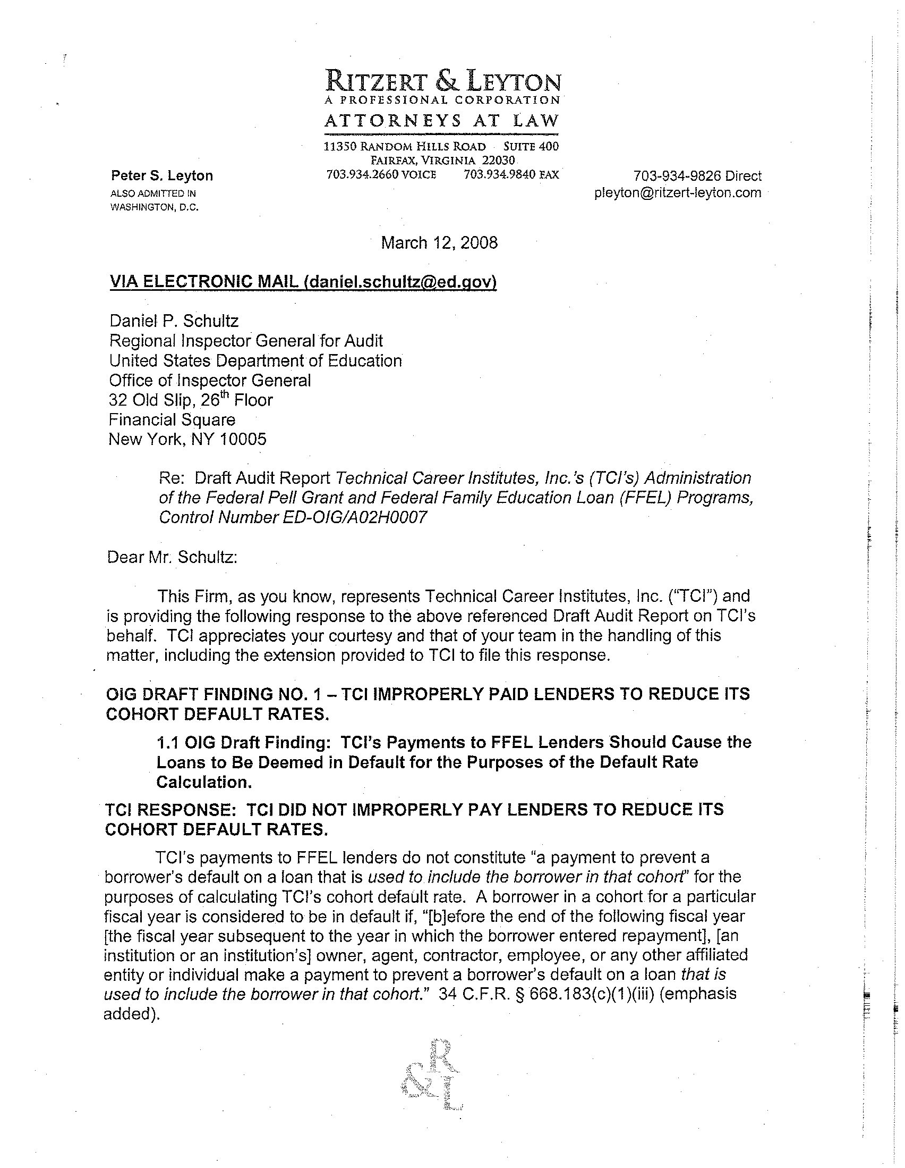
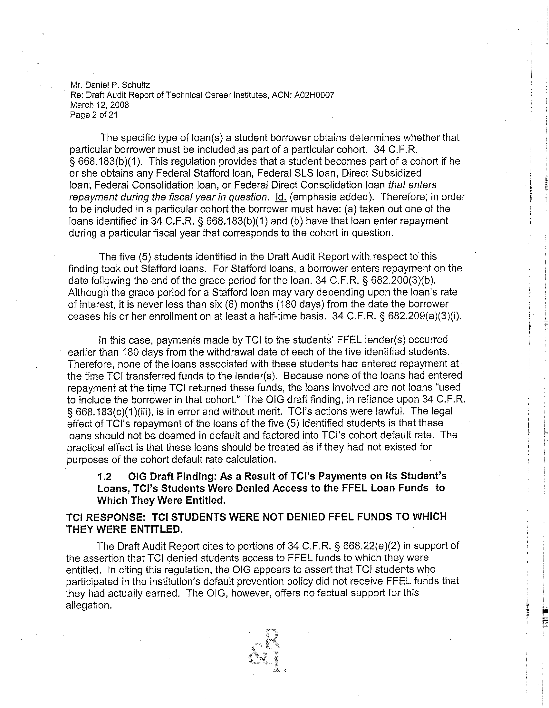
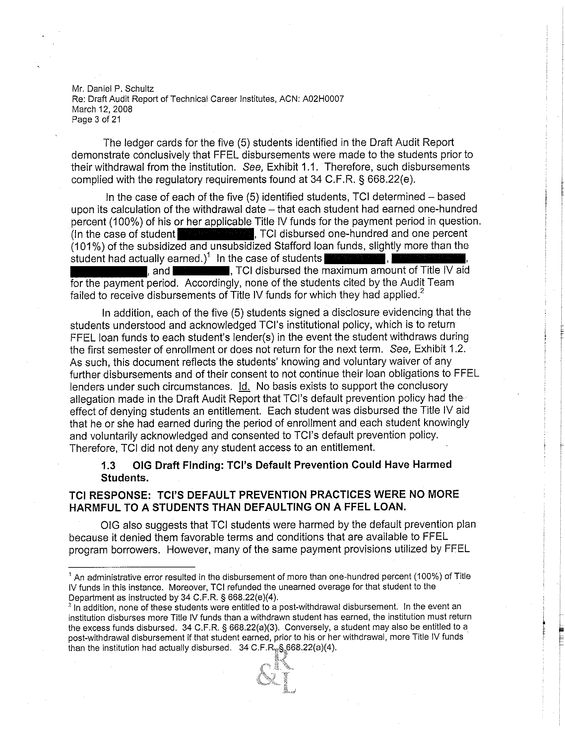
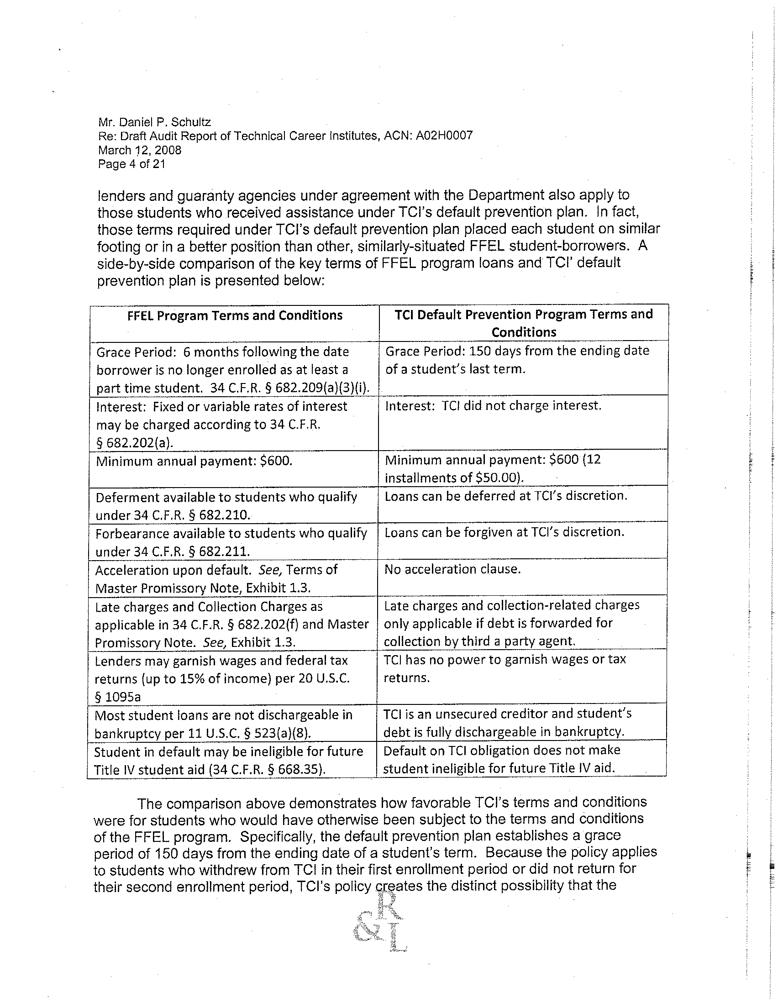
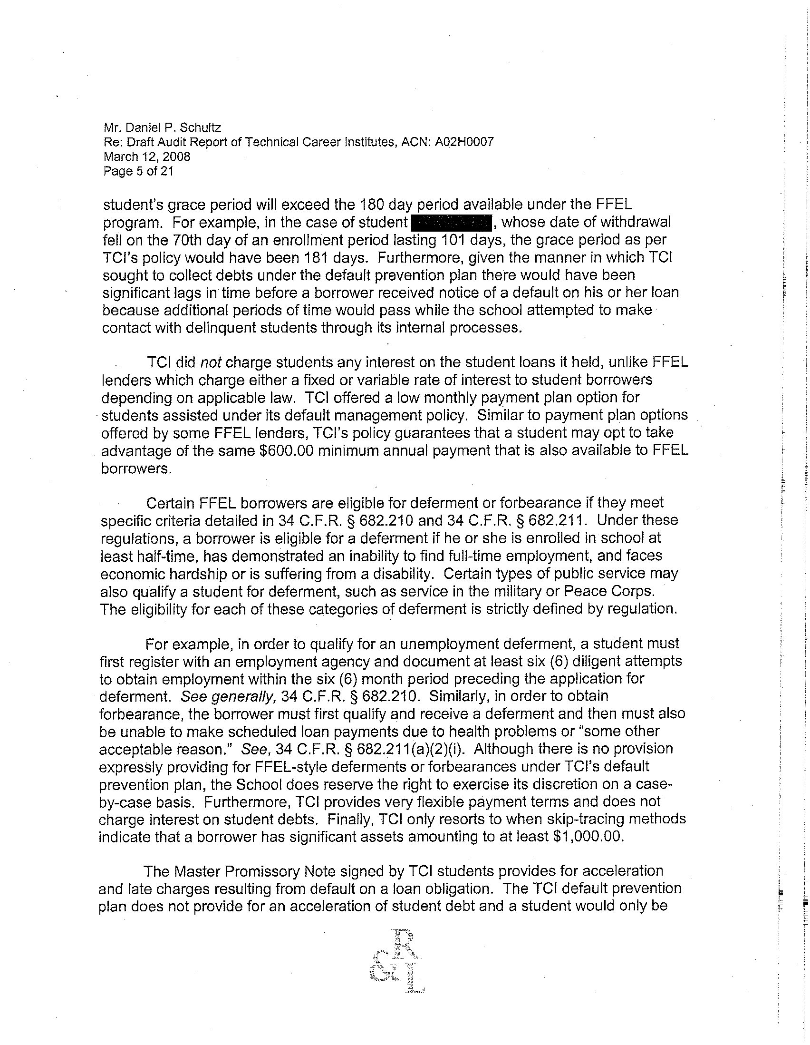
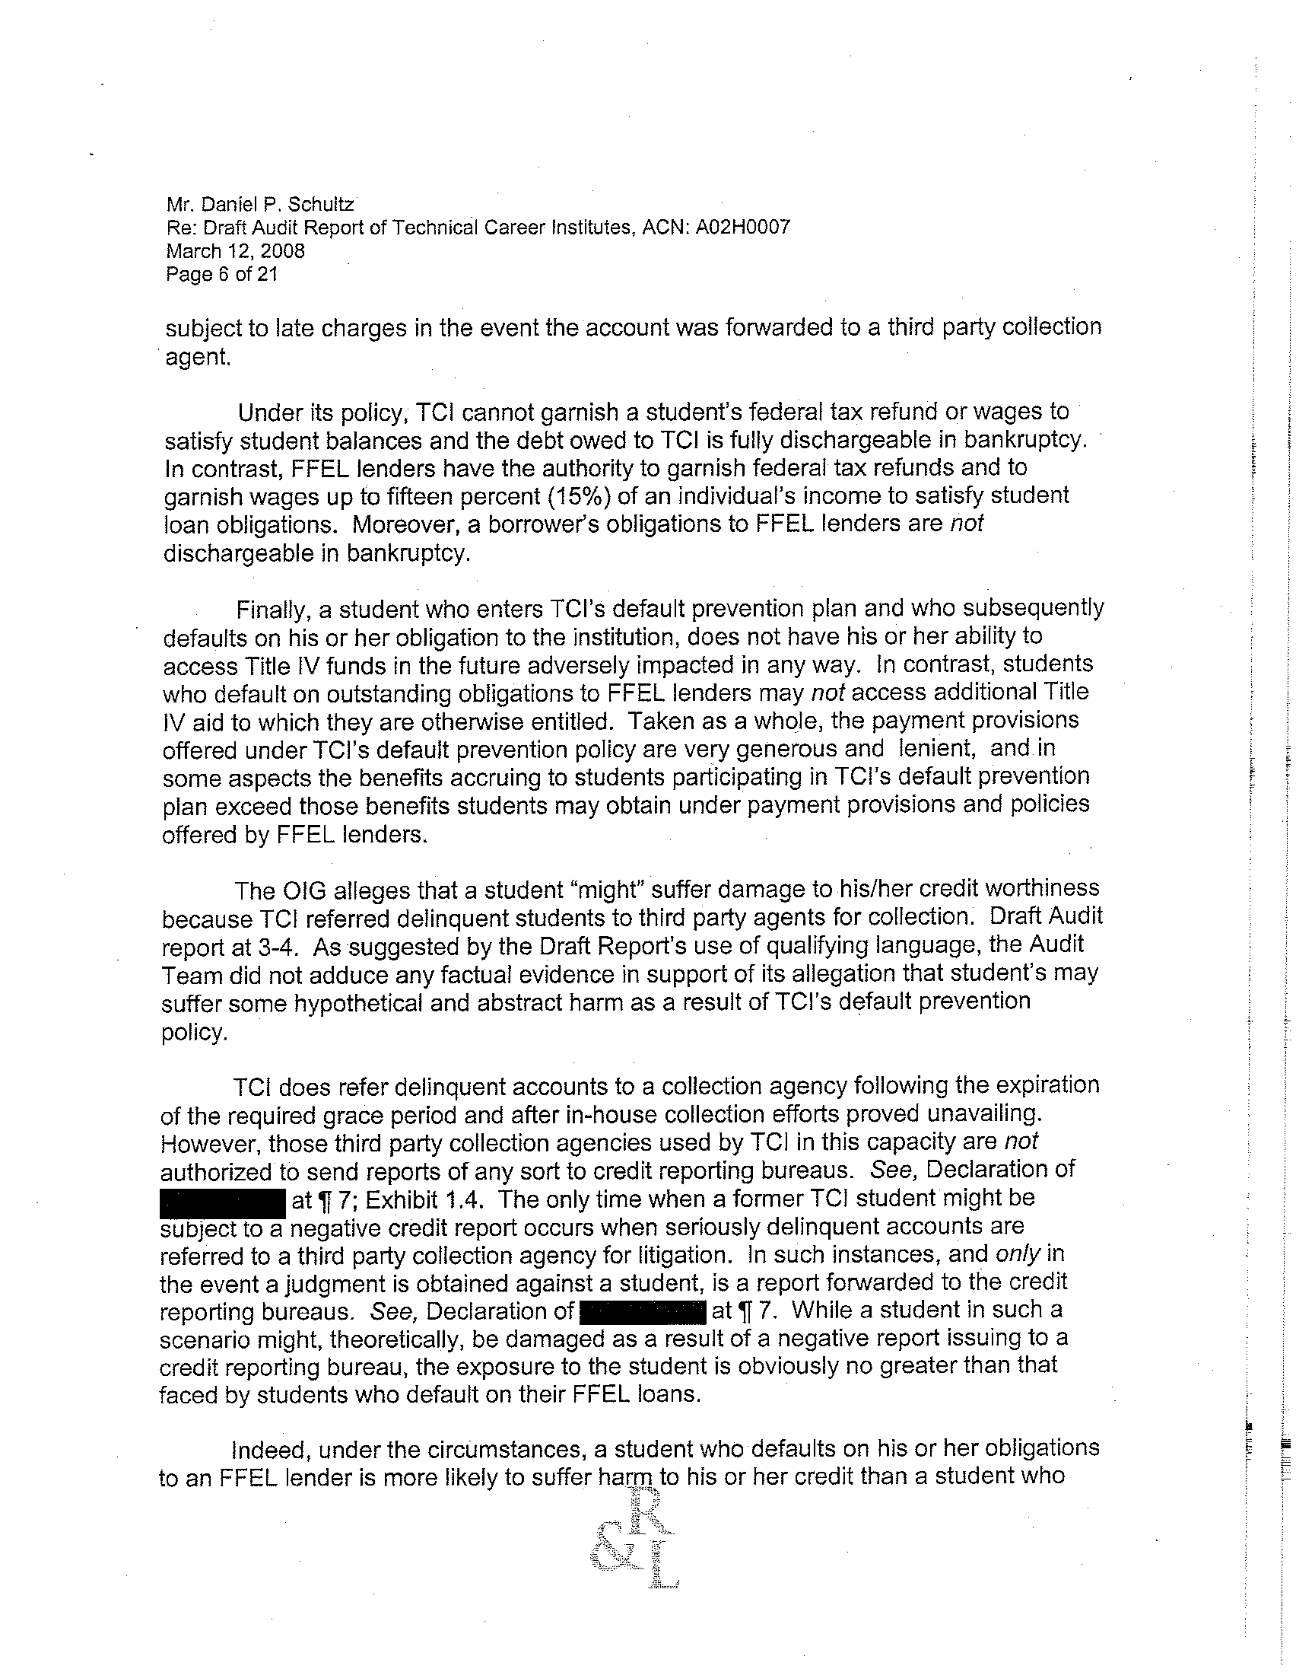
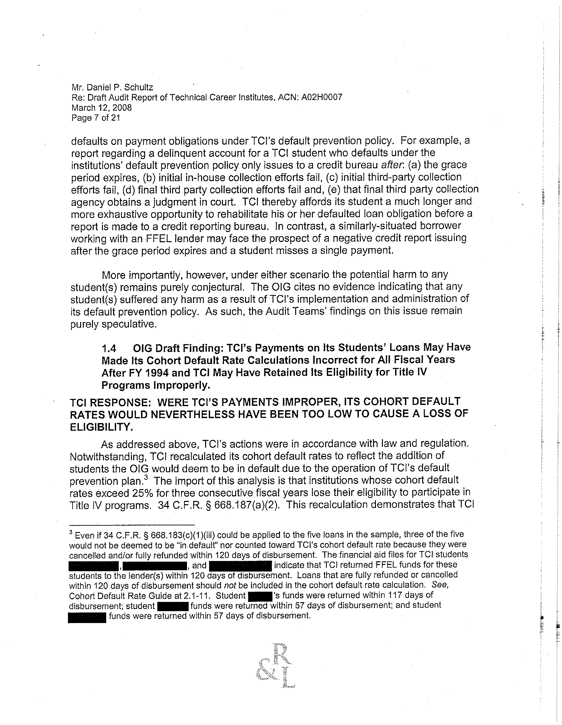
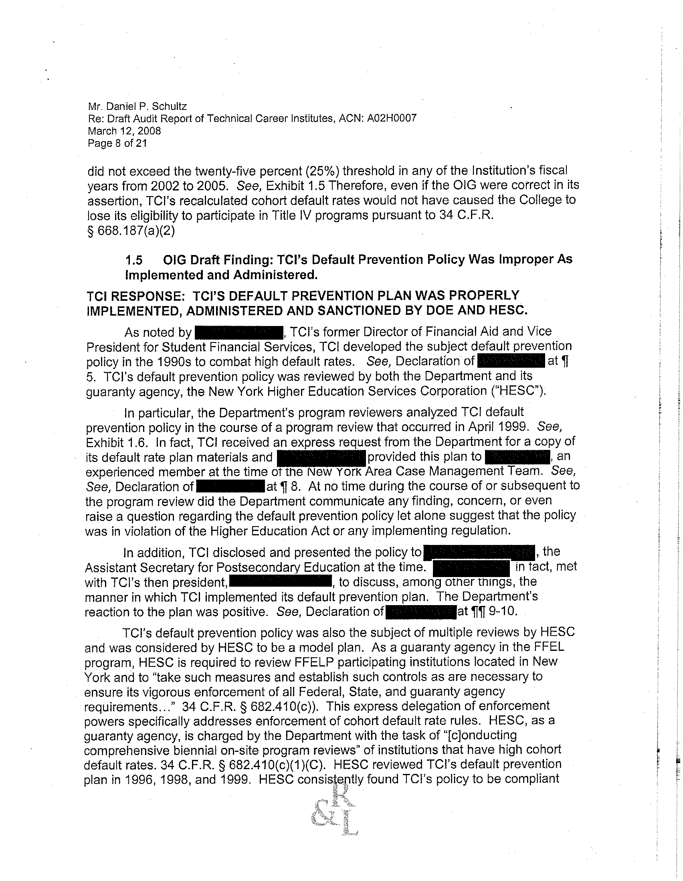
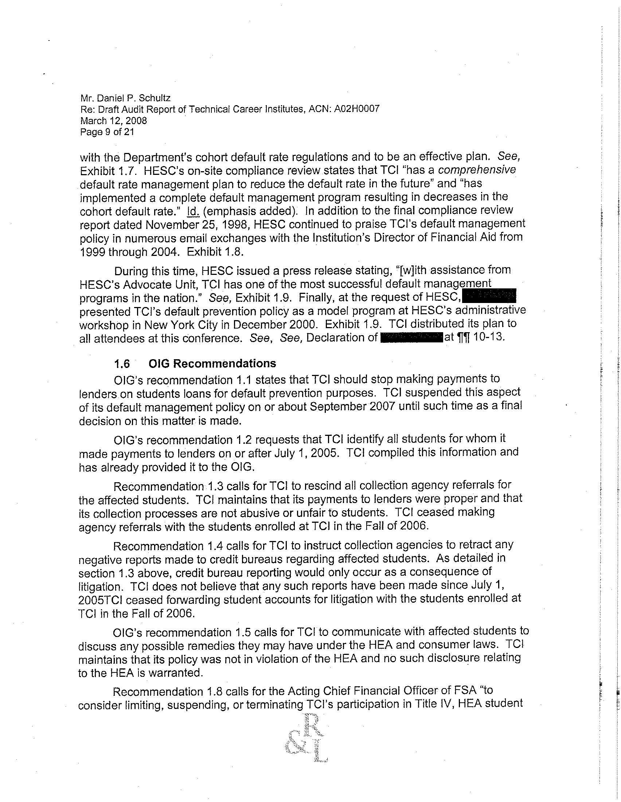
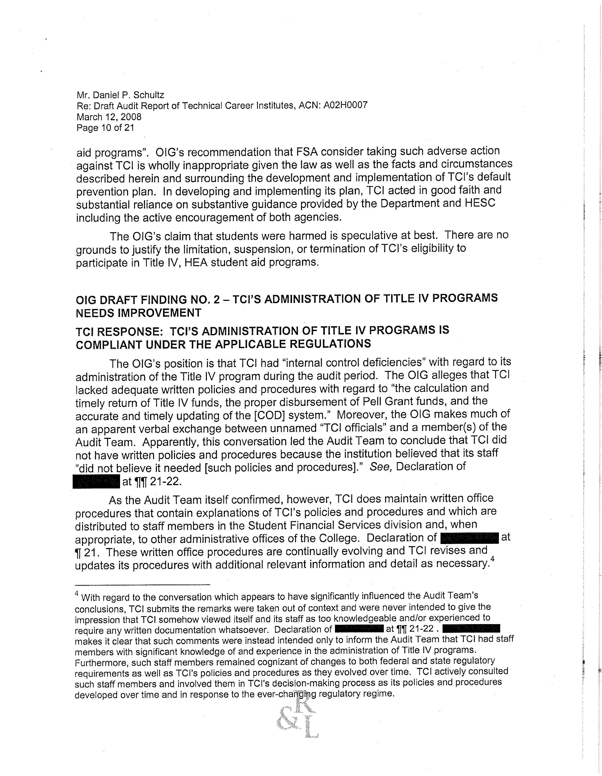
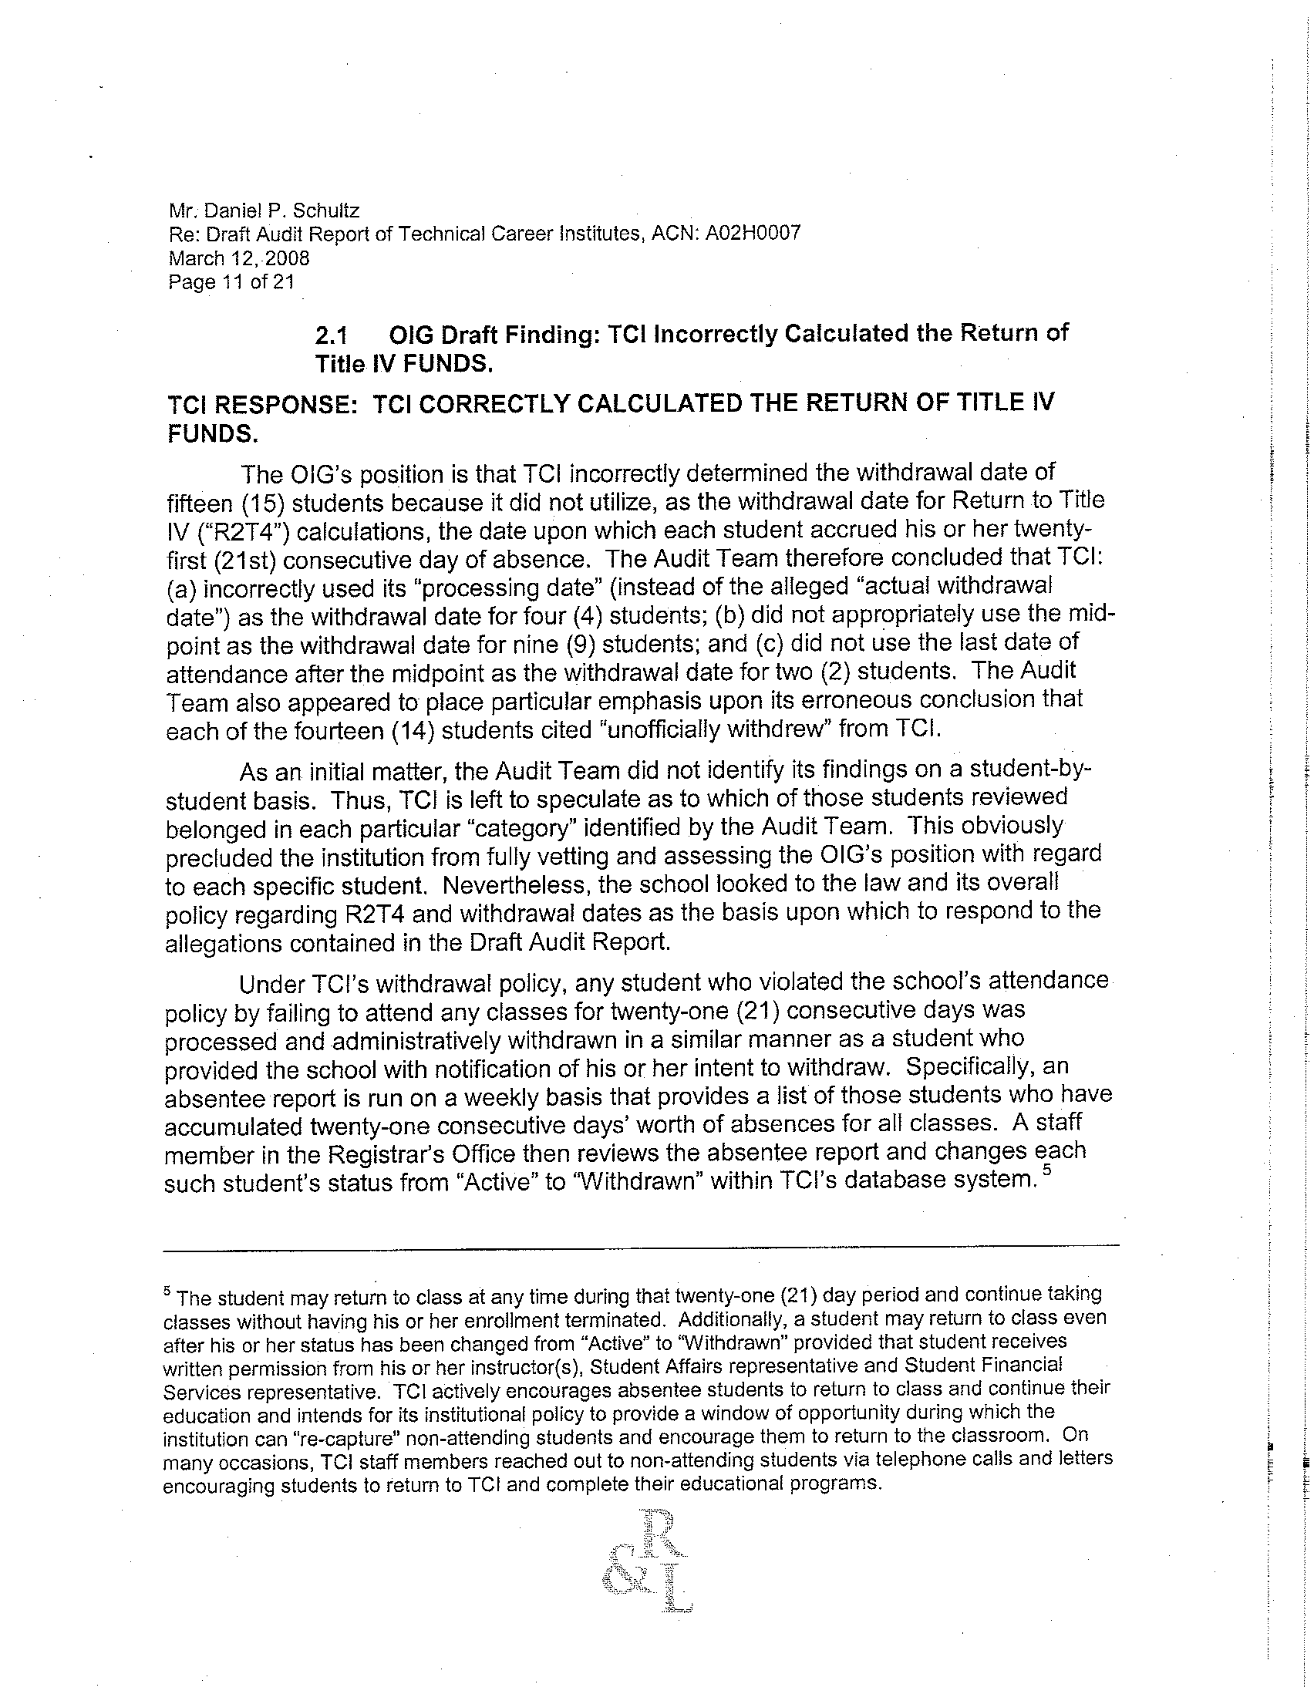
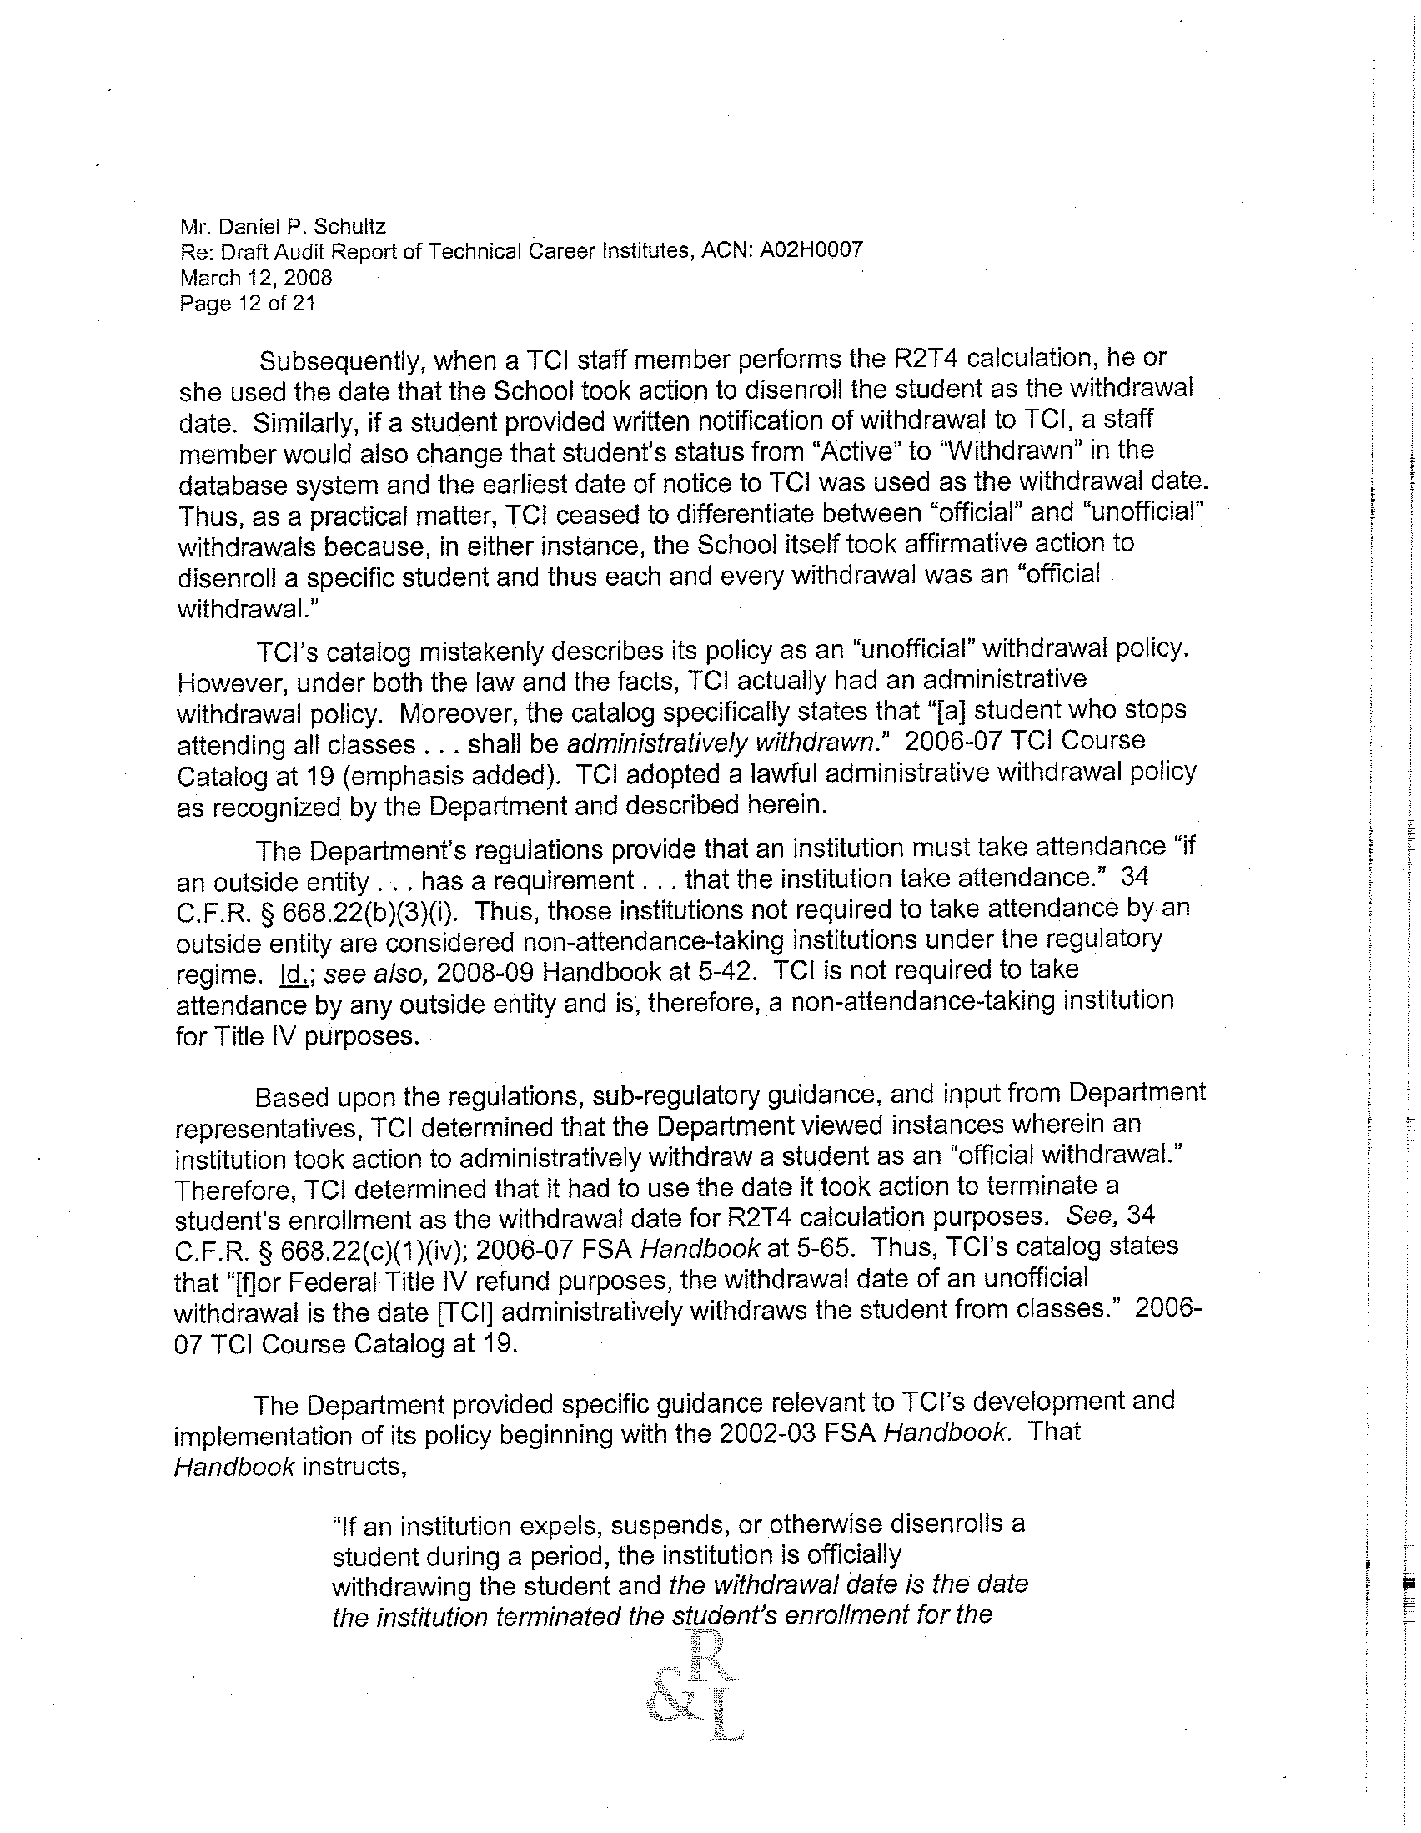
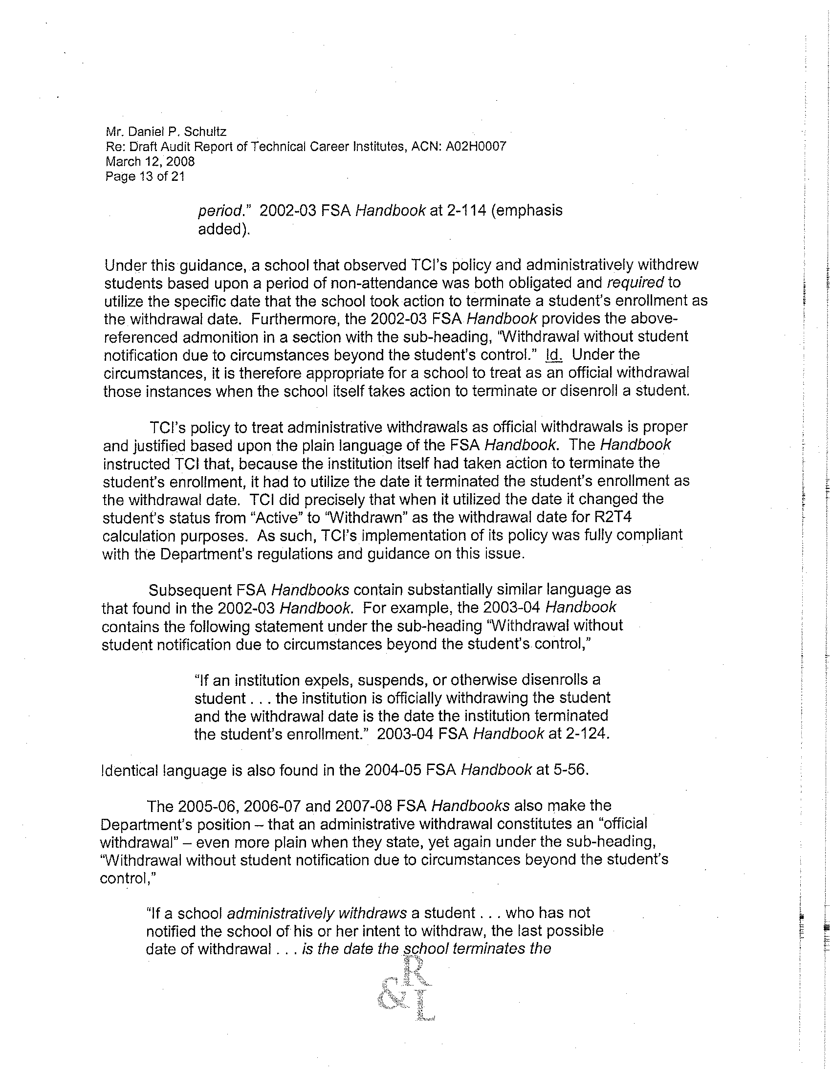
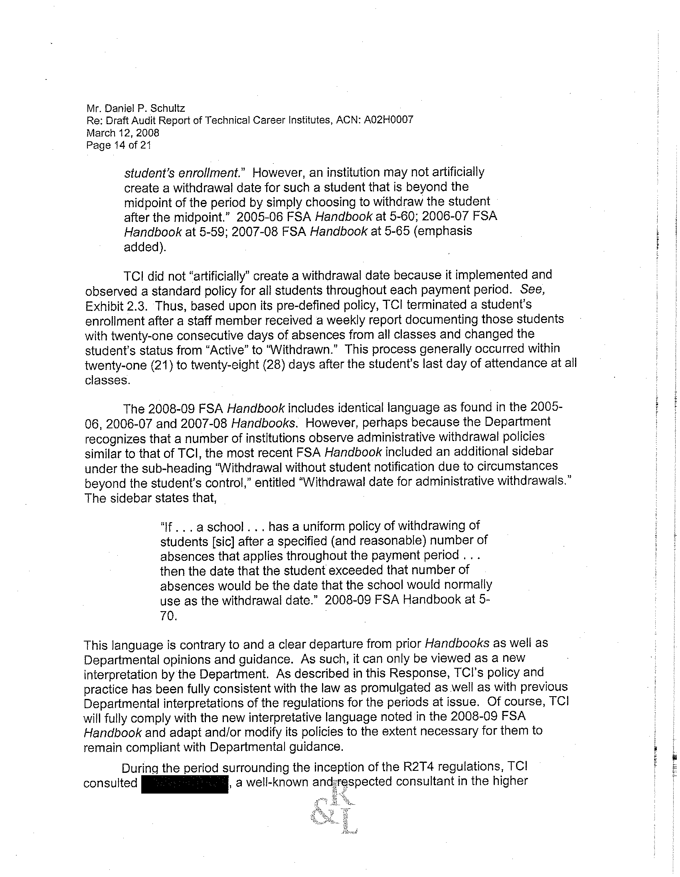
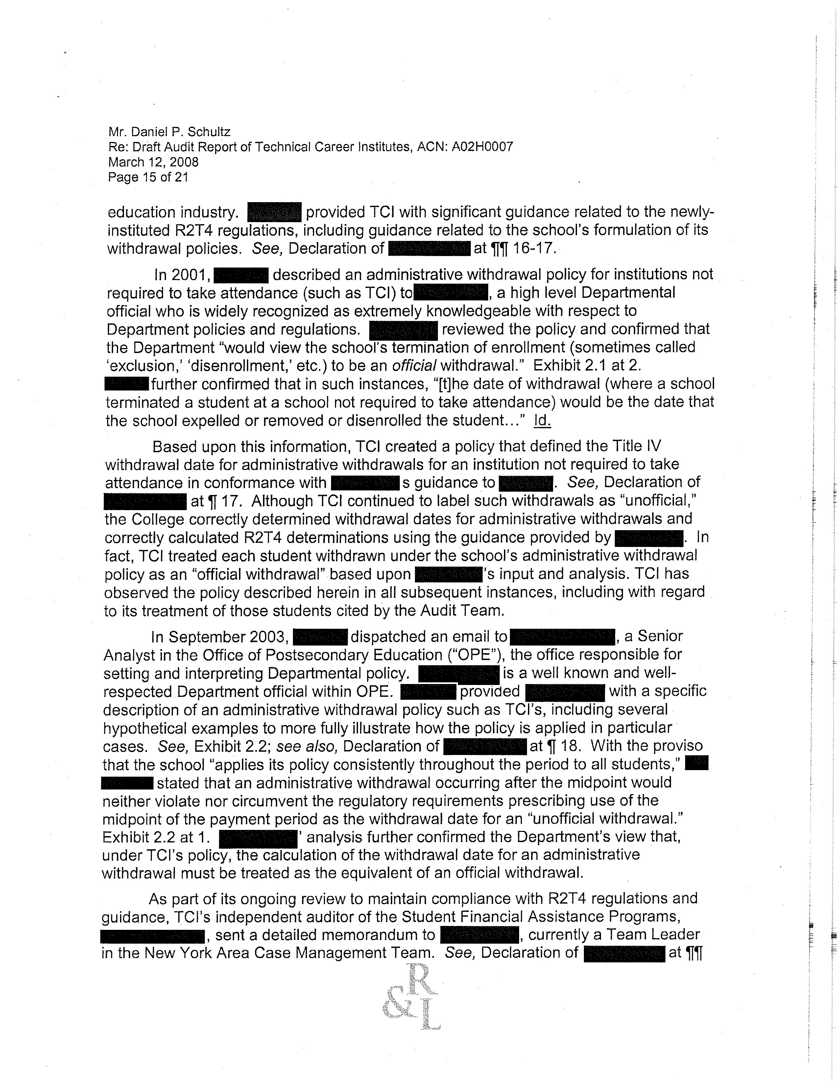
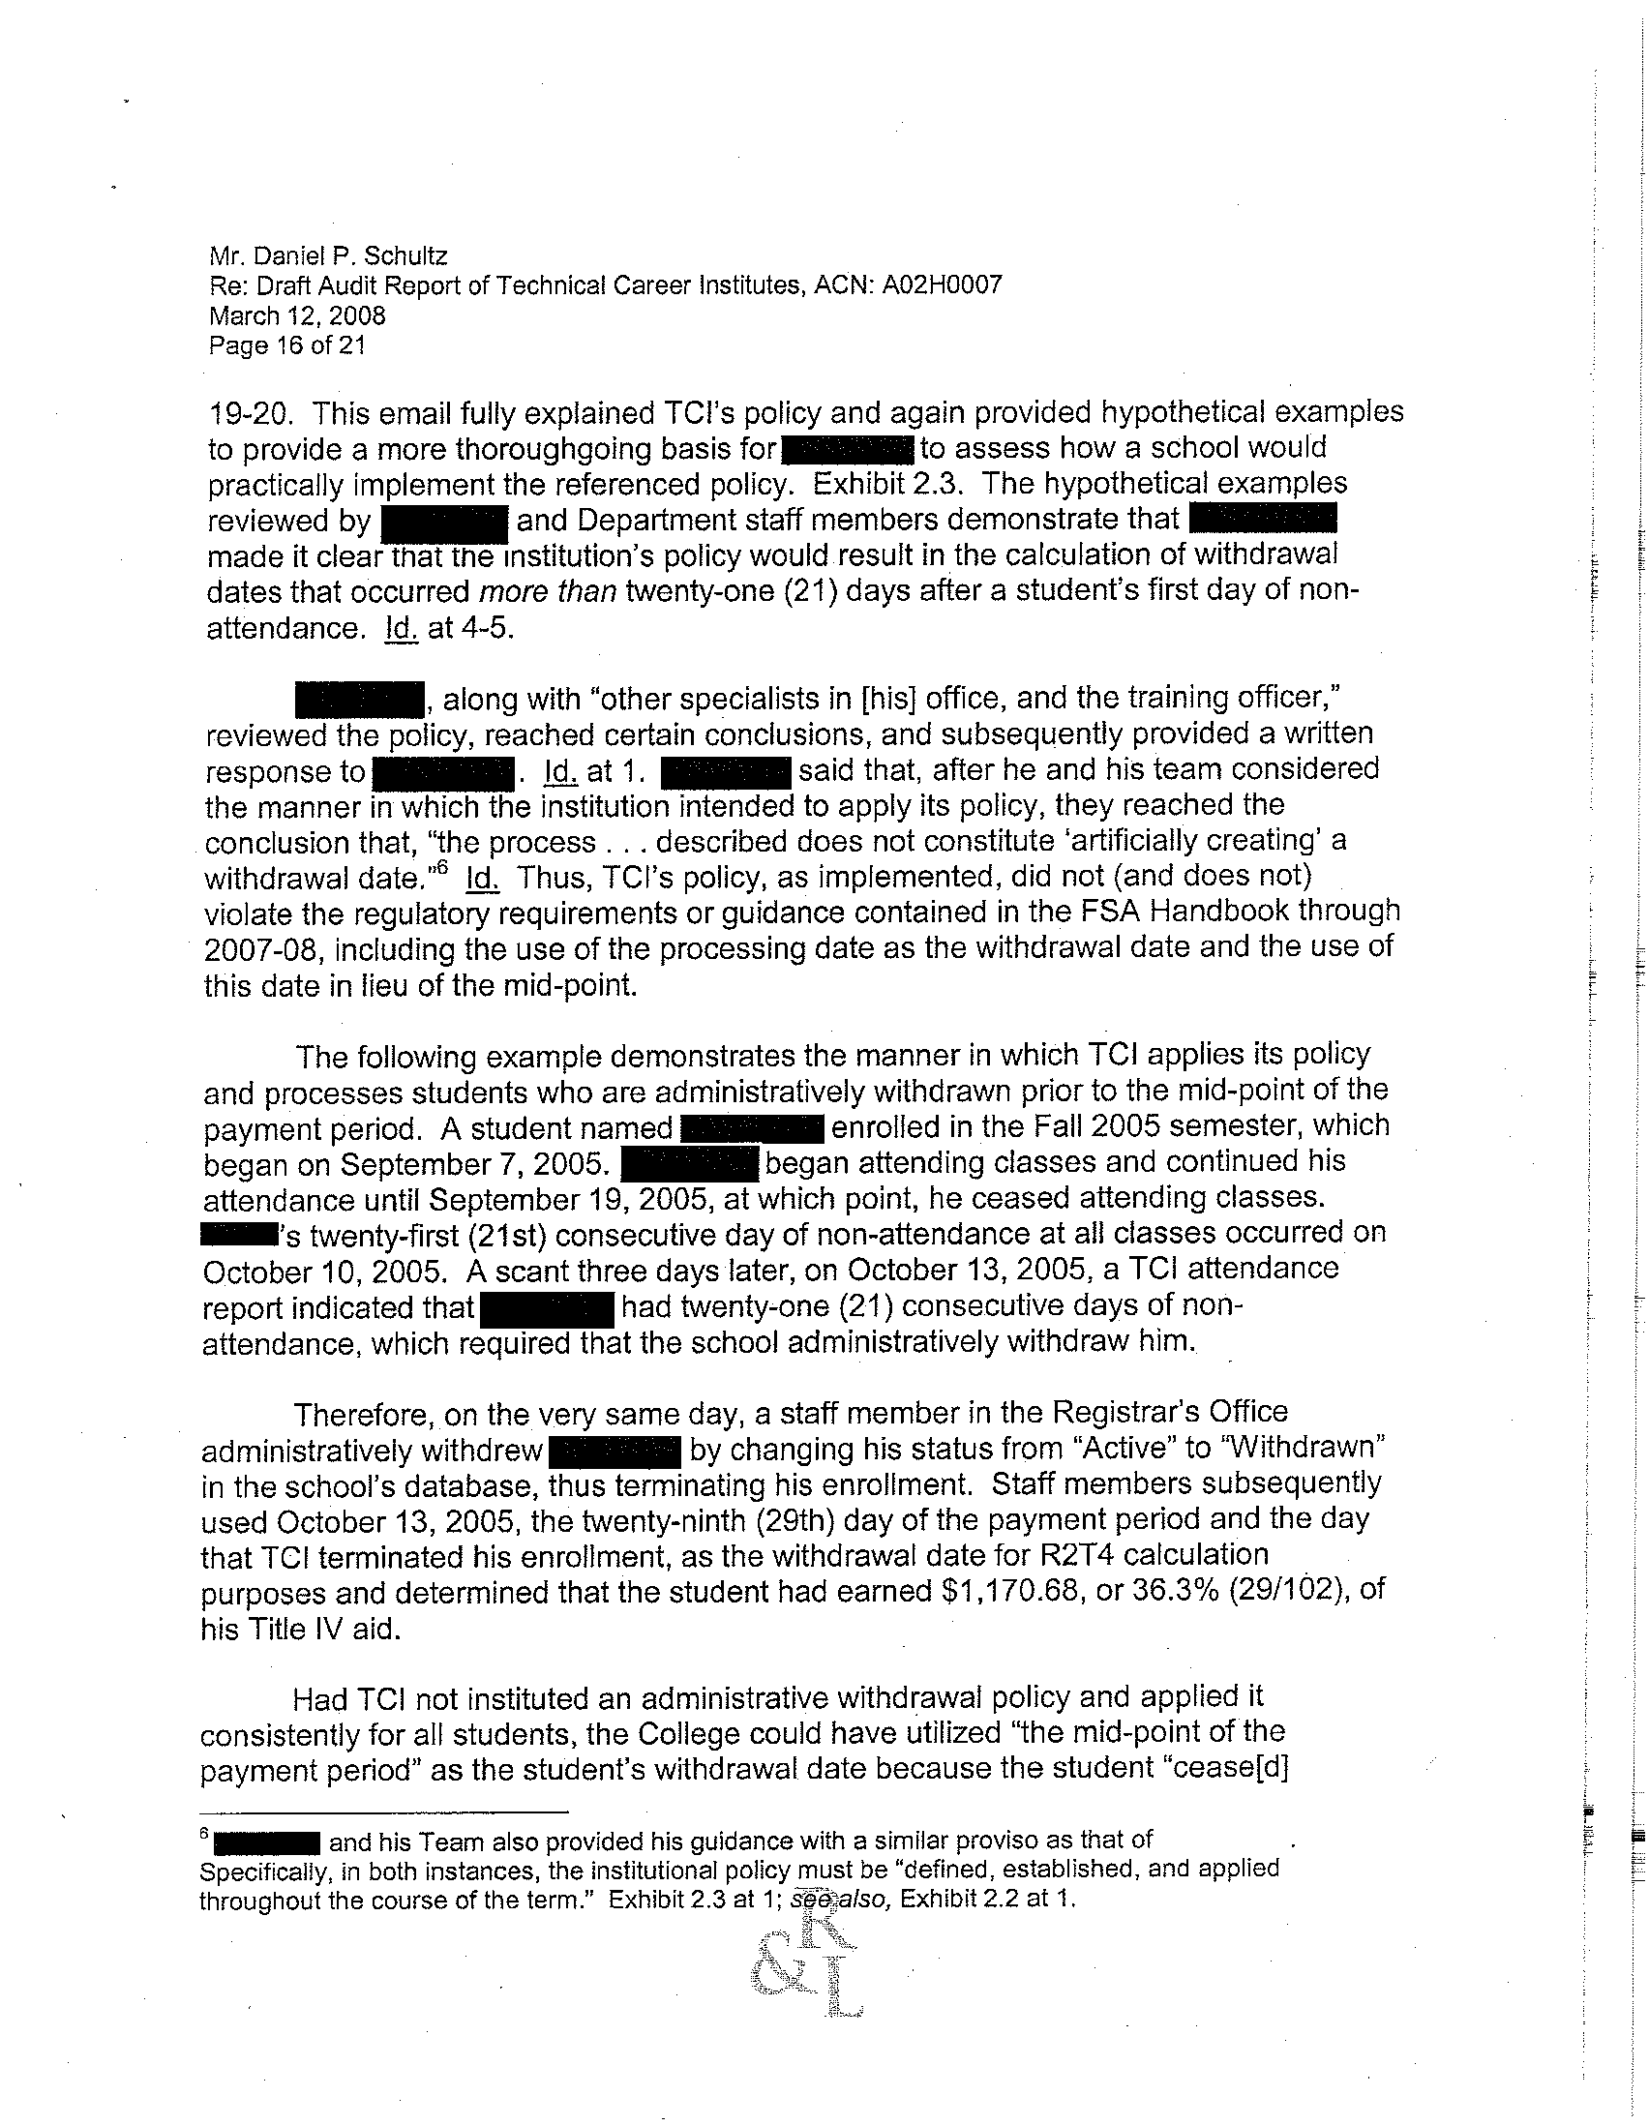
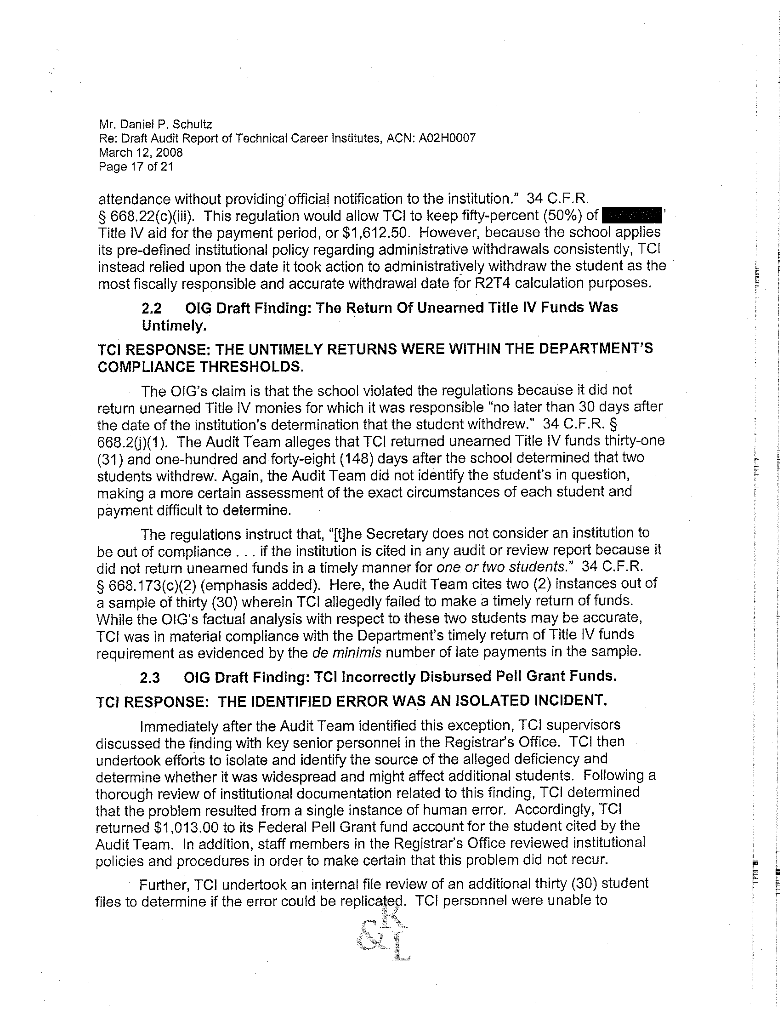
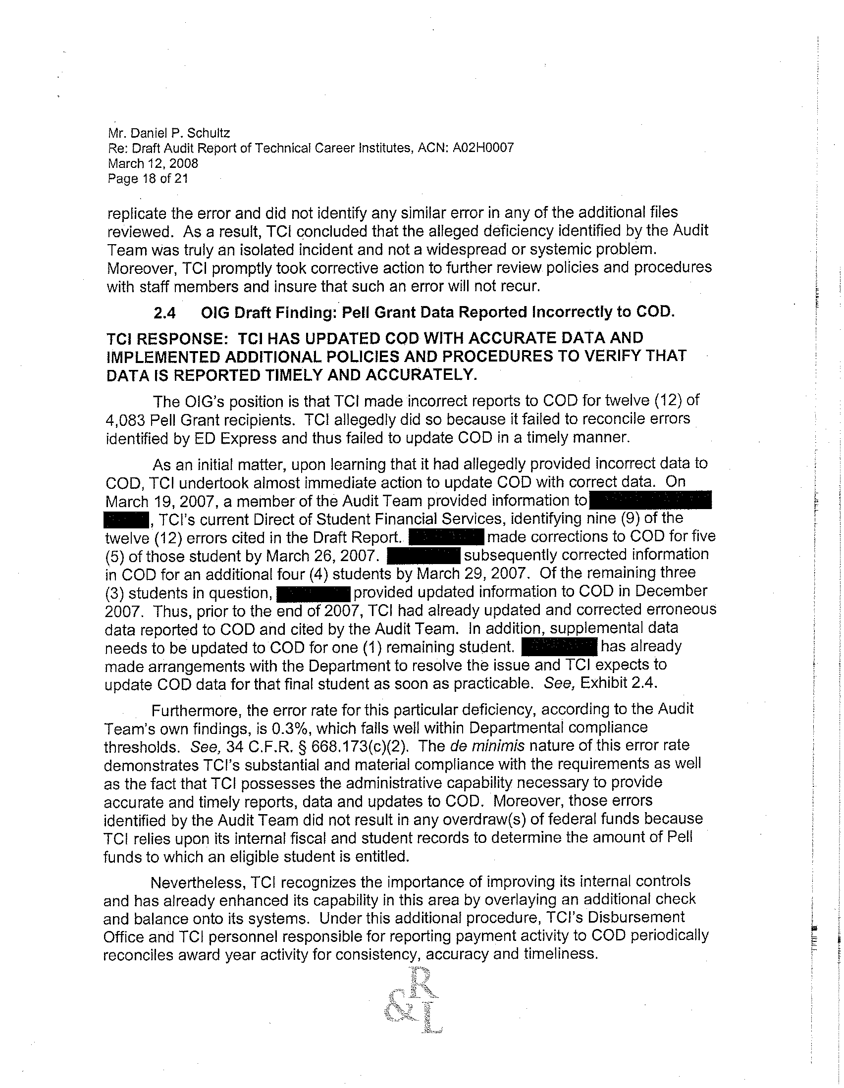
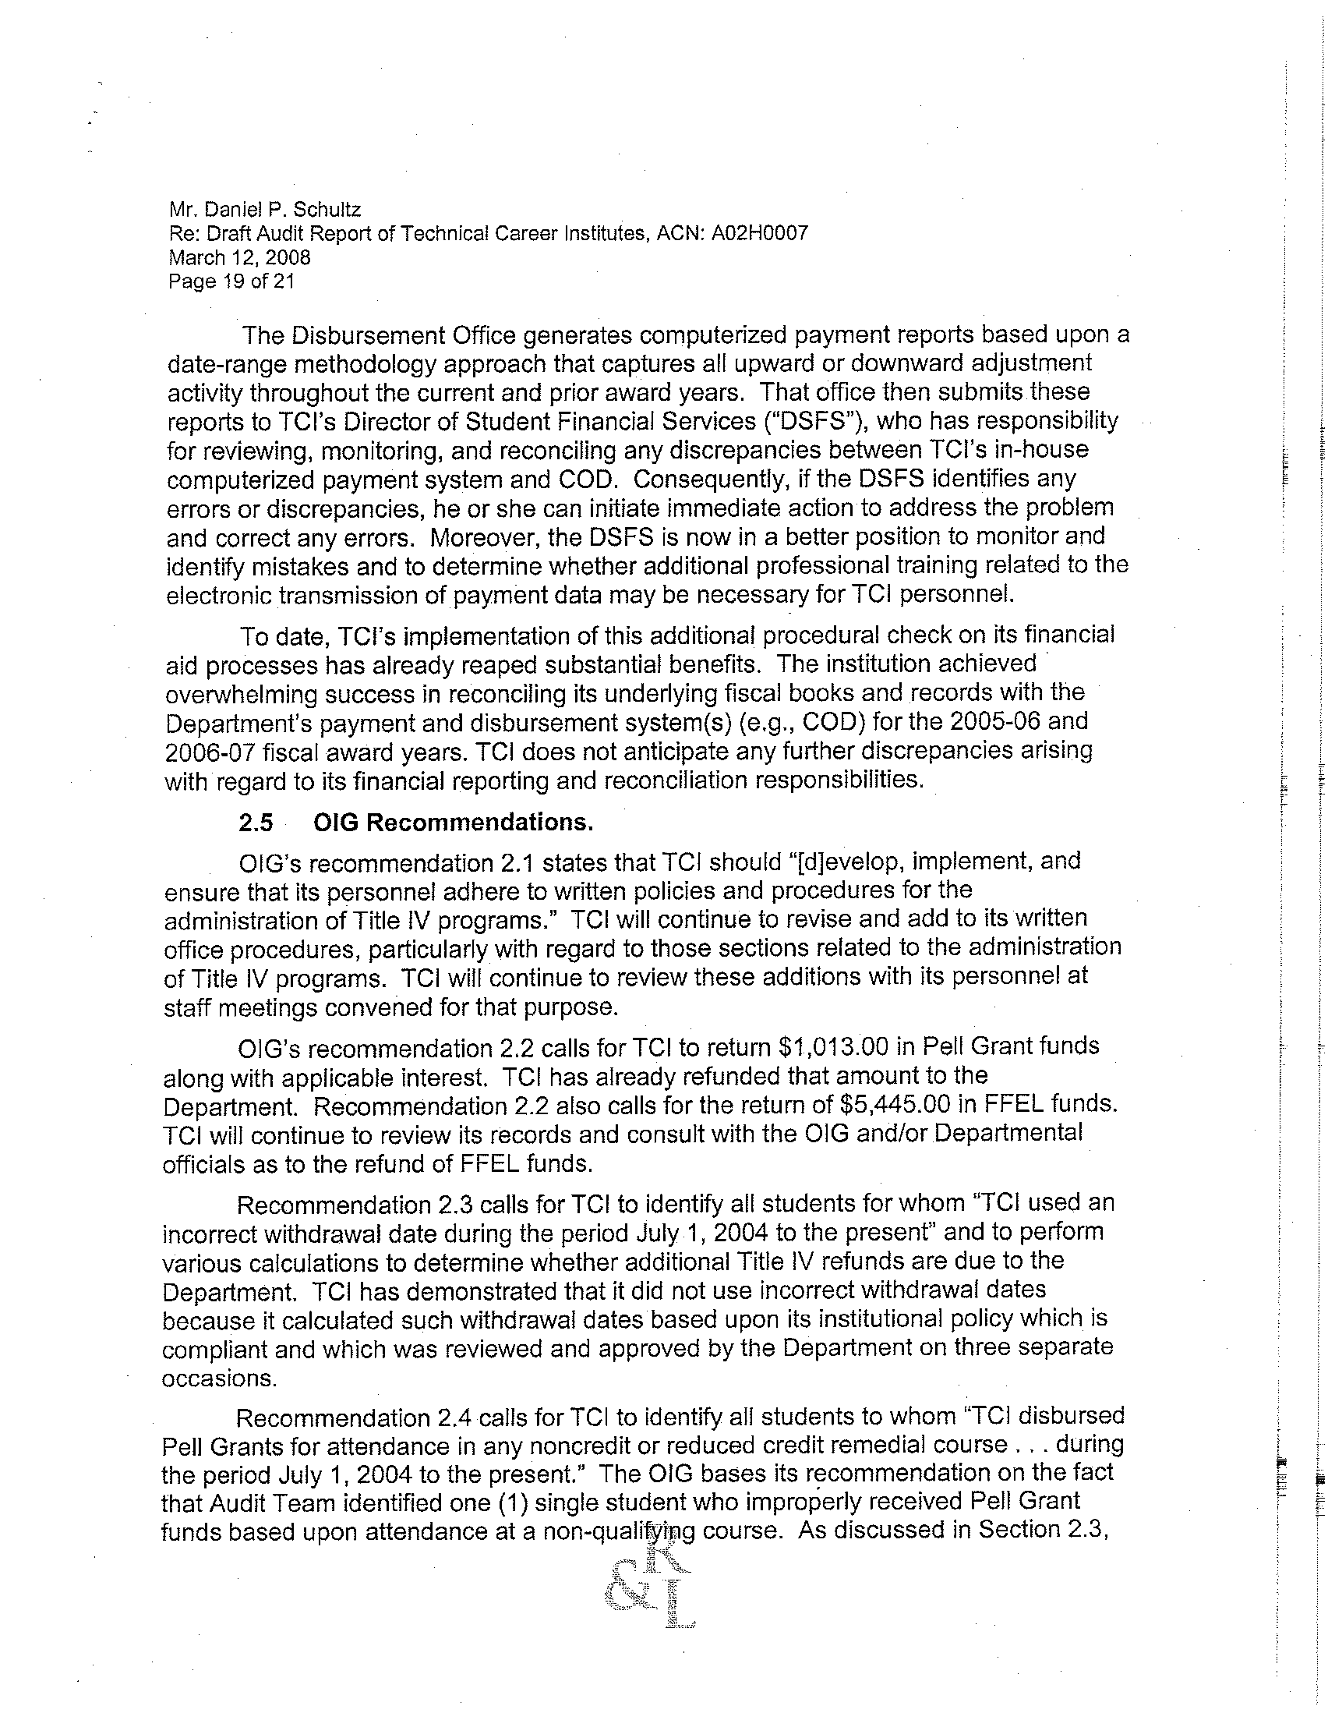
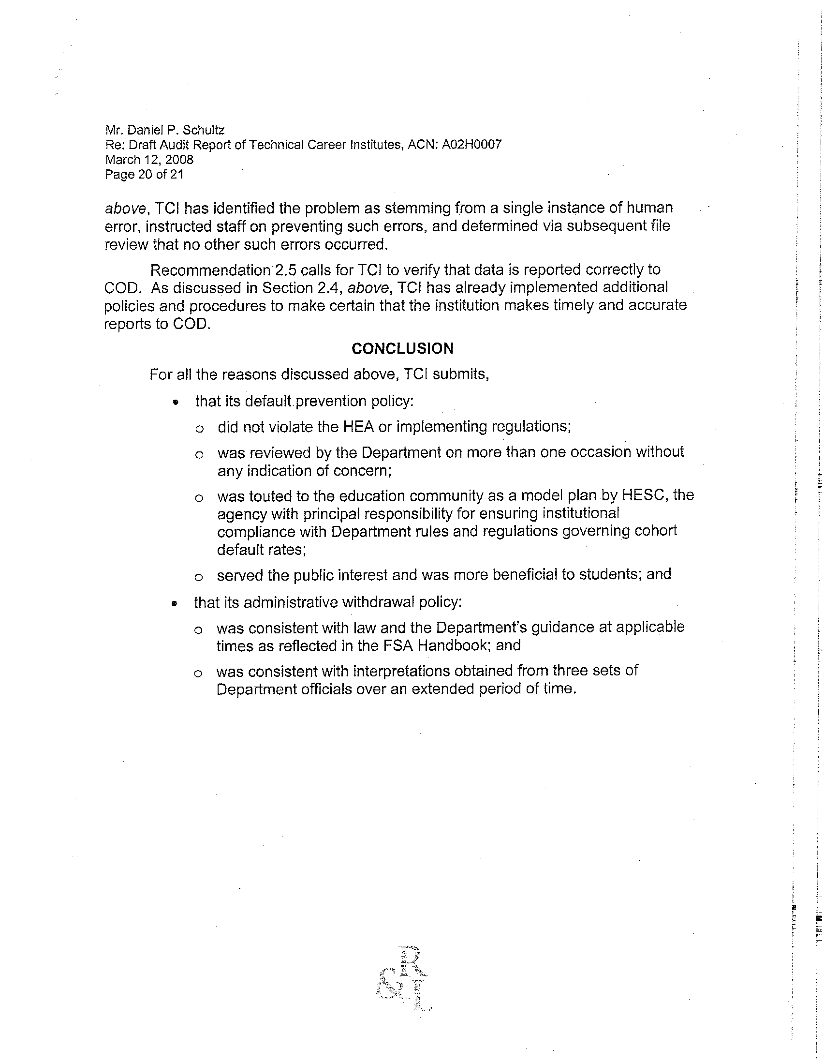
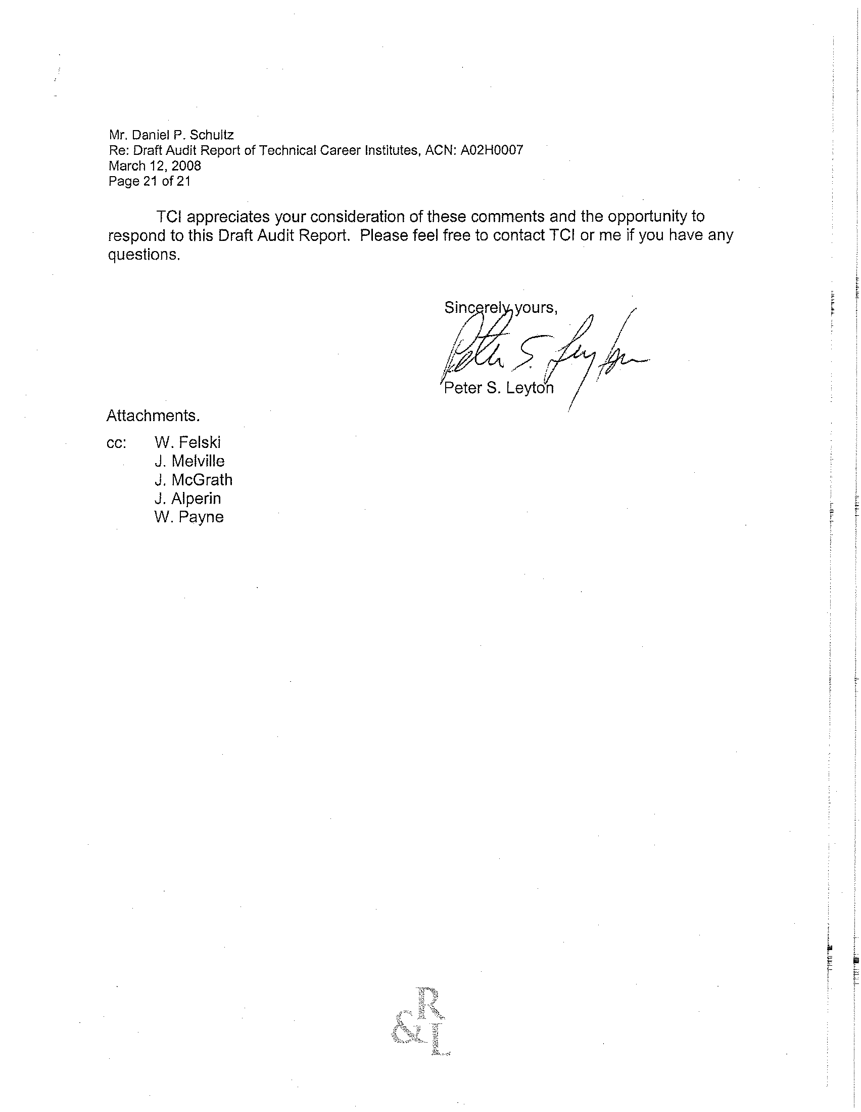

We identified a total of 1,502 students who withdrew from TCI during the period under review.
Our original sample for the return of Title IV funds included 30 withdrawn students: 13 students who had FFEL loans and/or other Title IV funding, and 17 students who did not have FFEL loans but had other Title IV funding.
Unless otherwise specified, all C.F.R. citations are to the July 1, 2005, volume.
For FY 1995, TCI’s original cohort default rate was 33.4 percent, but after an appeal it was revised to 24.7 percent.
The two students were included in TCI’s cohort default rate calculation for FY 2005. However, both of the students began and ended their TCI attendance in FY 2006, and the dates their loans were made were consistent with dates for loans to students who were included in TCI’s FY 2006 cohort default rate. Neither student should have been included in TCI’s FY 2005 cohort default rate calculation. Instead, both students should have been included in the FY 2006 cohort default rate calculation.
For most borrowers, default occurs after 6 months in a grace period, then 60 days during which the lender schedules the first payment, then 270 days of delinquency on the loan by the borrower, and after that, an average of about 90 days for the default claim to be filed and paid (34 C.F.R. §§ 682.200(b), 682.209(a)(2) and (3), and 682.406(a)).
The Final Audit Report, ED-OIG/A09G0030, entitled Technical Career Institutes' Verification of Applicant Information Submitted on the Free Application for Federal Student Aid (FAFSA), determined that TCI had policies and procedures in place that ensured FAFSA information was verified in accordance with applicable laws and regulations. TCI’s written policies and procedures, as included in its college catalog and internal memoranda, were adequate for its administration of its verification process, but were not adequate for the requirements reviewed during our audit or for TCI’s general administration of the Title IV programs.
The student was terminated due to incomplete immunization requirements.
One student was counted twice in our calculation of students for whom TCI did not return Title IV funds due to incorrect withdrawal dates. This student withdrew from two semesters during our review period, and TCI miscalculated the return of Title IV twice.
TCI miscalculated the return of Title IV funds for one of the two untimely returns.
New York State High School Equivalency Diploma and TCI degree requirements for Ability-to-Benefit students entering Fall 2004 state that for a student majoring in Industrial Electronics Technology (IETC), HIS-103 American History I was not a degree courses but it counted as a noncredit or reduced credit remedial course leading to a high school diploma or the recognized equivalent. COM204, Intro to Java Programming, was not an approved course for the IETC degree program, and it was not a noncredit or reduced credit remedial course leading to a high school diploma or the recognized equivalent.
EDExpress is the financial aid management software provided free of charge by ED, which TCI used to administer its Pell Grant funds.

