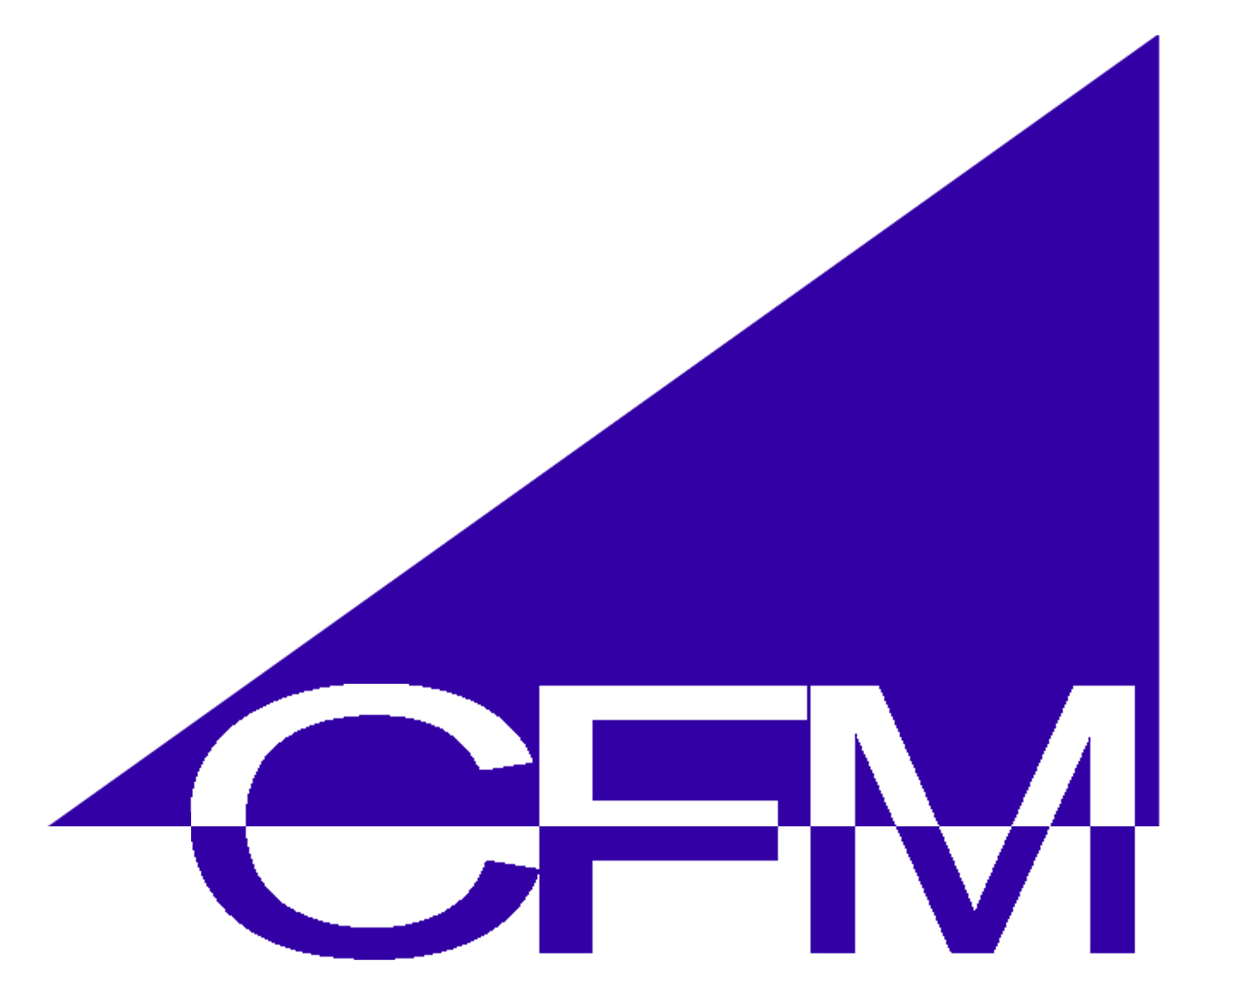

The State Home GRANT Program

The State Home Program is a partnership between the U.S. Department of Veterans Affairs (VA) and the States to construct nursing home, domiciliary, and/or adult day health care facilities. The program is authorized in Title 38 United States Code (USC) Section 8131-8137 and regulated in Title 38 Code of Federal Regulation (CFR) Part 59. VA may participate in up to 65 percent of the cost of construction or acquisition of State nursing homes or domiciliaries or for renovations to existing State Homes. A State Home is owned and operated by the State. VA assures Congress that State Homes provide quality care through inspections, audits, and reconciliation of records conducted by the State Home program managers and the VA medical center of jurisdiction. Under a separate State Home Grant program, VA also provides per diem payments to States for the care of eligible veterans in State Homes.

One of the most important functions in the Office of Construction & Facilities Management (CFM) is the work in VA’s State Home Grant Program. CFM’s, Facilities Quality Service provides consulting services to VA’s Office of Geriatrics and the States. CFM assists in reviewing state grant applications for program requirements and establishes VA funding participation. CFM also assures quality control for the program by monitoring the design/construction process and providing inspection services of the completed facilities.
.
The FY 2007 State Home grant budget is $85 million or $130 million in actual construction. When funds are appropriated for this program, they are authorized until expended. The FY 2008 budget appropriation is expected in the $250 million range for grants or $384 million in construction. This huge increase will be the largest appropriation in the program’s history.

Today there are 120 State Homes in 50 states and Puerto Rico

YR | Grant (65% Of Cost) | Construction Cost
FY 2002 | 21 projects -$100 | $150
FY 2003  FY 2004  FY 2005 | 29 projects - $121  43 projects - $101  30 projects - $104 | $180  $155  $160
FY 2006  FY 2007  proposedFY08 | 29 projects - $85  43 projects - $85  90 projects - $250 | $130  $130  $384

