  U.S. Department  of Transportation  Federal Aviation  Administration | Advisory  Circular

Subject: General Guidance and Specifications for Aeronautical Survey Airport Imagery Acquisition and Submission to the National Geodetic Survey | Date: 9/15/2007  Initiated by: AAS-100 | AC No: 150/5300-17A Change:

Purpose of this Advisory Circular (AC).
This AC provides the specifications for Airport Imagery Acquisition and how to submit the imagery to the National Geodetic Survey for approval in support of aeronautical information and airport engineering surveys.

Application.
The Federal Aviation Administration (FAA) and the National Geodetic Survey (NGS) Aeronautical Survey Program recommend the guidance and specifications in this AC for all airport projects. This AC does not constitute a regulation and in general is not mandatory. However, use of these guidelines is mandatory for surveys that are funded under Federal grant assistance programs. It also provides one, but not the only, acceptable means of meeting the requirements of Title 14 Code of Federal Regulations (CFR) part 139, Certification of Airports. Mandatory terms such as “must” apply only to those who conduct aeronautical information surveys using Airport Improvement Program (AIP) or Passenger Facility Charge Program (PFC) funds or those who seek to demonstrate compliance by use of the specific method described by this AC.

Cancellation.
This AC cancels AC 150/5300-17, General Guidance and Specifications for Aeronautical Survey Airport Imagery Acquisition and Submission to the National Geodetic Survey, dated March 29, 2006.

Principal Changes.
General typographical, grammatical, and editorial changes not affecting the actual standards are made throughout the document. With the current implementation of Wide Area Augmentation System (WAAS) Localizer Performance with Vertical Guidance (LPV) instrument approaches require additional airport surveying guidance necessary. To accommodate these LPV approaches, this revision includes the following principal changes:

Clarifies the requirement in paragraph 3 (now paragraph 5), for the airport sponsor rather than the contractor make submission of deliverables to NGS. This ensures the sponsor is involved in the process of data acquisition and delivery to the government.

Modifies the requirements for imagery deliverables in Paragraph 3a, Digital Stereo Imagery (now Paragraph 5a) by standardizing the file structure of the submitted imagery.
  - Modifies the requirements of paragraph 3b (now paragraph 5b ) Ground Control, for all elevations and coordinates to be specified to the thousandth of the specified unit of measurement rather than to the hundredth of a unit of measurement.
  - Suspends the requirement for contractors to provide a digital orthophoto as specified in Paragraph 3f, Final Report (now Paragraph 5f). This suspension is temporary while the FAA consults with industry to establish an appropriate standard.
  - Changes flying height requirement in Paragraph 7, Flying Height (now Paragraph 9), to a must not exceed height and to recommend lower altitudes for purposes such as mapping.
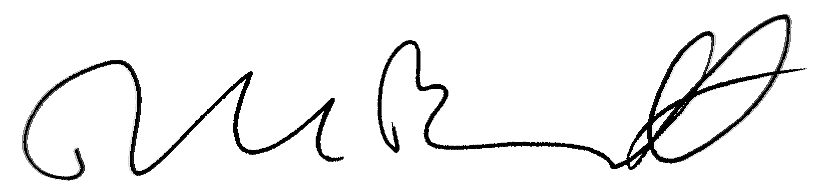

David L. Bennett
Director, Office of Airport Safety and Standards

TABLE OF CONTENTS

GENERAL INFORMATION 1
DELIVERABLES 1
WEATHER, SOLAR ANGLE, AND TIME OF YEAR 10
FLIGHT LINE NAVIGATION AND GUIDANCE 11
IMAGE QUALITY 11
POINTS OF CONTACT 11

This page intentionally left blank

GENERAL INFORMATION

This AC provides the guidance and specifications for contractors to acquire and submit airport imagery to the NGS in support of required FAA airport surveys. The FAA has tasked the Aeronautical Survey Program (ASP) at NGS to perform quality assurance on all airport surveys contracted by State aviation agencies and local airport authorities. NGS administers the ASP in accordance with an Interagency Agreement with the FAA. NGS will perform a photogrammetric analysis using this airport imagery to ensure the survey data adheres to the most current edition of the appropriate FAA ACs and program objectives.

All positional data provided under these specifications and guidelines must be referenced to the National Spatial Reference System (NSRS). The datum for the horizontal positions is the North American Datum of 1983 (NAD 83). The vertical datum is the North American Vertical Datum of 1988 (NAVD 88).

Provide complete written justification to exceed or deviate from this specification to NGS and the FAA through the airport sponsor. Requests to exceed or deviate from these specifications will be considered when written justification is provided to the FAA Airport Surveying-GIS Program Manager and NGS in advance.

DELIVERABLES

Information Provided by the Selected Contractor.
Provide to the NGS ASP through the airport sponsor the following items:

  - Digital Stereo Imagery. The airport sponsor must provide NGS ASP with digital stereo imagery of the entire area to be analyzed. The dimensions of this area depend on the type of survey the contractor is requested to perform. Acquire the imagery within at most 6 months prior to the ground survey. Submit the imagery well in advance of the ground survey for NGS review and approval prior to submitting the ground survey data.

(1) The directory structure for imagery deliverables must conform to the following requirements:

      - Establish the directory structure (see Figure 1) so each directory contains pertinent information about each item. Name the root directory using the assigned FAA airport location identifier, for example,

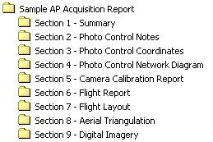BOS AP Acquisition Report

      - Develop a table of contents for each airport, and store it in the root directory. The use of a standardized submission format assists in NGS verification.

(2) The imagery deliverables must conform to the following requirements:

- Delivery medium—DVD or external USB compatible hard drive
- Flight Line Diagram—See Figure 3
- File Format—TIFF (Tagged Image File Format) or VITec Scanner Raster Format
Figure 1
AP Acquisition Report Directory Structure
- Scanner (for imagery collected with film)—Must use metric quality scanner
- Pixel Ground Sample Distance (GSD) of Scanned Pixels—10–30 cm
- Resolution—Must be of sufficient quality to allow photogrammetric measurement and analysis of airport features such as buildings, obstructions, equipment, edges of paved areas and pavement markings
- Image Quality—Must meet the highest professional standards. Individual airport features must be readily discernable

b. Ground Control. Provide to the NGS ASP for review and approval, the following information:

Ground Control Survey Points File—An ASCII text file listing the following items:

  - Point ID/Station Name
  - Northing (Universal Transverse Mercator [UTM] coordinates; meters specified to the thousandth)
  - Easting (UTM, Meters specified to the thousandth)
  - Orthometric Height in meters, specified to the thousandth, relative to NAVD-88
  - Ellipsoidal Height in meters to the thousandth of a meter.

Table 1, depicts a sample ASCII Ground Control Survey Points File.

TABLE 1
Ground Control Coordinates—Sample
Airport Name:
Coordinate System:
Zone:
Reference Ellipsoid:
Horizontal and Vertical Datum:
All heights are in meters

Station  Name | Northing | Easting | Orthometric  Height | Ellipsoidal  Height
P01 | 2086849.62 | 3579322.68 | 115.48 | 83.34
P02 | 2086905.37 | 3583818.97 | 78.47 | 46.29
P03 | 2092134.98 | 3584776.85 | 93.59 | 61.45
P04 | 2093245.00 | 3586869.35 | 97.09 | 64.94
P05 | 2089958.84 | 3591583.70 | 88.78 | 56.53
P06 | 2084575.11 | 3596417.02 | 51.81 | 19.39
P07 | 2080281.03 | 3598531.32 | 12.47 | -20.02
P08 | 2075655.30 | 3602180.66 | 3.04 | -29.52
P09 | 2075499.76 | 3599408.29 | 11.76 | -20.77
P10 | 2071002.61 | 3598110.64 | 63.01 | 30.49
P11A | 2070470.79 | 3593392.50 | 40.61 | 8.13
P13 | 2081879.33 | 3591462.22 | 59.19 | 26.81
P14A | 2080413.30 | 3585137.48 | 108.09 | 75.78

Ground Control Point -Sketches/Images—Individual scanned sketches and digital images of each ground control point (see Figures 2 and 5).

Ground Control Network Diagram—General diagram/sketch showing the ground control network of control points. This diagram may be incorporated with the Flight Line Diagram as in Figure 3 (next page).
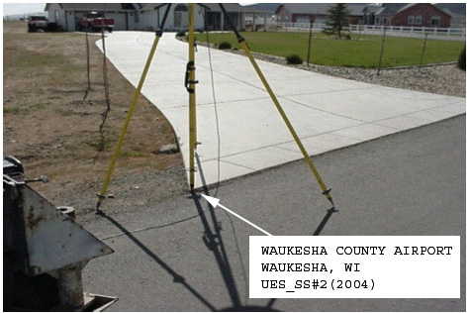
Figure 2
Sample Photo of Control Point with antenna located over the point. Note the caption has been added to the photo to aid in identification of the point.

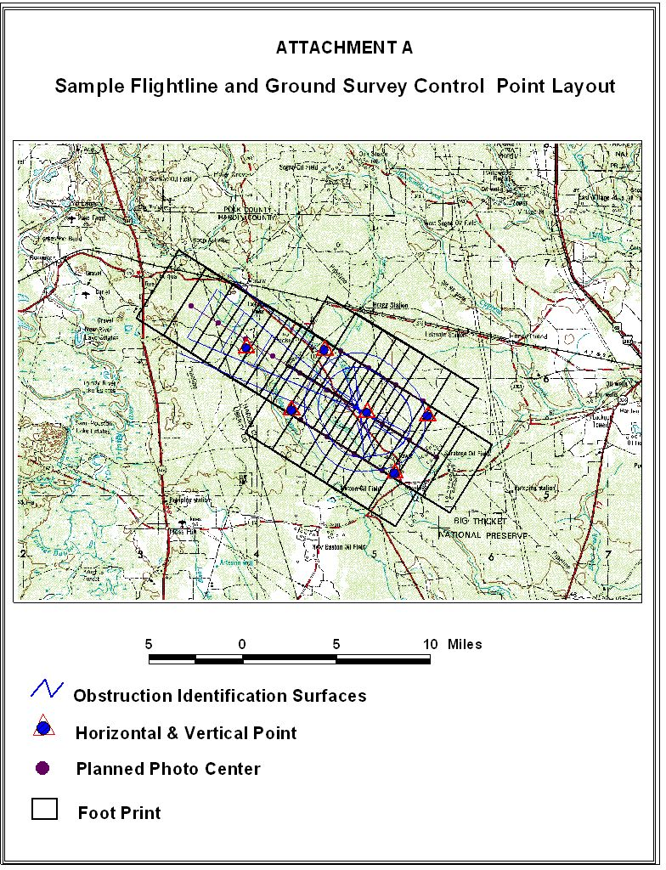

Figure 3
Sample Flight Line Diagram and ground Survey Control Point Layout showing obstruction identification surfaces, the horizontal and vertical point, planned photo center, planned footprint, and scale

c. Geo-Referencing. Provided imagery must be geo-referenced (such as by aero-triangulation, direct Global Positioning System (GPS)/Inertial Measurement Unit (IMU) observation, or both). For frame imagery, the contractor must provide an ASCII file (as in the Table 2 below), containing camera focal length and the X, Y, Z, omega, phi, kappa, of each image. The required Coordinate System is the Universal Transverse Mercator (UTM), NAD-83. Specify the Zone used and include with the submitted file the information enumerated below.

(1) Strip Number
(2) Image Number
(3) Easting specified in meters to the hundredth
(4) Northing specified in meters to the hundredth
(5) Orthometric Height specified in meters to the hundredth
(6) Omega specified in Radians to seven (7) decimal places
(7) Phi specified in Radians to seven (7) decimal places
(8) Kappa specified in Radians to seven (7) decimal places

Table 2

ASCII Image File (Results of the Geo-referencing) — Sample
GEO-REFERENCING RESULTS
Header Information:
Airport Name:
UTM Coordinate Zone:
Reference Ellipsoid:
Horizontal and Vertical Datum:
Camera Focal Length:

Strip# Image# Easting Northing Ortho Height Omega Phi Kappa
(Meters) (Meters) (NAVD 88) (Angles are radians)

1 1 3579254.35 2089643.60 3824.12 -.0001358 .0107300 -.8732658
1 2 3580688.07 2087953.67 3823.95 -.0162651 .0005193 -.8841331
1 3 3582126.18 2086260.81 3829.93 -.0404605 .0022521 -.8826661
2 1 3582017.30 2092108.36 3821.09 -.0306452 .0034061 -.8539204
2 2 3583490.60 2090446.64 3833.50 -.0095850 .0067647 -.8527867
2 3 3584965.37 2088806.15 3825.61 -.0219045 -.0030697 -.8461040

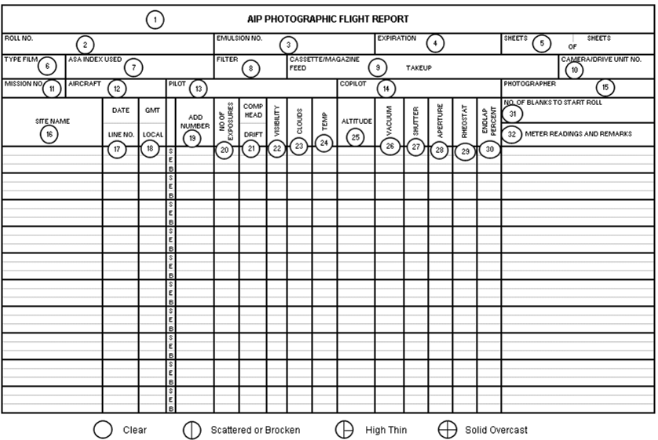
Figure 4
Sample Photographic Flight Report – the numbers associated with the form fields are detailed in paragraph 4d

d. Flight Report. Submit an Imagery Flight Report to the NGS ASP through the airport sponsor. The FAA recommends a company-derived format similar to Figure 4. Ensure all information detailed on the example form is included on any company-derived form(s). All forms will follow the instructions below.

Instructions for Completing the Photographic Flight Report for Airport Photography (Figure 4)

Photographic Flight Report Documentation

(1) DATE—Film is first loaded into the cassette of Magazine, Print “LOADED” and Date
(2) ROLL NUMBER—Year, Camera System Designator, Film Type (CN = Color Negative), and Sequential Roll Number for that Calendar Year.
(3) EMULSION NUMBER—Taken directly from the film can upon loading.
(4) EXPIRATION DATE—Taken from film can upon loading.
(5) SHEET NUMBER— X of Y sheets = 1 of 4, 2 of 4, etc.
(6) FILM TYPE—Plus-X Pan, X-100 Color Negative, etc.
(7) ISO INDEX—Film speed actually used (not EAFS from film can).
(8) FILTER—Wavelength of filter used, in Nanometers.
(9) CASSETTE/MAGAZINE—Feed and take-up cassettes or magazine identification number.
(10) CAMERA/DRIVE UNIT NUMBERS—Camera identification number or lens serial number/drive unit number.
(11) MISSION NUMBER —Aircraft Type (Cessna Citation II).
(12) AIRCRAFT—Aircraft Tail Number (N52RF)
(13) PILOT—Printed Surname.
(14) COPILOT—Printed Surname.
(15) PHOTOGRAPHER—Printed Surname.
(16) SITE NAME—Enter Airport Landing (AL) Number located at the top of the published approach chart, Obstruction Chart (OC) Number, or FAA assigned 3 letter Airport Identification, Airport Name (understandable abbreviations are acceptable: Apt, Fld, Muni, Reg, etc.), Place or Region, then indicate the State.
(17) DATE and LINE NUMBER—Date of photography (Month, Day, Year), flight line number (30-002, indicating a scale of 1:30,000 and Line No. 2). Add note “NEW DAY” to indicate a date change. Place near the date entry.
(18) CUT—Time (Coordinated Universal Time or GMT) in Hours and Minutes. Do not enter local time.
(19) ADD NUMBERS—Enter the first and last frame numbers of the line.
(20) NUMBER OF EXPOSURES—To remain blank.
(21) COMP HEAD/DRIFT—Enter the magnetic heading in degrees/variances in degrees left or right of the path of the aircraft and ground tracking over the planned flight line.
(22) VISIBILITY—Distance in statute miles out from the aircraft, in the direction of the sun, at which tree crowns are still separately discernable.
(23) CLOUDS—Enter an estimate of cloud-cover from choices at the bottom of the photographic flight report.
(24) TEMPERATURE—Enter the temperature in degrees Celsius at the time of the photography.
(25) ALTITUDE—Feet above ground level (AGL) over Airports.
(26) VACUUM—Enter vacuum reading from gauge or from camera display panel (600 mmws, or nominally 64 mb standard).
(27) SHUTTER—Enter speed of shutter during line of photography. Enter, if in automatic mode, variances in shutter speeds (450-550).
(28) APERTURE—Enter the actual aperture used. Final adjustment from camera indicator, not base exposure from an automatic light meter.
(29) RHEOSTAT—Enter the rheostat setting as a function of the ISO (“per xxx ISO”).
(30) ENDLAP—Enter the planned endlap as a whole number (60, 80, etc.).
(31) NUMBER OF BLANKS TO START OF ROLL— “6" is standard.
(32) METER READINGS and REMARKS—Record the automatic light meter readings (4 @ 1000), a description of the terrain, local ambient conditions, and remarks concerning abnormalities.

e. Camera Calibration Report. When using an aerial film based camera system to acquire the imagery required for the survey, provide to the NGS ASP through the airport sponsor the current USGS Camera Calibration certificate. The certificate must be dated less than 3 years before the date of imagery acquisition. If using a digital camera, provide the calibration report and/or the manufacturer’s recommended equivalent procedure for NGS review. If a manufacturer recommended procedure is provided, a Statement of Compliance on company letterhead will be submitted. The statement of compliance will—
(1) Certify that the manufacturer’s recommended procedure was completed at the recommended intervals as required.
(2) Identify the date the procedure was last accomplished before the imagery was flown.
(3) Be signed by an authorized representative of the company submitting the Statement of Compliance.

f. Final Report. Submit a Final Report containing the following sections identified below. The contractor is not required to develop or provide a Digital orthophoto to the FAA or the airport sponsor.

The final report will contain the following sections at a minimum:

(1) Equipment used to perform this work, including hardware models and serial numbers and software names and versions;
(2) Flight planning, if performed;
(3) Discussion of exposure settings used, filters used;
(4) Ground Control Survey;
(5) Geo-referencing procedures;
(6) Aircraft navigation;
(7) Weather, solar altitude, and time of year;
(8) Any unusual circumstances or problems, including equipment malfunctions, (including those already reported);
(9) Any deviations from these specifications (including those already reported); and
(10) Any recommendations for changes in these specifications for future work.

g. Transmittal Letter. Submitted deliverables must include an appropriate Transmittal Letter. The Transmittal Letter must contain an accurate listing of all enclosed items.

NGS will provide the contractor with the following information.
a. Receipt Acknowledgment. The NGS ASP will acknowledge by email receipt of the imagery deliverables to the airport sponsor within 2 working days. This email will also signify the start of the NGS ASP acceptance review.

b. Imagery Acceptance Review. The NGS ASP will provide to the airport sponsor an Imagery Usability Report, via email, within 5 working days of the starting date. If NGS determines the imagery is acceptable, the contractor may then submit the airport ground survey data. If NGS determines the imagery is unacceptable, the contractor must re-submit new imagery as soon as possible for review. This is the primary reason for submitting the imagery well in advance of the airport ground survey portion. The imagery will be evaluated by the criteria listed below:

(1) Ground Sample Distance (GSD)—GSD is between 10 and 30 cm.
(2) Stereo Coverage—Imagery must have sufficient overlap to permit stereo coverage of the entire area for analysis.
(3) Geometric Fidelity—Collection and processing of the image data will maintain, within accuracy requirements, the relationship between measurements made in the image model and real world coordinates.
(4) Geo-Referencing—The imagery is geo-referenced and the source data used for completing the geo-referencing is provided.
(5) Positional Accuracy—Positions of well-defined points determined from the stereo imagery must be within 1 meter relative to the National Spatial Reference System (NSRS) referenced to North American Datum of 1983 (NAD83) and the North American Vertical Datum of 1988 (NAVD88) at the 95 percent confidence level for Easting, Northing and Orthometric Height.
(6) Resolution—Imagery must be sufficiently sharp to allow identification, analysis, and measurement of airport features and obstructions.
(7) Image Quality—The imagery must be clear, sharp, and evenly exposed across the format. The imagery must be free from clouds, cloud shadows, smoke, haze, scratches, and other blemishes interfering with the intended use of the imagery.
(8) Acquisition Date—The imagery should be acquired within the 6 month period prior to the airport ground survey.
(9) Foliage – Imagery collected at time of full leaf foliage.
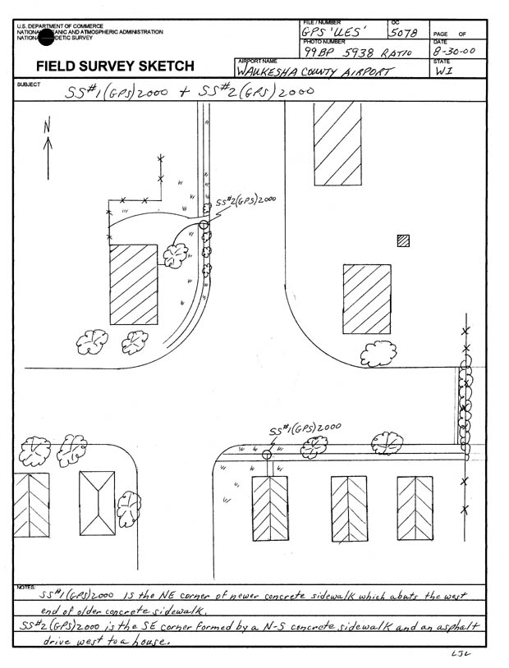

Ground Survey Image Control Points.
a. Image Control Points. Provide the ground surveyed control points used to geo-reference the imagery. A minimum of twenty (20) ground surveyed control points must be provided at each airport. The control point locations must be well defined, easily identifiable on the imagery, and well distributed throughout the area of analysis.

b. Image Control Point Sketches. Two types of sketches are required. The first is a sketch of the entire airport area showing all control points and should be included on the flight line diagram as depicted in Figure 3 on page 4. The second is a separate sketch of each control point, showing its immediate vicinity with a brief description of the point as in Figure 5 (left).
Figure 5
Sample Field Survey Sketch of a two closely positioned control points and their relationship to surrounding features

c. Selection of Control Points. The ideal type of point for control identification is one that produces a very small, recognizable, and symmetrical photographic image that has a distinct boundary of a relatively high to a lower contrast. Some examples of “well defined” control points are—

(1) A point at well-defined junctions of intersecting features (sidewalks, abutments, and roads)
(2) Corner points of any clear, well–defined feature (a parking lot, a tennis court, a road intersection)
(3) The center of a small isolated bush.

d. Accuracy and Datums. Horizontal positions must be determined with an accuracy of 0.3 meters relative to the National Spatial Reference System (NSRS) North American Datum of 1983 (NAD 83).

Orthometric elevations must be determined with an accuracy of 0.3 meters relative to the National Spatial Reference System (NSRS) North American Vertical Datum of 1988 (NAVD 88). In Alaska and other areas outside the continental United States where NAVD 88 benchmarks are not available, make GPS ties to tidal bench marks or contact NGS through the airport sponsor for further guidance.

Equipment and Materials.
a. Camera. The aerial camera used to collect imagery under these specifications and guidance must have equivalent manufacturer specifications to those specified in subparagraphs 1 and 2:

(1) Single lens metric camera with quality equivalent to or better than a Wild RC 30 or Zeiss RMK-TOP, with forward motion compensation.
(2) Digital mapping sensors such as the Z/I DMC, Leica ADS 40, Emerge DDS, or equivalent system.

The sensor must be a geometrically stable and calibrated system suitable to use for high-accuracy photogrammetric mapping; the sensor must be of a high enough resolution and have a large enough Field of View (FOV) to meet the review requirements as listed in paragraph 4b. The sensor must record in the red, green, and blue (RGB) spectral bands and produce an image replicating natural color. If the sensor records in the near IR band, it must be provided also.

b. Film. If film is used to obtain images, it must be a high-resolution aerial film. Film emulsions must be color negative (such as Kodak 2444 or AGFA X-100). The low-contrast target resolution of color negative emulsions must be rated at greater than or equal to 80 line pairs per millimeter (lp/mm). Emulsion and filter combinations selected must be sensitive to and record on the film the green, yellow, orange, and red hues of the tree leaf canopy.

Flying Height.
The target flying height must not exceed 12,000 feet above ground level (AGL) for film-based systems with a 6-inch focal length camera. Choose the flying height for a digital camera system to produce an image resolution and quality greater than or equal to the resolution and quality obtained from filmed based systems. Flying at lower altitudes is highly recommended to increase the usability of the imagery for other purposes, such as mapping. The flying height must not exceed 2 percent below or 5 percent above the target level identified in the survey work plan.

WEATHER, SOLAR ANGLE, AND TIME OF YEAR

Clouds. Clouds or cloud shadows must not appear on the imagery. High, thin overcast is permitted above the flying altitude if it does not cause ground mottling or a discernable reduction in light levels and/or ground object shadows.

Tree Leaves. Collect imagery to show full tree leaf coverage facilitating photogrammetric tree height determination. This requirement limits the acquisition window depending on season and geographic location.

Well-Defined Images. Collect imagery to obtain well-defined images. Do not attempt imagery acquisition where the ground is obscured by haze, smoke, smog, dust, or falling snow, sleet, rain, or other obscuring phenomena. Do not collect imagery when the airport ground area is covered by water (flood), snow, or ice obscuring airport features.

Visibility. The minimum visibility at the time of exposure must be 10 miles or greater. Determine the visibility by looking at objects on the ground toward the sun. The distance at which the detail of ground objects is clearly defined is the visibility. If the visibility is satisfactory, details of ground objects will be clearly defined at the edge of the view through the drift sight.

Sun Angle. Do not collect imagery when the sun angle is less than 30 degrees above the horizon. Ideally, the sun angle should be between 40 and 60 degrees above the horizon because of the intermediate-size shadows produced. In mountainous areas with steep terrain and/or areas with tall trees, increase the minimum sun to horizon angle. Extreme shadowing may cause imagery rejection. Determine the sun angle for a given day from either a “Solar Altitude Diagram” or appropriate computer software. The U.S. Naval Observatory’s web site, http://aa.usno.navy.mil/data/docs/AltAz.html, can be used to compute sun altitudes and sun azimuths for U.S. locations and world-wide positions.

FLIGHT LINE NAVIGATION AND GUIDANCE

General. All flight lines should be continuous and not be broken or patched. If a line requires a second flight, it must have the original flight line number.

Tilt. Ensure the tilt (departure from the vertical) of the camera is kept to a minimum. Tilt must not exceed +/- 3° for any photographic frame. The average tilt for the entire project must not exceed +/- 1°.

Crab. Ensure the imaging system is compensated for crab of the aircraft, with a resultant error not exceeding +/- 5°, as measured from the average line of flight with a differential between any two successive exposures not exceeding +/- 5°.

Overlap and Sidelap. For frame imaging systems, forward overlap must average 60 percent between consecutive exposures, while forward overlap must not be greater than 68 percent or less than 55 percent in any pair of consecutive images. The flight must be planned to minimize imagery Sidelap. Planning for the appropriate Sidelap normally equates to 50 percent overlap for a film-based system with the acceptable range being 30 to 60 percent.

IMAGE QUALITY

Image quality must meet the highest professional standards. Dark areas must not bleed together and individual objects must be readily discernable. Detail must be sufficiently sharp to allow photogrammetric measurement of tree heights, compilation of runway/taxiway edges and other fine map features, and accomplishment of other intended uses for the imagery. Image products must be free of abrasions, blemishes, scratches, tears, and irregularities. Fiducial marks must be clearly visible and sharp on every negative.

POINTS OF CONTACT

Contact the following offices for additional information or clarification regarding this guidance and associated specifications:

Image Review Coordinator Manager Aeronautical Survey Program
National Geodetic Survey, NOAA National Geodetic Survey, NOAA
ATTN: N/NGS33; SSMC3, Sta. 5359 ATTN: N/NGS, SSMC3, Sta. 8753
1315 East-West Highway 1315 East-West Highway
Silver Spring, MD 20910 Silver Spring, MD 20910
301-713-2685 x-151 301-713-3198 x-100
FAX 301-713-4572

