VMBIP Newsletter – June 27, 2008

Please scroll past the charts for VMBIP updates.

VMBIP Updates

- An updated McKesson Customer Service Escalation Path chart is included on the next page of this newsletter. The chart has been updated to reflect changes to the McKesson organizational structure that established two account manager positions.

As a reminder, VMBIP related all-grantee messages are posted to the VMBIP website at: http//www.cdc.gov/vaccines/programs/vmbip/documents.htm and previous newsletters are posted at http//www.cdc.gov/vaccines/programs/vmbip/newsletters.htm

If you have any questions or comments about the contents of this email, please contact Brad Prescott bap3@cdc.gov or Julie Orta jio7@cdc.gov, with a cc to your project officer.

Brad Prescott
Project Lead
Vaccine Management Business Improvement Project
Immunization Services Division
Centers for Disease Control and Prevention
404-639-8796 (direct)
404-639-8627 (fax)
bap3@cdc.gov

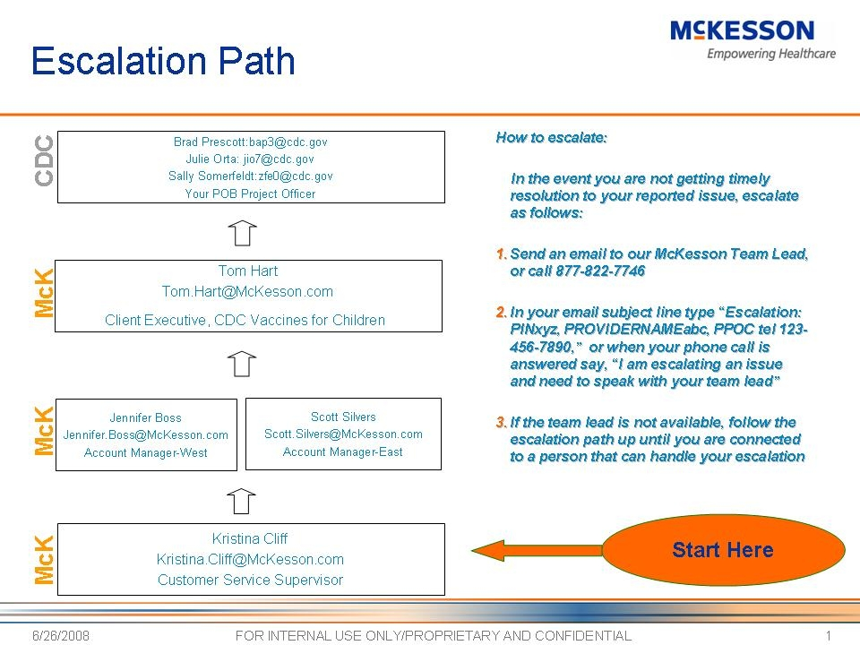

This document can be found on the CDC website at:
http://www.cdc.gov/vaccines/programs/vmbip/downloads/newsletters/vmbip-nl-06-27-08.doc

