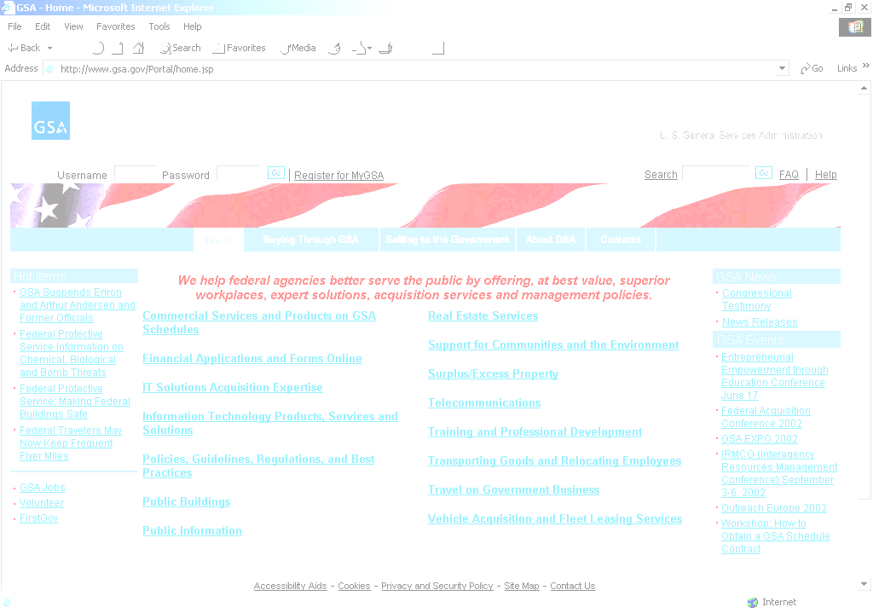
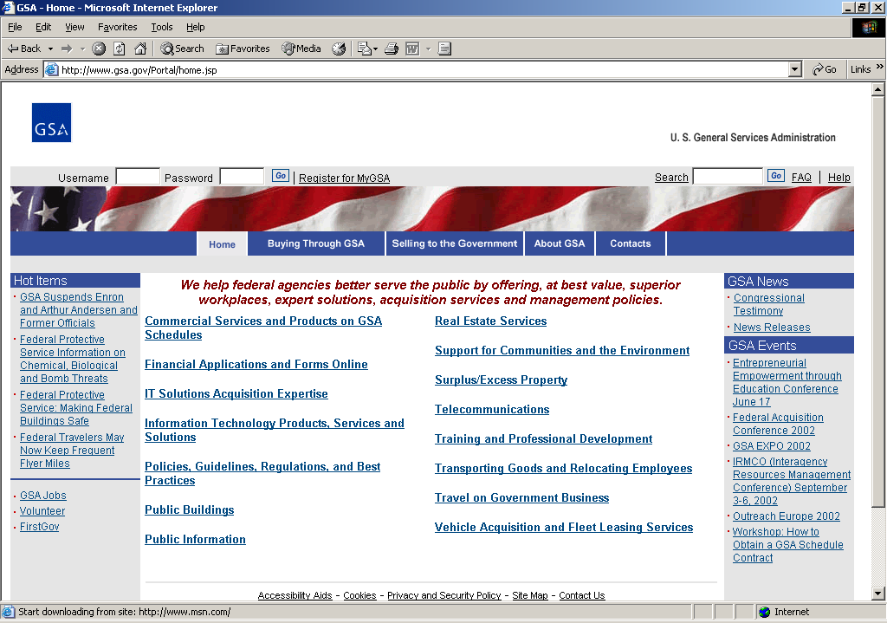

E-Government Act of 2002
Annual Status Update

Submitted by:
General Services Administration
September 21, 2007

CONTENTS

IMPLEMENTATION OF ELECTRONIC GOVERNMENT INITIATIVES 1

AGENCY INFORMATION MANAGEMENT ACTIVITIES 5

- Describe your agency’s efforts with respect to an internal agency-specific E-Government initiative.

The Catalog of Federal Domestic Assistance (CFDA) is a mandatory, government wide compendium of Federal executive branch programs, projects, services, and activities that provide assistance or benefits to the American public. CFDA contains both financial and non-financial assistance programs administered by the Federal government. As provided in Office of Management and Budget (OMB) Circular No. A-89 policy directive, the primary purpose of the Catalog is to help users to identify the types of Federal domestic assistance available to them, describe eligibility requirements for the particular assistance being sought, and to provide guidance on how to apply for specific types of assistance. Each agency designates an “A-89 Contact” to liaise with GSA on program updates and submissions. In addition, the intent of the Catalog is to improve coordination and communication between the Federal government and State and local governments. The Catalog provides users with access to programs administered by Federal departments and agencies in a single, searchable database, now accessible at www.cfda.gov.
Transferred from OMB to the General Services Administration (GSA) in 1984, the CFDA is authorized by Public Law 95-220, as amended by Public Law 98-169. GSA collects Federal agency assistance information; maintains an accurate, efficient information system; and publishes and disseminates Federal assistance information to the Federal, State, and local governments, Congress, and the general public.
A. Describe how the initiative is transforming agency operations.

The Catalog of Federal Domestic Assistance (CFDA) Web Portal is an electronic database of all of the Federal government’s assistance programs, which currently include over 1,700 grants, loans and other types of assistance programs administered by 58 Federal agencies and departments. By making the information available through a website, GSA provides two advantages to its users:
- Instant access to what was previously only available through an annual printed catalog.
- Free access to electronic data that was previously only available by purchase from the Government Printing Office, by visiting a State or local library where GSA distributed copies, or by obtaining one of a limited number of free copies GSA distributed directly to the general public.

B. Explain how your agency maintains an ongoing dialogue with interested parties to find innovative ways to use information technology for the initiative.

GSA maintains an ongoing dialogue with several interested parties to find innovative ways to use IT for the initiative. The interested parties consist of other Federal agencies, A-89 Contacts, OMB officials, the American public, and the technical support staff.

The Federal agencies, through the A-89 Contacts, provide ongoing dialogue with GSA concerning their abilities to use the portal and website effectively and efficiently in support of their efforts to get the grant or program information published on the website and catalog.

OMB officials, through their appointed budget reviewers, provide ongoing dialogue with GSA concerning their abilities to use the portal and website effectively and efficiently in support of their efforts to validate and verify budget information for the grants and programs that are published on the website and catalog.

The American public provides ongoing dialogue with GSA through the use of the portal feedback link. GSA reviews the comments and suggestions for new and improved capability, and if applicable, the IT solutions to satisfy these needs are identified, reviewed and implemented.

The technical support staff review and suggest technical architecture and application IT refreshes to keep the website and portal as technically current as possible to continue to provide unsurpassed services to support the CFDA initiative.

C. Identify external partners (e.g., Federal, State or local agencies, industry) who collaborate with your agency on the initiative.
According to OMB, “it is estimated that in 2008 the Federal Government will outlay $449 billion in grants to State and local governments.” Executive Order 12372, "Intergovernmental Review of Federal Programs," was issued to foster the intergovernmental partnership and strengthen federalism by relying on State and local processes for the coordination and review of proposed Federal financial assistance and direct Federal development. For that purpose, Single Points of Contact (SPOC) were established by States that chose to do so to participate in the intergovernmental review process. These “SPOC’s” participate with Federal agencies to collaborate on financial assistance issues germane to their respective States. The CFDA references the SPOC listing, and also identifies where specific assistance programs are excluded from this review process.
D. Identify improved performance (e.g., outcome measures) by tracking performance measures supporting agency objectives and strategic goals.

- Implementing this “paper free” electronic initiative to manage the production of CFDA data with 58 Federal agencies and departments through the CFDA Web Portal, has increased the efficiency and timeliness of collecting and publishing agency assistance information. As a result of this initiative, assistance information is disseminated more rapidly and more timely than was possible with only a single annual production cycle. Prior to CFDA, the catalog was printed annually, resulting in as much as one year of lag time in the availability of assistance information. Providing CFDA data through a website has increased accessibility to the published data. Search features enable faster and more comprehensive access to assistance information, including the ability to find/recognize information on useful and pertinent assistance programs. Publication of links to other e-Gov sites (e.g., USA.gov, Integrated Acquisition Environment (IAE) initiatives, Federal Asset Sales, etc.) enables CFDA users to realize efficiencies of other electronic government initiatives.

- GSA monitors the CFDA website and portal to establish categories and develop perspective on demographics and frequency of use. GSA identifies website customers with various metrics, and can better serve customers based on the visitor characteristics data. Based on available customer information and input, GSA adjusts reporting mechanisms to satisfy the requests and searches via the Catalog context libraries. In addition, GSA has identified tracking measures for processing, publishing, and routing program text. This is very helpful in resolving resource leveling issues and completing the task of website publishing and catalog production.

- CFDA has established objectives for the website uptime and downtime goals. GSA’s performance metric for “Operating Efficiently and Effectively” is to achieve 98 percent uptime for the CFDA website, with the understanding that downtime will occur with the event of daily and normal operations and maintenance, or unforeseen situations including power outages or natural disasters. For the first three quarters of FY 2007, the CFDA website has exceeded the goal of 98 percent for the amount of time the website is available for use, with an average of 99.73 percent. GSA records these measurements on a monthly, quarterly, and annual basis. GSA employs risk mitigation strategies with various events and tasks to reduce any downtime and promote uptime as much as possible. CFDA has been very successful in meeting and exceeding established uptime goals and minimizing downtime.

E. Quantify the cost savings and cost avoidance achieved through implementing the initiative (e.g., by reducing or eliminating other investments in information technology).

By eliminating print media, GSA achieved a cost avoidance of approximately $200,000 annually, and greatly reduced the amount of paper required to produce and publish the printed catalog.

In addition, CFDA has generated applicant savings. For the 2006 CFDA, the Government Printing Office printed over 20,000 copies for sale to the public at the cost of $75 each. Assuming this same level of demand, free access to the same or possibly more current information on the CFDA website has generated cost savings for applicants of at least $1.5M annually. In addition, customers receive the value added of electronic web search engine capabilities not possible with printed media, enabling time savings and potentially more thorough review of available assistance information.

F. Explain how this initiative ensures the availability of Government information and services for those without access to the Internet and for those with disabilities.

- The CFDA Website is 508 compliant. Until 2002, the CFDA was published in both print and electronic media; however, the printed catalog is only available now through the Government Printing Office on an annual basis at a fee, currently, $75.00. Previous efforts to provide access to CFDA information to those without access to the Internet included free distribution of the printed CFDA to Federal Depository Libraries, State and local Governments, Congressional Offices, and to the general public upon request as available. A PDF file of either the full volume of CFDA data or of selected sections is posted on the site annually, and is available for download and/or printing free of charge. Many community organizations use this means of sharing the data with those without computer access.

G. Explain how the project applies effective capital planning and investment control procedures.

The CFDA initiative is a non-Major initiative in GSA’s IT Capital Plan portfolio. The initiative has been in steady state operations since September 22, 2005, with no development, modernization or enhancement (DME) activity. The investment is annually reported in GSA’s IT Capital Plan submission to OMB. The project manager (PM) has been validated as having the necessary knowledge, skills and experience. The PM, along with members of the CFDA Staff perform cost and schedule reviews of contract support continuously by monitoring the contractor's execution of the project plan for the CFDA's operations and maintenance objectives which are agreed upon annually. As necessary, the project plan is modified to reflect unexpected priorities that require resources to be reallocated or for the schedule of milestones to be adjusted, as has been necessary in the case of the contractor's need to respond to GSA IT policy and security directives.

At present, there is discussion underway to assess how CFDA might be more effectively linked to the Grant community. This capability would enable greater insight and more effective reporting of overall assistance program opportunities and results. If approved, the necessary DME activity to implement this functionality will be managed to ensure appropriate planning and tracking of estimated and actual schedules and costs, in compliance with GSA’s capital planning and investment control policy and best practices.

- Please provide link(s) to your agency’s web site where the following information is located.

A. Your agency’s Information Resources Management (IRM) Strategic Plan.

http://www.gsa.gov/itstrategicplan

B. Final determinations, priorities, and schedules. Also include your agency’s information dissemination product catalogs, directories, inventories, and any other management tools used to improve the dissemination of and access to your agency’s information by the public.
http://www.usa.gov/webcontent/
http://www.usa.gov
http://www.gobiernoUSA.gov
http://www.USAservices.gov
http://www.pueblo.gsa.gov
http://www.consumeraction.gov
http://consumidor.gov
http://kids.gov
http://mymoney.gov

C. Your agency’s FOIA handbook, the link of your agency’s primary FOIA website, and the website link where frequent requests for records are made available to the public.

FOIA Handbook:
http://www.gsa.gov/gsa/cm_attachments/GSA_DOCUMENT/PublicInformationHandbook_R2E-s8V_0Z5RDZ-i34K-pR.doc

Link to the primary website:
www.gsa.gov/foia

Frequent requests for records:
http://www.gsa.gov/Portal/gsa/ep/programView.do?pageTypeId=8199&ooid=11388&programPage=%2Fep%2Fprogram%2FgsaDocument.jsp&programId=10155&channelId=-13641

D. A list of your agency’s public web sites disseminating research and development (R&D) information to the public, describing for each whether the website provides the public information about federally funded R&D activities and/or provides the results of Federal research.

Not Applicable

E. An inventory describing formal agency agreements (e.g., contracts, memorandum of understanding) with external entities (e.g., partnerships with State and local governments, public libraries, industry and commercial search engines) complementing your agency’s information dissemination program, briefly explaining how each agreement improves the access to and dissemination of government information to the public.

www.USAServices.gov

F. An inventory that describes your agency’s NARA-approved records schedules(s) or the link to the publicly-posted records schedules(s), and a brief explanation of your agency’s progress to implement NARA Bulletin 2006-02. For the brief explanation please report the number of systems for which a record schedule was submitted to NARA in FY 2007 and the number of systems still requiring records schedules.

Link to publicly-posted records schedule(s):
http://w3.gsa.gov/web/c/file.nsf/4b6aaf8da00cdb5c85256325005e3d48?OpenView

Number of schedules submitted to NARA in 2007: 0

Of GSA’s 28 Major initiatives, 13 fall into one or more of the following three categories:
a) do not constitute systems of records
b) contain only nonrecord copies of Federal Records
c) are otherwise not subject to the requirements of the Federal Records Act

Of the remaining 15, 13 are covered under existing records schedules, either GSA specific or General Records Schedules, and two need to be scheduled.

