LEMHI RIVER WATERSHED
ANNUAL REPORT
2007 GRAZING RESULTS
HAWLEY CREEK C&H ALLOTMENT

PURPOSE:

This report is submitted by the U.S. Forest Service (USFS) in accordance with the 1999 Lemhi River Watershed Bull Trout Biological Opinion (B.O.) requirements issued on September 15, 1999 by the U.S. Fish and Wildlife Service (FWS). The B.O. issued by FWS anticipated that livestock grazing in the riparian areas of streams within the Hawley Creek Allotment was likely to result in the incidental take of listed bull trout. Therefore, certain resource objectives and pasture use guidelines (in italics) were specified in order for livestock grazing to be authorized within the Hawley Creek watershed.

The first objective stated in the B.O. was to base turn out dates on range readiness.

A pre-season tour of the allotment was scheduled for June 8, everyone but Robson (USFS) and the rider for Hawley Creek Association cancelled. Robson and the rider inspected the Ranch Unit pipeline and bladder system and worked on the spring sources. The range was ready early again in 2007, and the mid-June on-date worked well. One permittee (242 Remuda Ranch) deferred their on-date until July 15.

The second objective stated that the actual number of days spent in each unit would be the amount of days listed for each unit in the AOP, and the third objective stated that cattle were to be completely moved to each new unit by the date specified.

Authorized grazing use levels for the 2007 grazing season were 97% of permitted use. Minor amounts of non-use was elected due to fluctuations in herd sizes. Comparing actual use to the authorized use level, less than 82% of the level authorized was used by the four permittees. Most of the shortfall was because of the early (9/5) move off the allotment with most of the cattle, and the deferred on-date elected by one permittee, mentioned above.

Periodic use supervision, monitoring, and actual use analysis indicates that cattle were moved on, or near the scheduled dates in the Annual Operating Instructions (AOI).With fewer cattle in the early unit, cattle stayed seven days longer than scheduled (24 days instead of 17) but used 108 fewer Headmonths than anticipated. The rotation sequences and durations for the mid-season sub-units went as-scheduled, but seven days later than expected. The early off-date (ten days ahead of anticipated) was due mainly to the effects the long hot dry spell of July and August had on both the forage resource, and the livestock.

Several site visits were made by District staff, and on a few trips staff were accompanied by at least one of the riders or permittees. The chronology of livestock moves and other significant events were discussed at the fall meeting on November 7, 2007.

The fourth objective stated by the B.O. specified that a rider would be on the allotment 2-3 days per week.

The Hawley Creek Association employed a range rider that tended to cattle from mid- June to mid- September, and helped permittees with maintenance of improvements. Year-end reports were submitted to the Forest Service by the permittees. Observations by District personnel indicated that the rider was present on the allotment and was responsive to livestock and resource management needs.

Grazing management actions and subsequent monitoring results are displayed in Tables 1 and 2 below. This data satisfys the last of the five stated objectives and guidelines ( items 1) thru 5) below) of the Biological Opinion:

1) OVERVIEW OF THE PROPOSED ACTION AND ACTUAL MANAGEMENT

The Annual Operating Instructions approved on May 1, 2007, described the Terms and Conditions of livestock grazing use and other prescribed actions for the Hawley Creek permittees. The following table desplays a comparison of permitted and authorized use, and the actual use reported at year-end:

Table 1. 2007 Hawley Creek Allotment Permitted, Authorized, and Actual Use by Permittee

PERMITTED AUTHORIZED ACTUAL USE
Permittee | Number | Dates | HM'S | Number | Dates | HM'S | Number | Dates | HM’s
McFarland Livestock | 302 | 7/1-9/30 | 913 | 290 | 6/16- 9/15 | 877 | 265 | 6/14-9/15 | 819
242 Remuda Ranch , LLC | 296 | 7/1-9/30 | 888 | 266 | 6/16- 9/15 | 805 | 279 | 7/15-9/3 | 468
Shiner Ranches Inc. | 247 | 7/1-9/30 | 741 | 247 | 6/16- 9/15 | 747 | 247 | 6/16-9/5 | 666
Leadore Land Partners, LLC | 316 | 7/1-9/30 | 956 | 316 | 6/16- 9/15 | 956 | 295 | 6/15-9/5 | 805
Total | 1,161 |  | 3498 | 1,119 |  | 3385 | 1,086 |  | 2,758

Total authorized cattle numbers were 1,119 head, however, there were only 807 head on the allotment during the first month, and an eventual total of 1,086 head on the allotment this year. The season length proposed was a full three months, with the shift to a two-week earlier on date putting the end of seasonal use on September 15. As explained earlier, although there were cattle on the allotment from 6/14 until mid-September, there were fewer days of use overall, than the permitted use. Total Headmonths of use planned was 113 Headmonths below permitted use. However, the actual use analysis reveals that a total of 2,758 Headmonths, or 79% of the permitted use, was used on the allotment in 2007.

Grazing Schedule and Use Standards

The 2007 AOI outlined a grazing strategy in which each of the three main units of the Hawley deferred rotation grazing system were divided into subunits. Cattle were confined to these areas for short durations ranging from three to thirty days, then all were moved to the next area. Table 2 below displays the allowable use standards and monitoring results recorded at the end of the season, by subunit:

The 2007 AOI also described the following grazing use standards for riparian areas and uplands:

1. Riparian area utilization levels in the Big Bear unit will be 40% except in Bog and Poison Creeks where riparian utilization levels will not exceed 35%.
2. Riparian area utilization levels in the Ranch unit will be 40% except in Reservoir Creek where riparian utilization levels will not exceed 35%.
- Riparian area utilization levels in the Little Bear unit will be 40% except in Poison Creek and Reservoir Creek where riparian utilization levels will not exceed 35%.
- Upland utilization levels throughout the allotment will be 50%.

In addition, the end-of-year report for 2006 prescribed an elevated use standard for the upper Quaking Aspen key area, from the residual stubble height of 4 inches, to 5 inches.

Climate Monitoring

The summer season began wet and cool, but turned hot and dry from mid- July through late-August. An analysis of Water Year 2006-2007 indicated the last 12 months produced 131% of normal precipitation at the Leadore guage. This included last October of 2006, which was 322% of normal for monthly total. The spring rains resulted in accumulations above average for two months (April and June), and slightly below average (March and May) for two months. Rainfall bottomed out in July, with only 0.2 inches of rain recorded. The weather pattern changed with significant rainfall after the 1st of September. The area remained frost-free for several weeks into early October.

2) REVIEW OF MANAGEMENT AND COMPLIANCE SUCCESSES AND FAILURES:

Livestock management on the Hawley Creek Allotment in 2007 continued to follow the AOI deferred rotation grazing strategy. The hot dry spell beginning in mid-July made moving cattle and keeping them within the designated sub-units difficult. The control of cattle in the upper Big Bear unit, near Horsethief Spring, was particularly difficult. Cattle got around the drift fence, and/or through the open gate on the road, and trailed over to Morrison Lake on the Montana side. The Dillon Ranger District notified Leadore Ranger District when this was detected on 8/22, and the permittees were immediately notified. A site visit on 8/24 found cattle in all sub-units of Big and Little Bear pastures. The Forest Range Specialist informed the rider and permittees to clean the Big Bear units and get all cattle into the upper Little Bear (upper Wheetip, Timber and Pasture) units.

Each subunit has a designated riparian key area for grazing use standards and long-term trend monitoring purposes. Permittees responded promptly when periodic compliance monitoring indicated that trigger points were met. Details of herd movements were discussed during the post-season meeting of November 7, 2007.

Range Improvement

Maintenance on fences and water developments began the week prior to turnout. Maintenance efforts put into fences, and spring developments appeared to be effective. The topic of structural maintenance will again be addressed at the spring of 2008 allotment meeting. The Bog Creek trail armoring project was completed on August 9 (see before and after photos below). The permittees did not complete the Horse Thief Springs water development projects, or the Horse Thief drift fence extension. These projects will remain as high priority for completion in 2008.

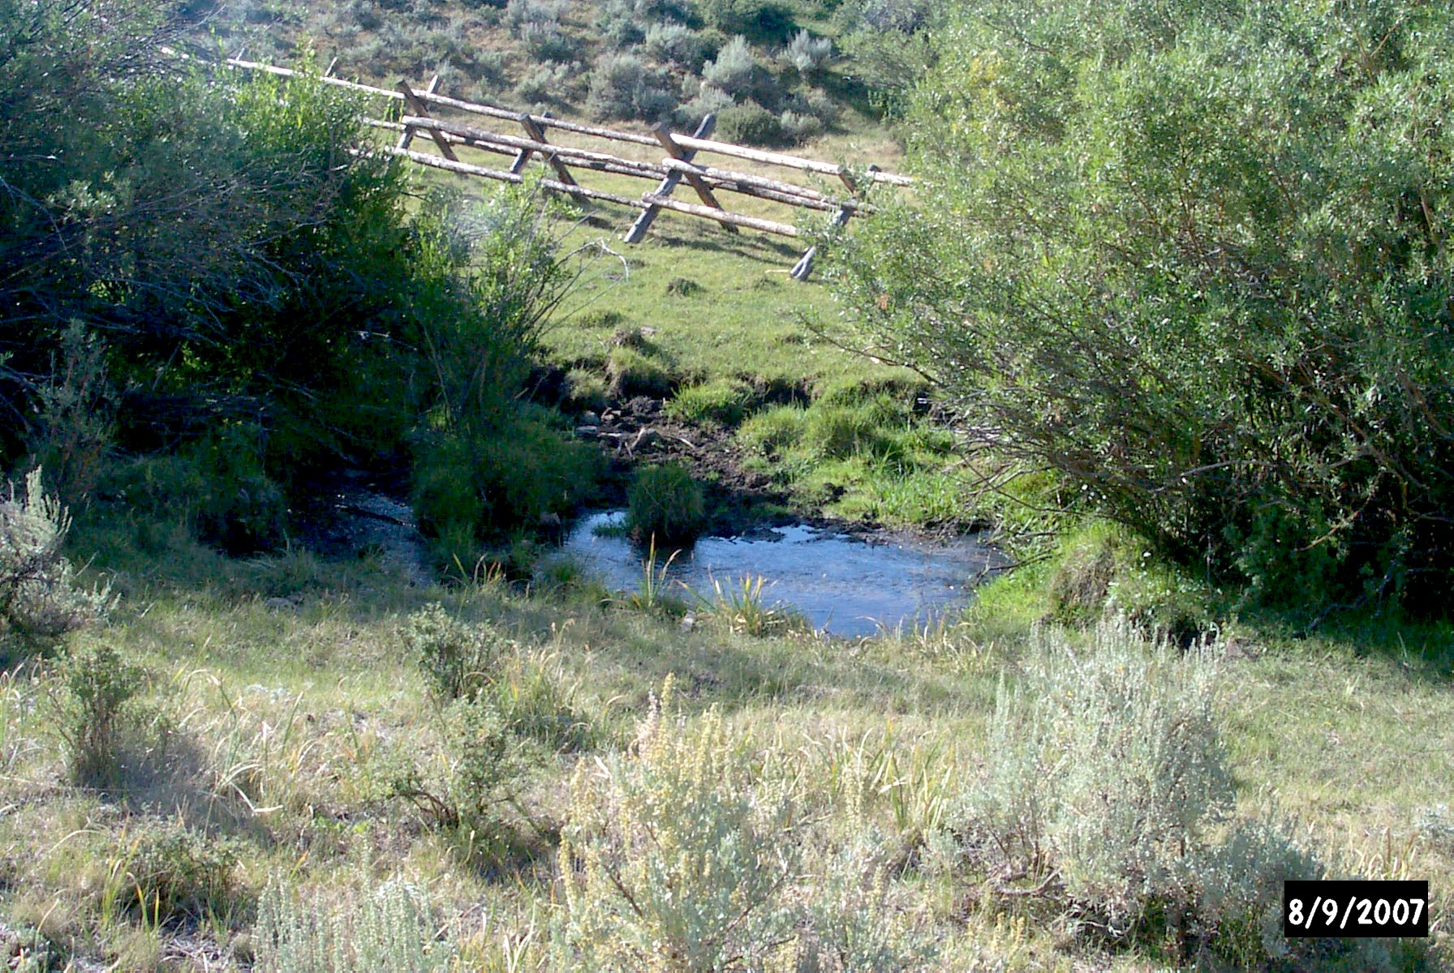

Photo 1. Bog Creek Crossing --before--

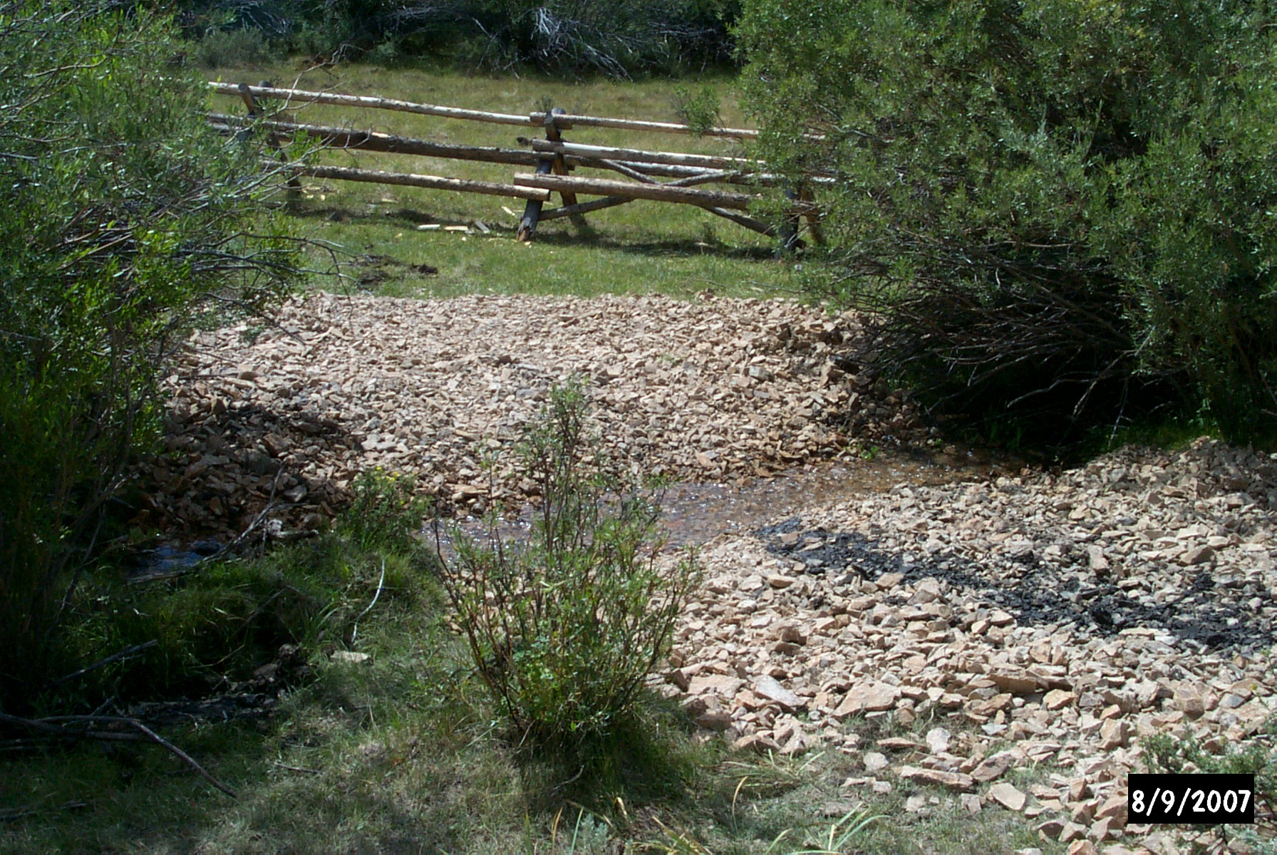

Photo 2. Bog Creek Crossing --after--

3a) SPECIFIC FOREST IMPLEMENTATION MONITORING DATA, DATE AND LOCATION:

Analysis of monitoring results and observations made on the Hawley Creek Allotment during the 2007 grazing season indicates that all use standards were met. Table 2 below displays results from the End-of-Year stubble height and utilization monitoring performed on the Allotment in 2007:
Table 2. Hawley Creek Allotment Use Standards and Monitoring Results
PASTURE/  Unit | AREA  MONITORED |  |  | MONITORING RESULTS  as of 10/07 |  |  |  |  |  |  | REMARKS
 |  |  |  |  |  | Use  Standard |  | Stubble  Median ht. |  |  |  |  | All measurements were taken at the end of the growing season
Little Bear |  |  |  |  |  |  |  |  |  |  |  | Met Standards
Wheetip |  | Upper Wheetip @ G.L. |  |  | 40% / 4” |  | 6” |  | +
Pasture |  | Upper Little Bear Cr. |  |  | 40% / 4” |  | 5” |  | +
Stove/Poison |  | Upper Poison  Upper Reservoir |  |  | 35% / 5” |  | 5”  4” |  | ok  --
Big Bear |  |  |  |  |  |  |  |  |  |  |  | Met Standards
 |  | Lower Bog Cr  Meadow Cr.  Big Bear Cr.  Lower Wheetip |  |  | 35% / 5”  40% / 4”  40% / 4”  40% / 4” |  | 5”  6”  6”  6” |  | ok  +  +  +
Fish Pasture |  |  |  |  |  |  |  |  |  |  |  | Met Standards
 |  | Big Bear above Poison Cr  Big Bear above Bog Cr |  |  | 40% / 4”  40% / 4” |  | 6”  8” |  | +  +
Ranch |  |  |  |  |  |  |  |  |  |  |  | Met Standards
 |  | Upper Quaking Aspen  Cabin Creek  Short Creek  Lower Reserv. below gate  Quaking Aspen/Deer Cr |  |  | 35% / 5”  40% / 4”  40% / 4”  35% / 5”  40% / 4” |  | 5”  5”  5”  6”  5” |  | +  +  +  +  +

Livestock grazing within the four pasture units of the Hawley Creek Allotment met standards in 2007. Of fifteen key areas measured, (including the four key areas that had measurements below use standards at the end of 2006), only one key area (upper Reservoir Creek) was marginal at 4 inches of residual stubble on hydric species. Twelve of the key areas had residual hydric stubble of at least 5 inches, and the Fish Pasture had residual hydric stubble measurements up to 8 inches.
Effectiveness Monitoring

One riparian greenline was re-read in 2007 in upper Little Bear Creek. The designated management area (DMA) has been monitored for seven years, and has remained at the Potential Natural Community and has a Site Wetland Rating of Very Good, with banks 100% stable. Riparian greenline monitoring utilizes the Monitoring Stream Channels and Riparian Vegetation-Multiple Indicators (BLM-ID Tech. Bulletin 2007-01, April 2007). These studies help determine the effectiveness of grazing management in meeting or moving towards desired future conditions on the Hawley Creek Allotment.

3b) SPECIFIC PERMITTEE MONITORING DATA:

The Actual Use Reports submitted by the Hawley Creek Association permittees were incorporated in the data presented above. The Association President also submitted an oral report at the fall Association meeting at the end of the grazing season. No other monitoring was presented.

4) NEW HABITAT TREND OR BULL TROUT POPULATION DATA:

Stream habitat trend measurements taken in 2007 include a) Sediment – Percent Fines (<.25”) at Depth; b) Streambank Stability – Percent Stable Streambanks; and c) Water Temperature.

a) Since 1993, sediment (core) sampling has been performed throughout the Salmon-Challis NF, including Hawley Creek. The attached Table 3 displays the results for all years measured at the three locations within the Hawley Creek Allotment:

Table 3. Sediment – Percent Fines (<.25”) at Depth

Station: Hawley Creek at Forest Boundary
Year | 93 | 94 | 95 | 96 | 97 | 98 | 99 | 00 | 01 | 02 | 03 | 04 | 05 | 06 | 07
Percent Fines | 22.6 | 22.5 | 26.4 | 18.9 | 14.8 | 19.1 | 23.9 | 35.4 | 22.1 | 26.3 | 26.7 | 20.2 | 12.8 | ---- | 16.3

Station: Big Bear Creek near confluence with Reservior Creek
Year | 93 | 94 | 95 | 96 | 97 | 98 | 99 | 00 | 01 | 02 | 03 | 04 | 05 | 06 | 07
Percent Fines | 20.1 | 46.9 | 54.6 | 32.1 | 27.5 | 39.7 | 15.1 | ---- | 29.9 | 33.7 | 22.0 | 18.4 | 13.4 | 21.9 | 27.9

Station: Reservoir Creek near confluence with Big Bear Creek
Year | 93 | 94 | 95 | 96 | 97 | 98 | 99 | 00 | 01 | 02 | 03 | 04 | 05 | 06 | 07
Percent Fines | 40.1 | 30.7 | 34.4 | 37.6 | 24.2 | 29.2 | ---- | 41.5 | ---- | 44.0 | 32.2 | 41.0 | ---- | 17.3 | 31.6

Note- Green values represent years where data met Forest Plan sediment goal levels for resident streams <29%.
Red values represent years where data did not meet Forest Plan goal levels for resident streams <29%.

Three stations were measured in 2007, two stations recorded met sediment goal levels and one station did not meet sediment goal levels.

b) Streambank stability is measured each year, in conjunction with stream sediment core sampling monitoring. Streambank stability was measured on three sites in 2007, and all three meet PACFISH/INFISH streambank stability Riparian Management Objectives, >80%.
Table 4 below displays data taken since 1993 as percent stable streambanks:

Table 4. Streambank Stability – Percent Stable Streambanks

Station: Hawley Creek at Forest Boundary
Year | 93 | 94 | 95 | 96 | 97 | 98 | 99 | 00 | 01 | 02 | 03 | 04 | 05 | 06 | 07
% Stable Banks | --- | 88.0 | 97.0 | 89.0 | 91.0 | 96.0 | 99.0 | 94.5 | 91.0 | 92.0 | 96.0 | 93.5 | 94.5 | ---- | 100

Station: Big Bear Creek near confluence with Reservior Creek
Year | 93 | 94 | 95 | 96 | 97 | 98 | 99 | 00 | 01 | 02 | 03 | 04 | 05 | 06 | 07
% Stable Banks | --- | ---- | 94.0 | 95.0 | 65.5 | 84.5 | 86.0 | 96.5 | 98.0 | 99.0 | 95.0 | 98.0 | 96.5 | ---- | 97.0

Station: Reservoir Creek near confluence with Big Bear Creek
Year | 93 | 94 | 95 | 96 | 97 | 98 | 99 | 00 | 01 | 02 | 03 | 04 | 05 | 06 | 07
% Stable Banks | --- | 84.0 | 94.0 | 68.0 | 90.5 | 78.0 | ---- | 64.0 | ---- | 91.5 | 86.0 | 89.0 | ---- | ---- | 95.5

- Water temperatures are monitored for various water temperature criteria found in State and Federal guidelines. A new format has been adopted for reporting results of water temperature monitoring based upon the EPA criteria of exceedence days. The following data from the Idaho Dept. of Fish & Game interagency database identifies the days of exceedence found within the three stream stations being monitored for water temperature within the Hawley Creek watershed. Table 5 below displays data taken since 2004 as exceedence days:

Table 5. Water Temperature – Compliance with State and Federal Standards
Selected Period of Record: July 12th to September 17th a total of 68 days each year

Station: Hawley Creek near Forest Boundary
Water Temperature Criteria | 2004 Exceedence Counts | 2005 Exceedence Counts | 2006  Exceedence Counts | 2007  Exceedence Counts
Idaho Coldwater Biota – 22 deg C Instantaneous | 0 | 0 | 0 | 0
Idaho Coldwater Biota – 19 deg C Average | 0 | 0 | 0 | 0
Idaho Salmonid Spawning – 13 deg C Instantaneous Spring | 20 | 19 | 20 | 19
Idaho Salmonid Spawning – 9 deg C Average Spring | 29 | 20 | 20 | 20
Idaho Salmonid Spawning – 13 deg C Instantaneous Fall | 15 | 20 | 26 | 25
Idaho Salmonid Spawning – 9 deg C Average Fall | 27 | 28 | 26 | 28
Idaho Bull Trout – 13 deg C Juvenile Rearing | 0 | 0 | 0 | 0
Idaho Bull Trout – 9 deg C Spawning Daily Average | 0 | 0 | 0 | 0
EPA Bull Trout – 10 deg C 7 day Average of Daily Max | 59 | 60 | 61 | 62

Station: Big Bear Creek below Little Bear Creek

Water Temperature Criteria | 2004 Exceedence Counts | 2005 Exceedence Counts | 2006  Exceedence Counts | 2007  Exceedence Counts
Idaho Coldwater Biota – 22 deg C Instantaneous | 0 | 0 | 0 | 0
Idaho Coldwater Biota – 19 deg C Average | 0 | 0 | 0 | 0
Idaho Salmonid Spawning – 13 deg C Instantaneous Spring | 0 | 0 | 0 | 0
Idaho Salmonid Spawning – 9 deg C ave.Sprg | 0 | 7 | 11 | 17
Idaho Salmonid Spawning – 13 deg C Instantaneous Fall | 0 | 0 | 0 | 0
Idaho Salmonid Spawning – 9 deg C ave. Fall | 0 | 0 | 0 | 2
Idaho Bull Trout – 13 deg C Juvenile Rearing | 0 | 0 | 0 | 0
Idaho Bull Trout – 9 deg C Spawning Daily Ave | 0 | 0 | 0 | 0
EPA Bull Trout – 10 deg C 7 day Average of Daily Max | 17 | 27 | 28 | 31

Station: Reservoir Creek near confluence with Big Bear Creek

Water Temperature Criteria | 2004 Exceedence Counts | 2005 Exceedence Counts | 2006  Exceedence Count | 2007  Exceedence Counts
Idaho Coldwater Biota – 22 deg C Instantaneous | 0 | 0 | 0 | n/a
Idaho Coldwater Biota – 19 deg C Average | 0 | 0 | 0 | n/a
Idaho Salmonid Spawning – 13 deg C Instantaneous Spring | 20 | 20 | 20 | n/a
Idaho Salmonid Spawning – 9 deg C Average Spring | 20 | 20 | 20 | n/a
Idaho Salmonid Spawning – 13 deg C Instantaneous Fall | 27 | 33 | 38 | n/a
Idaho Salmonid Spawning – 9 deg C Average Fall | 26 | 30 | 40 | n/a
Idaho Bull Trout – 13 deg C Juvenile Rearing | 0 | 0 | 0 | n/a
Idaho Bull Trout – 9 deg C Spawning Daily Ave | 0 | 0 | 0 | n/a
EPA Bull Trout – 10 deg C 7 day Average of Daily Max | 62 | 60 | 62 | n/a

The past four years of temperature samples displayed above were pared down to a sixty-eight day period (from July 12 to September 17) that was consistently monitored in each year’s data set. The new format adopted for reporting results of water temperature monitoring is based upon the EPA criteria of exceedence days. Exceedence is described as any two hour period measured above the stated parameter. The parameters selected have identified the levels of exceedence found within the Hawley Creek watershed, but do little to describe any level of significance.

The EPA bull trout criteria for water temperature days of exceedences is very difficult to meet in the Hawley Creek watershed (from discussions with Bob Rose, Salmon-Challis N.F. Fisheries Biologist), and may not be possible for these stream types even if they were in near-pristine condition. The data is presented here for comparison purposes for the years 2004 through 2007. The Forest will continue to monitor water temperature and will discuss the analysis and interpretation of this data among the interagency Level I group.

4b) BULL TROUT SURVEYS

Since 2004, fish presence and population denities have been monitored by electrofishing two 100 meter permanent trend monitoring stations on two streams within the Hawley Creek Allotment. The attached Table 6 displays the results for all years measured at the three locations within the Hawley Creek Allotment:

Table 6. Hawley Creek Watershed Fish Populations – Species Presence & Density

Station: Big Bear Creek above and below Poison Creek
Rainbow Trout | #Fish /100 square meters | #Fish / Acre | Size Range (mm)
2004 | 0 | 0
2005 | 1 | 21 | 200
2006 | N/A | N/A | N/A
2007 | 1 | 29 | 210-245
Cutthroat Trout | #Fish /100 square meters | #Fish / Acre | Size Range (mm)
2004 | 4 | 148 | 150-230
2005 | 8 | 341 | 70-230
2006 | N/A | N/A | N/A
2007 | 3 | 117 | 105-250
Bull Trout | #Fish /100 square meters | #Fish / Acre | Size Range (mm)
2007 | 2 fish observed | 2 fish observed | 140-170
Cutthroat x Rainbow | #Fish /100 square meters | #Fish / Acre | Size Range (mm)
2004 | 11 | 444 | 140-150
2005 | 0 | 0
2006 | N/A | N/A | N/A
All Fish | #Fish /100 square meters | #Fish / Acre | Size Range (mm)
2004 | 15 | 592 | 140-230
2005 | 9 | 362 | 70-230
2006 | N/A | N/A | N/A
2007 | 4 | 147 | 105-250

Station: Hawley Creek Approximately 40 meters below Hobo site. Hob site located approximately 0.9 meters up from cattlegaurd at mouth of canyon.

Rainbow Trout | #Fish /100 square meters | #Fish / Acre | Size Range (mm)
2007 | 7 | 273 | 90-255
Cutthroat Trout | #Fish /100 square meters | #Fish / Acre | Size Range (mm)
2007 | 1 | 21 | 160-195
All Fish | #Fish /100 square meters | #Fish / Acre | Size Range (mm)
2007 | 7 | 294 | 90-255

5) MANAGEMENT RECOMMENDATIONS FOR SUBSEQUENT YEARS:

A question of the status of LAA determinations for Hawley Creek was asked: Where are we in terms of overall trends, and what does management need to do to reach NLAA status, especially relative to other allotments on the Salmon-Challis N.F. with NLAA determinations? A review of the past monitoring reports for the Lemhi River Sub-watershed and a re-evaluation of the LAA determinations for Hawley Creek are necessary to answer these questions sometime in the near future. We need to know what our target is, and when we have reached it, in terms of habitat recovery for listed fish.

The success in meeting resource needs over these past few drought years has been due mostly to the permittees’ riding and herding efforts. The permittees’ success can also be attributed to their commitment to, and observance of, the Annual Operating Instructions. It remains important that all parties continue to meet periodically to discuss grazing strategies, resource objectives and improvement needs. Areas where past grazing use caused concern are now showing signs of recovery.

A hardened crossing for lower Bog Creek was implemented in 2007. Monitoring to track the effectiveness, improvement in bank stability, etc. will be done.

Projects agreed upon through consultation between agencies and publics continue to be necessary in order to enhance management opportunities and meet resource objectives. Spring developments will be installed in upper Horse Thief Creek, an order one tributary of Big Bear Creek. Alternative water source developments in upper Wheetip and Little Bear drainages will require clearance and NEPA analysis. Fences and water developments will continue to be important tools to maintain unit integrity and provide water for cattle away from sensitive stream zones. Fuels treatment will be considered in the future, both for forested and non-forested sites.

Periodic allotment evaluations will continue to review greenline monitoring data. Site specific management objectives will be derived from the evaluation and interpretation of this information, and applied in future revisions of management plans and consultation packages between agencies.

The Annual Operating Instructions for 2008 to be developed prior to the grazing season will include project maintenance and reconstruction needs, and will assign responsibilities to respective permittees.
The USFWS staff will again be invited to participate in the spring planning meeting in April, and the pre-season tour in June of 2008.
--END--

