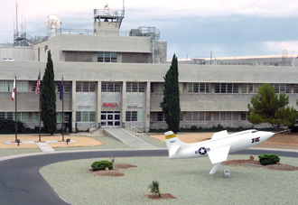
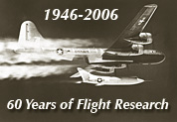

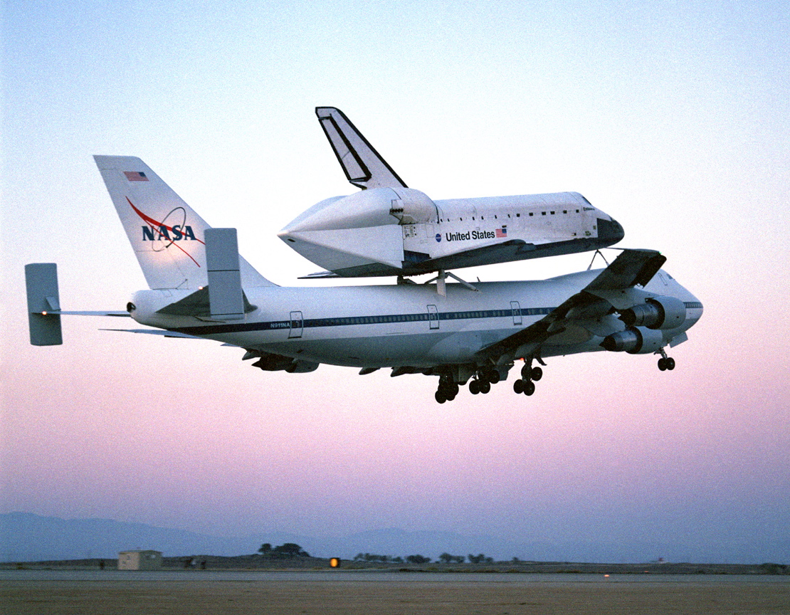
Contest Information
Poster and Essay Contest

NASA Dryden Flight Research Center's
60th Anniversary

To celebrate the 60th anniversary of the NASA Dryden Flight Research Center, NASA education office is sponsoring a poster and essay contest for students in grades 5-8 and 9-12. Participants will need to select a research project, or a person who made a significant contribution, or a technical advancement in NASA Dryden Flight Research Center’s history. Then write an essay and design a poster about this topic. Sample topics can be found at http://www.nasa.gov/centers/dryden/history/index.html.

Contest Rules
All essays and posters must be delivered on Tuesday, October 24, or Wednesday, October 25, to the NASA Aerospace Gallery, 38256 Sierra Highway, Palmdale, between 8:00 am and 4:00 pm. No late entries will be accepted. They may also be submitted by mail to NASA Dryden 60th Anniversary Poster Contest c/o Kimberly Irizarry, 38256 Sierra Hwy Suite A, Palmdale, California 93550. All entries must be received by October 25, 2006.

Essay Guidelines
Essays for 9th - 12th grade should be a minimum 1500 words, typed/word processed, not to exceed 1750 words.
Essays for 5th - 8th grade should be a minimum 1000 words, typed/word processed, not to exceed 1200 words.
Essays will be judged on the following categories:
Creativity of Topic Selection Focus on Selected Topic Language/Grammar and Writing Skills
Essays must include
- Cover Page including; name, grade, home address, phone number, word count, teacher, school, and school phone number.
- Why the topic was selected.
- 5th – 8th Grade Theme: Explain how the topic has had an impact on society.
- 9th – 12th Grade Theme: Explain what technological advancements resulted from the subject matter and how those advancements have contributed to society.

Poster Guidelines
Posters can be a drawing, painting, collage or any combination of these or other art forms. Artwork is only limited by the student’s imagination. The posters should be on a standard foam board size of 20 x 30.
Artwork may be flat or 3 dimensional, but all items must be securely attached to the foam poster board. Posters will be judged on the following categories:
Creativity Focus on Selected Topic Neatness Originality
Contest Awards
First, second and third place prizes will be awarded for both 5th -8th and 9-12th grade levels.
First Place Prize - 1 NASA Flight Jacket w/ personalized name tags, 1 Mahogany painted NASA aircraft model, and 1 NASA aircraft picture autographed by a NASA Research Pilot.

Second Place Prize - 1 NASA Flight Jacket w/ personalized name tags and 1 NASA aircraft picture autographed by a NASA Research Pilot.

Third Place Prize - 1 Mahogany painted NASA aircraft model and 1 NASA aircraft picture autographed by a NASA Research Pilot.
Contest Timeline
Oct. 24-25 2006
Essays and Posters should be submitted by October 24 or 25 to the Aerospace Gallery located at 38256 Sierra Hwy, Suite A, Palmdale, California, between the hours of 8 am and 4 pm. They may also be submitted by mail to NASA Dryden 60th Anniversary Poster Contest c/o Kimberly Irizarry, 38256 Sierra Hwy Suite A , Palmdale, California, 93550. All entries must be received by October 25, 2006

Oct. 26-27 2006
October 26 and 27 a committee from the Aero Institute/NASA Office of Academic Investments will screen all essays and posters. The top five posters/essays from each grade groups will be selected to be on display at the NASA Dryden Annual Employee Chili Cook-off. All entries/participants will receive a certificate for participating.
Oct. 31, 2006
First, second and third place winners will be determined by employees at the NASA Dryden Annual Employee Chili Cook-off.
Nov. 3, 2006
The Office of Academic Investments will announce winners. They will notify the winners and their teachers by phone.
Nov. 4, 2006
The six winning essay/posters will be on display in the entrance of NASA Dryden 60th Anniversary Gala Celebration at the Essex House Convention Center.
Nov. 7, 2006
A congratulatory ceremony will be held to publicly announce the winners and award prizes at 6:30 p.m. in the NASA Aerospace Gallery. Winners need not be present; prizes will be mailed for winners not attending the ceremony.
Contact Information
For further questions contact Kimberly Irizarry 661.276.3563
Essay Scoring Rubric
 | Score
 |  | - | Thorough, well-organized beginning, middle, and ending (conclusion)
6 |  | - | Beginning (introduction) uniquely captures reader's interest
Exceptional |  | - | Middle (body) has specific and illustrative supporting details
 |  | - | Ending (conclusion) is an integral part of the writing and leaves a powerful or lasting impression
 |  | - | Writer's voice apparent in tone, sentence structure and word choice
 |  | - | Almost no errors in mechanics, spelling and usage
 |  | - | Clearly focused, well organized beginning, middle, and ending
5 |  | - | Beginning (introduction) creatively captures reader's interest
Commendable |  | - | Middle (body) contains a variety of relevant supporting details
 |  | - | Ending (conclusion) is an integral part of the writing and provides strong closure
 |  | - | Precision and variety in sentence structure and word choice
 |  | - | Few errors in mechanics, spelling and usage
 |  | - | Coherent, focused, well-organized beginning, middle and ending
4 |  | - | Beginning (introduction) captures reader's interest
Proficient |  | - | Middle (body) contains appropriate, supporting details
 |  | - | Ending (conclusion) is an integral part of the writing
 |  | - | Exhibits appropriate sentence variety and word choice most of the time
 |  | - | Some errors in usage, mechanics, and spelling, but meaning is not obscured
 |  | - | Inconsistent organization of beginning, middle and end (conclusion)
3 |  | - | Beginning (introduction) may capture the reader's interest
Basic |  | - | Middle (body) contains supporting details which may not be sufficiently developed
 |  | - | Ending (conclusion) is weak or does not adequately provide closure
 |  | - | Limited sentence variety and word choice
 |  | - | Several errors in word usage, mechanics, and spelling that may obscure meaning
2 |  | - | Limited organization of beginning, middle and end (conclusion)
Limited |  | - | Beginning (introduction) does not capture the reader's interest
 |  | - | Middle (body) contains few supporting details which are not developed
 |  | - | Ending (conclusion) is absent or does not provide closure
 |  | - | Lacks sentence variety and word choice
 |  | - | Frequent errors in mechanics, usage, and spelling that obscure meaning
 |  | - | Little or no organization
1 |  | - | No beginning
Minimal |  | - | Middle (body) contains no supporting detail
 |  | - | No ending
 |  | - | No sentence variety and minimal word choice
 |  | - | Numerous errors which obscure meaning

