

Evaluation of the Teaching American History Program

Prepared by:

Daniel C. Humphrey
Christopher Chang-Ross
Mary Beth Donnelly
Lauren Hersh
Heidi Skolnik
SRI International

For:

U.S. Department of Education
Office of Planning, Evaluation and Policy Development

2005

This report was prepared for the U.S. Department of Education under Contract Number ED-01-C0-0059/0003 with SRI International. Dena Gross served as the contracting officer’s representative. The views expressed herein do not necessarily represent the positions or policies of the Department of Education. No official endorsement by the U.S. Department of Education is intended or should be inferred.

U.S. Department of Education

Margaret Spellings
Secretary

Office of Planning, Evaluation and Policy Development

Tom Luce
Assistant Secretary

Policy and Program Studies Service

Alan Ginsburg
Director

Program and Analytic Studies

David Goodwin
Director

September 2005

This report is in the public domain, except for the photograph on the front cover, which is used with permission and copyright, 2005, Getty Images. Authorization to produce this report in whole or in part is granted. While permission to reprint this publication is not necessary, the suggested citation is: U.S. Department of Education, Office of Planning, Evaluation and Policy Development, Policy and Program Studies Service, Evaluation of the Teaching American History Program, Washington, D.C., 2005.

To order copies of this report, write:

ED Pubs
Education Publications Center
U.S. Department of Education
P. O. Box 1398
Jessup, MD 20794-1398;

via fax, dial (301) 470-1244;

You may also call toll-free: 1-877-433-7827 (1-877-4-ED-PUBS). If 877 service is not yet available in your area, call 1-800-872-5327 (1-800-USA-LEARN); Those who use a telecommunications device for the deaf (TDD) or a teletypewriter (TTY), should call 1-800-437-0833.

To order online, point your Internet browser to: www.edpubs.org.

On request, this publication is available in alternate formats, such as Braille, large print, audiotape, or computer diskette. For more information, please contact the Department’s Alternate Format Center at (202) 260-9895 or (202) 205-8113.

Contents
List of Exhibits v
Acknowledgments vii
Executive Summary ix
Chapter 1 - Introduction 1
Origins of the TAH Program 3
The TAH Program: An Overview 3
Report Overview 4
Chapter 2 - How Are the Projects Organized to Improve the Teaching of
American History? 7
Needs Assessments and Weaknesses in Teaching American History 7
Structure of Project Activities 9
Backgrounds and Roles of Project Directors and Professional
Development Providers 10
TAH Project Partnerships 10
Recruiting Teachers for TAH Projects 11
Conclusion 13
Chapter 3 - Did Teaching American History Projects Reach the Districts
and Teachers Most in Need? 15
Demographics of the Districts That Received TAH Grants and the Schools
They Served 15
Participants in FY 2001 and FY 2002 Projects 17
Experience and Credential Status of TAH Participants 19
TAH Participants’ Training in History 22
Challenges of Recruiting the Least Qualified Teachers 25
Conclusion 26
Chapter 4 - What Is the Nature of Teaching American History
Professional Development? 27
TAH Professional Development Content 27
TAH Projects and NAEP Historical Periods, Themes, and Skills 29
TAH Projects and the Characteristics of Effective Professional Development 34
TAH Projects’ Follow-up Activities 35
The Challenge of Creating Effective Professional Development 36
Conclusion 37
Chapter 5 - What the Evaluators Learned about the Effectiveness
of TAH Projects 39
Internal TAH Project Evaluations 39
Project Directors’ and Participants’ Reports on TAH Project Effectiveness 41
Review of Teacher Materials: An Exploratory Sub-study 42
Results of the Exploratory Study of Teacher Materials 44
Conclusion 47
Chapter 6 - Conclusions 49
Implications for the TAH Projects 50
Policy Implications for the TAH Program 51
References 53

Appendix A
Additional Information A-1

Appendix B
Methodology, Data Collection Strategies, and Procedures B-1

Appendix C
Teaching American History Project Director Survey C-1

Appendix D
Teaching American History Project Participant Survey D-1

Appendix E
Teaching American History Project Materials Request Form E-1

Appendix F
Teaching American History Project NAEP-Based Materials Review Rubric F-1

Exhibits
Exhibit E-1 TAH Activities Reported by Project Directors xi
Exhibit E-2 NAEP Themes Addressed by TAH Projects xii
Exhibit E-3 Historical Methods Addressed by TAH Projects xiii
Exhibit E-4 Elements of Project Evaluations xiv
Exhibit E-5 TAH Project Directors’ Reports on Improvement
in Selected Areas xv
Exhibit E-6 Teacher Reports of the Contribution Made by Their TAH Project xv
Exhibit 1-1 NAEP American History Assessment Results, 1994 and 2001 1
Exhibit 1-2 TAH Program Appropriation Statistics for FY 2001
and FY 2002 4
Exhibit 2-1 How School Districts Participating in the TAH Program
Determined Their Needs for the Grant 7
Exhibit 2-2 Needs of Participating School District(s) that TAH Projects
Aimed to Address 8
Exhibit 2-3 TAH Activities Reported by Project Directors 9
Exhibit 2-4 Varied Approaches to Collaboration by TAH Projects 11
Exhibit 2-5 Reasons for Participating in a TAH Project 12
Exhibit 2-6 The Five Most Common Incentives for Participation in
TAH Projects, as Reported by Project Directors and Participants 13
Exhibit 3-1 Key Demographics for Students In Grantee Districts, Compared
With National Data 16
Exhibit 3-2 Total Participants in TAH Projects for Grants Awarded in
FY 2001 and FY 2002 18
Exhibit 3-3 School Levels Taught by Participants, 2002-03 19
Exhibit 3-4 Years of Teaching Experience Reported by TAH Participants 20
Exhibit 3-5 The Ten Subject Areas in Which TAH Participants Most
Frequently Reported Certification 21
Exhibit 3-6 Majors and Minors in History Held by TAH Participants
and by Teachers Nationally 22
Exhibit 3-7 Participants’ Reports of Professional Development Opportunities
Outside TAH Projects 23

Exhibit 3-8 Number and Percentage of Out-of-Field and Underprepared
High School California Teachers Assigned to Teach
Social Studies, 2003-04 25
Exhibit 4-1 History and Social Studies Standards Consulted During Planning of
TAH Projects 28
Exhibit 4-2 NAEP Chronological Periods Addressed by TAH Projects 29
Exhibit 4-3 NAEP Themes Addressed by TAH Projects 30
Exhibit 4-4 NAEP “Ways of Knowing and Thinking About U.S. History”
Addressed by TAH Projects 31
Exhibit 4-5 Incorporating Historical Thinking Skills 32
Exhibit 4-6 Historical Methods Addressed by TAH Projects 33
Exhibit 4-7 Using Historical Methods 34
Exhibit 4-8 Follow-up Offered by TAH Projects 36
Exhibit 5-1 Elements of TAH Project Evaluations 39
Exhibit 5-2 TAH Project Directors’ Reports on Improvement in Selected Areas 41
Exhibit 5-3 Teacher Reports of Contribution of Their TAH Project 42
Exhibit 5-4 Sample from the TAH NAEP-based Materials Review Rubric 43
Exhibit 5-5 Average Score by NAEP-based Historical Skills 46

Acknowledgments

The authors wish to thank the many individuals who assisted in this evaluation.

SRI International: Nancy Adelman, Lee Anderson, Katherine Baisden, Vanessa Barrat,
Deborah DuCharme, Stacey Eaton, Bonnee Groover, Heather Hough, Ruth Krasnow,
Amy Lewis, Bethany Martinez, Cimone Satele, and Michael Smith.

U.S. Department of Education: Dena P. Gross, Elizabeth Eisner, Alan Ginsburg,
David Goodwin, Daphne Kaplan, and Stacy Kreppel.

Technical Work Group: Thomas Adams, Maria Mazzenga, Jeffrey Mirel,
Cynthia Mostoller, James A. Percoco, Theodore K. Rabb, Jeffrey Smith, and William White.

Materials Review Panel: Thomas Adams, Ralph Giannini, Bill Hanna, Randal Mitchell, Chauncey Monte-Sano, Michael Stachon, Vivian White, and William Wilhelm-Safian.

And finally, our deep appreciation to the project directors, participants, and training providers who participated in the study’s data collection efforts.

Executive Summary
Nearly 20 years ago, the first national assessment of student achievement in U.S. history yielded disappointing results. Although policy-makers and researchers expressed great concern about the low scores, the federal government did not undertake large-scale efforts to address poor student performance, and few research dollars were dedicated to uncovering the causes of the problem. In 2001, after the release of another report describing the woeful state of history education, Congress acted, charging the Department of Education with creating the Teaching American History (TAH) Program to improve teacher content knowledge of and instructional strategies for U.S. history. In its first two years, the program’s total funding increased from $50 million to $100 million and grants were awarded to 174 local districts that proposed to serve a total of 24,000 teachers.

During this time period, the TAH program found a receptive audience and appeared to be providing the resources needed to meet its stated goals. The evaluation of the 2001 and 2002 grantee cohorts indicates, however, that the projects may not have reached those teachers typically considered most in need of additional professional development, and that the training provided did not always match research-based definitions of effective professional development.

The following executive summary provides key findings from this evaluation, which examined the implementation of the program and characteristics of the activities, content, and teacher participants for TAH projects awarded during the first two years of the program. The findings are based on surveys of participants and project directors, case studies, extant documents, and a pilot study of teacher-produced lesson plans.

► Key Findings

Participants

- TAH grants funded projects in districts with high-need student populations.
The grants went to districts that served large numbers of high-need students. Generally speaking, students in grantee districts were more likely to be from minority backgrounds, limited in English proficiency, and eligible for free and reduced-price lunches than students nationally, according to the Common Core of Data.

- The teachers who participated in TAH projects were often not those traditionally thought of as most in need of history professional development. Participants were most likely to be experienced secondary teachers (70 percent) with academic backgrounds in history. TAH project participants averaged 14 years’ teaching experience—the same as the national average reported in the 1999-2000 Schools and Staffing Survey. Almost all TAH teachers were certified (97 percent), although not necessarily in history. Compared with a national sample of secondary teachers who teach mostly social studies, TAH participants were more likely to have history degrees
(38 percent vs. 30 percent) and far more likely to have either a major or a minor in history (61 percent vs. 37 percent). TAH participants also reported that they had completed numerous college-level American history courses—between one and five courses for 49 percent of participants; between six and 10 courses for another 26 percent; and more than 10 courses for 22 percent. These findings, coupled with the fact that many teachers voluntarily participated in time-intensive TAH projects, suggest that TAH projects likely reached those teachers most interested in American history—not necessarily those most in need of additional professional development.

- TAH projects partnered with a wide range of organizations and institutions.
Although the law requires that grantees partner with at least one institution, projects have the flexibility to choose partners that will best suit their needs. The partners were instrumental in providing teachers with historical expertise, planning for professional development, working with teachers to design lessons and unit plans for classroom use, and providing teachers with historical materials and resources. Although projects experienced varying degrees of success, the participation of historians appeared to be key to successful projects.

Services

- Summer institutes were the professional development activity offered most frequently. Intensive summer institutes were key among the array of training opportunities projects offered to meet grantees’ and participants’ needs (see Exhibit E-1). Institute activities averaged 10 days in length and were attended by 76 percent of TAH participants.

Exhibit E-1

TAH Activities Reported by Project Directors
Source: SRI International, TAH Project Director Survey.
Exhibit reads: Ninety percent of all project directors reported summer institutes as an activity offered through their TAH projects.

- Projects covered a wide range of historical content, thinking skills, and methods. TAH projects exposed participants to historical content from early America to the present. The American Revolution and the Civil War were the most frequently covered periods in TAH projects, and the four NAEP U.S. History Framework themes were covered during TAH professional development (see Exhibit E-2). TAH projects also exposed participants to the historical thinking skills outlined in “Ways of Knowing and Thinking about U.S. History,” the cognitive dimension of the NAEP Framework. The projects also exposed participants to a variety of historical methods (see Exhibit E-3).

Exhibit E-2

NAEP Themes Addressed by TAH Projects
Source: SRI International, TAH Project Director Survey.
Exhibit reads: Ninety-one percent of project directors reported that their projects addressed the NAEP theme entitled “gathering of interactions, peoples, cultures, and ideas.”

Exhibit E-3

Historical Methods Addressed by TAH Projects
Source: SRI International, TAH Project Director Survey.
Exhibit reads: Ninety-four percent of project directors reported that participants in their TAH projects engaged in analyzing historical documents, such as manuscripts and diaries.

Quality and Effectiveness

- TAH project activities display some, but not all, of the research-based characteristics of effective professional development. Project directors’ and participants’ reports suggest that TAH professional development offered active learning, promoted coherence, and encouraged professional communication; however, generally speaking, the use of traditional training formats hampered most projects’ ability to offer other characteristics of research-based, high-quality professional development. Follow-up activities also fell short of meeting teachers’ classroom needs. Although 92 percent of project directors reported that project activities were sustained through follow-ups, only 31 percent of participants reported that a TAH project representative visited their classroom more than once. Ten percent indicated that a representative visited their classroom four or more times. Other forms of follow-up included dissemination of additional materials (reported by 73 percent of participants); additional workshops, training sessions, and meetings (71 percent); mailings (69 percent); and e-mail
(84 percent).

- Internal evaluations lacked the rigor to measure projects’ effectiveness accurately. Teacher self-reports were relied on by 91 percent of project directors to assess project professional development activities. Substantially fewer directors reported using other evaluation methods like analyzing the work products of teacher participants (64 percent), observing the classrooms of teacher participants (48 percent), or analyzing student or participant content knowledge in American history (46 percent and 41 percent, respectively) (see Exhibit E-4).

Exhibit E-4
Elements of Project Evaluations
Source: SRI International, TAH Project Director Survey.
Exhibit reads: Ninety-one percent of project directors reported that their TAH project evaluations included teacher self-reports.

- Project directors and participants reported positively on the effectiveness and quality of TAH projects. Project directors reported that participants improved their interest in teaching American history a great deal (44 percent) and that their content knowledge of American history substantially improved (50 percent); 29 percent indicated that student performance improved a great deal or substantially. Many participants also strongly agreed that the projects increased their ability to use historical methods
(59 percent) and taught them to use historical resources (47 percent). (See Exhibits E-5
and E-6).

Exhibit E-5

TAH Project Directors’ Reports on Improvement in Selected Areas
 | A Great Deal | Substantial | Moderate | Some | Little or no
Teachers' content knowledge | 17% | 50% | 25% | 7% | 0%
Teachers' knowledge of instruction | 18% | 34% | 34% | 12% | 2%
Teachers' interest in American history | 44% | 39% | 10% | 6% | 0%
Student performance | 10% | 19% | 29% | 34% | 7%
Student interest | 12% | 39% | 23% | 23% | 4%
Source: SRI International, TAH Project Director Survey.
Exhibit reads: Sixty-seven percent of project directors reported “a great deal” or a “substantial” amount of improvement in teachers’ content knowledge.

Exhibit E-6
Teacher Reports of the Contribution Made by Their TAH Project
 | Strongly Disagree (1) | (2) | (3) | (4) | Strongly Agree (5) | Not Applicable
Increased ability to use historical methods | 2% | 3% | 11% | 23% | 59% | 2%
Can better assess students in American history | 3% | 9% | 20% | 23% | 38% | 7%
Taught me to use historical resources | 4% | 6% | 17% | 23% | 47% | 3%
Consistent with state/district standards | 2% | 3% | 7% | 19% | 67% | 3%
Source: SRI International, TAH Participant Survey.
Exhibit reads: Fifty-nine percent of participants reported that they strongly agree that their participation in the TAH resulted in an increased ability to use historical methods.

- While TAH teacher work products demonstrated teachers’ knowledge of facts, they also revealed participants’ limited ability to analyze and interpret historical data. Findings from the exploratory study of teacher work products (lesson plans and research papers) indicated that while teachers had a firm grasp of historical facts and some lower- level historical thinking skills, they had difficulty interpreting and analyzing historical information. Although the teacher work products reviewed ranged in quality, nearly all products earned low scores on historical analysis and interpretation.

Coordination and Support

- TAH projects were not well-integrated with other local, state, and federal teacher development initiatives. The first two cohorts of TAH projects were not primarily organized to help meet No Child Left Behind’s goal of providing a highly qualified teacher for every student. In addition, TAH projects were not always well-integrated with state and local teacher development strategies and programs. The extra time, effort, and energy required to participate in TAH may have discouraged teachers who needed to meet specific professional development requirements to attain or maintain their teaching certification from participating in the program.

- A lack of research on effective professional development for American history teachers made project directors’ decisions about professional development somewhat subjective. The lack of definitive research on professional development in American history left project directors to use their best judgment to plan activities that they believed would increase teacher knowledge and improve student achievement.

- Avenues for projects to disseminate and share their materials were insufficient.
In seeking to share the materials and experiences of TAH participants with wider audiences, projects encountered technical and logistical obstacles. Ultimately, there was no systematic way to ensure that exemplary lessons and materials were distributed to a wide audience.

- Expanding TAH project grants to include the preparation of prospective American history teachers could result in a more comprehensive approach to the improvement of American history teaching and learning. TAH projects demonstrated the effectiveness of having practicing historians provide professional development to experienced teachers. Enlisting colleges and universities that provide preservice history teacher training could help ensure that beginning teachers enter the profession already prepared to teach U.S. history.
Chapter 1
Introduction
Since the release of the disappointing results of the first U.S. History National Assessment of Educational Progress (NAEP) examination in 1986, educators and policy-makers have expressed grave concerns about poor student achievement in American history. What caught the attention of many commentators was students’ inability to recall even the most basic facts about the American historical record or to demonstrate higher order historical thinking skills (Rothman, 1987). Substantive improvements did not occur when the examination was administered again in 1988, 1994, and 2001. In 2001, although some progress had been made over 1994’s results, overall scores remained low (see Exhibit 1-1). In the 4th, 8th, and 12th grades, fewer than
20 percent of students scored at or above the proficient level. Fourth- and eighth-graders performed somewhat better in 2001 than in 1994, but the results for 12th-graders did not change (Lapp et al., 2002). Equally distressing has been the persistent gap in achievement on the NAEP examination among racial groups, rural students, and low-income test-takers. (Appendix A provides more information about the NAEP examination and the disparity in scores among racial groups).

Exhibit 1-1
NAEP American History Assessment Results, 1994 and 2001
 | Percent of Students at Each Achievement Level
 | Below Basic |  | Basic |  | Proficient |  | Advanced
 | 1994 | 2001 | 1994 | 2001 | 1994 | 2001 | 1994 | 2001
Grade 4 | 36 | 33 | 47 | 49 | 15 | 16 | 2 | 2
Grade 8 | 39 | 36 | 48 | 48 | 13 | 15 | 1 | 2
Grade 12 | 57 | 57 | 32 | 32 | 10 | 10 | 1 | 1
Source: Livingston and Wirt (2003).
Exhibit reads: Fifty-seven percent of students in grade 12 scored below the basic achievement level in 1994 and 2001.

In speculating about the causes of the poor performance, some observers blamed poor instruction, others targeted inadequate teacher preparation, and still others argued that politics and activists had watered down the curriculum and sidelined traditional accounts of the past in favor of more inclusive and multicultural ones. Much of their speculation was grounded in conjecture, however. Despite the widespread interest over the last 20 years in teaching American history, the research base on the subject remains sparse. Although a review of the literature uncovered a substantial amount of material concerning lesson plans, program descriptions, and personal narratives, comparatively few peer-reviewed studies address best practices for teaching and learning how to teach American history. Policy priorities at the state and federal level have left history education and research underfunded relative to investments in mathematics and science instruction (VanSledright, 2002). In addition, history has struggled to redefine its position in the social studies model (Leming, Ellington, and Porter, 2003).

In fact, researchers and educators have yet to determine the most effective teaching strategies or professional development approaches for teachers of American history. Most available studies are small in scale and lack generalizability; nonetheless, they do highlight interesting themes (Wilson, Floden, and Ferrini-Mundy, 2001). The literature on history teacher preparation, for example, indicates that teachers do not know how to practice the discipline and, lacking that capacity, cannot pass critical knowledge and skills on to their students (Bohan Davis, 1998; Seixas, 1998; Slekar, 1998; Vinten-Johansen and McDiarmid, 1997). Research on teaching American history mostly concentrates on defining “good” teaching and indicating the impacts that external factors, like standards and high-stakes assessments, have on instruction (Brophy, 1992; Brophy and VanSledright, 1997; Evans, 1990; Grant, 2001; Hartzler-Miller, 2001; Leinhardt, 1997; Newmann et al., 1990; Smith and Niemi, 2001; Thornton, 1988; Wilson, 2001; Wineburg and Wilson, 2001a, 2001b, and 2001c). Such research lacks sufficient explanatory power, however, and few studies have attempted to connect history instruction to student learning (Wilson, 2001). Lastly, research on effective professional development approaches for history teachers has been minimal—primarily consisting of research on one state-funded program (Kroesch and Edwards, 2000; Medina et al., 2000; Podany, 2000;
St. John et al., 1999; Seixas, 1999).

Although research has proceeded at a slow pace, nearly every state has undertaken limited measures to develop student academic standards in history or social studies. These are positive steps, but have been undermined by uneven quality and a weak focus on history (American Federation of Teachers, 2001; Finn and Petrilli, 2000; Saxe, 1998; Stern, 2003). Moreover, attempts to produce a national set of history standards have encountered fiercely partisan disagreements about what their content should be (Nash, Dunn, and Crabtree, 2000). Fewer than half of all states conduct history or social studies assessments, and only half of that number has aligned their tests with their own states’ standards (Education Week, 2003).

Although research in the area of history instruction is limited, education studies in other subjects have demonstrated the connection between higher student achievement and skilled, high-quality teachers (Darling-Hammond, 1997; Ferguson, 1998; Haycock, 1998; Hirsch, Koppich, and Knapp, 1998; National Commission on Teaching and America’s Future, 1996). Logically, then, increasing the content knowledge and skill level of American history teachers should provide the basis for improving student understanding of, and achievement in, U.S. history. That rationale undergirds the premise, purpose, and structure of the Department of Education’s Teaching American History (TAH) program—the most significant federal investment in the teaching of U.S. history.

► Origins of the TAH Program
The impetus for the creation of the TAH program derived from one study and reactions by legislators and the media to a 2000 report on the weak historical knowledge of graduating seniors at elite colleges and universities (American Council of Trustees and Alumni, 2000). In reaction to the report, the House and Senate adopted a concurrent resolution “regarding the importance and value of education in United States history.” Senator Robert Byrd of West Virginia, one of the primary proponents of the resolution, then sponsored legislation to provide $50 million to the Department of Education to improve the teaching of traditional American history (P.L. 106-554).

► The TAH Program: An Overview
In 2001, Congress established the program to support teaching American history, improve instruction in the subject, and provide high-quality professional development for teachers. The competitive grant program provides funds to local school districts for developing and operating three-year professional development projects. As part of the program, grantees are required to partner with one or more institutions of higher education, nonprofit history or humanities organizations, or libraries or museums. These entities are expected to provide content expertise and instructional support in American history to the grantees. The funded projects are expected to demonstrate the components indicated in research on best instructional practices and support the development of critical skills necessary for teaching to higher standards. In addition, the projects are expected to have a long-term plan, be evaluated in regard to the degree to which they improve teacher effectiveness and student achievement, and demonstrate how school districts and institutions with content expertise could collaborate to teach American history better. The Department of Education plans to use some of the products and knowledge developed and disseminate them to a broader audience.

The application notice for the Teaching American History program’s first year, FY 2001, stated that the program was “to raise student achievement by improving teachers' knowledge, understanding, and appreciation of American history.” In FY 2001, 60 local education agencies received TAH grants. Although the grants averaged about $825,000, the amounts awarded to districts varied (see Exhibit 1-2). During FY 2002, the program’s appropriation and number of grantees doubled to $100 million and 114 districts. The average size of the grants also grew, and the range of the grant amounts increased.

Exhibit 1-2
TAH Program Appropriation Statistics for FY 2001 and FY 2002
 | FY 2001 | FY 2002
Total annual appropriation | $50,000,000 | $100,000,000
Total number of school districts awarded grants | 60 | 114
Grant minimum | $386,762 | $19,561
Grant maximum | $1,000,000 | $1,000,000
Average (mean) grant size | $827,276 | $867,903
Source: U.S. Department of Education, Teaching American History Grant Abstracts.
Exhibit reads: In FY 2001, the total annual appropriation for the TAH program was $50 million.

► Report Overview
This report is designed to answer three broad groups of research study questions: the types of activities TAH grantees are implementing; the content of the activities, including the specific subjects and areas of American history on which projects are focusing; and the characteristics and qualifications of teachers participating in the activities. (See Appendix A for complete list of research questions and data sources.) The report does not assess the impact of the TAH projects on student or teacher learning, but it does offer insights into the progress of the projects toward the improvement of teaching American history. This report draws on multiple data sources (project director and participant surveys, case studies of eight TAH projects, an exploratory analysis of teacher work products, and an extensive document review) to describe both the challenges and accomplishments of the 174 TAH projects from the 2001 and 2002 cohorts of grantees. The evaluation was conducted from October 2002 until May 2005.

This report is organized by key findings and is laid out as follows: Chapter 2 indicates how the projects were organized, and provides an overview of their activities, partners, and project directors. Chapter 3 discusses the extent to which the grantee districts and teachers met the Department of Education’s goal for improving American history teaching among the nation’s least qualified teachers serving the neediest students. Chapter 4 examines the professional development that project participants received and compares it with research-based definitions of high-quality professional development. Chapter 5 describes the available evidence on the effectiveness of TAH projects to improve teachers’ content knowledge of American history and their historical thinking skills. Chapter 6 concludes the report by highlighting the implications of the research findings for the individual projects and the TAH program as a whole.

Chapter 2
How Are the Projects Organized to Improve the Teaching of American History?
Grantees organized Teaching American History (TAH) projects to address many of the factors that contribute to poor student performance in American history. In preparation for writing their proposals, school districts and partner organizations identified project leaders, conducted needs assessments, and planned activities they believed would improve history instruction and student achievement. Typically, the projects offer intensive summer institutes or short-term professional development activities, along with opportunities for participants to engage in follow-up. Chapter 2 examines how the grantees identified their needs and how project staff and providers sought to improve the teaching of American history.

► Needs Assessments and Weaknesses in Teaching American History
The Department of Education issued the first TAH application notice on May 23, 2001, and the application notice for the second cohort of grants on April 3, 2002. Potential grantees had two months to prepare proposals. Nearly all of the project directors reported that they conducted a needs assessment, although the short submission timeline probably precluded an extensive examination of needs. Project directors reported that the grantees undertook a variety of needs assessments (see Exhibit 2-1).

Exhibit 2-1
How School Districts Participating in the TAH Program
Determined Their Needs for the Grant
(n = 139)
Type of Needs Assessment | Project Directors  Responding “Yes”  (percent)
An analysis of the availability and quality of professional development for teachers of American history | 61
An analysis of student performance in American history on standardized tests | 59
Teacher surveys regarding the need for training in American history to address state, district, or school standards | 55
An analysis of teaching credentials and content knowledge for teachers of American history | 54
Information supplied by the history/social studies coordinator to the superintendent about needs in the teaching of American history | 45
Source: SRI International, TAH Project Director Survey.
Exhibit reads: Sixty-one percent of project directors reported that they conducted an analysis of the availability and quality of professional development for teachers of American history as a way of determining their need for a TAH grant.

Project directors reported that their needs assessments identified a variety of weaknesses in the teaching of American history (see Exhibit 2-2). Not surprisingly, all project directors reported that their TAH projects aimed to address the need to improve teachers’ content knowledge in American history. Some projects identified other needs, including increasing the use of technology and addressing students’ weak literacy skills.

Exhibit 2-2
Needs of Participating School District(s) that TAH Projects Aimed to Address
(n = 149)
Need of Participating School District(s) | Project Directors  Responding “Yes”  (percent)
Increase teachers’ content knowledge in American history | 100
Increase opportunities for, and quality of, collaboration among teachers of American history | 89
Develop partnerships in American history with a college or university, museum, library/archive, and/or other historical organization | 88
Increase teachers’ knowledge of historical methods | 87
Improve academic performance of students who are low performing in American history | 83
Develop best practices for teaching American history | 83
Increase the instructional use of technology by teachers of American history | 75
Develop district resources for professional development in American history | 69
Increase district access to historical resources | 66
Improve literacy skills of students through American history | 53
Have teachers of American history meet the definition of highly qualified, as specified by the No Child Left Behind Act | 52
Source: SRI International, TAH Project Director Survey.
Exhibit reads: All project directors reported that their TAH project addressed the need to increase teachers’ content knowledge in American history.

Although only 52 percent of project directors reported that their TAH projects sought to address teachers’ need to meet the definition of highly qualified under the No Child Left Behind Act, that relatively low percentage probably reflects the timing of the law’s adoption relative to the application period of each cohort.

► Structure of Project Activities
Summer institutes were the most common form of TAH professional development (see Exhibit 2-3), with 90 percent of all project directors reporting that this activity was offered. As the project directors’ responses suggest, most projects engaged in a variety of activities. Ninety-four percent of project directors reported that their TAH project activities were “sustained over time, with ample follow-up activities and experiences.” Typically, participants attended a summer institute for one or two weeks and then were offered occasional follow-up opportunities (e.g., workshops, colloquia) that were not always directly focused on the teachers’ work in their classrooms during the school year. These professional development activities most frequently took place on a university campus (62 percent), at a historical site (46 percent), or at a museum (43 percent).

Exhibit 2-3
TAH Activities Reported by Project Directors
(n = 150)
SRI International, TAH Project Director Survey.
Exhibit reads: Ninety percent of all project directors reported that activities offered through their TAH projects included summer institutes.

Summer institutes averaged 61 hours, or about a week and a half, in length; other activities lasted from two days to just over a week.
► Backgrounds and Roles of Project Directors and Professional Development Providers
Most project directors (75 percent) were employed by the school district that received the grant. Directors typically worked for the districts as curriculum experts (40 percent), professional development specialists (26 percent), or administrators (26 percent), or in some combination of those roles. Seventeen percent of project directors were regular classroom teachers—often heads of their schools’ history or social studies departments. Of those not employed by the school district, most worked for a college or university (58 percent).

Project directors reported a range of responsibilities, although nearly all indicated that their primary functions involved “organiz[ing]/coordinate[ing] logistical information and other institutional support for professional development activities,” and “develop[ing] or select[ing] the professional development plan and methods of delivery.” Sixty-two percent of project directors also led the professional development activities in TAH projects.

University faculty also assumed significant roles in the training of teachers. Ninety-eight percent of project directors, for example, reported that university history faculty led professional development activities. Project directors also reported that museum educators, master teachers, representatives from historical associations, university education department faculty, and curriculum experts also led professional development activities but were far less likely to do so than university history professors.

► TAH Project Partnerships
The central role of university faculty in delivering professional development to TAH project participants derived from the grant’s requirement for grantees to partner with one or more institutions of higher education, nonprofit history or humanities organizations, or libraries or museums. Project directors reported that partners were most frequently responsible for leading and instructing participants, designing plans and approaches for professional development, working with teachers to design curriculum (e.g., lesson and unit plans) for classroom use, and producing materials for teachers’ use. Project directors also reported that although non-university partners were slightly less likely to lead professional development activities than were university faculty, all partners played significant roles in the development and implementation of the TAH projects.

Exhibit 2-4

Varied Approaches to Collaboration by TAH Projects
In one TAH case study, the three primary partners collaborated to ensure that the project functioned smoothly and met the institutional goals of each member. Initially, two of the partners had been planning to submit separate grant applications, but on learning that both shared a similar vision for helping develop history teachers, they decided to work together. Although each partner played distinct roles in the project, they discussed all significant decisions about summer institutes and follow-up with all stakeholders. “We meet once a week, and we think out loud,” the co-project director explained. “We don’t just talk about our piece. Everybody has a voice.” The historian of the project drove the content of the professional development provided, but all of the partners contributed to decisions about which historical topics would be covered. After the content of the courses had been chosen, the codirectors determined how the material was to be presented to the teachers. This approach not only ensured open communication among all partners but also helped the project provide a more coherent professional development experience for participants.
In another case study site, meanwhile, the university partner offered courses that were too intensive, controversial, and, according to the project director, not aligned with the content the state held participants responsible for in their classrooms. As a result, this grantee severed its official partnership with the history department and contracted with individual professors in the department to meet teachers’ needs.

► Recruiting Teachers for TAH Projects
TAH projects employed a variety of methods to recruit teachers. Some districts distributed flyers, communicated with school administrators, or promoted their projects at education conferences. Although some had a formal application process, others used more informal means of recruiting, such as allowing the partnering districts to choose who would attend. Other projects had to conform to the standards of the partnering institutions for selecting applicants. For example, one project had to ensure that participants met the criteria of the partner university’s admissions office.

Generally speaking, participants reported that they voluntarily participated in a TAH project; in fact, only 6 percent reported that their school or district administrators required them to do so. By far, the most common reason for participating in a TAH project was the teachers’ desire to improve content knowledge and teaching skills in American history (see Exhibit 2-5).

Exhibit 2-5
Reasons for Participating in a TAH Project
(Weighted n = 7,774; unweighted n = 976)
Reason Cited by Participants | Percent
Wanted to improve content knowledge/teaching skills in American history | 89
Was interested in learning more about American history | 79
Was seeking opportunities for teacher collaboration | 53
Wanted to maintain and/or improve qualifications for current teaching position | 36
Wanted to improve use of technology in the classroom | 31
Was teaching low-performing students | 20
Wanted to become a master teacher who trains others | 15
Wanted to be trained to teach American history | 8
Wanted to acquire degree/certification in American history | 6
Was teaching at a school identified as low-performing | 6
Was required to do so by my school site or district administrators | 6
Wanted to be trained to teach American history at a different grade level | 4
Source: SRI International, TAH Project Participant Survey.
Exhibit reads: Eighty-nine percent of participants reported that they participated in a TAH project because they wanted to improve their content knowledge/teaching skills in American history.

Aside from appealing to the internal motivation of participants, project directors also used multiple incentives to recruit participants (see Exhibit 2-6). As the case studies revealed, incentives often were needed—in some cases, were added after the fact—to solicit and increase participation.

Exhibit 2-6
The Five Most Common Incentives for Participation in TAH Projects,
as Reported by Project Directors and Participants
(Project directors: n = 148)
(Participants: weighted, n = 7,500; unweighted, n = 934)
Source: SRI International, TAH Project Director Survey; TAH Project Participant Survey.
Exhibit reads: Ninety-five percent of project directors (compared with
75 percent of participants) reported stipends were used as an incentive for participation in a TAH project.

Despite the variations between the project director and participant reports, financial incentives played a significant role in participant recruitment. These payments, however, consumed large portions of the projects’ budgets. Among the eight case study projects, for example, directors devoted as much as one-third of their budgets to financial incentives for participants.

► Conclusion
The TAH projects’ efforts to help improve teaching and learning of American history appear to have been well-organized. The grantees conducted needs assessments, albeit in a short period, with the weaknesses they identified in their districts mirroring research findings about teaching American history. The projects planned and organized professional development activities, typically employing summer institutes lasting more than a week with follow-up activities.
In addition, project directors and professional development providers appeared to be well-qualified to meet their responsibilities. Projects also employed a variety of recruitment strategies and used financial and other incentives to attract teachers.

The projects faced significant challenges in providing training to the teachers most in need of support, in offering professional development consistent with research-based characteristics of effective professional development, in providing evidence of their accomplishments, and in achieving positive outcomes and impacts. Chapters 3 and 4 examine these aspects of the projects more closely.

Chapter 3
Did Teaching American History Projects
Reach the Districts and Teachers Most in Need?
The invitational priority in the Department of Education’s FY 2001 and FY 2002 requests for proposals for the Teaching American History (TAH) program state that “the Secretary is particularly interested in receiving applications from high-poverty rural and urban” school districts to improve “instruction in chronically low-performing schools.” Implicit in that statement is that TAH projects should also serve those teachers most in need of improving their instruction in and knowledge of American history. Chapter 3 examines the characteristics of TAH grantee districts and the qualifications of TAH participants to determine how well the projects met that objective.
► Demographics of the Districts That Received TAH Grants and the Schools They Served
Demographic information for TAH grantee districts suggests that the awards were consistent with the invitational priority. The Department of Education awarded TAH grants in FY 2001 and FY 2002 to districts that, when compared with national data, had higher proportions of minority students, of students eligible for free and reduced-priced lunches, and of students classified as English-language learners. (See Exhibit 3-1, which presents demographic information from the Common Core of Data for grantees, compared to national figures.)

Exhibit 3-1
Key Demographics for Students In Grantee Districts,
Compared With National Dataª
Source: U.S. Department of Education, National Center for Education Statistics, Common Core of Data.
Exhibit reads: Fifty-two percent of students in TAH grantee districts in FY 2001 and
62 percent of students in TAH grantee districts in FY 2002 qualified for free and reduced-priced lunches. These figures exceed the national average of 37 percent.

ª Because Exhibit 3-1 is based on demographic information only for those districts for which CCD data was available, results should be interpreted with caution. In FY 2001, of the 60 districts awarded TAH grants, English-language learner data were available for 49 grantee districts; free and reduced-price lunch data were available for 51 districts; and data on minorities were available for 51 districts. In FY 2002, of the 114 districts awarded TAH grants, LEP data were available for 100 grantee districts; free and reduced-price lunch data were available for 91 districts; and minority data were available for 95 districts. National demographic data were compiled from the National Center for Education Statistics’ Overview of Public Elementary and Secondary Schools and Districts: School Year 2001-02, available at: http://nces.ed.gov/pubs2003/overview03/index.asp.

Demographic information about students in the grantee districts is one indicator of the projects’ success in meeting the goal of serving teachers who teach the neediest students. Additionally, because TAH projects served teachers in districts other than grantee districts, it is also helpful to look at project directors’ reports for a more comprehensive picture of schools where participants worked. Nearly all project directors (93 percent) reported that TAH participants worked in schools with large percentages of students eligible for participation in the free or reduced-price lunch program. Nearly three-quarters of project directors reported that participants in their TAH projects worked in low-performing schools (71 percent) and urban
(69 percent) schools. More than half of project directors (56 percent) reported that teachers in their TAH projects worked in rural schools. Forty-six percent of project directors reported that their TAH participants worked in schools with a large percentage of English-language learners. Project directors also reported that participating teachers taught gifted and talented students
(30 percent), special education students (30 percent), students with limited English proficiency (29 percent), and honors or Advanced Placement students (25 percent).
► Participants in FY 2001 and FY 2002 Projects
With the expansion of grants from 2001 to 2002 came an increase in the number of teachers served by TAH projects. Like the size of the appropriation itself, the number of participants the projects proposed to serve nearly doubled from the program’s first year to its second year (see Exhibit 3-2). (The report’s appendix includes lists of grant recipients for FY 2001 and FY 2002, respectively, as well as the projected number of participants for each project.)

Exhibit 3-2

Total Participants in TAH Projects for Grants Awarded in FY 2001 and FY 2002
 | FY 2001 | FY 2002
Average number of participants | 145 | 133
Participant minimum | 18 | 1
Participant maximum | 600 | 744
Number of participants (estimated) | 8,689ª | 15,159^{b}
Total participants in both cohorts (FY 2001 and FY 2002) | 23,848
Source: U.S. Department of Education, Teaching American History Grant Abstracts.
Exhibit reads: The average number of participants in a FY 2001 TAH project was 145.

ª Information about the total number of TAH participants projected for each project’s three-year grant cycle was compiled from project abstracts available through the U.S. Department of Education’s Web site (see http://www.ed.gov/programs/teachinghistory/2001tahabstracts/index.html). For FY 2001, information for 25 of the 60 grantees was unavailable. Therefore, the estimate of the total number of teachers participating in the
FY 2001 cohort was estimated by using the total number of participants when project data were available, added to the mean number of participants (145) for projects when information was unavailable.
^{b} Information about the total number of TAH participants projected for each project’s three-year grant cycle was compiled from project abstracts available through the U.S. Department of Education’s Web site (see http://www.ed.gov/programs/teachinghistory/2002tahabstracts/index.html). For FY 2002, information for nine of the 114 grantees was unavailable. Therefore, the estimate of the total number of teachers participating in the
FY 2002 cohort was estimated by using the total number of participants when project data were available, added to the mean number of participants (133) for projects when information was unavailable.

Just as the size of the grants varied, the number of individuals served by each TAH project also differed. A relationship did not necessarily exist, however, between the number of teachers served by the grant and the size of the grant award. (In FY 2002, for example, the number of participants in nine grantees’ projects awarded $1,000,000 ranged from 30 to 600.) Instead, grantees allocated their resources differently, depending on a project’s goals and structure. Whereas some projects chose to train many teachers less intensively, others focused on intensively training a small cadre of teachers. Some projects, for example, offered colloquia, which were open to all history teachers from participating districts, while others designated a small cohort of teachers to train intensively over the course of the three-year grant.

To develop a more detailed profile of participants, we gathered information on participants involved in TAH activities from June 1, 2002, to September 30, 2003. Ninety-two percent of participants during this period worked as regular full-time teachers. The remaining 8 percent included administrators (1 percent), itinerant teachers (less than 1 percent), long-term substitutes (less than 1 percent), postsecondary students or preservice teachers (less than 1 percent), paraprofessional or teacher aides (less than 1 percent), and others. Most participants taught in high schools (70 percent) (see Exhibit 3-3).

Exhibit 3-3
School Levels Taught by Participants, 2002-03
(Weighted n = 7,502; unweighted n = 938)
Source: SRI International, TAH Project Participant Survey.
Exhibit reads: Seventy percent of participants reported that they taught at the secondary grade level.

► Experience and Credential Status of TAH Participants
TAH participants averaged 14 years of overall teaching experience. Although the average participant was an experienced teacher, the projects also served teachers with less experience (see Exhibit 3-4). The amount of teaching experience for TAH participants is about the same as teachers nationally. Teachers in the 1999-2000 Schools and Staffing Survey, for example, also averaged 14 years of experience.

Exhibit 3-4
Years of Teaching Experience Reported by TAH Participants
(As of the End of the 2002-03 School Year)
(Weighted n = 7,448; unweighted n = 931)
Source: SRI International, TAH Project Participant Survey.
Exhibit reads: Twenty-six percent of all participants reported that, as of the end of the 2002-03 school year,ª they had been teaching between one and five years.

ª When calculating statistics for this item, responses of zero (for participants who had not yet completed a full year of teaching) were excluded. Thus, the exhibit represents the distribution of the number of years of teaching experience for participants who had taught for a year or longer.

More specifically, in terms of TAH participants’ American history teaching experience, the average number of years was less (8 years) than their overall teaching experience (14 years). In fact, a small number of TAH participants (14 percent), reported that they had not yet had a full year of experience teaching American history.

In addition to being a fairly experienced group, nearly all TAH participants (97 percent) reported that they had a regular or standard state certificate or advanced professional certificate in a subject. Participants also reported, however, that their credential was not always in history or social studies. In fact, participants reported holding certifications in nearly 40 subject areas (see Exhibit 3-5 for the 10 most common of these subject areas).

Exhibit 3-5
The Ten Subject Areas in Which TAH Participants
Most Frequently Reported Certification
(Unweighted n = 863)
Subject Area | Percent of Participants
Social studies (general) | 46
Elementary education | 32
History (general) | 23
American history | 13
English/language arts | 12
Special education | 10
Government/political science | 10
World history | 7
Secondary education | 7
Middle school education | 6
Note: Because the survey allowed participants to report certification in more than one field, percentages exceed 100 percent.
Source: SRI International, TAH Project Participant Survey.
Exhibit reads: Forty-six percent of teachers in the survey reported that they had a certification in social studies (general).

Compared with the national sample, TAH participants appear to be similarly qualified with respect to certification. Although these data sets are not directly comparable, among all teachers who teach mostly social studies, 94 percent reported that they held a regular/standard state certificate in their main teaching field.

► TAH Participants’ Training in History
Although not a perfect comparison, a higher proportion of TAH participants either have a major or minor in history compared with a national sample of secondary teachers who teach mostly social studies. Whereas 38 percent of all TAH participants and 50 percent of TAH secondary teachers reported having a major in history, only 30 percent of teachers in the national sample had history majors. Similarly, 23 percent of all TAH teachers and 27 percent of TAH secondary teachers reported having minors in history, compared with only 7 percent in the national sample (see Exhibit 3-6).

Exhibit 3-6
Majors and Minors in History Held by TAH Participants and by Teachers Nationally
(Weighted n = 7,480; unweighted n = 933)ª
Source: SRI International, TAH Project Participant Survey; NCES, Schools and Staffing Survey for 1999-2000 (revised May 2003).
Exhibit reads: Thirty-eight percent of TAH participants reported that they had a major in history, more than the 30 percent of teachers in the national sample that reported a major in history.

ª Note that in some cases (i.e., this exhibit) the total number of respondents represented in different categories varies slightly. In those instances, the category with the highest number of respondents is reported.
The majority of TAH participants not only held majors and minors in history but also completed significant numbers of university courses in American history. Roughly half (49 percent) of all participants reported that they had taken between one and five courses in American history. In addition, 26 percent reported that they had taken between six and 10 courses, and 22 percent reported that they had taken more than 10 courses in American history. TAH secondary teachers were more likely to have completed six or more courses in American history (61 percent) than were TAH elementary teachers (18 percent).

In addition to university training, TAH participants reported that they had previous professional development opportunities in American history. Nearly four out of five TAH participants reported that they had participated in some sort of professional development in American history outside of the TAH (see Exhibit 3-7).

Exhibit 3-7
Participants’ Reports of Professional Development Opportunities
Outside TAH Projects
(Weighted n = 6,054; unweighted n = 976)
Source: SRI International, TAH Project Participant Survey.
Exhibit reads: Seventy-three percent of TAH participants reported that they had participated in activities sponsored by professional associations, museums, or historical societies.
Although a history degree, significant course work, and professional development in American history are no guarantee of effective teaching, the educational backgrounds of the TAH participants suggest that they are likely to have a stronger knowledge of history and historical methods than most teachers who teach American history. Taken as a whole, TAH participants appear to be mostly veteran teachers with comparatively stronger backgrounds in American history than the average social studies teacher. TAH participants often appear to be self-motivated individuals who voluntarily pursued professional development opportunities (most commonly during their summer vacations) to improve their content knowledge and instructional effectiveness.

In addition to having stronger backgrounds than the average social studies teacher, TAH participants were far more qualified than the many out-of-field and underprepared teachers (defined as those without at least a preliminary credential) currently teaching American history. Although current national data on out-of-field and underprepared teachers are not available, recent data from California reflects the magnitude of the problem. An analysis of California data suggests that among fully credentialed high school teachers, large numbers teach a subject for which they do not hold the proper single subject authorization (see Exhibit 3-8). For example, among high school teachers assigned to teach at least one social science class, more than 1,200, or 14 percent, are fully credentialed but do not have a single-subject credential that authorizes them to teach the subject. An additional 6 percent of high school social science teachers do not hold a full credential.

Exhibit 3-8
Number and Percentage of Out-of-Field and Underprepared
High School California Teachers Assigned to Teach Social Studies, 2003-04
Assigned Subject | Fully Credentialed Out-of-Field High School Teachers | Underprepared High School Teachers | Total
Social science  (N = 8,711) | 1,207 (14%) | 517 (6%) | 1,724 (20%)
Source: CDE (2004); SRI analysis.
Exhibit reads: There are 1,207 (or 14 percent) fully-credentialed California social studies teachers who lack a credential in social studies.

Most TAH participants did not appear to be among the nation’s American history teachers who most needed to improve their skills and knowledge in this subject. Of course, all American history teachers can benefit from high-quality professional development. Although TAH teachers appeared to work with some of the needier populations of students, the projects did not attract the least qualified teachers who often work with these populations of students. The reasons for this are complex and tied to ways in which the projects are structured, the difficulties and demands already placed on the least qualified teachers, and the projects’ recruitment strategies.

► Challenges of Recruiting the Least Qualified Teachers
Directors generally organized TAH projects around extended summer institutes or workshops and a variety of follow-up activities. Some longer projects (three years in some cases) included extensive university course work that led to an advanced degree in history. All projects required a significant commitment of time and energy by their participants, and nearly all projects tried to compensate participants for their contribution with financial incentives; however, as our case studies suggest, monetary compensation may not have been the most effective method of attracting the teachers most in need of support.

Most of the case study projects reported difficulty in recruiting teachers. One project, for example, was unable to attract 30 high school teachers from the grantee district to obtain free master’s degrees. The project director cited insufficient lead time, informal recruitment practices, teachers’ intensive workload, and the three-year time commitment required of participants. To meet its goal, the project accepted applicants from middle and high schools in 13 surrounding school districts.

Most project directors interviewed acknowledged that they were most successful in recruiting self-motivated teachers with a strong interest in American history to their projects. In one case study, for example, a university historian who provided training to teachers highlighted the implications of the project’s recruitment problems. She acknowledged that, because this project (a master’s program) was so labor intensive, it may have served least well those teachers most in need. She theorized that teacher participants who did not do well in the project may have “fall[en] by the wayside” and that, in fact, some may have dropped out of the program altogether.

Nearly all of the project directors were rethinking their recruitment strategies, however. In one case, the project director had hired an American history teacher from the grantee district to primarily work on recruitment.

Although more aggressive recruitment strategies may help projects attract the least skilled American history teachers, the projects’ typical lack of integration into teachers’ regular school year responsibilities suggests that adopting a more aggressive recruitment strategy may not be sufficient. Taking the form of summer work, weekend or evening workshops, and periodic after-school sessions, the TAH projects added to teachers’ workloads. If the projects were able to integrate their professional development activities better with teachers’ daily work, the projects would be more likely to work with all teachers, not just the most motivated. Because projects were rarely able to recruit teams of teachers from a school, merging a project’s activities with the individual school’s professional development was nearly impossible. Seamless integration of a TAH project with a district’s broader professional development agenda will require strong leadership and a clear vision from the superintendent and the principals. TAH projects, however, had little time to develop a more complex form of professional development that is closely aligned with a district’s larger teacher development strategy. Furthermore, although partnerships with universities and other organizations provided much needed expertise in American history, they also added to the sense of the projects being separate from rather than complementary to the teachers’ responsibilities at their schools.

► Conclusion
The TAH projects did a remarkable job of quickly building partnerships, creating an organizational structure, and subsequently offering professional development to tens of thousands of American history teachers. This is no small accomplishment. Unfortunately, they were less successful in targeting the least prepared teachers for professional development opportunities.
Chapter 4
What Is the Nature of Teaching American History Professional Development?
The Teaching American History (TAH) program was designed to improve the historical knowledge and instructional skills of participating teachers, and have the participants, in turn, improve their students’ achievement in American history. Meeting these objectives is no small task. Critics of the quality of teaching American history sometimes point to weaknesses in professional development as a key part of the problem, specifically raising concerns about the accuracy and rigor of the information teachers receive (Stotsky, 2004). Although a thorough assessment of the quality of professional development offered by each TAH project exceeds the scope of this evaluation, this chapter presents evidence concerning the content of those activities. The chapter first details the content of the professional development that participants received and then examines the form that the professional development took.

► TAH Professional Development Content
TAH projects typically tried to improve teachers’ knowledge of American history and their ability to teach American history. To do so, most projects offered instruction on a range of periods in American history, on historical methods, and on strategies for delivering content. About two-thirds of the projects integrated content, methods, and pedagogy, whereas about one-quarter focused on building teachers’ content knowledge. Approximately 5 percent of project directors reported that their projects either primarily emphasized instructional strategies in teaching American history or primarily emphasized historical methods and processes.

Most projects developed their own professional development programs, although 27 percent of project directors reported that they based their projects on an existing model or framework for teaching and learning American history. The Teachers’ Curriculum Institute’s History Alive! and the National Council for History Education’s Building a History Curriculum: Guidelines for Teaching History in Schools were typical of the kinds of curricula or models the projects adopted. At one case study site that employed History Alive! the professional development offered to teachers emphasized the focus on standards-based content and multiple intelligence strategies that the curricular framework prescribes. In contrast, another TAH case study site developed its own professional development program based on the interest of district history teachers, the needs of district students, existing research on history education, and the writings of educational philosophers.

Nearly all project directors chose historical topics that matched what participants are responsible for teaching in their classrooms. Ninety-five percent of project directors, for example, reported that they consulted state standards in planning their TAH projects
(see Exhibit 4-1). Notably, the National Assessment of Educational Progress (NAEP) American history standards were less frequently consulted than district or state standards.

Exhibit 4-1
History and Social Studies Standards Consulted
During Planning of TAH Projects
(n = 147)
Source: SRI International, TAH Project Director Survey.
Exhibit reads: Ninety-five percent of project directors reported that state standards in history and social studies were consulted during the planning of their TAH project.

Project directors also reported that they varied the content of the professional development in accordance with the grade levels teachers taught. Fifty-nine percent of project directors, for example, reported that content for secondary teachers differed from that for elementary school teachers. In one project, this difference translated into a focus on themes and historic sites for elementary school teachers, with a focus on historical content for secondary teachers.

► TAH Projects and NAEP Historical Periods, Themes, and Skills
Although most TAH projects were not organized around NAEP’s U.S. History Framework, it did prove useful in describing the multiple historical periods, themes, and thinking skills that the projects typically addressed. Overall, the TAH projects covered each of the eight NAEP historical periods. Project directors reported that the projects gave greater focus to pre-Civil War and Civil War periods than to other periods in American history (see Exhibit 4-2); the American Revolution (including such topics as the Revolutionary War, Women in the Revolution, the Revolutionary Era, Revolutionary Ideals, and the Revolution through Local History) was the most commonly covered historical period, with the Civil War the second most commonly covered period.

Exhibit 4-2
NAEP Chronological Periods Addressed by TAH Projects
(n = 137)
Note: According to the National Assessment Governing Board (NAGB), the overlap in NAEP chronological periods reflects “the fact that the periods are not clearly delineated and that transitions from one context to another are typical” (Loomis and Bourque, 2001).
Source: SRI International, TAH Project Director Survey.
Exhibit reads: Seventy-two percent of project directors reported that their TAH projects addressed the NAEP Chronological Period “Revolution and the New Nation (1763 to 1815).”

Project directors also reported covering the four NAEP themes: (1) The Gathering and Interactions of Peoples, Cultures, and Ideas; (2) Change and Continuity in American Democracy: Ideas, Institutions, Practices, and Controversies; (3) Economic and Technological Changes and Their Relation to Society, Ideas, and the Environment; and (4) The Changing Role of America in the World (see Exhibit 4-3).

Exhibit 4-3
NAEP Themes Addressed by TAH Projects
(n = 134)
Source: SRI International, TAH Project Director Survey.
Exhibit reads: Ninety-one percent of project directors reported that their project addressed the NAEP Theme entitled “The Gathering and Interactions of Peoples, Cultures, and Ideas.”

According to the project directors, the TAH projects also familiarized participants with two cognitive domains, which are also referred to as NAEP’s “Ways of Knowing and Thinking About U.S. History.” Some NAEP historical skills were more likely to be addressed than others (see Exhibit 4-4). Specifically, project directors reported that the TAH projects were far more likely to emphasize “applying historical knowledge” and “recognizing multiple perspectives and seeing an era or movement through the eyes of different groups” than “making defensible generalizations” and “finding value statements.”

Exhibit 4-4
Specific “Ways of Knowing and Thinking About U.S. History”
Addressed by TAH Projects
(n = 139)
a

Note: The scholarly skills outlined above come from the two cognitive domains explained on pages 42-44 of the U.S. History Framework for the 1994 and 2001 National Assessment of Educational Progress (NAGB, 2001).
Source: SRI International, TAH Project Director Survey.
Exhibit reads: Ninety-three percent of project directors reported that applying historical knowledge was a “Way of Knowing and Thinking about U.S. History” addressed by their TAH project.

ª Note that NAEP identifies “explaining issues” and “identifying historical patterns” as two separate “Ways of Knowing and Thinking About U.S. History.” In SRI’s Project Director Survey, these two items were combined into one response option due to space considerations.
One of the case study projects focused on some of the historical thinking skills outlined in “Ways of Knowing and Thinking about U.S. History,” as Exhibit 4-5 demonstrates.

Exhibit 4-5
Incorporating Historical Thinking Skills
Professional development providers at one TAH project showed participants how historians ask historical questions, develop interpretations, and present their findings. “We want to give the teachers diverse perspectives of scholars talking about different topics in different ways,” the project director explained. “The first year they wanted the right answer, and now they know there are multiple interpretations. We want teachers to teach like this.” During one day’s activity, the project invited three historians to discuss their interpretations of the same historical topic. All presented their research, provided an overview of the methods they used, indicated how they arrived at their conclusions, and discussed the merits and weaknesses of competing interpretations. Following their presentations, the group participated in a roundtable discussion with participants; the question-and-answer session allowed the teachers to observe how contentious historical debates can be. With this approach, instead of simply receiving content passively, the participants understood how historians produce knowledge and how the same subject can be treated in dramatically different ways depending on the analytical frameworks and sources the investigator employs. Such work was a key component of the project’s goal of teaching participants how to “do” history. The project director advocated this approach rather than having teachers create simple timelines and memorize events, people, and places. “I’m a big believer in historical thinking skills as the most important thing. My goal in [this project] is to make sure that those historical thinking skills are never too far away from the teachers. It’s not enough for them to just replicate [what they’ve learned], but they have to be comfortable creating it themselves.” To this end, the teachers conducted original research using primary sources in the state’s historical society’s archives.

Historians often refer to the practice of their discipline as a craft; that is, each historian has his or her own way of collecting and examining evidence. Accordingly, project directors were asked to indicate the commonly used historical methods that project participants were exposed to (see Exhibit 4-6).

Exhibit 4-6
Historical Methods Addressed by TAH Projects
(n = 147)
Source: SRI International, TAH Project Director Survey.
Exhibit reads: Ninety-four percent of project directors reported that participants analyzed historical documents, such as manuscripts and diaries, as part of a TAH project.

According to project directors, TAH participants had opportunities to employ many of the historical methods historians use. Two of the case study projects offered particularly good examples of such exercises (see Exhibit 4-7).

Exhibit 4-7

Using Historical Methods
One case study project in the Northeast focused on local history and used easily accessible regional resources to help participants learn, “do,” and teach history. The project integrated content and pedagogy in its summer institute. During the mornings, teachers participated in seminars or listened to lectures on historical topics and readings; work in the afternoons included independent research, discussions of how to incorporate the morning’s ideas into their classrooms, or collaboration on the development of different instructional materials. Participants then presented their work to fellow attendees and project staff and received oral or written feedback about how to revise and strengthen the material.
In another case study project, participants analyzed 19th-century census data and teenage diaries, and discussed issues associated with the sources (e.g., census-taker biases, diary-keepers’ class backgrounds). With guidance from university faculty, participants discussed what the materials revealed about the social and cultural lives of people in the diary (“What does keeping a diary tell us about the education level of the writer?” “What do the different diaries reveal about the lives of the writers, their families, their class, and their beliefs?”). The providers also coached participants in using such primary sources in their classrooms.

Overall, the project directors’ reports suggest that the TAH projects did a good job of covering NAEP periods, themes, and skills. Next, we examine the form of the TAH projects’ professional development and compare it with research-based definitions of effective professional development.
► TAH Projects and the Characteristics of Effective Professional Development
Research to define effective history professional development is minimal, mainly consisting of evaluations of one state-run program in California (Kroesch and Edwards, 2000; Medina et al, 2000; Podany, 2000; St. John et al., 1999; Seixas, 1999). Because of the limited amount of history-specific research, findings concerning professional development in other academic subjects have been taken into consideration in the analysis here. For these other academic areas, researchers have identified a variety of characteristics that may positively affect teacher development. They include the following features: sufficient duration of development events (longer events are more likely to improve teacher practice), collective work (teachers are more likely to implement new knowledge and skills if they attend events with colleagues), content focus (teachers need deeper content knowledge to teach to challenging academic standards), active learning (the more engaged teachers are, the more likely they are to learn), coherence (teachers are more likely to implement new strategies if the strategies are aligned with curricular materials, standards, assessments, and other policies affecting teachers), a match with teachers’ professional skill level, and ongoing “reform” activities like study groups or mentoring that seek to change teacher practice (one-time workshops tend to be minimally effective) (Birman, Desimone, Porter, and Garet, 2000; Garet et al., 1999; Kennedy, 1999; Loucks-Horsley, 1999).
Not surprisingly, the TAH projects did not always offer training consistent with all of these features. Both participants and project directors, however, described a variety of activities that matched the research-based definitions of effective professional development. TAH projects, for example, frequently had teachers work together to develop curriculum and instructional materials. Among project directors, 78 percent reported such collaborative activities took place often or very often. Participant reports were similar. The case studies indicated that such activities provided participants with active learning opportunities, and promoted a sense of relevance and coherence.

As indicated earlier in this report, the projects appeared to be of sufficient duration and included some follow-up beyond the initial summer institute or workshop. In addition, both participants and project directors reported that TAH professional development included formal knowledge sharing by teachers. More than half (54 percent) of all project directors reported that such “train the trainer” activities took place often or very often. Participant data support the finding that formally sharing training was an important component of TAH activities.
Forty-three percent of participants reported that such sharing occurred “regularly” or “more than occasionally.”

Although project directors’ and participants’ reports suggest that TAH professional development offered active learning, promoted coherence, and encouraged professional communication, other characteristics of effective professional development appear to have been less common. Although comprehensive data have not been collected for all TAH projects, the case studies suggest that the projects had difficulty recruiting teams of teachers from the same school and therefore found it hard to undertake schoolwide reform efforts. Projects tended to follow traditional formats (workshops and courses) rather than incorporate reform structures (teacher networks, internships, and research projects). Project directors did recognize the importance of follow-up activities, as discussed below, and indicated that they included such activities in their programs.

► TAH Projects’ Follow-up Activities
Nearly all project directors strongly agreed or agreed (92 percent) with the statement that “project activities were sustained over time, with ample follow-up activities and experiences.” The follow-up activities, however, did not directly focus on the teachers’ work in their classrooms. TAH participants reported that follow-up activities were more likely to take the form of information delivery than visits to classrooms. In fact, only 31 percent of participants reported more than one visit to their classroom from a TAH project representative
(see Exhibit 4-8).

Exhibit 4-8
Follow-up Offered by TAH Projects
(Weighted n = 6,542; unweighted n = 817)
Source: SRI International, TAH Project Participant Survey.
Exhibit reads: Only 31 percent of participants reported that follow-up for the TAH project in which they participated involved more than one visit to their workplace (classroom).

Similarly, few TAH projects required participants to observe each other’s instruction or visit another teacher’s classroom. Only 10 percent of participants reported observing another teacher’s classroom four times or more. Case study findings indicate that projects did not undertake classroom-focused follow-up because of associated expense and difficult logistics. Some project directors reported that they provided classroom visits only when individual participants requested they do so. Regardless of the reasons, most TAH projects did not provide teachers with feedback about their teaching or observe teaching to assess project effectiveness.

► The Challenge of Creating Effective Professional Development
The TAH projects goals were ambitious: quickly build the organizational capacity necessary to provide high-quality professional development to large numbers of teachers, form effective partnerships between school districts and universities or other organizations, and carefully assess the project’s effectiveness. Although the projects deserve credit for their many accomplishments, the program’s overall goal may have been too ambitious to expect total success within the grant’s timeframe.

Ensuring that TAH professional development matched the characteristics of high-quality professional development proved especially challenging. Although providing such features as ongoing follow-up can be expensive and logistically difficult, the projects’ structures often made classroom-based follow-up extremely problematic. Furthermore, although the partnerships with universities and other organizations provided much needed expertise in American history, they also conveyed a sense that the projects were not strictly applicable to the teachers’ responsibilities at their schools. Because projects were rarely able to recruit a team of teachers from a single school, merging a project’s work with an individual school’s professional development activities was nearly impossible. Integrating a TAH project with a district’s broader professional development agenda needs the participation of district and school leadership. No evidence was found, however, of any significant involvement of either group in the case study projects.

TAH projects had little time to provide professional development aligned with a district’s teacher development strategy and a school’s daily operations. With the continuing support of the TAH program and continuing cohorts of grantees, however, projects should be able both to depart from traditional forms of teacher professional development and to harmonize teacher learning opportunities with daily classroom and teacher practices.

► Conclusion
Overall, TAH projects exposed participants to a wide range of historical periods, themes, and thinking skills that were consistent with the NAEP standards. In addition, the projects provided opportunities for participants to use historical methods, promoted active learning, and encouraged professional conversations about subject matter and instructional strategies. Project emphases, however, did not always correspond to what researchers have identified as key characteristics of effective professional development. In particular, most TAH projects offered little in the way of intensive classroom-based follow-up. Chapter 5 examines data on the impact of TAH activities on teachers.

Chapter 5
What the Evaluators Learned About the Effectiveness of TAH Projects
Because this program evaluation focused on the implementation of the first two cohorts of the Teaching American History (TAH) program, only limited information on the overall effectiveness of individual projects or the program as a whole is available. Ideally, further study will reveal the contributions of the program to gains in student achievement and teachers’ skills and knowledge. Analyses of selected internal project evaluations, participant and project director surveys, and eight case study projects, as well as an exploratory review of teacher materials, however, suggest that, although the projects provided benefits for improving the teaching of American history, they also had limitations.

► Internal TAH Project Evaluations
Project directors reported using a variety of approaches to assess the effectiveness of their TAH grants. Teacher self-reports were the most common element of TAH projects’ evaluation methods—in fact, 91 percent of all project directors reported including this component in their evaluation. Analyses of student work or achievement, classroom observations, or other more intensive forms of evaluation were far less common (see Exhibit 5-1).

Exhibit 5-1
Elements of TAH Project Evaluations
(n=148)
Source: SRI International, TAH Project Director Survey.
Exhibit reads: Ninety-one percent of project directors reported that their evaluations included teacher self-reports.
As Exhibit 5-1 illustrates, fewer than half of the project directors reported that their evaluations involved observing the classrooms of teacher participants (48 percent) or analyzing student or participant content knowledge in American history (46 percent and 41 percent, respectively). A somewhat greater number, 64 percent, analyzed the work products of teacher participants. This analysis (typically of lesson plans) took place during the summer institutes and workshops, and was part of the participants’ professional development. Although the analysis of teachers’ work products is an important component of the projects, few examples were found of projects using this method to determine what participants had learned during the professional development activities. Overall, the projects’ efforts to assess students’ or teachers’ knowledge of American history did not appear to be systematic.

Although project directors reported that they undertook various evaluation activities, the case study data suggest that they relied heavily on teachers' self-reports. One project director, for example, reported using a combination of teacher surveys and a review of student work. The project administered surveys at the beginning and end of the summer institute, and again at the end of the school year. Teachers were also asked to collect the lesson plans and examples of student work from their study of the Revolutionary War, assess these materials, and report any changes in student performance. According to the project director, the teachers reported gains in student learning and teacher knowledge.

Other projects undertook more ambitious evaluation activities but generally did not engage in systematic data collection. One project, for example, surveyed teachers and found that they reported positive gains in attitude, content knowledge, pedagogy skills, leadership skills, and knowledge of technology after they participated in the summer institute. In addition, the co-project director and some of her graduate students observed some participants’ classrooms and reported that teacher practice had improved, but they lacked the baseline data necessary to make comparisons.

While most of the case study projects remained dependent on teacher reports for their evaluations, projects appeared to be moving toward more rigorous evaluation efforts. One case study project used an external evaluator to study the historical writing ability of students whose teachers participated in the professional development and compared it with the ability of students whose teachers did not attend any TAH professional development. Preliminary findings suggest that the participants’ students earned higher scores than the students of nonparticipants. Recent competitions (beginning in 2003) for TAH grants have rewarded proposals for including more experimental or quasi-experimental research designs.
► Project Directors’ and Participants’ Reports on TAH Project Effectiveness
Assessments of the projects’ effectiveness were mostly limited to self-reports from project directors and participants. On the basis of their evaluation efforts, project directors reported on improvements in a variety of areas in teaching American history (see Exhibit 5-2).

Exhibit 5-2
TAH Project Directors’ Reports on Improvement in Selected Areas
(n=109)ª
 | A Great Deal | Substantial | Moderate | Some | Little or no
Teachers' content knowledge | 17% | 50% | 25% | 7% | 0%
Teachers' knowledge of instruction | 18% | 34% | 34% | 12% | 2%
Teachers' interest in American history | 44% | 39% | 10% | 6% | 0%
Student performance | 10% | 19% | 29% | 34% | 7%
Student interest | 12% | 39% | 23% | 23% | 4%
Source: SRI International, TAH Project Director Survey.
Exhibit reads: Sixty-seven percent of project directors reported “a great deal” or a “substantial” amount of improvement in teachers’ content knowledge.

ª Note that the number of respondent for each component of this item differed slightly, so the n reported in this exhibit represents the highest number of respondents that answered any part of this question.

Project directors reported a great deal of improvement in teachers’ interest in teaching American history (44 percent), as well as a substantial improvement in teachers’ content knowledge (50 percent). Project directors reported more modest improvements in student performance in American history, with only 29 percent reporting a great deal or substantial improvement.

TAH participants also reported that the projects made important contributions to their historical content knowledge and skills (see Exhibit 5-3).

Exhibit 5-3
Teacher Reports of Contribution of Their TAH Project
(Weighted n=7,520/unweighted n=942)ª
 | Strongly Disagree (1) | (2) | (3) | (4) | Strongly Agree (5) | Not Applicable
Increased Ability to Use Historical Methods | 2% | 3% | 11% | 23% | 59% | 2%
Can Better Assess Students in American History | 3% | 9% | 20% | 23% | 38% | 7%
Taught Me to Use Historical Resources | 4% | 6% | 17% | 23% | 47% | 3%
Consistent With State/District Standards | 2% | 3% | 7% | 19% | 67% | 3%
Source: SRI International, TAH Participant Survey.
Exhibit reads: The majority of respondents (59 percent) strongly agreed that the TAH project in which they participated increased their ability to use historical methods.

ª Note that the number of respondent for each component of this item differed slightly, so the n reported in this exhibit represents the highest number of respondents that answered any part of this question.

Despite the limits of self-reports, it is notable that the vast majority of project directors and participants believed that the TAH projects made important contributions to teachers’ knowledge of American history, historical methods, and pedagogical skills. Exploratory examination of lesson plans and other products from a sample of the projects suggests that, despite these self-reported gains by project directors and participants, there remains room for further improvement in teachers’ history knowledge.
► Review of Teacher Materials: An Exploratory Sub-study
As part of the evaluation, 44 teacher-produced materials (typically lesson plans) were collected and analyzed from six of the eight sites visited for case studies. The materials were created by teachers who had participated in a TAH project for at least a year (see Appendix B for more information on how the teachers and assignments were selected). SRI convened and trained an expert panel consisting of six experienced elementary and secondary history teachers, one assessment expert, one historian, and three SRI staff members with degrees in history to evaluate the materials collected during the site visits.

Over a span of three days the group was trained to use a common rubric and assess the materials. The first day was spent fine-tuning the assessment tool and conducting a whole-group review of two lesson plans. For the next two days, the 11 members were divided into three groups, split to ensure that historical expertise and school level were well-represented in each. The assignments were randomly distributed to the groups, and each group reviewed a different set of materials from each site. The final scores for each work product were the result of group consensus. The group used a rubric, based on NAEP’s cognitive domains and developed by SRI in concert with the assessment expert. Because of variations in how TAH projects assigned and collected teacher work samples, using NAEP provided an objective standard to measure all projects against. The two cognitive domains in the NAEP framework are: (1) Historical Knowledge and Perspective, and (2) Historical Analysis and Interpretation. Within each cognitive domain, the NAEP framework identifies another set of specific skills, known as “Ways of Knowing and Thinking About U.S. History.” The rubric used to assess the teacher materials had a three-point scale for each of the specific skills (see Appendix F for the complete rubric). Under the category of Historical Knowledge and Perspective, for example, the specific skill of “demonstrating knowledge and understanding of people, events, concepts, themes, movements, contexts, and historical sources,” had a three-point scale (see Exhibit 5-4):

Exhibit 5-4
Sample from the TAH NAEP-based Materials Review Rubric
Section 1: Historical Knowledge and Perspective

The teacher work product:

1.A. Demonstrates knowledge and understanding of people, events, concepts, themes, movements, contexts, and historical sources

1.A.1 Insufficient Evidence
1. has many factual errors | 2. has some incorrect factual information | 3. is factually accurate

1.A.2. Insufficient Evidence
1. knowledge is of superficial depth and incomplete breadth | 2. knowledge is in some depth or in breadth | 3. knowledge is of perceptive depth and comprehensive breadth

1.A.3. Insufficient Evidence
1. doesn’t use historical themes or incorrectly defines historical themes and incorrectly relates them to specific factual information | 2. partially defines historical themes and/or somewhat relates them to specific factual information | 3. clearly defines historical themes and accurately relates them to specific factual information

A number of factors affected the assessment of the teacher work products. These are discussed in the appendix.

► Results of the Exploratory Study of Teacher Materials
Overall, the materials reviewed exhibited both strengths and weaknesses, with the projects earning a combined average score across all rubric items of 1.73. Scores ranged from a high of 2.16 for all materials from one project to a low of 1.27 for another project.

Some projects distinguished themselves as stronger than others and, more specifically, certain teacher samples stood out among those submitted by the same project. A lesson plan developed by an elementary school teacher was the only one in our review to receive a perfect score in each NAEP category. Using local history as a lens, the lesson sought to engage third-, fourth-, and fifth-graders in understanding how colonial economies functioned (that is, before the institution of a unified monetary system). The lesson taught how people of Colonial America used currency and what value it had to them (to fulfill wants and needs). The lesson illustrated the teacher’s knowledge of and ability to use both lower and higher level historical thinking skills. Her description of the world and the challenges the initial colonists encountered demonstrated her firm grasp of the historical period and topic she was teaching, including knowledge of key people, places, and events. In addition, her lesson reflected her knowledge of the importance of, and her ability to include, balanced perspectives of both colonists and Native Americans, allowing her students to weigh the similarities and differences of the two groups. Moreover, by connecting students’ understanding of money’s current uses (also to fulfill wants and needs) with those of Colonial America, the teacher demonstrated that she could connect the past and the present, as well as identify historical patterns. To illustrate this aspect and ground the lesson in historical artifacts the teacher made good use of primary sources—including replicas of colonial money and a visit to a local museum—and students’ independent research on assigned Web sites. This example and others from this site (which had the highest overall average score) benefited from feedback provided by historians to teachers to guide the revisions of their initial efforts. Their work reflected what could be done when the proper support from skilled providers is readily available.

Some other lesson plans tended to lack such a depth of knowledge and historical thinking skills. For example, several of these lessons dealt with Colonial America but only in a way that demonstrated a superficial understanding of the era. Although the content presented in the first of these lesson plans was factually accurate, it lacked depth, and much of the rest of the plan did not demonstrate an understanding of key higher level historical concepts and thinking skills. No historical theme was established and an appreciation of chronology was lacking. Other than stating that this lesson covered an aspect of the colonial period, no understanding was demonstrated of when during the period this aspect was in effect or how the regions discussed changed over time.

Another lesson plan had similar problems. It explored the meeting of Native Americans and Europeans in the New World, attempting to gauge the impact of their interaction on the native peoples. Although the lesson was also factually correct, no sense of time was apparent from the material presented, no historical context was provided, the explanation of cause and effect was vague and simplistic, and no attempt was made to consider the topic from multiple perspectives—in this case, those of Native Americans and European settlers. It was also unclear where in the New World this contact occurred, when it took place, and which Native Americans and Europeans were interacting. No discussion of the complexity of this historical event was provided, merely a decontextualized focus on the physical and cultural violence visited on the Native Americans. This project’s lack of historical expertise appeared to have hampered its capacity to provide feedback to the teachers.

Across all six case study projects, the teacher assignments scored best in the Historical Knowledge and Perspective categories. These items largely measured factual knowledge (e.g., the ability to identify and place historical events and people accurately), sequencing of history, recognition of multiple perspectives, and development of a general conception of history. The average score across all projects in this section was 2.01 on a three-point scale. The scores ranged from a high of 2.78 in regard to the teachers’ ability to present factually accurate information to a low of 1.76 in regard to their ability to recognize multiple perspectives. The projects scored less well overall in the Historical Analysis and Interpretation categories, however. These items reflect higher order historical thinking skills. The average score across all projects in this section was 1.63. The scores ranged from 1.77 in regard to participants’ ability to establish significance to a low of 1.50 for their ability to identify historical patterns
(see Exhibit 5-5).

Exhibit 5-5

Average Score, by NAEP-based Historical Skillsª
 | Average
Historical Knowledge and Perspective
Demonstrates knowledge and understanding of people, events, concepts, themes, movements, contexts, and historical sources
Factual accuracy | 2.78
Depth and breadth of knowledge | 1.92
Define historical themes | 1.93
Sequences historical events
Places specifics in historical chronology | 1.85
Constructs and labels historical periods | 2.19
Recognizes multiple perspectives | 1.76
Sees an era or movement through the eyes of different groups | 1.79
Develops a general conception of U.S. history | 1.89
Historical Analysis and Interpretation
Explains historical issues | 1.61
Identifies historical patterns | 1.50
Establishes cause-and-effect relationships | 1.65
Establishes significance | 1.77
Applies historical knowledge | 1.64
Weighs evidence to draw sound conclusions | 1.74
Makes defensible generalizations | 1.63
Renders insightful accounts of the past | 1.58
Source: SRI International, Exploratory Study of Teacher Materials.
Exhibit reads: On a three-point scale, the factual accuracy of teachers’ lesson plans averaged 2.78.

ª Note that the rubric developed by SRI did not include the NAEP-based skill entitled “finds value statements” because the evaluation team deemed it too ambiguous.
Although this was an exploratory study, preliminary findings suggest that despite project directors’ reports that historical thinking skills from NAEP’s U.S. History Framework were covered during the participants’ professional development, some skills were easier for participants to master than others. Across all projects, most of the participants’ lesson plans and other products earned weak scores in historical analysis and interpretation. Although participants demonstrated the ability to be factually accurate, few were able to use that capacity in sophisticated ways.
► Conclusion
According to project directors’ and participants’ reports, the TAH projects appeared to have made important contributions to the improvement of participants’ knowledge of American history, their use of historical methods, and their ability to teach American history. A closer analysis, however, indicates there is more room for improvement in teachers’ historical analysis and interpretation skills. At the same time, the exploratory study revealed the potential benefits of undertaking such an analysis of teachers’ lesson plans and other products. Projects could benefit from a more careful analysis of the work of their participants. Overall, the examination of the available data on the projects’ effectiveness suggests the need to move beyond self-reports to more rigorous evaluation efforts.

Chapter 6
Conclusions
Whether examining the quality of the professional development that Teaching American History (TAH) projects offered or determining whether or not the projects served the teachers with the greatest needs, this evaluation found that looking below the surface revealed a more complex picture than first meets the eye. The TAH grants went to many urban and rural districts with large numbers of low-performing, minority, and poor students. On the surface, this finding suggested that TAH resources were reaching the teachers with the greatest need for improvements in their teaching of American history. And, at first glance, those teachers appeared to mirror the wider population of teachers based on their experience. A closer look at the academic backgrounds of the TAH participants, however, suggests that TAH teachers were far more likely to have majored or minored in history than the average social studies teacher. While the projects, perhaps, did not succeed in serving those teachers typically considered to be most in need of professional development, the analysis of teacher work products demonstrated that, like their fellow teachers, TAH participants also need to improve their historical skills.

On the surface, the TAH projects appeared to have incorporated many of the characteristics of research-based high-quality professional development. But a closer look revealed that the kinds of follow-up activities that the projects employed rarely included classroom-based support and assessment. Similarly, although the projects purported to have addressed the historical thinking skills in the U.S. History Framework for the 1994 and 2001 National Assessment of Educational Progress, this evaluation’s exploratory study of teacher lesson plans and other products revealed that the products did not exhibit strong historical analysis and interpretation.

Although looking below the surface reveals important areas for individual projects and the TAH program to address, it does not detract from the program’s significant accomplishments. After many decades with few resources dedicated to improving the teaching and learning of American history, the Department of Education launched the TAH program quickly and smoothly, and tens of thousands of American history teachers have already participated in program activities. Whether they started from scratch or built on preexisting relationships, many of the grantee districts have forged successful partnerships with university history departments and historical institutions. During the lifespan of the TAH grants they received, districts have increased their capacity to meet their history teachers’ professional development needs. In addition, some projects have successfully used the grants to create lesson plans, gathered various historical materials, and disseminated them for use by teachers who did not directly participate in the projects. In other words, the challenges that this evaluation revealed should be placed in the context of the overall value of the TAH program’s capacity to the assist American history teachers and their students.

► Implications for the TAH Projects
The No Child Left Behind Act (NCLB) has assumed greater prominence since the TAH projects examined here applied for their grants, and educators’ attention to the requirements and implications of the law has increased as well. A key NCLB requirement is to provide every child with a highly qualified teacher, and as a federal program, TAH needs to help meet NCLB goals.

The TAH projects trained large numbers of veteran teachers who were more likely to have a degree in history than the average social studies teacher. The projects were less successful in attracting and supporting the large number of American history teachers who lacked preliminary credentials or were teaching out of field. As the evaluation found, attracting the teachers with the greatest need will take more than financial incentives or more aggressive recruitment campaigns. Projects’ inability to integrate their professional development offerings with state and district efforts hindered their ability to reach the neediest teachers. In addition, existing burdens on teachers who are already busy trying to bring their credentials into compliance with NCLB’s “highly qualified” requirement can also preclude their participation in other professional development activities like TAH.

The evaluation also found that although the projects reflected many of the attributes of research-based highly effective professional development, they generally did not provide teachers with the kind of intensive in-classroom follow-up that is most likely to improve teacher practice. This finding suggests that projects may not be structured to provide training that is closely attuned to actual classroom needs. Furthermore, the need to attract more of the neediest teachers also suggests that current TAH projects have not integrated their strategies sufficiently with the realities of ongoing demands on classroom teachers.

Finally, the evaluation found that most TAH projects relied on self-reports to assess their effectiveness, and thereby failed to acquire adequate information to make sound decisions about how to improve the projects. Although subsequent cohorts of TAH grantees have been encouraged to improve their internal evaluations, even the more recent grantees recognize that rigorous evaluation is difficult and often costly. However, the first two cohorts of TAH grantees were often, in fact, assessing and helping teachers refine the lesson plans and other products that they produced during their participation. At the very least, a more systematic assessment of teachers’ lesson plans and other teacher work products could better inform project improvements than reliance on teacher reports.

► Policy Implications for the TAH Program
In addition to supporting the individual projects’ efforts to support NCLB goals by serving the neediest teachers, enhancing their follow-up activities, and improving evaluation, the TAH program could expand its current efforts to address the weaknesses of American history teaching and learning more thoroughly. Among the many needs is a better understanding of what constitutes effective professional development for American history teachers. As stated in the report, the research on professional development in history is quite limited. Although much of the research on effective professional development in other academic subject areas is applicable, almost nothing is known about the specific features of effective professional development in American history. The quality of some projects may have been affected by the lack of information about best practices and successful models. The TAH program could improve this situation by supporting additional research on the projects.

In addition, the TAH program currently addresses just one part of the system that contributes to ineffective American history education. As researchers have argued, American history textbooks and other materials are often of poor quality. Nonetheless, as the evaluation revealed, teachers in many of TAH projects were developing rich lesson plans, and projects were identifying and collecting useful historical artifacts, primary sources, and exemplary units of study. These resources were rarely distributed beyond the project participants, however.

Finally, as the evaluation indicated, involving university and college historians in the professional development of teachers had many benefits. The system of preservice teacher preparation has rarely tapped into the expertise of historians as part of the training provided to prospective educators. Noteworthy efforts in this regard are under way (e.g., the Carnegie Corporation of New York’s Teacher for a New Era), but the TAH program could accelerate efforts to involve historians in the preparation of new teachers by expanding its reach to include projects that involve teacher preparation programs. Because TAH grants are awarded to districts, the projects lack the capacity to pursue this endeavor.

The TAH program has an opportunity to improve the research on professional development for American history teachers, disseminate the resources that the projects have developed, and address some of the deficiencies of teacher preparation. This more comprehensive approach has the potential to speed the improvement of teaching and learning American history.

References
American Council of Trustees and Alumni (2000). Losing America’s memory: Historical illiteracy in the 21st century. Retrieved June 18, 2003, from: http://www.goacta.org/publications/Reports/acta_american_memory.pdf.
American Federation of Teachers (AFT) (2001). Making standards matter 2001. Retrieved June 18, 2003, from: http://www.aft.org/Edissues/standards/MSM2001/Index.htm.
Beatty, A. S., Reese, C. M., Persky, H. R., and Carr, P (1996). NAEP 1994 U.S. History Report Card: Findings from the National Assessment of Educational Progress. Washington, D.C.: Office of Educational Research and Improvement, U.S. Department of Education. Retrieved Sept. 24, 2003, from: http://nces.ed.gov/pubsearch/pubsinfo.asp?pubid=96085.
Birman, B. F., Desimone, L., Porter, A. C., and Garet, M. S. (May 2000). Designing professional development that works. Educational Leadership, 28-33.
Bohan, C. H., and Davis, O. L., Jr. (1998). Historical constructions: How social studies student teachers' historical thinking is reflected in their writing of history. Theory and Research in Social Education, 26, 173-197.
Brophy, J. (1992). Fifth-grade U.S. history: How one teacher arranged to focus on key ideas in depth. Theory and Research in Social Education, 20, 141-155.
California Department of Education, Educational Demographics Unit (2004b). CBEDS Professional Assignment Information Form, 2003-04. Retrieved Dec. 21, 2004 from: http://www.cde.ca.gov/ds/sd/cb/.
Council of Chief State School Officers (CCSSO) (2003). State Content Standards: A 50-State Resource. Washington, D.C.: Author.
Darling-Hammond, L. (1997). Doing what matters most: Investing in quality teaching. New York: National Commission on Teaching and America’s Future.
Education Week (Dec. 4, 1985). Ravitch: Test shows ‘cultural illiteracy.’ Bethesda, Md.: Author.
Education Week (2003). Quality Counts 2003: If I can’t learn from you. Bethesda, Md.: Author. Retrieved May 23, 2003, from: http://www.edweek.org/rc/articles/2004/10/15/qc-archive.html.
Evans, R. W. (1988). Lessons from history: Teacher and student conceptions of the meaning of history. Theory and Research in Social Education, 16, 203-225.
Evans, R. (1989). Teacher conceptions of history. Theory and Research in Social Education, 17, 210-240.
Evans, R. W. (1990). Teacher conceptions of history revisited: Ideology, curriculum, and student belief. Theory and Research in Social Education, 18, 101-138.
Ferguson, R. (1998). Can schools narrow the black-white test score gap? In C. Jencks and M. Phillips (eds.), The black-white test score gap. Washington, D.C.: The Brookings Institution.
Finn, C., and Petrilli, M. (eds.) (2000). The state of standards: 2000. Washington, D.C.: Thomas B. Fordham Foundation. Retrieved June 14, 2003, from: http://www.fordhamfoundation.org/library/soss2000/2000soss.html#TableB2.
Garet, M. S., Birman, B. F., Porter, A. C., Desimone, L., Herman, R., and Yoon, K. S. (1999). Designing effective professional development: Lessons from the Eisenhower Program. Washington, D.C.: U.S. Department of Education, Office of the Under Secretary, Planning and Evaluation Service.
Grant, S. G. (2001). It’s just the facts, or is it? The relationship between teachers’ practices and students’ understandings of history. Theory and Research in Social Education, 29, 65-108.
Hartzler-Miller, C. (2001). Making sense of “best practice” in teaching history. Theory and Research in Social Education, 29(4), 672-695.
Hawkins, E., Stancavage, F., Mitchell, J., Goodman, M., and Lazer, S. (1998). Learning about our world and our past: Using the tools and resources of geography and U.S. history (NCES 98518). Washington, D.C.: National Center for Education Statistics.
Haycock, K. (Summer 1998). Good teaching matters: How well-qualified teachers can close the gap. Thinking K-16, 3(2), 1-2. Available on the World Wide Web: http:/www.edtrust.org/K16.pdf.
Hirsch, E., Koppich, J. E., and Knapp, M. S. (1998). What states are doing to improve the quality of teaching: A brief review of current patterns and trends. Seattle, Wash.: Center for the Study of Teaching and Policy.
Hoffman, L. (May 2003). Overview of public elementary and secondary schools and districts: 2001-02 (Statistical Analysis Report). Washington, D.C.: U.S. Department of Education, National Center for Education Statistics (NCES 2003-411). Retrieved Dec. 21 2004, from: http://nces.ed.gov/pubs2003/overview03/index.asp.
Kennedy, M. M. (1999). Form and substance in mathematics and science professional development. NISE Brief, 3(2).
Kroesch, G., and Edwards, B. (2000). Getting older and better: Professional development for experienced teachers. In B. Hanna (ed.), Handbook of history-social science professional development: From the undergraduate major to the experienced teacher (pp. 55-64). Oakland, Calif.: University of California Office of the President.
Lapp, M. S., Grigg, W. S., and Tay-Lim, B. S. H. (2002). The nation’s report card: U.S. history 2001 (NCES 2002483). Washington, D.C.: National Center for Education Statistics.
Leming, J., Ellington, L. and Porter, K. (2003). Where did social studies go wrong? Washington, D.C.: Thomas B. Fordham Foundation.
Loomis, S. C. and Bourque, M. L. (eds.) (July 2001). National Assessment of Educational Progress achievement levels 1992-1998 for U.S. history. Washington, D. C.: National Assessment Governing Board, U.S. Department of Education. Retrieved May 12, 2005 from: http://www.nagb.org/pubs/historybook.pdf.
Loucks-Horsley, S. (1999). Research on professional development for teachers of mathematics and science: The state of the scene. School Science and Mathematics, 99(5), 258-271.
McDiarmid, G. W., and Vinten-Johansen, P. (2002). A catwalk across the great divide. In P.N. Stearns, P. Seixas, and S. Wineburg, Knowing, teaching, and learning history (pp. 156-177). New York: New York University Press.
Medina, K., Pollard, J., Schneider, D., and Leonhardt, C. (2000). How do students understand the discipline of history as an outcome of teachers’ professional development? Oakland, Calif.: Regents of the University of California.
Nash, G., Dunn, R. E., and Crabtree, C. A. (2000). History on trial: Culture wars and the teaching of the past. New York: Vintage Books.
National Assessment Governing Board (NAGB), U.S. Department of Education (2001). U.S. history framework for the 1994 and 2001 National Assessment of Educational Progress. Washington, D.C.: Author.
National Center for Education Statistics (2002). U.S. history highlights 2001 (The nation’s report card). Washington, D.C.: Author. Retrieved Sept. 17, 2003, from: http://nces.ed.gov/pubsearch/pubsinfo.asp?pubid=2002482.
National Center for Education Statistics (1997). Good study habits and academic performance: Findings from the NAEP 1994 U.S. history and geography assessments. Washington, D.C.: Author. Retrieved Sept. 17, 2003, from: http://nces.ed.gov/pubs97/web/97931.asp.
National Center for Education Statistics (1996a). Results from the NAEP U.S. history assessment—At a glance. Washington, D.C.: Author. Retrieved Sept. 17, 2003, from: http://nces.ed.gov/pubsearch/pubsinfo.asp?pubid=96869.
National Center for Education Statistics (1996b). U.S. history: What do students know, and what can they do? Washington, D.C.: Author. Retrieved Sept. 17, 2003, from: http://nces.ed.gov/pubs96/web/96895.asp.
National Commission on Teaching and America’s Future (NCTAF) (1996). What matters most: Teaching for America’s future. New York: Author.
National Council for History Education (NCHE) (2002). Building a history curriculum: Guidelines for teaching history in schools. Westlake, Ohio: Author.
Podany, A. (2000). Principles of teaching and professional development in history-social science. In B. Hanna (ed.), Handbook of history-social science professional development: From the undergraduate major to the experienced teacher (pp. 1-21). Oakland, Calif.: University of California Office of the President.
Ravitch, D., and Finn, C. E. (1987). What do our 17-year-olds know? A report on the first national assessment of history and literature. New York: Harper and Row.
Rothman, R. (Sept. 9, 1987). Students’ knowledge of history, literature ‘shameful,’ national assessment indicates. Bethesda, Md.: Education Week.
Saxe, D. W. (1998). State history standards: An appraisal of history standards in 37 states and the District of Columbia. Fordham Report, 2(1). Retrieved June 15, 2003, from: http://www.fordhamfoundation.org/standards/history/history.htm.
Seixas, P. (1998). Student teachers thinking historically. Theory and Research in Social Education, 26, 310-341.
Seixas, P. (1999). Beyond “content” and “pedagogy”: In search of a way to talk about history education. Journal of Curriculum Studies, 31, 317-337.

Slekar, T. D. (1998). Epistemological entanglements: Preservice elementary school teachers’ “apprenticeship of observation” and the teaching of history. Theory and Research in Social Education, 26, 485-508.
Smith, J., and Niemi, R. G. (2001). Learning history in school: The impact of course work and instructional practices on achievement. Theory and Research in Social Education, 29, 18-42.
Stern, S. M. (2003). Effective state standards for U.S. history: A 2003 report card. Washington, D.C.: The Thomas B. Fordham, Foundation. Retrieved Oct. 6, 2003, from: http://www.edexcellence.net/institute/publication/publication.cfm?id=320.
St. John, M., Ramage, K., and Stokes, L. (1999). A vision for the teaching of history-social science: Lessons from the California history-social science project. Inverness, Calif.: Inverness Research Associates.
Stotsky, S. (2004). The stealth curriculum: Manipulating America’s history teachers. Retrieved May 1, 2004, from: http://www.edexcellence.net/institute/publication/publication.cfm?id=331#1040
Thornton, S. J. (1988). Curriculum consonance in United States history classrooms. Journal of Curriculum and Supervision, 3, 308-320.
U.S. Department of Education. Teaching American history grant program abstracts. Retrieved Dec. 23, 2004, from: http://www.ed.gov/programs/teachinghistory/awards.html.
U.S. Department of Education, National Center for Education Statistics. Number of public school districts, by metro status and state, 2001. Washington, D. C.: Author. Retrieved Dec. 23, 2004, from nces.ed.gov/surveys/ruraled/data/SDU_Metro.asp.
U.S. Department of Education, National Center for Education Statistics (May 2003). Schools and staffing survey (SASS) for 1999-2000 (revised May 2003). Washington, D. C.: Author.
U.S. Department of Education, National Center for Education Statistics, Common Core of Data (CCD) (2002-2003). CCD public school district data for the 2002-2003 school year. Search for public school districts. Washington, D. C.: Author. Retrieved Dec. 21, 2004, from: http://nces.ed.gov/ccd/districtsearch/index.asp.
U.S. Department of Education (April 2002). Teaching American history grant program; Notice inviting grant applications for new awards for fiscal year (FY) 2002. Washington, D.C.: Author. Retrieved Dec. 23, 2004, from: http://www.ed.gov/legislation/FedRegister/announcements/2002-2/040302b.html.
U.S. Department of Education (May 2001). Teaching American history grant program: Notice inviting grant applications for new awards for fiscal year (FY) 2001. Washington, D.C.: Author. Retrieved Dec. 23, 2004 from: http://www.ed.gov/legislation/FedRegister/announcements/2001-2/052301d.html.
VanSledright, B. (2002). In search of America’s past: Learning to read history in elementary school. New York: Teachers College Press.
Vinten-Johansen, P., and McDiarmid, G. W. (1997). Stalking the schoolwork module: Teaching prospective teachers to write historical narratives. East Lansing, Mich.: National Center for Research on Teacher Learning. Retrieved June 3, 2003, from: http://ncrtl.msu.edu/http/rreports/html/pdf/Rr9702.pdf.
Williams, P. L., Lazer, S., Reese, C. M., and Carr, P. (1995). NAEP 1994 U.S. History: A first look (Findings from the National Assessment of Educational Progress). Washington, D.C.: National Center for Education Statistics. Retrieved Sept. 17, 2003, from: http://nces.ed.gov/nationsreportcard/pubs/main1994/hhigh.asp.
Wilson, S. (2001). Research on history teaching. In V. Richardson (ed.), Handbook of research on teaching (4th ed., pp. 527-544). Washington, D.C.: American Educational Research Association.
Wilson, S. M., Floden, R. E., and Ferrini-Mundy, J. (2001). Teacher preparation research: Current knowledge, gaps, and recommendations. Seattle, Wash.: Center for the Study of Teaching and Policy. Retrieved June 4, 2003, from: http://depts.washington.edu/ctpmail/Reports.html#TeacherPrep.
Wineburg, S., and Wilson, S. (2001a). “Models of wisdom in the teaching of history.” In S. Wineburg, Historical thinking and other unnatural acts: Charting the future of teaching the past. Philadelphia: Temple University Press.
Wineburg, S., and Wilson, S. (2001b). “Peering at history through different lenses: The role of disciplinary perspectives in teaching history.” In S. Wineburg, Historical thinking and other unnatural acts: Charting the future of teaching the past. Philadelphia: Temple University Press.
Wineburg, S., and Wilson, S. (2001c). “Wrinkles in time and place: Using performance assessments to understand the knowledge of history teachers.” In S. Wineburg, Historical thinking and other unnatural acts: Charting the future of teaching the past. Philadelphia: Temple University Press.

Appendix A
Additional Information

► Chapter One

The NAEP Exam in American History
Following the 1988 American history NAEP exam, the National Assessment Governing Board (NAGB) altered the assessment’s framework (Williams et al., 1995). It currently includes three features: (1) themes in American history, (2) periods of American history, and (3) ways of knowing and thinking about American history (divided into historical knowledge and perspective, and historical analysis and interpretation) (Hawkins et al., 1998). Unlike previous versions of the American history NAEP exam, 56 percent of the questions in the 1994 exam assessed students’ skills in using “stimuli” such as maps and primary source documents. Student scores on the NAEP exam in American history are on a scale of 500 and rated according to three levels: basic, proficient, and advanced. A NAEP score on the “basic” level indicates “partial mastery of the prerequisite knowledge and skills fundamental for proficient work.” A score of “proficient” indicates “solid academic performance” and “demonstrated competence.” An “advanced” score on NAEP indicates “superior” performance (National Center for Education Statistics, 1996a).

NAEP Results by Student Race/Ethnicity
As Exhibit A-1 illustrates, at all grades, white students outperformed their black and Hispanic peers in 1994 and 2001.

Exhibit A-1
NAEP American History Assessment Results, by Student Race/Ethnicity
1994 and 2001
 | Percentage of Students Scoring at or Above Basic Level
 | White |  | Black |  | Hispanic
 | 1994 | 2001 | 1994 | 2001 | 1994 | 2001
Grade 4 | 74 | 79 | 36 | 44 | 41 | 42
Grade 8 | 71 | 75 | 33 | 38 | 41 | 40
Grade 12 | 50 | 49 | 17 | 20 | 22 | 26
Source: National Center for Education Statistics (2002).
Exhibit reads: Seventy-four percent of white students in grade 4 scored at or above basic level on the 1994 NAEP American History assessment.

Exhibit A-2 presents the evaluation’s research questions and data sources.

Exhibit A-2 – Research Questions and Data Sources
 | Document  Review | Literature  Review | Project Director  Survey | Teacher  Survey | Project  Materials | Case  Studies
Characteristics of grantees and grantee activities
What types of activities are TAH grantees implementing? | P |  | P | S
To what extent are activities being implemented that are based on research in professional development and teacher training? | S | P | P |  | P | S
Are the activities based on specific models of professional development and teacher training in American history? | S | P | P |  | P
Who is partnering with LEAs to implement the activities, and what are the partners providing to the TAH projects to enhance their scope and quality? | P |  | P |  | S | P
What are the effects of grantee partnering relationships? |  |  | P | S | S | P
What are the demographic characteristics and other background features of the LEAs receiving funds? | S |  | P
How will the LEAs continue to provide teachers with professional development in American history after the grant period has ended? |  |  | P |  |  | P
Content of activities
To what extent are activities emphasizing American history content? | S |  | P | P | P | S
To what extent are activities emphasizing history methodology and processes? | S |  | P | P | P | S
To what extent are activities emphasizing pedagogical skills and pedagogical content knowledge? | S |  | P | P | P | S
If content is a focus, what areas of history are being taught to teachers? |  |  | S | S | P | S
What time periods and issues are being covered in the training? |  |  | S | S | P | S
What is the scope and depth of the content training? |  |  | S | S | P | S
To what extent does the training support the NAEP U.S. History standards and content items? | S |  | S |  | P | S
If student academic content standards and assessments in American history exist in the state or district, how do TAH projects support such standards and vice versa? |  |  | S | S | P | S
How do the TAH projects support and coordinate with other federal programs? |  |  | P |  |  | P
Teacher participants
What are the characteristics/qualifications of participating teachers? How do they compare with the SASS teacher sample in respect to degrees, certification, experience? |  |  | S | P
What grades and subjects do the teacher participants teach? |  |  |  | P
If grantees are implementing more than one type of activity with TAH funds, what are the characteristics of teachers participating in each type of activity? |  |  |  | P | P
How were the teachers chosen to participate in the projects? | S |  | P | P
To what extent are funded projects helping preservice teachers, new teachers, and veteran teachers? | S |  | S | P |  | S
To what extent do the least qualified and the most qualified teachers participate? | S |  | P
Do teachers volunteer to participate? | S |  | P
Are teachers offered an incentive to participate? | S |  | P | P
How are the projects implementing activities to ensure that all teachers in the district are “highly qualified” (according to NCLB)? | S |  | P |  |  | P
Is increasing the percentage of teachers who are highly qualified a project goal? | S |  | P |  |  | P
Are teachers who participate in project activities doing anything different in their classrooms as a result of their participation? |  |  | S | P | S | P
P = Primary source; S = Secondary source.

Exhibit A-3 lists the availability of history and/or social studies content standards by state.

Exhibit A-3
State History and Social Studies Standardsª
State | History Standards | Social Studies Standards | Year Adopted
Alabama |  | √ | 1998
Alaska | √ |  | 1995
Arizona |  | √ | 2000
Arkansas | √ (state history) | √ | 2000
California |  | √ | 1998
Colorado | √ |  | 1995
Connecticut |  | √ | 1998
Delaware |  | √ | 2001
Florida |  | √ | NA
Georgia |  | √ | NA
Hawaii |  | √ | 1999
Idaho |  | √ | 2003
Illinois |  | √ | 1997
Indiana |  | √ | 2001
Iowa | ---- | ----
Kansas |  | √ | 1999
Kentucky |  | √ | 1999
Louisiana |  | √ | 1997
Maine |  | √ | 1997
Maryland |  | √ | 2001
Massachusetts | √ (H/SSt) |  | 2002
Michigan |  | √ | 1996
Minnesota |  | √ | 1999
Mississippi |  | √ | 2000
Missouri |  | √ | 1999
Montana |  | √ | 2000
Nebraska |  | √ | 2002
Nevada |  | √ | 2000
New Hampshire |  | √ | 1996
New Jersey |  | √ | 1996
New Mexico |  | √ | 2001
New York |  | √ | 1996
North Carolina |  | √ | 1997
North Dakota |  | √ | 2000
Ohio |  | √ | 2002
Oklahoma |  | √ | 2002

a This chart is compiled from data gathered by the Council of Chief State School Officers’ State Content Standards: A 50-State Resource (2003), which does not provide data for the District of Columbia.

Exhibit A-3 (concluded)
State History and Social Studies Standards
State | History Standards | Social Studies Standards | Year Adopted
Oregon |  | √ | 2001
Pennsylvania | √ |  | 2003
Rhode Island |  | √ | 2001
South Carolina |  | √ | 2000
South Dakota | ---- | ----
Tennessee |  | √ | 2001
Texas |  | √ | 2000
Utah |  | √ | 2000/2002
Vermont | √ |  | 2000
Virginia | √ (H/SSt) |  | 2001
Washington | √ |  | 2002
West Virginia |  | √ | NA
Wisconsin |  | √ | 1998
Wyoming |  | √ | 1999
Total | 8 | 40
Source: CCSSO (2003).
Exhibit reads: The state of Alabama has content standards in social studies, which were adopted in 1998.

► Chapter Two
Exhibit A-4 lists the district, location, participant numbers, and funding amount of 2001 TAH grantees.

Exhibit A-4

Teaching American History Grant Recipients for Fiscal Year 2001
District | City | State | Number of Participants | Funding
Southeast Island School District | Thorne Bay | AK | -- | $597,135
Calhoun County Board of Ed | Anniston | AL | 18 | $523,977
Phoenix Union High School District | Phoenix | AZ | 5 teacher teams | $675,127
Baldwin Park Unified School District | Baldwin Park | CA | 138 | $783,786
Los Angeles County Office of Education | Downey | CA | 96 | $999,000
Glendale Unified School District | Glendale | CA | 25 | $1,000,000
Long Beach Unified School District | Long Beach | CA | 45 | $804,666
Los Angeles Unified School District | Los Angeles | CA | 400 | $1,000,000
Montebello Unified School District | Montebello | CA | 90 | $805,295
Oakland Unified School District | Oakland | CA | 90 | $999,238
Jefferson County Public Schools | Golden | CO | 360 | $864,977
Bridgeport Public Schools | Bridgeport | CT | -- | $724,024
The School Board of Broward County | Ft. Lauderdale | FL | -- | $999,326
Hillsborough County Public Schools | Tampa | FL | 120 | $999,734
The DeKalb County School System | Decatur | GA | -- | $538,835
Washington Community School District | Washington | IA | 29 | $701,133
West Central Four Regional Office of Education | Macomb | IL | -- | $608,286
Lincoln-Way High School District #210 | New Lenox | IL | 300 | $956,576
Community Unit School District 60 | Waukegan | IL | 40 | $921,966
Unified School District #499 | Galena | KS | -- | $633,327
East Baton Rouge Parish School Board | Baton Rouge | LA | -- | $993,595
Calcasieu Parish School Board | Lake Charles | LA | -- | $618,762
Assumption Parish School Board | Napoleonville | LA | -- | $842,644
Boston Public Schools | Boston | MA | 326 | $999,187
Mohawk Trail Rural School District | Shelburne Falls | MA | 225 | $999,239
Montgomery County Public Schools | Rockville | MD | 160 | $997,920
Baltimore County Public Schools | Baltimore | MD | -- | $997,354
Minneapolis Public Schools | Minneapolis | MN | 240 | $999,598
School District of Springfield R-12 | Springfield | MO | 30 | $854,917
Ritenour School District | St. Louis | MO | -- | $911,531
Charlotte-Mecklenburg Schools | Charlotte | NC | -- | $994,525
Educational Service Unit 7 | Columbus | NE | 40 | $931,935
Somersworth School District | Somersworth | NH | 57 | $645,987
West Morris Regional High School District | Chester | NJ | 180 | $553,785
Washoe County School District | Reno | NV | -- | $893,932
Broome-Tioga BOCES | Binghamton | NY | 100 | $814,171

Exhibit A-4 (concluded)
Teaching American History Grant Recipients for Fiscal Year 2001
District | City | State | Number of Participants | Funding
New York City Board of Education, Office of Multicultural Education | Brooklyn | NY | -- | $955,584
Monroe Board of Cooperative Educational Services (BOCES) | Fairport | NY | 120 | $921,207
Community School District #30 | Jackson Heights | NY | 300 | $998,400
Office of the Superintendent for Alternative, Adult and Continuing Education | Long Island City | NY | -- | $996,933
Community School District #1 | New York | NY | 600 | $872,850
Community School District #4 | New York | NY | -- | $498,306
Mansfield City School District | Mansfield | OH | 35 | $890,440
Coalgate Public Schools | Coalgate | OK | -- | $386,762
Lane Education Service District | Eugene | OR | 80 | $798,089
School District of Philadelphia | Philadelphia | PA | -- | $999,480
School District of Pittsburgh | Pittsburgh | PA | -- | $457,395
Ridgeway Area School District | Ridgeway | PA | 30 | $620,965
Capital Area Intermediate Unit 15 | Summerdale | PA | 150 | $940,358
Richland School District Two | Columbia | SC | -- | $953,361
Pine Ridge School | Pine Ridge | SD | 60 | $520,313
Houston Independent School District | Houston | TX | -- | $786,025
Region IV Education Service Center | Houston | TX | -- | $988,290
San Antonio Independent School District | San Antonio | TX | 245 | $999,691
Iron School District | Cedar City | UT | 30 | $700,623
Logan City School District | Logan | UT | -- | $999,954
Educational Service District 101 | Spokane | WA | -- | $529,641
School District of La Crosse | La Crosse | WI | 20 | $902,083
Wausau School District | Wausau | WI | 180 | $784,370
Regional Education Service Agency III | Dunbar | WV | 120 | $949,921
Note: -- Indicates data were not available for these grantees
Source: U.S. Department of Education, Teaching American History Grant Abstracts.
Exhibit reads: Southeast Island School District received a Teaching American History Grant of $597,135 in FY 2001.

Exhibit A-5 lists the district, location, participant numbers, and funding amount of 2002 TAH grantees.

Exhibit A-5

Teaching American History Grant Recipients for Fiscal Year 2002
District | City | State | Number of Participants | Funding
Anchorage School District | Anchorage | AK | 40 | $772,053
Madison County Board of Education | Huntsville | AL | 90 | $744,596
City of Opelika Board of Education | Opelika | AL | 102 | $999,944
Little Rock School District | Little Rock | AR | 123 | $995,953
Page Unified School District | Page | AZ | -- | $852,974
San Juan Unified School District | Carmichael | CA | 60 | $919,014
Clovis Unified School District | Clovis | CA | 60 | $995,400
Lawndale Elementary School District | Lawndale | CA | 120 | $991,670
Los Angeles Unified School District J | Los Angeles | CA | 240 | $1,000,000
Northern Humboldt Union High School District | McKinleyville | CA | 80 | $651,142
Grant Joint Union High School District | Sacramento | CA | 65 | $1,000,000
San Diego Unified School District | San Diego | CA | 90 | $525,527
Santa Ana Unified School District | Santa Ana | CA | -- | $879,925
San Luis Valley Board of Cooperative Services | Alamosa | CO | 120 | $700,092
School District #1 in the City and County of Denver | Denver | CO | 205 | $983,348
Adams County School District #12 | Northglenn | CO | -- | $999,518
Hartford Public Schools | Hartford | CT | 52 | $991,063
Stratford, Conn., Board of Education | Stratford | CT | 50 | $830,790
District of Columbia Public Schools | Washington | DC | 135 | $997,959
Indian River School District | Selbyville | DE | 150 | $947,547
Polk County School Board | Bartow | FL | 270 | $908,214
School Board of Orange County | Orlando | FL | 120 | $999,948
Richmond County Board of Education | Augusta | GA | 171 | $881,486
Coastal Plains Region Education Service Agency | Lenox | GA | 45 | $806,715
Savannah-Chatham County Public Schools | Savannah | GA | -- | $1,000,000
Hawaii State Department of Education | Honolulu | HI | 391 | $991,056
Mississippi Bend Area Education Agency | Bettendorf | IA | 70 | $708,370
Chicago Public Schools | Chicago | IL | 84 | $976,445
Chanute Public Schools | Chanute | KS | 36 | $861,021
Ballard County Board of Education | Barlow | KY | 45 | $933,705
Harlan Independent School District | Harlan | KY | 45 | $942,408
Bourbon County Schools | Paris | KY | 95 | $929,811
Ohio Valley Educational Cooperative | Shelbyville | KY | 55 | $972,500
Brookline Public Schools | Brookline | MA | 72 | $726,493

Exhibit A-5 (continued)
Teaching American History Grant Recipients for Fiscal Year 2002
District | City | State | Number of Participants | Funding
Fall River Public Schools | Fall River | MA | 200 | $970,555
Hudson Public Schools | Hudson | MA | 200 | $910,493
Lowell Public Schools | Lowell | MA | 100 | $961,600
Plymouth Public School District | Plymouth | MA | 80 | $751,771
Springfield Public Schools | Springfield | MA | -- | $919,458
Baltimore City Public School System | Baltimore | MD | 108 | $942,702
Menominee County Intermediate School District | Menominee | MI | -- | $648,064
Carl Junction R-1 Schools | Carl Junction | MO | 75 | $772,053
Winona R-III School District | Winona | MO | 75 | $19,561
Hattiesburg Public School District | Hattiesburg | MS | 36 | $858,139
Starkville School District | Starkville | MS | 30 | $1,000,000
Winona Separate School District | Winona | MS | 25 | $525,532
Anaconda School District No. 10 | Anaconda | MT | 90 | $757,611
Bozeman School District #7 | Bozeman | MT | 36 | $992,106
Missoula County Public Schools | Missoula | MT | 38 | $492,524
Shelby Public Schools | Shelby | MT | 80 | $997,896
Charlotte-Mecklenberg Schools | Charlotte | NC | 67 | $970,045
Durham Public Schools | Durham | NC | 70 | $885,434
North Carolina School of Science and Mathematics | Durham | NC | 160 | $996,267
Cumberland County Schools | Fayetteville | NC | 127 | $915,057
Pitt County Schools | Greenville | NC | 60 | $940,705
Roanoke Rapids Graded Schools | Roanoke Rapids | NC | 120 | $830,025
Grand Forks Public School District #1 | Grand Forks | ND | 310 | $940,096
Educational Service Unit #2 | Fremont | NE | 50 | $845,484
Lincoln Public Schools | Lincoln | NE | -- | $970,260
Bayonne Board of Education | Bayonne | NJ | 65 | $470,857
Gloucester City Public Schools | Gloucester | NJ | 75 | $405,837
Montville Township Board of Education | Montville | NJ | 120 | $982,130
Bergen County Technical Schools | Paramus | NJ | 172 | $979,141
Albany, Schoharie, Schenectady, Saratoga BOCES | Albany | NY | 1,500 | $909,966
Community School District 8 | Bronx | NY | -- | $997,660
Community School District 10 | Bronx | NY | -- | $999,850
Community School District 15 | Brooklyn | NY | -- | $999,936
Community School District 16 | Brooklyn | NY | -- | $1,000,000
Community School District 18 | Brooklyn | NY | -- | 993,323

Exhibit A-5 (continued)
Teaching American History Grant Recipients for Fiscal Year 2002
District | City | State | Number of Participants | Funding
Jamestown Public School District | Jamestown | NY | 100 | 741,804
Office of the Superintendent, Queen's High Schools | Jamestown | NY | -- | $722,168
New York City Board of Education/Manhattan High Schools Superintendent's Office | New York | NY | -- | $998,483
Dutchess County Board of Cooperative | Poughkeepsie | NY | 250 | $837,486
Yonkers Public Schools | Yonkers | NY | 300 | $930,000
Columbus Public Schools | Columbus | OH | 105 | $992,897
Dayton Public Schools | Dayton | OH | 80 | $915,615
Euclid City School Districts | Euclid | OH | 60 | $976,919
Fremont City Schools | Fremont | OH | 450 | $884,891
Lorain City School District | Lorain | OH | 315 | $956,963
Mahoning County Educational Service Center | Youngstown | OH | 100 | $834,687
Stratford Public Schools | Stratford | OK | 22 | $864,592
Vinita Public Schools | Vinita | OK | 8 | $640,302
Linn-Benton Lincoln Education Service District | Albany | OR | 70 | $1,000,000
School District No. 1, Multnomah County | Portland | OR | 75 | $816,952
Central Susquehanna Intermediate Unit | Lewisburg | PA | 45 | $1,000,000
School District of Philadelphia | Philadelphia | PA | 75 | $919,908
St. Mary's Area School District | St. Mary's | PA | 25 | $567,662
Burrillville School Department | Pascoag | RI | 60 | $500,682
Warren County Schools | McMinnville | TN | 100 | $936,452
Memphis City Schools | Memphis | TN | 80 | $983,227
Region V Education Service Center | Beaumont | TX | 190 | $774,697
Education Service Center, Region 2 | Corpus Christi | TX | 110 | $996,965
Dallas Independent School District | Dallas | TX | 200 | $996,893
The North Hills School | Irving | TX | 120 | $644,000
Fort Worth Independent School District | Fort Worth | TX | 90 | $995,191
Region IV Education Service Center | Houston | TX | 300 | $970,086
Victoria Independent School District | Victoria City | TX | 36 | $656,151
Weslaco Independent School District | Weslaco | TX | -- | $756,939
Weber School District | Ogden | UT | 260 | $995,860
Granite School District | Salt Lake City | UT | 138 | $949,984
Fairfax County Public Schools | Fairfax | VA | 120 | $987,585
Rockbridge County Public Schools | Lexington | VA | 20-54 | $797,927

Exhibit A-5 (concluded)
Teaching American History Grant Recipients for Fiscal Year 2002
District | City | State | Number of Participants | Funding
Newport News Public Schools | Newport News | VA | 84 | $565,494
Franklin County Public Schools | Rocky Mount | VA | -- | $457,450
Russell County Public Schools | Lebanon | VA | 100 | $1,000,000
Virginia Beach City Public Schools | Virginia Beach | VA | 189 | $984,161
Williamsburg-James City County Public Schools | Williamsburg | VA | 600 | $1,000,000
Caledonia Central Supervisory Union | Danville | VT | 150 | $993,923
Educational Service District 101 | Spokane | WA | 140 | $745,311
Educational Service District 112 | Vancouver | WA | 744 | $994,611
Cooperative Educational Service Agency #12 | Ashland | WI | 26 | $876,372
Cooperative Educational Service Agency #10 | Chippewa Falls | WI | 220 | $999,822
Cooperative Educational Service Agency #7 | Green Bay | WI | 210 | $822,146
Regional Education Services Agency | Beckley | WV | -- | $988,818
Note: -- Indicates data were not available for these grantees
Source: U.S. Department of Education, Teaching American History Grant Abstracts.
Exhibit reads: Anchorage School District received a Teaching American History Grant of $772,053 in FY 2002.

Appendix B
Methodology, Data Collection Strategies, and Procedures

In this section, we provide an overview of the methodology used for this evaluation, including our sampling strategy and data collection efforts for the project director and participant surveys, the procedures used for the selection of case studies and review of teacher materials, and the approach to data analysis.

► Project Director Survey
After OMB clearance in October 2003, a notification letter announcing the project director survey was mailed to the entire universe of directors of Teaching American History grants awarded in FY 2001 and FY 2002 (N= 174). The survey packet, consisting of a cover letter and the 37-item pencil and paper survey, was mailed in November 2003 (see Appendix C). A toll-free phone number was established for project directors to call if they had questions or concerns regarding the survey instrument, and was in place throughout the data collection process. Following standard procedure for survey administration, SRI mailed reminder postcards approximately one month after the initial mailing of the survey. These postcards urged those who had not yet responded to complete the survey, and provided contact information for questions or for an additional copy of the instrument.

Shortly after the postcard reminder, in mid-January, SRI mailed a letter from the Department of Education, again urging directors to respond to the survey. In addition, this letter requested the submission of a list of all those who had participated in the project, from inception through December 2003. These lists became the basis for establishing the universe of TAH participants (see below). Finally, a second mailing of the survey was completed in late January. SRI closed out data collection for the project director survey in mid-March 2004. Surveys were received from 150 of the 174 project directors, for a response rate of 86 percent.
► Participant survey

Requests for Participant Rosters
While data collection for the project director survey was underway in fall 2003, SRI began to collect rosters of TAH participants. SRI asked each project directors to provide a list of only those participants who had received training through their TAH grant from its inception through December 2003. (This request was deemed less burdensome than asking project directors to specify exact dates of involvement for participants, in light of the fact that many projects have grown in size or changed participants during the course of their grants.) Throughout the process, SRI communicated with project directors regularly about the nature of this request. In mid-January, SRI mailed a letter from the Department of Education that reminded project directors of the importance of this request to the overall evaluation.

As the rosters came in, SRI entered the lists of participants into a FileMaker database. SRI ended roster collection in late February and finalized the participant database in March. The final participant database included a total of 9,487 participants that participated in TAH projects through December 2003. This information was drawn from 158 programs, yielding a 91 percent response rate for roster collection.

Construction of the Participant Sample
Early analysis of the TAH project resulted in the recognition that, assuming comparable grant amounts, projects that train large numbers of participants versus those that train smaller numbers of participants approach professional development differently. With that in mind, a stratified sampling strategy for participants was developed that created four groups (or strata) of projects, defined by four levels of expenditures per teacher-participant. This construct of “program intensity” was calculated by dividing grant amount by number of participants (as listed on project rosters). The 174 projects were then grouped into four ordered quartiles of program intensity. Thus, the first group or strata typically included projects with higher numbers of participants—and lower “intensity” per participant, while the fourth group included projects with the lowest number of participants, and highest “intensity” per participant.

From within each of the four strata, SRI selected two projects for detailed investigation, which became the case study sites (see below). All participants from these eight case study sites were purposively included in the sample. An additional number of names were randomly selected from each stratum, to bring the total number sampled from each stratum to 550, for a total sample n of 2,200.

Data Collection for the Participant Survey
Letters announcing the participant survey were mailed to the 2,200 individuals selected for the participant sample in late March 2004. The survey packets, consisting of a cover letter clarifying the purpose and estimated time required for response, along with the 44-item pencil and paper survey were mailed immediately thereafter (see Appendix D). SRI sent postcard reminders to participants in mid-April. The second mailing of the survey packet was sent to participants at the end of April.

An additional effort was made to ensure responses from participants in the programs that had been selected for case study. Approximately one month later, in mid-May, SRI asked project directors in case study sites to elicit participants’ cooperation in the data collection through
e-mail, online discussions, Web sites, or any other method available. In late June, SRI made another appeal to participants by sending e-mail reminders to all non-respondents. SRI sent a third mailing of the survey to those respondents who said that they had lost or misplaced the survey. Throughout the data collection process for the participant survey, SRI maintained a toll-free phone number for participants to call with questions or concerns. SRI closed out data collection on the participant survey in August 2004, with a final response rate of 55 percent (respondent n = 1,185, which included eligible and noneligible respondents; see section on data analysis below).
► Case Study Data Collection
As detailed above, SRI’s sampling plan for the participant survey included dividing the projects into four strata based on the projects’ expenditure per participant, and then randomly selecting two projects from each stratum for case study. Teams of two SRI researchers conducted site visits, which lasted for two days. While on site, SRI researchers interviewed project directors and observed training (in the form of summer institutes) that was offered to teachers through the Teaching American History program. These site visits, which were conducted from the middle of June 2004 through the end of August 2004, provided SRI with rich information on such issues as the depth and breadth of training provided to teachers, the roles and responsibilities of partners, and the structure and organization of project activities.

Teacher Materials Review: A Pilot Study
In addition to the site visits, an in-depth review and assessment of teacher work products was conducted for a sample of participants from each case study project. SRI conducted a pilot study in summer 2003 to determine the feasibility of this task. We contacted five project directors and asked them to submit sample materials from their participants. Based on follow-up conversations with these individuals, we revised our request procedures.

For the actual review, SRI assembled and analyzed 44 teacher-produced materials from six of the eight case study sites. Project directors were asked to identify nine individual teachers or groups of teachers to participate; they were asked to choose nine representative teachers (see Appendix E). That is, project directors were not to select teachers who were the best or the worst in their projects. To be selected for this process, teachers had to have been participating in their TAH project for at least a year. Submitted materials included lesson plans, unit plans, research papers, and book reviews. Not all sites sent in nine sets of materials (see Exhibit B-1).

Exhibit B-1
Teacher Work Products Submitted
Site | Number of Teacher Work Products Submitted
Site One | 9
Site Two | 9
Site Three | 9
Site Four | 8
Site Five | 6
Site Six | 4
Source: SRI International, Exploratory Study of Teacher Materials.
Exhibit reads: Site one submitted nine teacher work products to SRI.

To ensure that the evaluation had the proper balance of historical expertise and teaching experience, SRI recruited a group of five experienced elementary and secondary history teachers, one assessment expert, one historian, and three SRI staff members to evaluate the materials. Two of the team members have Ph.D.s in history and one has an M.A. in the subject; another has a Ph.D. in history education; one other has a Ph.D. in education history.

During three days in early August 2004, the group trained and carried out the evaluation. The team spent the first day refining the assessment tool and conducting a whole group analysis of two lesson plans. The group used a three-point scale rubric, based on the U.S. history framework for the 1994 and 2001 National Assessment of Educational Progress (2001), and created by SRI and the assessment expert (see Appendix F). The NAEP framework divides the “Ways of Knowing and Thinking” into two cognitive domains: Historical Knowledge and Perspective and Historical Analysis and Interpretation. Each domain is then subdivided into the following skills:

● Historical Knowledge and Perspective
○ Demonstrates knowledge and understanding of people, events, concepts, themes, movements, contexts, and historical sources
○ Sequences historical events
○ Recognizes multiple perspectives
○ Sees an era or movement through the eyes of different groups
○ Develops a general conception of U.S. history
● Historical Analysis and Interpretation
○ Explains historical issues
○ Identifies historical patterns
○ Establishes cause-and-effect relationships
○ Establishes significance
○ Applies historical knowledge
○ Weighs evidence to draw sound conclusions
○ Makes defensible generalizations
○ Renders insightful accounts of the past

After each review, the team discussed which features of the rubric worked and which did not. This activity primarily involved changing the language in some of the assessment categories. In addition to refining the rubric, these initial reviews also allowed the team to develop some normative language for discussing and evaluating the materials.

Over the following two days, the eleven members were divided into three groups, split to ensure that historical expertise and school level were represented in each. The assignments were randomly distributed to the groups and each group reviewed a different set of materials from each site. Group consensus was used to determine the final scores for each work product.
► Survey Data Analysis

Weighting of Participant Sample
The first step in weighting of the participant sample was to determine the number of “ineligible” names from those sampled. An initial screening item on the participant survey asked potential respondents if they had participated in TAH professional development during the period of interest, June 1, 2002, to Sept. 20, 2003. Those who had not were asked to indicate as such and return the non-completed survey to SRI. Of the 1,185 responses (from sample n = 2,200), 209 respondents indicated they had not participated. This group was considered to represent the population of “non-eligible” names on the project rosters overall.

Weights were assigned to all 1,185 respondents, those eligible (n = 976) and those non-eligible (n = 209). From this process, the estimate of the universe of TAH participants between June 1, 2002, and Sept. 20, 2003 was obtained, a population N of 7,774. As per standard weighting procedures, respondent weights were assigned based on the extent to which a given response represented responses for all participants in a given project.

Data Analysis
For both surveys, responses were scanned into data files via the Cardiff system. Data analysis was conducted using SAS statistical software. For the project director survey, a preliminary analysis was conducted to determine if there were any systematic differences on survey variables between FY 2001 and FY 2002 programs. Analyses were conducted on the entire set of 150 respondents once it was determined that this was not the case.

Analyses for the participant survey were conducted on both the unweighted sample (n = 976) and weighted estimate of the universe of participants (n = 7,774). The weighted frequencies can be viewed as indicative of the population of participants during the study period.

Appendix C
Teaching American History Project Director Survey

This appendix contains the project director survey sent to TAH project directors.



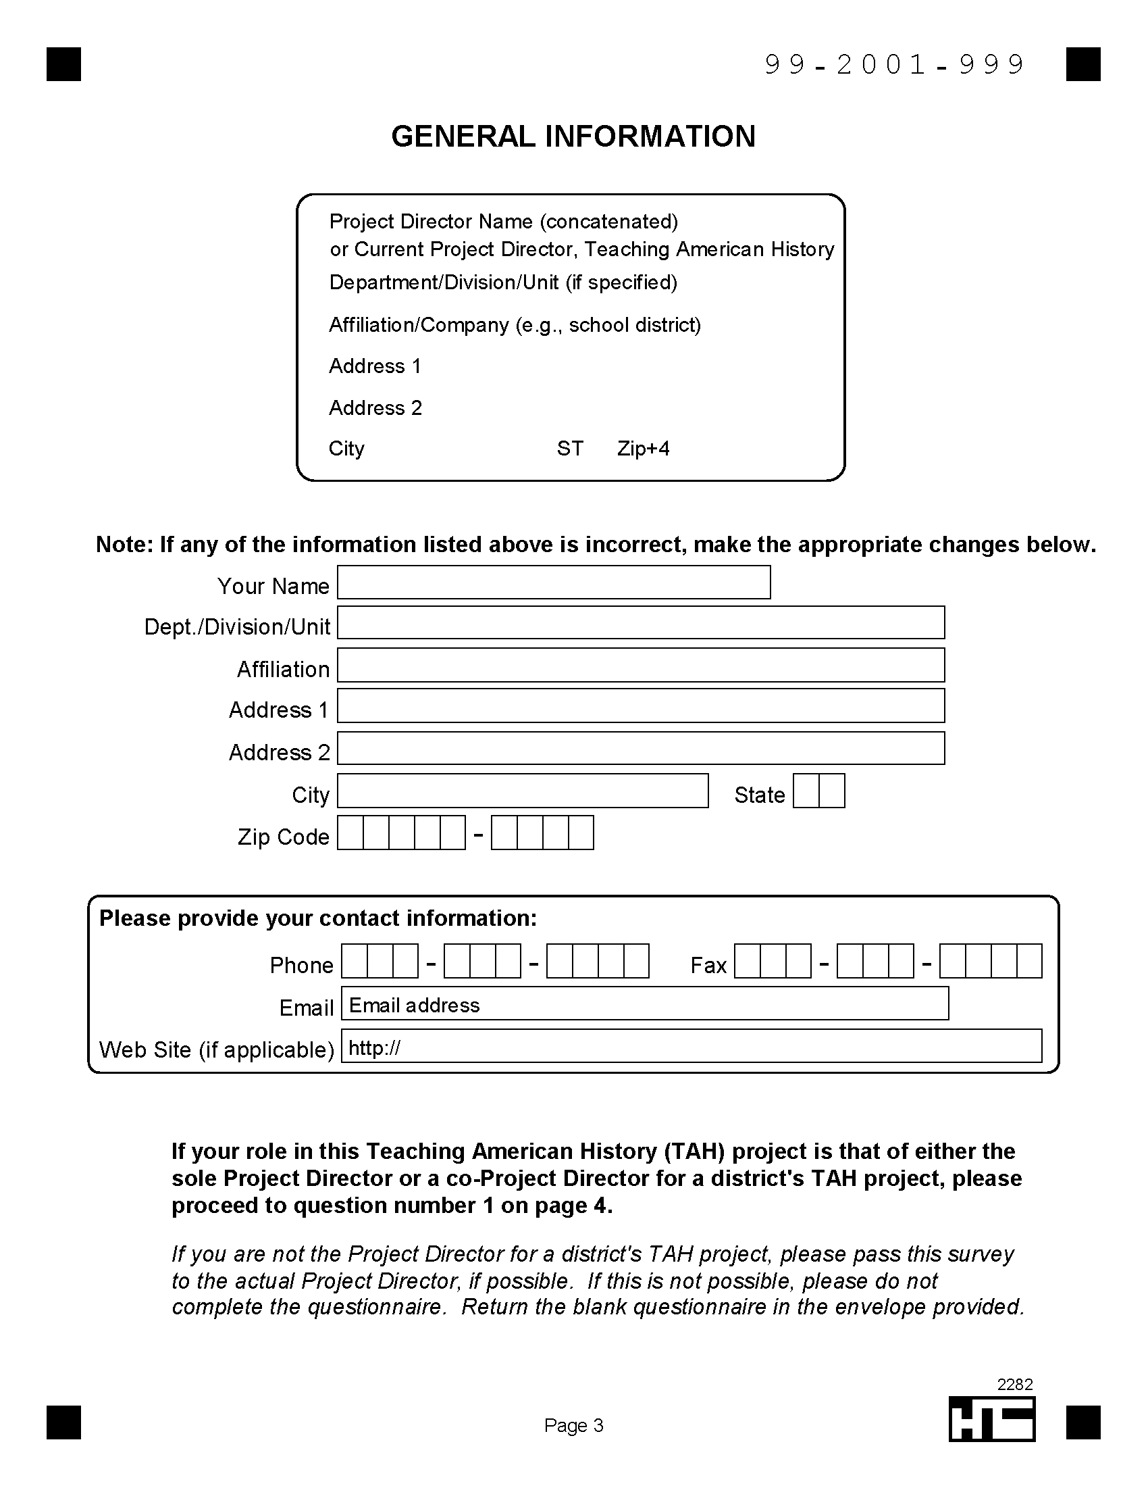
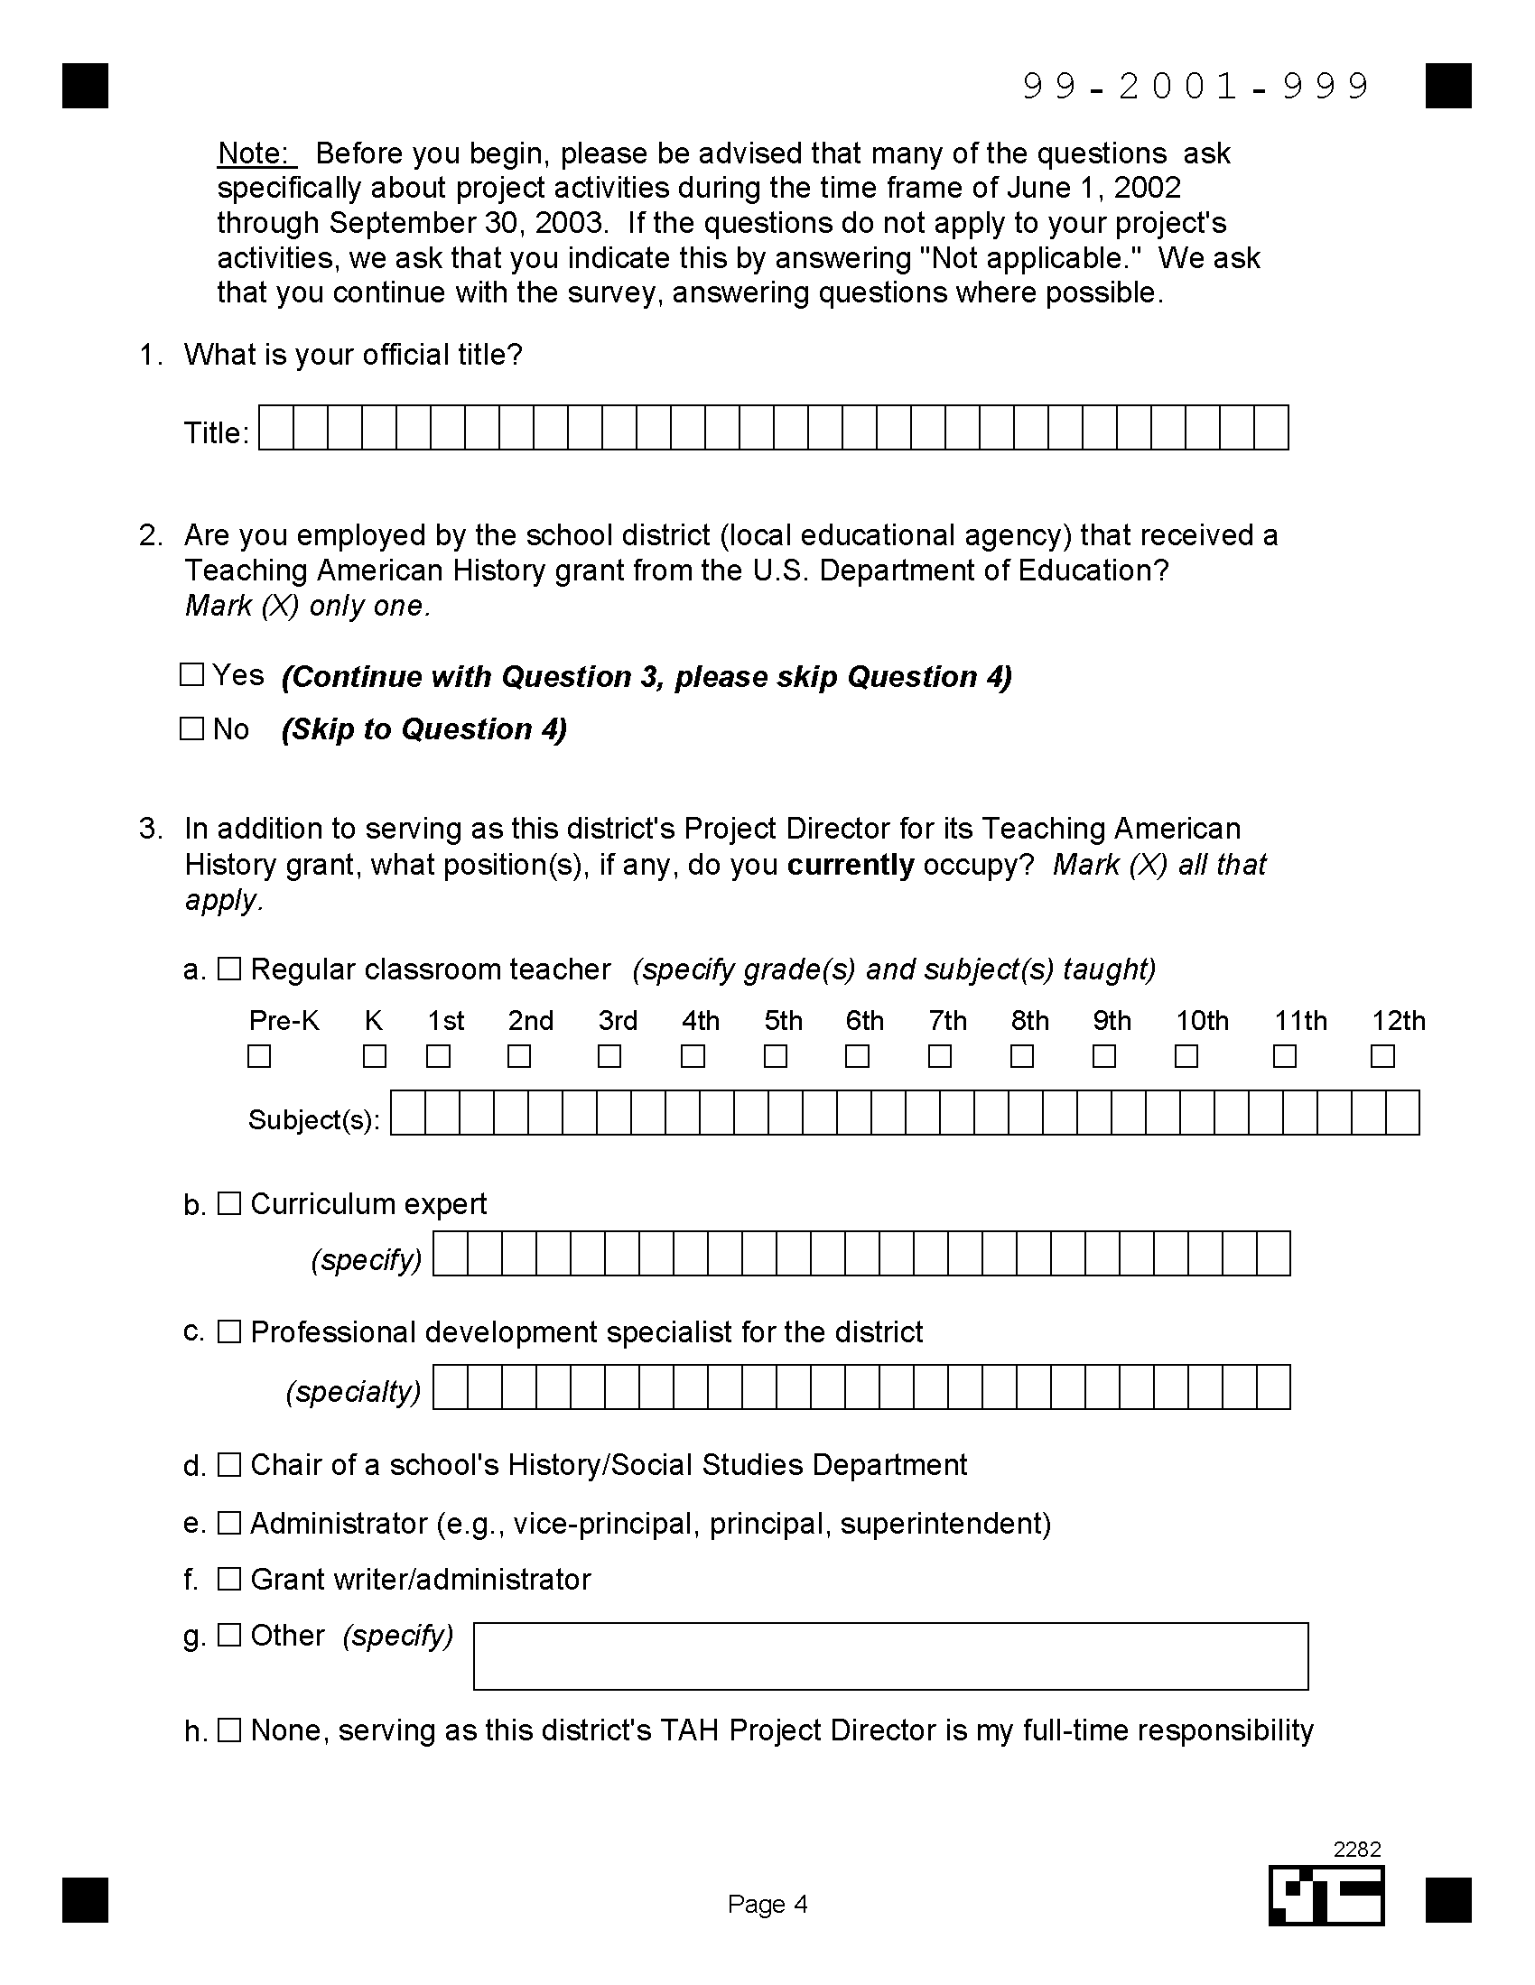

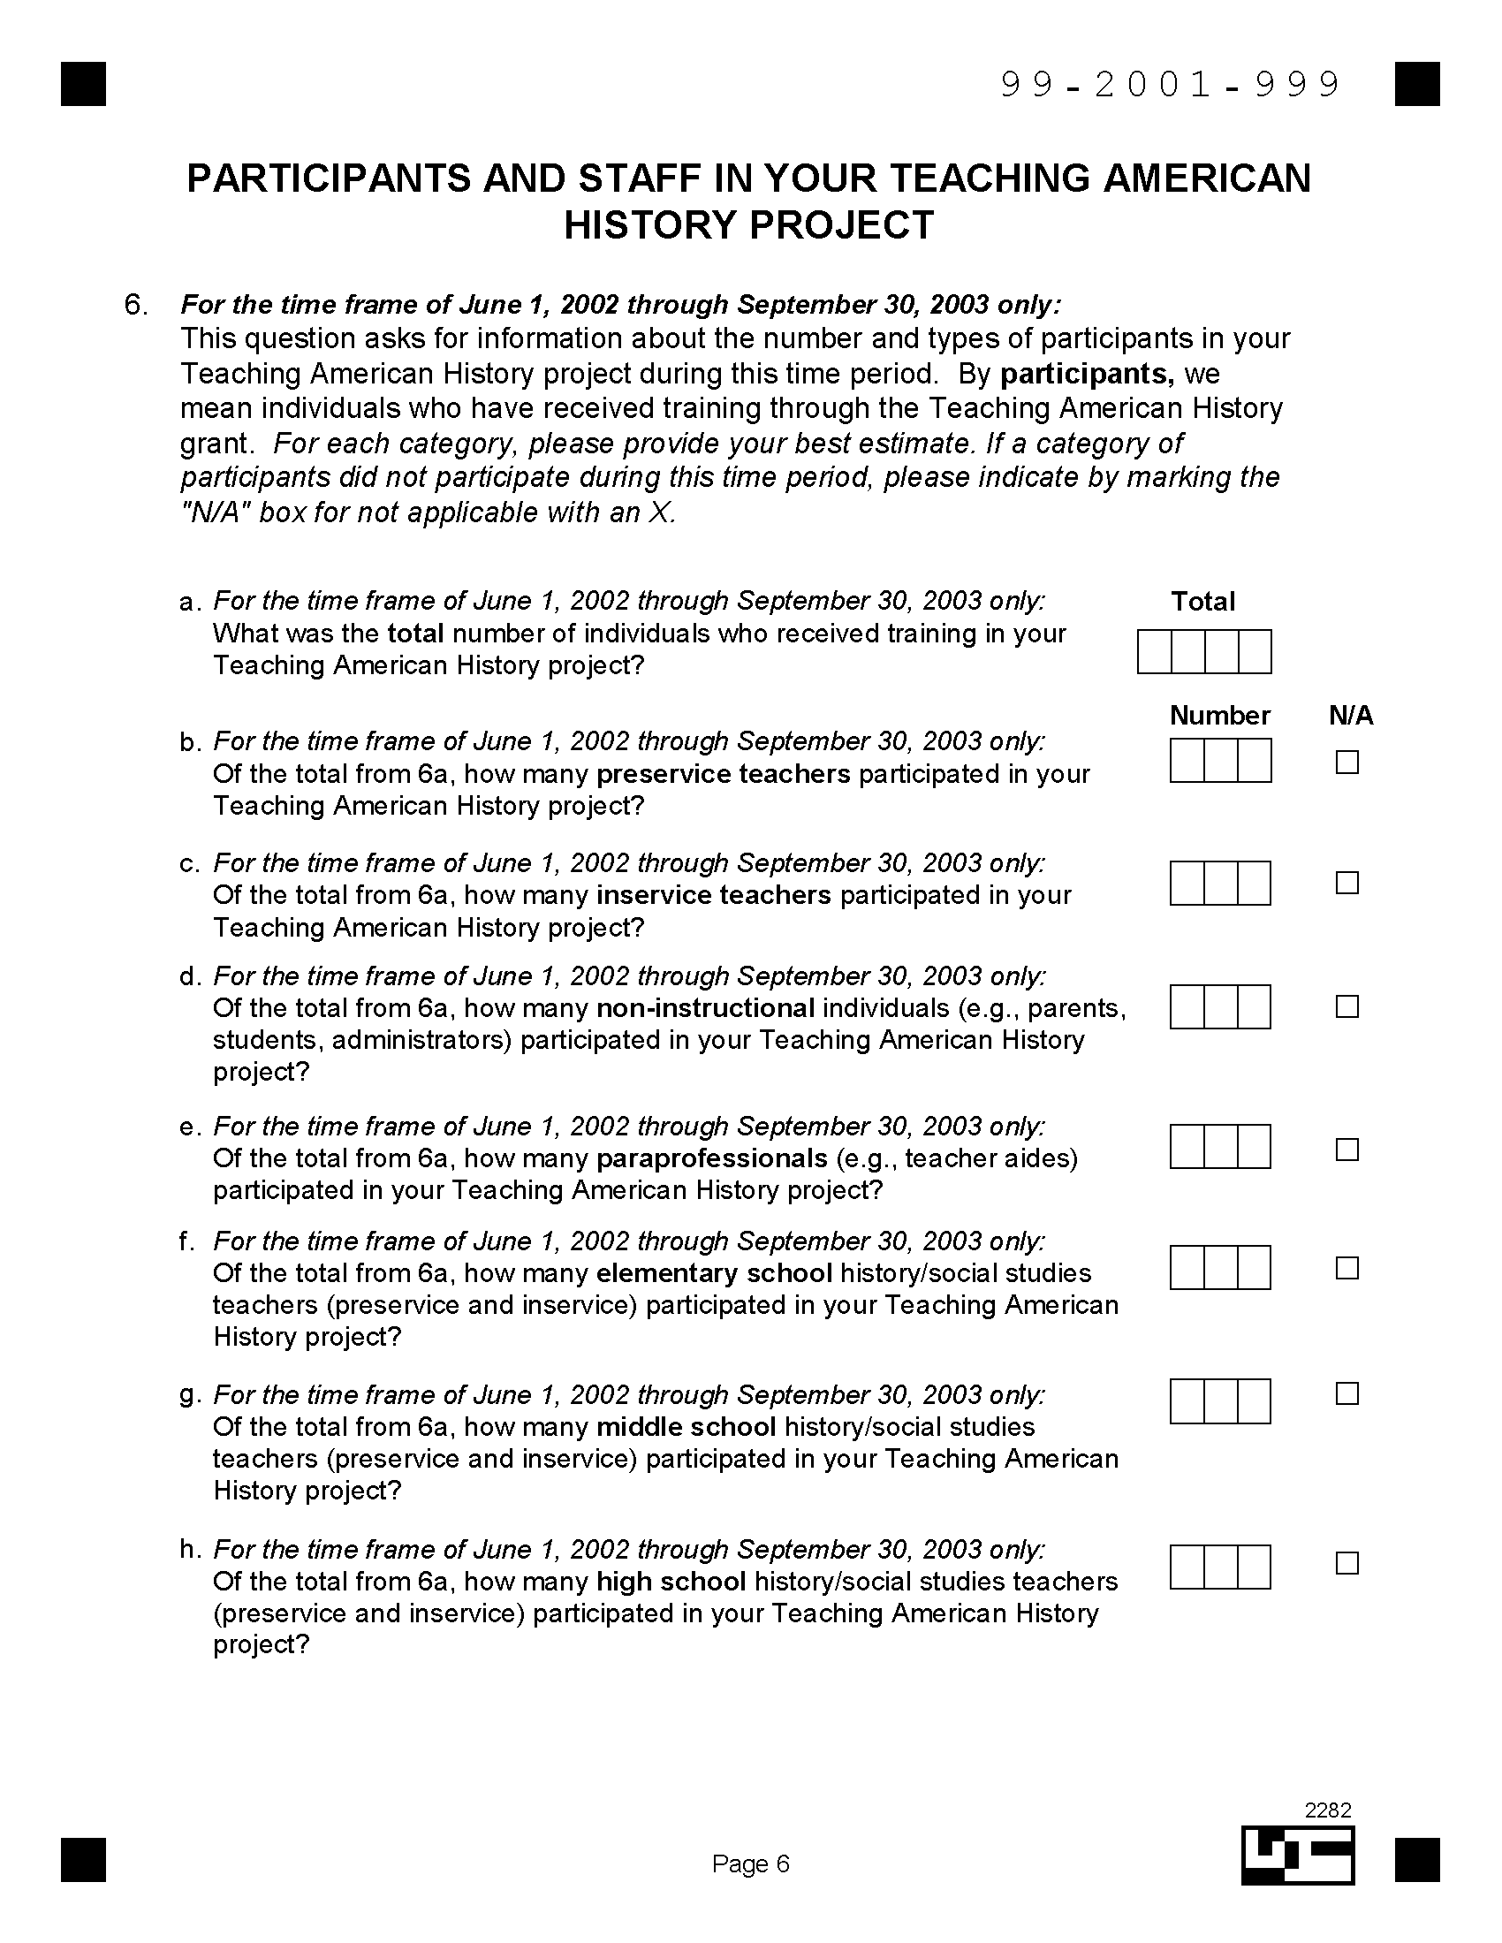


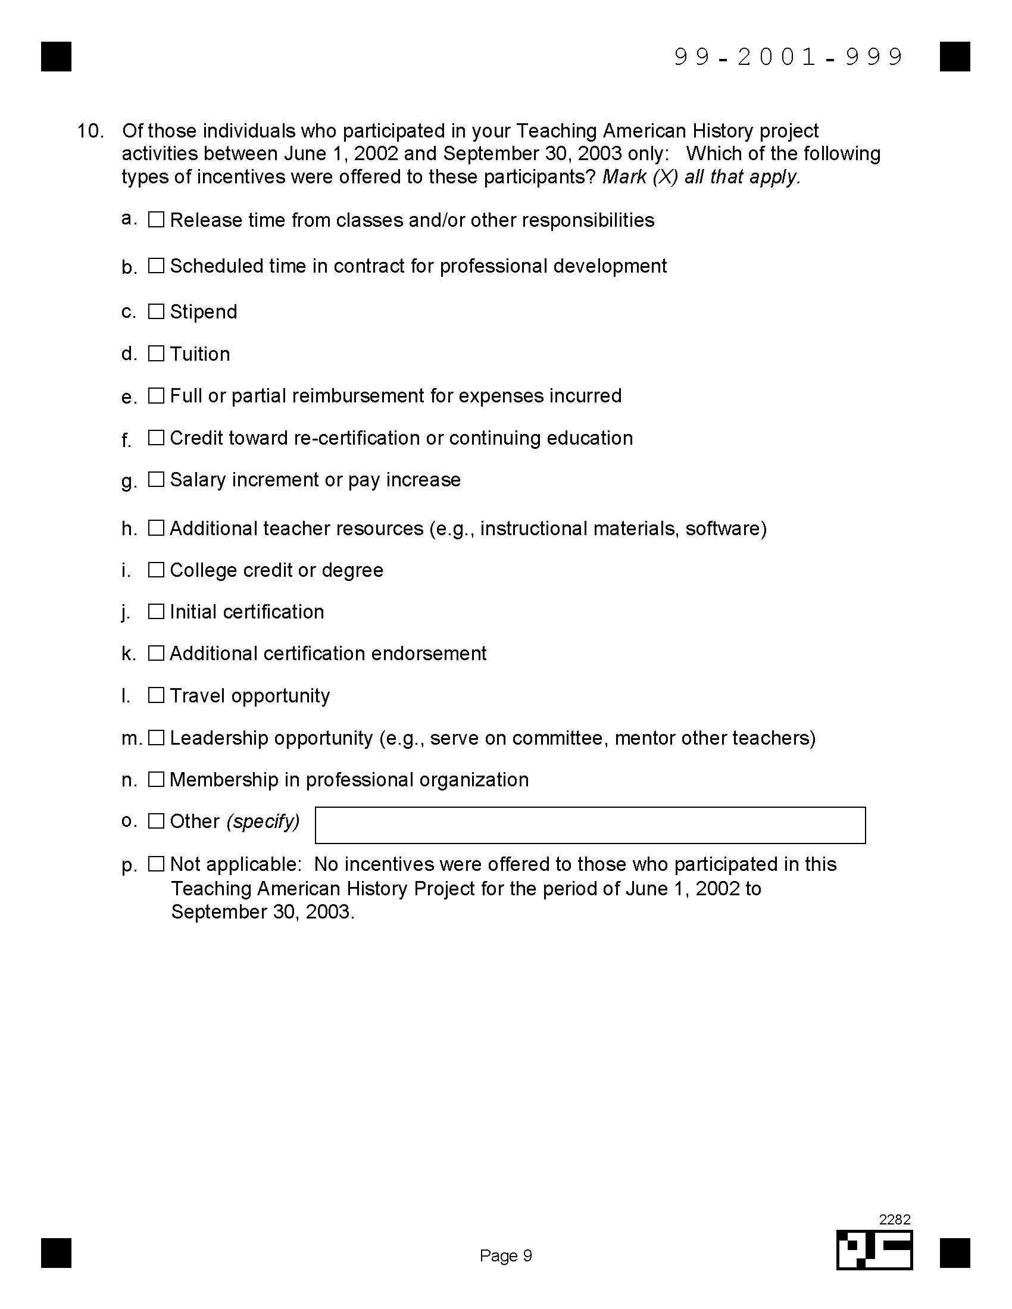
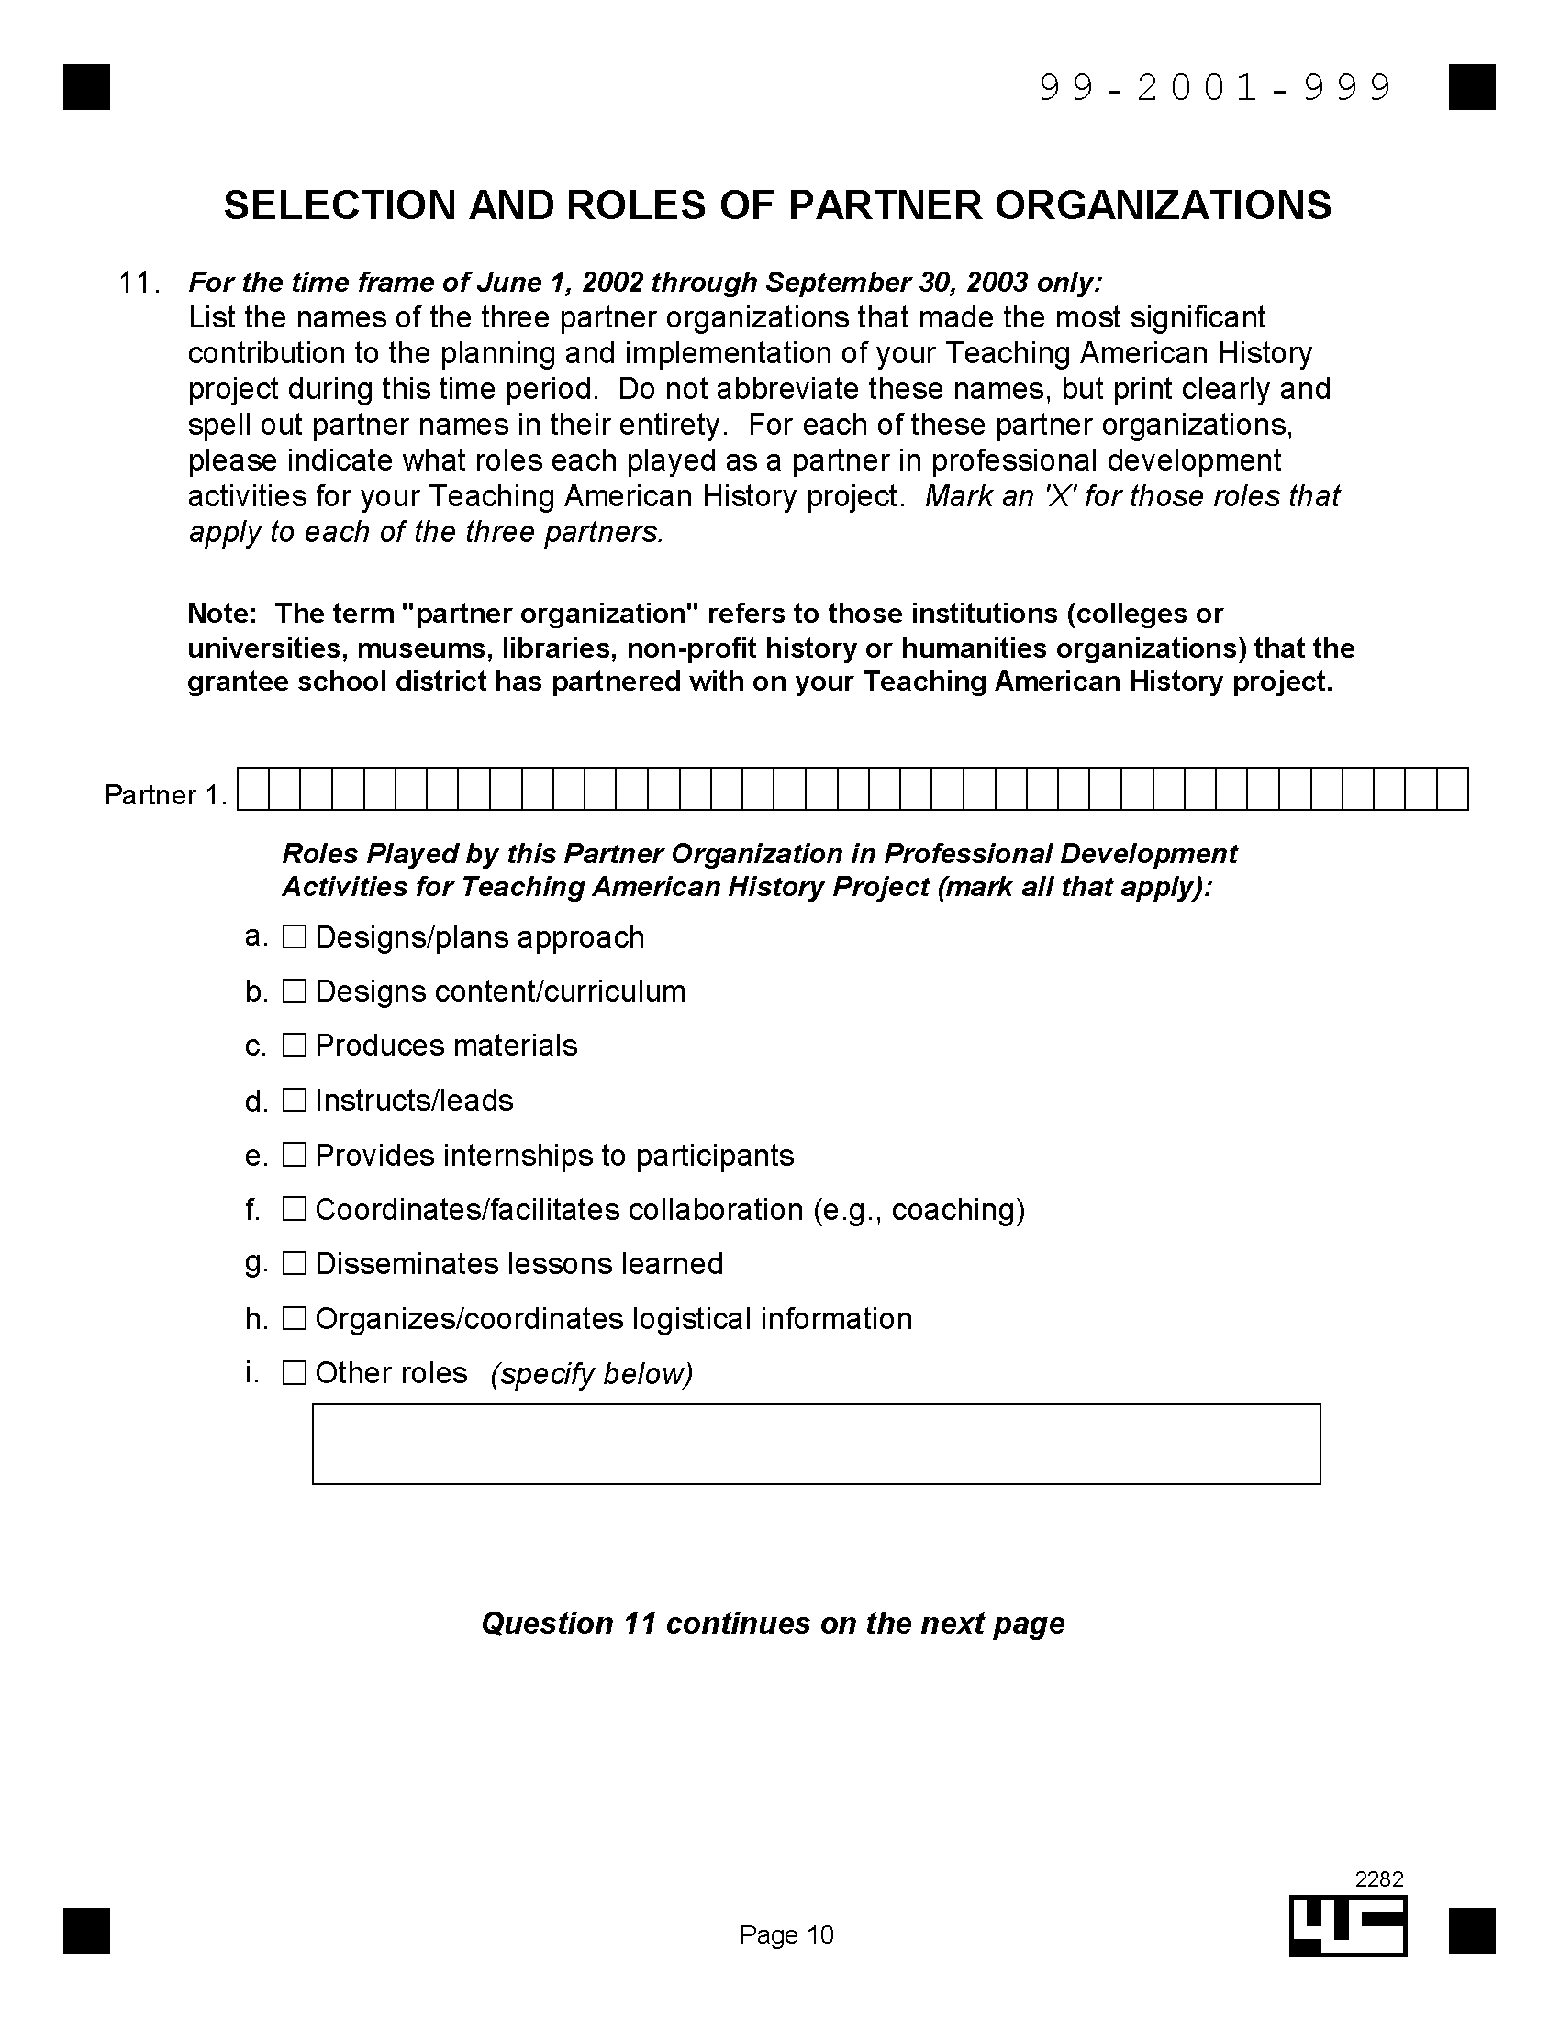
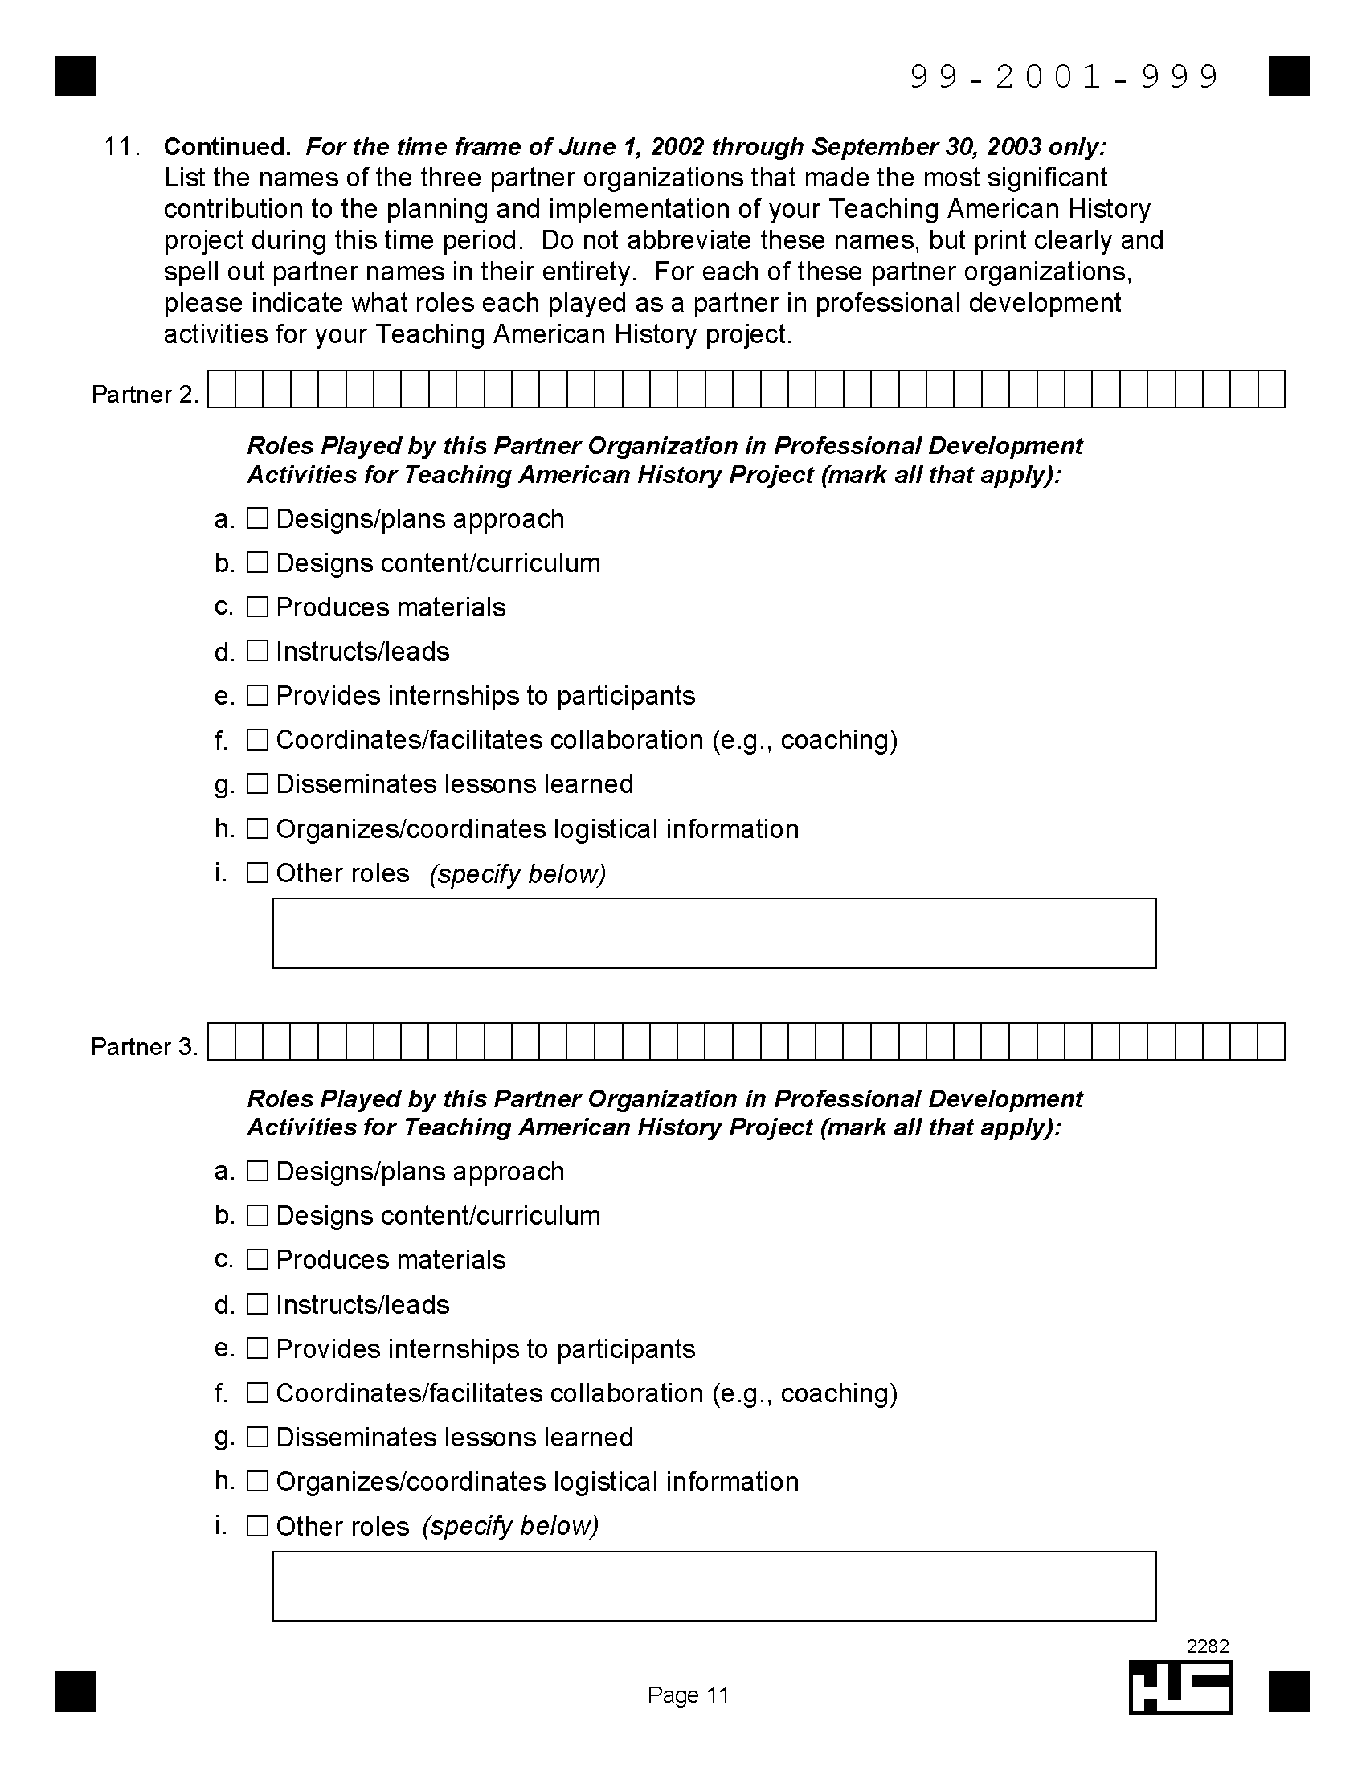
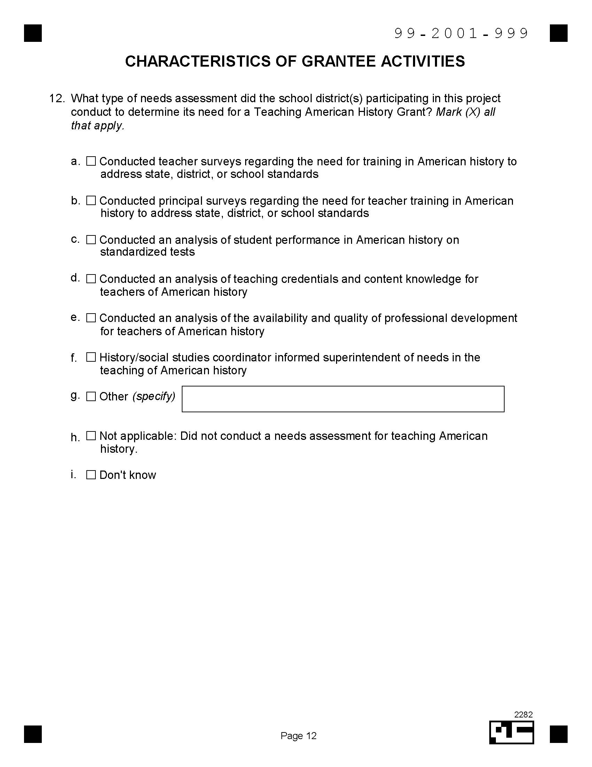
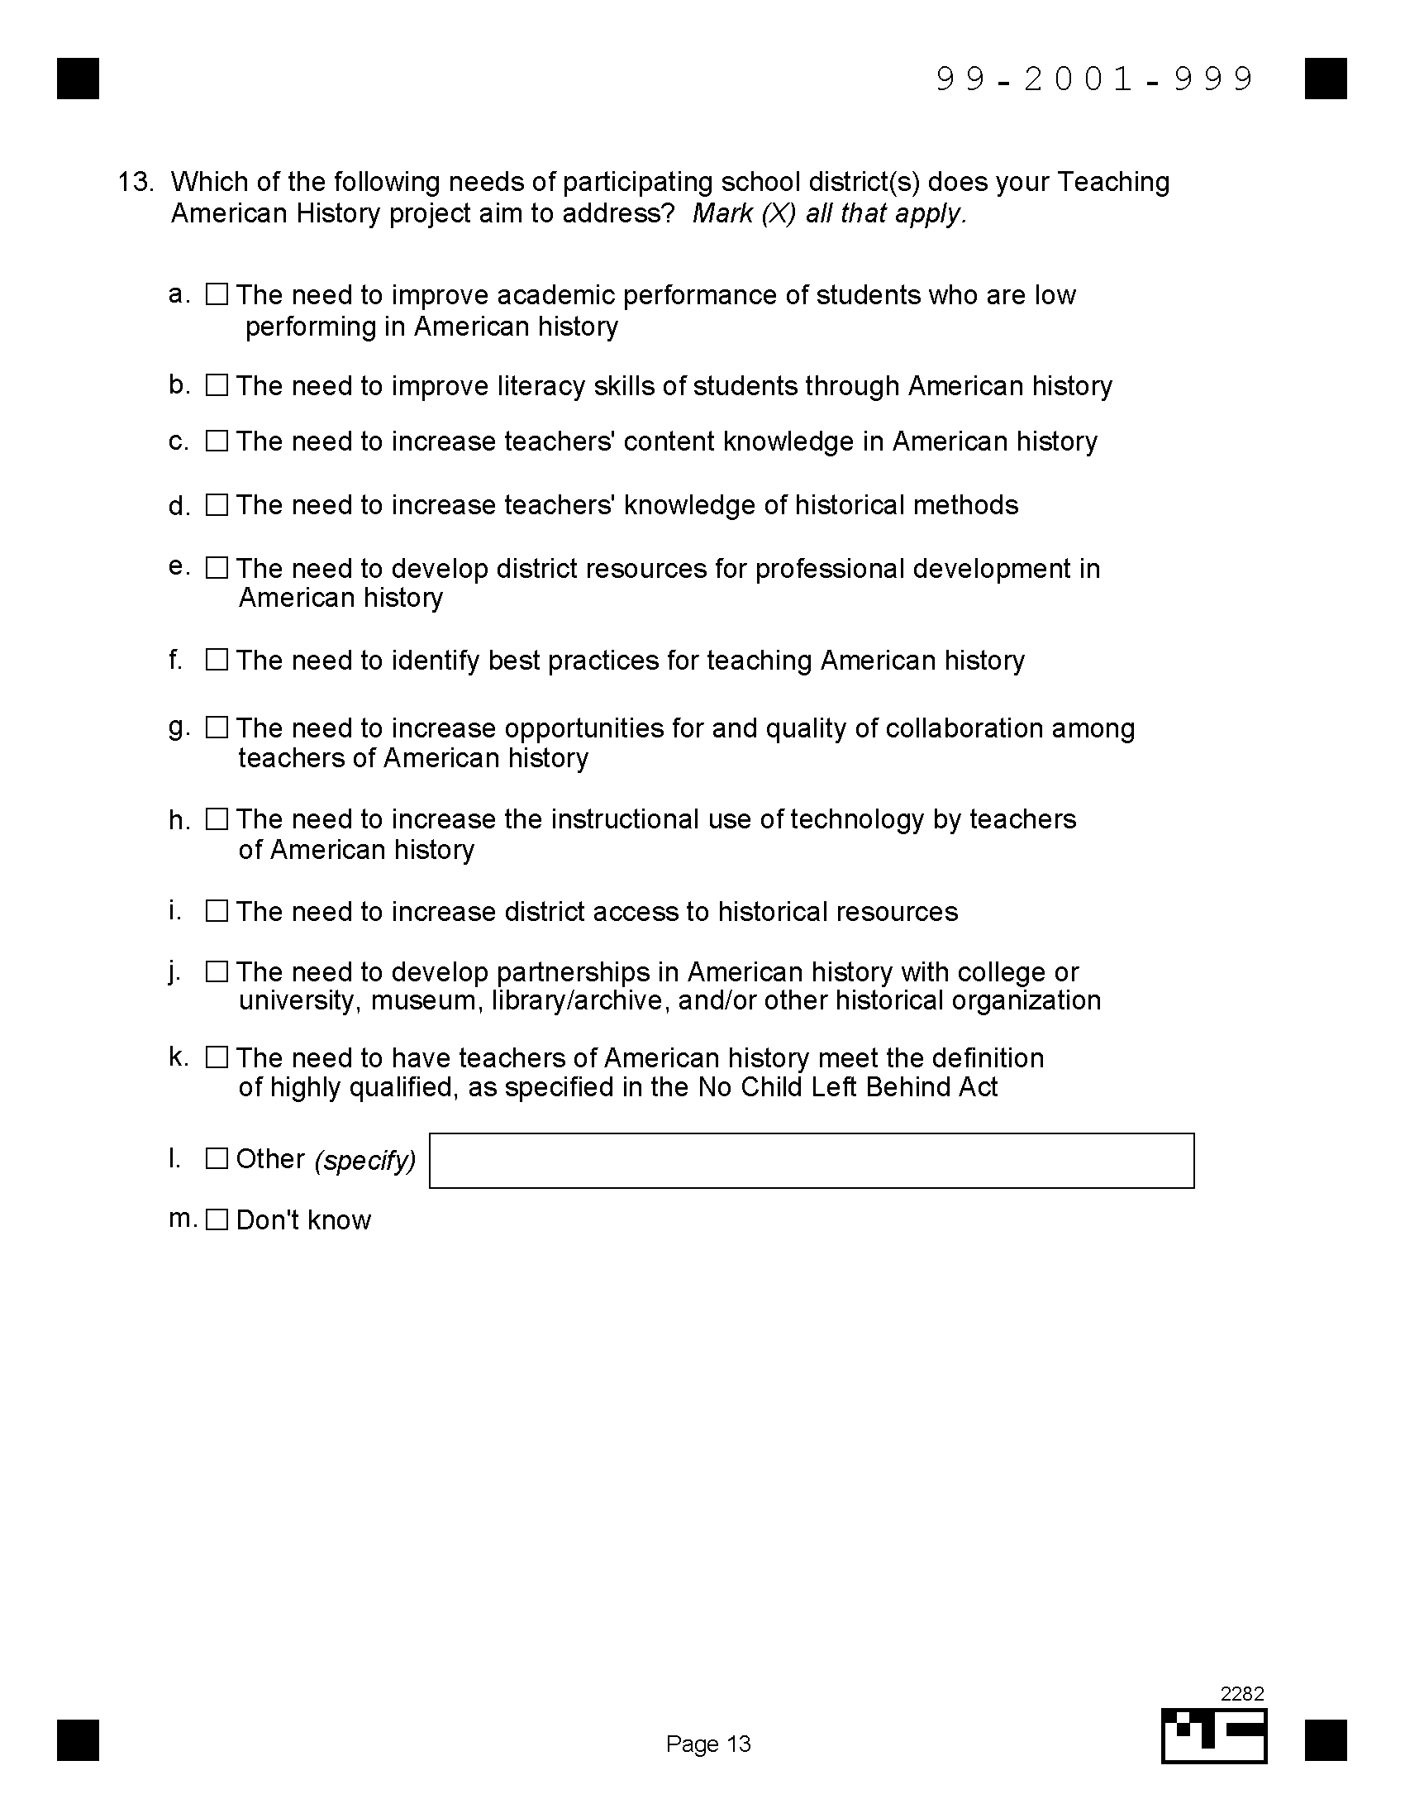
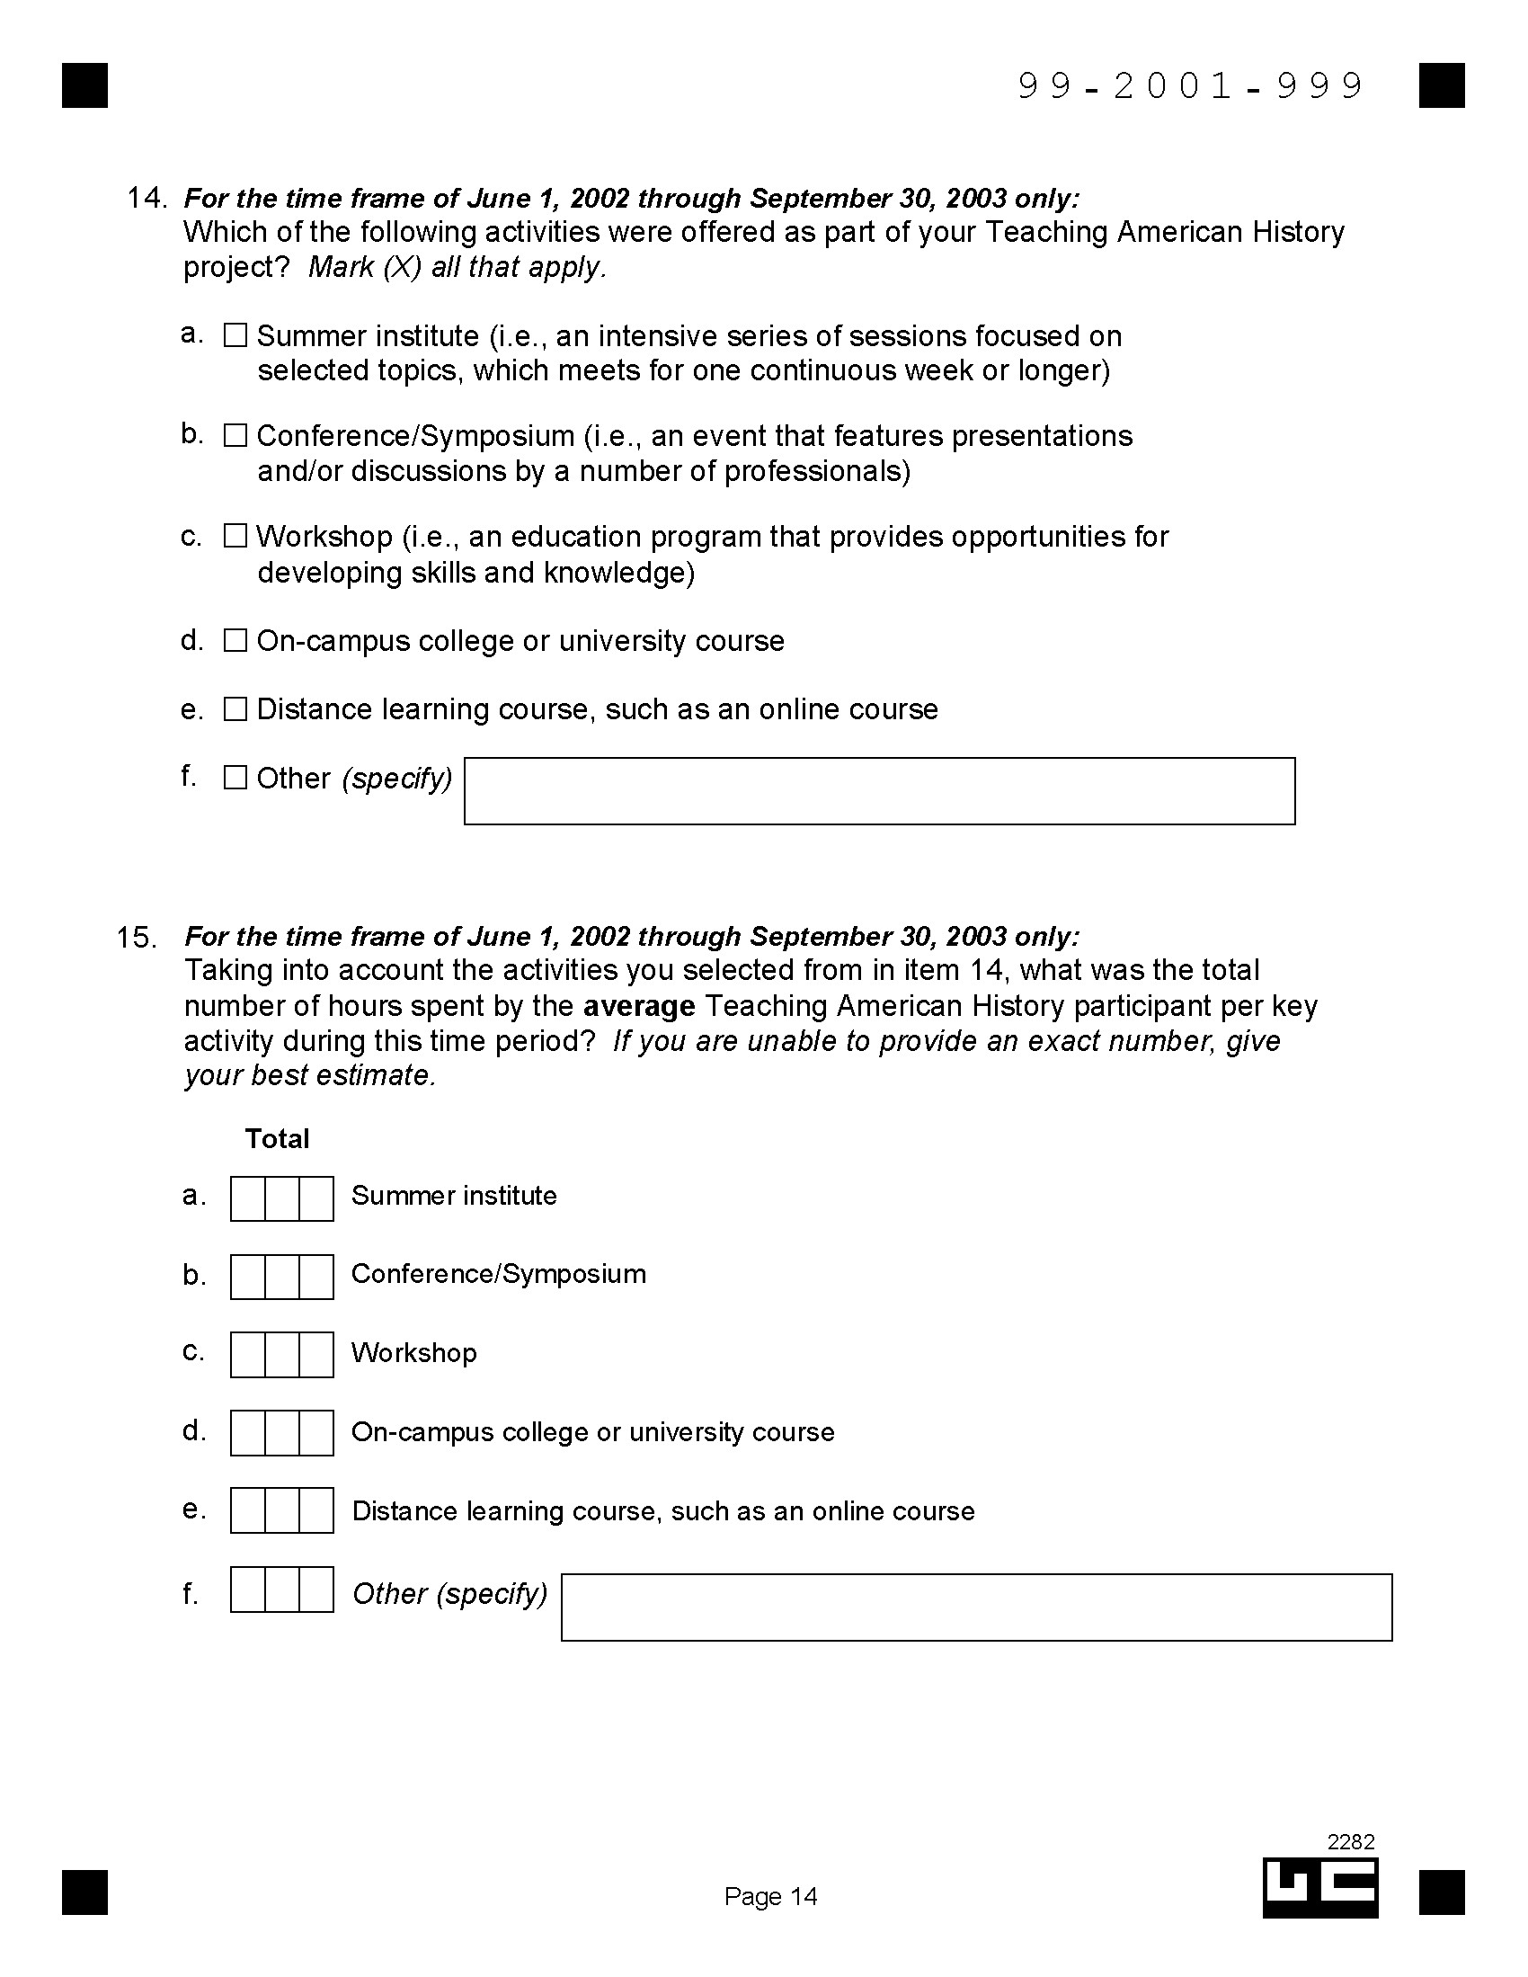
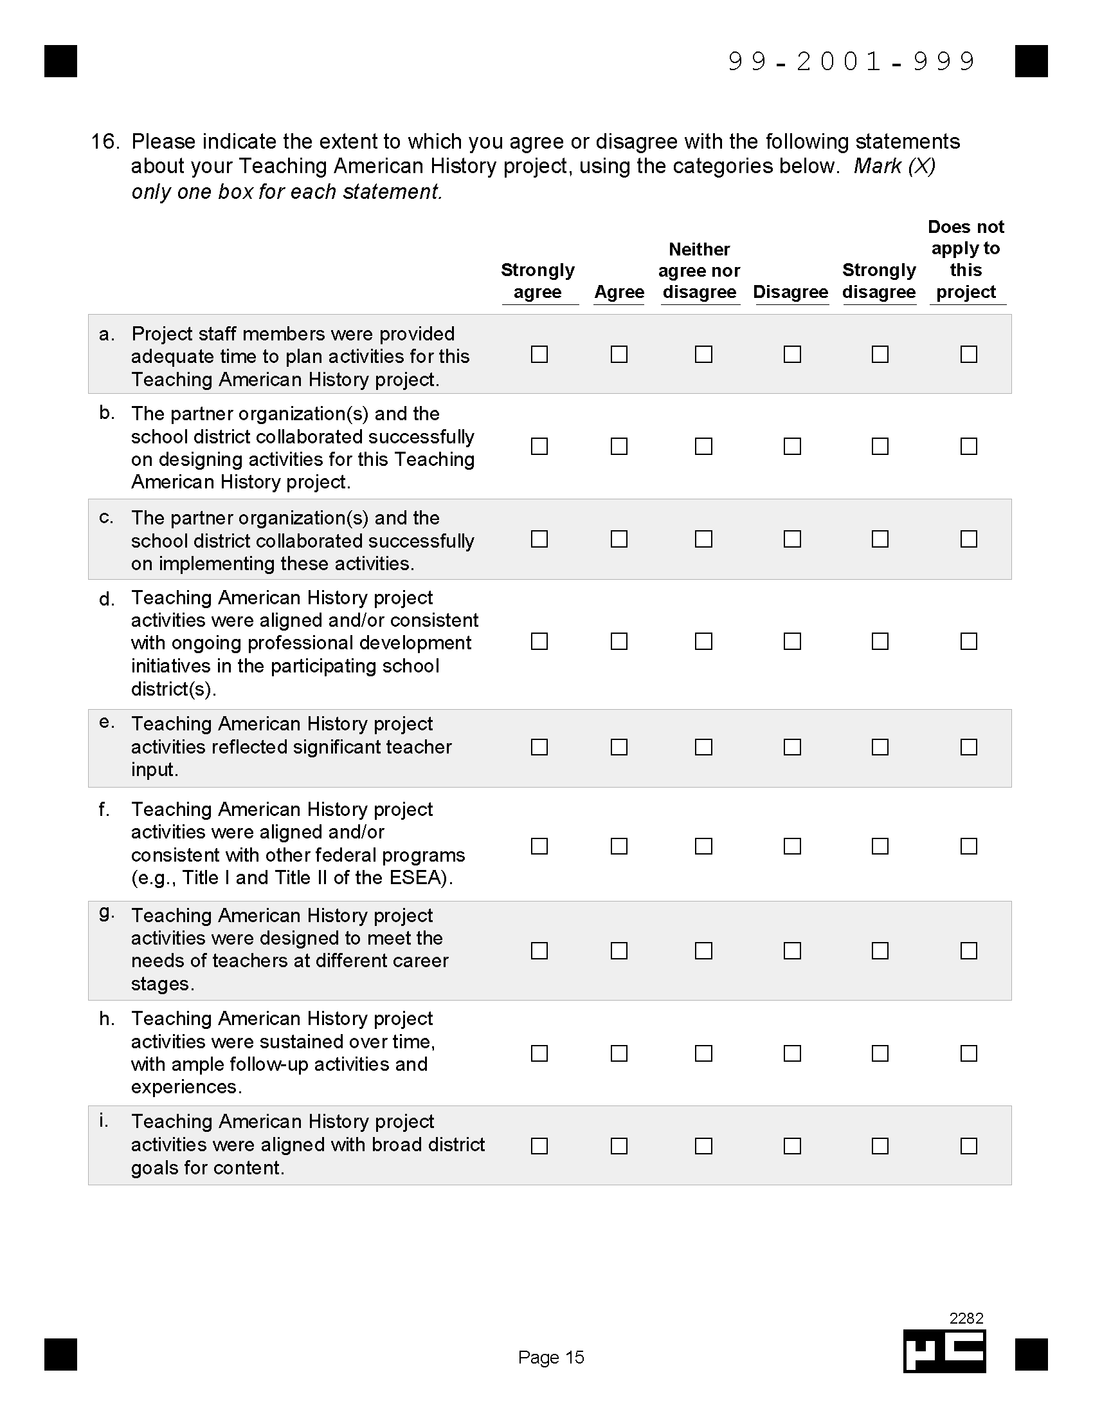
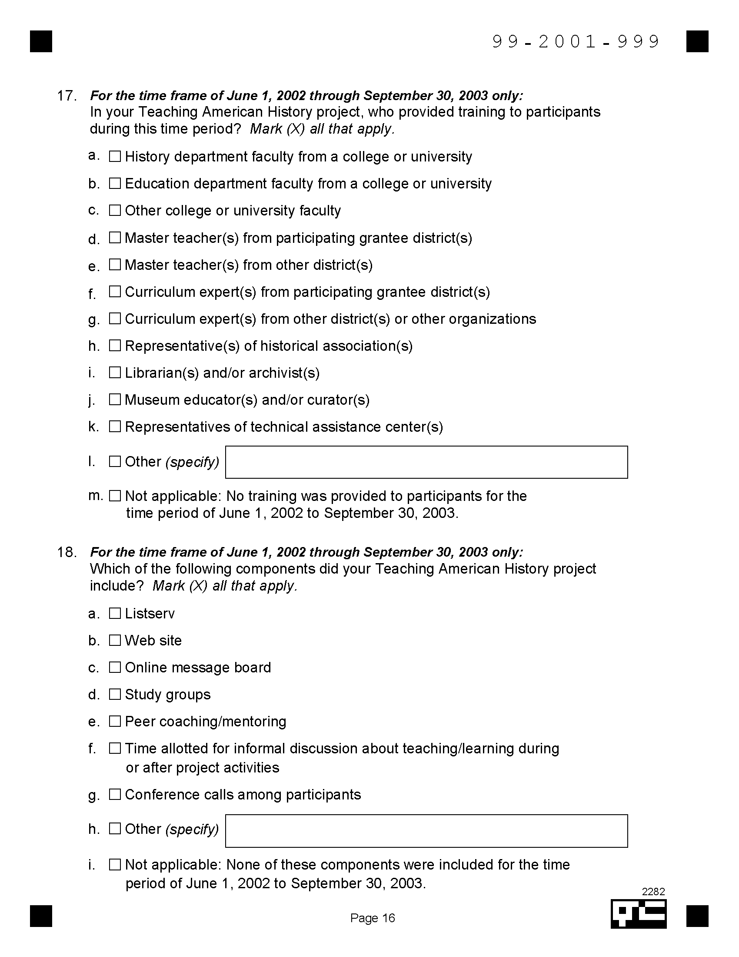
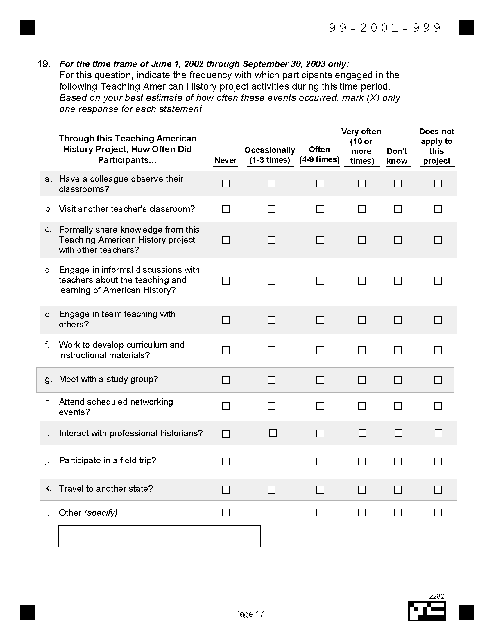
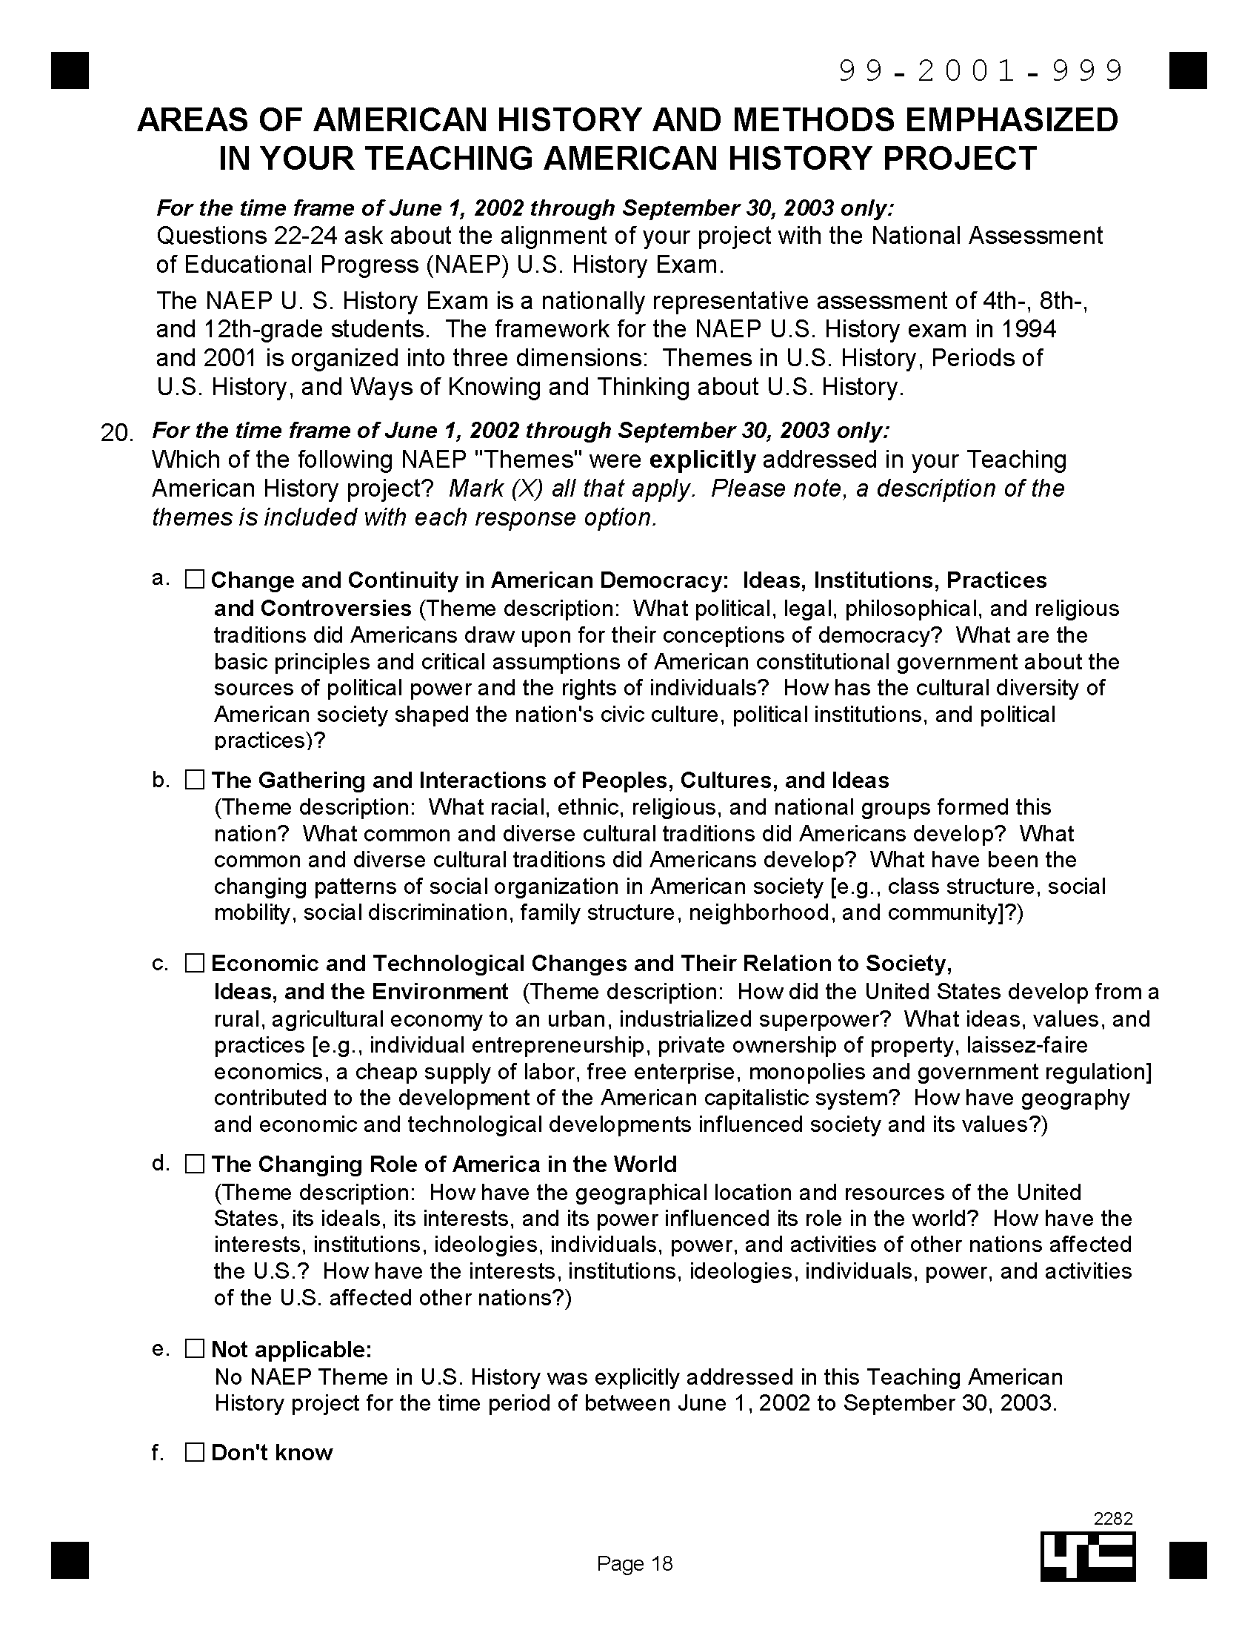
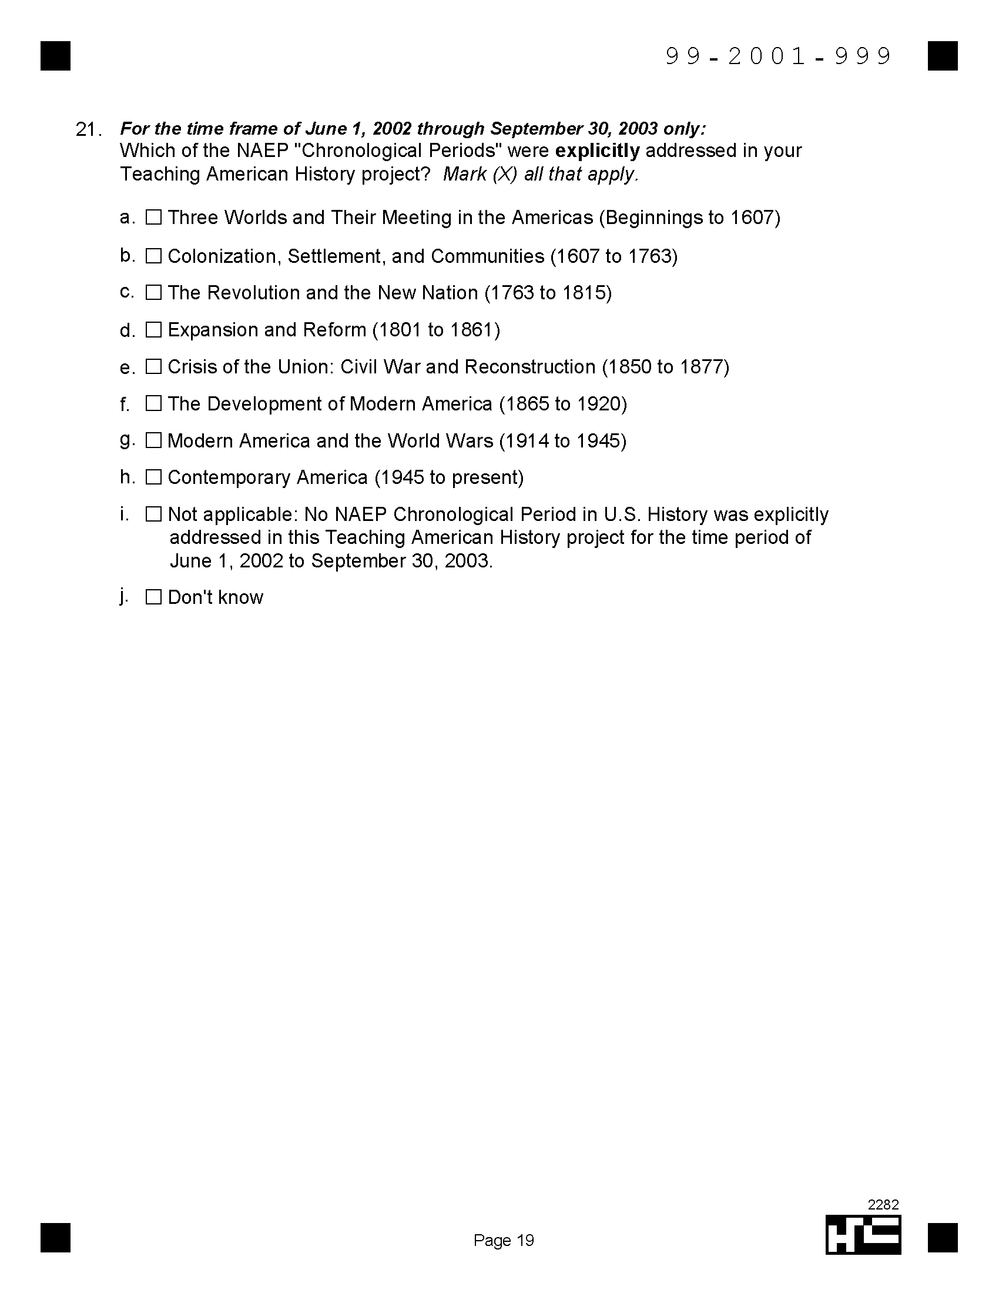
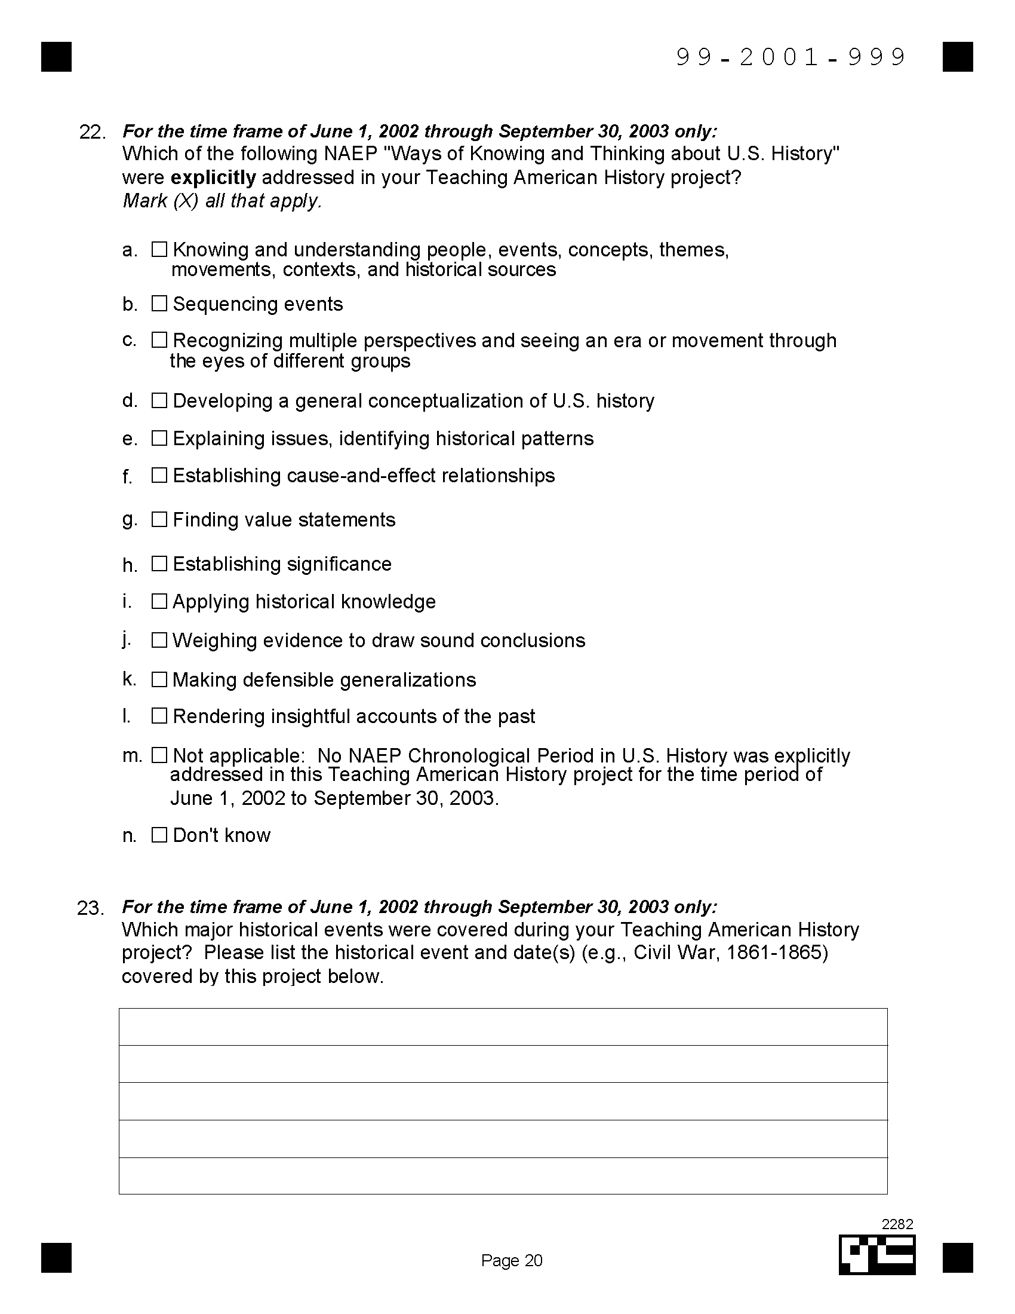
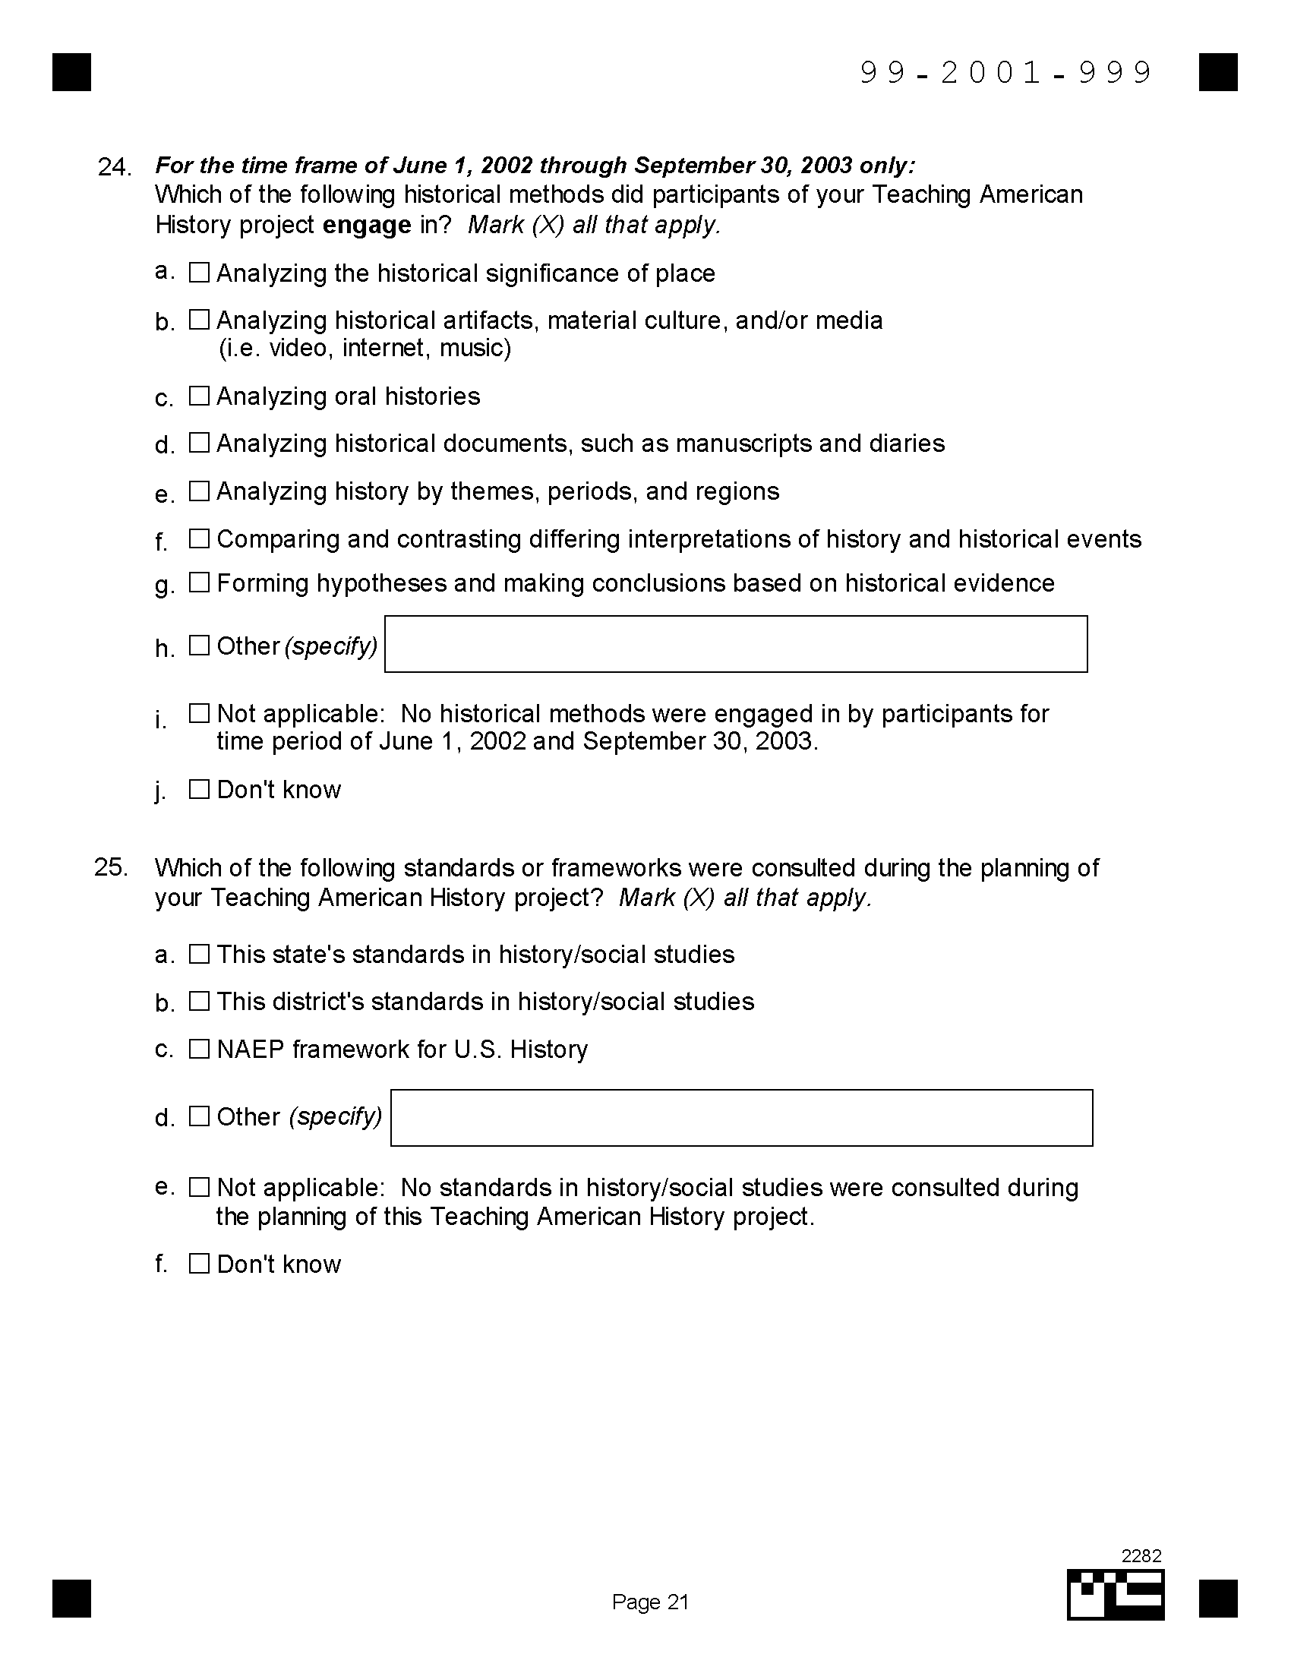
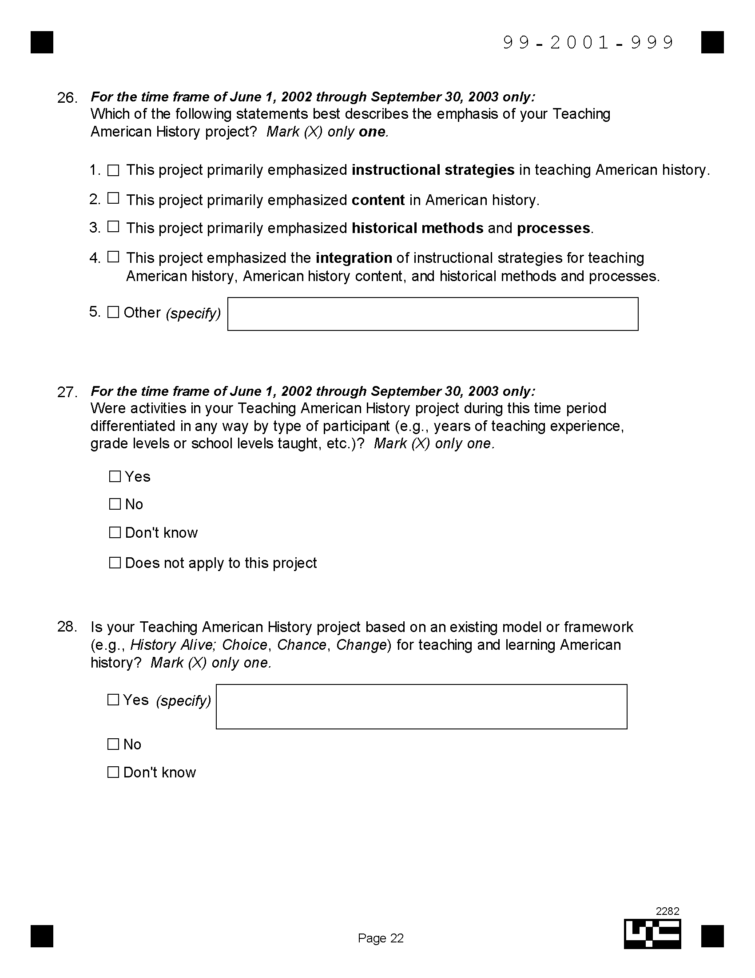

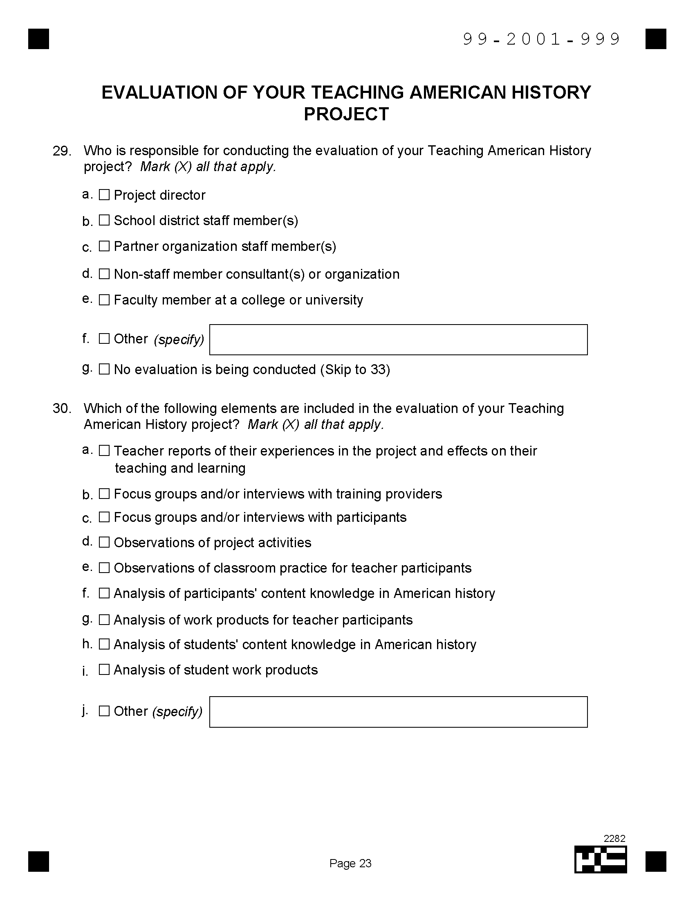
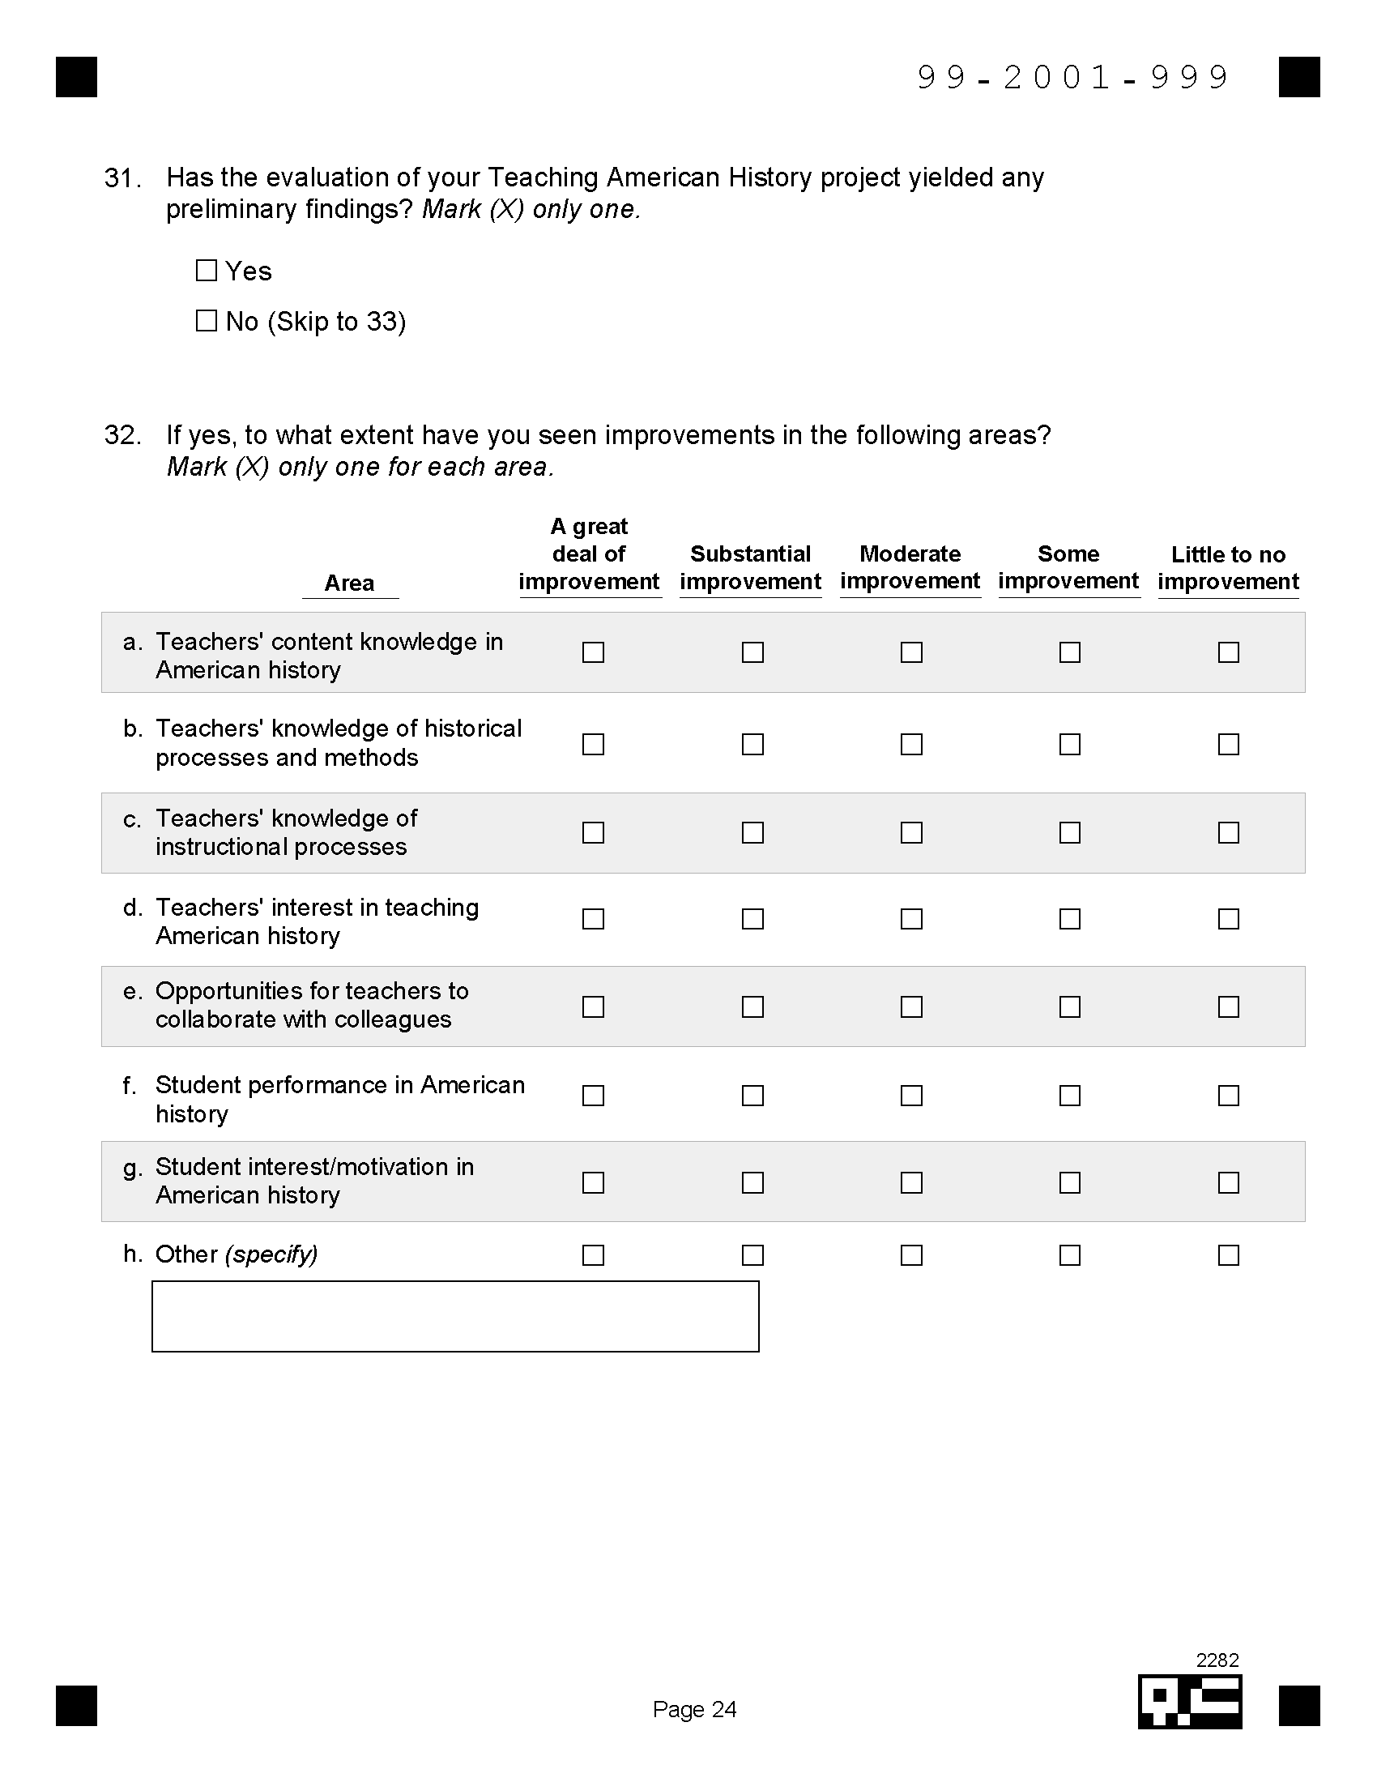
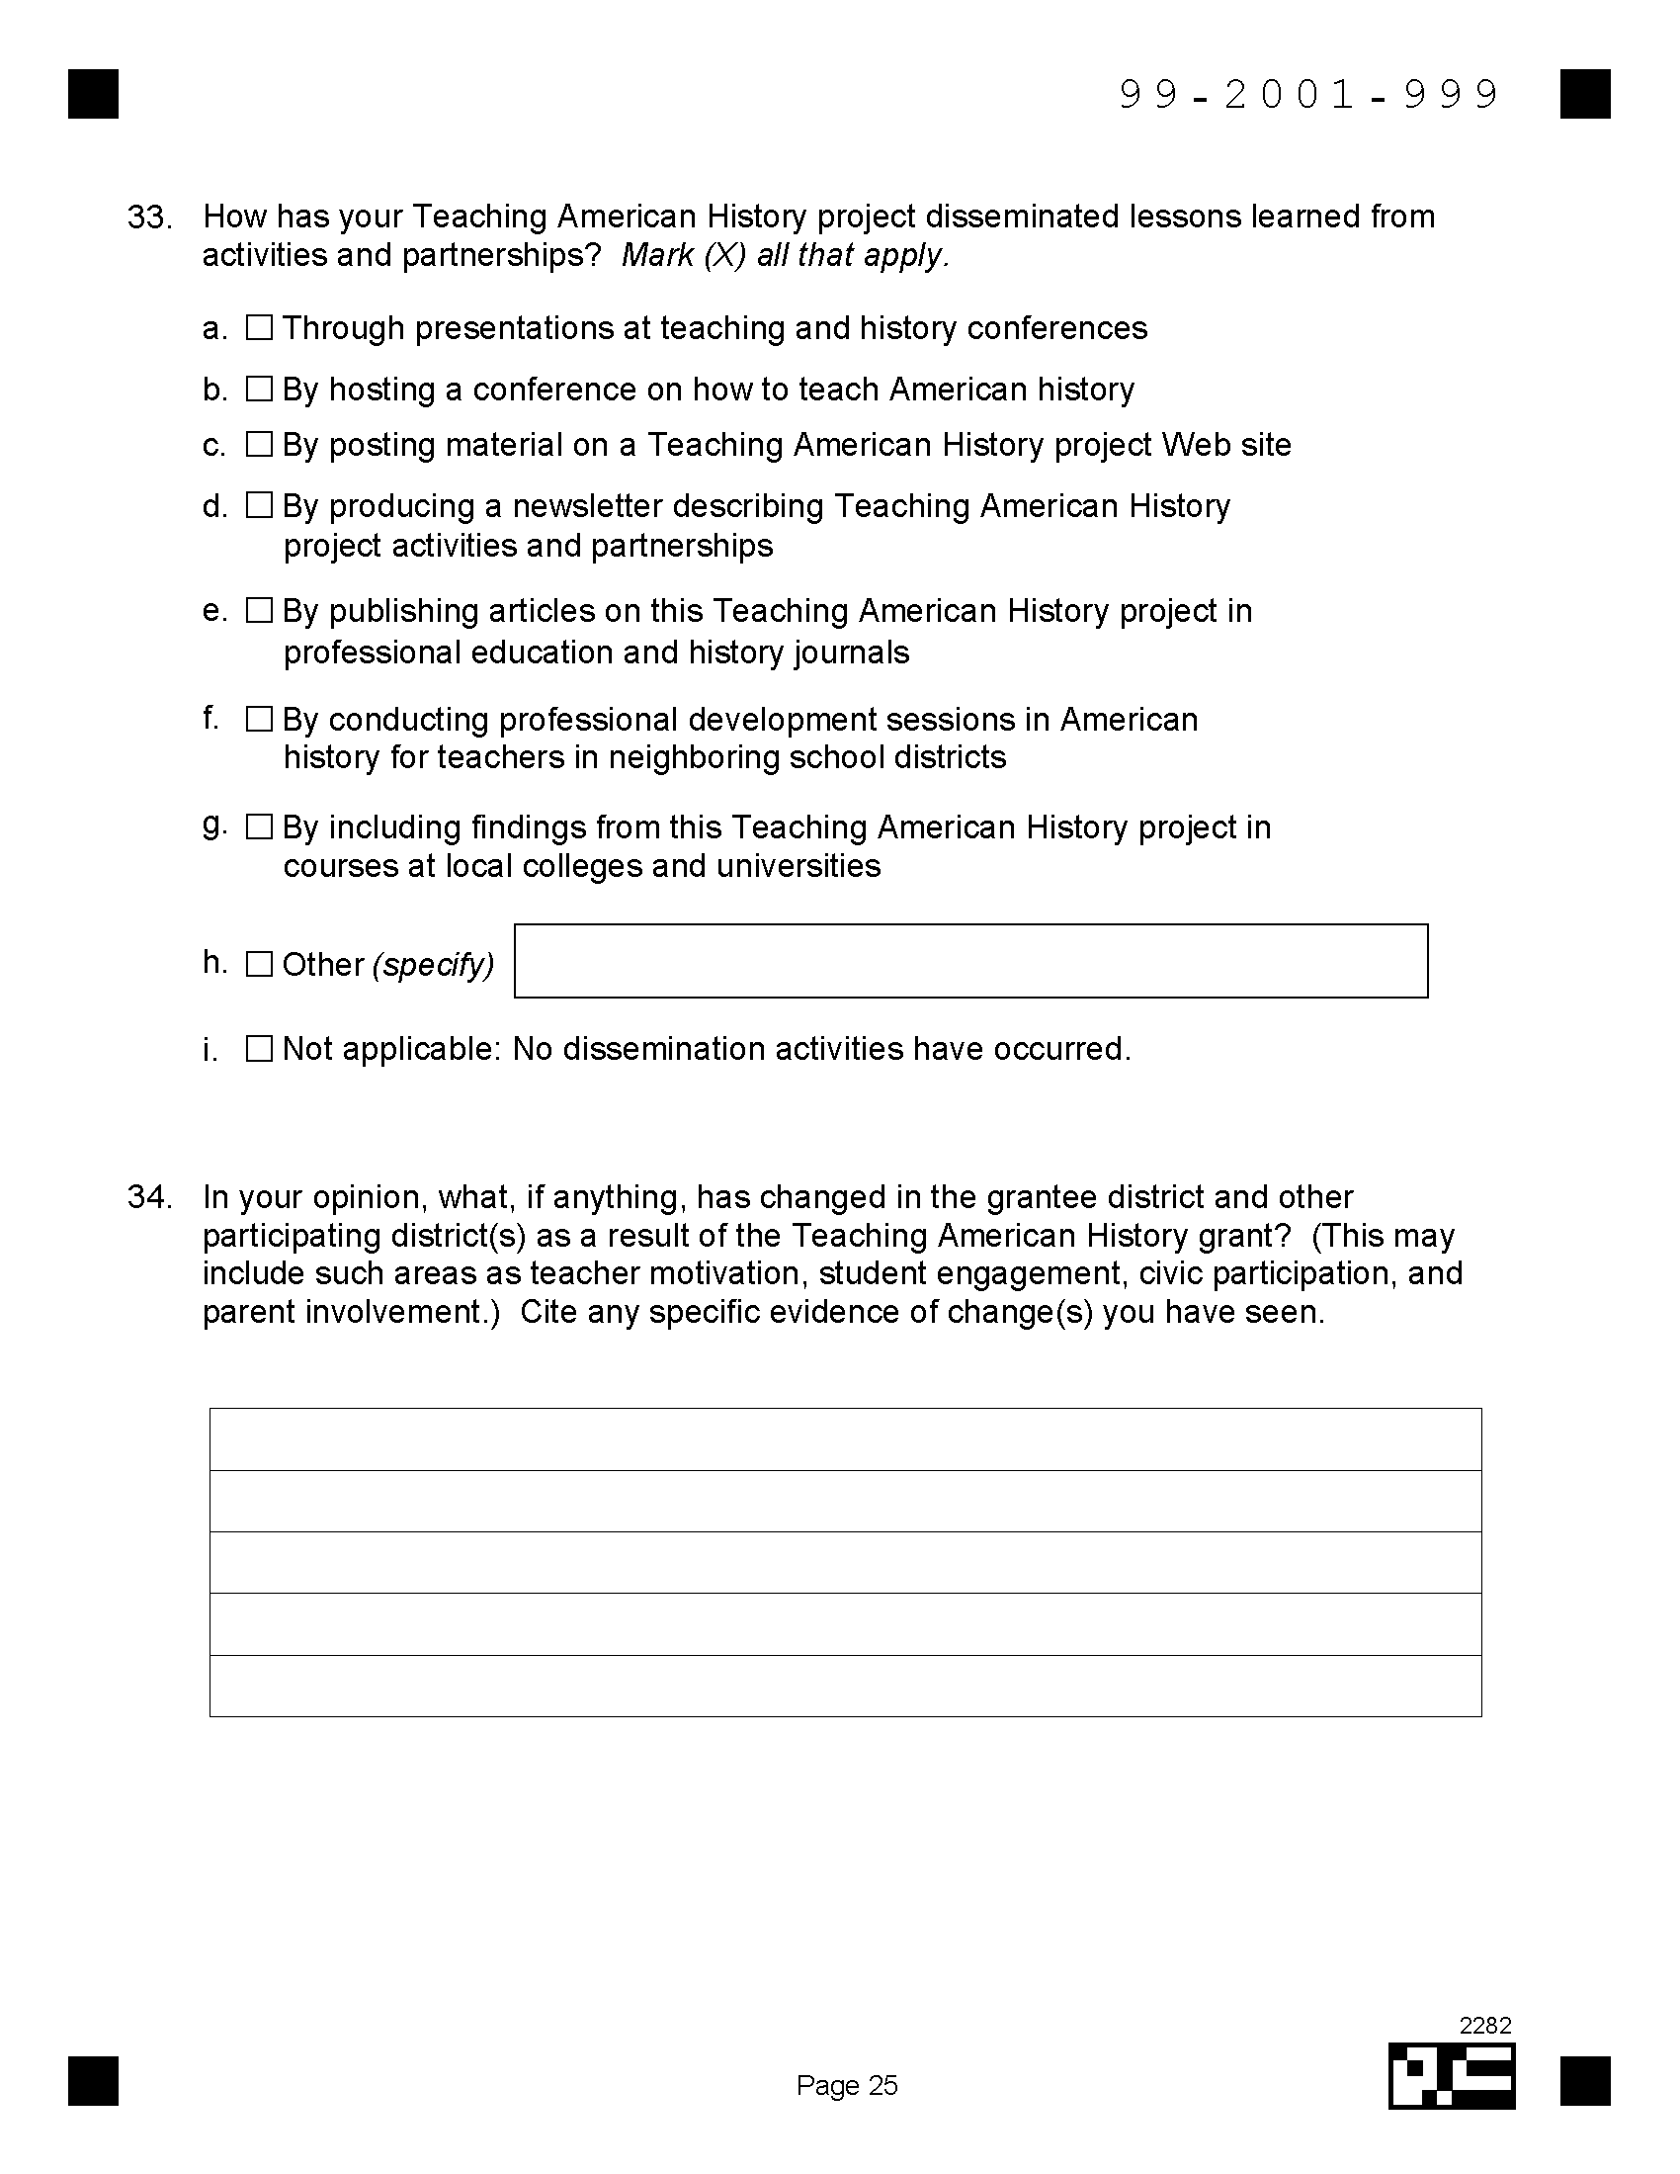


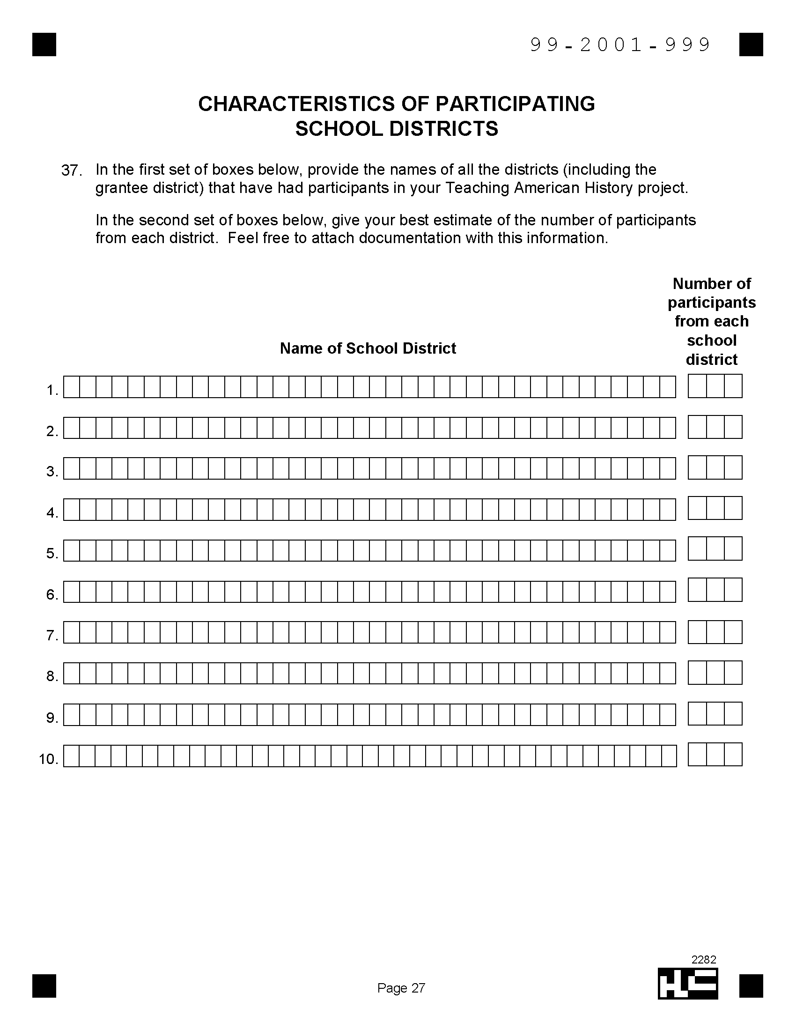
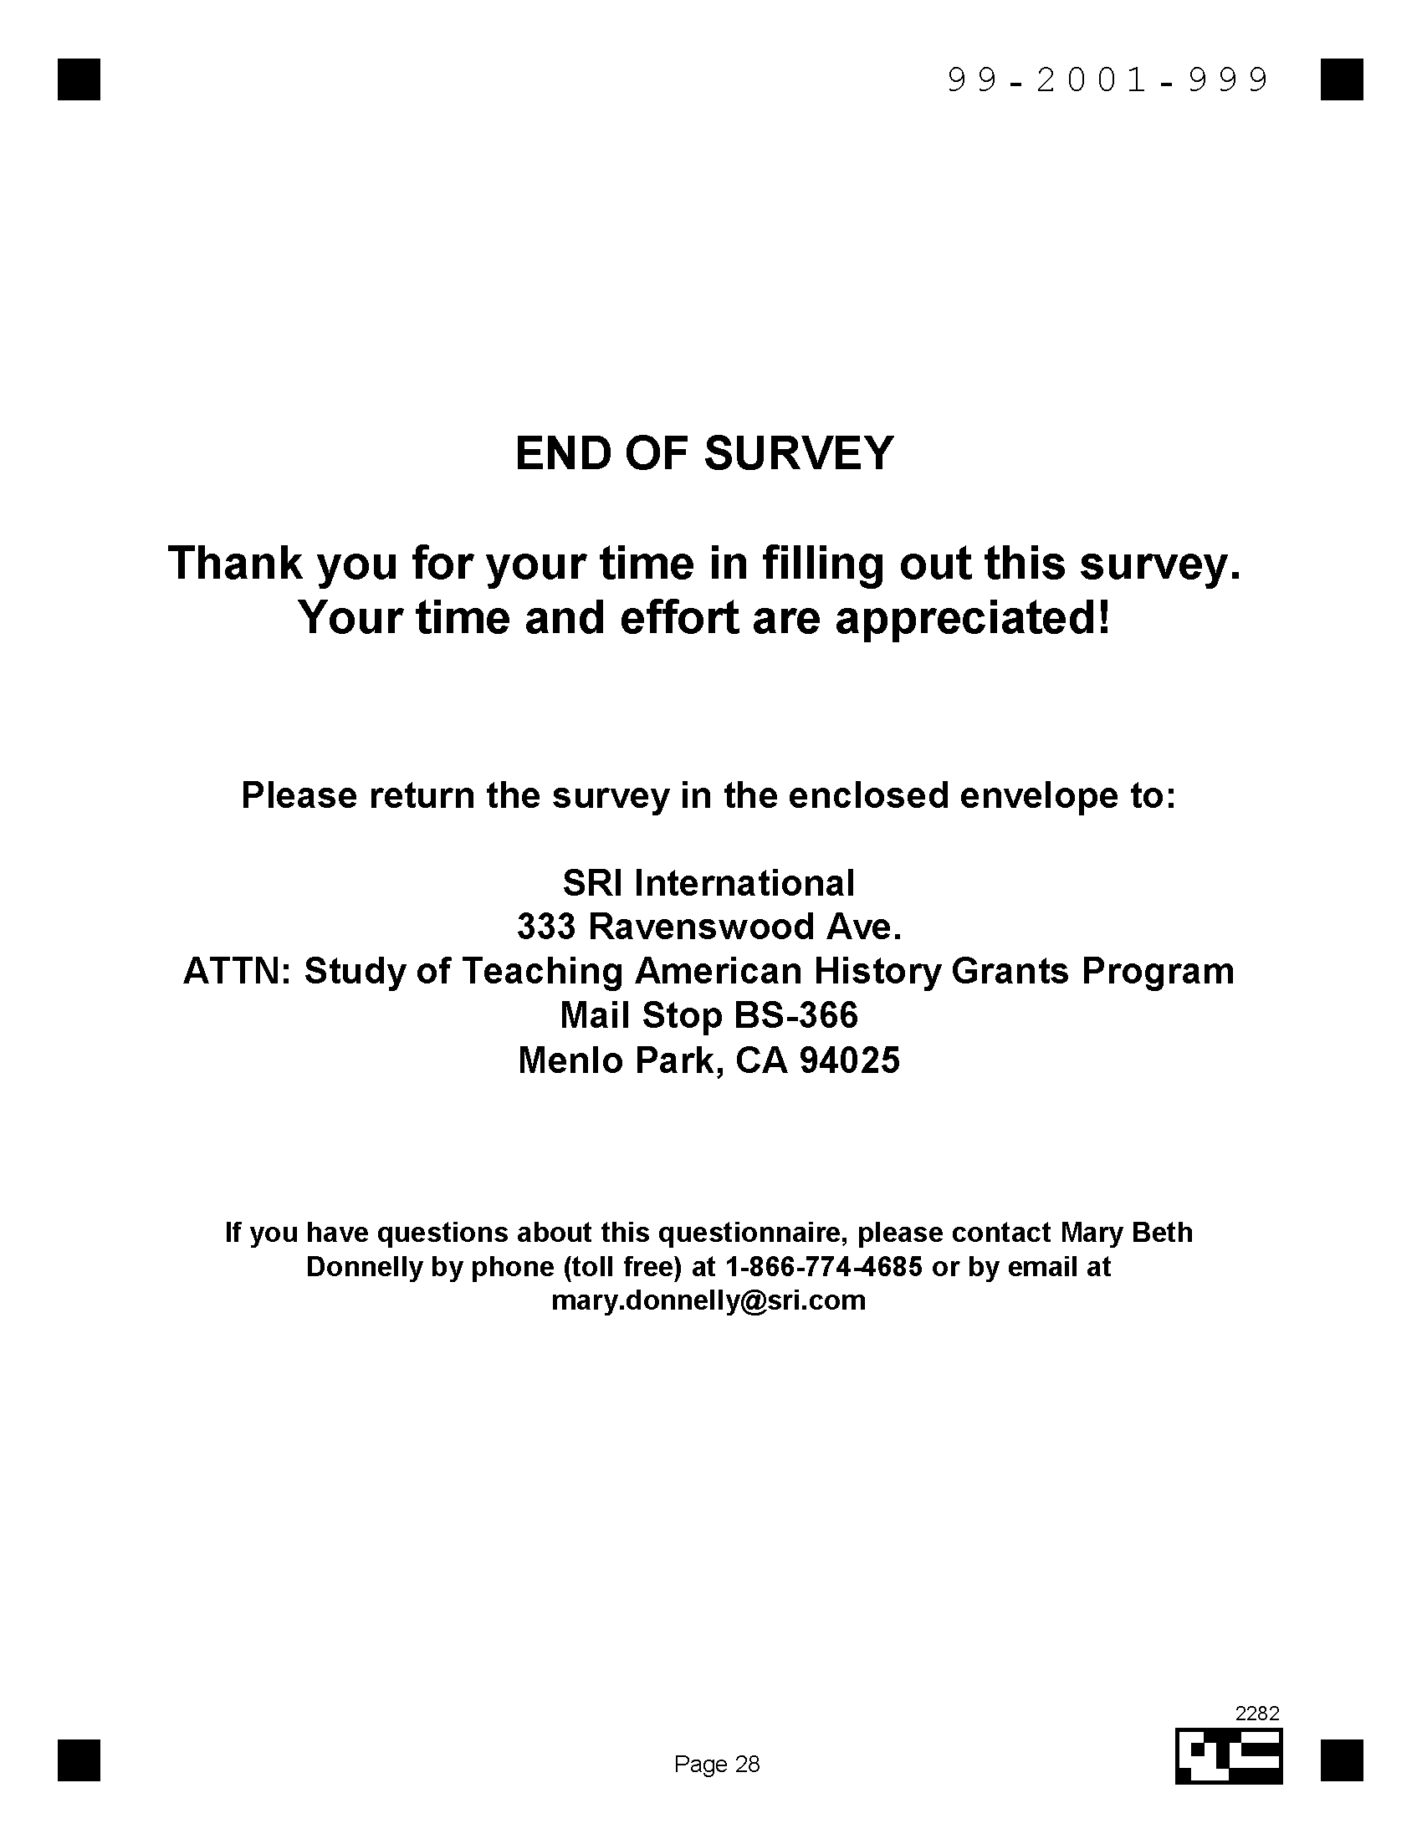

Appendix D
Teaching American History Project Participant Survey

This appendix contains the participant survey sent to TAH participants.

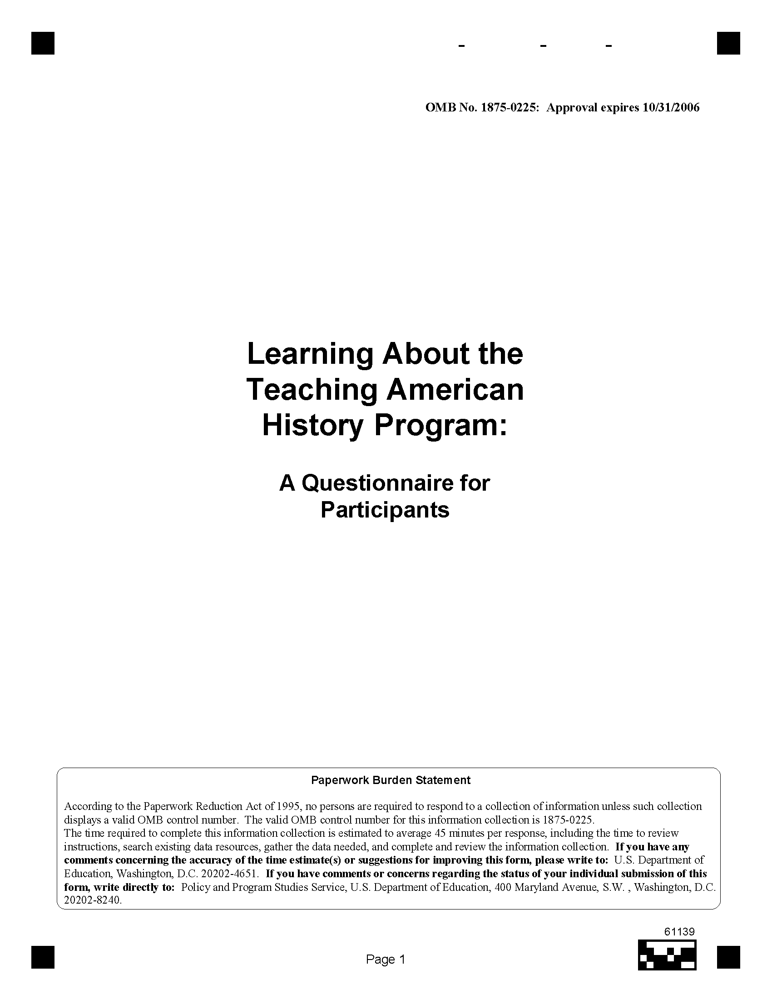

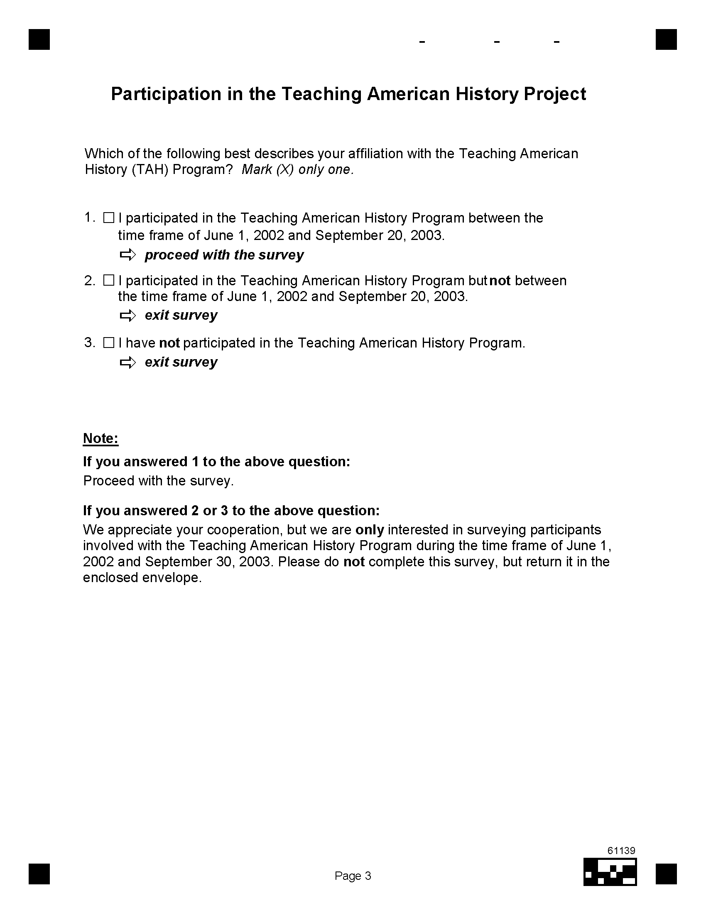



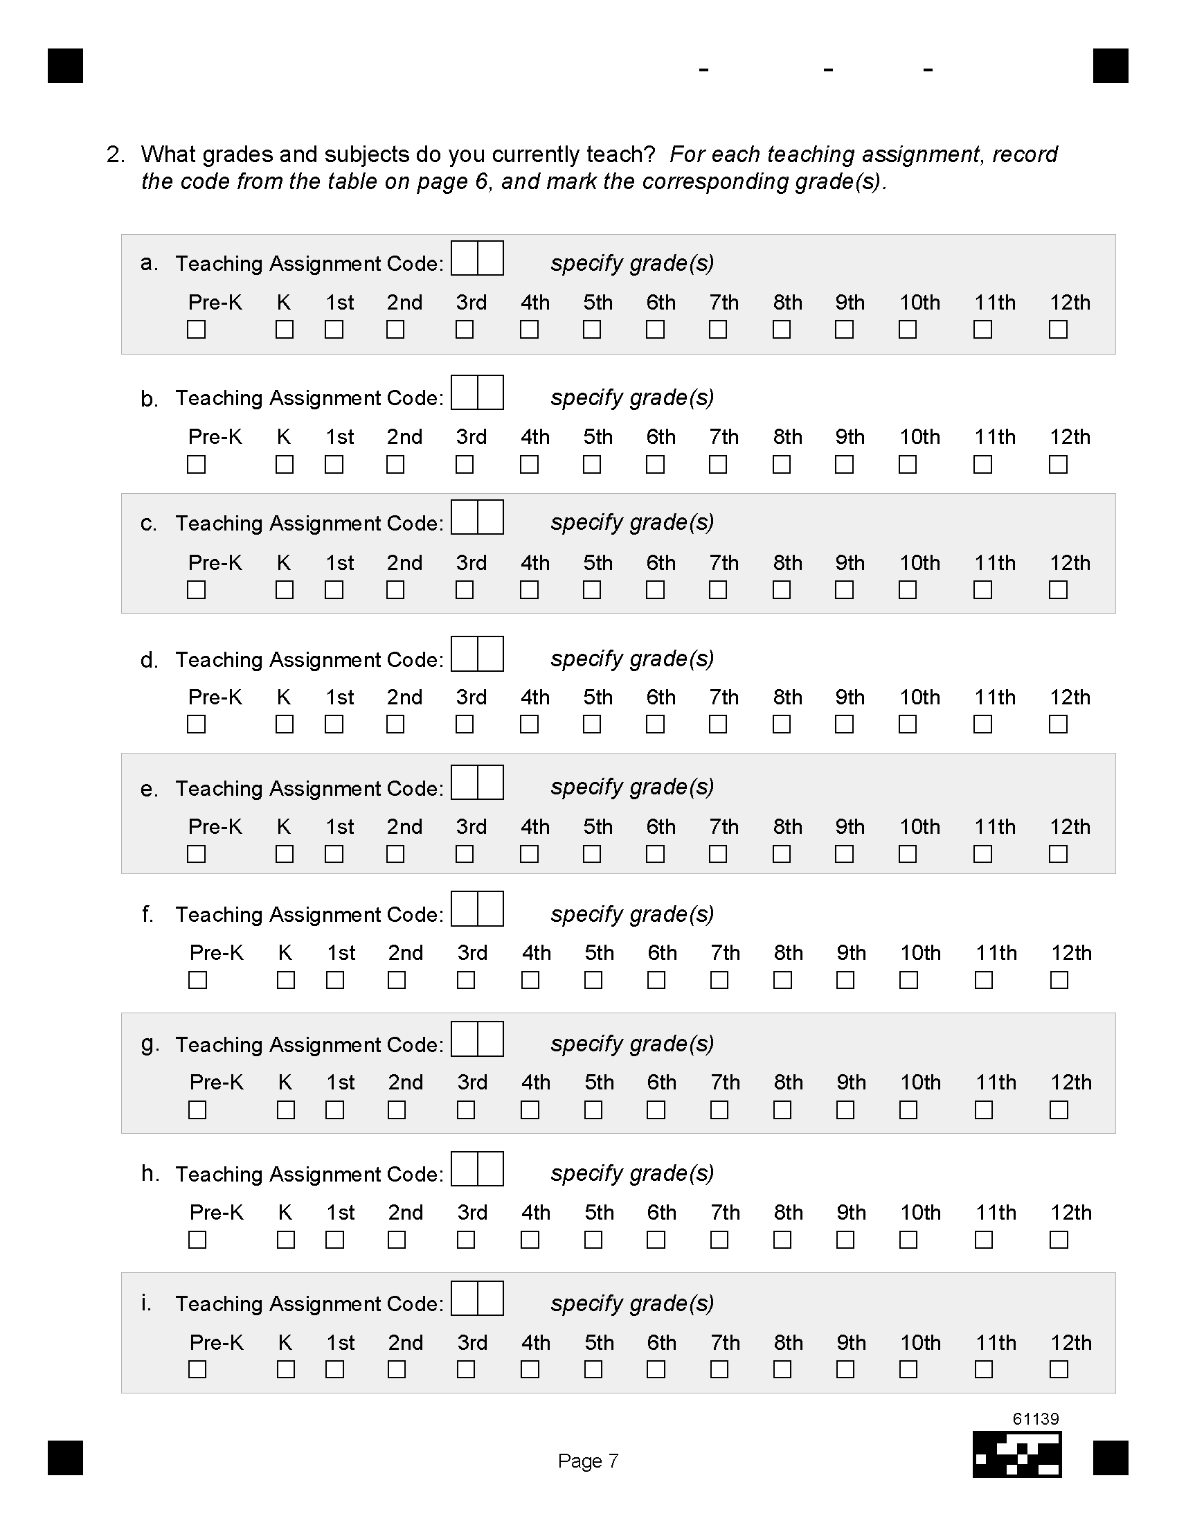



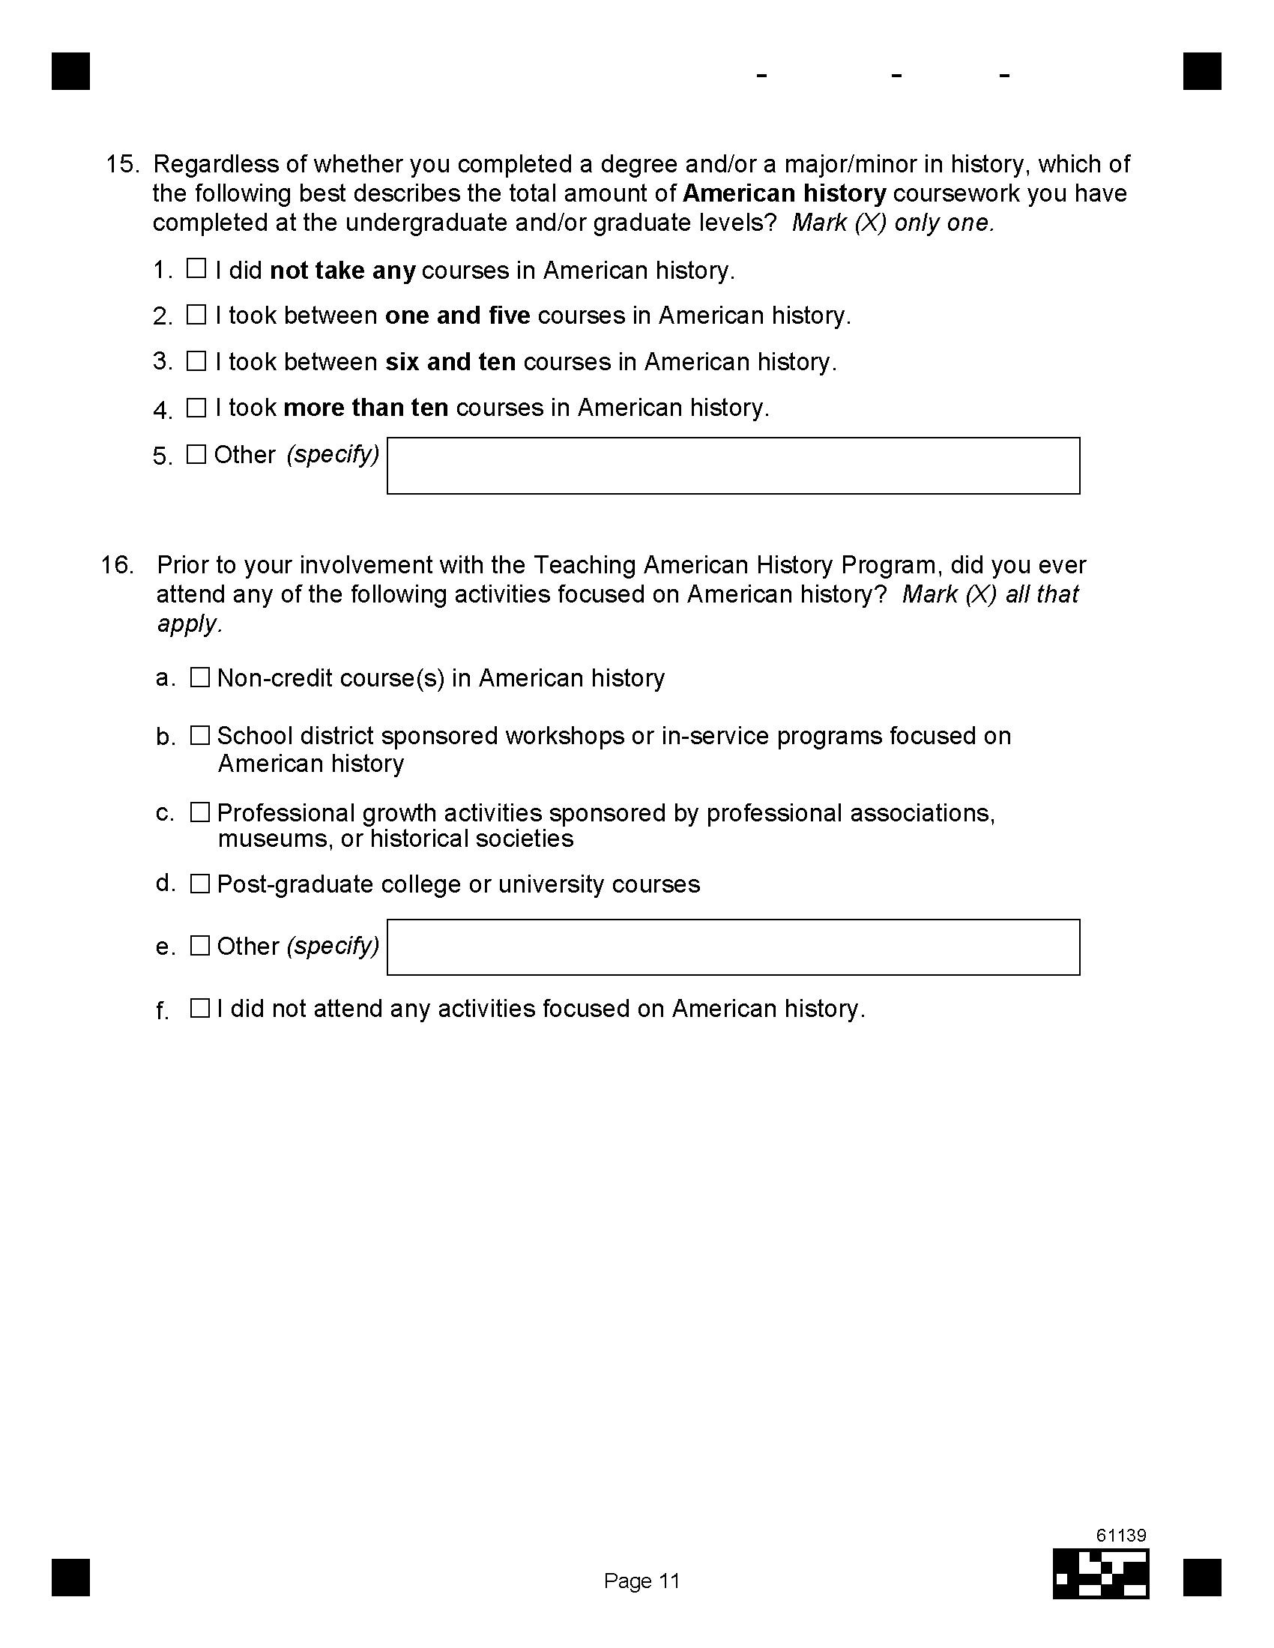
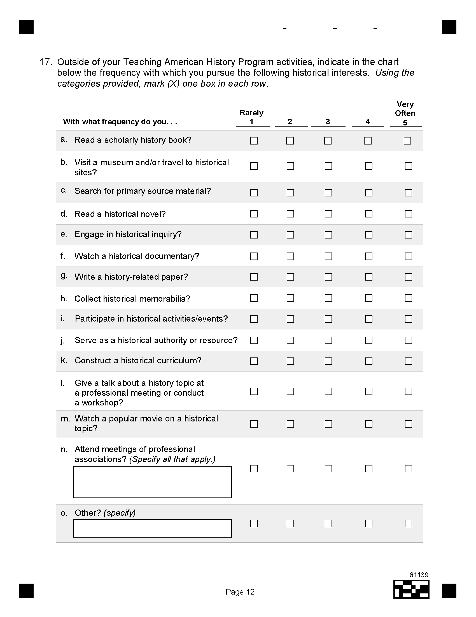
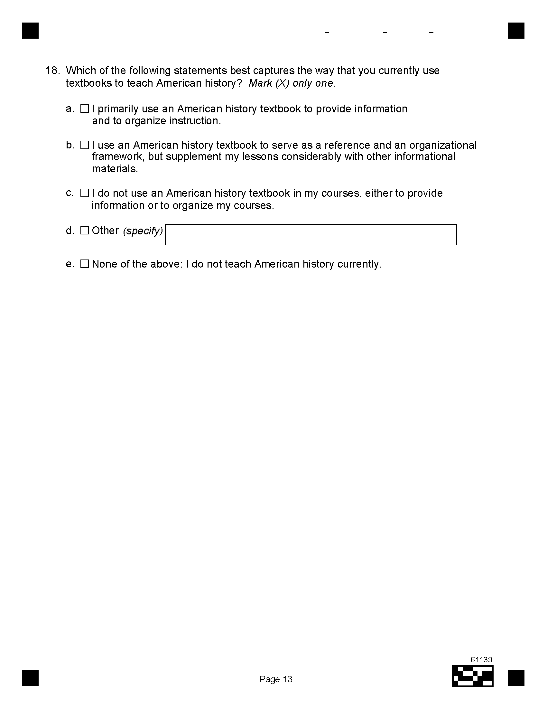
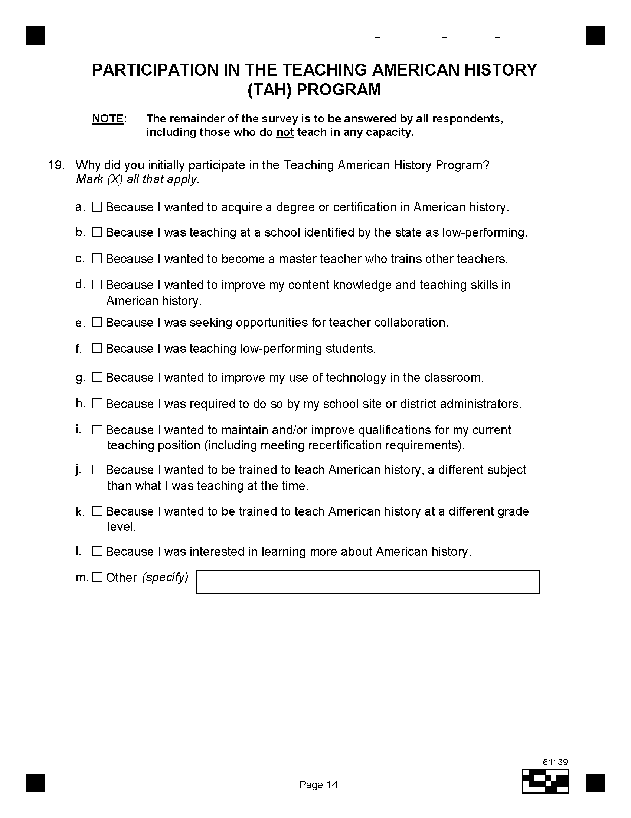
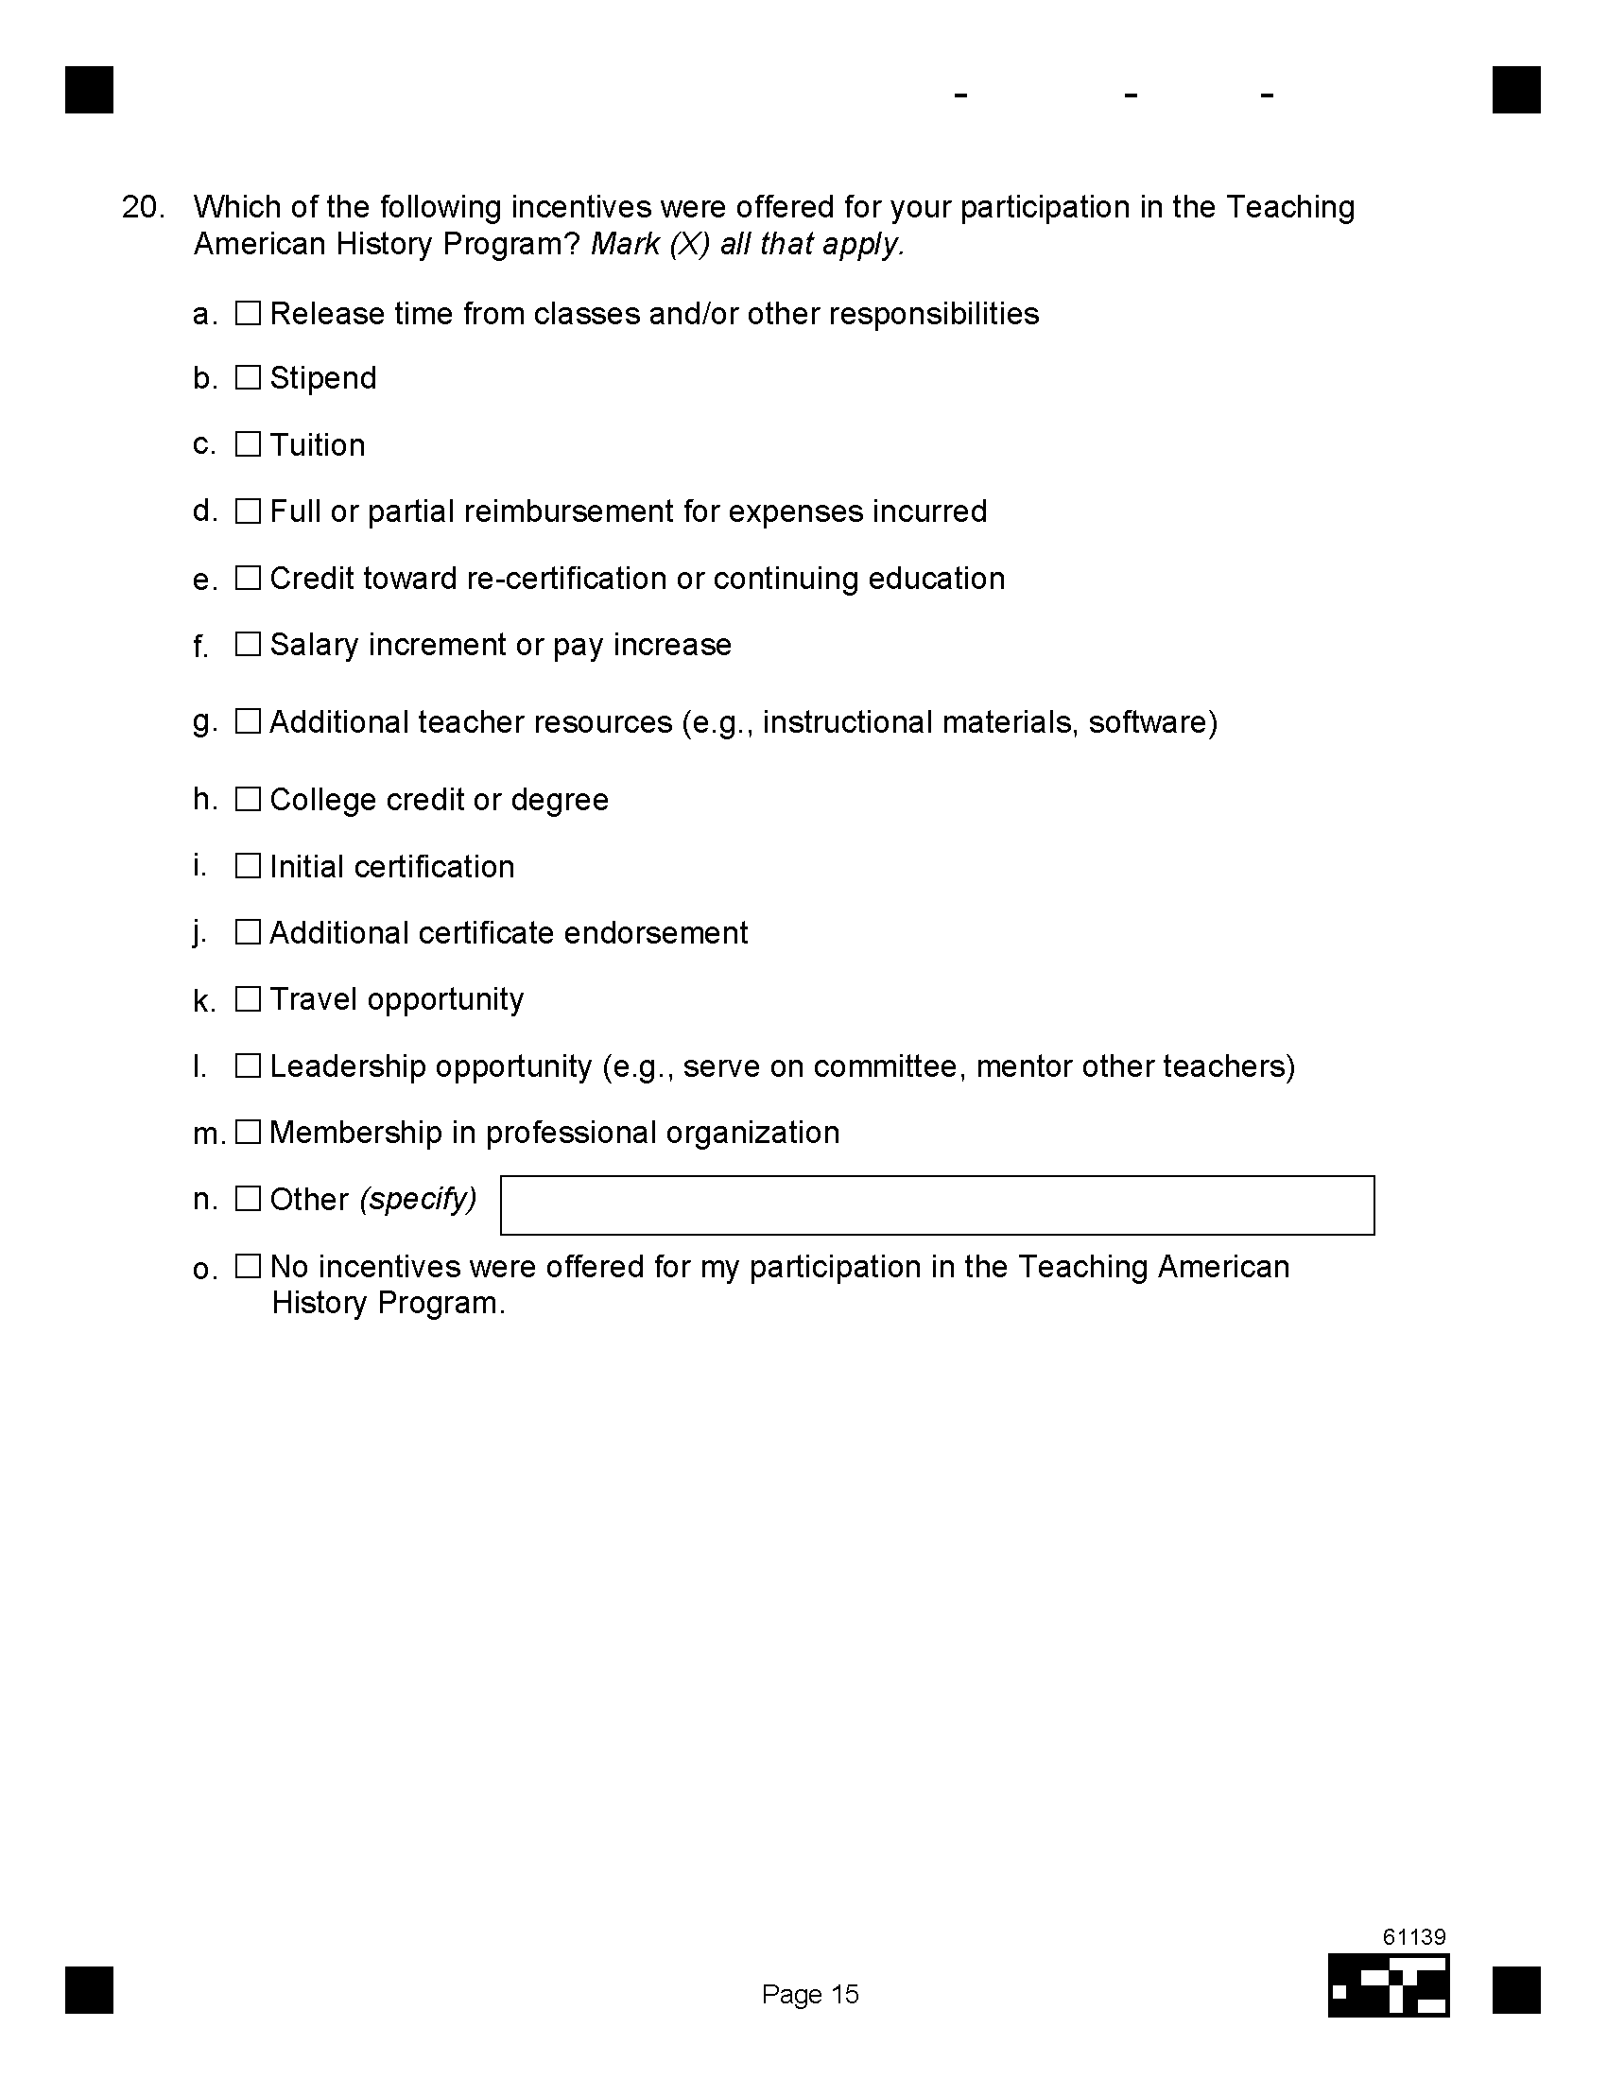
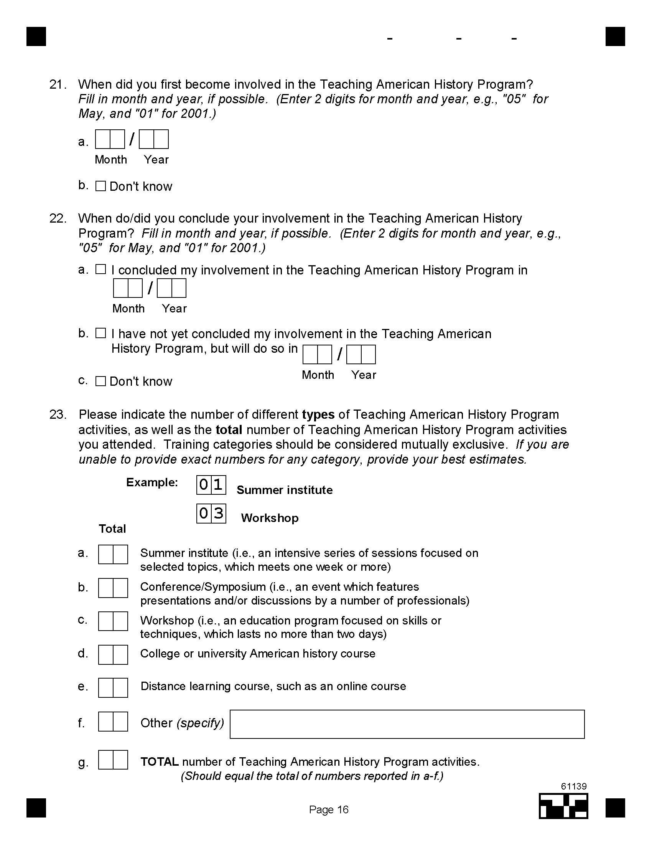
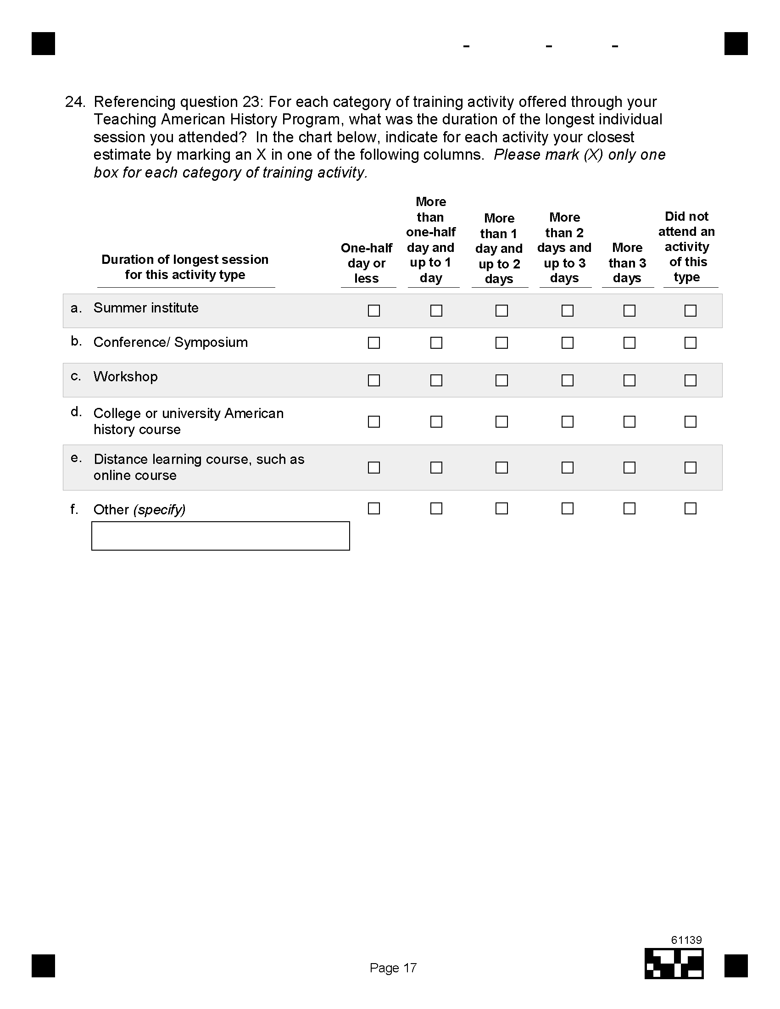
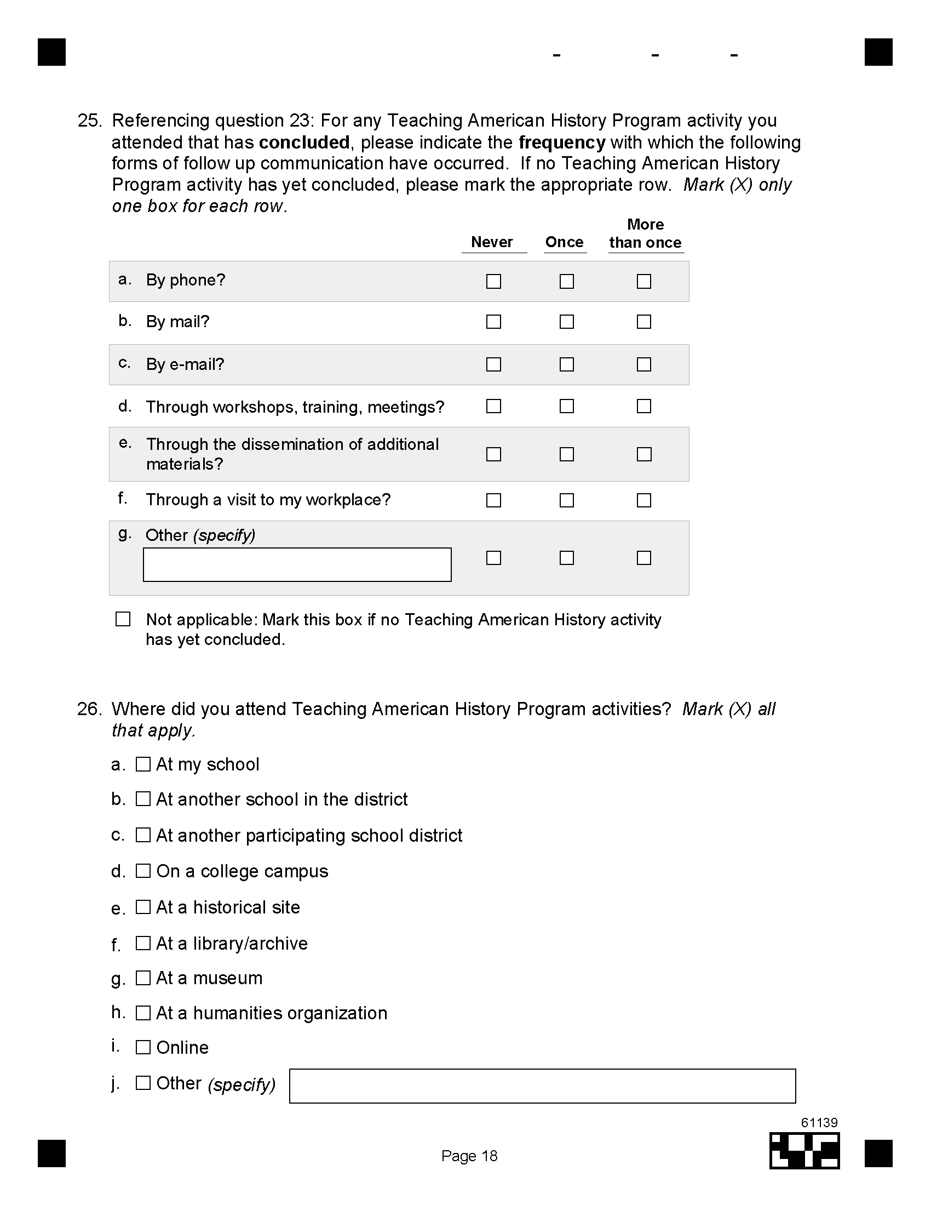
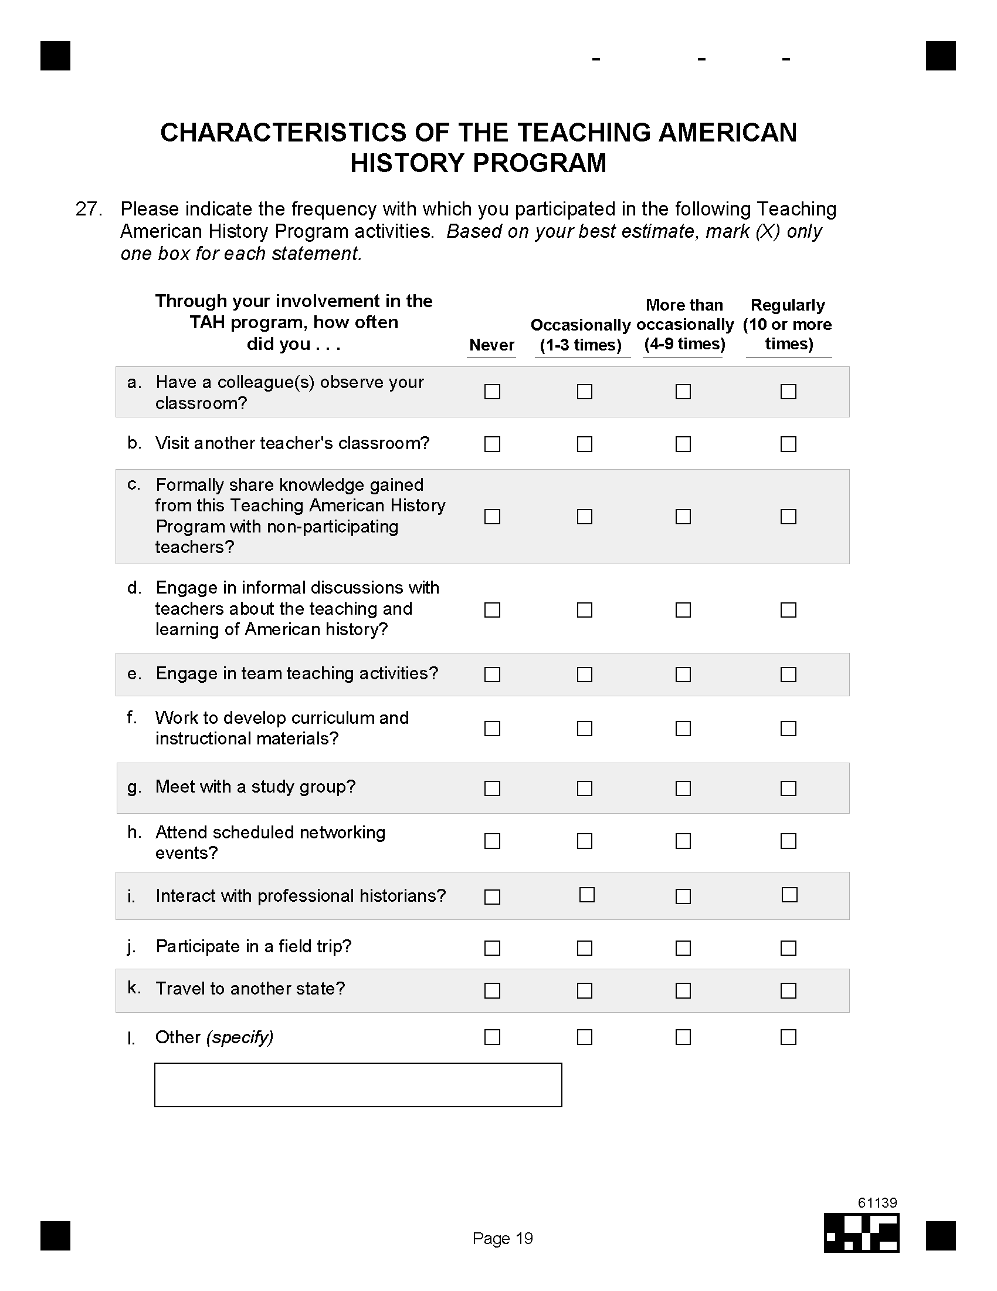
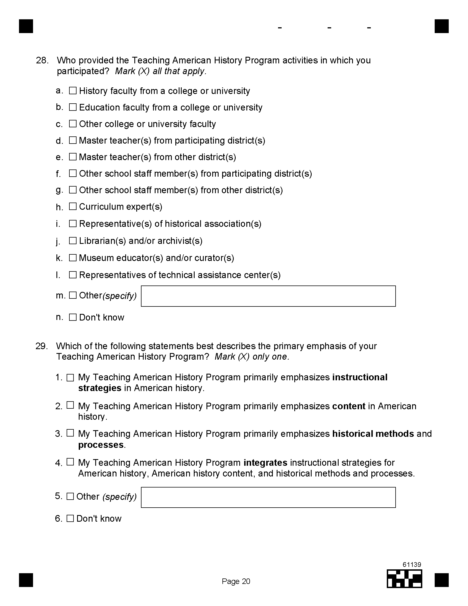
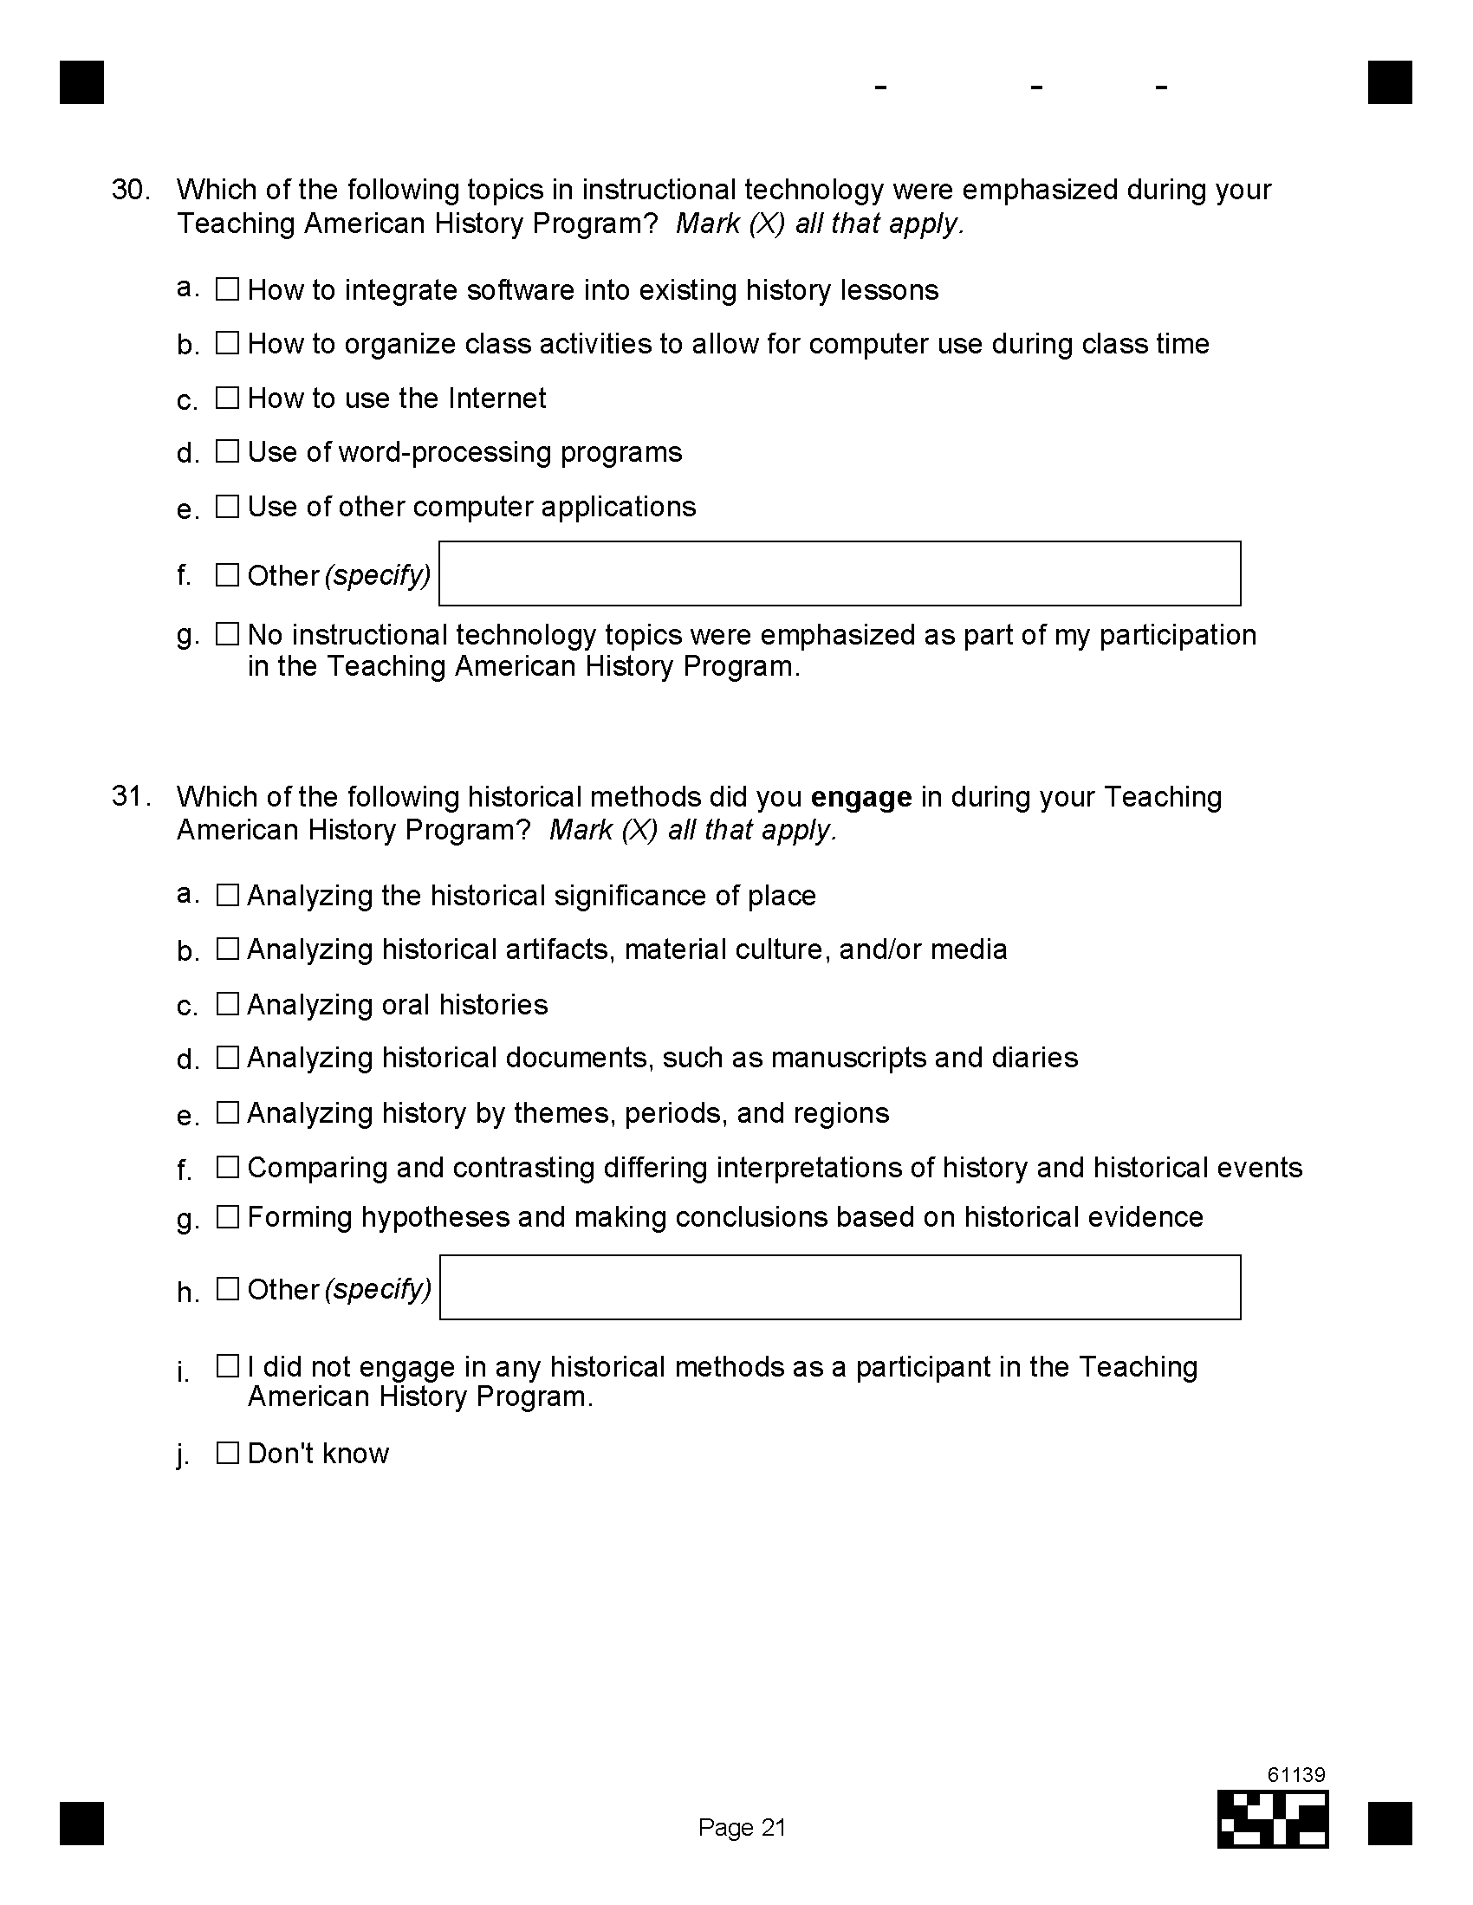
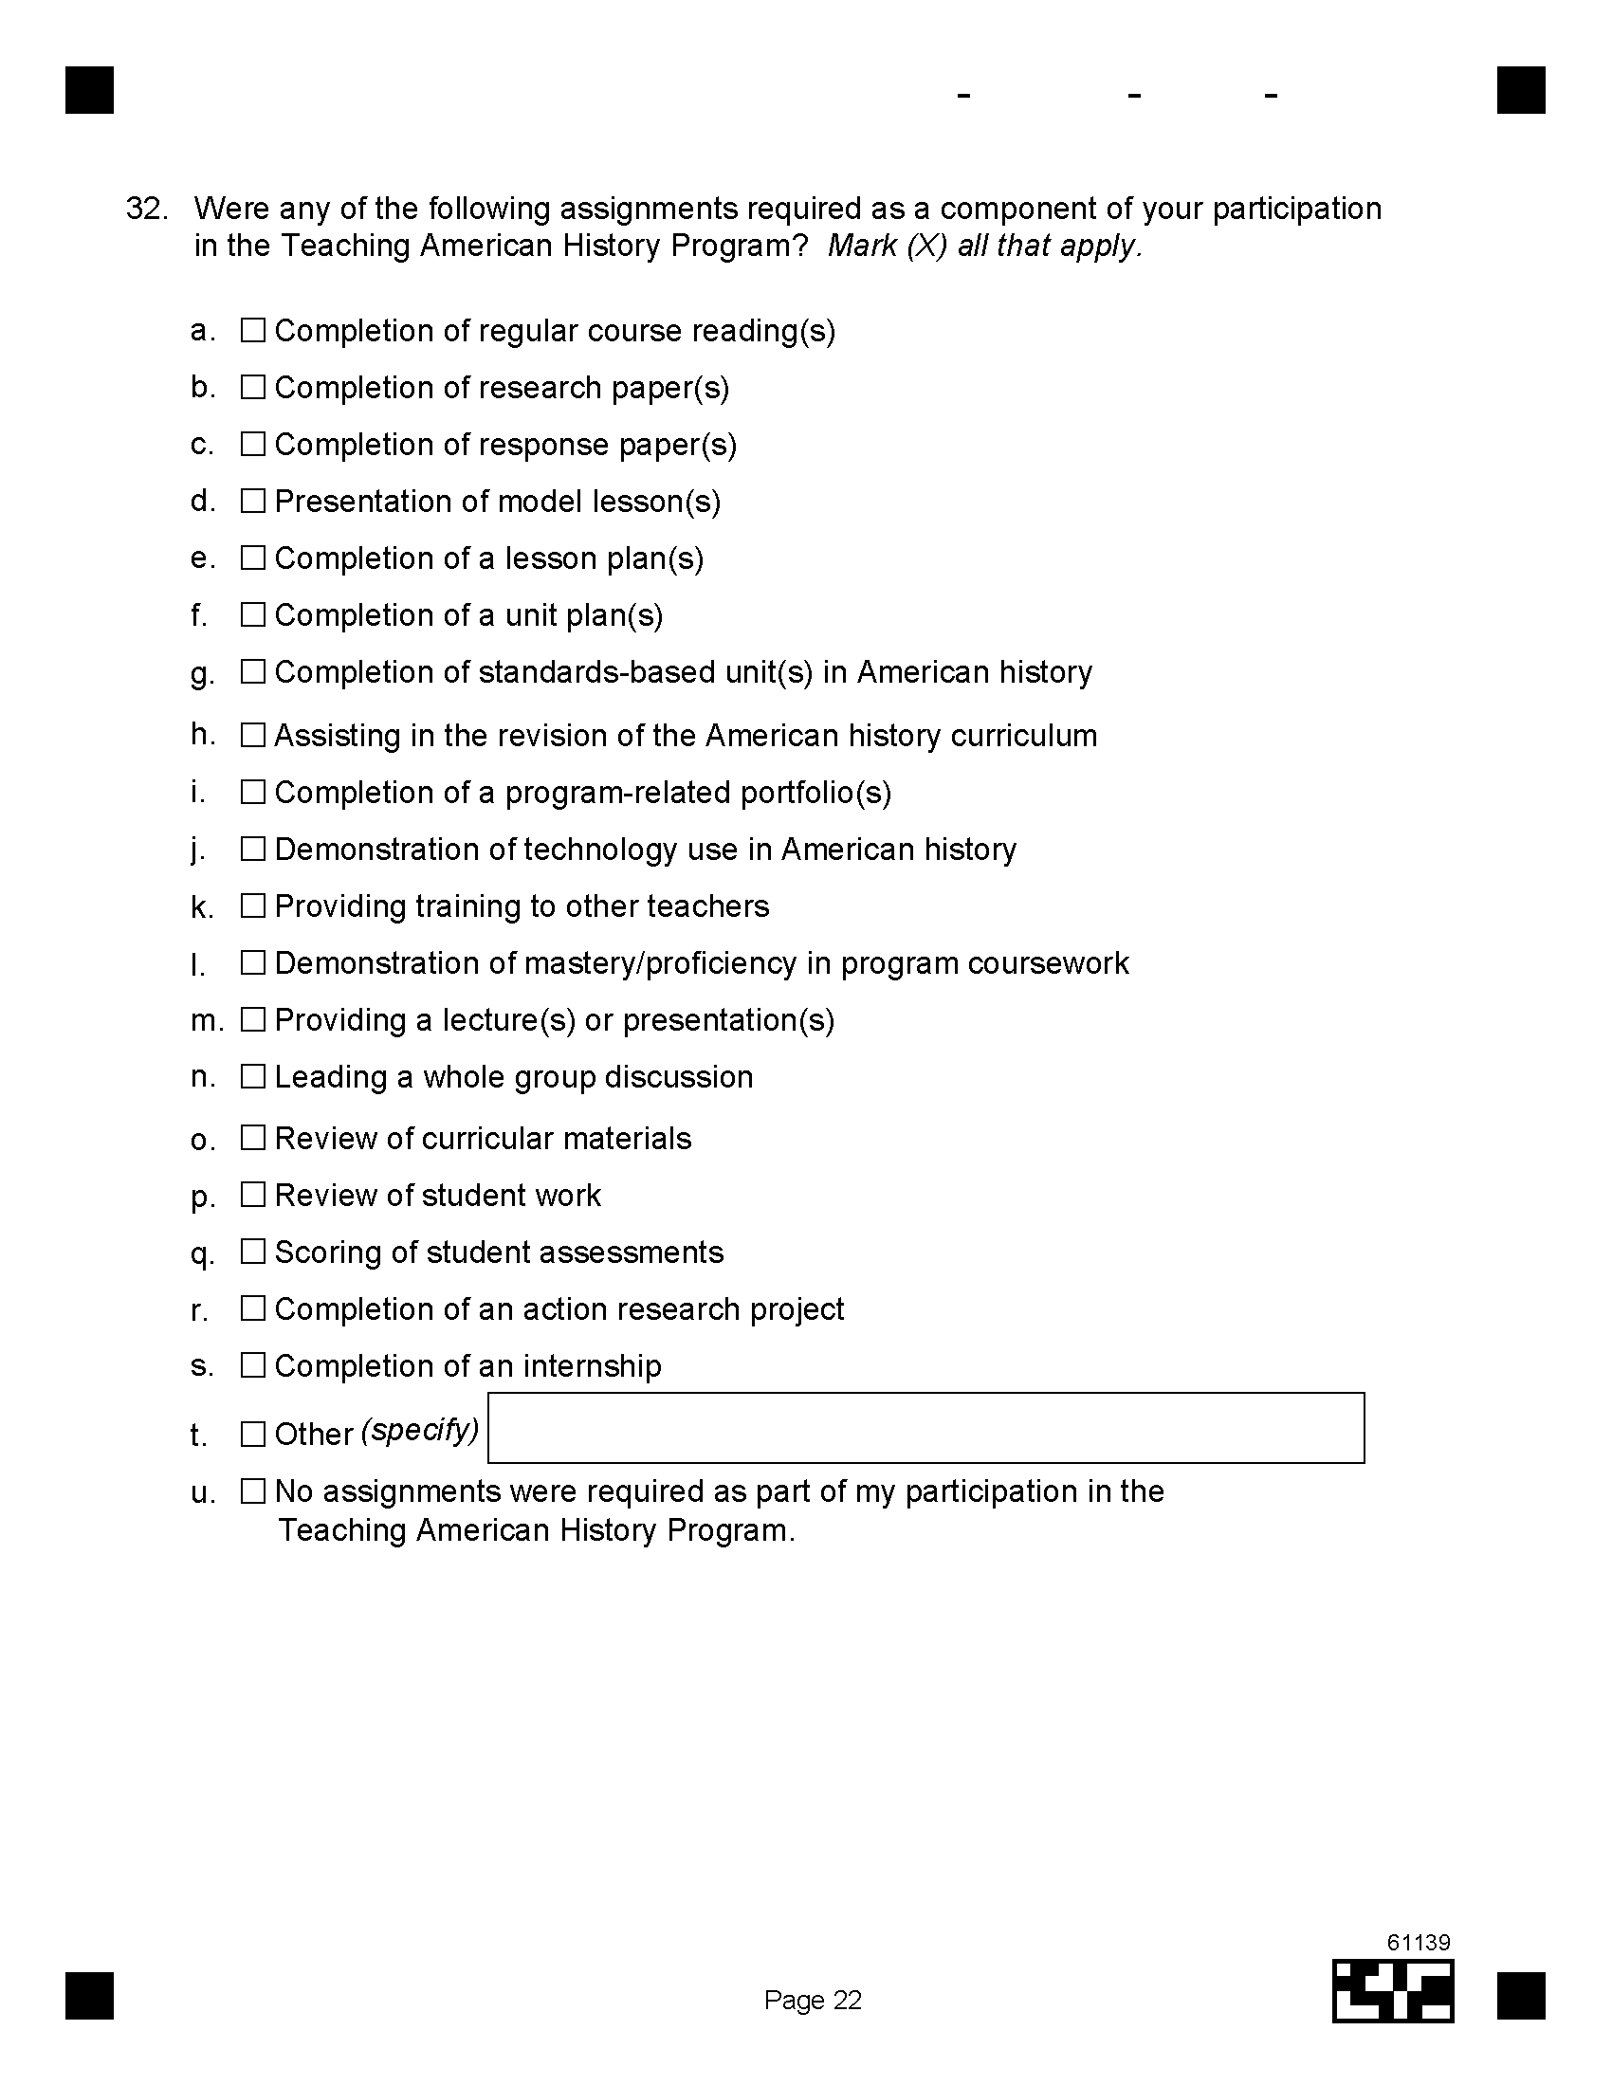
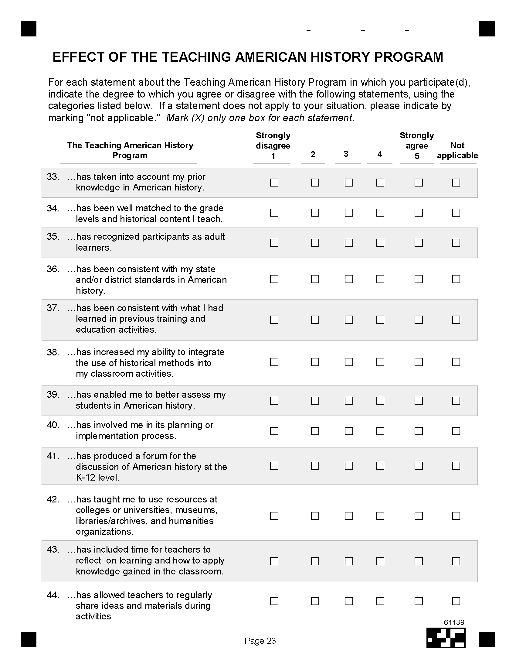
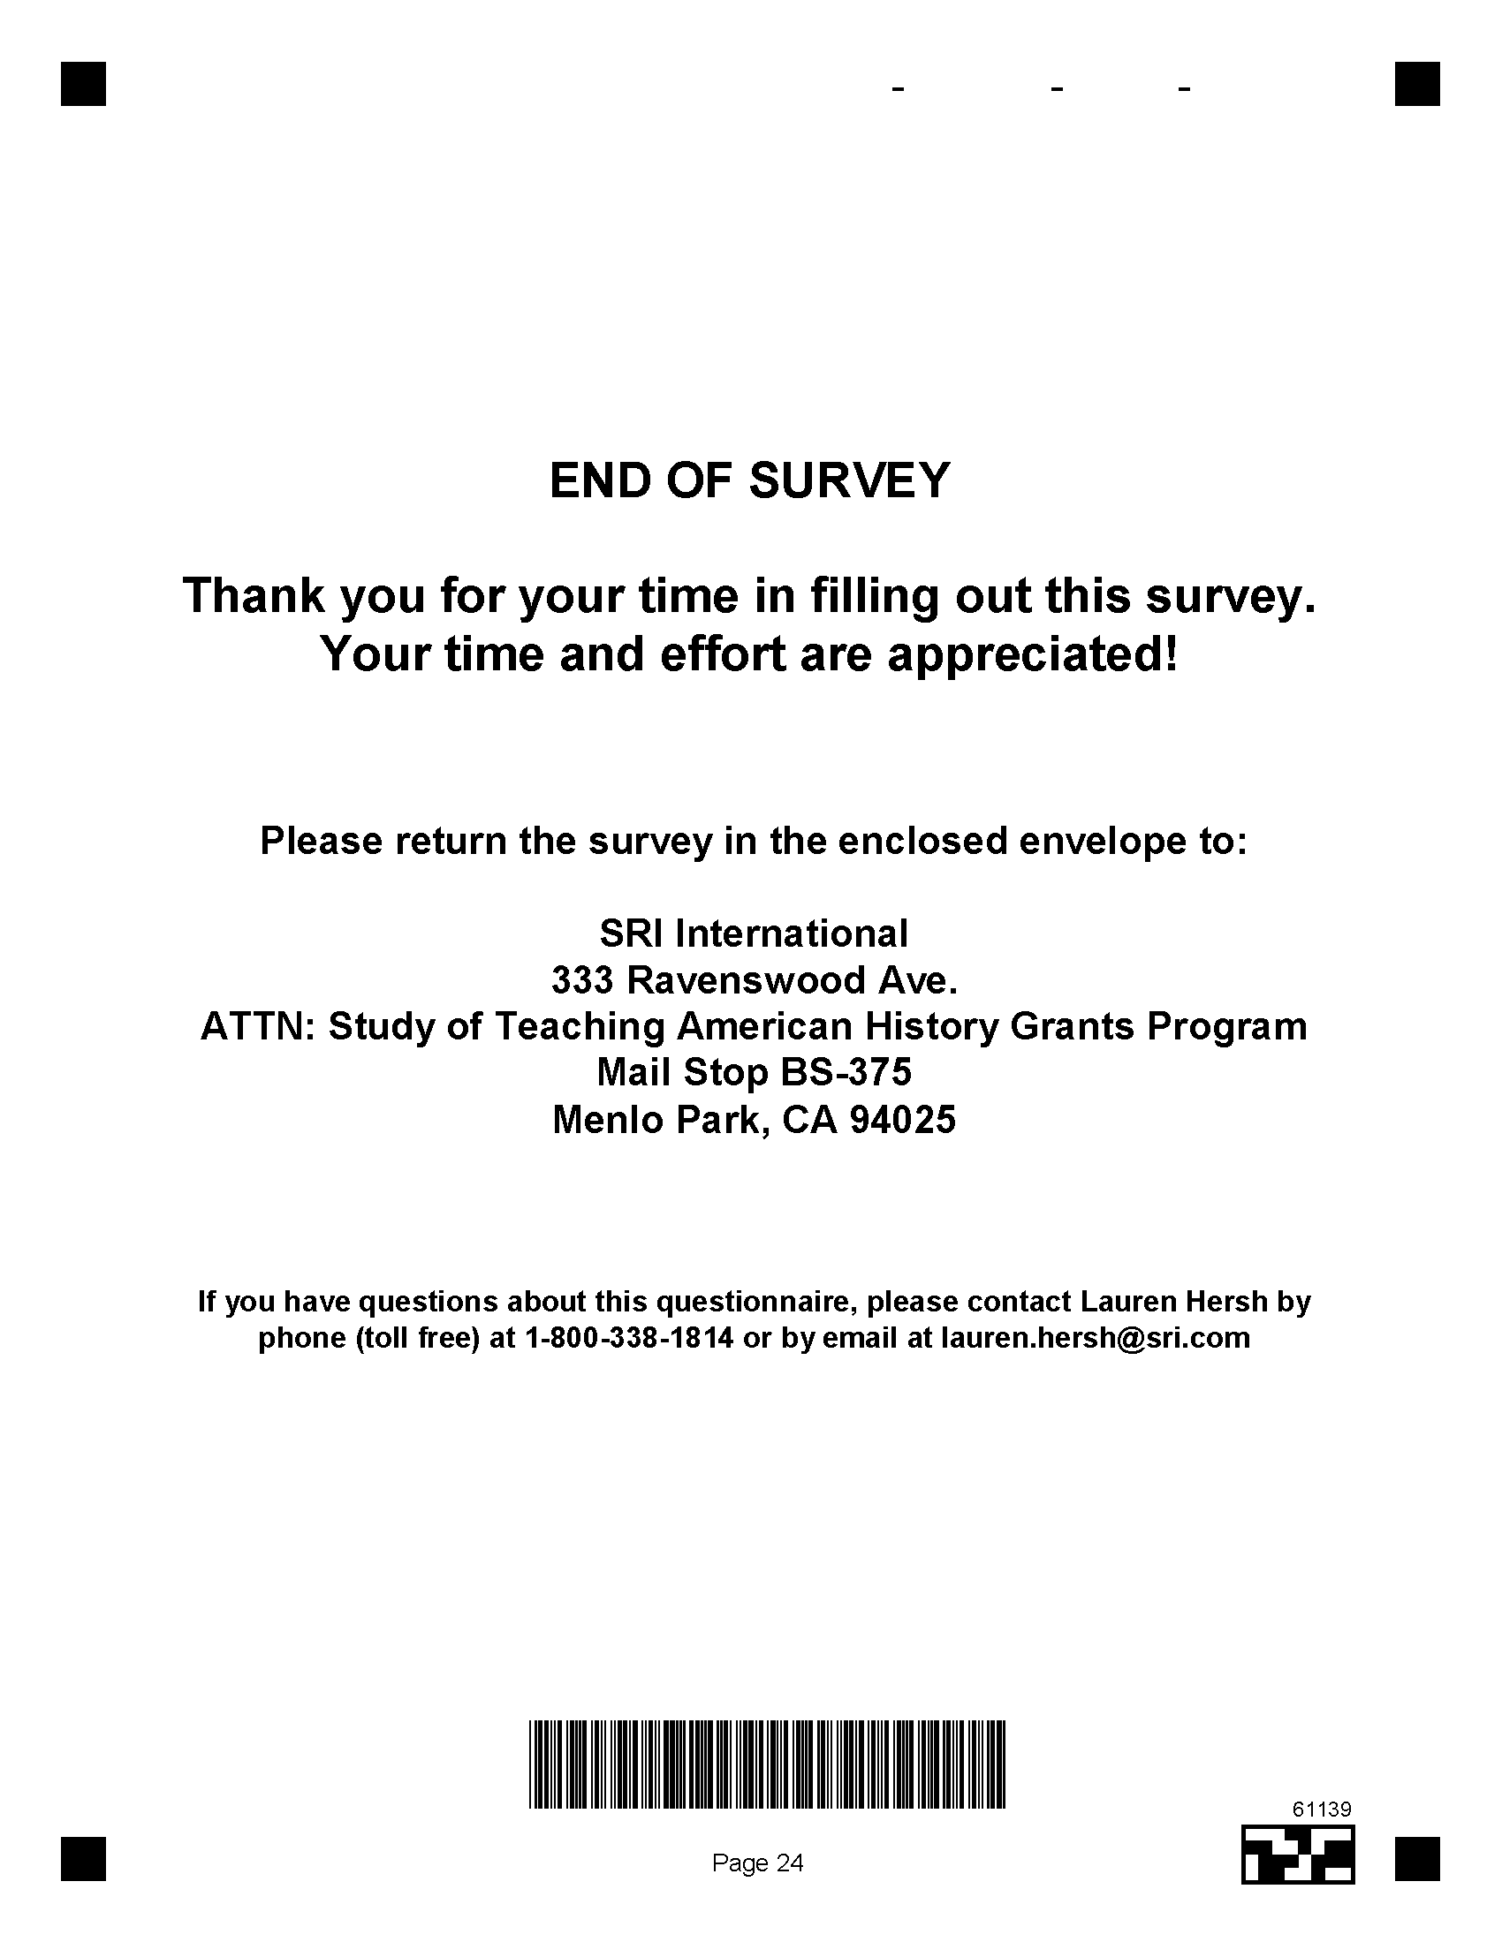

Appendix E
Teaching American History Project Materials Request Form

This appendix contains the materials request form sent to TAH project directors as part of the materials review component of this evaluation.

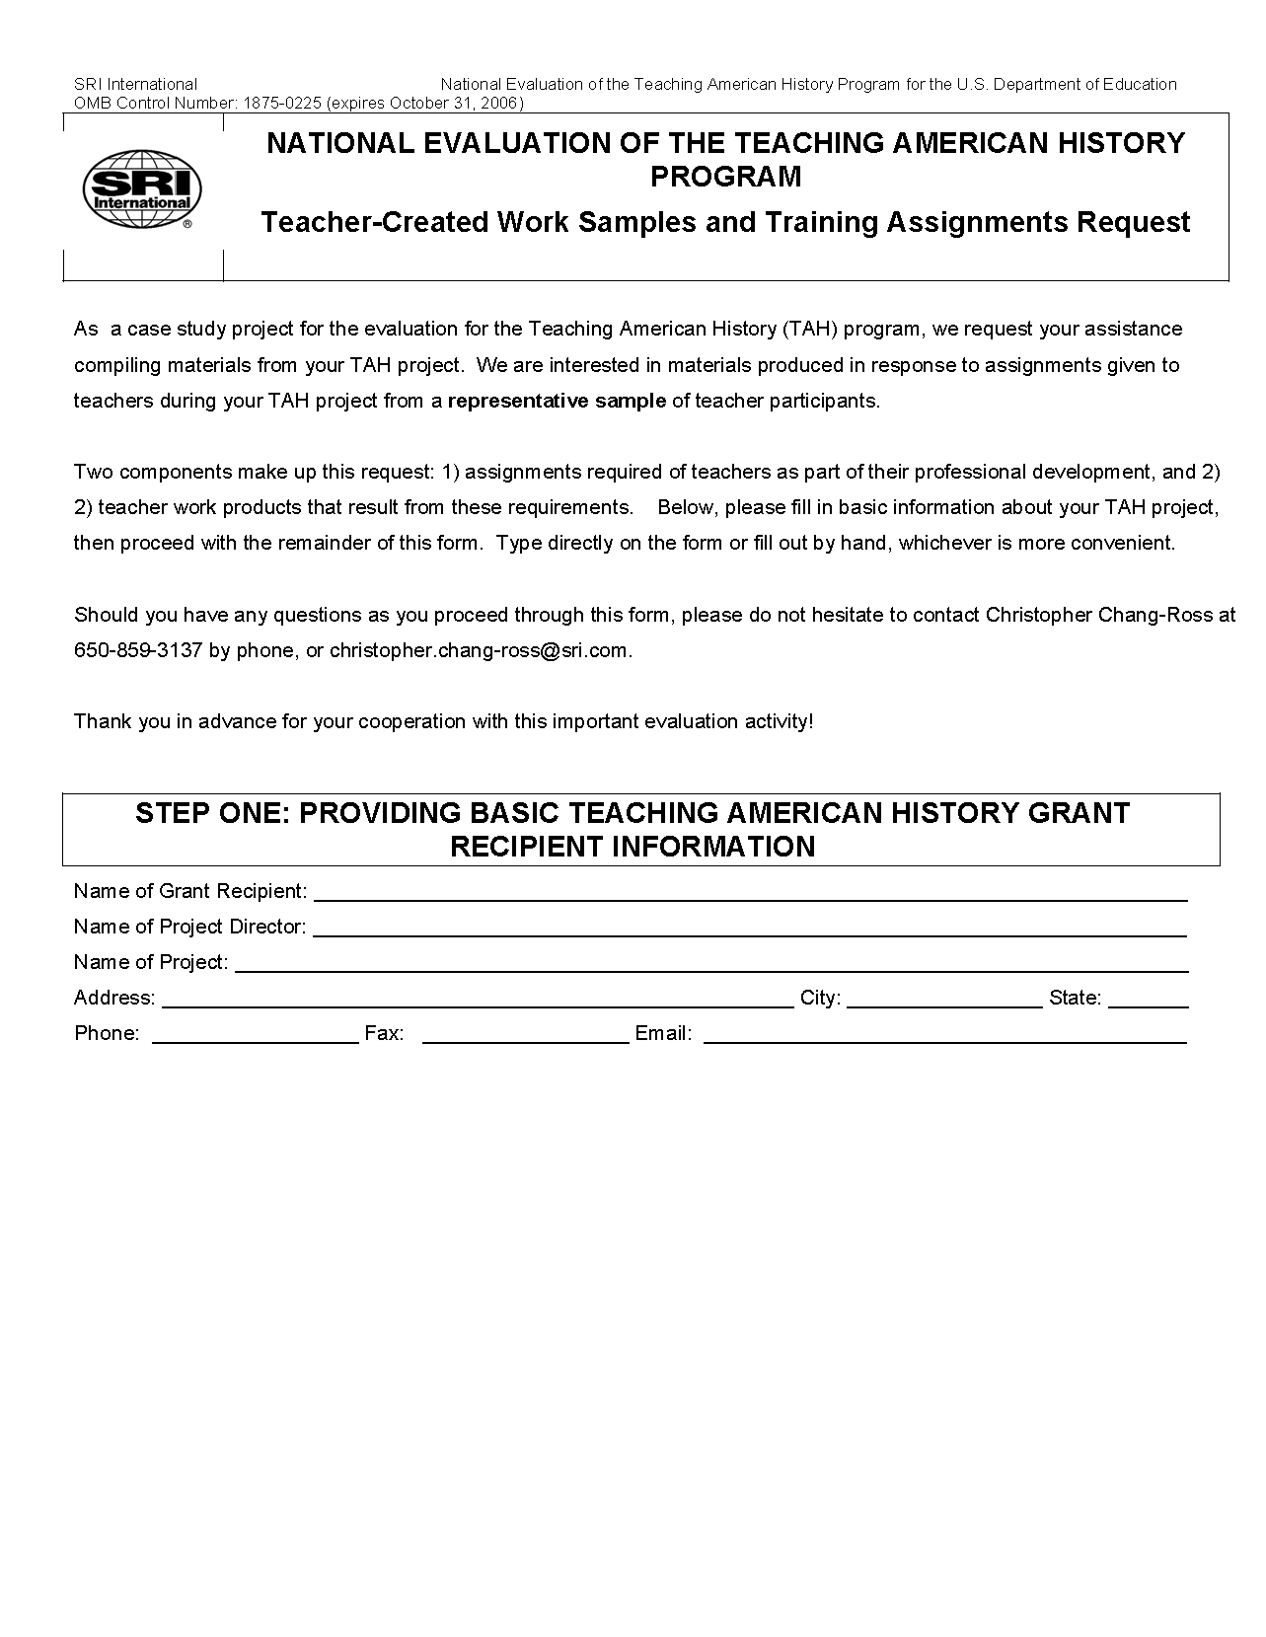





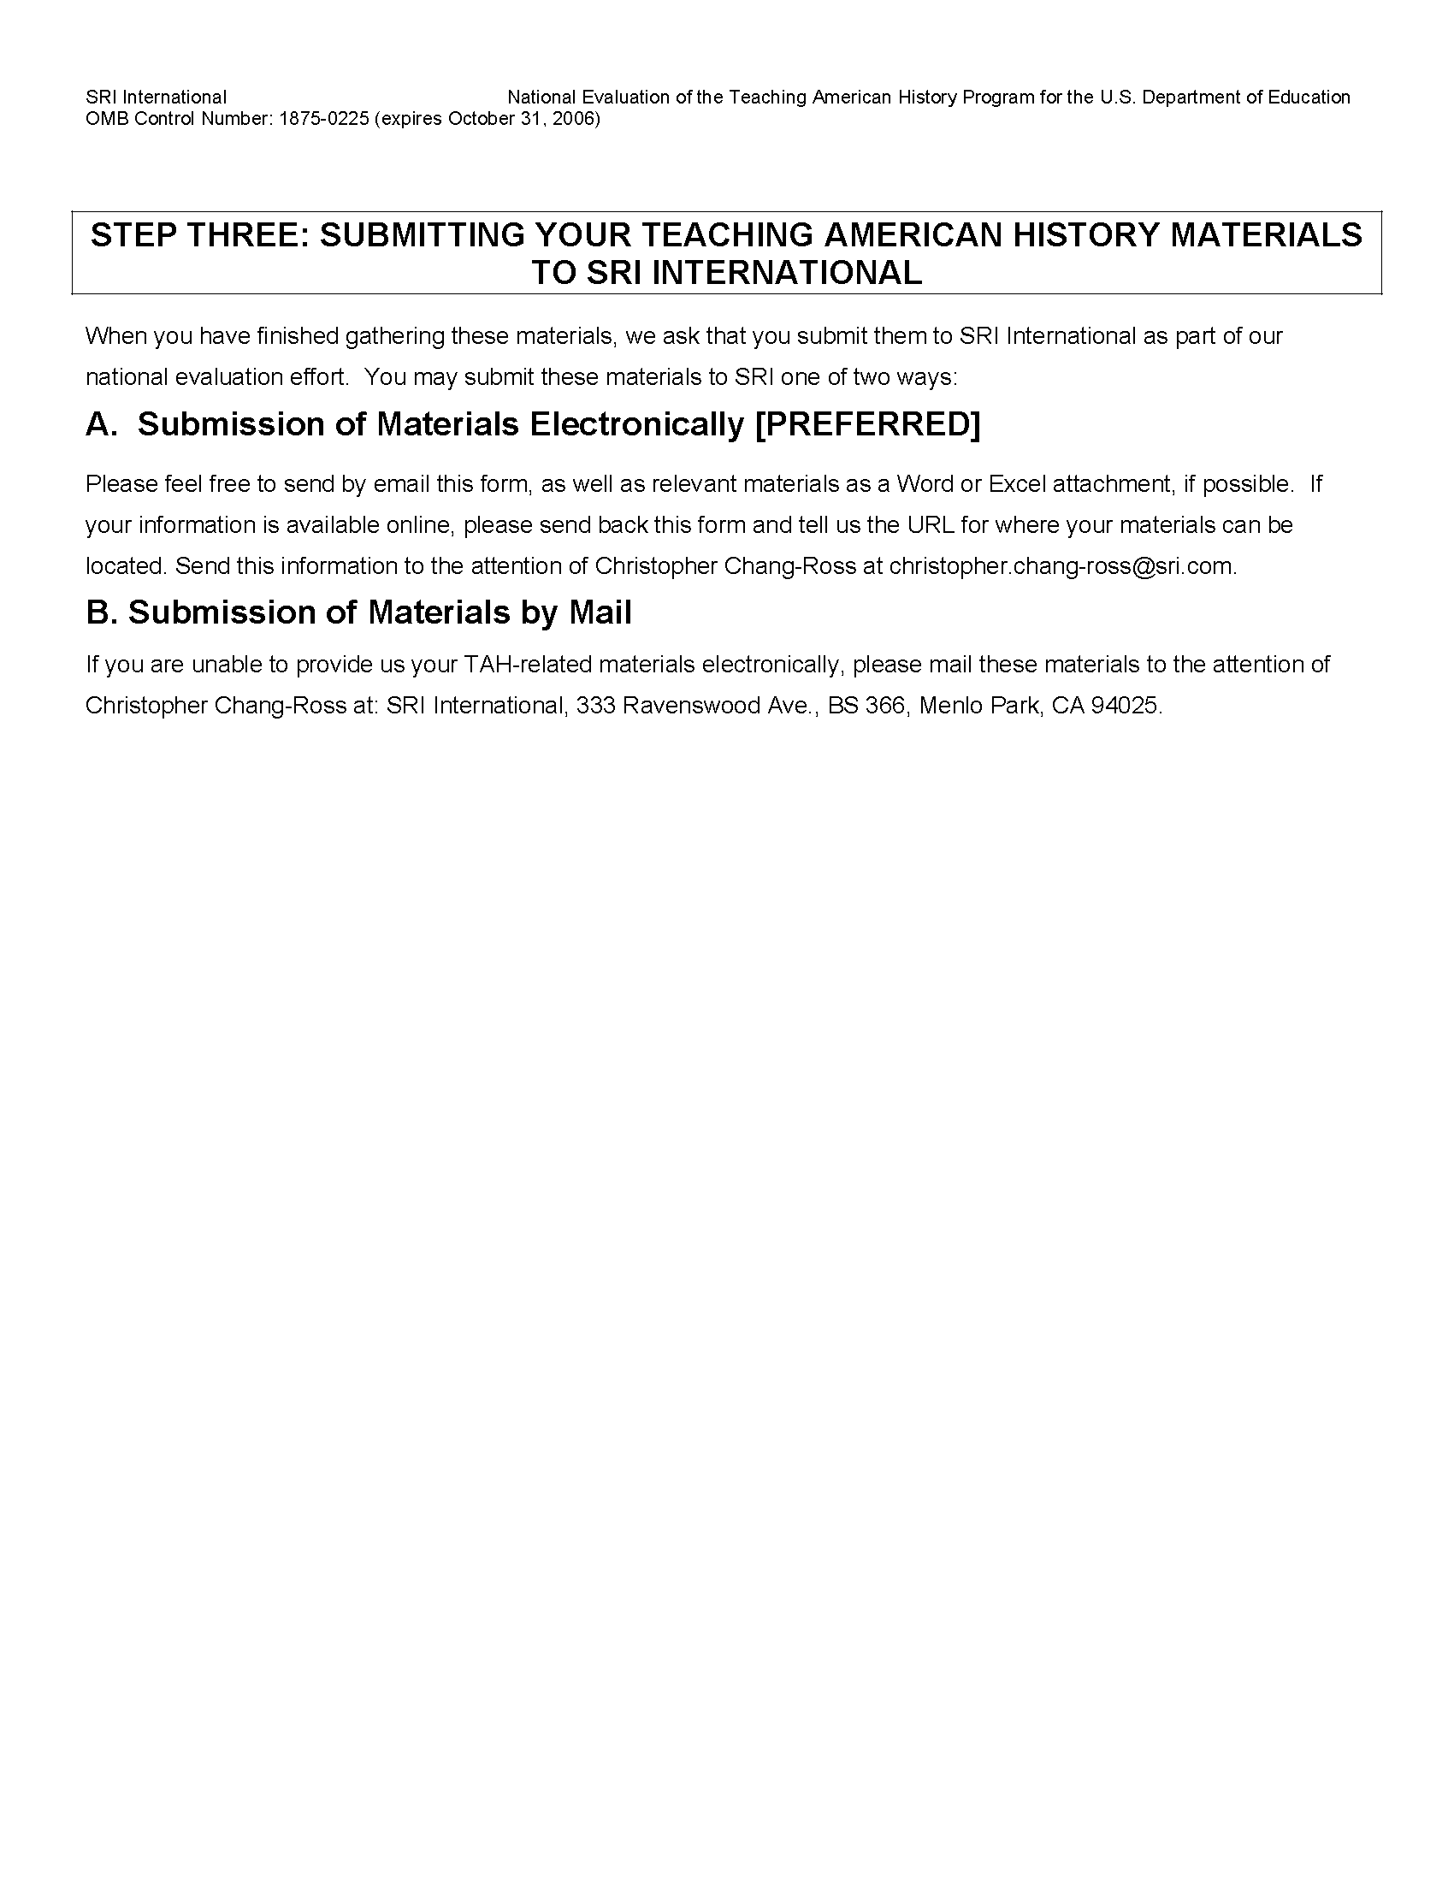

Appendix F
Teaching American History Project NAEP-Based Materials Review Rubric

This appendix contains the rubric used during the materials review component of this evaluation.

TEACHING AMERICAN HISTORY

NAEP-BASED MATERIALS REVIEW RUBRIC

Work Product Code _____________________________

Section 1: Historical Knowledge and Perspective

The teacher work product:

1.A. Demonstrates knowledge and understanding of people, events, concepts, themes, movements, contexts, and historical sources
1.A.1 Insufficient Evidence
1. has many factual errors | 2. has some incorrect factual information | 3. is factually accurate

1.A.2. Insufficient Evidence
1. knowledge is of superficial depth and incomplete breadth | 2. knowledge is in some depth or in breadth | 3. knowledge is of perceptive depth and comprehensive breadth

1.A.3. Insufficient Evidence
1. doesn’t use historical themes or incorrectly defines historical themes and incorrectly relates them to specific factual information. | 2. partially defines historical themes and/or somewhat relates them to specific factual information. | 3. clearly defines historical themes and accurately relates them to specific factual information.

1.B. Sequences historical events

1.B.1 Insufficient Evidence
1. correctly places few specifics in historical chronology | 2. correctly places some specifics in historical chronology | 3. clearly and correctly places most specifics in historical chronology

1.B.2 Insufficient Evidence
1. inaccurately constructs or labels historical periods | 2. somewhat accurately constructs and/or labels historical periods | 3. accurately constructs and labels historical periods.

1.C.1. Recognizes multiple perspectives

Insufficient Evidence
1. has one limited historical interpretation | 2. has an overemphasis  on one historical perspective  and/or an under emphasis of at least one significant historical interpretation | 3. comprehensively describes the past from balanced historical interpretation

1.C.2 Sees an era or movement through the eyes of different groups.

Insufficient Evidence
1. no description of the past from the viewpoints of participating individuals and/or groups | 2. limited description of the past from viewpoints of participating individuals and/or groups | 3. comprehensively describes the past from the viewpoints participating individuals and/or groups

1.D. Develops a general conception of U.S. history

Insufficient Evidence
1. does not presents meaningful topics within the context of U.S. history through historical sources | 2. partially presents meaningful topics within the context of U.S. history through historical sources | 3. effectively presents meaningful topics within the context of U.S. history through historical sources

Section 2: Historical Analysis and Interpretation

The work product:
2.A. Explains historical issues

Insufficient Evidence
1. presents no analysis or superficial analysis of the points of view, biases, and value statements about historical issues | 2. presents some analysis of points of view, biases, and value statements about historical issues | 3. presents comprehensive analysis of points of view, biases, and value statements about historical issues

2.B. Identifies historical patterns

Insufficient Evidence
1. presents no ways to organize information into historical patterns | 2. presents some ways to organize information into historical patterns | 3. presents significant ways to organize information into historical patterns

2.C. Establishes cause-and-effect relationships

Insufficient Evidence
1. does not identify key cause-effect relationships or makes vague, simple, and/or implausible explanations of historical causes and effects | 2. identifies key historical causes and effects, but the explanations are not as clear, detailed, or comprehensive as possible | 3. identifies clear explanations of key historical causes and effects

2.D. Establishes significance

Insufficient Evidence
1. does not address the important people, events, themes, and contexts and fails to establish the significance of the historical topic | 2. addresses some of the important people, events, themes, and contexts and does not completely establish the significance of the historical topic | 3. addresses most of the important people, events, themes, and contexts that establish the significance of the historical topic

2.E. Applies historical knowledge

Insufficient Evidence
1. makes weak arguments based on little evidence | 2. makes some good arguments based on somewhat convincing evidence | 3. makes a consistent argument based on convincing evidence

2.F. Weighs evidence to draw sound conclusions

Insufficient Evidence
1. uses too few or inappropriate primary and secondary sources to assess different views and to draw conclusions | 2. uses some appropriate primary and secondary sources to assess different views and to draw conclusions | 3. uses a variety of appropriate primary and secondary sources to assess different views and to draw conclusions

2.G. Makes defensible generalizations

Insufficient Evidence
1. reflects an inability to compose and support historical generalizations | 2. reflects a limited ability to compose and/or support historical generalizations | 3. reflects the ability to compose and support historical generalizations

2.H. Renders insightful accounts of the past

Insufficient Evidence
1. provides a simplistic account of the of the past | 2. provides a descriptive account of the past | 3. provides a clear and perceptive account of the past



In accordance with the No Child Left Behind Act, the law authorizing the TAH Program, each grantee was required to partner with at least one of the following institutions: (1) an institution of higher education, (2) a nonprofit history or humanities organization, or (3) museum or library.
Source: SRI International, TAH Participant Survey.
National Assessment Governing Board (NAGB), U.S. Department of Education. (2001). U.S. history framework for the 1994 and 2001 National Assessment of Educational Progress. Washington, D.C.: Author.
Other incentives reported by project directors included: release time from classes or other responsibilities (53 percent); travel opportunity (49 percent); full or partial reimbursement for expenses incurred (48 percent); membership in a professional organization (34 percent); tuition (35 percent); and scheduled time in contract for professional development (27 percent). Fewer than 10 percent of all project directors reported a salary increment or pay increase, initial certification, or additional certification endorsement.
As the case study projects revealed, TAH projects sometimes drew participants from geographically diverse schools and districts (i.e., teachers both in urban and rural schools could participate in the same TAH project).
Although the time frame for data collection for FY 2001 and FY 2002 projects resulted in provision of data for a relatively narrow time window, it nonetheless allowed both cohorts to hold professional activities over a full summer—the time of year in which the most intensive activities (i.e., summer institutes) take place.
The participant survey asked respondents to list the grade levels and subjects they taught. To collapse the school level of the respondent into elementary and secondary categories, only the first three assignments each teacher provided were considered.
The national questionnaire asked teachers whether they had a regular or standard state certificate in their teaching field, whereas the TAH survey asked whether teachers had a regular or standard state certificate and then asked them to specify what subject it was in.
For this analysis, “secondary teacher” is defined as one who teaches students in grades 7-12. About a quarter of TAH participants were elementary school teachers and were far less likely to have a degree in history than their secondary school colleagues. The national sample included only secondary teachers.
Only full-time teachers in California high schools have been included in this analysis. Teachers have been "assigned" to a subject if they reported they taught at least one class in a core subject—English, mathematics, social science, physical science, or life science. Teachers could have more than one assignment. For example, a teacher who teaches three periods of biology and two periods of English would have an English assignment and a life science assignment, both of which require the teacher to have the proper single subject authorization. Teachers who were assigned to a subject but lacked a full credential have been included in the underprepared category. Teachers who indicated they are fully credentialed and authorized to teach in a secondary classroom, but do not have subject matter authorization in their assigned subject have been included in the out-of-field category. The percentages in parenthesis indicate the proportion of out-of-field teachers or underprepared teachers in the total number assigned to teach at least one class in the subject.
National Assessment Governing Board (NAGB), U.S. Department of Education. (2001). U.S. history framework for the 1994 and 2001 National Assessment of Educational Progress. Washington, D.C.: Author.
National Assessment Governing Board (NAGB), U.S. Department of Education. (2001). U.S. history framework for the 1994 and 2001 National Assessment of Educational Progress. Washington, D.C.: Author.
As stated earlier, the U.S. Department of Education introduced an invitational priority for experimental and quasi-experimental evaluation designs as part of its application notice for FY 2003 and subsequent fiscal years. In addition, the U.S. Department of Education, in its FY 2006 Budget Request to Congress, has asked Congress for the flexibility to spend some TAH funds on such “national activities” as identifying and disseminating model lesson plans and materials from TAH projects.
Please note that the NAEP American history scores from 1994 and 2001 are not directly comparable with scores from the NAEP assessments of the 1980s because the American history assessment was substantially revised before the 1994 administration of the test (National Center for Education Statistics, 1996b).
The total number of participants yielded from the roster collection is understandably less than the total number of projected participants in Exhibit 3-2. This is because rosters provided by project directors listed only those participants from the beginning of their grants up through 2003, while Exhibit 3-2 lists the total number of participants project over the grant’s three-year cycle.
Because we did not receive rosters from 16 programs, participants from these programs were not able to be included in the universe of participants for the participant sample.
Note that the rubric developed by SRI did not include the NAEP-based skill entitled “finds value statements” under the second cognitive domain because the evaluation team deemed it too ambiguous.
As explained earlier, the universe of participants for this evaluation was defined as those participants who received training in a TAH project from its beginning through December 2003.

