National Park Service Saguaro National Park 3693 South Old Spanish Trail
U.S. Department of the Interior Tucson, AZ 85730

520-733-5100 phone
520-733-5183 fax

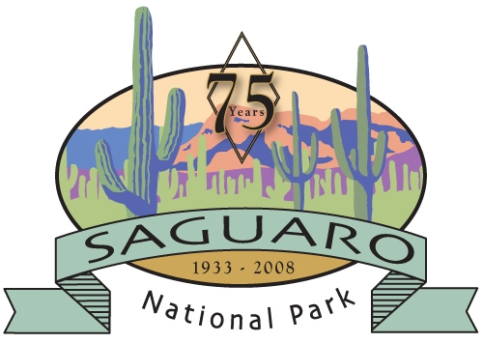
Saguaro National Park News Release

For Immediate Release
July 4, 2008
Contacts: Susan Keys (520) 733-5133
Saguaro National Park Fire Information Hotline (520) 733-5150

Chimenea Wildland Fire Use Fire Update

The Chimenea Wildland Fire Use fire received over three inches of rain on the afternoon of July 3, 2008. The total involved acreage is now 115. A few interior logs continue to smolder, and Fire Managers will continue to monitor the area of the fire and take action as needed. The Chimenea Wildland Fire Use fire is located in the Saguaro Wilderness, south of Madrona Canyon. This 115 acre lightning-ignited fire started on June 26 and is being managed for resource benefits.

The Chimenea Wildland Fire Use Fire occurred in an area adapted to fire. The Ponderosa Pine in this area has thick bark that acts as insulation. The low intensity of the fire helped reduce the risk of large crown fires that may decrease or eliminate habitat including nesting, roosting and foraging areas.

All trails at Saguaro National Park are now open to visitors.

For additional information, please call the park’s fire information hotline, (520) 733-5150 or visit www.nps.gov/sagu/parkmgmt/fire_updates.htm

08-28

