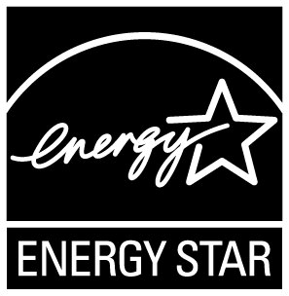
2009 ENERGY STAR® Award Application:
Excellence in Home Performance with
ENERGY STAR Promotion

Eligibility: Excellence in Home Performance with ENERGY STAR Promotion
Home Performance with ENERGY STAR program sponsors. Active partners that have submitted a Home Performance with ENERGY STAR implementation plan, and have signed a Partnership Agreement

Description: This award recognizes active Home Performance with ENERGY STAR program sponsors who have developed innovative and successful marketing campaigns and sales materials that promote Home Performance with ENERGY STAR.

Narrative: Your narrative description should be no more than three pages, but may be accompanied by samples of consumer marketing materials (print ads, commercials, sales material, earned media, contractor co-op ads, web page, etc). As part of your narrative, please provide campaign metrics of number/frequency of mailings, print ads, impressions, broadcasts, web hits, and consumer inquires and homes improved, etc. Also provide samples of contractor recruitment marketing efforts and number of contractors that attended training and have signed up to deliver Home Performance with ENERGY STAR under the program. Your narrative should demonstrate how promotional activities helped increase the number of homes improved.

Criteria: To be considered, applicants must demonstrate that they have met any or all of the following criteria:

- Improved homeowner awareness of how a home works as a system and the value of a whole house assessment.
- Raised homeowner awareness of Home Performance with ENERGY STAR
- Improved contractor knowledge of how a home works as a system and the value of a whole house assessment.
- Recruited a contractor base to make whole house improvements and to promote Home Performance with ENERGY STAR.

