RESTORING THE DELTA

PARTNERSHIPS FOR WATER QUALITY AND BOTTOMLAND HARDWOOD
RESTORATION IN THE LOWER MISSISSIPPI ALLUVIAL VALLEY

Business Plan

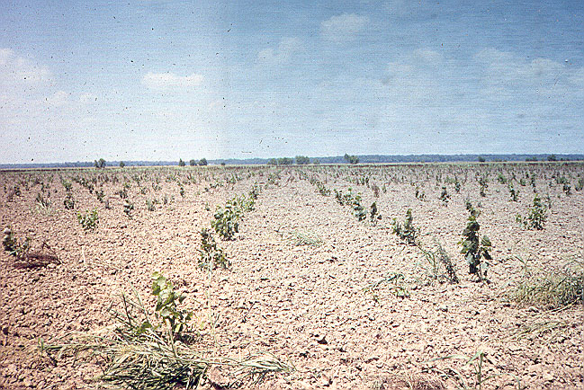

- EXECUTIVE SUMMARY (Instructions are to write this section last)

INTRODUCTION

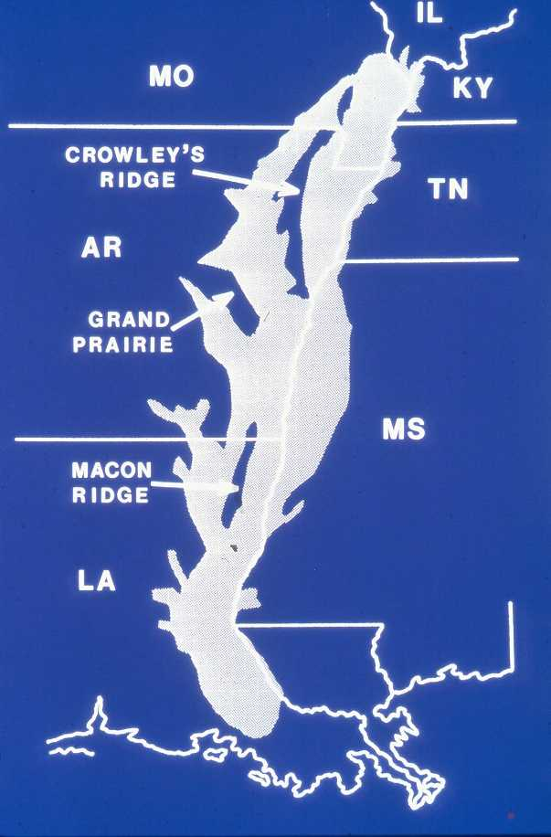
  - Mission and Vision Statements
The Mission of the Restoring the Delta Watershed Restoration Project is to catalyze restoration of bottomland hardwood ecosystems in the Lower Mississippi Alluvial Valley, by strengthening existing partnerships, building new relationships, providing a scientific foundation and developing new restoration techniques, and implementing a restoration program on private land. The intent of this Business Plan is to guide the Forest Service and partners in the exploration, analysis, and augmented delivery of ongoing and future restoration within the Lower Mississippi Alluvial Valley (LMAV). Much work is underway, yet the remaining task in front of conservation partners is both extensive and complex. Key to restoration of this ecosystem will be returning significant acres of prior converted farmland to a bottomland hardwood forest ecosystem. Our goal is to strengthen existing partnerships by enhancing, as appropriate, the role of the Forest Service within this system.

Figure 1. The Lower Mississippi Alluvial Valley

Our Vision for the Restoring the Delta Watershed Restoration Project is to be recognized as international leaders in restoration of large river floodplain ecosystems. We are a partnership of many diverse organizations focused on restoration of the Lower Mississippi Alluvial Valley. We will achieve our restoration goals while remaining sensitive to the needs of the residents of the LMAV and their quality of life, while improving quality of water, enhancing wildlife habitat, and supporting economic wellbeing. Ducks Unlimited and the Forest Service have been active partners since 1984, and both parties have maintained an active presence with other partners in the LMAV. Building on the strengths of these partnerships, this business plan will position Ducks Unlimited and the Forest Service as catalyst to augment and enhance restoration of this valuable ecosystem.

B) The Place
The Lower Mississippi Alluvial Valley (LMAV) covers more than 24 million acres in parts of seven states extending from southern Illinois to the Gulf of Mexico (Figure 1). Historically, the LMAV was largely bottomland hardwood forests. Flooding of the mighty Mississippi River and its tributaries shaped this land. Rich soils left by these floods produced a vast forested wetland sheltering a great diversity of wildlife. Settlers in the 1800’s, searching for fertile farmland, cleared forests, starting from the highest and best-drained sites. During the 1900’s flood control efforts straightened and deepened rivers, drained swamps, and encouraged forest clearing on lower, wetter sites. Between 1950 and 1976, approximately one-third of the LMAV’s bottomland forests were converted to agriculture. By the 1980’s less than 20% of the original forested wetlands were left.

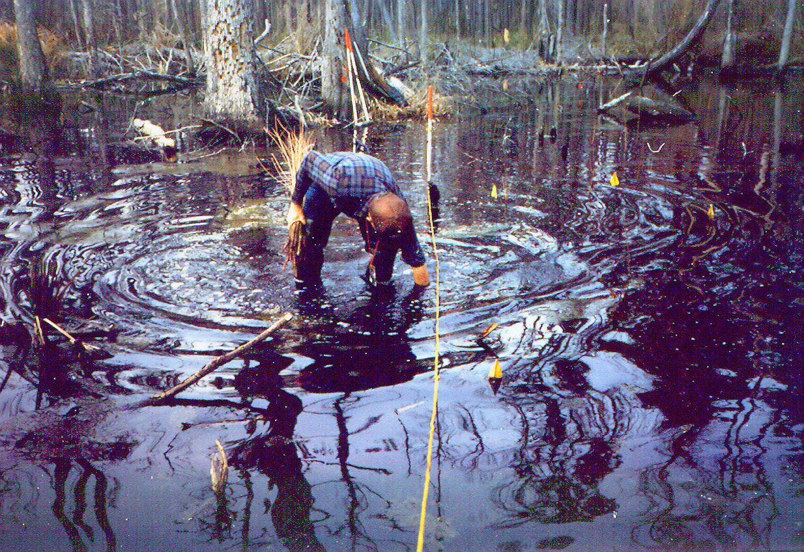
While the loss of the forests was devastating to this ecosystem, equally damaging were the effects of flood control projects (i.e. levees and channelization) that separated the rivers from the floodplains. Deforestation and draining of wetland areas resulted in a loss of critical wildlife and fish habitat, decreased water quality, reduced flood water retention, and increased sediment loads, all of which have contributed to an expansion of the hypoxic zone in the Gulf of Mexico. The Environmental Protection Agency has identified the Mississippi Delta as an area of significant concern regarding surface and ground water quality. The region’s abundant rainfall, finely textured alluvial soils and intensive cultivation have contributed to serious non-point source pollution problems. An estimated 12-45 tons of soil per acre are lost from agricultural lands in the LMAV each year leading to increased water turbidity, siltation, pollution from pesticide and herbicide run-off, toxicity to fish and other aquatic organisms, oxygen depletion and eutrophication.

The potential for afforestation in the LMAV is estimated at 500,000 acres or more. Current plans by other agencies, as shown in the Table 1, illustrate the extent of on-going activity.

Table 1. Planned Afforestation in the Lower Mississippi Alluvial Valley

 |  | Area (ha)¹
Program | Agency² | 1995 | Planned  To 2005 | Total
Wildlife Refuges | USFWS | 5,180 | 10,000 | 15,180
Wetland Mitigation | COE | 2,025 | 9,700 | 11,725
State Agencies | MS, LA, AR | 13,500 | 40,500 | 54,000
Wetlands Reserve Program (WRP) | NRCS | 53,000 | 47,750 | 100,750
Total |  | 73,705 | 107,950 | 181,655
¹Estimates furnished by participants at the Workshop on "Artificial Regeneration of Bottomland Hardwoods: Reforestation/Restoration Research Needs", held May 11-12, 1995 in Stoneville, Mississippi.

²USFWS=U. S. Fish and Wildlife Service; COE=U. S. Army Corps of Engineers; MS=Mississippi; LA=Louisiana; AR=Arkansas; NRCS=U. S. Natural Resources Conservation Service, formerly Soil Conservation Service.

C) The Work
(1) The Situation Being Addressed
The first objective of the program outlined in this plan is to increase acres of restoration in the LMAV by providing opportunities to landowners, through demonstrated outcomes and technical assistance. This reforestation scenario attempts to maintain property values and county tax structures, which are fast becoming critical issues in LMAV restoration. Current estimates, although conservative, are that 40,000 acres, in addition to existing programs, could be reforested over a 5-year period if significant economic returns could be demonstrated to landowners. Conservation partners in the LMAV rely on a variety of sources to restore forest vegetation and hydrology. Over the past 20 years, programs to restore river flows and reforest economically marginal farmland have changed land use in the LMAV. To date these efforts have been driven by offering economic incentives to willing landowners in the form of conservation easements, cost-share reforestation, water management structures, and direct purchase of fee title. What has not been fully explored is how to address landowner needs in a manner sufficient to allow him/her to convert from row crop agriculture to tree crops, and to establishing a forest ecosystem without relying on direct payments. That is, how can conservation partners provide willing landowners with the ability to restore agricultural lands, utilizing economic returns from timber management and recreation as the primary incentives.
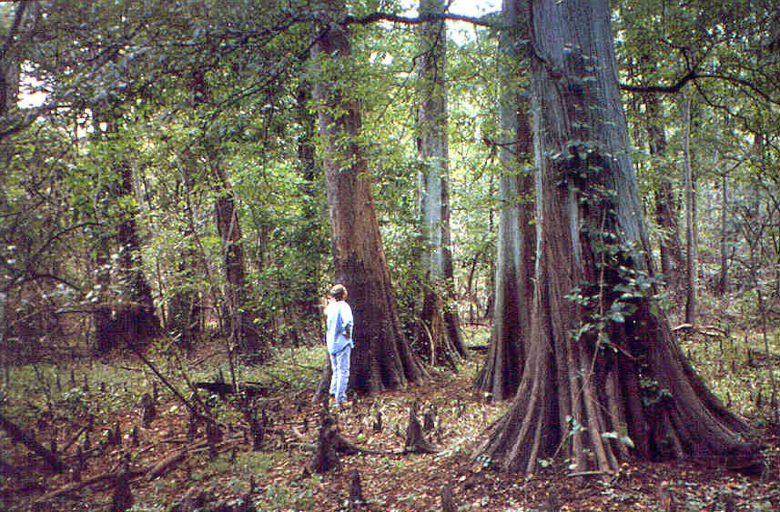
The second objective of this program is to work with others to meet the challenge of restoring the health of this expansive watershed to a properly functioning condition, in a manner that enhances residents' quality of life and meets society’s demands for water quality improvement. Reforestation and returning water management to agriculture lands are acknowledged as important components to restoring the LMAV. However, they are the first steps in a long journey to restore this area to its native condition. Realistically, society’s demands will prohibit much of this area from full restoration. Conservation partners are challenged to work within these demands, yet restore portions of the LMAV to a point that will reverse environmental damage and sustain watershed health. Major changes in flood control policy and land use practices present significant opportunities to address vexing environmental issues such as habitat loss or fragmentation for Neotropical songbirds, and nutrient loading into the Gulf of Mexico which has contributed to the development of an hypoxic zone.

(2) The Publics to be Served

(a) Private Landowners

Evidence exists that LMAV landowners want to retire certain lands from farming. Currently, only 1 of every 5 landowners who sign-up for the Wetland Reserve Program (WRP) in Mississippi are accepted in the program and similar numbers exist for Louisiana and Arkansas. In addition, many other landowners have expressed a willingness to reforest agricultural lands, yet are uncomfortable with signing an easement with the “government”, as required by the WRP. Much of this demand is a result of trying to farmlands that flood to frequently to be economically viable. Changing demographics are another reason that lands are now available for restoration. As in many farming communities, the younger generations are seeking employment elsewhere. In summary, public demand for assistance in reforestation exceeds the capacity of the existing programs and partnerships. Moreover, even if existing programs were funded at a higher level, none of these programs fully addresses sustainable forest management as a means to restore this ecosystem.

Recreation & Recreation Industry

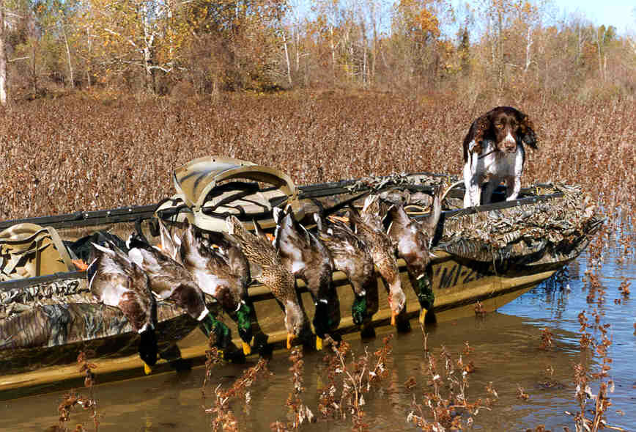
Outdoor recreation in the LMAV is as steeped in tradition as farming. As people leave the LMAV for life in the city, they return often to enjoy the area’s abundant wildlife populations. Wildlife related recreation is a multi-million dollar business in the LMAV. It is well documented that reforestation increases the habitat capability for many high demand wildlife species, such as white tailed deer. Currently many landowners in the LMAV with young stands (0-5 age class) of bottomland hardwoods are able to secure $13-$15 per acre for leased hunting rights. These stands generally produce a quality hunting opportunity due to the increased forage and cover provided by these young stands. However as these stands move into the 10-20-age class those benefits are predicted to decline, unless the stand is manipulated to increase browse production. It is unclear if the current stocking rates of existing programs will provide an economically viable incentive for this type of management. The added value from sustainable forest management is the economic incentives for maintaining wildlife habitat.

      - Timber Managers and Businesses
Timber management in general is considered a long-term commitment. Developing markets based solely on bottomland hardwood plantations is unlikely. However, many opportunities could exist for timber managers and existing businesses with the implementation of an economically sustainable forest management program in the LMAV. Due to past land clearing and conversion to row crops, most sawmills and pulpwood facilities have relocated. This program will provide those facilities located adjacent to the Delta region with an opportunity to increase their available procurement range with the increase in reforested lands. Several pulp facilities and sawmills are within a 100-mile radius of potential reforested lands.

Short-term opportunities will exist if mills take advantage of short rotation cottonwood that is presently being used as a “nurse crop” for inter-planting. Economic returns from cottonwood would likely be realized in a minimum of 10 years. Consultant foresters could potentially increase their client base through management of these reforested lands and future harvest operations.

      - Downstream Water Users
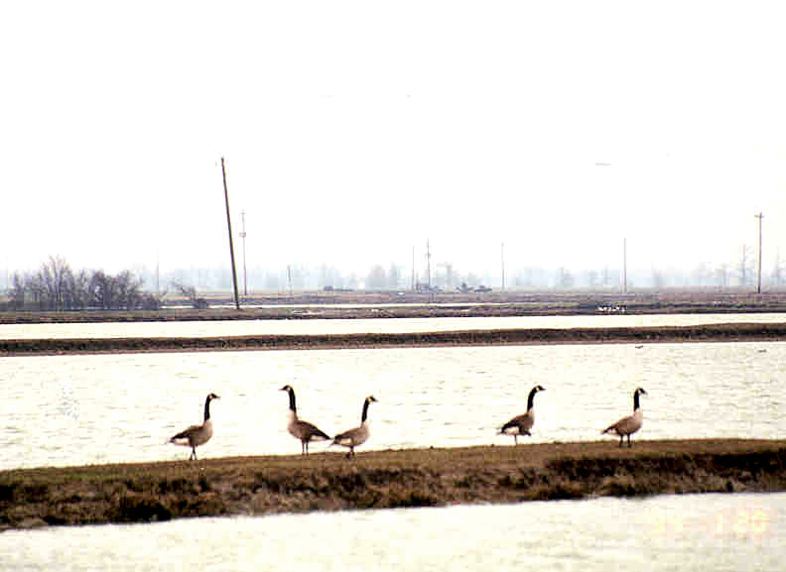
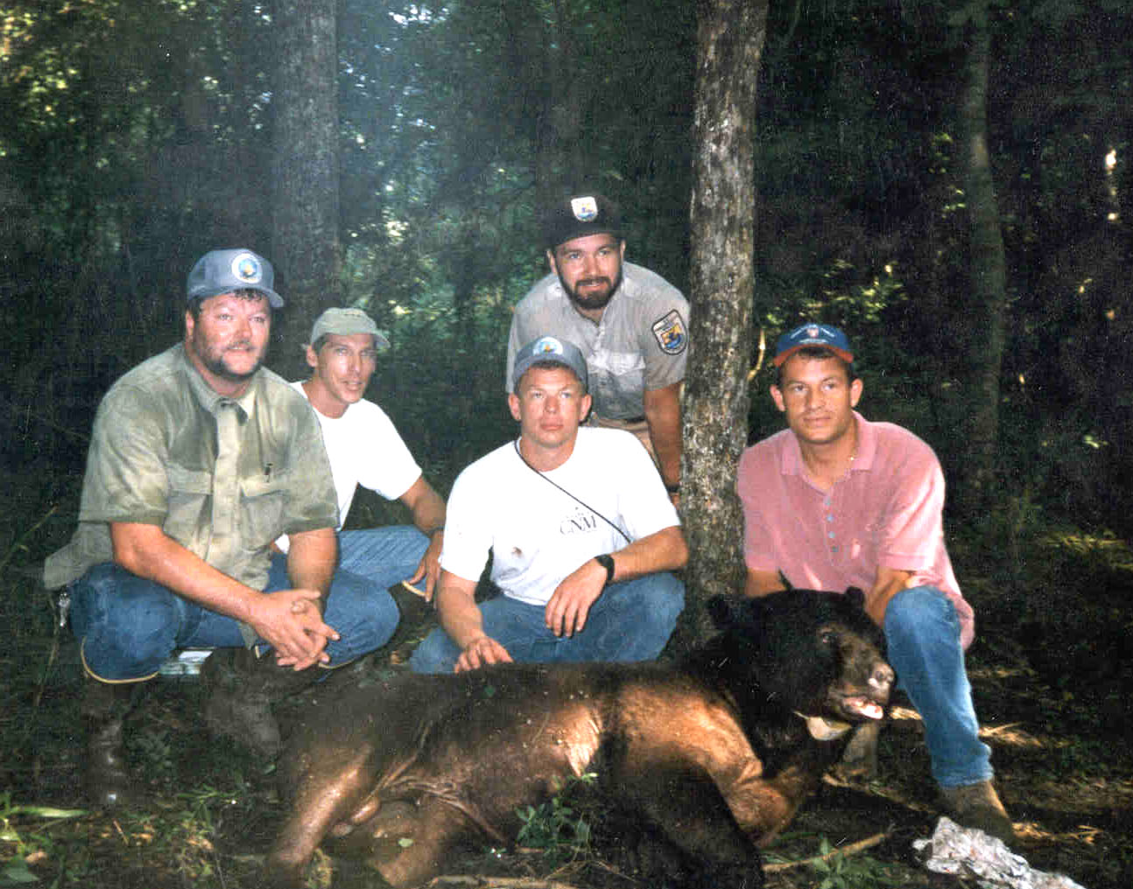
Hypoxia, the condition in which dissolved oxygen levels are below those necessary to sustain most animal life, occurs in the northern Gulf of Mexico. Research indicates that the primary cause is excess nutrients entering the Gulf from the Mississippi-Atchafalaya basin, in combination with stratification of Gulf waters. Since 1980, the Mississippi and Atchafalaya Rivers have discharged about 1.6 million metric tons of nitrogen into the Gulf annually. Nitrate loads have tripled since 1955-1970. About 90% of the nitrate comes from non-point sources. Recent estimates indicate that the majority of the nitrate enters the Mississippi River from agricultural runoff above the LMAV. Earlier concern focused on the LMAV, specifically the Yazoo-Mississippi Basin. Nevertheless, current indications are that most of the rivers in the Yazoo Basin are impaired. Despite controversy over these data, the Environmental Protection Agency is expected to focus significant resources on the LMAV in order to improve water quality. Some policy alternatives being considered are a 20% to 40% reduction in nitrogen use and conversion of agricultural land to forests in order to restore and enhance natural denitrification processes.

      - Global/International
Defenders of Wildlife identified southern-forested wetlands as one of the twenty-one most endangered ecosystems in the United States. The Partners in Flight planning process has identified bottomland systems across the South as the highest priority habitats for maintenance of breeding populations of Neotropical migratory birds as well as staging habitats for these birds during migration. In separate assessments, the Nature Conservancy and Defenders of Wildlife identified the South as having high to extreme risk for significant loss of aquatic biodiversity. These groups and the World Wildlife Fund regard sustained conservation actions in the region as vital to maintaining a significant proportion of the freshwater fauna of the United States with emphasis on native fishes, freshwater mussels, and crayfishes. Management of forest ecosystems usually treat these non-game animals, whether aquatic or terrestrial, as constraints on or by-products of the management process. However, forest birds, warmwater fish communities, and freshwater mussels are all indicators of ecosystem quality and integrity.

- Actions to Take
- Synthesize and assess ongoing work
In 1999, Ducks Unlimited Inc. received a Federal Aid Grant to fund wetland planning within the LMAV. The objective is to develop a GIS based model that identifies target areas for wetland restoration and enhancement across a large scale. The model is being specifically designed to meet the needs of the Lower Mississippi Alluvial Valley Joint Venture, but is intended to have national application across several Joint Ventures.

In July of 1999, Ducks Unlimited=s Institute for Wetland and Waterfowl Research organized a meeting of parties interested in wetland restoration and enhancement of both forested and non-forested wetlands in the Mississippi Alluvial Valley. Attendees of the meeting included members of the Lower Mississippi Alluvial Valley Joint Venture, staff of the Patuxent Wildlife Research Center, the Arkansas Multi-Agency Wetland Planning Team, and Ducks Unlimited personnel. The purpose of the meeting was to identify what information was required to develop the wetland planning model. This group agreed that a GIS data layer describing seasonal flooding of both forested and non-forested habitat was the most important information need. Although additional data layers will be required to improve the model, these layers remain to be prioritized.

The Forest Service and Ducks Unlimited plan to host another meeting bringing together an expanded original group of participants to discuss progress on the wetland planning model, and to prioritize the remaining data layers that have yet to be addressed. Discussions for this meeting will include, but not be limited to, the need for additional satellite imagery, digitizing soil survey data, and assessing the best way to analyze social and economic changes in the LMAV.

(b) Develop and Enhance Needed Partnerships
Due to the time constraints of developing this draft business plan, we have had limited occasion to network the opportunities provided by the Large-scale Watershed Restoration Program to existing partners, much less develop relationships with others who might contribute to this effort. Nevertheless, preliminary discussions have begun with the Fish and Wildlife Service about their carbon sequestration program in the LMAV; with the Center for Forest Sustainability at Auburn University, including a field tour of potential collaborative research sites; and with Delta F.A.R.M. as an avenue to reach interested landowners.

During the process of completing this business plan, a concentrated effort will be made to outreach this program to partners. Plans are underway to host a tour of this area inviting national leadership from the Forest Service to visit the LMAV to help assess the broadened role of the Forest Service in restoring this ecosystem. In addition, Ducks Unlimited has offered to host a forum or summit to enhance partnerships and accelerate collaboration. It is acknowledged that much work is needed to enhance and solidify existing partnerships while welcoming new agencies and organizations into this restoration effort.

(c) Develop Demonstration Areas for Afforestation
Three types of demonstrations sites will be established: older plantations that will be measured and manipulated to demonstrate on-going management and substantiate outcomes such as wildlife habitat and carbon sequestration; new plantings on economically marginal farmland to develop and demonstrate afforestation techniques; and riparian areas to have forested buffers installed.
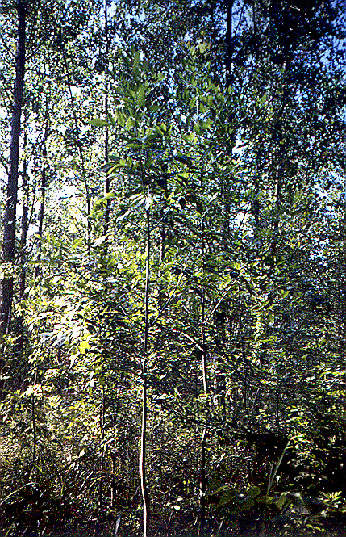
        - Manipulations of existing stands to predict outcomes
The earliest reforestation efforts in the LMAV began in 1981. However, a few stands were established prior to this date, specifically the Red River Management Area in Louisiana and the Delta National Forest in Mississippi have plantations established in the 1960s and 1970s, respectively. Today, many of these stands are fully stocked and appear to be economically viable for manipulating forest structure and composition through timber harvest. However, much is unknown and most landowners are hesitant to act. Since many of these stands are on public lands, opportunities exist to create operationally sized demonstration areas of how these stands respond to management. Both of these early plantations would be ideal for demonstration sites and we (CBHR) have recently installed a thinning study at the Red River WMA. Many questions remain related to management of existing hardwood plantations, and some of these require experiments longer than the term of this project. Issues raised by interested parties are:

- What are the expected economic returns at various stocking levels and ages?
- What opportunities are available for stand management and structure manipulation?
- What is the desired stand density and likely growth rates?
- When will yield tables be available?
- Are there thinning guides for timber management with opportunities to enhance or maintain wildlife habitat?
- What are the potential economic returns from hardwood plantations within the LMAV based on different sites and soil series?

        - Establishing sustainable forests through afforestation
In 1995, through the transfer of lands from the Farmers Home Administration to the U.S. Fish and Wildlife Service and USDA Forest Service a partnership was formed to restore this abandoned farmland while providing information to the public. This area is located in the LMAV in Sharkey County Mississippi and is known as the Sharkey Restoration Site. The CBHR is currently working with partners at the Sharkey Restoration Site to demonstrate an intensive approach to reforestation which provides a landowner with options to produce income from timber, and provides opportunities to manipulate restored stands in the future to further enhance wildlife habitat.

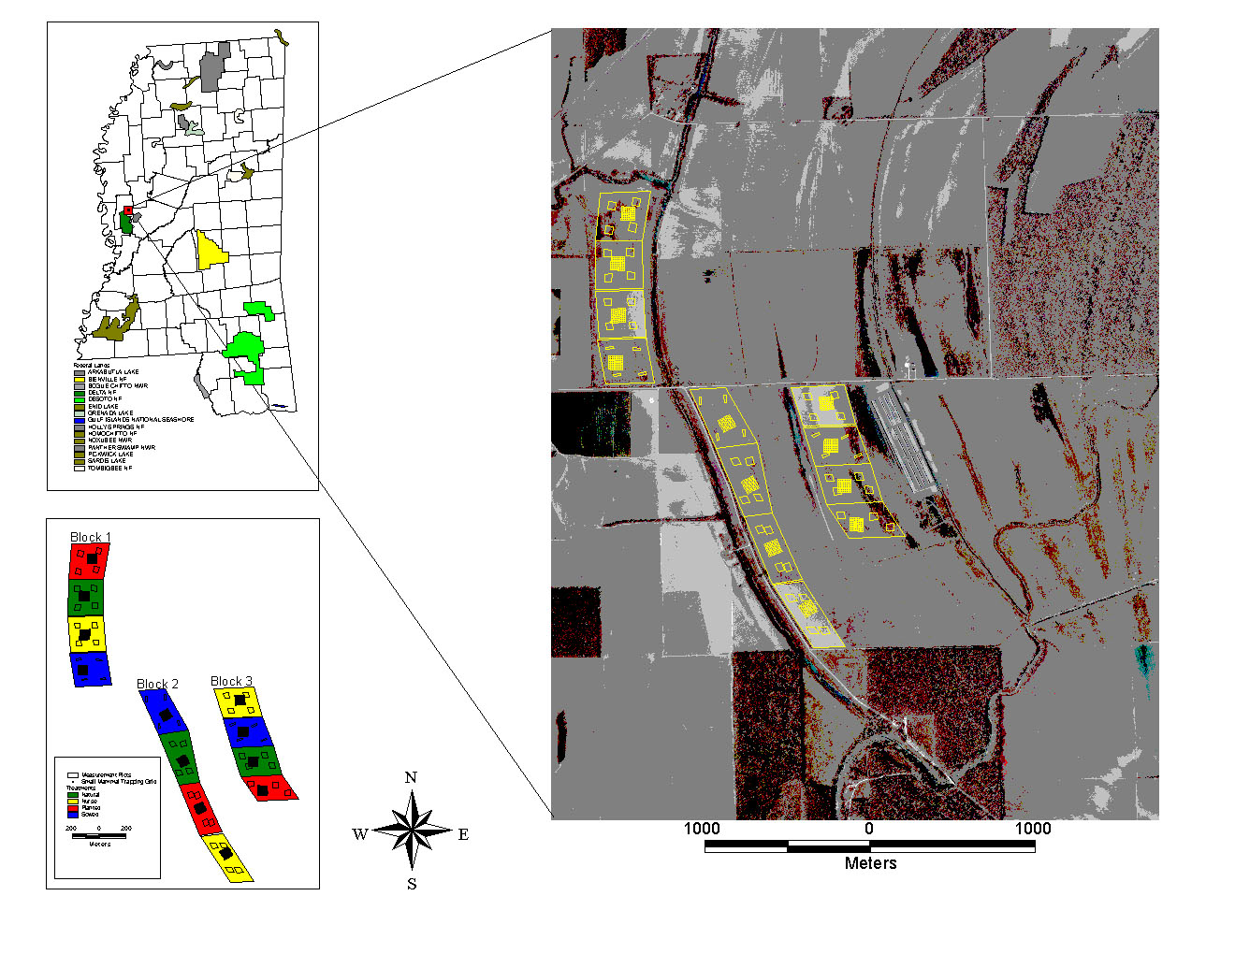
During FY 2000 the CBHR and partners will increase the restoration options available to landowners by developing and demonstrating both the biological feasibility and economic viability of alternative afforestation techniques. We will establish research and demonstration sites as companions to the existing Sharkey Restoration Site. For afforestation sites, we will establish demonstrations on a range of site qualities in order to meet the diverse needs of landowners, including extending our current work inter-planting. Fundamental research on oak seedling physiology underway at the Sharkey site will guide future efforts to expand the inter-planting technique to more demanding soil and flooding conditions, using combinations of other tree species. For sites too saturated for cottonwood, we will use willow (Salix sp.) as the fast growing native tree nurse crop. In addition to inter-planting, we will demonstrate other methods of quickly establishing mixed species stands on economically marginal farmland. On better sites, we will examine using fast-growing native species inter-planted with slower growing native species for conversion to natural stands; cottonwood plantations for pulpwood and saw-timber; and willow short-rotation intensive culture plantations for bio-fuels.

(iii) Riparian buffers using trees instead of grasses
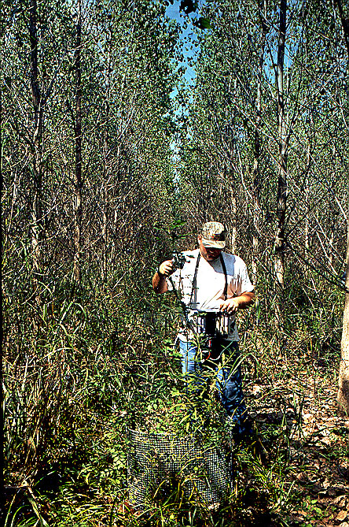
Managing wet soils and surface water on a farm as a unit with appropriate tree crops provides restoration of wetland functions, protection of surface water, and still generates income for the operator. Use of forested buffer strips in an agricultural landscape is uncommon, although several studies have examined the filtering action of forested riparian zones and concluded that buffer strips are quite effective in removing soluble nitrogen and phosphorus (up to 99%) and sediment. The efficiency of pesticide removal by forested buffer strips has been examined in some environmental fate studies. Buffer strips 50 ft or wider are generally effective in minimizing pesticide contamination of streams from overland flow.

- Quantify Carbon Sequestration
Forests play an important role in the global carbon cycle and contain more carbon than is found in the atmosphere. Forests in the US contain about 50 billion metric tons of carbon. Although forest management is a controversial topic in negotiations implementing the Kyoto Protocol to the UN Framework Convention on Climate Change, most observers agree that afforestation activities will qualify for carbon sequestration credits. The need remains, however, for an accounting system at the sub-national level to account for carbon sequestration in forest management, and for information on major components of the forest carbon budget. Two research projects in the LMAV have been established by UtiliTree, a non-profit company established in 1995 by 41 electric utilities. Both projects are in Louisiana in cooperation with researchers from Louisiana Tech University. Estimated benefits are 9.0 tons CO₂ sequestered per acre over the first five years after establishment, and 600 tons per acre by the end of the 70-year rotation. Additional research is needed to quantify benefits of other afforestation treatments (using different species, at several planting densities, with establishment techniques that result in different survival rates, on sites of differing inherent productivity and flood regime). Changes in soil carbon over the course of time, a major carbon sink, can be estimated by sampling a chronosequence (time series), as we have done for oak planted on Sharkey clay soil (a typical restoration treatment).

River and Hydrology Restoration
Opportunities for restoration of natural river flows are limited to smaller tributaries of the Mississippi River and its major tributaries in the LMAV. We will capitalize on opportunities in the region, even though sites may be outside the LMAV proper. Two possibilities exist, both on National Forests in Mississippi: the Little Tallahatchie River on the Holly Springs NF, and the Homochitto River on the Homochitto NF.

        - Little Tallahatchie River
This project involves restoration of ecological functions and biodiversity of 23 river miles of the Little Tallahatchie River. This river reach includes approximately 12,800 acres of riparian area and drains about 62,000 acres to its south. This reach was degraded about 5 decades ago through the operation of the Little Tallahatchie River Channelization Project and the later diversion of flow from two tributaries into an 11-mile channel which parallels the river channel. The curtailment of flow left several miles of the original channel with no or very reduced summer flows, resulting in filling of some reaches. Riverine-floodplain interactions and the lineal extent of fishable waters were reduced. The re-river project will divert flow of Puskus and Cypress Creeks from the canal to the original channel, providing year-round base flows to a 23-mile reach and a likely increase in frequency of low to moderate flood pulses throughout the system. The river restoration project is underway by the Corps of Engineers. Our project will be to restore floodplain forest habitat in order to further enhance aquatic function and provide waterfowl habitat.

        - Homochitto River
Placeholder: There is ongoing discussion with the Homochitto NF and the COE to reverse the effects of channelization on this river.

- Quantify presumed benefits at research/local scale
Quantify the environmental benefits of afforestation of marginal farmland and buffer strips along water bodies, in terms of reduced sediment delivery to surface water, reduced non-point source pollutant loadings on aquatic systems, and enhanced wildlife habitat. Environmental benefits of reforestation in general have been recognized. Wildlife benefits, for example, are obtained almost immediately in a fast-growing cottonwood plantation as compared to other techniques used for reforestation under WRP such as direct-seeding oak species. Although some may feel that the intensive cultivation required to establish cottonwood works against wildlife, it has been found that wildlife importance values for all wildlife food plants in several cottonwood plantations peaked in the fourth, fifth, and sixth growing seasons. The vertical structure provided by cottonwood, virtually in the first growing season, provides needed habitat for neotropical and other songbirds. Research in bioenergy plantations has further documented the beneficial effects of short rotation woody crops on wildlife habitat .

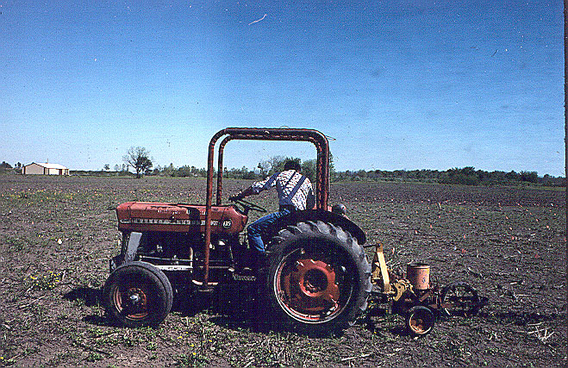
Specific impacts on water quality are under investigation. In one study by a cooperator, cottonwood as a short-rotation bio-energy crop was compared to conventional cotton. Cottonwood improved water quality by reducing soil erosion as well as levels of nitrate, phosphorus, pesticides, and herbicides. Differences were apparent within three months. Sediment losses under cottonwood were about half that under cotton, apparently due to increased infiltration and less runoff under cottonwood. In order to capture any future payments for pollution abatement, it is necessary to quantify actual reductions. Controlled field experiments have not been conducted. We will utilize the knowledge gained and expertise developed in the Stoneville comparison of cottonwood versus cotton, to guide this portion of the project.

Enhancement of wildlife habitat will be quantified by projecting results from other studies and our on-going research at the Sharkey Restoration. Measurements of vertical foliage diversity will be used to quantify habitat improvements and project species usage in buffer strips. Habitat improvement in plantations on marginal soil units will be estimated from similar sites where population levels have been measured.

      - Extrapolate benefits to implementation/watershed scale
Small-scale research plots can document the level of benefits obtained from applying specific watershed restoration techniques at the field or stand level. These site-specific benefits and costs need to be extrapolated across the landscape in order to guide implementation and inform policy makers. As part of this project, DU will provide leadership in working with FS and FWS to maintain an integrated GIS database. The spatial data will be used to help assess lands in the watershed that are most important in providing watershed values and identify those most in need of restoration and protection. The GIS database will allow policy makers to understand the impacts of various restoration scenarios. Working with partners, DU will lead the effort to assemble existing spatially referenced databases on land characteristics (flood regime, soils, current land use, land ownership); to create new data layers that display the results of the research projects; and to add data layers which display the location and effects of restoration and management projects of other partners and players that could impact the project (such as flood control project of the Corps of Engineers or levee boards; new highway construction; additions to public lands; etc.).

      - Develop spatial analysis capability
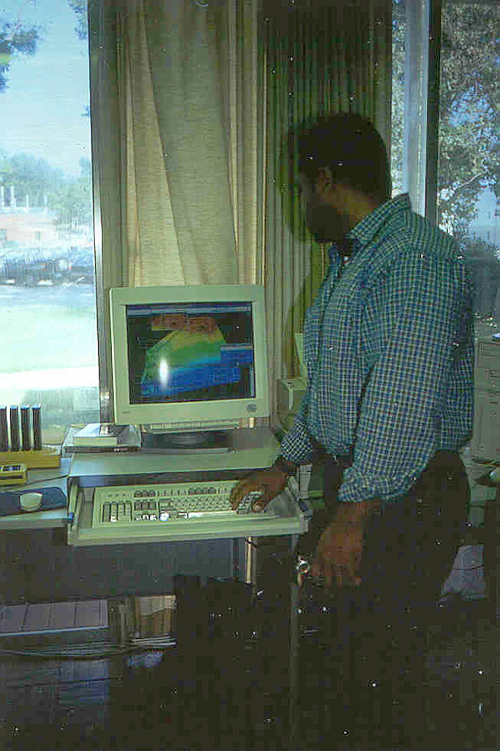
The U.S. Geological Survey (Mississippi Embayment NAWQA) has developed the Eco-Assessor, a GIS-based support system for the lower Yazoo River Basin. Eco-Assessor is designed to aid policymakers, planners, and managers in determining the best locations for the restoration of forested wetlands based on pre-defined ecological and geographic criteria, along with probability of successful restoration. Functional characteristics of potential restoration areas are organized by data layer: hydrology, water quality, and habitat. The overall potential for restoration success, defined as the physical ability of a parcel of land to sustain a functional wetland, is also considered. Surrogate data layers are used to predict the location of parcels with high potential for restoration. Categories within each data layer are assigned a rank that indicates probability of success and rankings for all data layers are summed to a cumulative rank. This cumulative rank can be used to determine the locations that are overall the most likely to be successfully restored to a particular vegetation community.

Ducks Unlimited and the Forest Service will work with the USGS to apply and extend their spatial analysis tools to the Delta Restoration Watershed Project. This will involve three activities: further testing of the analysis algorithms; refining the data layers used in the analysis; and extending the database to the rest of the LMAV. In addition, we will test and incorporate other analytical tools for scaling local benefits to the watershed level; and for conducting landscape level analysis of future land-use scenarios.

      - Technology Transfer and Project Marketing
An aggressive technology transfer program will be needed to provide landowners with information on growing and marketing trees as an alternative to traditional agricultural crops. We propose to bring together the afforestation technology that has been developed or will be developed by this project, into the context of actual farm units and show that native hardwoods are profitable alternative crops on marginal soybean land and as a buffer strip on better land along watercourses and water bodies.

        - Outreach
A large part of the project will be outreach to the farming community, particularly limited resource farmers. Our approach will be through traditional mechanisms of key organizations and individuals, and by developing demonstration sites.

          - Outreach Mississippi – On January 14, 1999 all USDA agencies in Mississippi, Mississippi State University, Alcorn State University, and Mississippi Forestry Commission signed a partnership agreement to better insure delivery of programs and service to rural Mississippians. This program delivers technical assistance, public information about Forest Service programs and projects, and assistance through Economic Recovery Grants. Outreach Mississippi can provide an immediate communications link and marketing approach to reach the under-served and non-traditional landowners and communities in the Delta. Outreach Mississippi also provides access to the County Extension Service administered by Alcorn State University and Mississippi State University and the Mississippi Forestry Commission Landowner Assistance Coordinator.

          - Forested Flyways – The American Forest Foundation American Tree Farm System, Ducks Unlimited, and International Paper have launched a new conservation partnership to help private forest owners in the southeast to enhance waterfowl habitat, wetlands, and migratory corridors, and improved rivers, streams lakes and ponds on their properties. By promoting the benefits of forest management and opportunities to generate alternative sources of income Forested Flyways works to sustain healthy forest for the long term. This partnership provides access to a large network of forest landowners along with the opportunity for peer-to-peer education and encouragement to increase landowner awareness about the environmental and economic benefits associated with long-term planning and forest management.

        - Coordination
A need has been identified to establish a full-time coordinator position in partnership with DU, CBHR, and other groups. This will allow the FS to provide a needed catalyst for program delivery. In addition, the individual filling this position will have a unique opportunity to work side-by-side with other non-profit organizations, federal and state agencies, and private citizens to learn partnership building techniques that are critical to the future of the Forest Service. This position will be maintained by the CBHR in Stoneville, MS. and reside in the Southern Regional Office of Ducks Unlimited.

- Implement afforestation and hydrology manipulation
By delivering this LMAV project through the Mississippi Partners Project, Arkansas Partners Project and the Louisiana Waterfowl Project of Ducks Unlimited in partnership with the Center for Bottomland Hardwoods Research, we are able to utilize an existing infrastructure of field and administrative staff to implement the Delta Restoration Watershed Project. As a result, this multi-million dollar project can be initiated immediately. Reforestation and/or hydrology restoration does not require federal or state permitting. Annual habitat monitoring will be included as part of this project. Steps must be taken immediately (i.e., FY 2000) to identify landowners, design appropriate afforestation (primarily, match species to site and landowner objectives), and contract with nurseries for needed seedlings for planting in winter of 2000-2001 (December to February).

    - Outcomes to be Achieved
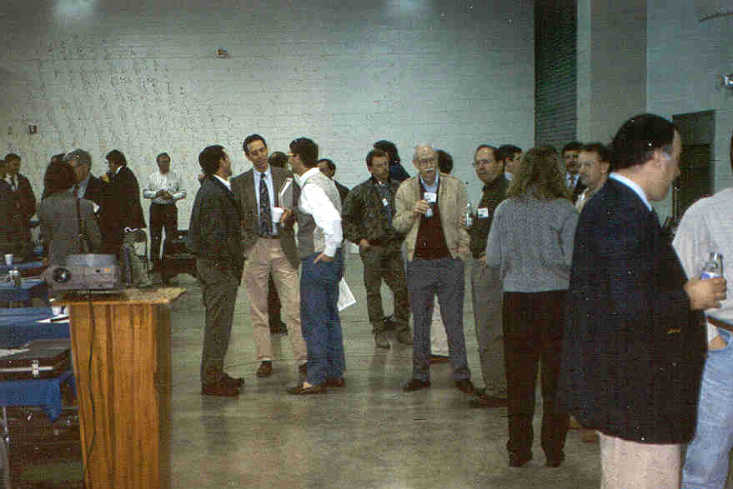
      - Collaboration to Better Serve the Public
Enhancing and augmenting existing LMAV partnerships provide LMAV landowners with additional needed opportunities to participate in restoring the “delta” ecosystem through re-establishing forest and hydrology on existing agricultural lands. Unlike existing programs, this program delivery will be based on benefits to the landowner, not payments or easements. Outcomes include increased recreation, economic returns from timber management and increased land values. Through science-based research landowners will have access to valuable information and proven techniques to guide them in their decision making process. Information and techniques will include topics such as reforestation on wetter sites, methods for enhancing the restoration of forest structure and composition, and the role of riparian buffer strips. Planned research will also help managers and policy makers quantify the benefits of restoration such as water quality & carbon sequestration. Working through established partnerships, we propose to afforest 40,000 acres of cropland with bottomland hardwoods and restore hydrology to 134,000 acres over a 5-year period. The program will position the USDA Forest Service, state, corporate and private forestry interests, and potentially other parties, as interactive partners in a full array of programs providing value to the private landowner.

      - Improve water quality

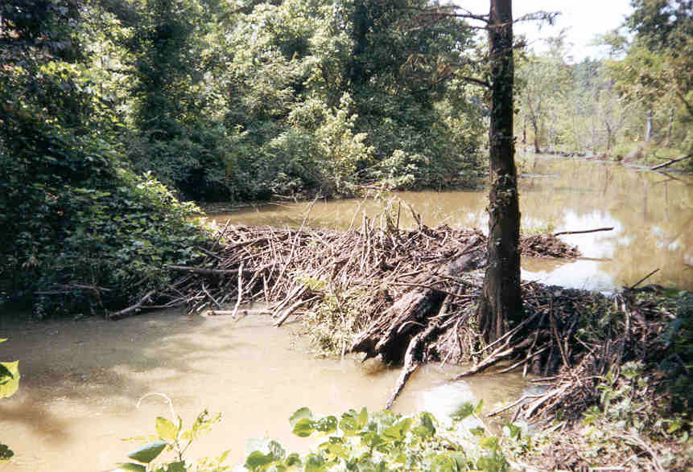

      - Sequester 500,000 tons of carbon over 10 years

      - Enhance wildlife habitat

    - Benefits
      - Source of income to landowners
Amenity value of the rural landscape will be enhanced by increasing the amount of forest cover, and for farmers in the LMAV, tree crops represent a new crop.

      - Avoidance of water quality regulation and costs of implementing TMDL’s
Forested wetlands and buffer strips will protect surface waters from nutrient, sediment, and possibly pesticide transport, raising water quality and improving aquatic ecosystems.

      - Avoidance of downstream treatment costs for water

      - Improved carbon balance in the region

      - Wildlife habitat created
Successful restoration of bottomland hardwood forests and associated aquatic systems will enhance wildlife habitat, especially for Neotropical migratory songbirds but also for raptors and waterfowl. Restored riparian areas and streams will enhance aquatic diversity, restore ecological function, and provide increased opportunity for fishing, hunting, and recreation.
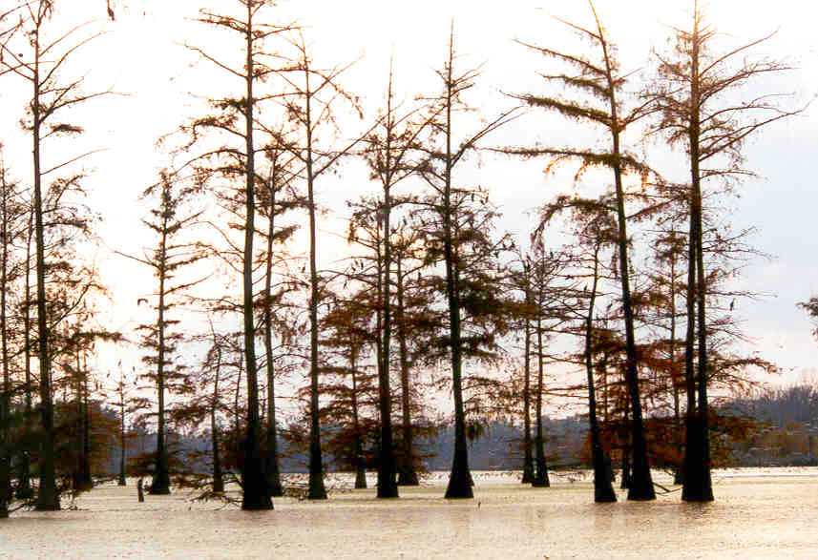

    - Measurement
      - Focus of the research portions of project. Working with Business Council for Sustainable Development to develop a rapid assessment method for determining the sustainability of restoration projects.

      - Measure and document benefits in terms of water quality improvement, carbon sequestration, and wildlife habitat enhancement in small scale research and demonstration project

      - Extrapolate benefits over the LMAV at landscape scale

      - Detailed work plans will be developed for all aspects of the project and our ability to meet the time frame set by the work plans will be one measure of success. Evaluations will be made of all presentations made to user groups, in order to continuously improve the content and delivery system. Focus groups will be used to hone presentations, publications, and television spots prior to delivery. Numbers of contacts with users, numbers of users who implement the technology, and total acres implemented will be assessed. Based upon implementation rates, returns to users and environmental benefits secured by implementation of the technology will be projected.

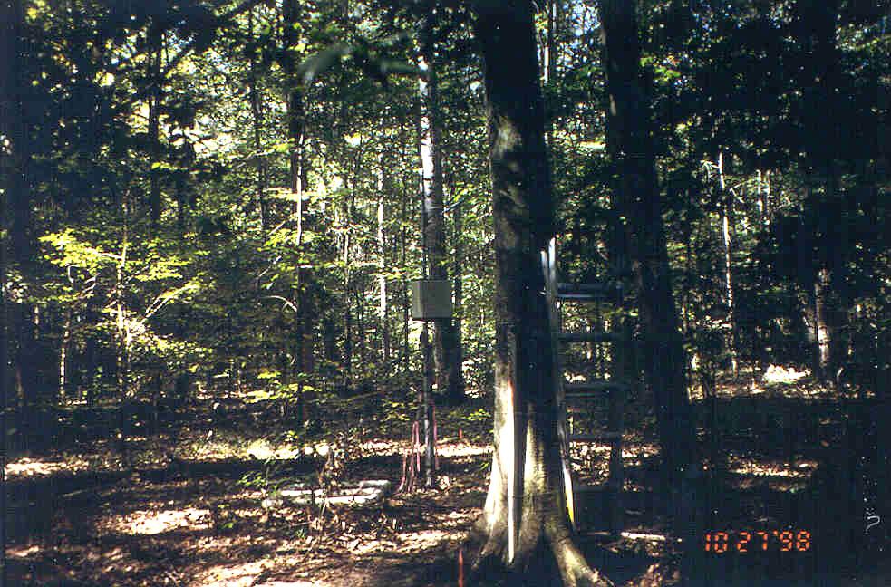

III) The Customers and How They Benefit
A) The People and the Land as Customers

B) The People
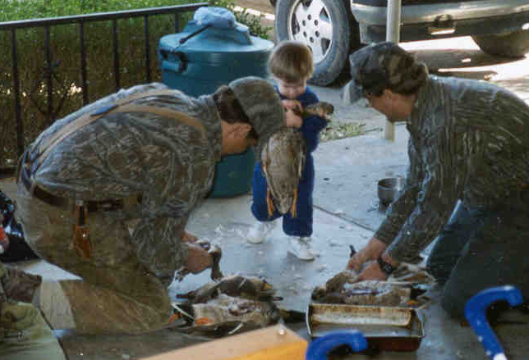
(1) Who Benefits?
Beneficiaries include:
- Landowners
- Hunters and anglers
- Recreational and non-consumptive wildlife users
- Hunters and recreationists in other watersheds
- People who use paper and lumber products
- Downstream water users
- Gulf of Mexico fishermen
- Society in general

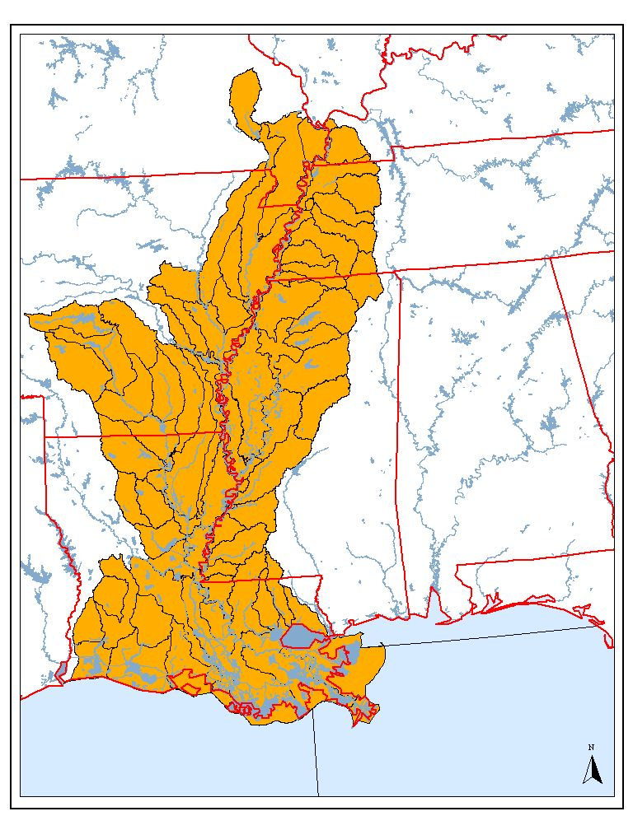
- Who Does Not Benefit?
People who don’t benefit include:
- Agribusinesses
- Local government
- Infrastructure providers (school districts, hospitals, public safety agencies),

C) The Land

The LMAV extends from just below Cairo, Illinois to central Louisiana (see map). This area once supported the largest expanse of bottomland hardwood and wetland forests in the United States. Extensive flood control projects over the last 200 years have significantly altered regional and local hydrology throughout the LMAV. As much as 96% of the loss of bottomland hardwood forests in the LMAV has been due to conversion to agriculture. Between the early 1800s and 1935, about one-half of the original forests were cleared. A later surge in forest clearing for agriculture took place in the 1960s and 1970s in response to a rise in soybean prices. When prices eventually fell, land that was marginal for agriculture became idle because it was still subject to spring and early summer backwater flooding.

- The Competition: Other Ways of Achieving the Main Benefits

Due to the sensitive nature of this information, we have chosen to wait to write it until discussions with partners are further along.

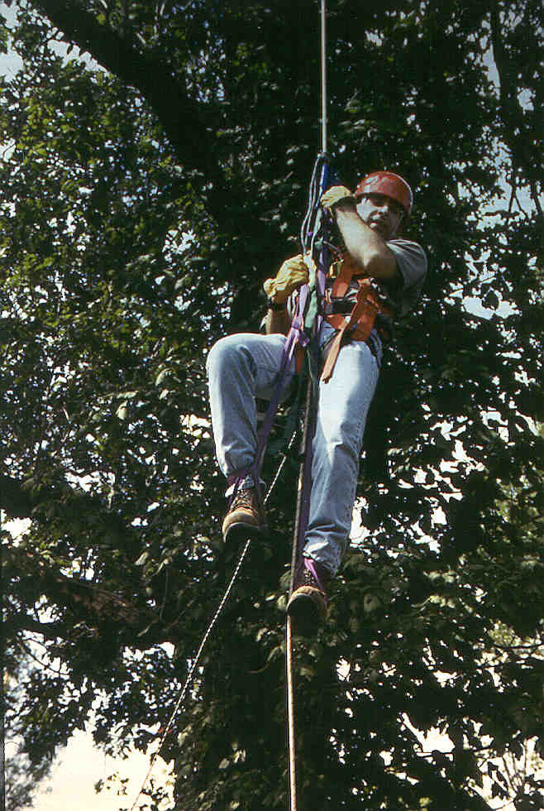
V) Measurement and Accountability
- Accountability for Activities

(1) Activities that need to be measured
      - Studies installed

      - Papers published

      - Landowners contacted, signed up

      - Acres planted

      - Water control structures installed

      - Outreach conducted (field days, meetings, conventions)

(2) How do we measure completion?

B) Accountability for Customer Satisfaction (Social Outcomes)

- Who do we measure?

(a) Landowners

- (b) Partners

- (c) Regulatory agencies

- (d) Publics

- How do we measure?

      - Survey
- Public awareness at field days, expos, etc.
- Satisfaction of partners and non-partner groups
- Technology implementation by Landowners, users

      - Signups
- Projected levels of landowner participation
      - Continuance of voluntary approaches to meeting water quality criteria (BMPs)

Who's Measured? |  | How Do We Measure?
 | Survey | Signup Level | Policy Outcomes
Landowners |  | 
Partners |  |  | 
Regulatory Agencies |  |  | 
Publics | 
Recreationists | 
Hunters | 
Professional Foresters | 

- Who measures
      - Principles

- Who’s accountable
(a) Principles and Partners

C) Accountability for conditions on the land (Resource Outcomes)
(1) Measurement

(a) Acres restored

(b) Carbon sequestered

(c) Wildlife habitat enhanced

(d) Water quality improved

(2) Who’s Accountable?

- Summary Chart–Who’s Accountable for What

 | Primary Responsibility | Secondary Responsibility
Research Activity | Stanturf | SRS
Implementation Activity | Hopkins | DU
Coordination Activity | Coordinator | Management Team
Customer Satisfaction Measurement | Coordinator | Management Team
Resource Condition Assessment | Management Team | Partners

VI) Community

Who Are the Players?

Principals
      - Center for Bottomland Hardwoods Research, Southern Research Station
Initiated in March 1996 by combining four research work units, the Center for Bottomland Hardwoods Research (RWU-SRS-4155) is a team of 16 scientists studying bottomland hardwood and wetland forest ecosystems. The Center has research facilities at three locations: the Southern Hardwoods Lab in Stoneville, MS; the Forest Hydrology Lab in Oxford, MS (co-located with the Holly Springs NF); and the Seed Biology Lab in Starkville, MS, in a facility owned by Mississippi State University. The mission of the Center is to provide the scientific basis for sustainable management of southern bottomland hardwood and wetland forests and associated stream ecosystems. Scientists at the Center are organized into four teams; each team is assigned to a broad problem area, a grouping of related research issues. One or several scientists are responsible for designing and carrying out research studies that seek to solve problems or overcome limitations to our knowledge. The four problem areas are: (1) Regeneration and Reproductive Biology; (2) Stand Management and Forest Health; (3) Ecology of Aquatic and Terrestrial Fauna; (4) Ecological Processes and Ecosystem Restoration.

(b) Ducks Unlimited
Through its River CARE (Conservation of Agriculture, Resources and the Environment) initiative, cooperates with a variety of public agencies, non-government organizations and private landowners in implementing reforestation and hydrology restoration practices on agricultural lands throughout the LMAV. Ducks Unlimited has been instrumental in the establishment and implementation of wetlands conservation programs on private lands in the Delta portions of Mississippi, Arkansas and Louisiana during the past decade. The Mississippi Partners Project, the Arkansas Partners Project and the Louisiana Waterfowl Project have become synonymous with wetland conservation accomplishments on private lands in the project area. These partnership programs represent an effective coalition of state, federal, and private conservation interests combining their collective resources to work hand in hand with private landowners to enhance the wildlife values of their agricultural lands.

In addition to their conservation programs, Ducks Unlimited has established the Institute for Wetland and Waterfowl Research (IWWR) as their science arm. The Mission of the IWWR is to help guide conservation of waterfowl and wetlands by developing and sustaining a premier program of research and by education of professionals in wetland and waterfowl biology.

    - On-Going Partnerships
      - North American Bird Conservation Planning and Implementation Partnerships
Comprehensive Bird Conservation Planning has progressed further in the Mississippi Alluvial Plain than anywhere else in the country. Partners in Flight has been working closely with the North American Waterfowl Management Plan (NAWMP) team for 12 years, and was recently joined by the United States Shorebird Conservation Plan (USSCP).

(i) North American Waterfowl Management Plan (NAWMP): The Lower Mississippi Valley is one of the seven high priority areas originally (1986) identified in the NAWMP. That designation led to the establishment of the Lower Mississippi Valley Joint Venture (1990) to guide long-term efforts of private, State and Federal cooperators as they define and implement restoration goals. This effort identified the need to reforest 500,000 acres of bottomland hardwoods to benefit waterfowl Neotropical migrant songbirds, Louisiana black bear, alligator snapping turtles, pallid sturgeon and other wildlife.

(ii) Partners in Flight: Specific habitat goals have been established for forest-breeding non-game species and in-transit shorebirds. A complete GIS analysis of the 22 million-acre valley turned up over 37,000 patches of forest over one hectare in size, only a few of which seem to be of sufficient size and configuration to support healthy populations of key bird species. Natural resource managers and researchers from throughout the valley have set long-term goals for the number, characteristics, and rough distribution of forested patches for the entire eco-region, many of which simultaneously meet many waterfowl needs.

        - United States Shorebird Conservation Plan: The draft plan for shorebird conservation in the Lower Mississippi Valley/West Gulf Coastal Plain (LMVGCP) identified numerous wetland habitats needed for shorebirds to rest and replenish stores of energy expended during migration. Thirty-one of the 31 species found in the region occur regularly. Regional habitat objectives were set based on fall population estimates. Habitats in the region that possess the greatest potential for shorebirds include agricultural fields, moist soil impoundments, semi-permanent impoundments, and aquaculture ponds. Specific management practices for each of these habitat types are described in the plan. Also identified within the plan was the need for outreach and education. Providing land managers and supervisors with specific management information (migration chronology, water depth and vegetation density tolerances, etc.) and objectives should facilitate an increase in the quality and quantity of shorebird habitat in the region.

3) USDA Forest Service, Southern Region (R-8)
(a) State and Private Forestry, Region 8
- In the past, funded technology transfer/restoration specialist position at CBHR
- Help with developing partnerships with state forestry agencies

      - National Forests in Mississippi

        - Delta National Forest
Delta National Forest (DNF): Comprised of 60,000 acres of bottomland hardwoods and forested wetlands, the DNF is the only entirely bottomland hardwood ecosystem in the National Forest System. Several areas on the DNF have been preserved as research natural areas. These are excluded from timber management and are used to study specific naturally occurring reference forest types. The Green Ash, Sweetgum, and Overcup Research Natural Areas showcase each of these species in their most typical ecosystem.
- Plantation demonstration site
- Technical assistance
- Water management demonstration sites
- Natural forest reference sites

        - Holly Springs National Forest
- Little Tallahatchie River restoration site

        - Homochitto National Forest
- Homochitto River restoration site

      - St Francis National Forest
- Natural forest reference sites

      - Kisatchie National Forest
- Iatt Creek Bottomland Hardwood Long-Term Ecological Research Site

      - US Geological Survey
- National Wetlands Research Center, Lafayette, LA (research collaborators)
- National Water Quality Assessment Program, Mississippi Embayment Project
The goals of the National Water Quality Assessment (NAWQA) Program are to describe trends in the quality of a large part of the Nation=s water resources and to identify the major natural and human factors that affect the quality of these resources. Assessment of the Mississippi Embayment study unit, which covers an area of about 49,800 square miles, and includes parts of Arkansas, Kentucky, Louisiana, Mississippi, Missouri, and Tennessee, began in 1994. Much of the NAWQA work is done at more than 160 sites selected to represent a broad spectrum of land-use conditions. The occurrence and distribution of common inorganic constituents, trace elements, nutrients, and pesticides and other organic compounds in surface and ground water are being investigated. The amounts of nutrients and suspended sediment being transported by the area, including assessment of algal, fish, and aquatic macroinvertibrate communities, are being evaluated as integral indicators of water quality. Organochlorine compounds, PCBs (polyclorinated biphenyls), and trace elements are measured in fish tissue and in bed sediments.

      - Agricultural Research Service
- National Sedimentation Lab, Oxford, research collaborators
- Weed Science Lab, Stoneville, buffer strip research
- Mississippi Management Systems Evaluation and Assessment Project (MSEA)

      - Army Corps of Engineers
- Waterways Experiment Station, Vicksburg, research collaborators
- Vicksburg District
- Yazoo Backwater Flood Control Project (102,000 acres of bottomland hardwood restoration as an environmental benefit of the project)
- Lake George Restoration Area, demonstration site
- Little Tallahatchie River restoration
- Any river restoration demonstration project in LMAV

      - Natural Resources Conservation Service
- Wetlands Reserve Program
- Regional Wetlands Team, Vicksburg, MS
- Wildlife Habitat Management Institute, Madison, MS
- State and county staff in each state in LMAV

      - Environmental Protection Agency
- Atlanta and Dallas regions; FS liaison in each
- Past partner in funding Technology Transfer/Restoration Specialist
- Gulf of Mexico Program
- Hypoxia in Gulf of Mexico; new program aimed at Yazoo-Mississippi basin on the horizon

Potential Partners–State Agencies

Yazoo-Mississippi River Basin Joint Water Management District
- GIS capability
- Watershed planning expertise

Mississippi Forestry Commission
- Technical assistance

Mississippi Department of Environmental Quality
- Hypoxia Problem
- Total Maximum Daily Loading

Mississippi Department of Wildlife, Fisheries and Parks
- Demonstration sites

Louisiana Department of Wildlife and Fisheries
- Red River Wildlife Management Area, older plantation demonstration site

Louisiana Forestry Commission
- Technical assistance

Arkansas Game and Fish Commission
- Technical assistance

Arkansas Natural Heritage Commission
- Technical assistance

Potential Partners–Private Sector

Delta Council
- Economic development, flood control, transportation
- Supports forestry and agriculture research
- Stanturf on Forestry and Wildlife committee

Business Council for Sustainable Development-Gulf of Mexico Program

The Business Council for Sustainable Development-Gulf of Mexico Program (BCSD-DM) is a non-profit assembly of business leaders from the United States and Mexico dedicated to creating cross-border, public-private partnerships for promoting and implementing sustainable development. Established in 1993, BCSD-GM was founded on the belief that business success will increasingly be measured by its contribution to economic, social, and environmental sustainability. The Council's goal is to pursue projects and policy options that offer concrete, measurable ways to achieve sustainable development. The BCSD-GM is a regional arm of the World BCSD (WBCSD). The WBCSD, a 125-member body focused on global sustainable development policy issues, is based in Geneva, Switzerland. The Center for Bottomland Hardwoods Research is a partner with the BCSD-GM and others organizations in the Missouri Bootheel Reforestation Demonstration Project. That project's primary goal is to demonstrate that reforestation is an economically feasible and environmentally preferable alternative to continued farming of marginal cropland in the Missouri Bootheel and Southern Illinois. Funding has been obtained from the McKnight Foundation, the National Fish and Wildlife Foundation, and member organizations of the BCSD-GM, including Westvaco.

National Council of the Paper Industry for Air and Stream Improvement
- Cooperative research on Sharkey Restoration Site
- Interest in Carbon Sequestration in Forestry

Crown Vantage Corporation
- Cooperator on interplanting and fertigation research

Landowners

Delta Wildlife Foundation
- Provides wildlife habitat enhancement landowner assistanceprogram
- WRP planting contracts
- Landowner organization
- Stanturf is technical advisor to their board

Delta F.A.R.M.
- Water quality protection landowner assistance program
- WRP hydrology restoration monitoring program starting soon
- Landowner organization

Mississippi Farm Bureau
- Landowner organization

Mississippi Forestry Association
- Landowner organization

Partners–Universities

Auburn University, School of Forest and Wildlife Sciences
The Center for Forest Sustainability (CFS) was established in 1999 within the School of Forest and Wildlife Sciences by a competitively awarded grant from Auburn University. The CFS is a multidisciplinary, inter-college effort to focus nationally-recognized strengths in research and outreach on sustainable forestry. One goal is sustaining plantation productivity by improving regeneration and maximizing growth rates, while increasing yields, enhancing carbon sequestration, providing wildlife habitat, and protecting water quality. Due to the similarities in the research focus of the CFS and the Delta Restoration Project, we are close to formalizing this partnership. This has been facilitated by the long history of successful research collaboration between scientists at Auburn and the Center for Bottomland Hardwoods Research.

Mississippi State University, Forestry and Wildlife Research Center
- Research collaborations
- Cooperator on Sharkey Site, Soil Quality Response

      - Louisiana Tech University
- Research collaborations
- UtiliTree research projects are potential demonstration sites

Louisiana State University, School of Forestry, Wildlife, and Fisheries
- Research collaborations

University of Arkansas-Monticello, Forestry Research Center
- Research collaborations

Mississippi Valley State University, Department of Biological Sciences
- Research collaborations

Alcorn State University, Mississippi River Research Center
- Research collaborations
VII) Governance
A) Big Decisions
(1) How Big Decisions Will Be Made
The goal of the Restoring the Delta Partnership project is to bring together partners and catalyze action toward a common goal of watershed restoration. Much remains to be done to inform and gain commitments from potential partners, and that is the one objective of what we regard as the Forest Service-Ducks Unlimited Joint Venture. The FS-DU Joint Venture is the core of the larger partnership umbrella. We need to remain flexible enough to bring other partners, with their own objectives and resources, under the umbrella of this partnership. Therefore, it is premature to finalize a governance structure for the partnership so that "governance" presently is an issue only for the Forest Service-Ducks Unlimited Joint Venture.

Both the Forest Service and Ducks Unlimited have their own interconnected networks of partnerships. It is our intent to work through these networks and existing partnerships to develop a structure for the umbrella partnership. In the meantime, a management team will govern the FS-DU Joint Venture. The Management Team consists of Dr. John Stanturf, Southern Research Station, Forest Service; Dr. Curtis Hopkins, Ducks Unlimited; Mr. Larry Moore, District Ranger, Delta National Forest; and Cynthia Ragland, National Taking Wing Coordinator. As soon as a Coordinator can be hired, she/he will serve on the Management Team.

- What Big Decisions Have To Be Made
Over FY 2000, this Management Team for the Joint Venture will evolve into a governance structure for the Restoring the Delta Partnership. During January 2000, the Management Team will hold several meetings to inform potential partners of the project and activities; to solicit involvement; and to engage in substantive discussions of how the FS-DU Joint Venture can come alongside partners efforts to add value to both, and move toward realizing the Restoring the Delta Partnership.

(3) Accountability For Big Decisions
For the interim (until the Business Plan is finalized) each activity (II.C.3) will be under the primary direction of one or more members of the Management Team, with the other members providing input. Primary responsibility for managing the activities is as follows:

- Synthesize and Assess Ongoing Work--Hopkins
- Develop and Enhance Needed Partnerships--All
- Develop Demonstrations Areas for Reforestation--Stanturf and Moore
- Quantify Carbon Sequestration--Stanturf
- River and Hydrology Restoration--Stanturf, Hopkins, and Moore
- Quantify Presumed Benefits at Research/Local Scale--Stanturf
- Extrapolate Benefits to Implementation/Watershed Scale--Hopkins and Stanturf
- Develop Spatial Analysis Capability--Stanturf and Hopkins
- Technology Transfer and Project Marketing--Moore and Coordinator
- Implement Afforestation and Hydrology Manipulation--Hopkins

B) Implementation Management

(1) What needs to be implemented
- Each research study will have a plan that details actions and responsibilities
- Each afforested site will have a management plan which details immediate treatments and discusses on-going management and who is responsible
- The umbrella Partnership needs to be developed
- The GIS layers need to be acquired and the analytical capability developed

(2) How Implementation Will Be Managed
(i) Research and Demonstration Actions
- Each research/demonstration activity will be developed in cooperation with partners and customers, by forming a design team of researchers and customers
- Each research study will have a Principal Investigator who is in charge of and accountable for day to day implementation
- Research studies will be documented according to standard procedures (formal study plan process within SRS, the Cooperative Research Agreement process with university partners, or both)
(ii) Afforestation and Hydrology Restoration Actions
- Priority afforestation and hydrology restoration areas will be identified through spatial analysis, based on weighting schemes developed by partners
- Day to day implementation of the afforestation program implementation will be the responsibility of the Coordinator, working with the staff of Ducks Unlimited
- A protocol will be developed which describes what actions to be taken, when, and by whom for all afforestation sites
- Each site will have a long-term management plan developed by a design team consisting of foresters, wildlife biologists, and hydrologists drawn from partners' staff

VIII) Marketing and Sales

- Marketing the Project

(1) Political Communication
Support for the project is needed from
- Delta Council, landowners
- Mississippi Congressional delegation
- Fish and Wildlife Service
- Region 8

At least neutrality, if not support, needed from:
- Local governments
- Natural Resources Conservation Service
- Other NGO’s (Nature Conservancy, Sierra Club, Dogwood Alliance, etc.)

(2) Public Communication

(a) Message to the public

(b) Communication Plan for Public
Obstacles to widespread adoption of restoration techniques are several: lack of landowner knowledge and familiarity with restoration techniques, necessity to make large capital investments with unknown likelihood of success, and our inability to quantify expected ecological and economic benefits. Perhaps the most effective way to reach end users with new technology is through demonstrations on the land of influential operators. We propose a portfolio of projects and activities to address these obstacles primarily through transfer of existing technology, with applied, developmental and adaptive research to tailor the technology to specific landowner conditions. Demonstration sites on private and public land also will allow us to develop the specific cost and return data to attack the second barrier, lack of financing for the conversion. Ecological benefits will be quantified by research and monitoring at the demonstration sites and utilization of appropriate models.

(3) What Should We Avoid
- Linking project to non-structural alternative to Yazoo Pump Project
- Looking like a federal land grab
- Looking like a federal land retirement program
- Looking like a duplication of the WRP
- Looking like an assault on private property rights
(4) What Should We Celebrate
- Planting first contract in each state
- Bringing in new partners

B) What Must Be Done and When

C) What Will We Be Selling For A Fee
- Carbon credits
- Workshops and training materials

IX) The Project Implementation Team

A) What Skills Are Needed
(1) Technical skills, research and implementation
- Plant Physiology
- Community Ecology
- Soil Science
- Wildlife Biology
- Fisheries Biology
- Entomology
- Silviculture
- Plant Pathology
- Hydrology
- GIS/GPS

- Communication skills
- Marketing and outreach
- Graphic design, publishing
- Computer specialist (Webmaster)

- Administrative and Coordination skills
- Budget, fiscal, procurement, contracting
- Liaison between partners

- What skills are lacking on project team
- Ecophysiologist
- Hydrologist
- Coordinator/Partnership Developer

B) Core Team Members (Management Team)
(1) Center for Bottomland Hardwoods Research–Dr. John Stanturf
- (2) Ducks Unlimited–Dr. Curtis Hopkins
- (3) National Forests in Mississippi--Mr. Larry Moore
- (4) Watershed Team Liaison--Ms. Cindy Ragland
- Coordinator--To be hired; the Coordinator will:
- Serve as an information clearinghouse, and provide centralized tracking, targeting, and priority setting for FS restoration efforts
- Work with FS Research, DU’s Institute for Wetlands and Waterfowl Research, academia, and others to assess ongoing research, define information needs, and transfer new information and technology, as it becomes available.
- Develop/implement a communication strategy to maintain program visibility/partner success
- Serve as primary FS liaison to DU, COE, EPA, FWS, USDA, and other agencies involved in LMAV restoration efforts.
- Coordinate among FS and S&PF to ensure an integrated effort on private and public lands.
- Serve as FS liaison to State natural resource agencies (forestry, wildlife, water management)
- Continuously update the business plan for the watershed project and target incorporation of new partners as well as expanding the existing funding base.

C) What Communication Systems and Habits Are Needed
Communication will be open. Primary mode will be e-mail with agreed-upon routing and copies. Coordinator will prepare a monthly project summary of activities and accomplishments which will be distributed to all partners, cooperators, and contractors. Monthly conference call will discuss accomplishments of past month, activities of next month.

- Internet-based communication to publics, potential partners
- E-newsletter to partners (monthly)
- Public outreach and awareness program through displays, advertising
- Field days
- Customer publications
- Project marketing, brochures
- Popular press articles
- Special documentary program on PBS

X) Risks and Assumptions

A) What Are the Most Likely Pitfalls
(1) The possibilities
- Communications breakdowns
- Turf battles and/or political machinations
- Cooperator or contractor doesn’t deliver quality product on time
- Can’t get sufficient seedlings to plant
- Natural disaster (summer flood, ice storm, insect/disease problem) wipes out demonstration area

(2) Risk reduction strategies
- Constant, open communication
- Common, consistent message about project goals and objectives
- Turn potential competitors into partners
- Forward planning
- Early contact with nurseries

(3) Damage Control

      - Who manages emergencies
- Management Team

      - Critical contingency programs

      - What are our options?

B) What Assumptions Might Prove False

- The assumptions
- Landowners are interested in trees as alternatives to row crops
- Commonality of interests among partners in restoration objectives
- Win/Win alternatives sufficient to motivate players to cooperate

- Consequences if false
- Turf battles kill project
- Can't find willing landowners, nothing to restore

- Ways to check assumptions
- Discussions with potential partners
- Discussions with customers (landowners, organizations)

- Ways to change the plan if assumptions prove false

- Use monetary incentives such as easement payments
- Implementation through other programs (i.e., WRP)
- Limit restoration objectives
XI) Project Timeline
A) Outcomes Posting
(1) Ecological Outcomes

(a) Short term

(b) Long Term

(2) People Benefits

(a) Current and Future

B) Actions Posting
(1) The Actions that need to be taken
(a) Research and Demonstration (Responsibility: Stanturf , Post-Docs, University Partners)

FY 2000

- Identify candidate sites for demonstrations of techniques and buffer strips in MS, AR, and LA
- Prepare controlled flooding facility at Sharkey for stock type comparison
- Develop study plans for demonstration sites; buffer strips; and controlled flooding.
- Survey floodplain forests at Little Tallahatchie Re-River site, develop restoration plan
- Re-measure Sharkey Demonstration Site (year 5) and publish.

FY 2001
- Install second demonstration site, MS, AR or LA (Sharkey analogue on wetter site)
- Install stock type comparison in controlled flooding facility
- Install first forested buffer demonstration
- Finalize restoration plan for Little Tallahatchie floodplain forests and look for funding
- Publish on Sharkey demonstration site (synthesis of work to date–silviculture, physiology, small mammal, Neotropical bird and raptor utilization)

FY 2002
- Install Third demonstration site, MS, AR or LA
- Install Second forested buffer demonstration, MS, AR or LA
- Measure all installed studies
- Publish 1st-year results from Second Demonstration site
- Publish 1st-year results from controlled flooding study
- Publish 1st-year results from first buffer site
- Publish restoration plan for Little Tallahatchie River site, including native fishes and mussels, rehabilitation of existing forests, enhancing waterfowl habitat

FY 2003
- Install Fourth demonstration site, MS, AR or LA
- Install Third forested buffer demonstration, MS, AR or LA
- Measure all installed studies
- Publish 2nd-year results from Second Demonstration site
- Publish 2nd -year results from controlled flooding study
- Publish 2nd-year results from first buffer site
- Publish 1st-year results from Third Demonstration site
- Publish 1st-year results from Second buffer site

FY 2004
- Measure all installed studies
- Install follow-on study in controlled flooding facility
- Publish 1st-year results from Fourth Demonstration site
- Publish 1st-year results from Third buffer site
- Publish 2nd- year results from Third Demonstration site
- Publish 2nd- year results from Second buffer site

- Publish 3rd -year results from Second Demonstration site
- Publish 3rd -year results from First buffer site
- Publish Summary and Synthesis, Demonstration Sites
- Publish Summary and Synthesis, Buffer Strip Sites

b. Quantify Benefits at Local Scale (Responsibility: (Responsibility: Stanturf , Post-Docs, University Partners)

FY 2000
- Prepare study plans for water quality studies at fertigation site, buffer strips, controlled flooding facility
- Install water quality study at fertigation site
- Install water quality study at First buffer strip site
- Measure above and belowground carbon pools and fluxes at Sharkey Demonstration Site
- Hold workshop on criteria and indicators of restoration success
- Measure carbon fluxes at fertigation site
- Publish synthesis paper on small mammal and bird utilization of restoration sites

FY 2001
- Re-measure carbon pools and fluxes at fertigation site
- Measure water quality at fertigation site
- Measure water quality at First buffer strip site
- Install water quality study at Second buffer strip site
- Publish evaluation method
- Publish 1st-year data on carbon sequestration under intensive cottonwood (fertigation)
- Publish summary of carbon sequestration over five years at Sharkey Site, comparing four restoration treatments
- Publish proceedings of workshop on criteria and indicators of restoration success
- Publish method for rapidly assessing restoration success in terms of multiple benefits
- Publish on water quality and soil chemistry changes under controlled flooding

FY 2002
- Re-measure carbon pools and fluxes at fertigation site
- Measure water quality at First buffer strip site
- Measure water quality at Second buffer strip site
- Measure carbon pools and fluxes at First buffer strip site
- Measure carbon pools and fluxes at Second buffer strip site
- Install water quality study at Third buffer strip site
- Install small mammal study at Second demonstration site, MS, AR or LA
- Install bird utilization study at Second demonstration site, MS, AR or LA
- Install study of artificial cavity boxes in cottonwood/red oak treatment at Sharkey Site

- Measure carbon pools and fluxes at Second Demonstration site, MS, AR or LA
- Publish 1st-year water quality results from First Buffer strip site
- Publish 2nd-year water quality at fertigation site
- Publish survey of wildlife utilization on Second Demonstration site

FY 2003
- Re-measure carbon pools and fluxes at fertigation site
- Measure water quality at First buffer strip site
- Measure water quality at Second buffer strip site
- Measure water quality at Third buffer strip site
- Measure carbon pools and fluxes at First buffer strip site
- Measure carbon pools and fluxes at Second buffer strip site
- Measure carbon pools and fluxes at Third buffer strip site
- Measure carbon pools and fluxes at Sharkey Demonstration site
- Measure carbon pools and fluxes at Second Demonstration site, MS, AR or LA
- Measure carbon pools and fluxes at Third Demonstration site, MS, AR or LA
- Install small mammal study at Third demonstration site, MS, AR or LA
- Install bird utilization study at Third demonstration site, MS, AR or LA
- Publish 2nd- year water quality results from First Buffer strip site
- Publish 1st-year water quality results from Second Buffer strip site
- Publish 3rd- year water quality at fertigation site

FY 2004
- Measure all installed studies
- Publish 1st-year small mammal utilization results from Fourth Demonstration site
- Publish 1st-year water quality results from Second Buffer strip site
- Publish 2nd- year water quality results from First Buffer strip site

- Publish 3rd- year water quality at fertigation site

- Publish 1st-year results of water quality at Third buffer site
- Publish 2nd- year results from Third Demonstration site
- Publish 2nd- year results from Second buffer site
- Publish 3rd -year results from Second Demonstration site
- Publish 3rd -year results from First buffer site
- Publish Summary and Synthesis, small mammal utilization at Demonstration Sites
- Publish Summary and Synthesis, water quality at Buffer Strip Sites

c. Extrapolate to Watershed Scale (Responsibility: Hopkins and Stanturf with Partners)

FY 2000

- Assemble data layers, identify data gaps
- Create new data layers
- Update on-going activities of Partners
- Develop plan for extending USGS Eco-Assess program to rest of LMAV
- Discuss development of a basin-wide planning and analysis tool with other partners

FY 2001
- Continue assembling, updating, and creating data layers
- Hold workshop with potential customers to demonstrate use of Eco-Assess for basin-wide restoration planning
- Publish paper on potential for cottonwood plantations to sequester carbon and policy implications for land use decisions in the LMAV
- Use evaluation tool to develop pro forma extended cost/benefit analysis for restoration alternatives for a typical LMAV landowner

FY 2002
- Continue assembling, updating, and creating data layers
- Develop and distribute for beta-testing a basin-wide restoration planning software package
- Project basin-wide benefits from restoration under various policy and regulatory scenarios

FY 2003
- Continue assembling, updating, and creating data layers
- Finalize and distribute a basin-wide restoration planning software package
- Refine estimates of restoration benefits under basin-wide planning scenarios using information from demonstration and research sites

FY 2004
- Continue assembling, updating, and creating data layers
- Provide technical support for basin-wide restoration planning software package
- Further refine estimates of restoration benefits under basin-wide planning scenarios using information from demonstration and research sites
- Transfer development and technical support for basin-wide restoration planning software package to another entity

d. Coordinate Partners Actions (Responsibility: Coordinator and Management Team)

FY 2000
- Hire individuals
- Meet with potential partners in January
- Bring committed partners to Business Planning session in Atlanta in February
- Develop specific partnership mechanisms (MOU, Coop Agreement, contract)

- Develop and initiate communication methods for partners (monthly newsletter? Website? Joint marketing tools; signage, brochures, logos, etc.)
- Hold field day at Sharkey Site

FY 2001
- Communicate with Partners through agreed-upon methods
- Hold quarterly Partnership meeting
- Initiate agreements with new partners
- Develop summary reports of accomplishments according to Partners needs

FY 2002
- Communicate with Partners through agreed-upon methods
- Hold quarterly Partnership meeting
- Initiate agreements with new partners
- Hold field days at new demonstration sites
- Develop summary reports of accomplishments according to Partners needs

FY 2003
- Communicate with Partners through agreed-upon methods
- Hold quarterly Partnership meeting
- Initiate agreements with new partners
- Hold field days at new demonstration sites
- Develop summary reports of accomplishments according to Partners needs

FY 2004
- Communicate with Partners through agreed-upon methods
- Hold quarterly Partnership meeting
- Hold field days at new demonstration sites
- Develop summary reports of accomplishments according to Partners needs

e. Technology Transfer and Marketing (Responsibility: Coordinator and Management Team)
FY 2000
- Develop technology transfer plan
- Develop publication series aimed at customers (landowners, consultants)
- Develop large (free-standing) and small (table-top) displays of project
- Develop marketing plan, including brochures
- Develop and place advertising in trade journals to inform public, elicit landowners
- Publish popular articles on project, specific research results

FY 2001
- Implement technology transfer plan

- Initiate publication series aimed at customers (landowners, consultants)
- Produce 2 to 5 tech transfer publications
- Exhibit displays at 5 public venues
- Distribute marketing materials to landowners and consultants at targeted public meetings and/or field days
- Develop and place advertising in trade journals to inform public, elicit landowners
- Publish popular articles on project, specific research results

FY 2002
- Produce 2 to 5 tech transfer publications
- Exhibit displays at 5 public venues
- Distribute marketing materials to landowners and consultants at targeted public meetings and/or field days
- Develop and place advertising in trade journals to inform public, elicit landowners
- Publish popular articles on project, specific research results

FY 2003
- Produce 2 to 5 tech transfer publications
- Exhibit displays at 5 public venues
- Distribute marketing materials to landowners and consultants at targeted public meetings and/or field days
- Develop and place advertising in trade journals to inform public, elicit landowners
- Publish popular articles on project, specific research results
- Prepare nominations for national awards (Taking Wing, Rise to the Future, conservation groups, etc.)

FY 2004
- Produce 2 to 5 tech transfer publications
- Exhibit displays at 5 public venues
- Distribute marketing materials to landowners and consultants at targeted public meetings and/or field days
- Develop and place advertising in trade journals to inform public, elicit landowners
- Publish popular articles on project, specific research results
- Prepare nominations for national awards (Taking Wing, Rise to the Future, conservation groups, etc.)
- Prepare longer feature articles on project accomplishments, video documentaries with local Public Broadcasting or university communications departments, etc.

f. Implement hydrology restoration and afforestation (Responsibility: Hopkins and DU staff)
FY 2000
- Identify potential landowner customers, with Partners help

- Sign contracts with landowners
- Develop long-term stewardship plans for each parcel
- Secure sources of seedlings, planting contractors, site prep contractors, etc.
- Book needs with nurseries for FY 2001 planting season

FY 2001
- Identify potential landowner customers, with Partners help
- Sign contracts with landowners
- Develop long-term stewardship plans for each parcel
- Secure sources of seedlings, planting contractors, site prep contractors, etc.
- Book needs with nurseries for FY 2002 planting season
- Plant demonstration sites
- Restore 5,000 acres on private land

FY 2002
- Identify potential landowner customers, with Partners help
- Sign contracts with landowners
- Develop long-term stewardship plans for each parcel
- Secure sources of seedlings, planting contractors, site prep contractors, etc.
- Book needs with nurseries for FY 2003 planting season
- Plant demonstration sites
- Restore 10,000 acres on private land

FY 2003
- Identify potential landowner customers, with Partners help
- Sign contracts with landowners
- Develop long-term stewardship plans for each parcel
- Secure sources of seedlings, planting contractors, site prep contractors, etc.
- Book needs with nurseries for FY 2003 planting season
- Plant demonstration sites
- Restore 12,500 acres on private land

FY 2004
- Identify potential landowner customers, with Partners help
- Sign contracts with landowners
- Develop long-term stewardship plans for each parcel
- Secure sources of seedlings, planting contractors, site prep contractors, etc.
- Restore 12,500 acres on private land

C. Pathway Conflict Analysis
- Hiring coordinator
- Locating interested landowners
- Booking seedlings
- Planting window is narrow (Dec-March at the widest)

D. Milestones
- Studies installed
- Planting completed each year

E. Appendix: Commitments supporting the timeline
XII. Financial Plan

A. Spreadsheets by quarter, FY 2000 and by year beyond
1. Revenue

a. Sources of Funds by types

Fees
Non-governmental funding
Forest Service Funding
Other Agency Funding
Contributions of good and services
b. Activities to Solicit Funding
2. Expenses

a. People

b. Out of pocket costs
B. Cost Estimates by Project Component

1. Costs by organization

a. Assumption of fixed costs
b. Variable costs
Term Personnel
Cooperative Agreements
Contracts
Travel
Equipment
Supplies
Other variable costs
XIII. Our Concerns

