Annual Performance Progress Report - Executive Summary
Time Period: Fiscal Year 2003 – 2004
Performance Accomplishments
Performance Target Achievement | Number
Total Number of Key Performance Measures (KPMs) | 16
Number of KPMs at target for most current reporting period | 5
Number of KPMs not at target for most current reporting period | 10
Number of KPMs – data not available | 1

The State Library’s Annual Performance Report for 2003-04 reports on 16 performance measures that serve to evaluate the extent to which the agency is advancing toward its long range goals, adopted by the State Library Board of Trustees. These goals were developed to influence three Oregon Benchmarks and four other high level outcomes for improved library services in the state. In 2003-04, 10 of the 16 measures showed improvement, four did not, one was unchanged, and one is new, and cannot be assessed yet. The following table summarizes our performance accomplishments:

+36% | Number of research assistance transactions for state employees.
+5% | Percent of state agency customers rating service “very good” or “excellent.”
unchanged | Percent of state employees registered to use SmartORgov.
+76% | Average number of daily visits to SmartORgov.
+9%  +2% | Number of individuals registered to receive Talking Book and Braille Services.
 | Number of talking books and Braille books checked out per year.
+1% | Percentage of Talking Book and Braille Services customers rating service “very good” or “excellent.”
+39% | Total donations to Talking Book and Braille Services.
+33% | Percentage increase [rate of growth] in local library services to children.
-32% | Percentage increase [rate of growth] in interlibrary lending.
+30% | Average daily visits to the FindOR government information locator system.
-50% | Number of public libraries making improvements to achieve OBM #38 minimum service criteria.
NEW | Number of schools making improvements to achieve Oregon Quality Education standards for school libraries.
+164% | Average number of hours of training per FTE staff member.
+21% | Number of FTE below affirmative action parity goal for women, disabled persons, and persons of color.
-22% | Number of hours worked by State Library volunteers.

Degree and Type of Agency Influence on Their Chosen Benchmarks and High-Level Outcomes

The following table summarizes the extent to which the State Library was able to influence Oregon Benchmarks and other high-level outcomes in 2003-04:

Oregon Benchmark or Other High-Level Outcome | State Library Influence in 2003-04
OBM #38 Percent of Oregonians served by a public library that meets minimum service criteria. | Two percent fewer Oregonians were served by an adequate public library in 2002-03 than in the previous year. Staff reductions at the Clackamas County Library caused that library to fail to meet the Benchmark standards which accounted for the bulk of the decrease statewide. The State Library was not able to influence the Benchmark significantly in 2003-04.
OBM #18 Percent of Oregon children entering school ready-to-learn. | Oregon public libraries were able to increase growth in library services to children (book check-outs and program participation) in 2002-03 from 6% to 8%. Research shows that use of a public library contributes significantly to early literacy development. The State Library’s Ready to Read Grant program encourages and assists local libraries to improve their services to children.
OBM #19/20 Percent of third/eighth graders who achieve established skill levels: a. reading | As reported above, services to children continued to grow in 2002-03. Since the Ready to Read Grant program began in 1993, library service to children in Oregon has increased 91%.

HLO a. Percent of Oregon state government employees who use information provided by the State Library for planning, decision-making, and service delivery. | More state government employees are turning to the State Library to meet their high-level information needs, as evidenced by increases in research assistance transactions (+58%) and use of the SmartORgov website (+76%).
HLO b. Percent of Oregonians with print-related disabilities who have the same access to reading materials as other Oregonians. | Registration to use the Library’s Talking Book and Braille Services increased (+9%), as did book circulation (+2%), reversing a downward trend in the past several years.
HLO c. Percent of Oregonians who are able to access information from any Oregon library. | Growth in interlibrary lending has slowed, but is still very strong at 12% for the year. State Library grant support for shared automated resource sharing systems continues to contribute to the increase.
HLO d. Percent of Oregon students who are served by a school library that meets Oregon Quality Education Model standards. | This is a new HLO. The State Library will begin collecting data in cooperation with the Oregon Department of Education in 2004-05. The Library hopes to be able to influence this by disseminating data and recognizing best practices.

Future Challenges

In order to meet the State Library Board’s long range goals and positively influence the Oregon Benchmarks and other high-level outcomes, the following challenges will have to be met:

- How to continue to provide more information services to state agency employees during a period of limited resources?

- How to effectively market the information services of the State Library to state agency employees so that they take advantage of the services that are available?

- How to ensure permanent public access to state agency publications and information when many publications are no longer printed?

- How to reach and serve the increasing number of blind and print-disabled Oregonians with Talking Book and Braille Services?

- How to continue to effectively leverage local public library efforts to improve library services to children, especially preschool children from low-income families?

- How to more effectively leverage local efforts to provide adequate public library services for every Oregonian?

- How to reverse the trend of disinvestment in public school library services in the state and begin to build back quality school libraries in every school?

- How to increase cooperation among all types of libraries and begin to make progress on developing a statewide library catalog that makes library materials from every library accessible to every Oregonian?
Annual Performance Progress Report - Part I, Managing for Results
Time Period: Fiscal Year 2003 – 2004
Agency: State Library | Date Submitted: September 30, 2004 | Version No.:
Contact: Jim Scheppke | Phone: 503-378-4367
Alternate: Keith Adams | Phone: 503-378-4243

Agency Name: State Library |  | Agency No.: 54300

The following questions shed light on how well performance measures and performance data are leveraged within your agency for process improvement and results-based management.
- How were staff and stakeholders involved in the development of the agency’s performance measures? | The State Library’s performance measures were developed by the State Library Board Budget Committee in 2002. The Budget Committee consisted of three board members, five managers and two classified staff. In addition, feedback from all of the teams at the library was solicited. The measures were disseminated to stakeholders as part of the 2003-05 Agency Request Budget and adopted in a public meeting in June, 2002.
- How are performance measures used for management of the agency? | Most of the measures are collected and reported quarterly and reviewed in a Management Team meeting and by all staff at Team Meetings. They are then reported and discussed with the State Library Board at bi-monthly State Library Board meetings.
- What training has staff had in the use performance measurement? | All of the managers at the state library have had some training in the use of performance measurement. Some of the staff have had training. The State Library will look for opportunities for agency-wide training on effective use of performance measurement.
- How does the agency communicate performance results and for what purpose? (Please include your agency’s URL for Performance Measures and this Annual Report) | The Annual Performance Report will be posted to the State Library website:  http://www.osl.state.or.us/home/  The posting will be announced to library stakeholders through library newsletters for the purpose of informing stakeholders about our performance.
- What important changes have occurred in the past year? | - SB 12 passed the Legislative Assembly, setting new priorities for the Library’s federally funded library development program.  - SB 238 authorized the library to begin to analyze and report data on school libraries.  - One third of the Library reference staff (2 FTE) was eliminated in the Legislatively Approved Budget for 2003-05, but a new librarian position was created to coordinate the FindOR search engine for Oregon.gov.
Annual Performance Report- Part II, Key Measure Analysis
Time Period: Fiscal Year 2003 – 2004

Agency Name: State Library |  |  |  |  | Agency No.: 54300
Key Performance Measure (KPM) |  | 1999 | 2000 | 2001 |  | 2002 | 2003 | 2004 | 2005 | 2006 |  | 2007
# 54300-1. Number of research assistance transactions for state employees. | Target |  |  |  |  |  |  |  | 13,500
 | Data | 15,414 | 11,573 | 14,209 |  | 12,831 | 11,018 | 14,948
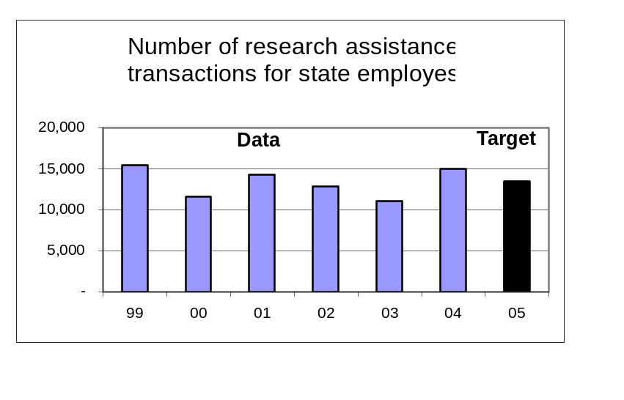Data Source: Internal count recorded by Library staff compiled quarterly.
Key Performance Measure Analysis

To what goal(s) is this performance measure linked?
Goal: Improve library services to state government; increase usage and user satisfaction.

What do benchmark (or other high-level outcome) data say about Oregon relative to the goal(s)? What is the impact of your agency?
More state government employees are turning to the State Library to meet their high-level information needs.

How does the performance measure demonstrate agency progress toward the goal?
The data shows a 36% increase in information transactions that is attributed to improved information products, more effective marketing and training of state agency customers, and improved tracking of research assistance transactions using a new automated tracking system.

Compare actual performance to target and explain any variance.
The State Library Board did not set a target for 2004, but the result for 2004 exceeds the target the Board set for the end of the biennium in 2005.

Summarize how actual performance compares to any relevant public or private industry standards.
There are no standards for research assistance transactions for state employees from state library agencies.

What is an example of a department activity related to the measure?
The State Library’s SmartORgov website (www.SmartORgov.org) provides a comprehensive suite of commercial information databases for our state government customers, in addition to the combined library catalogs of the State Library, the State of Oregon Law Library, the Willamette University Hatfield Library, and the Willamette University Law Library.

What needs to be done as a result of this analysis?
We are making plans to move SmartORgov to the new Govnet intranet for state agencies. By being a highly visible part of Govnet we hope to continue to increase the number of research assistance transactions for our customers.
Annual Performance Report- Part II, Key Measure Analysis
Time Period: Fiscal Year 2003 – 2004

Agency Name: State Library |  |  |  |  | Agency No.: 54300
Key Performance Measure (KPM) |  | 1999 | 2000 | 2001 |  | 2002 | 2003 | 2004 | 2005 | 2006 |  | 2007
# 54300-2. Percent of state agency customers rating service “very good” or “excellent.” | Target |  |  |  |  |  |  |  | 80%
 | Data | 74% |  | 85% |  | 88% | 89%
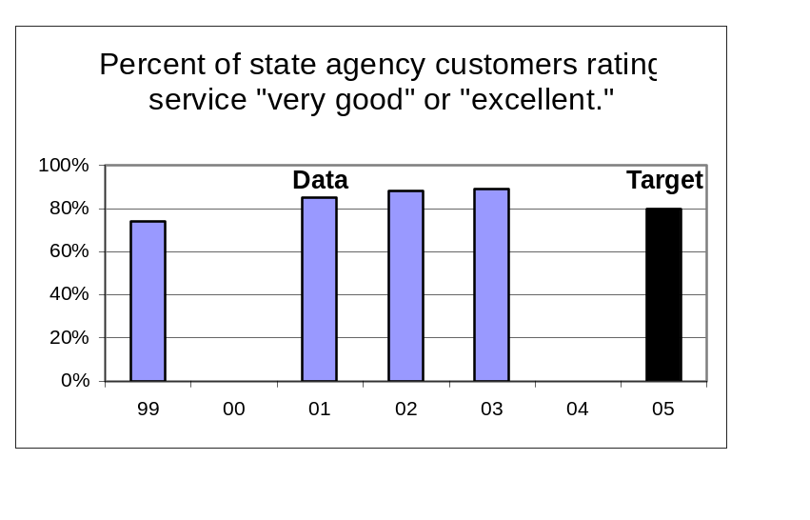Data Source: Annual customer satisfaction survey conducted by Library staff.

Key Performance Measure Analysis

To what goal(s) is this performance measure linked?
Goal: Improve library services to state government; increase usage and user satisfaction.

What do benchmark (or other high-level outcome) data say about Oregon relative to the goal(s)? What is the impact of your agency?
More state government employees are turning to the State Library to meet their high-level information needs, and are satisfied with the service they receive.

How does the performance measure demonstrate agency progress toward the goal?
The 2003 survey shows a 5% increase in customers giving high marks to State Library services.

Compare actual performance to target and explain any variance.
The State Library Board did not set a target for 2004, but the result for 2004 exceeds the target the Board set for the end of the biennium in 2005.

Summarize how actual performance compares to any relevant public or private industry standards.
There are no standards for research assistance transactions for state employees from state library agencies.

What is an example of a department activity related to the measure?
The increase in satisfaction is related to the library’s leading-edge implementation of automated and Web-based information services via our SmartORgov website. These include: 1) addition of multiple direct user online databases; 2) fast and efficient Web delivery of customer-requested print copy images and electronic text; 3) library staff marketing and training efforts, introducing customers to online Web-based information services and supplementary library services.

What needs to be done as a result of this analysis?
We will continue to improve Web-based information services and information request delivery methods in order to maintain our high level of customer satisfaction.
Annual Performance Report- Part II, Key Measure Analysis
Time Period: Fiscal Year 2003 – 2004

Agency Name: State Library |  |  |  |  | Agency No.: 54300
Key Performance Measure (KPM) |  | 1999 | 2000 | 2001 |  | 2002 | 2003 | 2004 | 2005 | 2006 |  | 2007
#54300-3. Percent of state employees registered to use SmartORgov | Target |  |  |  |  |  |  |  | 20%
 | Data | 8% | 9% | 12% |  | 14% | 15% | 15%
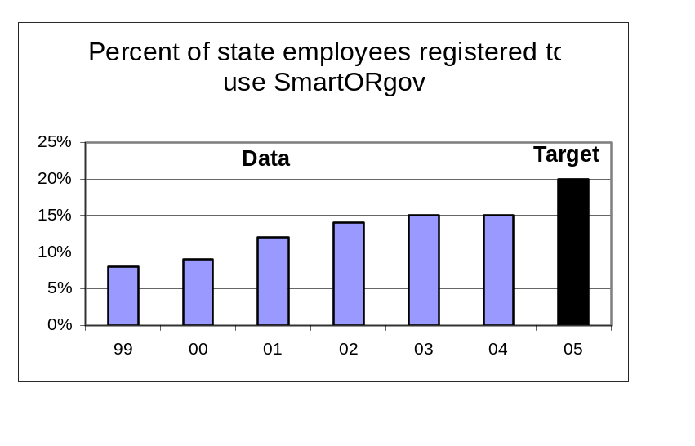Data Source: Internal count recorded by Library staff divided by an adjusted count of state employees obtained from DAS HRSD; calculated quarterly.

Key Performance Measure Analysis

To what goal(s) is this performance measure linked?
Goal: Improve library services to state government; increase usage and user satisfaction.

What do benchmark (or other high-level outcome) data say about Oregon relative to the goal(s)? What is the impact of your agency?
Growth in the number of state employees using our website has stalled in the past three years.

How does the performance measure demonstrate agency progress toward the goal?
Different strategies will have to be pursued to increase the number of state employees using our website to obtain information.

Compare actual performance to target and explain any variance.
The State Library Board did not set a target for 2004, but it will be a challenge to meet the biennial target set by the Board.

Summarize how actual performance compares to any relevant public or private industry standards.
There are no standards for the percentage of state employees registered to use an advanced Web-based information system at a state library agency.

What is an example of a department activity related to the measure?
In the past year we have conducted 34 marketing and training sessions for state agency employees, including the popular “Desktop Learning” trainings that instruct agency employees on how to use SmartORgov and other State Library services.

What needs to be done as a result of this analysis?
We developed a new training plan this year that involves taking more training to state employees outside of the Salem-area and providing more specialized training. We also plan to redesign and move SmartORgov to be a highly visible component of the new Govnet intranet system for state employees.

Annual Performance Report- Part II, Key Measure Analysis
Time Period: Fiscal Year 2003 – 2004

Agency Name: State Library |  |  |  |  | Agency No.: 54300
Key Performance Measure (KPM) |  | 1999 | 2000 | 2001 |  | 2002 | 2003 | 2004 | 2005 | 2006 |  | 2007
#54300-4. Average number of daily visits to SmartORgov | Target |  |  |  |  |  |  |  | 400
#54300-4. Average number of daily visits to SmartORgov | Data |  |  |  |  | 200 | 180 | 316
Data Source: Counted by SmartORgov system software.
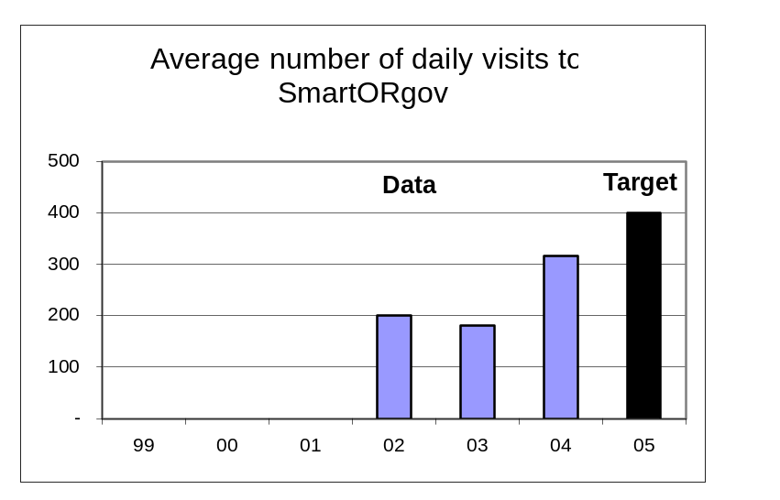

Key Performance Measure Analysis

To what goal(s) is this performance measure linked?
Goal: Improve library services to state government; increase usage and user satisfaction.

What do benchmark (or other high-level outcome) data say about Oregon relative to the goal(s)? What is the impact of your agency?
Though we aren’t seeing more state employees use our information website, the ones that do are using it more.

How does the performance measure demonstrate agency progress toward the goal?
Data shows a 76% increase in usage from 2002-2003. This is the result of our marketing and training efforts and improvements to the quality and quantity of electronic resources available on SmartORgov.

Compare actual performance to target and explain any variance.
The State Library Board did not set a target for 2004, but we are on track to achieve the target for 2005.

Summarize how actual performance compares to any relevant public or private industry standards.
There are no standards for the average number of daily visits to an advanced Web-based information system at a state library agency.

What is an example of a department activity related to the measure?
This year we implemented the “One Search” search engine to allow easy searching for information across all of the licensed databases and library catalogs, making SmartORgov easier to use for our state agency customers.

What needs to be done as a result of this analysis?
By moving SmartORgov to the Govnet intranet for state employees we believe we can continue to see growth in the use of SmartORgov.
Annual Performance Report- Part II, Key Measure Analysis
Time Period: Fiscal Year 2003 – 2004

Agency Name: State Library |  |  |  |  | Agency No.: 54300
Key Performance Measure (KPM) |  | 1999 | 2000 | 2001 |  | 2002 | 2003 | 2004 | 2005 | 2006 |  | 2007
#54300-5. Number of individuals registered to receive Talking Book and Braille Services | Target |  |  |  |  |  |  |  | 7,000
 | Data | 6,978 | 6,588 | 6,574 |  | 6,328 | 6,174 | 6,726
Data Source: Internal count recorded by Talking Book and Braille Services staff; calculated quarterly.
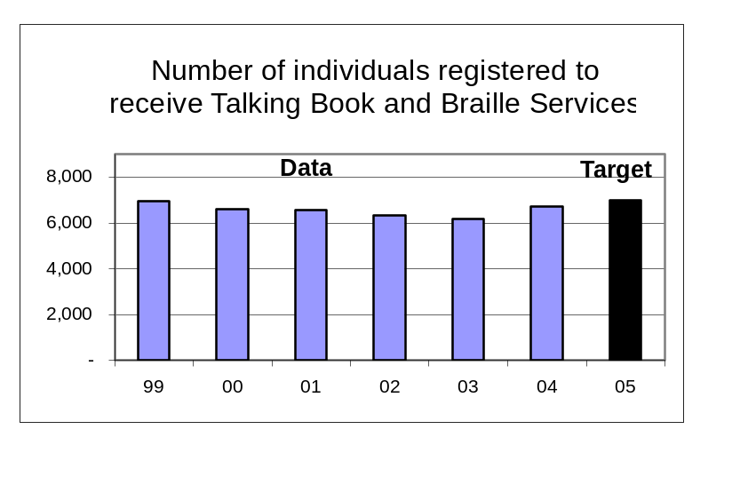

Key Performance Measure Analysis
To what goal(s) is this performance measure linked?
Goal: Improve, adapt, and market talking book and Braille services to a growing user population.

What do benchmark (or other high-level outcome) data say about Oregon relative to the goal(s)? What is the impact of your agency?
This year we saw a positive impact on the percent of Oregonians with print-related disabilities who have the same access to reading materials as other Oregonians.

How does the performance measure demonstrate agency progress toward the goal?
Through increased outreach and marketing the Talking Book and Braille Services staff was able to achieve an 8.9% growth in registration.

Compare actual performance to target and explain any variance.
The State Library Board did not set a target for 2004, but we are on track to achieve the target for 2005.

Summarize how actual performance compares to any relevant public or private industry standards.
There are no standards for this performance measure. A 2002 study showed that Talking Book and Braille Services served 13% of the eligible population in Oregon as compared to an average of 12% for seven comparable state programs (AZ, CO, IA, MN, OR, WA, WI).

What is an example of a department activity related to the measure?
Recently, Talking Book and Braille Services has actively promoted its services through disability support groups, retirement facilities, health care facilities, assisted care residences, and public libraries. We partnered with the Oregon Commission for the Blind to participate in their Independence Fairs in several locations throughout the state.
What needs to be done as a result of this analysis?
TBABS needs to promote its services to a targeted market with the aid of a long-range plan, paid advertising, and services that appeal to potential users, such as digital talking books that play on CD players.
Annual Performance Report- Part II, Key Measure Analysis
Time Period: Fiscal Year 2003 – 2004

Agency Name: State Library |  |  |  |  | Agency No.: 54300
Key Performance Measure (KPM) |  | 1999 | 2000 | 2001 |  | 2002 | 2003 | 2004 | 2005 | 2006 |  | 2007
#54300-6. Number of talking books and Braille books checked out per year. | Target |  |  |  |  |  |  |  | 375,000
 | Data | 368,465 | 369,234 | 358,827 |  | 348,224 | 345,833 | 354,410
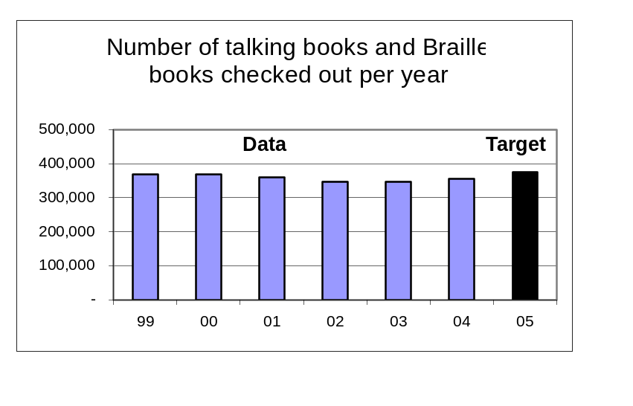Data Source: Counted by the Talking Book and Braille Services check-out system software.

Key Performance Measure Analysis

To what goal(s) is this performance measure linked?
Goal: Improve, adapt, and market talking book and Braille services to a growing user population.

What do benchmark (or other high-level outcome) data say about Oregon relative to the goal(s)? What is the impact of your agency?
In 2004 the Library reversed a two-year downward trend in the use of Talking Book and Braille Services.

How does the performance measure demonstrate agency progress toward the goal?
The 2.4% increase in check-outs in 2004 can be attributed to the fact that the unit was fully staffed for most of 2004 and new staff are highly motivated to provide excellent services to our customers.

Compare actual performance to target and explain any variance.
The State Library Board did not set a target for 2004, but we are on track to achieve the target for 2005.

Summarize how actual performance compares to any relevant public or private industry standards.
There are no standards for this performance measure. A 2002 study showed that Talking Book and Braille Services had the highest annual checkouts per registered borrower (53) of seven comparable state programs (AZ, CO, IA, MN, OR, WA, WI).

What is an example of a department activity related to the measure?
In early 2004 we installed a new automated check-out and catalog system purchased entirely with funds donated to Talking Book and Braille Services, mostly by customers. This will help our staff become more productive and help maintain an accurate count of checkouts, something that was occasionally a problem in the past.
What needs to be done as a result of this analysis?
The staff plans to use the new automated system to better define the reading profiles of each customer to improve service. The staff also plans to contact customers who have not used the service recently.

Annual Performance Report- Part II, Key Measure Analysis
Time Period: Fiscal Year 2003 – 2004

Agency Name: State Library |  |  |  |  | Agency No.: 54300
Key Performance Measure (KPM) |  | 1999 | 2000 | 2001 |  | 2002 | 2003 | 2004 | 2005 | 2006 |  | 2007
#54300-7. Percent of Talking Book and Braille services customers rating service “very good” or "excellent” | Target |  |  |  |  |  |  |  | 92%
 | Data |  | 92% |  |  |  | 93%
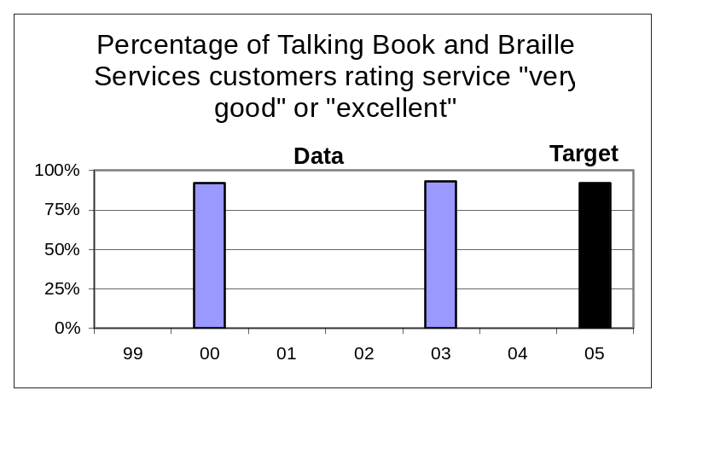Data Source: Biennial customer satisfaction survey conducted by Talking Book and Braille Services staff.
Key Performance Measure Analysis
To what goal(s) is this performance measure linked?
Goal: Improve, adapt, and market talking book and Braille services to a growing user population.

What do benchmark (or other high-level outcome) data say about Oregon relative to the goal(s)? What is the impact of your agency?
Talking Book and Braille Services has maintained the high satisfaction rating by its customers.

How does the performance measure demonstrate agency progress toward the goal?
The biennial target was met.

Compare actual performance to target and explain any variance.
The State Library Board did not set a target for 2004, but we exceeded the biennial target

Summarize how actual performance compares to any relevant public or private industry standards.
There are no standards for this performance measure.

What is an example of a department activity related to the measure?
Staff makes personal contact with customers as much as possible.
What needs to be done as a result of this analysis?
TBABS staff will be increasing our contact with customers via a plan to personally contact each customer at least once a year to verify recorded information and inquire if any changes in service are needed.

Annual Performance Report- Part II, Key Measure Analysis
Time Period: Fiscal Year 2003 – 2004

Agency Name: State Library |  |  |  |  | Agency No.: 54300
Key Performance Measure (KPM) |  | 1999 | 2000 | 2001 |  | 2002 | 2003 | 2004 | 2005 | 2006 |  | 2007
#54300-8. Total donations to Talking Book and Braille Services. | Target |  |  |  |  |  |  |  | $95,000
 | Data | $68,225 | $102,016 | $138,309 |  | $77,609 | $119,777 | $167,020
Data Source: Internal accounting by the State Library Business Office.
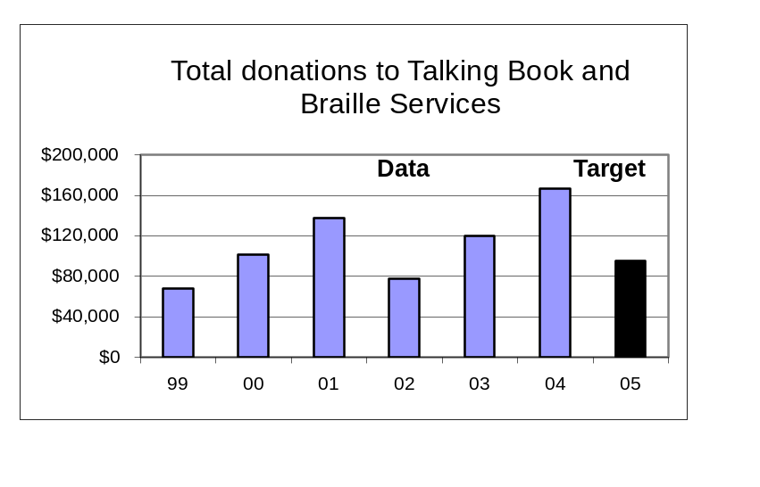
Key Performance Measure Analysis
To what goal(s) is this performance measure linked?
Goal: Improve, adapt, and market talking book and Braille services to a growing user population.

What do benchmark (or other high-level outcome) data say about Oregon relative to the goal(s)? What is the impact of your agency?
With continued support for our fund development efforts such as we saw in 2004 we will have a better chance of reaching our goal of serving more eligible Oregonians with Talking Book and Braille Services.

How does the performance measure demonstrate agency progress toward the goal?
The 39% increase in income from our fund development program, mostly from users of the program, indicates strong support for program enhancements and for building the endowment fund.
Compare actual performance to target and explain any variance.
The State Library Board did not set a target for 2004, but we exceeded the biennial target

Summarize how actual performance compares to any relevant public or private industry standards.
There are no standards for this performance measure.

What is an example of a department activity related to the measure?
We conduct two annual solicitations and also encourage memorial gifts and planned giving. This year we received a bequest for the endowment fund that totaled $49,313.
What needs to be done as a result of this analysis?
We plan to make a stronger effort to encourage planned giving in order to attract some major support for the Talking Book Library Endowment Fund in future years.

Annual Performance Report- Part II, Key Measure Analysis
Time Period: Fiscal Year 2003 – 2004

Agency Name: State Library |  |  |  |  | Agency No.: 54300
Key Performance Measure (KPM) |  | 1999 | 2000 | 2001 |  | 2002 | 2003 | 2004 | 2005 | 2006 |  | 2007
#54300-9. Percentage increase in local public library services to children. | Target |  |  |  |  |  |  |  | 10%
 | Data | 0% | 10% | 9% |  | 6% | 8%
Data Source: Internal accounting by the State Library Business Office.
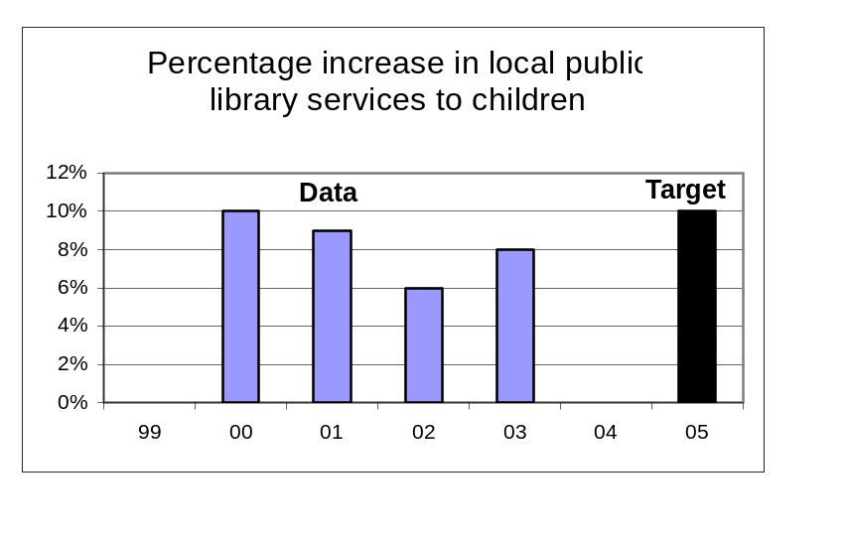

Key Performance Measure Analysis

To what goal(s) is this performance measure linked?
Goal: Lead public libraries to achieve excellence in services to children.

What do benchmark (or other high-level outcome) data say about Oregon relative to the goal(s)? What is the impact of your agency?
Oregon public libraries were able to increase growth in library services to children (book check-outs and program participation) in 2002-03 from 6% to 8%. Research shows this will impact the percentage of Oregon children entering school ready-to-learn.

How does the performance measure demonstrate agency progress toward the goal?
State funds provided by the State Library through the Ready to Read Grant program continue to leverage strong commitment and effort in local libraries that result in increased services to children. This occurred despite funding reductions to the program in 2002.
Compare actual performance to target and explain any variance.
The State Library Board did not set a target for 2004. It may be difficult to reach the biennial target due to funding reductions.

Summarize how actual performance compares to any relevant public or private industry standards.
There are no standards for this performance measure.

What is an example of a department activity related to the measure?
The State Library made 124 Ready to Read Grants to local public libraries in 2003-04 totaling $574,532. Funding was reduced by 18% from the prior year. The State Library staff also conducted an internal program evaluation that was presented to the State Library Board in August, 2003.
What needs to be done as a result of this analysis?
The State Library Board will appoint a task force to review the staff evaluation of the program and to make recommendations for future program improvements.

Annual Performance Report- Part II, Key Measure Analysis
Time Period: Fiscal Year 2003 – 2004

Agency Name: State Library |  |  |  |  | Agency No.: 54300
Key Performance Measure (KPM) |  | 1999 | 2000 | 2001 |  | 2002 | 2003 | 2004 | 2005 | 2006 |  | 2007
#54300-10. Percentage increase in interlibrary lending. | Target |  |  |  |  |  |  |  | 15%
#54300-10. Percentage increase in interlibrary lending. | Data | -1% | 28% | 19% |  | 19% | 13%
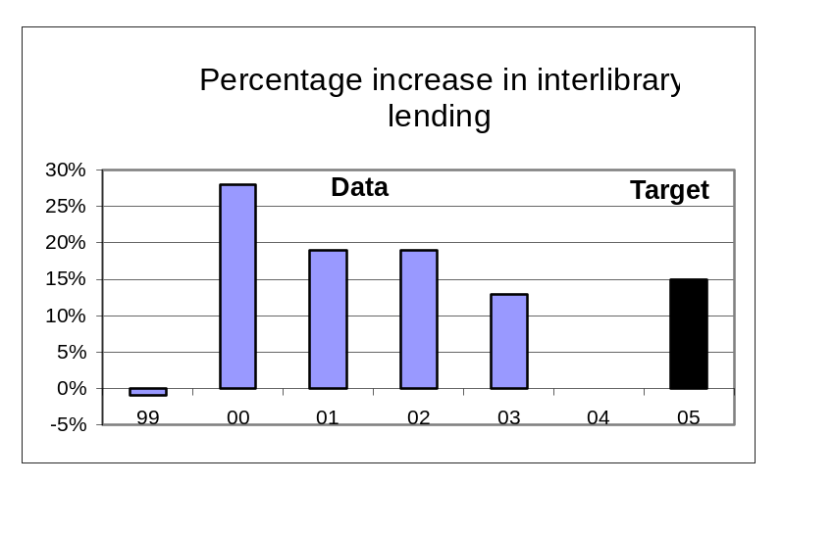Data Source: Derived from annual survey conducted by State Library staff of all public and academic libraries.

Key Performance Measure Analysis

To what goal(s) is this performance measure linked?
Goal: Take a leadership role in developing a comprehensive statewide library resource sharing network, including improved citizen access to government information.
What do benchmark (or other high-level outcome) data say about Oregon relative to the goal(s)? What is the impact of your agency?
The State Library is impacting the percentage of Oregonians who are able to access information from any Oregon library through grant support for shared library automated resource sharing systems.

How does the performance measure demonstrate agency progress toward the goal?
The growth in interlibrary lending that we saw several years ago is moderating. In 2000 and 2001 there was rapid growth in library consortia like the Orbis academic library consortium and the Southern Oregon Library Information System. Consortial membership activity has waned in recent years which accounts for slower growth.

Compare actual performance to target and explain any variance.
The State Library Board did not set a target for 2004, but the Library is on track to meet the goal for 2005.

Summarize how actual performance compares to any relevant public or private industry standards.
There are no standards for this performance measure.

What is an example of a department activity related to the measure?
The State Library and the Oregon Library Association helped to pass SB 12 in the 2003 Legislative Assembly. The bill eliminated a program that reimbursed libraries that made more interlibrary loans than they borrowed for their own users. But it left in place a requirement that Oregon libraries not charge other Oregon libraries for interlibrary loans in order to participate in other State Library resource sharing programs.
What needs to be done as a result of this analysis?
Continue current activities with the exception of the net lender reimbursement program.
Annual Performance Report- Part II, Key Measure Analysis
Time Period: Fiscal Year 2003 – 2004

Agency Name: State Library |  |  |  |  | Agency No.: 54300
Key Performance Measure (KPM) |  | 1999 | 2000 | 2001 |  | 2002 | 2003 | 2004 | 2005 | 2006 |  | 2007
#54300-11. Average daily visits to the FindOR government information locator system. | Target |  |  |  |  |  |  |  | 2,220
 | Data |  |  |  |  |  | 910 | 1,185
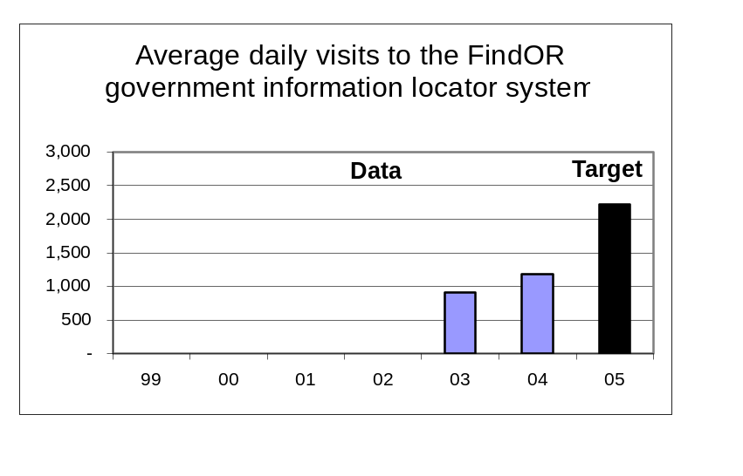Data Source: Counted by FindOR system software.

Key Performance Measure Analysis

To what goal(s) is this performance measure linked?
Goal: Take a leadership role in developing a comprehensive statewide library resource sharing network, including improved citizen access to government information.
What do benchmark (or other high-level outcome) data say about Oregon relative to the goal(s)? What is the impact of your agency?
The State Library is impacting the ability of Oregonians to access information about state government on Oregon.gov.

How does the performance measure demonstrate agency progress toward the goal?
The average daily use of FindOR grew by 30% between FY 2003 and 2004. However, the annual growth masks a steep decline in use in recent months which we attribute to the new Oregon.gov home page design that offers two alternative ways to navigate the site. In the last quarter of FY 2004, the average daily visits were only 565.

Compare actual performance to target and explain any variance.
The State Library Board did not set a target for 2004, but it is unlikely that the goal for 2005 will be met.

Summarize how actual performance compares to any relevant public or private industry standards.
There are no standards for this performance measure.

What is an example of a department activity related to the measure?
The Library provides training to agency personnel in metatag enrichment of agency Web sites, and in effectively using the search engine.

What needs to be done as a result of this analysis?
Continue working with agencies to improve FindOR performance to make it the most efficient way to access specific information (reports, etc.) on state agency websites.

Annual Performance Report- Part II, Key Measure Analysis
Time Period: Fiscal Year 2003 – 2004

Agency Name: State Library |  |  |  |  | Agency No.: 54300
Key Performance Measure (KPM) |  | 1999 | 2000 | 2001 |  | 2002 | 2003 | 2004 | 2005 | 2006 |  | 2007
#54300-12. Number of public libraries making improvements to achieve OBM #38 minimum service criteria. | Target |  |  |  |  |  |  |  | 3
 | Data | 4 | 10 | 10 |  | 2 | 1
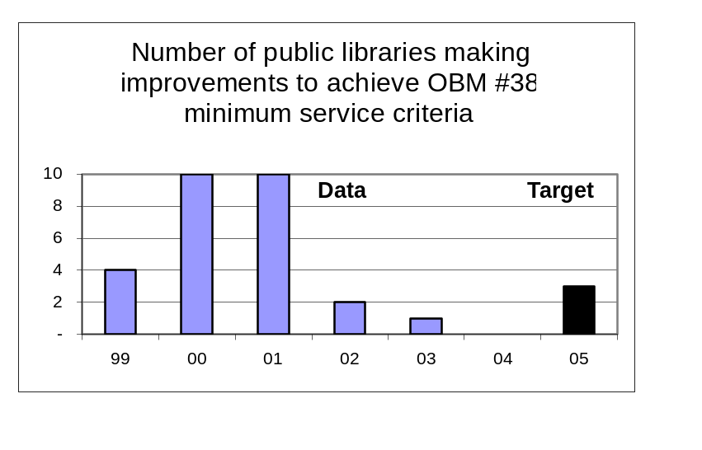Data Source: Derived from annual survey conducted by the State Library of all Oregon public libraries.

Key Performance Measure Analysis

To what goal(s) is this performance measure linked?
Goal: Assist local communities to develop school and public library services for unserved and underserved Oregonians.
What do benchmark (or other high-level outcome) data say about Oregon relative to the goal(s)? What is the impact of your agency?
The State Library was unable to have much impact on the percent of Oregonians served by a public library that meets minimum service criteria in 2003.

How does the performance measure demonstrate agency progress toward the goal?
In 2000 and 2001 the State Library offered incentive grants to public libraries not meeting the minimum standards. But most libraries could not sustain the improvements when the grant funds ran out, so the strategy was changed to support grassroots organizations working for sustainable improvement.
Compare actual performance to target and explain any variance.
The State Library Board did not set a target for 2004. We are still hoping to meet our biennial goal for 2005.

Summarize how actual performance compares to any relevant public or private industry standards.
There are no standards for this performance measure.

What is an example of a department activity related to the measure?
In recent years we have funded the Lane Library League, the Linn Library League and other grassroots organizations and efforts to plan for permanent and sustainable improvement in local library services, usually involving the creation of a library taxing district. We expect to see these efforts achieve results beginning in 2005.
What needs to be done as a result of this analysis?
Continue with the current strategy of making federal Library Services and Technology Act Grants and providing other assistance to grassroots organizations working to improve libraries.
Annual Performance Report- Part II, Key Measure Analysis
Time Period: Fiscal Year 2003 – 2004

Agency Name: State Library |  |  |  |  | Agency No.: 54300
Key Performance Measure (KPM) |  | 1999 | 2000 | 2001 |  | 2002 | 2003 | 2004 | 2005 | 2006 |  | 2007
#54300-13. Number of schools making improvements to achieve Oregon Quality Education Model standards for school libraries. | Target |  |  |  |  |  |  |  | 10
 | Data
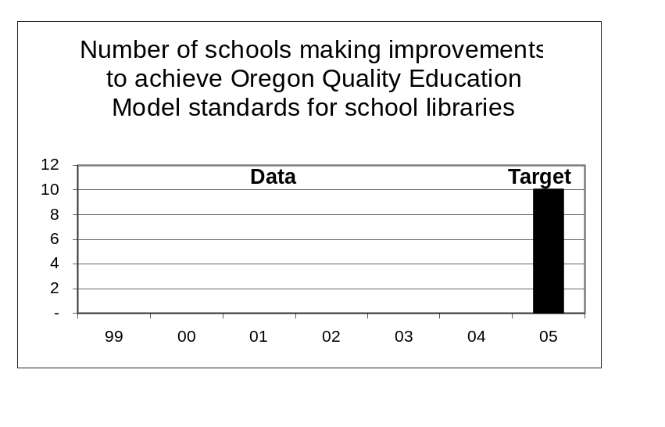Data Source: Derived from annual data collection from school districts conducted by the Oregon Department of Education.

Key Performance Measure Analysis

To what goal(s) is this performance measure linked?
Goal: Assist local communities to develop school and public library services for unserved and underserved Oregonians.
What do benchmark (or other high-level outcome) data say about Oregon relative to the goal(s)? What is the impact of your agency?
[New]
Performance measure is in development and will be tested by August 2004.
How does the performance measure demonstrate agency progress toward the goal?
We cannot assess agency progress at this time.
Compare actual performance to target and explain any variance.
The State Library Board did not set a target for 2004. We are still hoping to meet our biennial goal for 2005.

Summarize how actual performance compares to any relevant public or private industry standards.
There are no standards for this performance measure.

What is an example of a department activity related to the measure?
The State Library is working with the Oregon Department of Education to improve the presentation and distribution of school library statistics to the K-12 community. Access to these data will assist schools in determining how well they are meeting OQEM standards and for making improvements.
What needs to be done as a result of this analysis?
Once the analysis is available we will work with the Oregon Educational Media Association to develop improvement strategies.

.
Annual Performance Report- Part II, Key Measure Analysis
Time Period: Fiscal Year 2003 – 2004

Agency Name: State Library |  |  |  |  | Agency No.: 54300
Key Performance Measure (KPM) |  | 1999 | 2000 | 2001 |  | 2002 | 2003 | 2004 | 2005 | 2006 |  | 2007
#54300-14. Average number of hours of training per FTE staff member. | Target |  |  |  |  |  |  |  | 25
 | Data | 21 | 22 | 28 |  | 16 | 11 | 29
Data Source: Internal count recorded by Library Administrative Services.
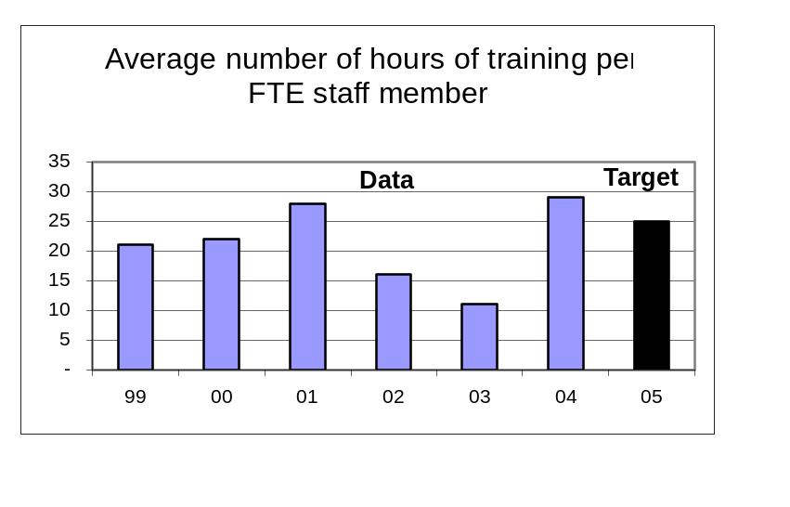

Key Performance Measure Analysis

To what goal(s) is this performance measure linked?
Goal: Support staff development, participation, and innovation to achieve continuous quality improvement.
What do benchmark (or other high-level outcome) data say about Oregon relative to the goal(s)? What is the impact of your agency?
This is an internal organizational development goal that does not directly impact a benchmark or high level outcome.
How does the performance measure demonstrate agency progress toward the goal?
The data reveals a significant increase in training hours beginning in 2003 and continuing through 2004. The increase is the result of several factors, including implementation of a new performance review and developmental planning process, increased attention to job-related training opportunities, and increased availability of training workshops provided by the Department of Administrative Services and the Department of Consumer and Business Services.
Compare actual performance to target and explain any variance.
The State Library Board did not set a target for 2004, but we exceeded the biennial goal in 2004 and hope to do so again in 2005.

Summarize how actual performance compares to any relevant public or private industry standards.
There are no standards for this performance measure.

What is an example of a department activity related to the measure?
We completed current training and development plans for all employees.
What needs to be done as a result of this analysis?
We need to continue the emphasis on accurate data collection and continue to focus on updating and following through on employee development plans.
Annual Performance Report- Part II, Key Measure Analysis
Time Period: Fiscal Year 2003 – 2004

Agency Name: State Library |  |  |  |  | Agency No.: 54300
Key Performance Measure (KPM) |  | 1999 | 2000 | 2001 |  | 2002 | 2003 | 2004 | 2005 | 2006 |  | 2007
#54300-15. Number of FTE below affirmative action parity goal for women, disabled persons, and persons of color. | Target |  |  |  |  |  |  |  | 4.0
 | Data | 7.5 | 6.9 | 4.7 |  | 6.0 | 4.2 | 5.1
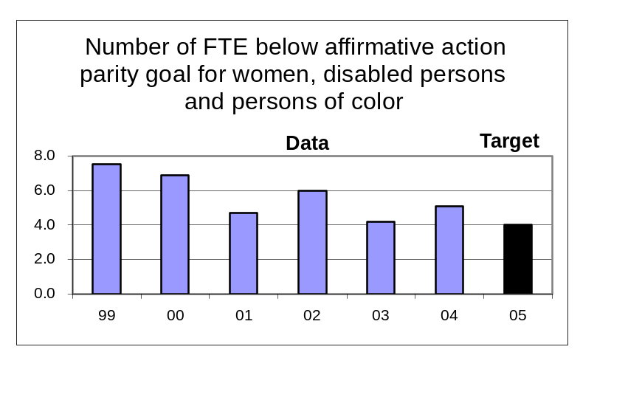Data Source: Reported to the Library quarterly by the Department of Administrative Services.

Key Performance Measure Analysis

To what goal(s) is this performance measure linked?
Goal: Support staff development, participation, and innovation to achieve continuous quality improvement.
What do benchmark (or other high-level outcome) data say about Oregon relative to the goal(s)? What is the impact of your agency?
This is an internal organizational development goal that does not directly impact a benchmark or high level outcome.
How does the performance measure demonstrate agency progress toward the goal?
The data reveals that the Library has made overall progress towards achieving parity goals. Very few persons with disabilities or people of color have obtained a Master of Library and Information Science degree, creating a small pool of qualified professional librarians from which to recruit. The current method of establishing parity goals is statistically designed for large agencies and does not provide accurate goals or data for use by smaller agencies. The current data system is under review with the goal of improving the usefulness and accuracy of the reports and goals for smaller agencies.
Compare actual performance to target and explain any variance.
The State Library Board did not set a target for 2004, but we hope to be able to meet the biennial target for 2005.

Summarize how actual performance compares to any relevant public or private industry standards.
The parity goals for women, disabled persons, and persons of color constitute standards that we strive to meet.

What is an example of a department activity related to the measure?
Extensive recruiting among minority groups for vacant positions at the State Library.
What needs to be done as a result of this analysis?
Participate in the revision of the state Affirmative Action data reporting and parity setting system. Work with the Governor’s Office of Affirmative Action to continue improving creative recruitment methods to increase our pool of qualified minority applicants.
Annual Performance Report- Part II, Key Measure Analysis
Time Period: Fiscal Year 2003 – 2004

Agency Name: State Library |  |  |  |  | Agency No.: 54300
Key Performance Measure (KPM) |  | 1999 | 2000 | 2001 |  | 2002 | 2003 | 2004 | 2005 | 2006 |  | 2007
#54300-16. Number of hours worked by State Library volunteers. | Target |  |  |  |  |  |  |  | 18,000
 | Data | 13,607 | 15,634 | 19,361 |  | 17,469 | 16,837 | 13,167
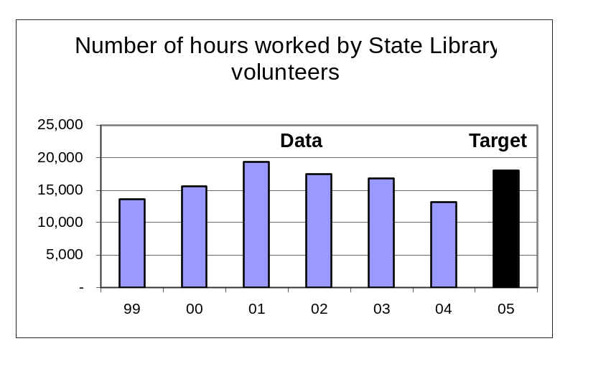Data Source: Internal count recorded by Library Administrative Services.

Key Performance Measure Analysis

To what goal(s) is this performance measure linked?
Goal: Support staff development, participation, and innovation to achieve continuous quality improvement.
What do benchmark (or other high-level outcome) data say about Oregon relative to the goal(s)? What is the impact of your agency?
This is an internal organizational development goal that does not directly impact a benchmark or high level outcome.
How does the performance measure demonstrate agency progress toward the goal?
As we have improved staff productivity through better hiring and new technology, we have improved our volunteer recruitment system by better defining the best use of volunteers, developing volunteer position descriptions and schedules needed to complete the volunteer work. We have reduced our reliance on community service workers in Talking Book and Braille Services by increasing staff productivity, utilizing a new automated library check-out and catalog system.
Compare actual performance to target and explain any variance.
The State Library Board did not set a target for 2004. It is unlikely that we will meet our biennial target given current trends and practices.

Summarize how actual performance compares to any relevant public or private industry standards.
There are no standards for this performance measure.

What is an example of a department activity related to the measure?
Work experience programs with AARP, Winema Job and Career Center Workforce Integration Program, Confederated Tribes of the Siletz and our business partner, Parrish Middle School.
What needs to be done as a result of this analysis?
To achieve the number of volunteers needed we must recruit from a broad population group that includes citizens who choose to volunteer, work experience volunteers and student volunteers.

