Improving Emergency Preparedness - Developing an Environmental Emergency Response Plan

2006 - 2007

Environmental Public Health Leadership Institute Fellow:

Michelle Clausen Rosendahl, MPH, REHS
Environmental Division Coordinator, Siouxland District Health Department
1014 Nebraska Street
Sioux City, IA 51105
712-279-6119
mclausen@sioux-city.org

Mentor:

Daneen Farrow-Collier, MSPH
Public Health Advisor, Centers for Disease Control and Prevention
Environmental Health Services Branch
National Center for Environmental Health
Division of Emergency and Environmental Health Services

Acknowledgements:

Frances Sadden, RNC, BSN, MA
Health Director, Siouxland District Health Department

Charles Cipperley, BS, RS
Deputy Director, Environmental Director, Siouxland District Health Department

Dan Weakley, BS
Laboratory Director, Siouxland District Health Department

David Peter Stroh, MA
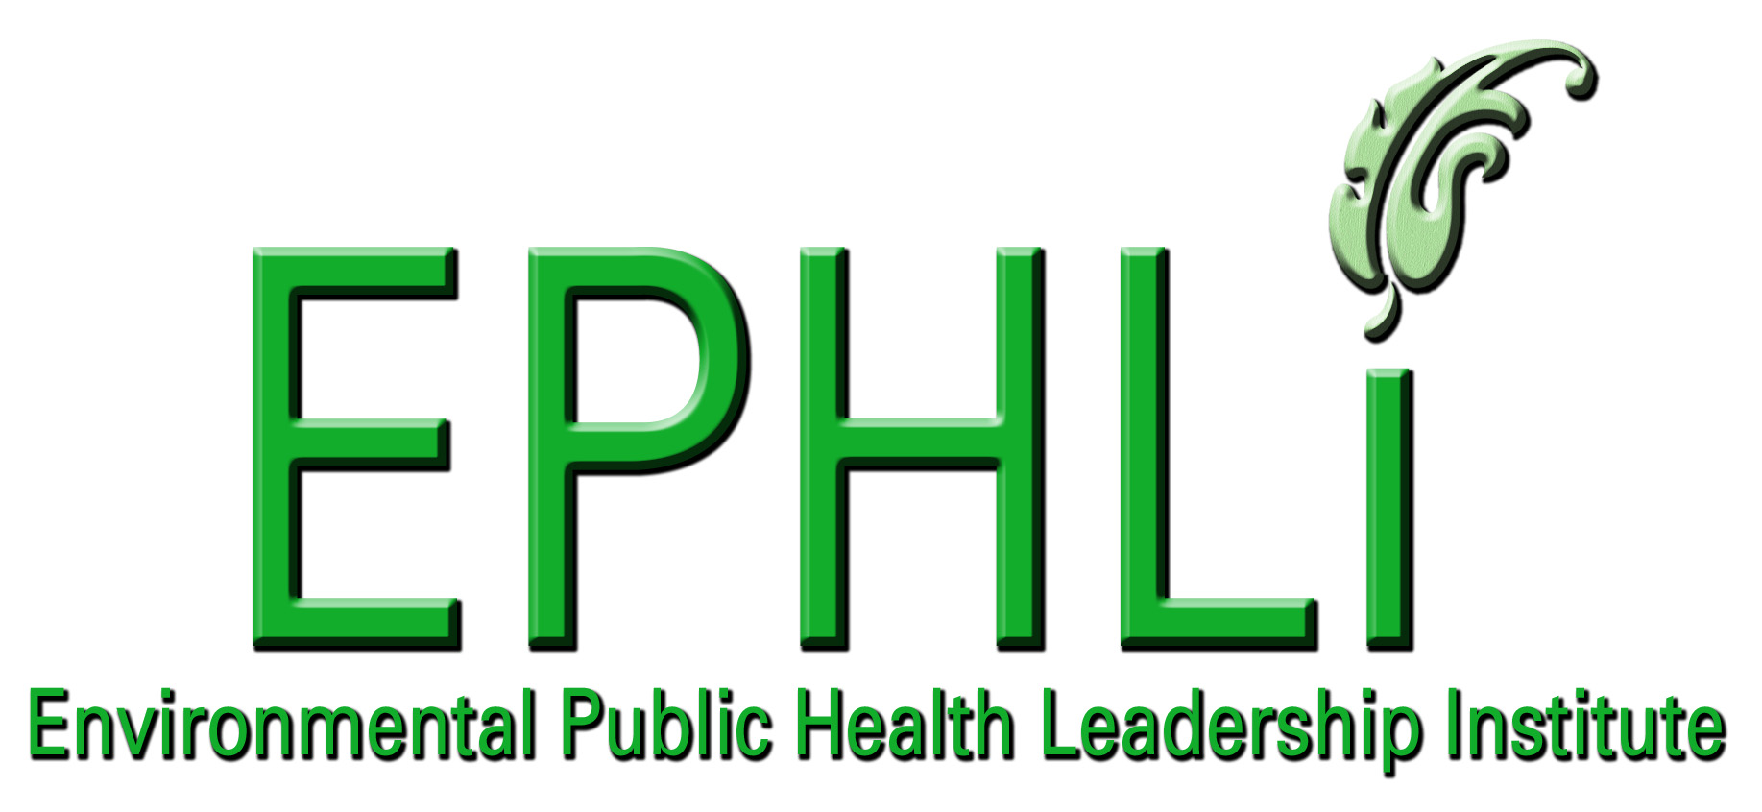
Partner, Bridgeway Partners

EXECUTIVE SUMMARY:

Public health has undergone a major change in the last few years, with public health practitioners preparing to be first responders in the event of a natural or man-made emergency event. While the Siouxland District Health Department (SDHD) has been working extensively on an emergency response plan, the lack of a specific environmental health response plan had been identified as both an organizational issue and community public health issue that needed attention. Existing plans focus primarily on setting up mass-dispensing or health assessment sites in the case of an illness outbreak, not on environmental response to a disaster such as a flood, fire, storm, contamination of the food supply, or illness outbreak.

Currently, the SDHD Environmental Division responds to emergencies on a reactive basis, instead of proactively developing a written plan for systematic response to events such as storms, fires, floods, power outages, or foodborne illness outbreaks. The overall goal of this project is to enhance the preparedness and effectiveness of the Environmental Division of SDHD in responding to environmental emergencies in order to increase safety for the public and environment, and minimize the impact during an event. To do this, the Environmental Division is developing a written environmental health emergency response plan, including procedures, roles and responsibilities, training needs, equipment inventory and needs, and a contact directory. Following completion, the Division will go through the process of implementation, including distribution and training, equipment acquisition, schedule for review, exercising and assessment, and integration of the environmental plan with the overall emergency response plans of the Department and greater Siouxland area.

INTRODUCTION/BACKGROUND:

The need for environmental emergency preparedness planning has become especially evident due to several factors including:
- Recent emergencies and other events that have reinforced the need for a systematic, pre-planned response – such as 9/11/01, Hurricanes Katrina and Rita, and also other less-serious events such as a foodborne illness outbreak, power outage, or snowstorm.
- Media and other coverage has highlighted the role of the environmental health practitioner and made the public more aware of their role in environmental emergencies, which increases expectations of the public.
- The State of Iowa will be requiring local agencies holding state contracts to develop a working plan.
- Current funding is probably as good as it will ever be for items related to emergency response and preparedness.
- Environmental Division employees need and want to know what their role will be and what expectations others will have of them during an emergency.

Problem Statement:
The Siouxland District Health Department Environmental Division responds to emergencies on a reactive basis, instead of proactively developing a written plan for systematic response to events such as storms, fires, floods, power outages, or illness outbreaks.

To enhance the preparedness and effectiveness of the Environmental Division of the Siouxland District Health Department in responding to environmental emergencies in order to increase safety for the public and environment, and minimize the impact during an event, a written plan will be developed and implemented.

Behavior Over Time Graph:

Figure 1: Behavior over time graph indicating that the ability to respond systematically to an environmental emergency or event has remained static, even though the organizational and public demand for an organized and prepared response has increased dramatically. Financial resources available for emergency planning have also increased considerably; however, are now back on the decline.

Causal Loop Diagrams and applicable archetypes:

Figure 2: Causal loop diagram detailing an archetype of Shifting the Burden where the long term fix is the development of a written environmental emergency response plan; however, the short term fixes of assuming someone else has already assembled a suitable plan and handling problems as they arise leading to the belief that a plan is not needed prevent a comprehensive plan from being developed.

10 Essential Environmental Health Services:

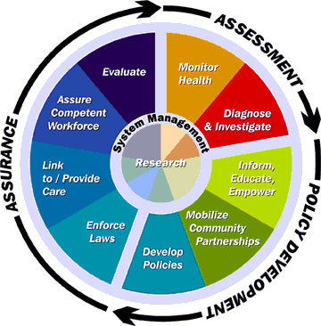

Figure 3: Relationship of the core functions of public health with the ten essential services.
Source: Public Health Functions Steering Committee (July 1995) ¹

The fundamental obligations of public health include: preventing epidemics and spread of disease, protecting against environmental hazards, preventing injuries, promoting and encouraging healthy behaviors and mental health, responding to disasters and assisting communities in recovery, and assuring the quality and accessibility of health services.² The core functions and essential services provide the framework for meeting these obligations. Environmental emergency response preparedness planning supports many of the essential services, primarily the following:

Essential Service #3 - Inform, educate, and empower people about health issues.
- Through prior planning and employee training, we will be more prepared to develop and deliver a clear, consistent message to the public including information and instructions in the event of an emergency.

Essential Service #4 - Mobilize community partnerships to identify and solve health problems.
- SDHD has been part of a community-wide emergency planning team for several years. The addition of an environmental component to the plan will further clarify what services we have to offer and where we fit in with the rest of our partners. It will also open even more lines of communication and cooperation within the community.

Essential Service #5 - Develop policies and plans that support individual and community health efforts.
- The emergency response plan itself supports this essential service. In addition, the planning will ultimately identify needs and lead to the development of more written procedures.

Essential Service #6 - Enforce laws and regulations that protect health.
- During any emergency response situation, as in during routine environmental activities, applicable laws and regulations will be enforced.

Essential Service #8 - Assure a competent workforce.
- As a part of the implementation of the emergency response plan, each Environmental Division employee will receive training. This will include training on the actual plan, federal NIMS training, and any other needs identified in the associated training plan. In addition, current training records will be kept for each employee, and employees will be provided with identified necessary resources, such as disaster field manuals.

Essential Service #9 - Evaluate effectiveness, accessibility and quality of personal and population-based health services.
- It is intended that this plan will be continually evaluated and revised, throughout its development, and following implementation. As the draft plan is developed, it will be reviewed by various stakeholders in order to identify further needs and problems. Following implementation, the plan will be exercised, and also reviewed annually and changes made as needed. The true test of the plan will be when it is put to use in an actual event, and post-event evaluation is completed.

Essential Service #10 - Research for new insights and innovative solutions to health concerns.
- As a part of plan development, we will be researching plans and best practices of other jurisdictions. In addition, the state of Iowa has done extensive review of existing plans as it developed its template plan that will be used as the basis for SDHD environmental emergency planning.

National Goals Supported

CDC Health Protection Goals ³
This project directly supports the Center for Disease Control (CDC) goal of People Prepared for Emerging Health Threats, which states that people in all communities will be protected from infectious, occupational, environmental, and terrorist threats. This goal is further broken down into the following components:

Pre-Event
- Increase the use and development of interventions known to prevent human illness from chemical, biological, radiological agents, and naturally occurring health threats.
- Decrease the time needed to classify health events as terrorism or naturally occurring in partnership with other agencies.
- Decrease the time needed to detect and report chemical, biological, radiological agents in tissue, food or environmental samples that cause threats to the public’s health.
- Improve the timeliness and accuracy of communications regarding threats to the public’s health.

Event
- Decrease the time to identify causes, risk factors, and appropriate interventions for those affected by threats to the public’s health.
- Decrease the time needed to provide countermeasures and health guidance to those affected by threats to the public’s health.

Post-Event
- Decrease the time needed to restore health services and environmental safety to pre-event levels.
- Improve the long-term follow-up provided to those affected by threats to the public’s health.
- Decrease the time needed to implement recommendations from after-action reports following threats to the public’s health.

Improving emergency preparedness by developing an environmental emergency response plan for the use of SDHD and also through improved communication and cooperation between involved stakeholders will increase the ability to meet identified goals in pre-event, event, and post-event scenarios.

National Strategy to Revitalize Environmental Public Health Services ⁴
Similarly, successful environmental emergency response planning and its associated activities also support the initiatives detailed in CDC’s National Strategy to Revitalize Environmental Public Health.

Goal I - Build Capacity: Strengthen and support environmental public health services at the state, tribal, territorial, and local levels.

Goal II - Support Research: Support research to define effective approaches to enhance environmental public health services.

Goal III - Foster Leadership: Foster leadership to enhance environmental public health services.

Goal IV - Communicate and Market: Improve communication and information sharing among environmental public health agencies, communities, strategic partners, and other stakeholders, and better market environmental public health services to policy makers and the public.

Goal V - Develop the Workforce: Promote the development of a competent and effective environmental public health workforce.

Goal VI - Create Strategic Partnerships: Foster interactions among agencies, organizations, and interests that influence environmental public health services.

Project Logic Model

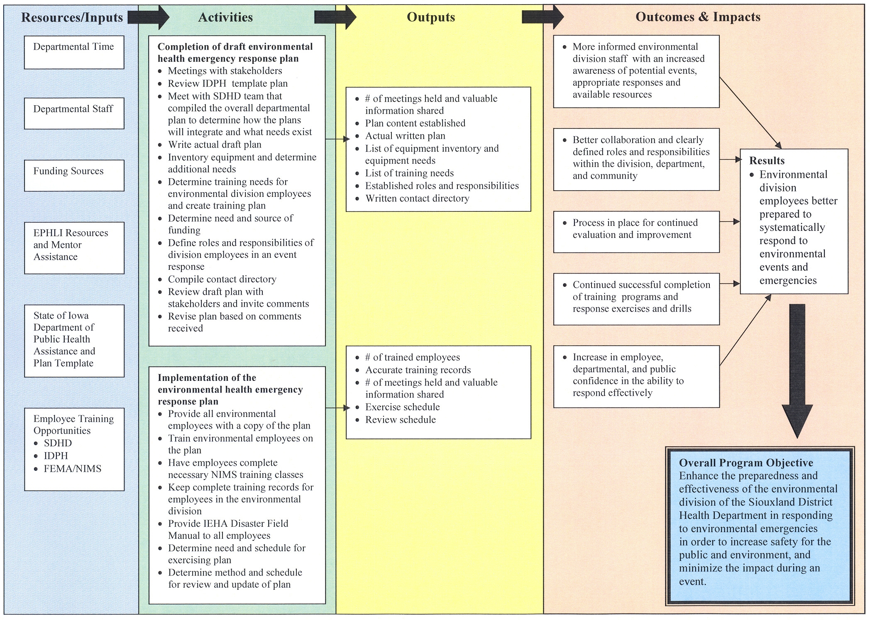

PROJECT OBJECTIVES/DESCRIPTION/DELIVERABLES:

Program Goal: To enhance the preparedness and effectiveness of the Environmental Division of the Siouxland District Health Department in responding to environmental emergencies in order to increase safety for the public and environment, and minimize the impact during an event.

Health Problem: The Siouxland District Health Department Environmental Division responds to emergencies on a reactive basis, instead of proactively developing a written plan for systematic response to events such as storms, fires, floods, power outages, or foodborne illness outbreaks.

Outcome Objective: By July 31, 2007, Siouxland District Health Department Environmental Division will have a written emergency response plan that is supported by the needed employee training.

Determinant: The potential for harm to human health in the event of an environmental emergency and the increased risks caused by the lack of a systematic plan for response.

Impact Objective: By December 31, 2007, all Environmental Division employees of the Siouxland District Health Department will be armed with the planning and training needed to respond in an effective, systematic way to a variety of environmental events.

Contributing Factors:
- Lack of staff time to assess the situation and prepare a written plan.

- Already experiencing increased workload for most environmental employees.

- Development of a Health Department emergency plan that covers primarily illness outbreaks and mass drug dispensing sites leads to the perception that we do have an emergency response plan in place that will cover all events and emergencies.

- Recent requirement from the State of Iowa that each County develop an environmental emergency response plan.

- Lack of a major environmental event within the service region to bring the problem of lack of a response plan to the forefront.

- Concern that a written plan would be too rigid and not adaptable to various situations

Process Objectives:

- By July 31, 2007, complete a draft environmental health emergency response plan including introductory information, response guidelines for particular incidents, equipment inventory and needs, training needs, defined roles and responsibilities, and other necessary information.

- By December 31, 2007, complete integration of the environmental response plan with the overall Departmental plan, train environmental employees on the plan, and complete any other training requirements such as NIMS to ensure a systematic, competent response in the event of an environmental emergency or event.

METHODOLOGY:

Event: Completion of the draft environmental health emergency response plan.

Activities:
  - Meet with necessary stakeholders to determine needs related to environmental health emergency response plan
  - Review State of Iowa’s template plan
  - Meet with SDHD team that compiled the overall Health Department emergency incident plan to determine how the plans will integrate and what needs exist
  - Write actual draft plan
  - Inventory equipment and determine additional needs
  - Determine training needs for Environmental Division employees and create training plan to include departmental training, State training, and NIMS classes
  - Determine need and source of funding
  - Define the roles and responsibilities of Division employees in an event response
  - Compile contact directory
  - Review draft plan with stakeholders and invite comments
  - Revise plan based on comments received

Event: Implementation of the environmental health emergency response plan.

Activities:
- Provide all environmental employees with a copy of the final version of the environmental health emergency response plan
- Train environmental employees on the plan
- Have employees complete the necessary NIMS training classes
- Keep complete training records for employees in the Environmental Division
- Provide Iowa Environmental Health Association Disaster Field Manual to all employees
- Acquire equipment to fill identified needs
- Determine need and schedule for exercising plan
- Determine method and schedule for review and updating of plan

RESULTS AND NEXT STEPS:

Completion of the activities outlined in this project has been progressing. Some changes have been made along the way, including the original timeline proposed for the project which ended up being too ambitious. Now we are on track to have the plan completed and approved by our Board of Health by July 2007. Implementation of the plan should then be completed by the end of the year. Another change that had to be made was in how the plan would be integrated with the overall emergency response plan for SDHD. Originally a draft of the environmental emergency response plan was to be completed, and determining how the two plans would integrate and what needs still existed was to come later. It quickly became apparent; however, that determining how the plans would integrate really needed to come first, and several meetings with the team that compiled the overall Department plan have taken place. This has been very beneficial, because it clarified what was still needed and eliminated the need to work on components that were already in existence. The environmental plan will become an annex of the overall departmental plan, which itself is an annex of a community-wide plan.

After work on this project had begun, the Iowa Department of Public Health put together a checklist of performance measures for counties to use while developing an environmental emergency response plan to ensure that certain capabilities are achieved and maintained. ⁵ Successful completion of all items on the checklist by the deadline will lead to a small amount of funding that we will be able to put towards implementation. The checklist includes the following items:

- Does the environmental health (EH) response plan contain defined response action levels?
- Does the EH response plan address safety information and requirements for EH responder PPE (Personal Protection Equipment)?
- Does the EH response plan contain a listing of outside public or private contact agencies to assist during the emergency?
- Does the EH response plan contain an attachment or appendix listing essential response equipment with an inventory of supplies that the County/City EH department has access to during an emergency?
- Does the EH response plan contain an attachment including an appropriate form to document response actions by the EH staff during an emergency?
- Does the EH response plan adopt NIMS components, principles, or policies?
- Does the EH response plan contain an attachment or appendix containing job action sheets for the EH staff listing incident specific staff duties?
- Does the EH response plan refer to an existing notification structure containing 24/7 contact numbers for all staff?
- Has the EH response plan been adopted by the responsible agency or appropriate board of authority?

Based on what is included in our draft plan so far, listed activities that still must be completed, and what already exists as a part of the SDHD response plan, we will be able to meet all of these performance measures.

LEADERSHIP DEVELOPMENT OPPORTUNITIES:

Michelle Clausen Rosendahl

It has truly been a privilege to be a part of the second class of the Environmental Public Health Leadership Institute. I really appreciated the focus on environmental health and the opportunity to learn from and share ideas with environmental health professionals from across the country with expertise in widely diverse areas. The Institute provided me with new tools for approaching a problem, and the systems thinking and modeling concepts have proven to be valuable ways to describe and work through a problem, and visually get my point across to others. The self assessments and individual development plans were a real opportunity to identify strengths and weaknesses, and set some concrete goals for myself. This especially served as the impetus that I needed to successfully prepare for and pass the test for credentialing as an REHS/RS. Thank you to all of the staff, faculty, and mentors who make EPHLI happen. The opportunity to meet so many leaders in the field of environmental health, including the faculty, mentors, and fellows, has been invaluable.

ABOUT THE EPHLI FELLOW

Michelle Clausen Rosendahl, MPH, REHS

Michelle Clausen Rosendahl has been with the Siouxland District Health Department (SDHD) in Sioux City, Iowa since 2001 and became the Environmental Division Coordinator in 2006. In this position, she coordinates programs and a staff of six that provides environmental health services to 10 counties in Northwest Iowa, including food safety, hotel/motel licensure, swimming pool and spa program, tattoo and tanning inspection, well and septic permitting, disease surveillance, health education, and emergency planning. In addition, she manages the Siouxland Childhood Lead Poisoning Prevention Program and coordinates the community lead coalition. She was a scholar of the Iowa Community Health Leadership Institute in 2003-2004, and became a Registered Environmental Health Specialist/Registered Sanitarian (REHS/RS) in 2006.

Prior to joining SDHD, she was employed as an environmental chemist working in water quality. In addition, she served as an adjunct faculty member of Western Iowa Tech Community College for over seven years teaching courses in the Biology Department, primarily Human Anatomy and Physiology, and was selected for inclusion in Who’s Who Among America’s Teachers in 2004 and 2005. She received a Bachelor of Science degree in Biology from Iowa State University in 1995 and a Master of Public Health degree from Des Moines University in 2005 where she was recognized as the Graduate with Distinction, the highest honor awarded by the college.

REFERENCES

- Public Health Functions Steering Committee. Public Health in America, Fall 1994. (July 1995). Available at: http:/health.gov/phfunctions/public.htm

- Harrell, J. A., Baker, E. L., and the Essential Services Work Group. (1994). The Essential Services of Public Health. Available at: http://www.apha.org/ppp/science/10es.htm

- CDC. Health Protection Goals Fact Sheet. Atlanta, GA. Dept. of Health and Human Services. (2005). Available at: http://www.cdc.gov/about/goals/default.htm

- CDC. A National Strategy to Revitalize Environmental Public Health Services. Atlanta, GA. Dept. of Health and Human Services. (2003). http://www.cdc.gov/nceh/ehs/Docs/nationalstrategy2003.pdf

- Iowa Department of Public Health. Environmental Health Improvement Plan Checklist. Des Moines, IA. Division of Acute Disease Prevention and Emergency Response. (August 2006).

