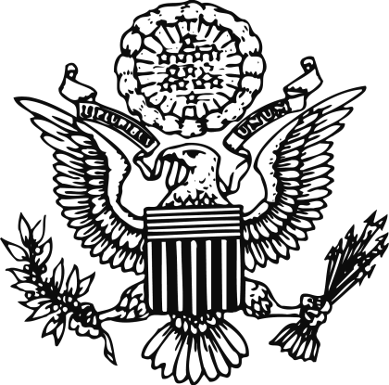

Embassy of the United States of America

Useful Links

DR News
www.listin.com.do (Spanish)
www.hoy.com.do (Spanish)
www.dr1.com

DR Trade Associations
American Chamber of Commerce in Santo Domingo
www.amcham.org.do/english/index.htm

Santo Domingo Chamber of Commerce
and Production
www.ccpsd.org.do

DR Government
Presidency of the Dominican Republic
www.presidencia.gov.do/ingles/welcome.htm

Ministry of Industry and Commerce
www.seic.gov.do

Central Bank of the Dominican Republic (Spanish)
www.bancentral.gov.do

General Directorate of Customs (Spanish)
www.dga.gov.do

National Statistics Office (Spanish)
www.one.gov.do

US Organizations in the DR
US Embassy in Santo Domingo
www.usemb.gov.do/index.htm

US Consular Services in Santo Domingo
www.usemb.gov.doc/Consular/conspa.htm

US Public Diplomacy Office in Santo Domingo
www.usemb.gov.do/pas/franklincenter.htm

US Foreign Agricultural Service in Santo Domingo
www.usemb.gov.do/FAS/fas-sindex.htm

US Export Financing Resources
Ex-Im Bank
www.exim.gov

Overseas Private Investment Corporation
www.opic.gov

US Trade and Development Agency
www.tda.gov

US Government
US Government’s Official Web Portal
www.firstgov.gov

US Customs and Border Protection (Export Information)
www.cbp.gov/xp/cgov/export/

US Department of Commerce
- Export America
www.export.gov/exportamerica

- US Government Export Portal
www.export.gov

- Trade Advocacy Center
www.export.gov/advocacy

- Trade Stats Express
http://tse.export.gov

- US Patent and Trademark Office
www.uspto.gov

