GOVERNMENT/INDUSTRY FORUM

BUILDING COMMISSIONING: EVOLVING APPROACHES AND DOCUMENTED RESULTS

October 9, 2003

National Academy of Sciences
Washington, DC

Sponsored by

The Federal Facilities Council

BUILDING COMMISSIONING: EVOLVING APPROACHES AND DOCUMENTED RESULTS

Date: October 9, 2003

National Academy of Sciences Auditorium

Background: Organizations that build new facilities must have some means of verifying that the systems and equipment installed (heating, ventilation, air conditioning, fire protection, security) are capable of being operated and maintained to meet the design intent and the owner’s needs. Owners of existing facilities are also seeking ways to improve energy efficiency, indoor air quality, occupant comfort, and asset value. Building commissioning is a process that can be used to meet all of these objectives. It involves testing systems and correcting identified problems to optimize performance in both new and existing buildings. However, building commissioning is not a standard industry practice, due, in part to:

- A lack of awareness of commissioning by owners, construction managers, and design professionals
- Concern about additional up-front costs
- Insufficient data to substantiate the costs and benefits of commissioning to building construction and operation

Purposes: To identify key issues, practices, tools, and research-based data related to building
commissioning
To highlight federal agency initiatives

Audience: The forum is targeted to senior executives, facility program managers, architects, engineers, construction managers, financial and procurement analysts, and others involved with facilities programming, management and operation.

Sponsor: This forum is sponsored by the Federal Facilities Council (FFC), a cooperative
association of federal agencies having interests and responsibilities related to all aspects of federal facility design, construction, operation, and management. Established in 1953, the FFC operates under the National Research Council, the principal operating agency of the National Academies, congressionally chartered, private, non-profit corporations. Additional information is available at http://www.nationalacademies.org/ffc

The FFC sponsor agencies are the:

Department of the Air Force
Air National Guard
Department of the Army
Army Corps of Engineers
Department of Defense, Federal Facilities Division
Department of the Interior
Department of Energy
Department of Navy
Department of State
Department of Veterans Affairs
General Services Administration

Immigration & Naturalization Service
Indian Health Service
National Aeronautics & Space Administration
National Institutes of Health
National Institute of Standards and Technology
National Science Foundation
Office of Real Estate-Commerce
Smithsonian Institution
U.S. Coast Guard
U.S. Postal Service

Agenda

7:45-8:45 am Registration and Coffee

8:45 am Welcoming Remarks; Purpose of Forum
Speaker: Lt. Gen. Henry J. Hatch, U.S. Army (ret.), Chair, Federal Facilities Council

9:00 am Commissioning Resources for Federal Agencies
The Department of Energy’s Federal Energy Management Program (FEMP) helps federal
agencies to reduce the costs and environmental impacts of their facilities. This presentation will focus on resources developed by FEMP, including a Model Commissioning Guide and Specifications.

Speaker: Ms. Beth Shearer, Director, Federal Energy Management Program

9:15 am Keynote Address: Overview of Building Commissioning
An overview focusing on the general purposes of building commissioning; the commissioning process; the potential value and benefits for owners and tenants alike; recognized barriers to implementing commissioning on a more widespread basis; trends; and directions for the future.

Speaker: Mr. Richard Casault, President, Casault Engineering

9:45 am Building Commissioning from an Owner Organization’s Perspective
Building commissioning has been an integral part of the planning, design, and construction program at Emory University since 1996. The speaker will address why Emory established a commissioning program; its processes for commissioning; staffing issues and training; costs and benefits; lessons learned; and the relationship of commissioning with LEED and other construction “best practices”.

Speaker: Mr. Robin Smith, Building Commissioning Coordinator, Emory University

10:15 am Break

10:45 am Building Commissioning from a Commissioning Agent’s Perspective
Using recent commissioning projects as examples, the speaker will address the commissioning agent’s role and responsibilities in new projects and the re-commissioning of existing buildings; what an owner should expect in terms of staffing; timing; costs and benefits when hiring a commissioning agent; and the owner’s responsibilities in relation to the agent.

Speaker: Ms. Rebecca Ellis, Principal, Sebesta Blomberg & Associates

11: 15 am Costs and Benefits of Commissioning
The costs and benefits of building commissioning have been documented through research and case studies from a variety of sources. This presentation will focus on quantitative information to make the “business case” for commissioning, as well as general issues related to monitoring and verification.

Speaker: Dr. Dan Turner, Ph.D., Director, Energy Systems Laboratory, Texas A&M University

11:45 am Panel Discussion: What Owner Organizations Need to Know.

Moderated discussion involving the morning’s speakers.

12:15 pm Lunch (provided on-site)

Federal Agency Initiatives

1:30 pm DoD’s Demonstration Project on Reduction in Long-Term Facility Operating, Maintenance and Energy Costs.
This session will provide an overview of a pilot program that is designed to optimize the operations and maintenance of facilities through the use of commissioning and other good practices. The outcomes of the project will be tracked and a report evaluating the demonstration program will be submitted to Congress by January 2005.

Speaker: Mr. Viejo Panu, Program Manager, Design, Construct, and Commissioning Program, U.S. Army Corps of Engineers

2:00 pm NASA’s Approach to Sustainability and Commissioning
NASA has embarked on a facilities management initiative that incorporates building
commissioning into an overall program for sustainable development. This presentation will focus on the catalyst for this approach and NASA’s approach to commissioning.

Speaker: Mr. Calvin Williams, Senior Program Manager, Facilities Engineering, NASA

2:30 pm GSA’s Total Building Commissioning/Commissioning Planning Tool
The GSA is developing a Web-based prototype tool to generate commissioning plans. This session will focus on the planned features of this tool and the status of development.

Speaker: Mr. David Eakin, Chief Engineer, Public Buildings Service, General Services Administration

3:00 pm Commissioning on an International Scale: The State Department’s Approach
The U.S. Department of State has recently restructured its commissioning program in response to an unprecedented construction program and other drivers. This presentation will focus on issues related to commissioning buildings globally and the State Department’s approach.

Speaker: Mr. Tom Hodges, Construction and Commissioning Division, Office of Overseas Buildings Operations, U.S. State Department

3:30 pm Questions from Audience for Agencies’ Representatives

4:00 pm Thank you and Adjourn

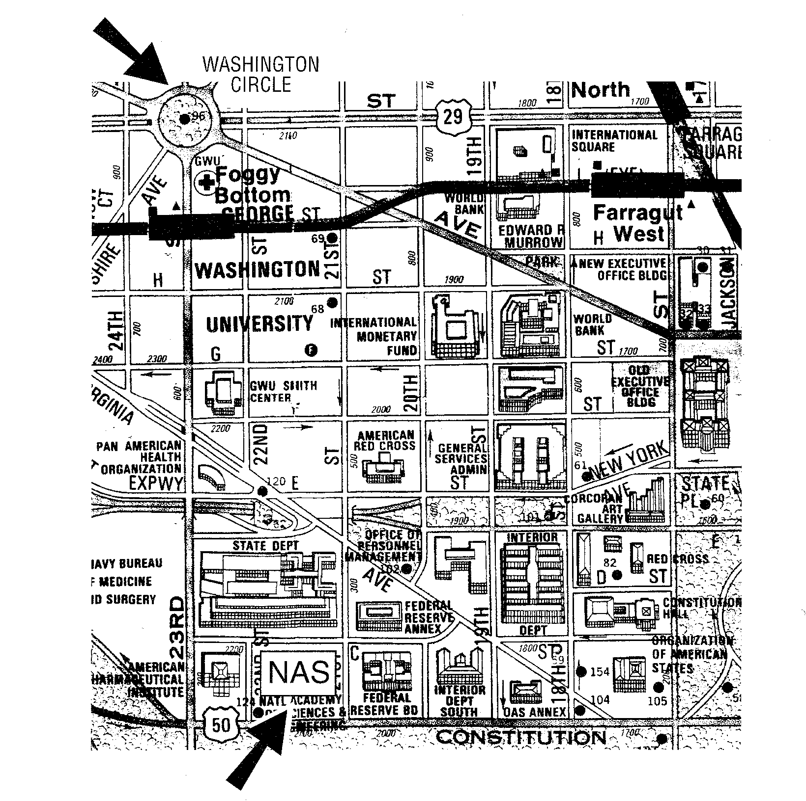Location: The National Academy of Sciences Building is located at 2101 Constitution Avenue, NW, in Washington, D.C. The main entrance is at 2100 C Street.

Transportation: There is very limited visitor parking at the National Academy of Sciences Building. Participants are encouraged to use public transportation or arrive by taxicab.

The NAS is located about 10 blocks from the Foggy Bottom Metro Station (Blue and Orange Lines). A shuttle bus designated National Academies operates between the Foggy Bottom Metro Station and the NAS building. It stops in front of the Metro Station on 23rd Street (do not cross 23rd Street) at 7:35 am, 8:15, and 8:35 am, arriving at the NAS in ten minutes (do not use shuttle designated Express). The shuttle bus departs the NAS building from C Street for the Metro every 30 minutes.

Registration

Registration fees are as follows:
- No charge for staff from Federal Facilities Council sponsor agencies (listed on page 2) –however, you must return the registration form below by e-mail to lstanley@nas.edu or fax to: (202) 334-3370.
- $50.00 for all others. Checks should be made payable to the National Academy of Sciences. The Federal Facilities Council cannot accept government or other credit cards.

All participants are asked to register by September 25, 2003. Anyone attending who is not from an FFC sponsor agency should mail the form below and a check for $50.00 to: Federal Facilities Council, c/o National Research Council, 500 Fifth Street, NW, Room 944, Washington, DC 20001.

If you have any questions or need assistance, please contact Lynda Stanley at (202) 334-3374, or by e-mail at lstanley@nas.edu.

The following individual will attend the forum on Building Commissioning on October 9, 2003.

Name:

Title:
Organization::
Address:
Phone:
Fax:
E-mail:

