1. Quick Summary

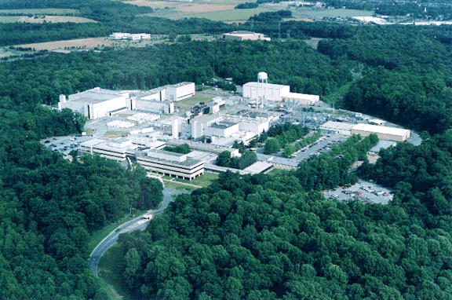
Total Building Space (ft²):……………………. | 725,066
# of Buildings:………………………………….. | 37
Largest Building (ft²):  Lyman Spitzer Office Bldg (office/lab)…… | 111,943
Trailers:………………………………………….. | 0
Wooden Buildings:……………………………. | 1
Excess Facilities: Uncontaminated ………..  Contaminated…………… | 1  1
Excess Space Cleaned up in FY02 (ft²):…… | 57,000
Replacement Plant Value¹:…………………… | $281 Million
Landlord Program:…………………………….. | SC Fusion Energy Sciences
¹Includes buildings and other structures and facilities, but not excess facilities.

2. Rank in Space and No. of Buildings

3. Programmatic Funding – SC provides 98% of the operating funding.

SC– Office of Science
WFO– Work for Others

4. Age of Space–is the age of building space by gross square feet (gsf). More than 40 percent of PPPL building space is over 21 years old and 31% is over 40 years old.

5. Building Maintenance Funded –Actual maintenance is the expenditure of all real property maintenance activities in the current fiscal year regardless of funding source (indirect, operating or capital funding). Required maintenance is the estimate of all costs to perform maintenance activities deemed necessary by engineering and life-cycle studies (it does not address major renovations or improvements needed). Deferred maintenance is maintenance that was planned but was postponed to a future period due to lack of funds. Deferred maintenance is increasing while actual maintenance has declined from FY 2000 to FY 2001.

- Building Condition Index (BCI) – indicates the condition of space in ‘active’ buildings (excess facilities are excluded). BCI is calculated on a building-by-building basis, as Total Deferred Maintenance as a percentage of Replacement Plant Value (RPV), where Deferred Maintenance is maintenance that was planned but not performed. Buildings with a low BCI are rated in better condition than those with higher BCI – see chart below for quality rating for the BCI percentages. Generally deferred maintenance does not include major rehabilitation/renovations and improvements needed to better accommodate mission activities (e.g. improvements in vibration, air quality, temperature, access to power, etc.)

Quality Rating: Building Condition Index Range:
- Excellent BCI < 2%
- Good 2% ≤ BCI < 5%
- Adequate 5% ≤ BCI <10%
- Fair 10% ≤ BCI <25%
- Poor 25% ≤ BCI <60%
- Fail BCI ≥ 60%
7. Infrastructure Investment–is composed of funding for line-items, GPP/GPE, excess facilities, and indirect maintenance. Line-items (LI) fund construction of general purpose infrastructure, such as roads, utility systems, and general purpose buildings. Excess facilities funding provides for clean-up and removal of excess buildings. Infrastructure line items and excess facilities are provided by the Science Lab Infrastructure program. General Plant Project (GPP) and General Purpose Equipment (GPE) are funds for equipment and infrastructure that are shared by facilities across the site. The SC Fusion Energy Science program provides GPP/GPE funds and the SC Science Lab Infrastructure program funds excess facilities clean-up starting in FY 2002. Indirect Maintenance is real property maintenance that is funded by laboratory overhead. It does not include housekeeping or groundskeeping.

Most Recent Line-Item Project: Life Safety & Fire Protection Upgrade project, $4.9M in FY 1993
Summary of Proposed Modernization Projects
from PPPL’s 2000 Strategic Facilities Plan:
Line Item Construction | $13.05M
GPP/GPE |  | $28.2M

- Recapitalization Period–is the number of years needed to fully maintain infrastructure as it ages. It is calculated by dividing Total Replacement Plant Value by the total amount spent on construction (the sum of line-items and GPP/GPE).
PPPL Recapitalization Periods
FY ‘01 | 165 years
FY ‘02 | 192 years
FY ‘03 | 260 years

- Third Party Facilities – PPPL has no plans for third-party financing of its facilities.

Sources: Facilities Information Management System (FIMS) Database, April 2002
FY ’03 Budget Crosscut
Lab Strategic Facilities Plan
Institutional Plans and other documentation

Contact: John Yates, SC-82
Tel: 301-903-8435
Fax: 301-903-8442
E-mail: John.Yates@science.doe.gov

