1. Quick Summary
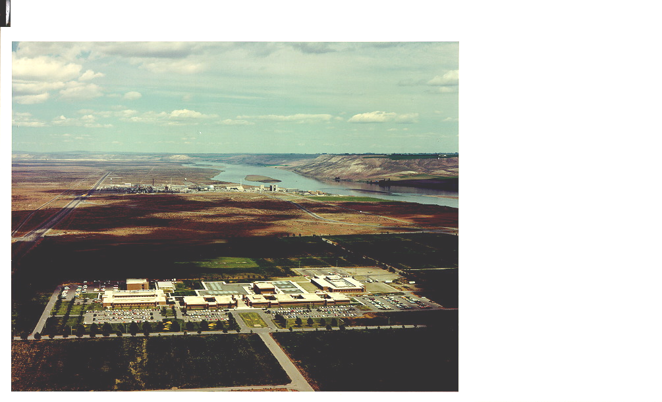
Total DOE Owned Building Space (gross ft²):…………………………………..  Battelle Leased Building Space………...  Battelle Owned Building Space………...  DOE Leased Building Space……………. | 901,256  509,000  496,000  76,000 | 46% DOE Owned  25% Battelle Owned  25% Battelle Leased  4% DOE Leased
# of DOE Buildings (see Section 9):…... | 40
Largest Occupied Building (gross ft²): William R. Wiley Environmental Molecular Science Laboratory ……… | 200,000
Trailers:…………………………………….. | 1
Wooden Buildings:………………………. | 2
Excess Facilities: Uncontaminated …..  Contaminated ……... | 1  0
Excess Space To Be Removed in FY 02 | 26,000
Replacement Plant Value¹:……………… | $401 Million
Landlord Program:……………………….. | SC Biological & Environmental Research
¹Includes buildings and other structures and facilities, but not excess facilities.

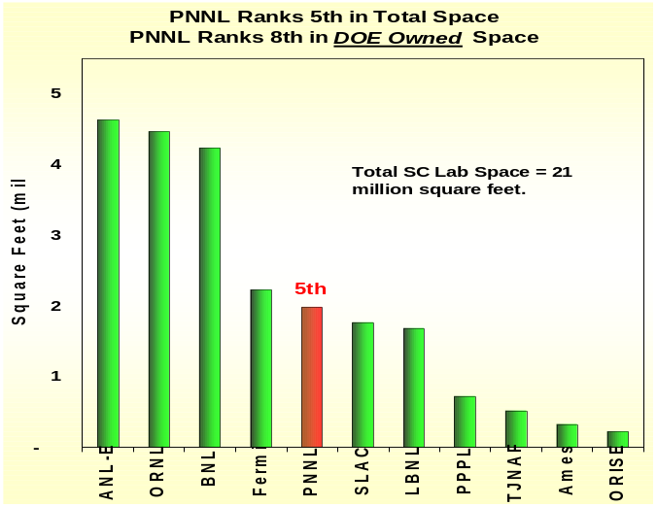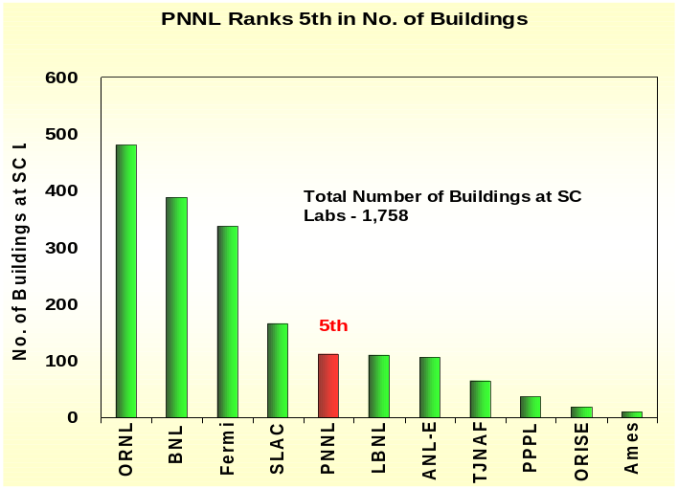2. Against Other SC Labs Rank in Space and No. of Buildings

3. Operating Funding – SC provides 11% of the lab’s operating funding which was ~$413M in FY 2001 (Operating funding does not include construction, GPP/GPE or Work for Other DOE labs.)
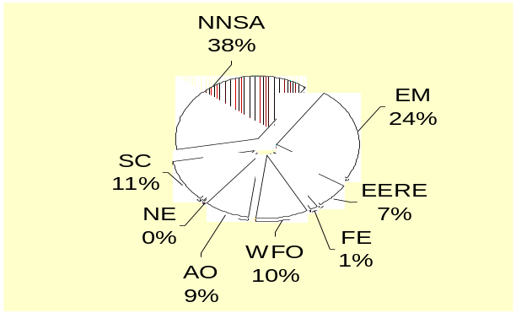
SC – Office of Science
EERE – Energy Efficiency and Renewable Energy
EM – Environmental Management
FE – Fossil Energy
NE – Nuclear Energy

NNSA – Nonproliferation and National Security
WFO – Work for Others
AO – All Others

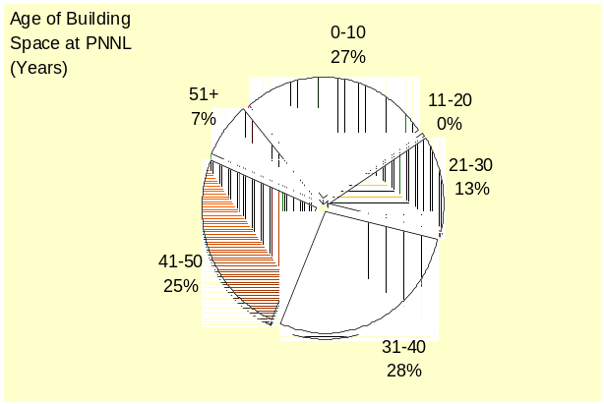4. Age of Space–is the age of building space by gross square feet (gsf). Sixty percent of the PNNL building space is over 30 years old with 32% being over 40 years old.

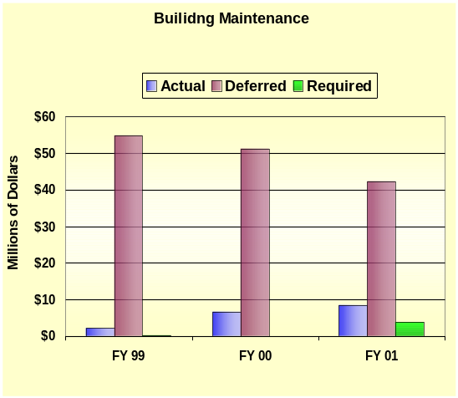
5. Building Maintenance Funded – Actual maintenance is the actual cost of all real property maintenance activities in the current fiscal year. Required maintenance is the estimate of all costs to perform maintenance activities deemed necessary by engineering and life-cycle studies. Deferred maintenance is maintenance that was planned but was postponed to a future period due to lack of funds. Actual maintenance is increasing resulting, in part, in the reduction of deferred maintenance. The other contributors to the decrease in deferred maintenance are GPP and infrastructure line items.

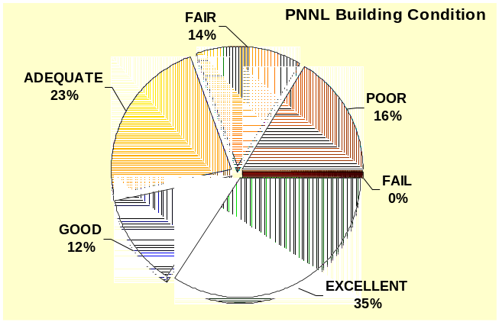6. Building Condition Index (BCI) – indicates the condition of space in buildings. BCI is calculated on a building-by-building basis, as Total Deferred Maintenance as a percentage of Replacement Plant Value (RPV), where Deferred Maintenance is maintenance that was planned but not performed. Buildings with a low BCI are rated in better condition than those with higher BCI – see chart below for quality rating for the BCI percentages. Generally deferred maintenance does not include major rehabilitation/renovations and improvements needed to better accommodate mission activities (e.g. improvements in vibration, air quality, temperature, access to power, etc.). Sixteen percent of their building space is classified as less than fair; none are classified as Fail.

Quality Rating: Building Condition Index Range:
- Excellent BCI < 2%
- Good 2% ≤ BCI < 5%
- Adequate 5% ≤ BCI <10%
- Fair 10% ≤ BCI <25%
- Poor 25% ≤ BCI <60%
- Fail BCI ≥ 60%

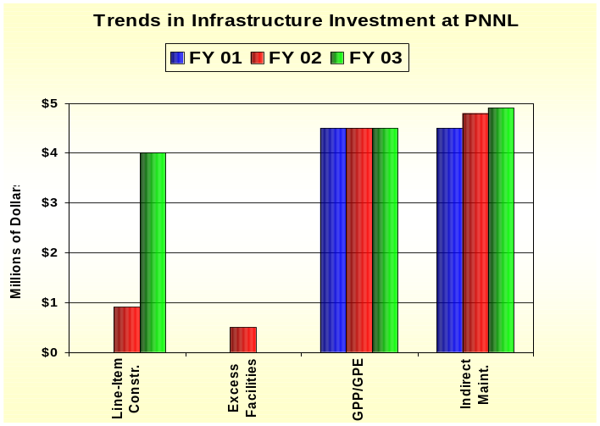7. Infrastructure Investment–is composed of funding for line-items, GPP/GPE, excess facilities, and indirect funded maintenance. Line-items (LI) fund construction of general purpose infrastructure, such as roads, utility systems, and general purpose buildings. Excess facilities funding provides for clean-up and removal of excess buildings. General Plant Project (GPP) and General Purpose Equipment (GPE) are funds for equipment and infrastructure that are shared by facilities across the site. The SC Biological and Environmental Research program provides GPP/GPE funds while the SC Science Lab Infrastructure program funds infrastructure line items and excess facilities starting. Indirect Maintenance is real property maintenance that is funded by laboratory overhead. It does not include housekeeping or grounds keeping.

Most Recent Line-Item Project: Laboratory Systems Upgrade, FY 2002, Total Estimated Cost - $9M
8. Recapitalization Period (RP)–is the number of years needed to fully maintain infrastructure as it ages. It is calculated by dividing Total Replacement Plant Value by the total amount spent on construction (the sum of line-items and GPP/GPE).
Trend in Recapitalization Period
FY ‘01 | 89 years
FY ‘02 | 74 years
FY ‘03 | 47 years

Summary of Proposed Modernization Projects
In PNNL’s 2000 Strategic Facilities Plan:
Line Item Construction | $ 18.6M
GPP/GPE | $ 59.4M

The reduction in the RP reflects the funding for the Lab Systems Upgrade line-item project initiated in FY 2002 and transfer of excess facilities to EM.

- Third Party and Leased Facilities – in addition to their DOE owned buildings, PNNL occupies 48 Battelle owned buildings on Battelle land in Richland and Sequim, Washington; and eight Battelle leased buildings in Richland. All these facilities are third-party financed. The latest is the 29,000 gsf User Housing Facility completed in 2001. The next planned facility will be another third-part venture, which will house office and laboratory space close to the Environmental Molecular Science Laboratory.

Sources: Facilities Information Management System (FIMS) Database, April 2002
FY ’03 Budget Crosscut
Lab Strategic Facilities Plan
Institutional Plans and other documentation

Contact: John Yates, SC-82
Tel: 301-903-8435
Fax: 301-903-8442
E-mail: John.Yates@science.doe.gov

