1. Quick Summary
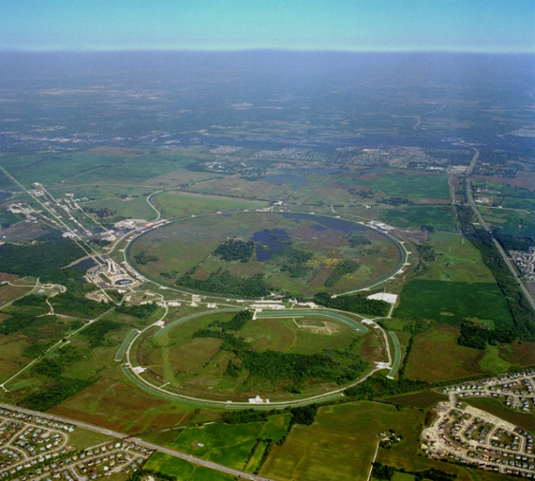
Total Building Space (gross ft²):…………………. | 2,232,691
Buildings:…………………………………………….. | 337
Largest Occupied Building (gross ft²):  Wilson Hall ………………………………………..…. | 515,896
Trailers: .……………………………………………… | 112
Wooden Buildings:…………………………………. | 155
Excess Facilities: Uncontaminated ….…………..  Contaminated ………………… | 28  0
Excess Space to be Removed in FY02:…………. | 0
Replacement Plant Value¹:………………………… | $1.42 Billion
Landlord Program:………………………………….. | SC High Energy Physics
¹Includes buildings and other structures and facilities, but not excess facilities.
The Rings of Fermi Lab

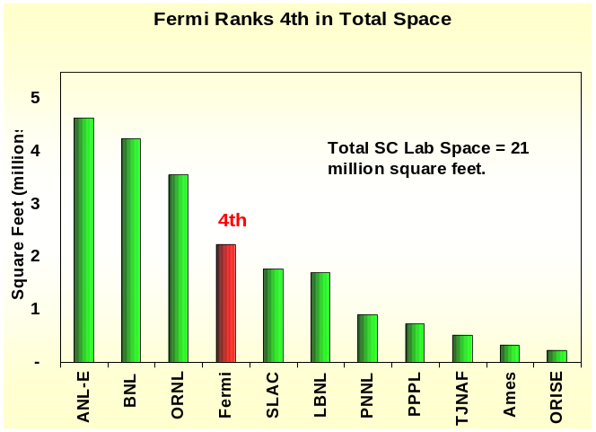2. Rank in Space and No. of Buildings Against Other SC Labs
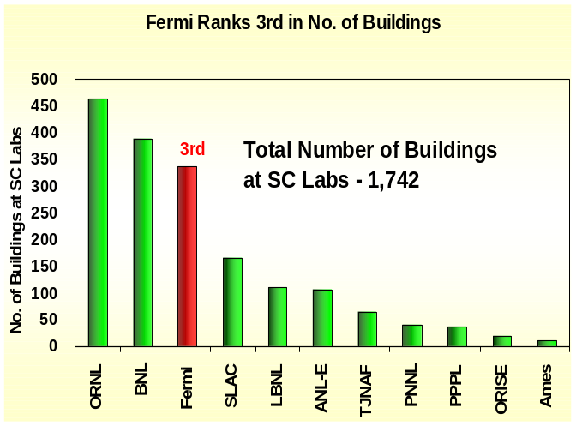

- Programmatic Funding – SC provides 99% of the operating funding.
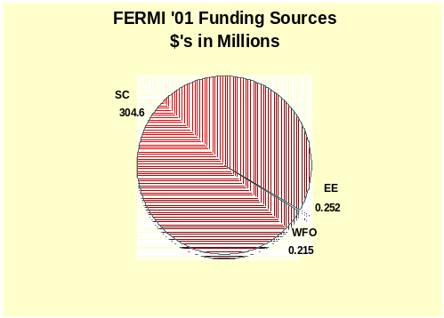

SC (HEP) – Office of Science / High Energy Physics
EE –Energy Efficiency
WFO – Work for Others

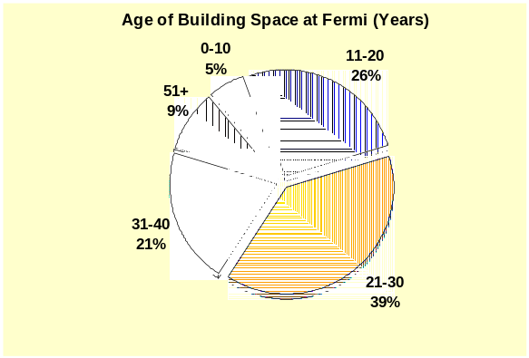4. Age of Space–is the age of building space by gross square feet (gsf). Thirty percent of the Fermi building space is over 30 years old and nine percent is over 51 years.

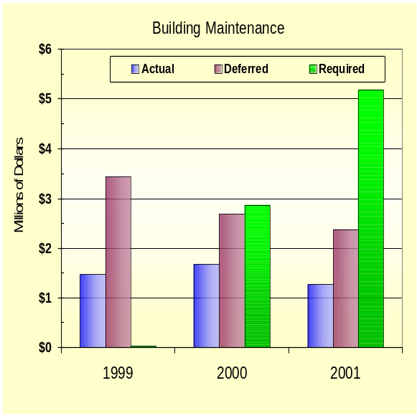

5. Building Maintenance Funded–Actual maintenance is the actual cost of all real property maintenance activities in the current fiscal year. Required maintenance is the estimate of all costs to perform maintenance activities deemed necessary by engineering and life-cycle studies. Deferred maintenance is maintenance that was planned but was postponed due to a lack of funds. The increase from FY 2000 to FY 2001 in deferred maintenance reflects a reinterpretation of the deferred maintenance definition.

- 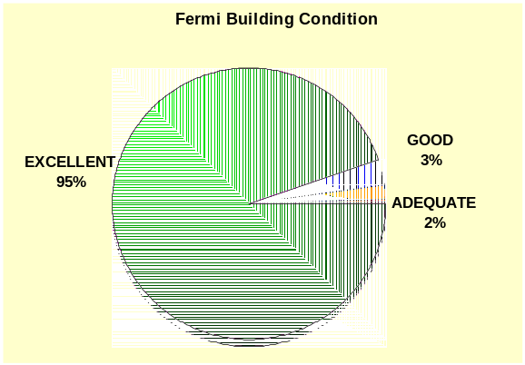Building Condition Index (BCI) – indicates the condition of space in buildings. BCI is calculated on a building-by-building basis, as Total Deferred Maintenance as a percentage of Replacement Plant Value (RPV), where Deferred Maintenance is maintenance that was planned but not performed. Buildings with a low BCI are rated in better condition than those with higher BCI – see chart below for quality rating for the BCI percentages. Generally deferred maintenance does not include major rehabilitation/renovations and improvements needed to better accommodate mission activities (e.g. improvements in vibration, air quality, temperature, access to power, etc.). 95% of the Fermi buildings are rated in excellent condition!

Quality Rating: Building Condition Index Range:
- Excellent BCI < 2%
- Good 2% ≤ BCI < 5%
- Adequate 5% ≤ BCI <10%
- Fair 10% ≤ BCI <25%
- Poor 25% ≤ BCI <60%
- Fail BCI ≥ 60%

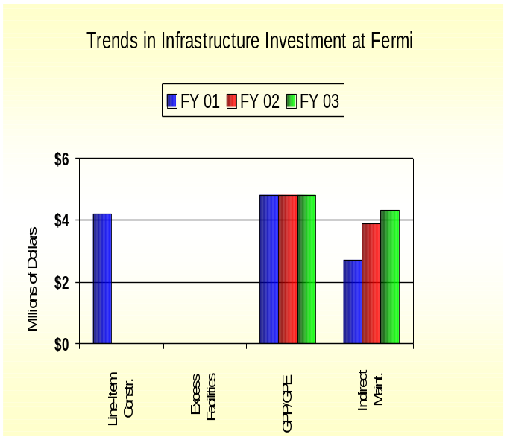7. Infrastructure Investment–is composed of funding for line-items, GPP/GPE, excess facilities, and indirect maintenance. Line-items (LI) fund construction of general purpose infrastructure, such as roads, utility systems, and general purpose buildings. Excess facilities funding provide for clean-up and removal of excess buildings. General Plant Project (GPP) and General Purpose Equipment (GPE) are funds for equipment and infrastructure that are shared by facilities across the site. The SC High Energy Physics program provides GPP/GPE funds. Starting in FY02, the SC Science Lab Infrastructure program funds infrastructure line items and excess facilities starting. Indirect Maintenance is real property maintenance that is funded by laboratory overhead. It does not include housekeeping or groundskeeping.

Most Recent Line-Item Project: Wilson Hall Safety Improvements, FY ’99, TEC $15.6M
Summary of Proposed Modernization Projects
in Fermi’s 2000 Strategic Facilities Plan
Line Item Construction | $6.6M
GPP/GPE | $60.3M

8. Recapitalization Period–is the number of years needed to fully maintain infrastructure as it ages. It is calculated by dividing Total Replacement Plant Value by the total amount spent on construction (the sum of line-items and GPP/GPE).
Fermi Recapitalizaton Periods
FY ‘01 | 158 years
FY ‘02 | 296 years
FY ‘03 | 296 years

9. Third Party Facilities -

Sources: Facilities Information Management System (FIMS) Database, April 2002
FY ’03 Budget Crosscut
Lab Strategic Facilities Plan
Institutional Plans and other documentation

Contact: John Yates, SC-82
Tel: 301-903-8435
Fax: 301-903-8442
E-mail: John.Yates@science.doe.gov

