UNITED STATES DEPARTMENT OF AGRICULTURE
Rural Utilities Service

RUS BULLETIN 1751F-801

SUBJECT: Electrical Protection Fundamentals

TO: All Telecommunications Borrowers
RUS Telecommunications Staff

EFFECTIVE DATE: Date of Approval

EXPIRATION DATE: Seven years from effective date

OFFICE OF PRIMARY INTEREST: Engineering Standards Branch, Telecommunications Standards Division

PREVIOUS INSTRUCTIONS: This bulletin replaces Telecommunications Engineering and Construction Manual (TE&CM) Section 801, Number 4, issued October 1982.

FILING INSTRUCTIONS: Discard TE&CM 801 and replace with this bulletin. File this bulletin with 7 CFR 1751 and RUSNET.

PURPOSE: To provide information on the electrical protection of telephone systems. The general concepts of system protection for modern telephone plants are illustrated.

Adam Golodner 5/22/95
_____________ __________
Administrator Date

TABLE OF CONTENTS

1. GENERAL 5
1.1 Protection Engineering 5
1.2 Electrical Disturbances 5
1.3 Electrical Protection Goals 6
1.4 Considerations 6
1.5 Planning 6
1.6 Protection Measures 6
1.7 Equipment Exposure 6
1.8 Central Office Protection Considerations 7
1.9 Familiarity with Protection Problems 7
2. CODES 7
2.1 Introduction 7
2.2 Compliance with Codes 8
2.3 Local and National Codes 8
3. SOURCES OF DISTURBANCES 8
3.1 Lightning 8
3.2 Electric Power Systems 16
3.3 Electromagnetic Pulse (EMP) Phenomena 21
4. EFFECTS OF LIGHTNING SURGES 22
4.1 Introduction 22
4.2 Aerial Facilities 22
4.3 Buried Cable Plant 23
4.4 Station and Other System Equipment 25
5. FUNDAMENTAL PROTECTION MEASURES 25
5.1 Introduction 25
5.2 Shielding 26
5.3 Parallel Conductivity 27
5.4 Grounding 27
5.5 Voltage Limiting and Equalization 29
5.6 Metallic Voltages 29
5.7 Aerial, Buried, and Underground Cable 30
5.8 Solid-State Electronic Equipment 30
5.9 Current Interruption 30
5.10 Acoustical Click Limitation 31
5.11 Construction and Spacing 31
5.12 Special Protection 32
6. COMMONLY USED PROTECTION DEVICES 32
6.1 Voltage Limiting Devices 32
6.2 Current Limiting Devices 34
6.3 Other Protection Devices 36

TABLES

TABLE 1 RESISTIVITY OF VARIOUS SOILS 11
TABLE 2 CARBON BLOCK ARRESTER COLOR CODES 33

FIGURES

Figure 1 Mean Annual Thunderstorm Days 38
Figure 2 Lightning Damage Probability Map 39
Figure 3 Lightning Stroke Crest Current Distribution 40
Figure 4 Surge Test Wave Form 41

Figure 5 Exploded View of Arrester Assembly 42
Figure 6 Circuit Breaker Trip Delay 43
Figure 7 Fused Type Station Protector 44
Figure 8 Neutralizing Transformer 45
Figure 9 Isolating Transformer 46

The FIGURES Section which contains all the graphs is available on hard copy only.

INDEX:

Protection
Protection, Fundamentals
Protection, Electrical

ABBREVIATIONS

ac Alternating Current
ANSI American National Standards Institute
ATIS Alliance for Telecommunications Industry Solutions
cm centimeter
dc Direct Current
dB Decibel
EMP Electromagnetic Pulse
HEMP High-Altitude Electromagnetic Pulse
IEEE Institute of Electrical and Electronics Engineers, Inc.
kV Kilovolt (1000 volts)
km kilometer (1000 meters)
MGN Multigrounded Neutral
mm millimeter
NEC National Electrical Code
NESC National Electrical Safety Code
NFPA National Fire Protection Association
NID Network Interface Device
SCR Silicon Controlled Rectifiers
TE&CM Telecommunications Engineering and Construction Manual
µs Microsecond (one millionth of a second)
V Volt

DEFINITIONS

Arc A luminous discharge of electronic current crossing a gap between two electrodes.

Earth Resistivity A measurement of the electrical resistance of a unit volume of soil. The commonly used unit of measure is the ohm meter (õ·m) which refers to the resistance measured between opposite faces of a cubic meter of soil.

Fault Current A current that flows from one conductor to ground or to another conductor owing to an abnormal connection (including an arc) between the two. Note: A fault current flowing to ground may be called a ground fault current.

Isokeruanic Level The average annual number of thunderstorm days.

Multigrounded Neutral The neutral of a power distribution system having multiple direct electrical connections to earth ground. In a multigrounded neutral system, at least four (4) grounds are provided in each mile (1.6 km) of line, not including grounds at individual services. This multiple grounding arrangement provides a low impedance path to earth ground for the purpose of absorbing lightning and power switching surges. It also provides a return path for residual (unbalanced) currents resulting from less than perfect balance on associated multiphase power distribution systems.

1. GENERAL

1.1 Protection Engineering: The basic objectives of protection engineering are: (1) the safeguarding of subscribers, the public, telephone company personnel and telephone plant (inside and outside) against high voltage contacts and lightning; (2) the reduction of interference caused by low frequency induction from power lines and other sources; (3) the mitigation of crosstalk between telephone circuits; and (4) the mitigation of electrolysis in underground and buried cable. The best time for combating these influences is during the design and construction of telephone plant. Details on specific protection recommendations can be found in the 800 series of the Telecommunications Engineering and Construction Manuals (TE&CM) (proposed conversion to RUS Bulletins 1751F-801 through 1751F-825).

1.2 Electrical Disturbances: Telephone systems are subject to disturbances from external sources of electrical energy. These sources include electrical power supply circuits and natural phenomena, such as lightning and low energy static charges. Electrical disturbances enter the telephone system via direct contacts, by induction from magnetic fields and electric fields, or by conduction from interconnected electrical conducting paths. The effect in the telephone plant may be confined to interference during normal use or operation, as in the case of noise or interference with signaling; or the disturbance may be capable of creating hazards to subscribers, the public, and telephone personnel, and damage to plant (outside and inside).

1.2.1 The electrical protection discussed in this bulletin pertains to the control of abnormal potentials and currents that may appear in telecommunications plant. It is impossible to provide simple specific rules to cover all protection requirements. Because of variations in plant and equipment making up a total system, only generalized recommendations are given. Additional recommendations for the protection of specific types of plant, equipment, and environmental conditions are provided in the reference sources cited in Paragraph 1.1. Protection of facilities such as power generating stations and power substations involve special concerns. Because of their special considerations, RUS recommends that borrowers consider retaining the services of a consulting engineer that specializes in such protection designs.

1.2.2 Equipment and material design engineers need to be aware of the abnormal voltages and currents which may occur within telecommunications plant for the obvious reason of selecting plant appropriate for the purpose and particular environment.

1.2.3 Evaluation of the effects of abnormal potentials and currents on various types of plant and equipment in the telephone system is a primary concern of the telephone system engineer.
After determination of the effects, the most suitable form of mitigation has to be recommended for each situation.

1.3 Electrical Protection Goals cover two areas related to abnormal potentials which may occur on telecommunications plant:

1.3.1 First is to minimize, as far as practical, electrical hazards to the general public and to subscribers. There is also need to protect the employees who are involved in the construction, operation and maintenance of the telecommunications system;

1.3.2 Second, is to minimize, as far as practical, damage to aerial, buried or underground plant and equipment and to buildings or structures that may be associated with such plant or equipment.

1.4 Considerations: Where the general public, customers or employees are concerned, safety from electrical shock and other hazard should be the prime consideration. Protection of plant and equipment is a secondary consideration and involves a balance between the initial cost of the appropriate protection measures and their maintenance expense versus the value of increased service reliability and cost of repairs to plant and equipment.

1.5 Planning: Those protection problems such as connections to multigrounded neutrals, grounding locations, etc., relating to the economics of the design should be identified and studied early during the planning phase of a new facility. Most protection measures are more costly to implement after plant has been installed. Where service continuity is essential, there is no reasonable alternative to providing an initial high level of protection.

1.6 Protection Measures: Some measures are primarily designed to be effective against lightning. Other measures are utilized to minimize damage from electric power systems. There are also specific measures associated with the mitigation of noise and signaling problems. Most of these measures are discussed in detail in the reference sources cited in Paragraph 1.1.

1.6.1 Most protective measures designed for protection against lightning damage will also afford protection against electrical power system damage and vice versa. Some will also provide improved noise performance. Likewise, some of the measures applied to the telecommunications system for noise reduction will also provide protection against the effects of lightning and power related problems.

1.7 Equipment Exposure: Telecommunications equipment exposure to lightning and power system related surges varies. Equipment located in a central
office building is usually less exposed to direct lightning and high current power line contacts and induction than plant and equipment located outside a central office building. Outside plant equipment as a consequence is usually more rugged than central office equipment. While central office equipment may be less exposed to direct surge activity, central office equipment is, nevertheless, occasionally subjected to direct lightning hits or lightning side flash induction from nearby hits, especially at offices collocated with antenna towers. Central office equipment is also exposed to transient surge remnants that are passed to it from the outside plant over the telecommunications conductors, cable shields, and metallic messengers and strength members. Over the years, central office equipment has become more and more sophisticated and has demonstrated a greater sensitivity to surges and proven to be a greater challenge to the protection engineer.

1.8 Central Office Protection Considerations: A major concern to consider when determining the protection to be used at a central office, as compared with subscriber stations, is the effect of equipment failure on overall service continuity. Where the probability of trouble is small, some risk of equipment damage might be taken at a subscriber station providing there is no compromise of subscriber safety. However, with the same probability, the possibility of damage at an office may be too great because of the ultimate effect upon a far greater number of circuits and subscribers. In the majority of subscriber circuits, the lowest impedance path connection to ground is at the office. In such cases the current, resulting from either a power fault or induction in the communications facilities, would flow toward the office rather than toward the stations. Current flows toward the point of least impedance. If the office protection is not adequate, such current might result in overheating and possible damage of electronic components in line circuits.

1.9 Familiarity with Protection Problems: Prior to designing a protection system, the engineer has to be familiar with the various methods and types of protective devices described in the reference sources cited in Paragraph 1.1. Familiarity with possible protection problems common to the particular area where the telecommunications system is located is essential. For example, has there been frequent lightning damage, excessive power related damage, or perhaps high circuit noise in the area? With this information, a protective system can be designed to provide the best performance in the desired protection area.
2. CODES
2.1 Introduction: The National Electrical Code (NEC) and the National Electrical Safety Code (NESC) are nationally recognized standards of electrical wiring for the protection of the public and utility personnel against shock hazards and property against fire hazards. Both codes are approved by the American National Standards Institute (ANSI), as American National Standards. The NEC, which is formally identified as ANSI/NFPA 70 and sponsored
by the National Fire Protection Association (NFPA), generally covers wiring in or on a building. The NESC, which is formally identified as ANSI/IEEE C2, is sponsored by the Institute of Electrical and Electronics Engineers, Inc. (IEEE), and covers outside wiring. Portions of both codes cover wire spacings, insulation, and clearances above the ground for telephone lines. Climbing space on poles is also included. Also covered are protector requirements, grounding of protectors, cables and guy wires and bonding between the power and communications systems.

2.2 Compliance with Codes: RUS insists that borrowers always comply with current code requirements as a condition to using loan funds. Code compliance is always mandatory in places where customers and the public have access to telecommunications plant. For areas not accessible to customers and the public, NEC Section 90-2(b)(4) does allow as an exemption to its requirements: "Installations of communications equipment under the exclusive control of communications utilities located outdoors or in building spaces used exclusively for such installations." RUS recommends that borrowers not readily use this exemption and instead, always attempt to comply with code requirements. The exemption should be utilized only in cases where it is impracticable or infeasible because of equipment availability, etc.

2.3 Local and National Codes: At all locations accessible to customers and the public, telecommunications plant and apparatus have to meet the applicable provisions of the national codes or local ordinances. In some instances local ordinances may be stricter than the national codes. The engineer should become familiar with both national and local codes.

3. SOURCES OF DISTURBANCES

3.1 Lightning

3.1.1 Lightning is a transient high current electrical discharge. It occurs when a region of the atmosphere attains an electrical charge of sufficient potential to cause dielectric breakdown of the air. Lightning is usually an electrical discharge from cloud to cloud or from cloud to earth. Cloud to cloud discharges are more numerous but are usually of little concern to the protection engineer responsible for telecommunications system protection. Cloud to cloud discharges may produce electrostatic induction in telecommunications plant susceptible to this type interference. Usually, induced magnitudes are relatively low and may be a source of noise but are rarely a hazard to personnel or equipment. Lightning strokes from cloud to ground are a source of possible hazardous potentials and currents. Direct strokes to wire and cable plant may produce serious arcing near the point of contact. This is caused by the plant becoming a part of the series path between the cloud and earth along which large amplitude surge currents
will flow. Voltage differences could occur in the plant in sufficient enough magnitude to produce dielectric breakdown and hazardous shock conditions. Lightning strokes from cloud to earth near telecommunications plant may involve the telephone plant in several ways:

3.1.1.1 The earth at the point of lightning strike will undergo a steep rate of change in voltage which radiates outward in a radial direction from the stroke incidence point. If the magnitude of the ground potential rise is sufficient, dielectric breakdown of the sheath material may result and the cable will become part of the conductive discharge path. The effects on the plant are similar to those produced by a direct stroke but the voltage and current magnitudes will be lower;

3.1.1.2 When a nearby stroke does not involve the plant directly through a conductive discharge path, the fields associated with such strokes may be sufficiently intense to produce inductive effects hazardous to personnel and plant; and

3.1.1.3 There is another lightning related phenomenon which may be the greatest source of hazardous potentials and current to telecommunications plant and users. A direct stroke to a neighboring power system may produce a dielectric breakdown (ionization) of the air resulting in an arc between two components of the power system. This can occur between two phase wires, a phase and neutral wire, or between a phase wire and grounded hardware. The resulting unbalanced condition of the power system may induce high magnitude potentials in parallel telecommunications plant. These induced potentials can last for longer time periods than do induced potentials associated with nearby lightning strokes and can result in greater damage in the telecommunications plant.

3.1.2 Lightning occurs in all areas of the United States. The annual incidence and relative intensity of thunderstorms vary greatly from area to area. Telecommunications plant will be exposed to the effects of lightning in varying degrees. The exposure in sparsely settled rural areas will be the greatest because there is little benefit from the shielding provided by other grounded structures. Plant located in cities and other built up areas has less exposure because of the presence of high structures that tend to intercept lightning strokes. There are also the benefits from shielding provided by other grounded conducting media such as public water systems. Between these two extremes there are varying degrees of exposure depending on the density of grounded structures in the area.

3.1.3 There are two general types of thunderstorms: convection storms and frontal storms:

3.1.3.1 Convection storms are local in area and are of relatively short duration. Convection type thunderstorms account for the majority of thunderstorm days in the United States.
Convection type storms are caused by local heating of the air near the earth which rises and meets cold air at higher altitudes. These storms are predominant during the summer months and in warm climates. They are non-regenerative in nature and the rain usually accompanying such disturbances cools the earth, dissipating their energy source. There are indications that the magnitude and incidence of lightning strokes to ground during these storms are lower than with frontal type storms;

3.1.3.2 Frontal storms extend over large areas and may last for several hours. Studies show that frontal type storms cause appreciably more damage than convection type storms. Frontal type thunderstorms are produced when a front of warm moist air encounters a cold front. These storms may extend for several hundred miles and expose large areas to severe lightning discharges. They are regenerative in nature because the frontal air masses may continue to move into the area and maintain the turbulent conditions for hours.

3.1.4 Storm frequency is measured by the number of "thunderstorm days" experienced at a specific location during a year. The National Weather Service defines "thunderstorm day" as any day during which thunder is heard at a specific observation point. Such observations merely confirm the presence of lightning but do not provide information relative to the number of strokes to earth.

3.1.4.1 The National Weather Service has compiled extensive data from hundreds of observation points on the annual incidence of thunderstorm days in the United States. The data has been plotted in an isokeraunic map. This map is used extensively for estimating plant exposure to lightning. See Figure 1, "Mean Annual Thunderstorm Days."

3.1.4.2 Information on stroke incidence for various areas is essential for estimating the probable telecommunications plant exposure. It has been customary to use a "Stroke Factor" based on areas typically experiencing each type of storm (convection and frontal). This provided a rough approximation since there were only two factors: one, for frontal type storms and the second for convection type storms. Later work in this area has developed a "Proportion Factor," based on geographical latitude, which provides a better representation of the exposure.

3.1.4.3 The electrical resistivity of the earth (resistance of the earth to the flow of current) is almost as important as the intensity and frequency of occurrence of lightning strokes in determining the probability of lightning damage. The unit of earth resistivity, the ohm meter, is defined as the resistance, in ohms, between opposite faces of earth (soil) one cubic meter in volume. An alternative measurement, the ohm centimeter, is defined as the resistance, in ohms, between opposite faces of a one cubic centimeter cube of earth. If earth resistivity is high, the voltage which a given stroke develops across a
dielectric, and the distance that lightning currents travel along a conductor before attenuating to harmless values are greater than if the earth resistivity is low. The result is that the probability of lightning damage is greater in some parts of the country with high earth resistivity and only moderate incidence of storms than it is in other parts with low resistivity and greater storm incidence. Earth resistivity varies over a considerable range in the continental United States from a few ohm meters along part of the Gulf of Mexico coast to 10,000 ohm meters or more in upland or mountainous country. Table 1 gives ranges of earth resistivity values to be expected for various types of soils.

TABLE 1 RESISTIVITY OF VARIOUS SOILS

RESISTIVITY
SOIL TYPE (OHM METERS)
Loam 5 to 50
Clay 4 to 100
Sand/Gravel 50 to 1,000
Sandstone 20 to 2,000
Granite 1,000 to 2,000
Slates 600 to 5,000
Limestone 5 to 10,000
Shale 5 to 10,000

3.1.4.4 A lightning damage probability map combines data on thunderstorm days, earth resistivity, and geographical latitude (Figure 2, "Lightning Damage Probability Map"). It is intended as a broad guideline indicating the estimated lightning exposure factor across the contiguous United States. The map represents a useful tool when employed as intended. This map should be employed in assessing generalized protection practices over a wide geographical area. For example, by examining the map a protection engineer could quickly justify the use of maximum duty gas tubes on a system wide basis in Florida while determining this would not be cost effective in California.

3.1.4.5 While Figure 2 may be used to determine if broad areas may experience greater than average lightning problems, local experience can reveal exceptions to these guidelines. A microwave tower on a hilltop in a low lightning damage area may require special protection while equipment in a city of tall

buildings served by cable in ducts may require minimal protection even when located in a very high damage area. Establishing concise standards for evaluation of local experience is impossible. Good engineering judgement based on the best available experience and information has to be exercised to obtain optimum protection for the system under consideration.

3.1.5 The characteristic cloud formation normally associated with convection and frontal type storms is the cumulonimbus cloud, commonly referred to as the "thunderhead." Strong winds, heavy rain, hail and lightning are associated with such clouds. These clouds, when fully developed and observed from a long distance, have a characteristic anvil shape with a broad top, a sharply defined outline with a brilliant white area near the top and sometimes a cap of ice crystals. There are several theories relating to thunderstorm electrification. They all have the common problem of accounting for the quantity of charge that is required to produce lightning.

3.1.6 Knowledge as to the polarity of a lightning stroke is of little practical value to a protection engineer. A surge propagated through an object in either direction will have the same effect. As a matter of interest, studies indicate that strokes to ground can occur from either positively or negatively charged clouds. The majority of strokes to ground, however, are between negatively charged clouds and corresponding positively charged earth. The resulting electron flow is from the cloud to earth.

3.1.6.1 A lightning discharge is usually initiated from the charge center in a cloud in ionization steps that are called stepped leaders. A stepped leader may be initiated at a location where the discharge involves a tall structure. When a negative cloud area is discharged to a positive earth area, the process involves movement of a stepped leader path which is pre-ionized by a steadily moving pilot leader. The pilot leader leaves no visible track. The stepped leader follows the pilot leader path in approximately 50 yard (15 meter) increments at 50 µs intervals, with accompanying luminosity at each step. This discharge pattern has been recorded on fast-moving film.

3.1.6.2 As soon as the stepped leader reaches the earth, neutralization of the negatively charged channel begins at the earth and travels in a brightly luminous path toward the cloud at 10 percent of the velocity of light. This is the main lightning stroke. The upward progress of the main stroke toward the cloud is accompanied by a rising surge of current from cloud to earth. This main surge of current, which lasts less than a millisecond, may be followed by a low current lasting approximately 100 ms. A second leader, called a dart leader, may then occur which originates in a different part of the cloud charge center. It will follow the same path to earth but does not exhibit the stepped characteristic of the first leader. The dart leader may result in a second main stroke which in turn may be followed by a
third dart leader and so on. The average number of strokes in multiple discharges is about four. Single stroke discharges are quite common while discharges having more than six strokes are rare. The median number of strokes per multiple discharge is two. The time interval between strokes in a multiple discharge is so short (20 ms) that several strokes may appear to the eye as one bright stroke. The first stroke in a multiple discharge is assumed to contain the highest energy discharge to earth.

3.1.7 Potentials associated with a lightning discharge are very high. Estimates of the potentials required to initiate a discharge are in the order of 5 to 20 million volts. It would require potentials in excess of these values were it not for the nonuniformity of the electrostatic field between cloud and earth. Ionization of the charge center in a cloud initiates the pilot leader which carries charge with it toward earth. The field at the tip of the leader becomes progressively intense and ultimately proceeds until it contacts the earth or some object on it. Occasionally, the charge fed from the cloud to the leader is not sufficient to maintain its progress, and the charge will dissipate without producing a stroke.

3.1.7.1 The primary concern of a protection engineer is not related to the potentials associated with lightning strokes but rather the damage to plant from high magnitude currents. Crest current values vary over a wide range from stroke to stroke. The magnitude depends on meteorological factors and the overall impedance of the stroke. Representative curves showing the distribution of the crest magnitudes for direct lightning strokes to aerial and buried structures are shown in Figure 3, "Lightning Stroke Crest Current Distribution." The average initial stroke is about 16 kA in the case of aerial structures and 30 kA for buried. While these currents are large it should be remembered that they are values associated with direct strokes. Typical surges conducted or induced into telecommunications facilities are considerably smaller. Ordinarily, the energy in a direct stroke is so great as to make protective measures impractical and uneconomical for normal telecommunications plant. However, radio towers and similar structures should be designed to withstand most direct strokes.

3.1.7.2 The impedance of objects such as telecommunications plant, which may become part of the path along which lightning current surges flow, is considerably lower than the total stroke path impedance. It is, therefore, appropriate to consider a lightning stroke as essentially a constant current source.

3.1.7.3 Recorded measurements reveal that there are wide variations in rise and decay times between lightning strokes. Lightning is sometimes referred to as "hot" or "cold" lightning. "Cold" lightning surges are characterized by rapid rates of rise, high crest currents and relatively short decay times. These strokes leave no trace of burning or fusing but do develop explosive pressures in materials where the vapor produced cannot
readily be vented. "Hot" lightning surges will generally have much lower crest current values with slower rise and delay times. Such long duration surges do not produce significant explosive effects but may ignite combustible materials and fuse conductors.

3.1.8 The very high current values associated with lightning strokes to earth combined with the possible hazard to the public, personnel, and telecommunications plant have to be given proper respect. Such appreciation should be tempered with the knowledge that statistically there is a probability that strokes to earth may not always produce plant damage. The possible hazard is real, but there is considerable information indicating that there are limiting factors on the probability that any stroke to earth will occur at or near enough to telephone plant to cause damage. Factors that reduce the nature and frequency of the hazard are as follows:

3.1.8.1 The actual number of lightning strokes to earth that may occur in any given square mile (hectare) per thunderstorm day is small; probably less than one. Based on this, it is evident that even in areas with maximum frontal storm activity such as the southern tip of Florida (See Figure 1) there will not be a high number of strokes to earth per square mile (hectare) per year.

3.1.8.2 Telecommunications plant actually occupies only a very small part of the area affected by the storm. The probability, therefore, that strokes to earth within that area might affect the plant by direct stroke, induction or even distance conduction and produce damage or hazard is limited.

3.1.8.3 Figure 3 shows that of those few strokes to earth which do affect aerial and buried structures, only a small percentage are of the high current, destructive, type.

3.1.8.4 Local terrain variations and shielding of telecommunications plant by tall trees and/or other tall structures will further limit the probability of damage from a stroke to ground. Aerial cable in joint construction is well shielded by the power system.

3.1.8.5 Towers, structures, etc., are designed to provide low resistance high-current paths to ground for direct strokes with minimum or no resulting damage. Telecommunications cable shields are designed and further protected against the effects of all except a direct stroke. The induced voltage in the plant is the major concern of the protection engineer.

3.1.9 D. A. Bodle and P. E. Gresh, of Bell Laboratories, conducted a study of the effects of lightning surges in paired telephone cable facilities. The report "Lightning Surges in Paired Telephone Cable Facilities" was published in the Bell System Technical Journal in March 1961. Five trunk routes were studied in an urban environment. Two routes were entirely underground while three had aerial and underground components.
The plant was well shielded by closely spaced buildings, extensive power distribution facilities, and buried metallic pipe systems; other telecommunications cables providing additional shielding were also installed in the same conduit. During the period of study, surges on cable pairs did not exceed 90 volts. Pairs with aerial extensions should still be considered as exposed to lightning since surges will propagate for considerable distances into the underground cable.

3.1.9.1 One buried and two aerial trunk cable routes were also studied. Some rather conclusive results were obtained relating to the characteristics of lightning surges to which terminal equipment can be exposed. The test location for all of these studies was at a central office and the test pairs were equipped with 3 mil (0.1 mm) carbon block protectors. Subsequent studies by RUS and Bell Laboratories did record higher voltage levels but both studies were conducted on cable pairs at a field location rather than at the central office. The Bell Laboratories test locations were equipped with 6 mil (0.2 mm) rather than 3 mil (0.1 mm) carbon block protectors.

3.1.9.2 Even though there were considerable differences in the types of paired cable studied, the statistical results were quite similar. For each thunderstorm, it was found that 20 surges are likely to exceed 100 volts, five are likely to exceed 250 volts and one is likely to exceed 400 volts. The maximum surge recorded was 450 volts.

3.1.9.3 The study indicated that surges were fundamentally impulses with a measurable rise time to peak value and an exponential decay time without severe oscillations or polarity reversals. All three cables studied had a median rise time of 100 µs. This is quite long in comparison to the common thinking of lightning related surges. A small number of surges had a rise time as slow as a millisecond while some were as fast as a few microseconds.

3.1.9.4 There was a definite similarity in the decay times recorded for the three test cables. The average time was in the order of 400 µs with the 1 to 99 percent range falling between 100 and 200 µs.

3.1.9.5 Based on these studies, a composite wave shape was selected for use as a standard test wave for cable circuits. This wave is commonly described as the 10/1000 µs wave, see Figure 4, "Surge Test Wave Form." It is customary to define the wave shape of a surge by two numbers such as 10/1000 (ten by one-thousand) where both values express time in microseconds. The number 10 expresses the rise time from 10 percent to 90 percent peak value and the number 1000 represents the subsequent decay time interval from zero (beginning of surge) to 50 percent of the peak surge value. This wave is now used as a reproducible wave shape for testing the dielectric strength of materials and power apparatus used on paired telephone
facilities, especially solid-state type apparatus. The magnitude of the peak voltage for this test is determined by the characteristics of the protection devices behind which the equipment will operate. RUS uses 1000 volts peak for the standard voltage surge testing of electronic equipment.

3.1.10 The effects of lightning on the telephone plant and a general discussion of lightning protection techniques are covered in Paragraphs 4 and 5.

3.2 Electric Power Systems

3.2.1 Since power and telecommunications companies normally serve the same customers, their outside plant facilities are usually closely associated. It is advantageous to the companies, as well as in the best interest of the general public, that both plants be coordinated as to location, design, construction, operation and maintenance. Unnecessary conflicts can thus be avoided and the possibility of direct contacts, normal and abnormal low frequency induction, and noise can be reduced.

3.2.2 Damage to a telephone system which may be attributed to electric power supply lines can occur in two ways: (1) by magnetic induction, and (2) by direct contact between overhead power supply lines and aerial telephone facilities (cable).

3.2.2.1 Whenever power and telephone lines parallel one another at close separation, the coupling between them can be fairly high. Earth resistivity in the area also has a bearing on the degree of coupling between the power and telephone system. If there is a high magnitude of unbalanced earth return current, voltage may be induced on the telephone system metallic elements in sufficient magnitude to be dangerous to personnel working on the telephone system. The high current may be caused by power system load unbalance or a fault condition. The induced voltage may result in hazards to the public, acoustic shock, and damage to telephone plant. If the induced voltage exceeds the breakdown of station protectors, it is probable that many station protectors may become permanently grounded.

3.2.2.1.1 When an energized phase conductor of a MGN power system is grounded, current flows between the substation power source and the point where the ground fault occurs. This is similar to the condition that would exist if the majority of a three-phase power system load was connected to a single phase. A similar situation occurs when two phase conductors of a delta or an isolated neutral system become grounded. In this case the fault current will flow between the two fault points rather than back to the substation. Earth return fault current, in either case, results in an increased magnetic field intensity surrounding the power line involved. The increased magnetic field intensity subsequently will induce higher voltages in parallel telephone circuits. The magnitude of the induced
voltage is proportional to the magnitude of the fault current and the degree of coupling involved.

3.2.2.1.2 Following the operation of power system overload protection equipment because of a phase conductor ground fault, a three-phase power system will operate in an unbalanced state. The phase on which the ground fault occurs will be de-energized resulting in an operating unbalanced two phase system. This results in an increased magnetic field intensity with an associated higher induced voltage in parallel telephone circuits. While the magnetic field intensity will be less than that experienced during the fault it will be much higher than that found during normal three-phase operation. This unbalanced operation will extend over a much longer period of time than that of the original ground fault. Depending on the separation and the length of exposure, the induced voltage magnitude could be high enough to be a hazard to personnel and result in plant damage.

3.2.2.1.3 Another possible magnetic induction source of damage is the power follow arc, which is associated with lightning. Damage to a telephone system from a power follow arc can be similar to that from a direct power contact when the arc occurs between the power and telephone lines. Where a power follow arc occurs between power system conductors or a power system conductor and ground, a telephone system running parallel (especially, joint use facilities) with the power line may incur damage as a result of magnetic induction due to the large current unbalance that the power system incurs during the event.

3.2.2.2 The possibility of damage to telephone systems because of accidental contacts between electric power supply and aerial telephone lines is a significant hazard requiring protection measures. The most common causes of these accidental contacts are lack of adequate care installing telephone facilities in joint use lines, falling tree limbs, improper conductor sag, damage to power and/or telephone plant by the public, structural failures, poor maintenance, sleet and wind storms, and conductor failure caused by lightning burns. These contacts may occur at crossings, underbuilds, in joint construction, and where power supply and telephone lines are paralleled with inadequate separation. The National Electrical Safety Code (ANSI/IEEE C2) provides information on minimal separation and construction, and special attention should be made to be certain that the NESC is closely observed on facilities involving joint use or joint occupancy, close parallels, or crossings with power lines. Because of the decrease in aerial telephone plant construction, which is most vulnerable to this type of problem, damage caused by direct power contacts is decreasing.

3.2.2.2.1 When a line fault to ground occurs in a wye-grounded power system (unigrounded or multigrounded), thousands of amperes may flow. If the faulted conductor makes a direct contact with aerial telephone plant, the magnitude of impressed voltage and
current on the aerial plant and the duration of the fault will depend on how well the telephone system is grounded. The fault current flows back to the substation transformer through the ground path. The objective is to provide a low impedance path to ground to ensure the prompt and positive de-energization of the power system through the operation of its overload protection equipment. In addition, it is desirable to reduce the potential on the telephone cable shield below the shield to core dielectric level to minimize the possibility for damage in the telephone system from power system faults. In the case of a common multigrounded neutral (MGN) type power system1, prompt and positive de-energization of a power circuit can usually be assured in the event of contact with aerial telephone plant by frequent grounding to the MGN.

3.2.2.2.2 With non-grounded (delta) systems, the current through a single contact with telephone plant is substantially the charging current of the metallically-connected power network through a single-phase fault to ground. This current is proportional to the normal power voltage to ground and to the total line length (on a three-phase basis) of the metallically-connected power network. Involvement of RUS borrower telephone plant with delta systems is mostly with lower voltage systems (4.2 kV or below) which because of the low voltage are of relatively short lengths. Hence, in these cases, current in the telephone plant will be low and of no significance from an outside plant hazard standpoint. The maximum voltage from the telephone plant to ground at the point of contact, which is significant as regards hazards to line workers, is proportional to this current and to the impedance of the telephone plant to ground as seen from the point of contact. Again, effects from voltages of 4.2 kV or lower, are hardly high enough to constitute a hazard. However, occasional cases may occur in some parts of the country where contacts are possible with delta systems at higher voltages and of greater length. Such cases may require special attention from the standpoint of telephone plant voltage to ground from a single contact, especially where the telephone plant impedance to ground is high (as is the case with high protector grounding resistances). But even here currents in the telephone plant are so small that hazards to plant or other property, from the standpoint of possible hazards to persons, are negligible. Power system protective devices such as pole-top reclosers, fuses, etc., would, of course, not be operated. Even where no material hazard is created by the single contact, noisy conditions in the telephone system will ordinarily call attention to the existence of such a contact although the power system will not be made inoperative and power operating personnel may be unaware of the condition, at least for some time after it occurs.
3.2.2.2.3 When a double fault to ground occurs on a delta system with one of the two faults to telephone plant, practically the full phase to phase voltage may be impressed on the telephone plant but the ability to de-energize the power system will be limited by the impedances of the two ground connections (the ground at the delta source and the ground through the telephone facility at the fault location. Protection against single faults to ground (involving contact with telephone plant) on unigrounded wye systems with ground relaying, and on delta systems equipped with wye-connected grounding blocks and ground relaying, can be achieved on aerial telecommunications cable plant by connecting the support strand to driven ground rods at frequent intervals. The chances, however, of achieving satisfactory coordination are still much poorer than in the case of MGN systems. For the above reasons, coordinated protection at crossings and in joint use or joint occupancy with other than MGN systems is difficult to achieve and safety is largely dependent on mechanical strength. In view of these considerations, joint use or joint occupancy with other than MGN power systems should be avoided wherever practicable.

3.2.2.2.4 An area of increasing concern is the joint burial of power and telecommunications cables in a common trench. In this situation, should a dig in occur (for example, an excavation company's trenching machine digs through and severs the power and telephone cables) there is a likelihood that the telephone facilities may become energized. As a result, care has to be taken to assure coordination of telephone plant in joint burial situations to prevent accidental fusing. The NESC has significantly more stringent requirements for direct-buried joint use/joint occupancy power and telecommunications installations; protection engineers should be aware of these requirements and ensure that they are observed. Because of telecommunications noise concerns, RUS recommends that direct-buried joint use/joint occupancy of primary power and communications facilities be limited to one half mile (0.8 km) or less.

3.2.3 Two steps should be taken to avoid power contact or follow arc hazards. The first is to design, construct, operate, and maintain the power and telephone lines in such a manner that adequate separations and mechanical strengths are achieved where possible. The second step is to coordinate the protective equipment of the two systems to ensure prompt de-energization of the power line in the event of a contact.

3.2.4 Buried, rather than aerial, plant should be considered when joint use or joint occupancy construction with non-multigrounded neutral types of power systems is necessary. If aerial plant has to be used under these conditions, a study of local grounding conditions and the power system characteristics should be made to determine if there are any practical means of obtaining coordinated protection. RUS should be contacted for advice.
3.2.5 When aerial telephone circuits are in close proximity to alternating current power lines, a voltage, which is sometimes called an electrostatic2 voltage, appears on the telephone wires as a result of the electric field surrounding the power conductors; this field is caused by electric charges on the power wires. Under normal conditions, the electrically induced voltage on telephone cable conductors is limited to a very low value by drainage provided by cable shielding and the central office line termination.

3.2.6 High voltage transmission lines used to transfer bulk electric power from one location to another are usually delta or unigrounded wye connected. They also normally have a good load balance between the three phases. As a result of the good balance the magnetic field intensity is not as high as that associated with power distribution systems. The harmonic content of a high voltage transmission line is usually quite low so they are not a source of noise in a telephone system. There is a possibility of a high induced 60 Hz voltage on telephone circuits where a long parallel exists. With unigrounded wye systems the potential for extremely high earth return fault currents with high associated power system unbalance will produce an excessive magnetic field intensity. The resulting magnetic field could induce damaging voltages on nearby parallel telephone systems. Because of these possibilities, long parallel exposures to high voltage transmission lines should be avoided. Where unavoidable, special protective measures as described in TE&CM Section 825 (proposed conversion to RUS Bulletin 1751F-825) are available and should be employed.

3.2.7 Telephone equipment which is powered by commercial electric power can be exposed to overvoltage transients. Some transients are related to the normal switching operation of the power system. Surges related to switching are normally at a relatively low magnitude and may not be damaging but they can be responsible for electronic equipment operational problems. Transients of higher magnitude may be produced by lightning surges. Damage to telephone plant apparatus associated with low voltage ac powered circuits is a problem of increasing concern to the telecommunications industry. This is because of the trends toward miniaturization and the use of sensitive semiconductor components. Equipment using silicon controlled rectifiers (SCRs) and semiconductor diodes such as in battery chargers and power supplies can be particularly vulnerable to power line overvoltages. The occurrence and magnitude of these potentially damaging voltages range from minimum in highly urban areas to maximum in remote rural locations. They may arise from:
3.2.7.1 Surges on primary distribution circuits because of lightning and switching operations;

3.2.7.2 Surges that originate in secondary circuits from such sources as lightning strokes coupling with grounding electrodes; and

3.2.7.3 Transients generated within load circuits. Such transients may also be from electrically adjacent loads.

3.3 Electromagnetic Pulse (EMP) Phenomena

3.3.1 Nuclear explosions at or near the earth's surface produce two transient effects which may damage aerial, buried, and underground plant, and electronic equipment. The massive, abrupt, movement of electrical charge associated with a nuclear explosion causes two primary electromagnetic pulse (EMP) events. First, a high magnitude pulse of current flows in the ground radially outward from the point of explosion. Second, a high magnitude pulsed electromagnetic field propagates radially outward from the point of explosion as from a vertical dipole. The damage to telecommunications plant from these components of the EMP phenomena may be compared in a very general way to that of the currents and fields associated with a lightning stroke. High altitude bursts could generate relatively unconfined electromagnetic fields and relatively small earth currents. On the other hand, bursts close to the earth, besides physical damage, could produce large earth currents within their ground zero point and electromagnetic fields that would be somewhat confined. Theoretical projections have indicated that a single high altitude nuclear explosion detonated above the center of the United States could generate an electromagnetic field of such intensity that it could detrimentally affect telecommunications circuits across the entire country.

3.3.2 Hardening of telecommunications plant is usually understood to refer to a modification of plant structural design to resist the blast and shock effects of a nuclear explosion. It has become evident, however, that these effects are not the only concerns. The effects of radiation have been recognized for some time. However, the effects of the electromagnetic pulses (EMP) are of increasing concern to those engineers who have to ensure that an electronic system will function during and after a nearby nuclear explosion. Concern for EMP damage is primarily caused by the use of semiconductor equipment and magnetic memory devices which are especially sensitive to EMP.

3.3.3 At the present there are no plans for hardening most telecommunications plant. Such action is limited to plant carrying essential defense communications. The Electromagnetic Protection Working Group (T1E1.7) of the ANSI TI Secretariat is developing a standard which will be entitled, "Above-Baseline
Electrical Protection for Designated Telecommunications Central Offices and Similar-Type Facilities Against High-Altitude Electromagnetic Pulse (HEMP)." Readers are referred to this standard for further details regarding HEMP. Information on the availability of ANSI T1 standards may be obtained from the Alliance for Telecommunications Industry Solutions (ATIS), 1200 G Street, NW, Suite 500, Washington, D.C. 20005.

4. EFFECTS OF LIGHTNING SURGES

4.1 Introduction: Lightning surges can appear in various parts of a communications system. They may produce explosive effects from arcing, dielectric failures, and fusing of conductors.

4.2 Aerial Facilities

4.2.1 Supporting metallic structures are relatively immune to significant lightning damage. Concrete footings associated with supporting structures have to be protected from the explosive effects of lightning when lightning surges pass through the concrete. This protection is provided by bypassing the footings from the metallic tower legs to ground via heavy gauge grounding conductors. The grounding conductor connects the conductive tower leg to buried grounding electrodes.

4.2.2 Wood poles are frequently splintered and sometimes shattered by a direct stroke. The shattering is produced by sudden vaporization of moisture present in the pole. Sustained combustion of a wood pole caused by lightning is improbable. Major damage usually occurs in the pole top as the stroke current ultimately arcs to the line facilities.

4.2.3 Stroke current may arc across the sheath and may fuse open cable conductors. Once a surge has contacted line facilities, it will seek paths to ground, and the extent of plant damage will depend upon how rapidly and in what manner the surge reaches effective ground.

4.2.4 With metallic shielded cable, stroke currents of low magnitude may not seriously damage the shield by arcing nor produce core conductor problems. As surge current propagates along the shield, it produces a potential between the core conductors and the shield (core to shield voltage). The shield potential with respect to ground is a function of the impedance drop along the shield while the core to shield voltage is a function of the resistive component only. This is a result of practically all the magnetic flux established by the shield current cutting the core conductors and thus canceling out the reactive component. The core to shield voltage, therefore, is equal to the product of surge current and the shield resistance. For illustration, consider a section of cable that is completely insulated from ground except for a single good ground connection at one end. A surge current entering the shield at the
ungrounded end flows through the entire length. The crest magnitude of the core to shield voltage is the product of the surge current and the shield resistance of the cable section. (This is essentially true because the small capacitance current may be neglected.) In cable plant, the problem is complicated because of ground paths established by arc-over to grounded hardware and by randomly distributed grounds such as guys connected to the supporting strand. Because of such complexities, solutions involving plant are usually only approximations. Since the surge currents will not have a constant value except in short sections of shield, it is necessary to add the incremental voltage drops (current times the shield resistances) along the cable route.

4.2.5 The core to shield voltage will normally have a maximum value at the point where surge current enters the shield. When a breakdown occurs at or near the stroke point, or if a protector operation occurs at or near the point, the facility voltage to ground drops to essentially zero and increases gradually with increasing distances from the stroke point. The voltage is a function of the facility voltage drop (current times the shield resistance) compared to ground. The core to shield voltage builds up again, but to a substantially lower value than at the stroke point prior to the initial breakdown. If the original core to shield voltage at the stroke point is quite high, it is probable that several punctures will occur along the cable.

4.2.6 Lightning problems are principally of the core to shield type in trunk cables where all pairs proceed from one terminal point to another with a minimum of side taps. Conductor to conductor faults are more common in distribution plant where there are frequent connections to individual stations. In this latter type plant, the possible combinations of grounds, which not only act as sinks for lightning surges but on rare occasions as sources, are so much greater than trunk plant that theoretical analysis is impractical.

4.3 Buried Cable Plant

4.3.1 Lightning surge currents along the shield of a buried cable produce core to shield voltages in the same manner as in the aerial plant previously discussed. Lightning effects described for trunk versus distribution cable also apply to buried forms of these cables. The manner in which surge current flows into ground from buried cable is more predictable than for aerial cable. This is especially true when fairly accurate data is available on soil resistivities.

4.3.2 Since the core to shield voltage is, for practical purposes, equal to the product of the surge current in the shield and the dc shield resistance, determination of the core shield voltage for any given set of conditions is a matter of adding the
incremental voltage (current times the shield resistance) drops along the cable route.

4.3.3 Soil resistivity has a significant impact on how a cable performs when exposed to such events as lightning (direct hits, etc.,) and other sources which cause high earth potential gradients problems. Resistivity also has a significant impact on how cable shield currents discharge to earth. In areas of high soil resistivity, lightning surge currents incur less attenuation and tend to flow toward buried cable because the cable's shield and conductors offer a better conductivity path in which to dissipate the surge energy.

4.3.3.1 Soil resistivity will vary even along relatively short sections of a cable route. The usual practice from a practical standpoint is to use a value of soil resistivity which is assumed to be representative of a reasonably large area. This representative value may be determined by averaging the recorded soil resistivity values from several measurements along the route. (For soil resistivity measurement information see TE&CM Section 817; proposed for a combined conversion with other TE&CM sections into RUS Bulletin 1751F-815). As a simplification, it is frequently assumed that the soil resistivity is uniform and the current leaves the shield at an exponential rate.

4.3.3.2 When a more rigorous consideration of core to shield voltages is desired for a buried cable design, it is necessary to consider the condition of a two layer earth structure which provides a closer approximation of actual field conditions. The average resistivity of the surface layer of earth in which the cable is buried will usually be significantly different from that at greater depth. The effects of lightning voltages in two layer earth will be entirely different from those in uniformly conducting soil. For example, where the soil resistivity below the surface layer is low, strokes that do not arc directly to the cable will not usually cause trouble, even though the surface layer where the cable is buried has a high resistivity. This condition can be assumed to occur where the low resistivity layer is at a depth of about 10 meters (30.5 feet) or less. Conversely, when the lower layer has high earth resistivity, cable faults may be experienced from strokes contacting earth at a considerable distance from the cable. This can occur even though the surface resistivity is only moderately high.

4.3.4 The computation of core to shield voltage is a tedious, time consuming operation. The many factors and considerations have been incorporated in a series of empirical formulas, graphs, and tables of cable electrical specifications which can be used to determine core to shield or conductor to conductor voltage for a given situation. Combining this information with environmental factors such as earth resistivity, it is possible to estimate whether a cable provides the necessary safety margin between dielectric breakdown voltage and expected lightning induced
voltages. Discussion of the computation techniques is beyond the scope of this bulletin.

4.3.5 Insulated jackets are commonly used over the shields of buried cable and wire for mechanical and corrosion protection. Even though these jackets may have substantial dielectric strength they do not provide effective protection against direct lightning strokes. The voltages associated with direct strokes will in most cases exceed jacket dielectric strength. After the initial puncturing of the jacket, which occurs at or near the stroke point, subsequent puncturing is highly probable. Higher stroke currents with buried cable will produce punctures to the extent that, from a surge standpoint and along the punctured length, it may be considered essentially the same as a shield in direct contact with the soil.

4.4 Station and Other System Equipment

4.4.1 Any equipment connected to outside plant will be exposed to lightning surges to some degree. Cable in urban areas will have the lowest exposure while that located in sparsely settled rural areas will have the highest. A cable in an urban area which extends into a rural area will have a higher exposure to lightning surges than one entirely located in an urban area.

4.4.2 Equipment installed along a line, such as voice frequency or carrier repeaters, will be exposed to higher surge potentials than terminal equipment. This is caused by the equipment being located closer to the major sources of lightning.

4.4.3 Lightning primarily produces longitudinal surges on a cable pair and subjects equipment connected to the pair to high potentials between the cable conductors and ground. Because of cable circuit unbalances and asymmetrical operation of protection devices, metallic surge potentials may occur. When determining appropriate protection requirements both types of extraneous potentials have to be considered. For components that are connected in series with the line, such as loading coils, the ability of the components to carry surge current has to be considered.

5. FUNDAMENTAL PROTECTION MEASURES

5.1 Introduction: It is not economically feasible to provide total protection for every possible situation through basic insulation and conductivity incorporated in the design of equipment, material and plant. Some additional protection measures are usually required in situations involving relatively high lightning or power contact exposure. The following supplementary measures provide the basic principles of protection:
5.1.1 Shielding diverts lightning surges before contact with telecommunications plant.

5.1.2 Parallel Conductivity provides additional paths to reduce the surge current that would otherwise flow through telecommunications plant.

5.1.3 Grounding diverts surge or fault current from the telecommunications plant to ground as close to the point of contact as practical. This can be accomplished by direct connections or through insulating discharge gaps.

5.1.4 Voltage Limiting and Equalization is accomplished by the bonding and use of discharge gaps, semiconductor diodes, and nonlinear resistances.

5.1.5 Current Interruption is accomplished through fuses, fuse links and circuit breakers.

5.1.6 Current Limiting is accomplished by the proper use of circuit impedance.

5.1.7 Acoustical Click Limiting is accomplished through use of semiconductor click suppressors (varistors).

5.1.8 Construction and Spacing provides sturdy plant and adequate spacing between power and communications facilities.

5.2 Shielding

5.2.1 Shielding is provided by placing a grounded conductor or conductors such that they will intercept lightning strokes that might otherwise arc directly to telecommunications plant. To shield aerial plant, a conductor may be placed above it with sufficient separation to reduce the possibility of arcing between the shield wire and the telecommunications plant but close enough to create a shielding zone. Existing plant on a pole line will provide sufficient shielding for facilities installed below it to eliminate the need for placing a shield wire. In joint construction with a power system, the power conductors provide adequate shielding for the telecommunications plant located beneath the power wires. However, high induction into the communications system may occur should a lightning stroke produce a power follow arc.

5.2.2 Telecommunications cable buried in the earth may be damaged by lightning strokes that arc to the cable through the earth. Those cables having heavy metallic coverings of such materials as wire and tape armor are less susceptible to damage from heat developing at the arc contact point. A core to shield insulation failure may still occur as a result of surge current flowing in the shield. Where there is a record of such trouble, buried shield wires may be installed along the cable. The shield wires distribute sufficient current to earth so that the remnant
current reaching the cable will not be great enough to cause a cable fault.

5.3 Parallel Conductivity

5.3.1 Lightning current flowing in the shield of a cable develops a voltage between the conductors within the cable core and the shield. This core to shield voltage is a function of the surge current and the resistance of the shield. Low shield resistance is therefore a critical factor in cable protection problems. For the same reasons of low shield resistance, maintaining good longitudinal shield continuity along the total cable length is absolutely essential.

5.3.2 In the manufacturing of lead shield cables, the shield for any given core diameter was made only as thick as necessary for mechanical reasons. The thickness of a lead shield varied with the core diameter. In most cases, the lead shield thickness provided to meet mechanical requirements was adequate to meet electrical conductivity requirements. The thickness of an aluminum shield has been selected to have approximately the same conductivity as the shield of equivalent size lead sheath cables up to about 1 inch (25 mm) in diameter. Satisfactory mechanical properties are obtained in aluminum shield cables manufactured today even in larger cable sizes without increasing the thickness of the shield material above that used on 1 inch (25 mm) diameter cables. The lower conductivity of an aluminum shield versus lead in the larger size cables is not of practical significance since it is adequate for most applications.

5.3.3 Alternative measures may have to be considered in areas of high lightning exposure where the resistance of the cable shield is such that there is a probability of excessive core to shield potentials. Alternative measures include installation of cable with a 10 mil (0.25 mm) copper shield to increase the shield conductivity or provision of shield wires to reduce the magnitude of lightning current reaching the cable. In some severe situations combinations of alternatives may be required to effectively protect the cable.

5.4 Grounding

5.4.1 Grounding is the first line of defense against excessive lightning damage in telecommunications plant and equipment. When lightning current enters telecommunications plant, the extent of possible damage may be reduced if means are available for its rapid removal. C. F. Boyce of the South Africa Post Office wrote3 that a cable with the shield in continuous contact with the earth is less likely to be damaged by a nearby lightning stroke than one with a plastic sheath. It is impractical,
because of corrosion problems, to bury commonly used shield materials in direct contact with earth. Research was conducted sometime ago to develop semi-conducting cable jacketing materials. Initial results looked promising using carbon-impregnated plastic jackets; however, efforts failed to produce materials that could retain long-term conducting properties over the expected life of a telecommunications cable.

5.4.1.1 The best method for dissipating surge currents is to provide frequent earth grounding points along the route. Multigrounded power neutrals with their frequent connections to earth generally provide a convenient means of good grounding for telecommunications plant. Underground metallic pipe systems and other extensive buried structures also provide effective grounding media. Grounding electrodes will have to be installed at those locations where the previously mentioned means of grounding are not available. Effective grounding is discussed in TE&CM Section 817 (proposed for a combined conversion with other TE&CM sections into RUS Bulletin 1751F-815).

5.4.1.2 Frequent grounding is also an effective means for controlling noise in telecommunications cables.

5.4.2 It is practically impossible to secure an impedance-free path to remote earth. Even under ideal grounding conditions, such as an extensive metallic water pipe system where the contact impedance to earth is low, the earth itself introduces additional impedance. A grounding conductor may also have a significant reactive impedance component which is inconsequential at 60 Hz but which presents a high impedance to a steep wavefront surge current. (Rapidly rising wave fronts of lightning surges exhibit high frequency characteristics). As a consequence, there will always be differences of potential between grounded plant and remote earth. Telecommunications plant is considered to be adequately grounded where such potentials do not present a shock hazard or exceed the dielectric strength of the plant involved.

5.4.3 Direct grounding is preferable and is used for those parts of a telecommunications system such as cable messengers, guy wires, shields, etc., which do not carry intelligence. Working conductors are usually grounded through discharge gaps which effectively isolate telecommunications conductors for all normal working voltages and are otherwise transparent to the system during normal system operation. A discharge gap provides a path to ground for working circuits when the voltage on the circuit exceeds the breakdown level of the gap.

5.4.4 Bonding is also used in telecommunications electrical protection measures to reduce the possibility of electrical shock. The use of grounding alone may not assure protection unless supplemented by reliable solid bonding connections between conducting objects which personnel may contact either accidentally or in the normal performance of their duties. Among the more obvious applications of bonding are the interconnection
of power and telecommunications system grounds, equipment cases, and other metallic components of an installation, such as cable shields at a pedestal. A less obvious situation is the case of personnel standing on the ground while operating, maintaining or repairing equipment. A conductive grid under the areas where personnel stand that is bonded to the equipment will help to reduce the voltage difference between the person and ground.

5.4.5 The grounding and bonding at a central office installation is complex. Special designs are essential with digital switching equipment. It is suggested that TE&CM Section 810 (proposed conversion to RUS Bulletin 1751F-810) be consulted for a discussion of this subject. Readers should also review the beneficial single-point grounding check list for central offices that is included in Part IV of RUS Bulletin 1753E-001, "RUS General Specification for Digital, Stored Program Controlled Central Office Equipment."

5.5 Voltage Limiting and Equalization

5.5.1 Good electrical protection measures include the installation of facilities that enhance voltage equalization and help prevent the build-up of hazardous voltage differences between various metallic plant components. Direct bonding of non-current-carrying metal hardware using solid mechanical or welded connections is the most effective way to help equalize potentials. The technique of direct bonding, of course cannot be used on working pairs and equipment ports during normal operation. The most common method of limiting and equalizing voltages in working lines and equipment is by means of discharge gaps called protectors. These discharge devices are connected from line to line and/or between line and ground to limit longitudinal voltages.

5.5.2 Telephone lines should be brought into a building as near as possible to the power service entrance where common grounding of utilities can be established, see TE&CM Section 805 (proposed conversion to RUS Bulletin 1751F-805). This reduces the possible hazard of high potential differences and danger of side flashing by establishing short, low impedance connections to a common ground.

5.6 Metallic Voltages

5.6.1 Metallic voltages are produced from longitudinal surge voltages in two ways. The first is caused by unbalances in the plant and occurs in the same manner as circuit noise from induced power influence. Metallic voltage levels produced from plant unbalances should not be high enough to damage properly designed equipment. For example, a 2000 volt longitudinal surge on plant which has 60 dB balance will produce a metallic voltage of only 2 volts. The second and more damaging way longitudinal voltages may be produced is nonuniformity in protector operation. Metallic surge voltages, under some conditions, can be as high as
700 to 800 volts peak. Such metallic voltages may occur when the protector gap connected to the tip conductor has a 450 volt peak breakdown and the gap connected to the ring conductor has a 800 volt peak operating value. A longitudinal surge up to 800 volts peak on the ring conductor could then cause current to flow through the connected equipment to ground via discharging across the lower voltage gap connected to the tip side.

5.6.2 Where there is sufficient magnitude of longitudinal surge potentials to operate both protectors, the metallic surge potential will be much lower after both protectors have operated. There may still be residual peaks that might damage some types of miniaturized equipment.

5.7 Aerial, Buried, and Underground Cable

5.7.1 Studies of lightning surge effects on aerial and buried cable have shown that during a single thunderstorm day it is likely there will be at least one surge of 1000 to 1300 volts peak induced on cable pairs as observed at the station end of a loop. The study cable pairs were all equipped with 6 mil carbon blocks. Protectors normally used at the station end of the loop provided dependable surge voltage limitation of about 600 volts peak.

5.7.2 Field tests indicate that, in underground cable pairs located in metropolitan areas, electrical surges do not exceed 90 volts peak. When connected apparatus used exclusively in this environment is capable of withstanding such surge magnitude, no further protection is needed.

5.8 Solid-State Electronic Equipment: The use of integrated circuits and large scale integration in telecommunications equipment mandated a need to develop methods of limiting abnormal voltages in some cases to only a few volts. Low voltage protection incorporating semiconductor diode circuits and other solid-state types of protectors are used as a second stage of protection behind the normal protectors. This type of protection is usually provided internally in the equipment by the equipment manufacturers or, more recently, by telephone customers in the form of external secondary protectors at such station devices such as computer modems, telephone answering machines, etc.

5.9 Current Interruption

5.9.1 Under steady-state conditions, current in a circuit can be interrupted by use of a fuse or circuit breaker. When the current through a fuse or circuit breaker reaches a magnitude greater than some value above its nominal rating, the device will open and interrupt the current. The excess current value determines the time lapse before interruption occurs. If current is just above the nominal value it may take several minutes to interrupt current flow. With much larger currents fuses and
breakers will operate in a very short time. A fuse or circuit breaker is considered effective when:

5.9.1.1 Its time current operating characteristic is lower than that of the circuit it is intended to protect; and

5.9.1.2 Its voltage holdover and short circuit current rating characteristics are properly coordinated with the circuit being protected.

5.9.2 Fuses and circuit breakers are not satisfactory for interrupting lightning surge currents because of inherent time delay. The primary use of both devices are for interruption of power fault current before wiring and components can be damaged by overheating.

5.9.3 Since fuses and circuit breakers are not effective for limiting short duration surges, plant designs usually include some means of diverting surge currents through other paths having adequate current carrying capacity. One way to achieve this is by providing an alternative path of lower impedance around the vulnerable components (see TE&CM Section 822, proposed conversion to RUS Bulletin 1751F-822).

5.10 Acoustical Click Limitation

5.10.1 Acoustical click is a short duration abnormal sound level output from a telephone receiver. Abnormally high receiver currents may be caused by system switching transients; however, the principal source is usually metallic surges initiated by potentials from lightning and induced power line transients. These metallic surges are sometimes aggravated by such things as telecommunications circuit unbalance, sparkover, and protector operation.

5.10.2 The intensity of these clicks is effectively reduced by nonlinear click suppression devices (usually a varistor) connected in parallel with the receiver in the receiver cavity.

5.11 Construction and Spacing

5.11.1 The first line of defense against power contacts and induction is good construction which assures adequate mechanical strength and proper spacing between power and communications facilities. A second defense measure is provided by establishing numerous, solid conducting, paths to ground along the communications facilities sufficient to prevent excessive voltage rise in those facilities. These grounding paths will pass enough power line fault current and provide for rapid operation of de-energizing devices (fuses, breakers, reclosers, etc.,) on the faulted power line to cause line conductors to "fuse" open, or switch open, at the fault point abruptly alleviating the spread of damage to a wide area of telecommunications plant. The joint
cooperative effort of telecommunications and power company personnel is essential to achieve coordinated protection.

5.11.2 The insulation on telecommunications conductors may often be adequate to withstand power voltages, but reliance upon insulation alone introduces considerable hazard. The insulation of many outside plant items is not sufficient enough to prevent telecommunications plant from becoming energized as a result of power contacts.

5.11.3 Cooperative effort should be sought where there is a high probability of a power contact requiring protective measures. For example, telecommunications lines in joint construction with power lines should be equipped with protectors capable of discharging sufficient current to ensure prompt de-energization of the faulted power circuit. Protector grounds should be connected to the power system multigrounded neutral. In some cases, exposed circuits may be equipped with fusible links. These circuits should be adequately grounded to prevent excessive rise in potential at the equipment locations.

5.11.4 Line conductors, cable shields and messengers in the vicinity of power circuits should be adequately bonded and grounded as a safety measure. Personnel working on these conductors should treat them as energized power conductors at all times.

5.12 Special Protection

5.12.1 There are situations, such as telecommunications facilities serving power stations, where special protection measures are required. These types of situations are discussed in TE&CM Section 825 (proposed conversion to RUS Bulletin 1751F-825). Because of the hazards and special considerations for designing protection at such facilities, RUS recommends that borrowers consider retaining the services of a consulting engineer that specializes in such protection designs.

6. COMMONLY USED PROTECTION DEVICES

6.1 Voltage Limiting Devices

6.1.1 The general category of voltage limiting devices includes not only gap devices, such as air gap carbon arresters and gas tubes, but also solid-state units such as silicon avalanche diodes, metal oxide varistors, etc. The voltage limited device essentially acts as an open circuit until threshold or breakdown voltage or current is reached. At the breakdown point, a voltage limiter changes to a conducting mode and provides a low impedance shunt across the terminals it is protecting. In this manner voltage across a load in parallel with the voltage limiting device will be restricted to approximately the voltage limiter's threshold voltage.
6.1.2 The most common category of voltage limiting device used in typical telephone systems is the gap type arrester, such as the gas tube and carbon arrester. Carbon arresters employ the dielectric breakdown of an air discharge gap as a means of providing the low impedance shunt. The discharge gap type arrester will generally handle considerable energy. Unfortunately, it is difficult to produce discharge gaps with extremely low breakdown voltages. Also, by their nature, discharge gaps provide a broad range of probable breakdown voltages, frequently ± 25 percent from the nominal. In some instances these limitations may make discharge gaps useless without additional supplemental protection, while in other cases these limitations may not matter and the discharge gaps will be the most economical means of protection.

6.1.2.1 Carbon block air discharge gap arresters are available in a number of breakdown ranges, and are color coded as shown in Table 2. The primary objection to the carbon block form of arrester is the higher maintenance associated with low breakdown voltage units. When a small gap is employed, there is a tendency for carbon particles to become lodged in the gap, thus permanently grounding the unit and disabling the circuit for use. Where larger gaps can be employed, permanent grounding occurs less infrequently.

TABLE 2 CARBON BLOCK ARRESTER COLOR CODES

NOMINAL DC BREAKDOWN
COLOR CODE VOLTAGE RANGE
White 350 to 600
Blue 500 to 1,100
Yellow 700 to 1,400

6.1.2.2 Prolonged exposure to voltage in excess of its breakdown or threshold voltage can become a hazard unless the arrester assembly is designed to respond to such events. An arrester assembly from a carbon block station protector is an excellent example of a discharge gap type protector which will fail in a short circuited mode when subjected to long duration energization, see Figure 5, "Exploded View of Arrester Assembly," The cylindrical electrode is recessed about 0.004 inches (0.01 mm) from the top of the ceramic insulator so that when the unit is assembled an isolation gap exists between the carbon disk and cylindrical carbon. This isolation gap is the air gap that has to be ionized for the unit to provide a low impedance path to ground. In the event of a long duration energization, such as from a power contact, cement between the ceramic insulator and
cylindrical carbon softens, permitting the carbon to slip, under the spring's pressure, and close the gap. If energization continues beyond this point, the generation of heat within the unit melts the fusible pellet, permitting the metallic cage to slide completely over the ceramic insulator and contact the mounting base electrode, thus providing a metallic bypass around the carbon electrodes.

6.1.3 Gas tube arresters, covered in detail in TE&CM Section 823 (proposed conversion to RUS Bulletin 1751F-823), are discharge gap electrodes in a sealed atmosphere of inert gas. In general, maintenance of gas tubes is lower than for carbon block protection, however, the initial cost of the gas tube arrester is higher than for the carbon block arrester.

6.1.3.1 Gas tube arresters are also available in a design that will fail in a short circuited mode when subjected to long duration energization. All RUS accepted and technically accepted station protector assemblies employ fail-short designs.

6.1.4 At present, because of their relatively lower cost and comparatively low maintenance, solid-state voltage limiting devices are now being used in large quantities in telephone central office mainframes and are fast becoming the telephone industry's "primary" protection at central offices. These devices are also used as low voltage "secondary" solution for electronic equipment. Some telephone companies are using station protectors which incorporate solid-state limiters at stations but because some manufacturers are advising against use of current designs at stations because of their low energy handling capabilities, there has not been significant station application of solid-state units. RUS would not recommend use of currently available solid-state protectors in station applications.

6.2 Current Limiting Devices

6.2.1 The fuse, such as used in a fused type station protector is probably the prime example of a current limiting device. Other devices, such as fuse links, circuit breakers and heat coils are also examples of current limiting devices. Current limiting devices appear as a short or low impedance until excessive current flows through them. When the current reaches certain levels for certain time periods these devices open the circuit and isolate connected equipment from further exposure to line current. Since most current limiting devices are thermally activated, there is a significant delay before the device operates. The time versus current curve for a typical self-resetting circuit breaker is illustrated in Figure 6, "Circuit Breaker Trip Delay." While this device is slow compared with most fuses, it provides an excellent illustration of what the protected device has to withstand before this form of protection will operate.
6.2.2 The fused type station protector illustrates a previously predominate method of reducing current passing through a protected telecommunications load (station), see Figure 7, "Fused Type Station Protector." It was essential that fuse type station protectors be connected with the fuses between the line and the arresters so that operation of the arresters provide current paths to ground for operation of the fuses.

6.2.3 Fuseless station protectors are now the predominantly used form of protection and are preferred to fused protectors wherever requirements of Article 800 of the National Electrical Code (NEC) requirements can be met. When properly installed, fuseless protectors provide equivalent voltage limiting to fused protectors.

6.2.3.1 Installation of fuseless protectors requires special consideration by the telephone company system designer. The foremost consideration is compliance with the NEC Article 800 provisions. The designer has to consider the fusing coordination of the loop circuitry and the protector when using fuseless protectors. Basically, the NEC requires (1) the conductors in the distribution cable serving a protector drop wire, or (2) the conductors in a stub cable serving a protector drop wire, or (3) the conductors of a fuse link installed between the drop wire and exposed plant serving a protector drop wire to fuse open before the drop wire conductors, internal protector wiring, or the protector grounding conductor fuse open.

6.2.3.2 RUS requires use of at least a #12 AWG, copper, grounding conductor for grounding a protector; thus, premature fusing of the grounding conductor is usually not a concern.

6.2.3.3 Drop wire used on RUS borrowers' systems is 22 AWG or equivalent; thus, for all situations except use of 19 AWG distribution cable, premature fusing of drop wire is usually not a concern.

6.2.3.4 Manufacturers produce fuseless protectors with various current-carrying capacities which "Listing" agencies recognize by noting the maximum fuse link with which the protector can be used. Common maximum fuse link ratings for fuseless protectors include 22, 24, and 26 AWG copper conductor with thermoplastic insulation and 20 AWG, 40 percent, copper-clad steel wire (bridle wire). Thus, the designer has to be certain that the maximum fuse wire category of the fuseless protector used is appropriate for the installation.

6.2.3.5 If the main distribution cable conductors or cable stub conductors serving the drop are too course for the fuseless protector design or the drop wire, a fuseless protector has to be connected in series with a fuse link consisting of a short length of wire. In many cases, the distribution wire gauge is 24 AWG or finer and the protector has at least a 24 AWG maximum fuse link rating and a fuse link is not required.
6.2.3.6 Telecommunications conductors of 24 AWG have a time-current fusing characteristic that is equivalent to about a 30 ampere fuse instead of the 7 ampere unit used in fused type station protectors. As a result, fuseless protectors require much less maintenance. Because much greater energy is required to open the 24 AWG fuse link than is required to open a 7 ampere fuse, the current carrying parts of fuseless station protectors have to be capable of handling relatively large amounts of energy without becoming a fire hazard. This capability is provided by a metallic bypass consisting of the cap, spring, cage, and melting of the fusible pellet shown in Figure 5. The advantage of fuseless station protectors, and the disadvantages of fused station protectors are discussed in TE&CM Section 805 (proposed conversion to RUS Bulletin 1751F-805).

6.2.4 Heat coils are not fuses, but may be connected in series between the line and the line circuit equipment of the central office. Abnormal current through the winding of the heat coil generates heat which softens a soldered connection and permits a spring to open a set of contacts and isolate the equipment from the line circuit while optionally grounding the energized outside plant conductor. Heat coils have been used to protect line cards from induced voltages and current that are not high enough to operate protection devices on the mainframe but that are sufficient enough to damage components on line cards. RUS has surveyed digital switch manufacturers and found that all switch manufacturers now include electronic designs in their line cards that limit abnormal current flow. RUS, thus, does not recommend the use of heat coils.

6.3 Other Protection Devices

6.3.1 While the items covered in Paragraphs 6.1 and 6.2 are the most frequently used protection devices, other items exist whose application is important to comprehensive protection of a telephone system. Several of the more important examples are discussed in the following paragraphs.

6.3.2 Neutralizing Transformer: The principle of the neutralizing transformer is to produce induced potentials in the telephone conductors equal in magnitude and opposite in polarity to the potentials developed by power line induction or a ground potential rise at a power station. The two ends of the primary winding are connected to the ground at different locations so that the voltage to be neutralized appears across this winding. Secondary windings having a 1:1 ratio to the primary are connected in series with the telephone circuit conductors in such a way that the potentials induced from the primary are opposed to and approximately equal to the induced foreign potential on the conductors. Use of the neutralizing transformer for electrical protection is covered in detail in TE&CM Section 825 (proposed conversion to RUS Bulletin 1751F-825). An example of a neutralizing transformer is shown in Figure 8, "Neutralizing
Transformer." Neutralizing transformers might also be used for noise control in some situations.

6.3.3 The isolating transformer is simply a 1:1 transformer with high dielectric capability which "isolates" the station terminal equipment from the remainder of the communications facility. Thus, the station terminal is free to "float" with the local ground without feeding excess voltage back into the communications facility.

6.3.3.1 Isolating transformers are generally less expensive and more compact than neutralizing transformers. They are available with dielectric withstand capability from 1000 V to approximately 25 kV and insertion losses of approximately 1 dB at either voice or carrier frequencies, depending on the transformer selected. One shortcoming of the isolating transformer is that it does not provide DC continuity. The use of isolating transformers is discussed further in TE&CM Section 825 (proposed conversion to RUS Bulletin 1751F-825). An example of an isolating transformer is shown in Figure 9, "Isolating Transformer."

6.3.4 All dielectric fiber optical links are being used in lieu of neutralizing and isolating transformers for serving power generating and power substations. As discussed previously, RUS recommends that service to such facilities be designed by a consulting firm that specializes in such designs. For further details see TE&CM Section 825 (proposed conversion to RUS Bulletin 1751F-825).
Figure 1 Mean Annual Thunderstorm Days

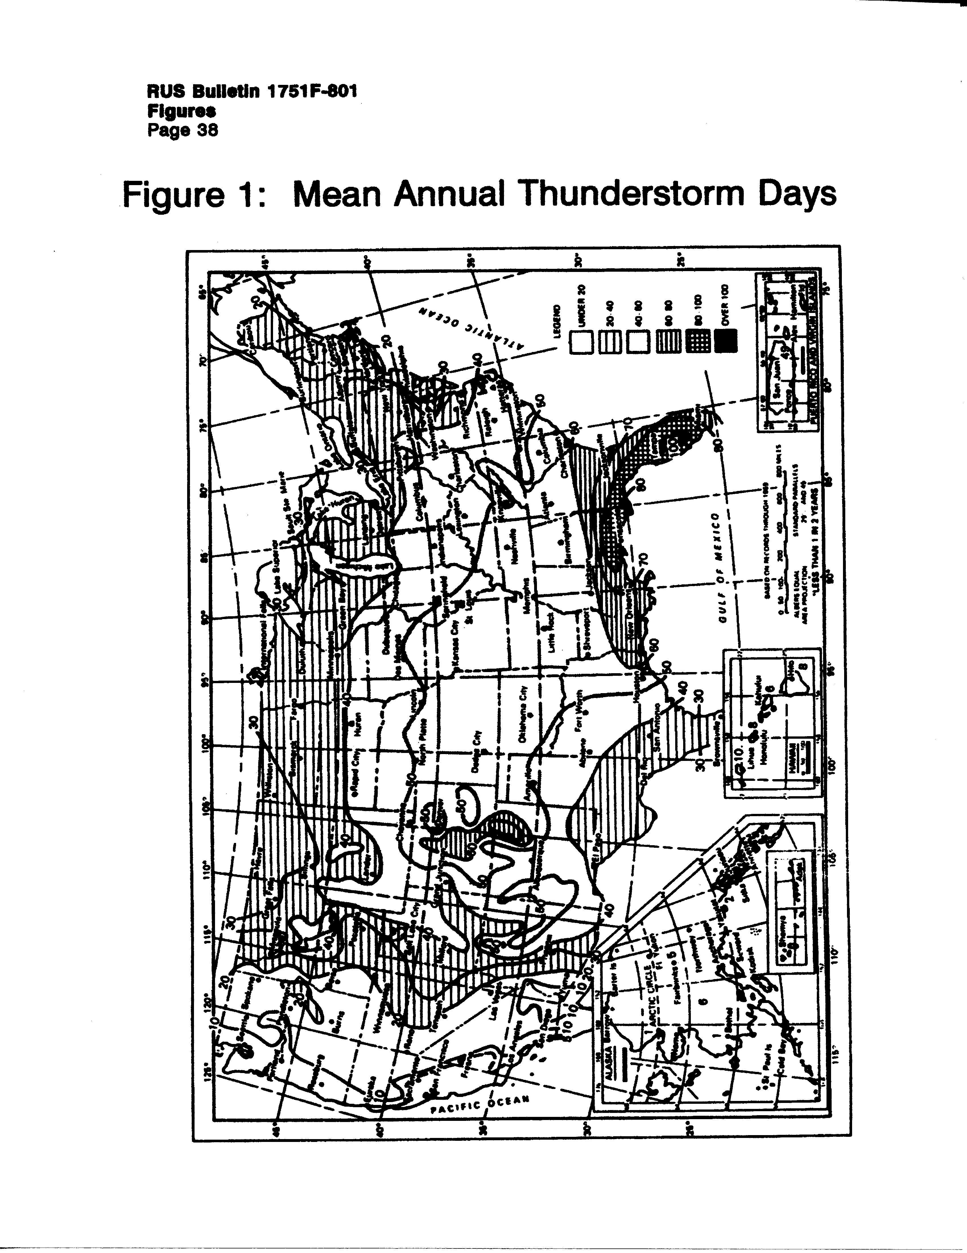

Figure 2 Lightning Damage Probability Map

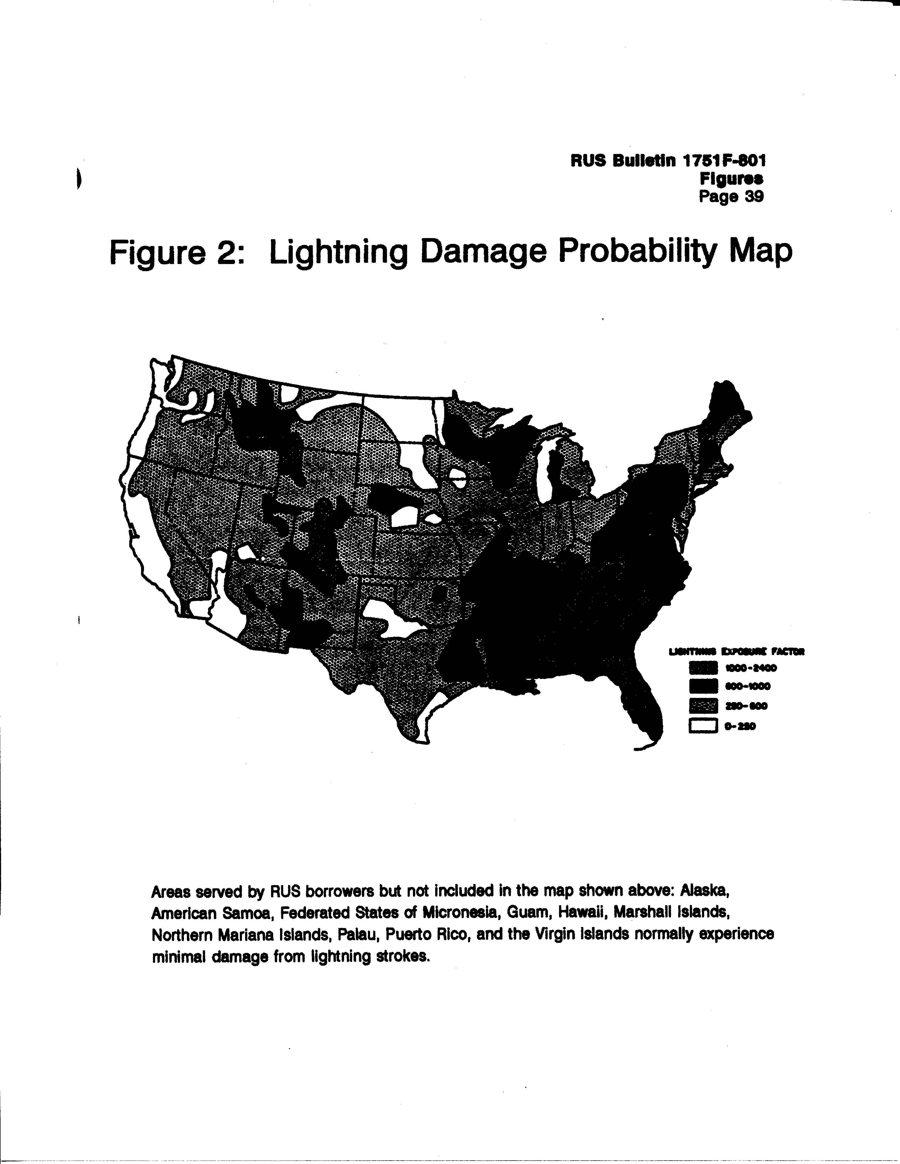

Figure 3 Lightning Stroke Crest Current Distribution

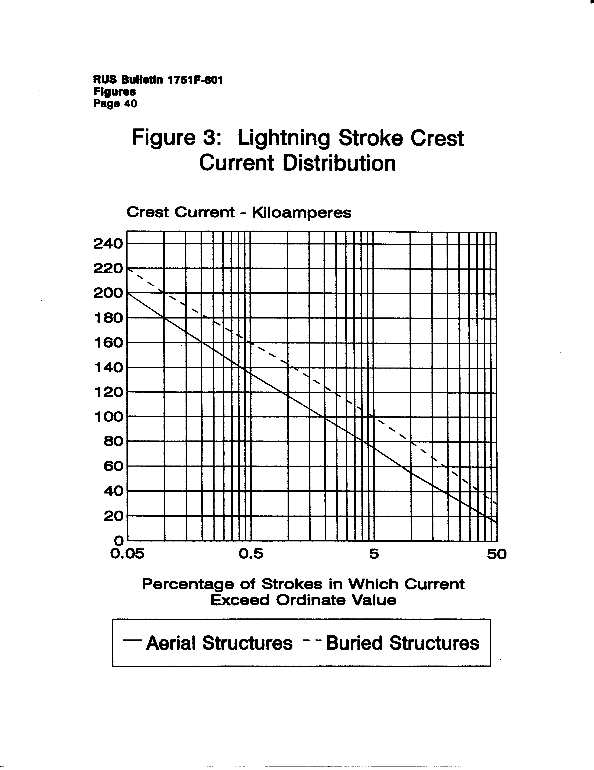

Figure 4 Surge Test Wave Form

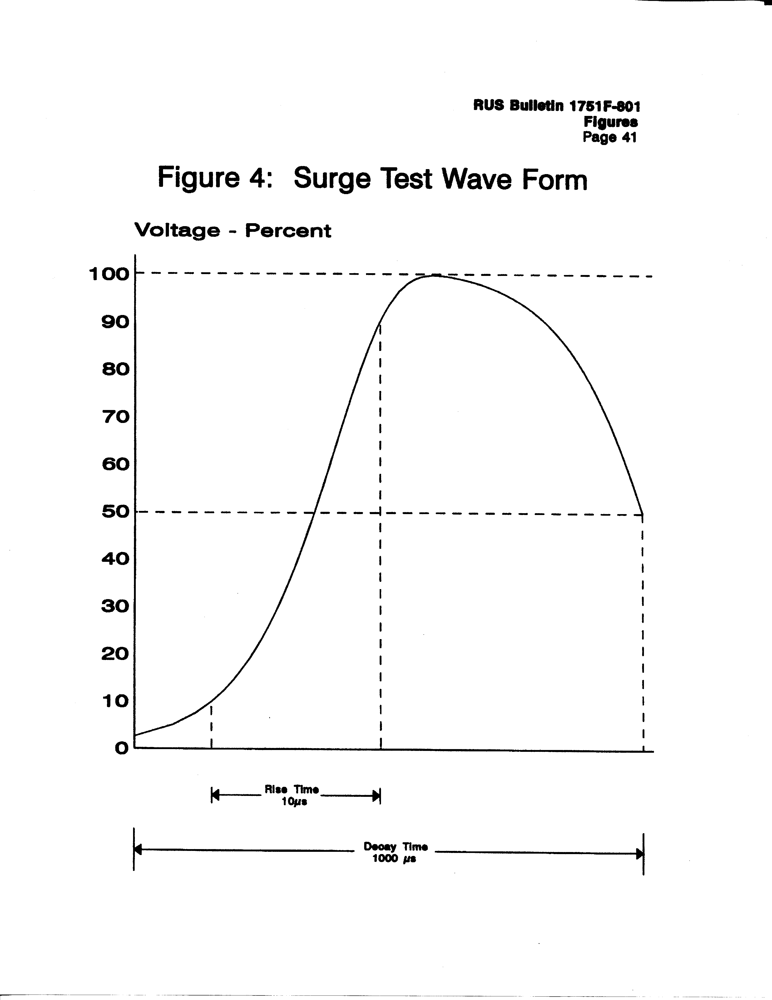

Figure 5 Exploded View of Arrester Assembly

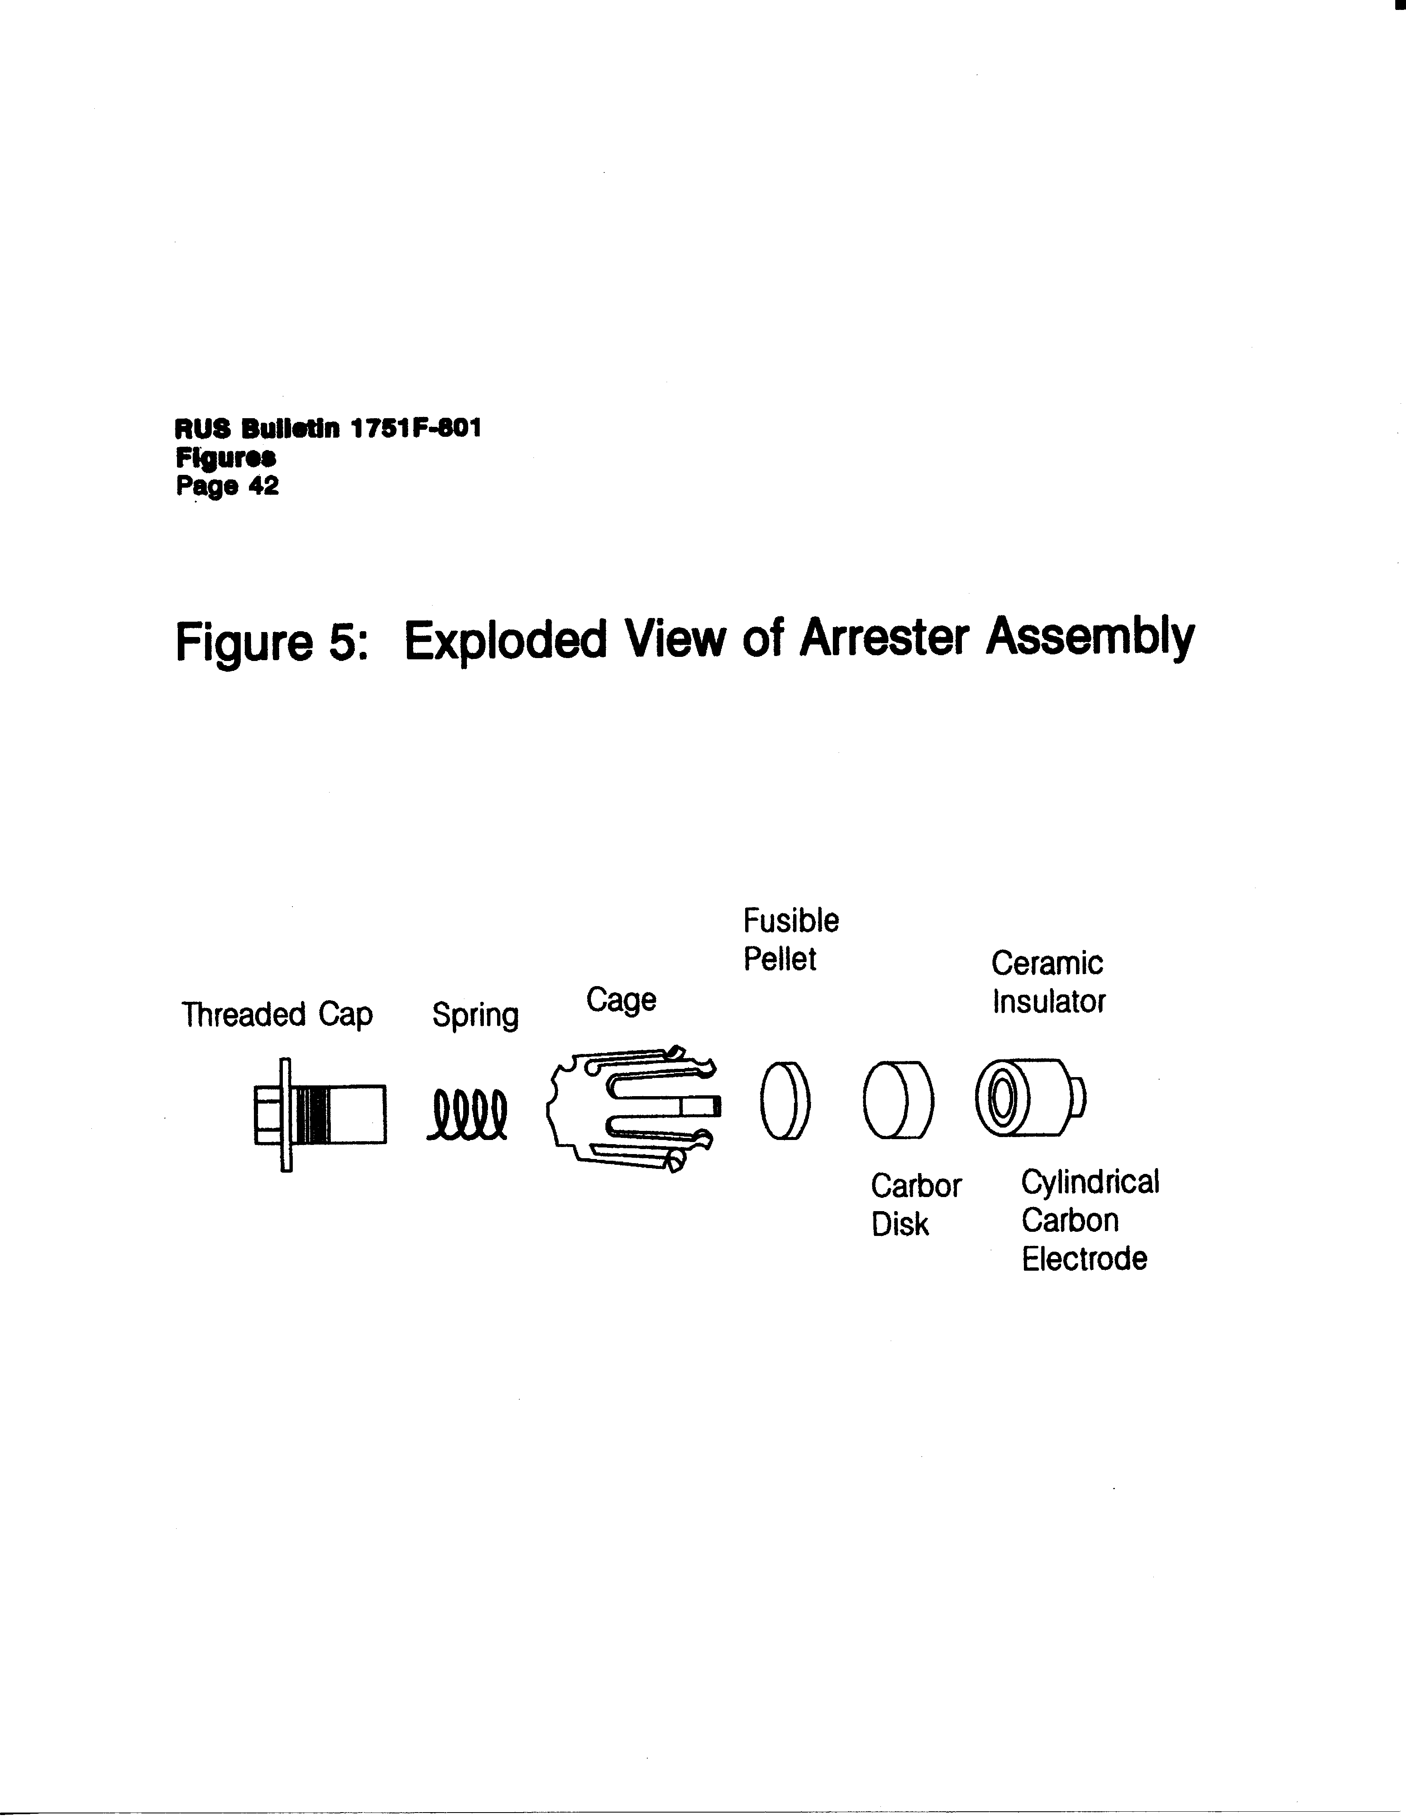

Figure 6 Circuit Breaker Trip Delay

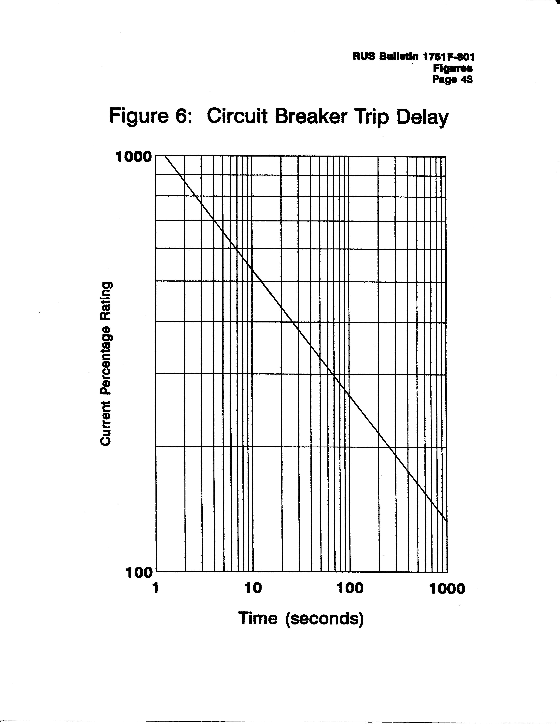

Figure 7 Fused Type Station Protector

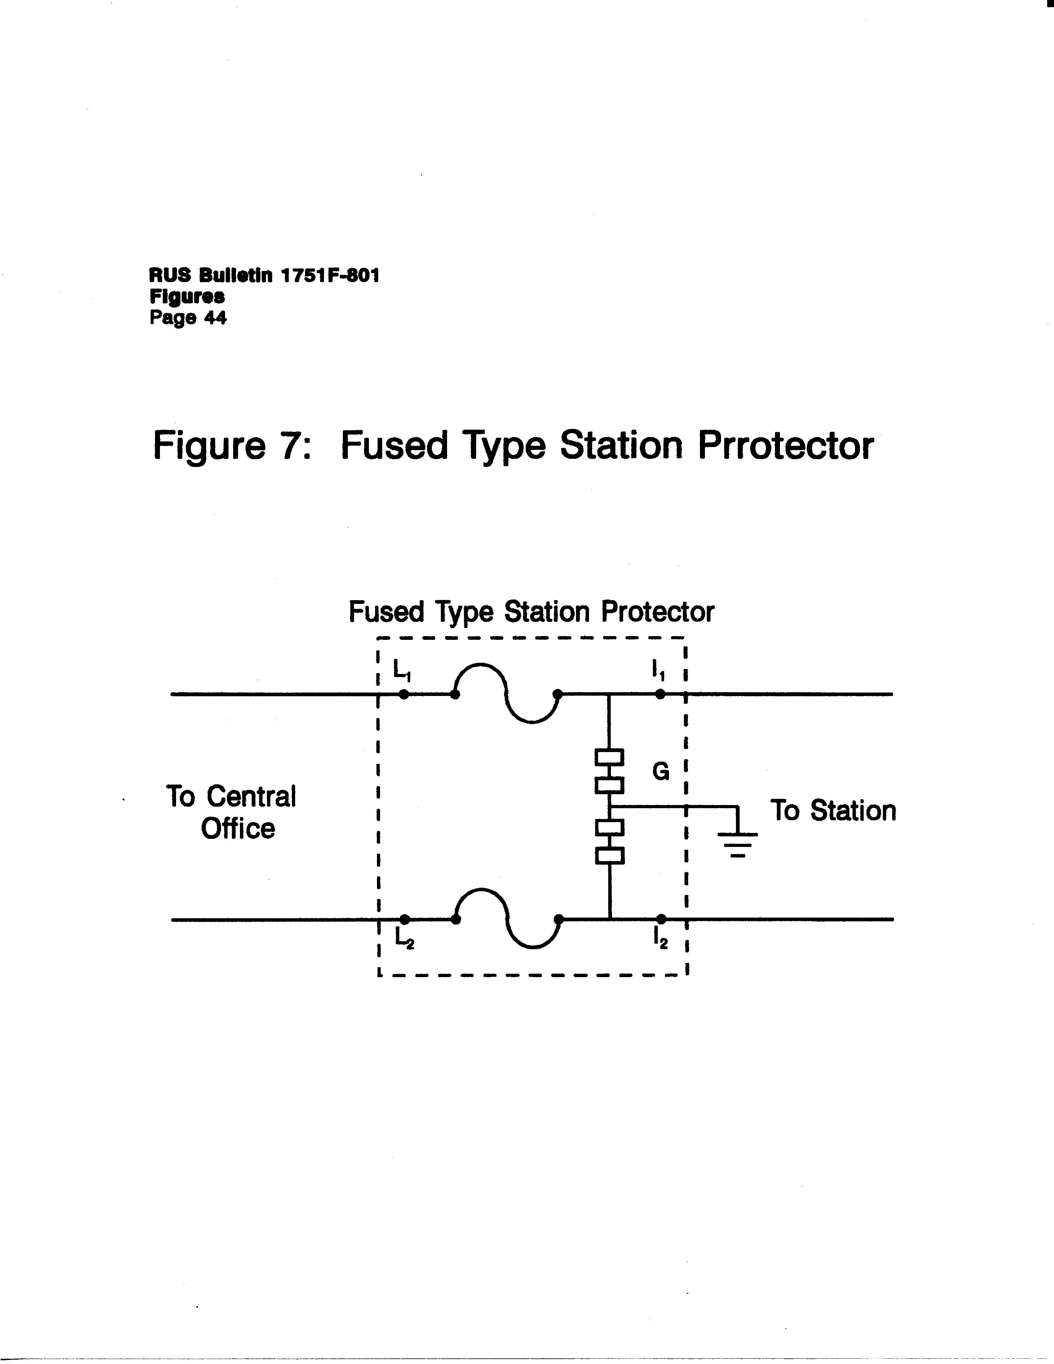

Figure 8 Neutralizing Transformer

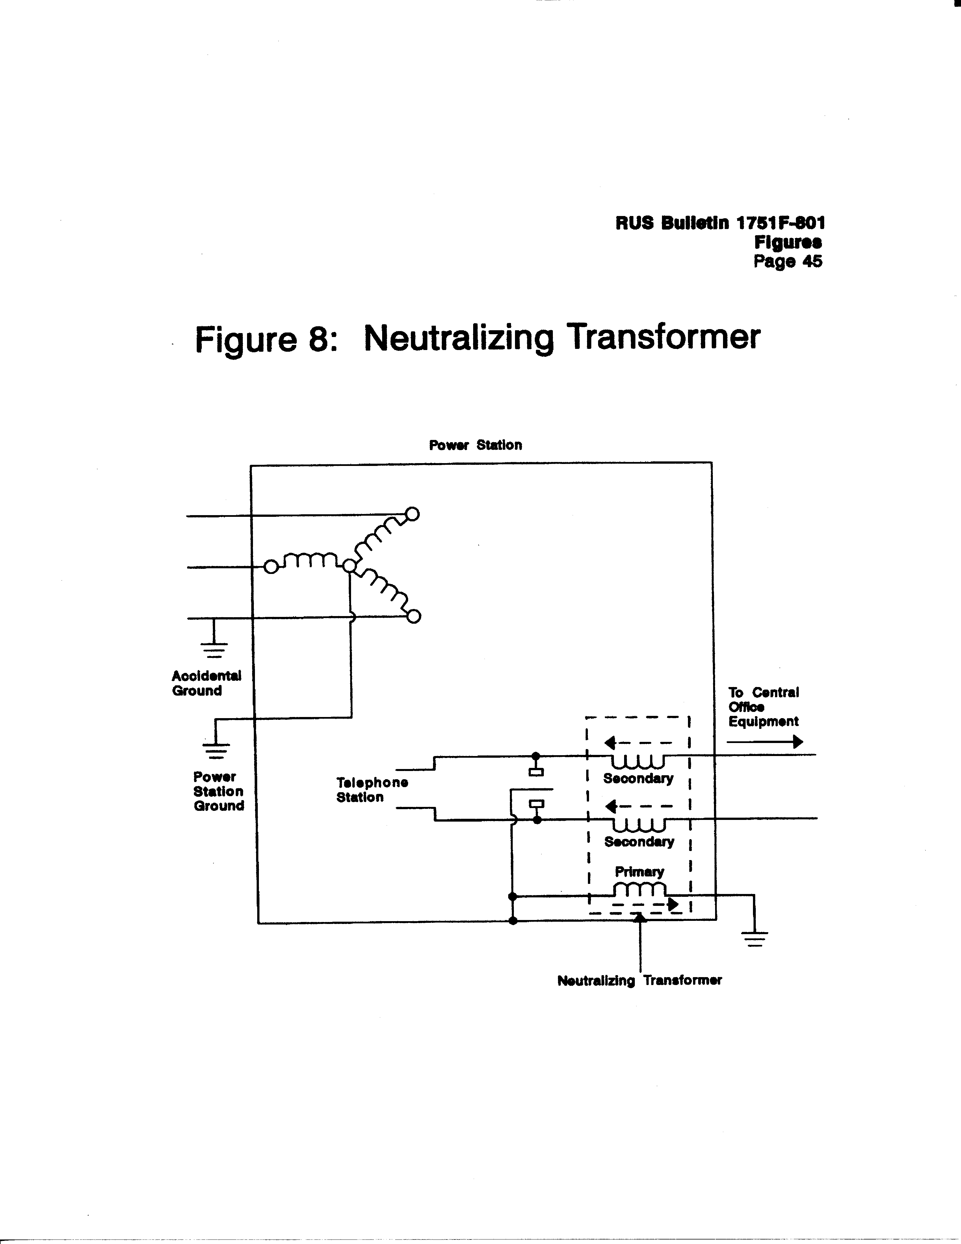

Figure 9 Isolating Transformer

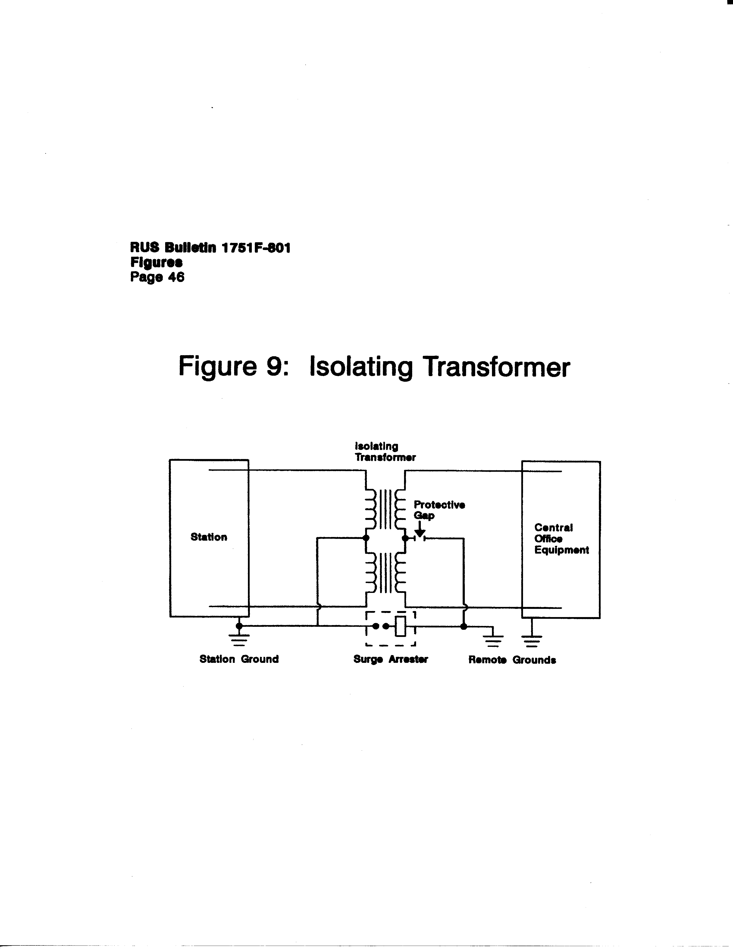

1A common multigrounded neutral (MGN) electric power supply system is a "Wye" connected system which has solidly interconnected primary and secondary neutrals and at least four grounds per mile (1.6 km) of line, exclusive of grounds at customer's premises.
2 2Though the relations depend upon electrostatic principles, the term "electrostatic" is not appropriate for this situation because of the continuously varying field which is involved.
3Lightning, Volume 2, "Lightning Protection," Chapter 25, "Protection of Telecommunications Systems," edited by R. H. Golde, 1977.

