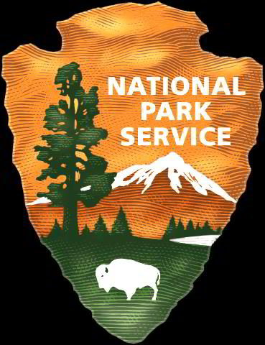
Whale Skeleton Display
At Bartlett Cove
National Park Service
U.S. Department of the Interior

Glacier Bay National Park
And Preserve

The National Park Service will prepare an Environmental Assessment for the Bartlett Cove area to consider display of a 46 foot humpback whale skeleton. The environmental consequences of a range of alternatives will be analyzed.

Why display a whale skeleton?

In the summer of 2001, a dead humpback whale was found floating in the mouth of Glacier Bay. Glacier Bay National Park and Preserve wishes to tell the story of this whale by allowing visitors the opportunity to see the skeleton, and to use this opportunity to educate people about its life history and conservation threats to whales in general. There is also considerable educational value in cleaning, preserving, and preparing the bones for display. Since 2001, many volunteers from the community, including high school and college students, have worked alongside NPS staff to help with the monumental task of retrieving, cleaning and preserving the whale bones.

Should the skeleton be displayed, and if so, how?

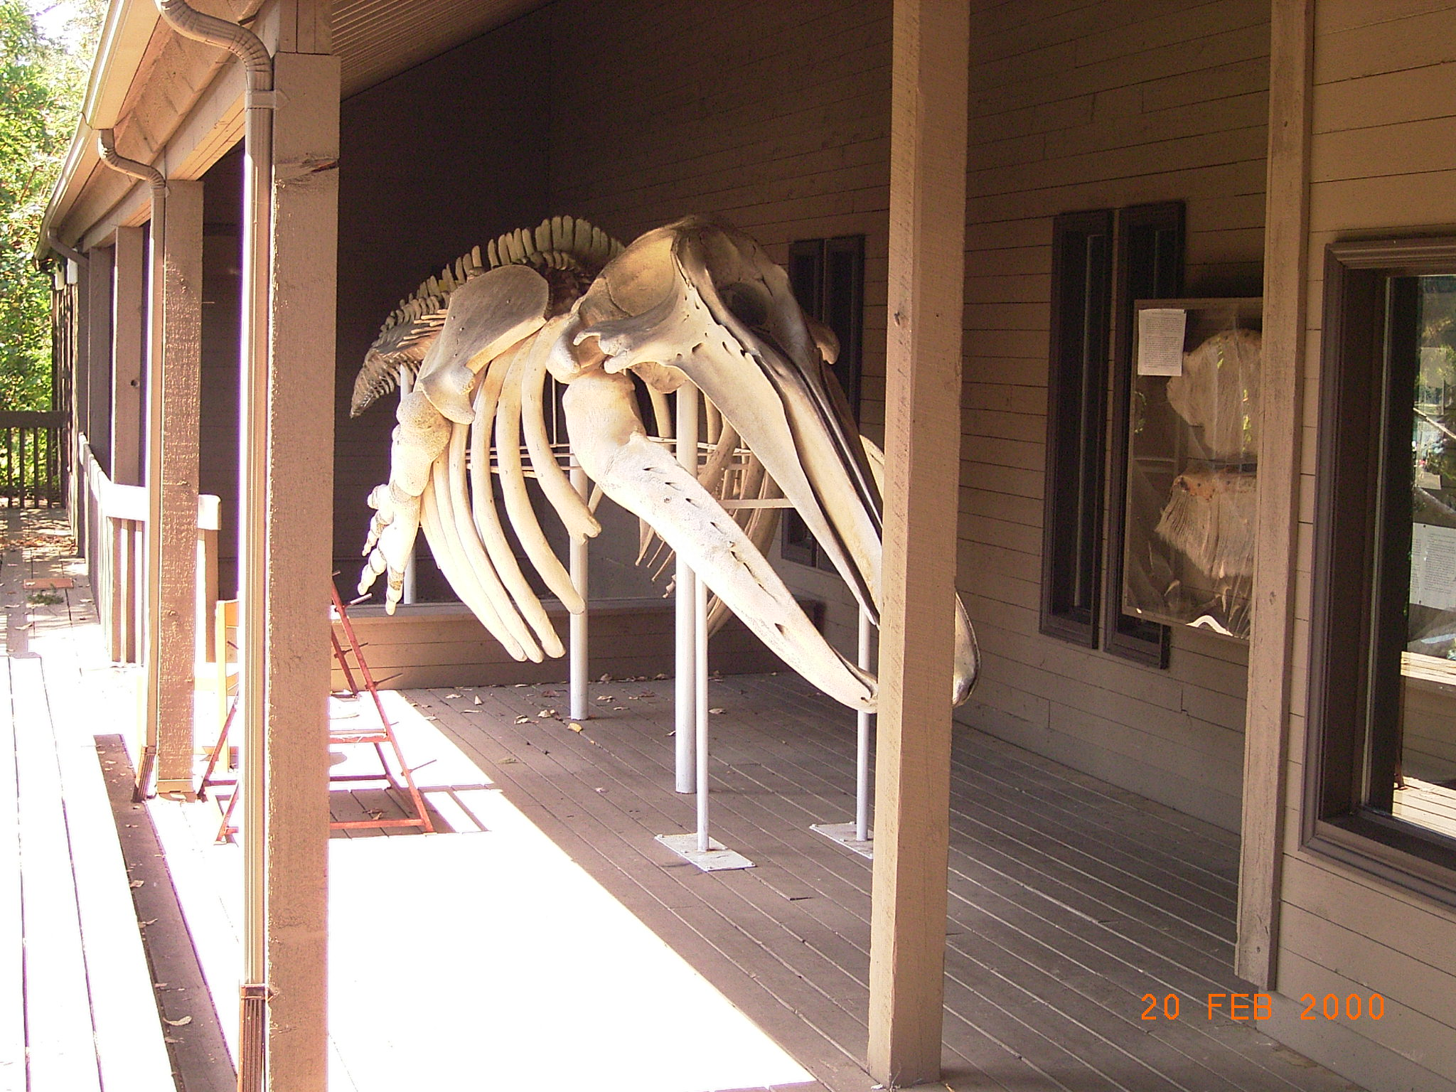
The NPS needs to consider carefully how a large whale skeleton display would fit into existing uses of Bartlett Cove visitor facilities. Bartlett Cove is a culturally important place in the homeland of the Huna Tlingit. It is also the place where virtually all kayakers, visitors at local B&Bs, tour vessel passengers and private boaters embark for trips into Glacier Bay’s backcountry. Local residents, commercial fishermen, researchers and others also visit Bartlett Cove to access Glacier Bay Lodge, the NPS Visitor Center and the public dock. Park visitor services at Bartlett Cove are intended to fill a variety of needs including opportunities for education and inspiration.
A gray whale skeleton on display at Pearson College in British Columbia.
Photo courtesy of Garry Fletcher, Pearson College.

Factors to consider in making this decision include effects on Park visitors and concessioners, effects on wildlife and coastal habitat, and the visual impact of an additional structure in Bartlett Cove. Locations along the beach trail between the Visitor Information Station and the Lodge are being considered as potential locations for the display.

Here are some preliminary possibilities:

- Store the preserved bones without a display.
- Display a few selected whale bones in an existing facility.
- Display the skeleton on a support structure without a roof.
- Build a 30’x50’ structure similar to the Tlingit canoe shelter to display the skeleton.

What part can I play?

Whether you are a local resident, fisherman, subsistence user, lodge or business owner or interested member of the public, changes in facilities at Bartlett Cove may affect you or your business. Any decision needs to accommodate those visiting, working, living, and recreating in Bartlett Cove now and in the future. Comments on the ideas presented here, new ideas, questions, requests to be on our mailing list, and any concerns are welcome. It is also important for you to help us identify the effects various courses of action could have on you or your business. Please send your comments to: Allison Banks Glacier Bay National Park & Preserve PO Box 140 Gustavus, AK 99826, Allison_Banks@nps.gov, or phone 907-697-2611. Comments should be submitted to the NPS postmarked no later than February 20, 2008.



