APPENDIX D: VALUATION PROTOCOL

The appraisal process is the lender’s tool for determining if a property meets the minimum requirements and eligibility standards for a FHA-insured mortgage. Underwriters bear primary responsibility for determining eligibility; however, the appraiser is the on-site representative for the lender and provides preliminary verification that the General Acceptability Criteria standards have been met.

FHA RESIDENTIAL APPRAISAL REQUIREMENTS
This section provides specific instructions for completing appraisal report forms.

The appraisal reporting form to be used will depend on the property type that is being appraised. The appraiser must select the appropriate appraisal form for reporting an FHA appraisal from the following:

- Uniform Residential Appraisal Report (Fannie Mae Form 1004 March 2005) – Required to report an appraisal of a one-unit property or a one-unit property with an accessory unit.
- Manufactured Home Appraisal Report (Fannie Mae Form 1004C March 2005) – Required to report an appraisal of a one-unit manufactured home.
- Individual Condominium Unit Appraisal Report (Fannie Mae Form 1073 March 2005) – Required to report an appraisal of a unit in a condominium project or a condominium unit in a planned unit development (PUD).
- Small Residential Income Property Appraisal Report (Fannie Mae Form 1025) – Required to report an appraisal of a two- to four-unit property.

An appraisal performed for HUD/FHA purposes requires that all sections of the appraisal form be addressed. The appraiser must complete the form in a manner that clearly reflects the thoroughness of the investigation and analysis of the appraisal findings. The conclusions about the observed conditions of the property provide the rationale for the opinion of market value. The completed appraisal form utilized, together with the required exhibits, constitutes the reporting instrument to HUD for FHA-insured mortgages.

The FHA Appraisal is made | Under the following conditions
A. “As Is” | - There is/are no repair(s), alteration(s) or inspection conditions noted by the appraiser, or  - Establishing the “as is” value for a regular 203(k), or  - The property is being recommended for rejection
B. “Subject to Completion per Plans and Specifications” | - Proposed Construction where construction has not started, or  - Under Construction but not yet complete (less than 90%), or  - Regular 203(k)
C. “Subject to the following Repairs or Alterations” | - Repair or Alteration Condition(s) noted by the appraiser, or  - Streamline 203K, or  3. Under Construction, more than 90% complete with only minor finish work remaining (buyer preference items i.e., floor coverings, appliances, fixtures, landscaping, etc.). This eliminates the need for construction exhibits.
D. “Subject to the following Required Inspection” | 1. Required Inspection(s) noted by the appraiser

FHA Quick Tips

Minimum Property Requirements (MPR) and Minimum Property Standards (MPS)
For new construction to be eligible for FHA financing, it must comply with HUD’s Minimum Property Standards (including 24 CFR 200.926d). Existing construction must comply with HUD’s
Minimum Property Requirements (HUD Handbook 4905.1). .

In the performance of an FHA appraisal, the appraiser must denote any deficiency in the appropriate section(s) (site issues in the site section, improvement issues in the improvements section) of the appraisal report. The appraiser is to note those repairs necessary to make the property comply with FHA’s Minimum Property Requirements (MPR) or Minimum Property Standards (MPS) together with the estimated cost to cure. The lender will determine which repairs for existing properties must be made for the property to be eligible for FHA-insured financing.

Cosmetic repairs are not required; however, they are to be considered in the overall condition rating and valuation of the property. Examples of cosmetic repairs would include surface treatments, beautification or adornment not required for the preservation of the property. For example, generally, worn floor finishes or carpeting, holes in window screens, or a small crack in a windowpane are examples of deferred maintenance that do not rise to the level of a required repair but must be reported by the appraiser.

The physical condition of existing building improvements is examined at the time of the appraisal to determine whether repairs, alterations or inspections are necessary - essential to eliminate conditions threatening the continued physical security of the property.

Required repairs will be limited to necessary requirements to:
- protect the health and safety of the occupants (Safety)
- protect the security of the property (Security)
- correct physical deficiencies or conditions affecting structural integrity (Soundness)

A property with defective conditions is unacceptable until the defects or conditions have been remedied and the probability of further damage eliminated. Defective conditions include:
- defective construction
- other readily observable conditions that impair the safety, sanitation or structural soundness of the dwelling

Typical conditions that would require further inspection or testing by qualified individuals or entities:
- infestation – evidence of termites
- inoperative or inadequate plumbing, heating or electrical systems
- structural failure in framing members
- leaking or worn-out roofs
- cracked masonry or foundation damage
- drainage problems

Appraisers are reminded not to recommend inspections only as a means of limiting liability. The reason or indication of a particular problem must be given when requiring an inspection of any mechanical system, structural system, etc.

These guidelines are provided to assist in the examination of the property. To perform this analysis, the appraiser must have full access to all property improvements.

If unable to visually evaluate the improvements in their entirety, contact the lender and reschedule a time when a complete visual inspection can be performed. This includes access to the crawl space and attic. The appraiser is not required to disturb insulation, move personal items, furniture, equipment, plant life, soil, snow, ice or debris that obstructs access or visibility.

An inspection done in accordance with these guidelines is visual and is not technically exhaustive. These guidelines are applicable to buildings with four or less dwellings units and their related property improvements.

Unacceptable Locations
FHA guidelines require that a site be rejected if the property being appraised is subject to hazards, environmental contaminants, noxious odors, offensive sights or excessive noises to the point of endangering the physical improvements or affecting the livability of the property, its marketability, or the health and safety of its occupants. Rejection may also be appropriate if the future economic life of the property is shortened by obvious and compelling pressure to a higher use, making a long-term mortgage impractical.

If the condition is clearly a health and safety violation, contact the lender for further instructions before completing the appraisal. The lender must clear the condition and may require an inspection or reject the property. If there is any doubt as to the severity, report the condition and submit the completed report. For those conditions that cannot be repaired, such as site factors, the appraised value is based upon the existing conditions.

Site Hazards And Nuisances
The appraiser must note and comment on all hazards and nuisances affecting the subject property that may endanger the health and safety of the occupants and/or the structural integrity or marketability of the property, including: subsidence, operating and abandoned oil and gas wells, abandoned wells, slush pits, heavy traffic, airport noise and hazards, runway clear zones/clear zones, proximity to high pressure gas, liquid petroleum pipelines or other volatile and explosive products, residential structures located within the fall distance of a high-voltage transmission line, radio/TV transmission tower, etc., excessive hazard from smoke, fumes, odors, and stationary storage tanks containing flammable or explosive material.

If hazards or nuisances are observed, the appraiser must describe the condition(s) and make a requirement for repair and/or for further inspection, and prepare the appraisal “subject to repairs” and/or “subject to inspection” in the site section of the report. Supporting documentation provided by the appraiser may include extra photos or copies of site studies or analyses, property reports, surveys or plot plans, etc.

Any and all references to Valuation Condition items addressed in Chapters 2 and 3 are to be addressed in the appropriate section of the applicable appraisal reporting form. For example, Chapter 2, Sec. 2-2-E, Slush Pits, instructs: “If there is any readily observable evidence of slush pits, mark the "yes" column in VC-1”. The new protocol will require the appraiser to address this condition in the site section of the appraisal report and note that the property may not be eligible for FHA financing referencing the information contained in chapter 2; otherwise, the guidance provided by chapters 2 and 3 remains in effect.
Soil Contamination
Check readily observable evidence of hazardous substances in the soil. Conditions that could indicate soil contamination include pools of liquid, pits, ponds, lagoons, stressed vegetation, stained soils or pavement, drums or odors. If any of these conditions exist further analysis or testing is required.
Note the proximity to dumps, landfills, industrial sites or other sites that could contain hazardous wastes.

If there is any readily observable surface evidence of leakage from an underground storage tank, further analysis or testing is required. If there is readily observable evidence of on-site contamination, make a requirement for further inspection in the site section of the report.

Grading and Drainage
Check for readily observable evidence of grading and drainage problems. Proper drainage control measures may include gutters and downspouts or appropriate grading or landscaping to divert the flow of water away from the foundation. If the grading does not provide positive drainage from the improvements, make a repair requirement. Note any readily observable evidence of standing water near the property that indicates improper drainage. If the standing water is problematic, make a repair requirement in the site section of the report.

Individual Water Supply and Sewage Systems
Identify the type of utilities in the site section of the appraisal report. When water and sewer are private, well and septic testing is to be governed by state or local requirements; however, the appraiser must note any readily observable deficiencies regarding the well or septic system. The appraiser is also required to report on the availability of connection to public and/or community water/sewer systems. The lender is responsible for the determination of the feasibility for requiring connection.

Wood Destroying Insects/Organisms
Report any evidence of infestation in the “improvements section” of the appraisal report under “foundation” by simply marking the evidence of infestation box.

Private Road Access and Maintenance
Address private road access in site area under “off-site improvements”. Private streets must be protected by permanent recorded easements or be owned and maintained by a HOA. Shared driveways must also meet these requirements.

Each property must have vehicular or pedestrian access. If the property is inaccessible by foot or by vehicle, note this deficiency. FHA defines all-weather surface as a road surface over which emergency vehicles can pass in all types of weather. If the property is not provided with an all-weather surface, note the absence of such in the appraisal..

Structural Conditions
Appraiser must answer yes/no question on the appraisal addressing physical deficiencies affecting structural integrity. If answered “yes”, provide an explanation addressing the nature of the deficiency and recommend repairs, alterations or required inspections, in the improvements section under physical deficiencies/adverse conditions.

Foundation
Report any evidence of dampness or settlement by noting such under the foundation section of improvements description.

Describe the nature of the deficiency and recommend repairs, alterations or required inspections, if any, in the improvements section under physical deficiencies/adverse conditions.

Roofing
Identify roofing material type, and the condition observed, in the improvements section of the report. The nature and degree of any noted deficiency will determine whether the appraiser addresses the deficiency in the narrative comments area of the report under “condition of the property”, or “physical deficiencies” affecting livability or structural soundness.

Mechanical Systems
Report on the condition of the improvements, which includes mechanical systems. The nature and degree of any noted deficiency will determine whether to address the deficiency in the narrative comments area of the report under “condition of the property”, or “physical deficiencies” affecting livability or structural soundness.

Check mechanical, plumbing and electrical systems in the subject property to ensure that they are in proper working order. This examination entails turning on the applicable systems and observing their performance. If any conditions exist that would affect the health or safety of the occupants, condition the appraisal on the repair or alteration of the condition” and/or a “required inspection.” The following is not an all-inclusive list, but a listing of the more common readily observable property deficiencies.

Electrical System
- Examine the electrical system to ensure that there is no visible frayed wiring, or exposed wires in living areas and note if the amperage appears adequate for the property.
- Operate a representative number of lighting fixtures, switches and receptacles inside the house, garage and on the exterior walls and note any deficiencies. If the appliances present at the time of the inspection do not appear to be reasonable (undersized), determine if there is adequate amperage to run “standard” appliances, as per local code.
• The appraiser is not required to insert any tool, probe or testing device inside the panels or to dismantle any electrical device or control.

Plumbing System
• Flush the toilets and turn on a representative number of faucets to determine that the plumbing system is intact, that it does not emit foul odors, that faucets function appropriately, that both cold and hot water run and that there is no readily observable evidence of leaks or structural damage under fixtures.
• Turn on several cold water faucets in the house to check water pressure and flow. Flushing a toilet at the same time will also reveal any weaknesses in water pressure.
• If the property has a septic system, examine it for any signs of failure or surface evidence of malfunction.

Other Health and Safety Deficiencies
Address all health and safety issues, physical deficiencies or adverse conditions that affect the livability, soundness or structural integrity of the property. The nature and degree of any health and/or safety issues will determine whether to address said deficiency in the narrative comments area of the report under “condition of the property”, or “physical deficiencies” affecting livability or structural soundness.

Lead Based Paint Hazards
For any home built prior to 1978, check for evidence of defective paint surfaces, including: peeling, scaling or chipping paint. For all FHA insured properties, correction is required to all defective paint surfaces in or on structures and/or property improvements built before January 1, 1978 in accordance with 24 CFR Part 35. Provide a detailed description and identify the exact location of any deficiency under “physical deficiencies” affecting livability.

Comparable Selection
At a minimum, comparable selection should be based on properties having the same or similar locational characteristics as well as physical characteristics which includes: style, age, size, utility and condition.
Comparable sales should never be selected based on sales price.

In selecting comparables, use the bracketing method. Bracketing, as defined in The Dictionary of Real Estate Appraisal, Fourth Edition, Appraisal Institute, is “a process in which the an appraiser determines a probable range of values for a property by applying qualitative techniques of comparative analysis to a group of comparable sales. The array of comparable sales may be divided into two groups – those superior to the subject and those inferior to the subject. The adjusted sales prices reflected by these two groups limit the probable range of value for the subject and identify a bracket in which the final value opinion will fall.” It is advisable to bracket sales using both dwelling size and sales price whenever possible. If bracketing is not possible, the appraiser should explain why.

For properties in established subdivisions, or for units in established condominium or PUD projects that have resale activity, the appraiser should use comparable sales from within the same subdivision or project as the subject property if there are any available. Resale activity from within the subdivision or project should be the best indicator of value for properties in that subdivision or project. If the appraiser uses sales of comparable properties that are located outside of the subject neighborhood, he or she must include an explanation with the analysis.

For properties in new subdivisions, or for units in new (or recently converted) condominium projects, the appraiser must compare the subject property to other properties in its general market area as well as to properties within the subject subdivision or project. This comparison should help demonstrate market acceptance of new developments and the properties within them. The comparable selection should include at least one sale outside the subdivision or project and one sale from within the subdivision or project. The third sale may be either.

In selecting the comparable sales, the appraiser should keep in mind that sales or resales from within the subject subdivision or project are preferable to sales from outside the subdivision or project as long as the developer or builder of the subject property is not involved in the transactions.

Rural properties often have larger lot sizes and their locations can be relatively undeveloped. As a consequence, there may be a shortage (or absence) of recent comparable sales in the immediate vicinity. This may cause the appraiser to select comparable sales that are located a considerable distance from the subject property. In those instances, the appraiser must use his or her knowledge of the area and apply good judgment in selecting comparable sales that are the best indicators of value for the subject property. In these situations, the appraiser must include an explanation of why the particular comparable sales were selected.

Only closed (settled) sales may be used as comparable sales 1, 2 or 3. If a sale is over six months is used, an explanation must be provided.

No sales over one year old are permitted except as “additional comparable sales” and would be identified as comparable sale(s) 4, 5 or 6. Properties under contract may be also be submitted as additional comparable sales 4, 5 or 6 to support trends or value conclusions observed.

FHA, VA, Conventional or cash sales are acceptable as comparable sales.

Intended Use of Appraisal
The intended use for all appraisals prepared for FHA is to support the underwriting requirements for an FHA-insured mortgage.

FHA Appraisals
FHA appraisals are no guarantee that the property is free from defects. The appraisal only establishes the value of the property for mortgage insurance purposes. Buyers need to secure their own home inspections through the services of a qualified inspector and satisfy themselves about the condition of the property.

Contractual Responsibility of Appraisers
The appraiser is hired by the lender and therefore has a contractual responsibility to the lender. However, the appraiser provides services for HUD programs, and therefore, has an obligation to perform these services commensurate with the standards and requirements of HUD. This dual responsibility of the appraiser is recognized in the review and reporting requirements of HUD. The lender and the appraiser must meet their respective obligations as prescribed by HUD/FHA. These contractual obligations to the lender and HUD/FHA are in addition to the appraiser’s legal obligations to his or her credentialing state.

For HUD/FHA purposes
FHA appraisals are subject to the following scope of work, intended use, intended user, definition of market value, statement of assumptions and limiting conditions, and certifications. Modifications, additions, or deletions to the intended use, intended user, definition of market value, or assumptions and limiting conditions are not permitted. The appraiser may expand the scope of work to include any additional research or analysis necessary based on the complexity of this appraisal assignment. Modifications or deletions to the certifications are also not permitted. However, additional certifications that do not constitute material alterations to this appraisal report, such as those required by law or those related to the appraiser’s continuing education or membership in an appraisal organization, are permitted.

Field | Protocol
Scope of Work | The scope of work for this appraisal is defined by the complexity of this appraisal assignment and the reporting requirements of this appraisal report form, including the following definition of market value, statement of assumptions and limiting conditions, and certifications. The appraiser must, at a minimum: (1) perform a complete visual inspection of the interior and exterior areas of the subject property, (2) inspect the neighborhood, (3) inspect each of the comparable sales from at least the street, (4) research, verify, and analyze data from reliable public and/or private sources, and (5) report his or her analysis, opinions, and conclusions in this appraisal report.
Intended Use | The intended use of this appraisal report is for the lender/client to evaluate the property that is the subject of this appraisal for a mortgage finance transaction.
Intended User | The intended user of this appraisal report is the lender/client and HUD/FHA
Definition of Market Value | "The most probable price which a property should bring in a competitive and open market under all conditions requisite to a fair sale, the buyer and seller, each acting prudently, knowledgeably and assuming the price is not affected by undue stimulus."

Statement of Assumptions and Limiting Conditions: The appraiser’s certification in this report is subject to the following assumptions and limiting conditions:
Field | Protocol
1. Matters of a Legal Nature | The appraiser will not be responsible for matters of a legal nature that affect either the property being appraised or the title to it, except for information that he or she became aware of during the research involved in performing this appraisal. The appraiser assumes that the title is good and marketable and will not render any opinions about the title.
2. Sketch of Improvements | The appraiser has provided a sketch in this appraisal report to show the approximate dimensions of the improvements. The sketch is included only to assist the reader in visualizing the property and understanding the appraiser’s determination of its size.
3. Special Flood Hazard Area | The appraiser has examined the available flood maps that are provided by the Federal Emergency Management Agency (or other data sources) and has noted in this appraisal report whether any portion of the subject site is located in an identified Special Flood Hazard Area. Because the appraiser is not a surveyor, he or she makes no guarantees, express or implied, regarding this determination.
4. Court Testimony | The appraiser will not give testimony or appear in court because he or she made an appraisal of the property in question, unless specific arrangements to do so have been made beforehand, or as otherwise required by law.
5. Adverse Conditions | The appraiser has noted in this appraisal report any adverse conditions (such as needed repairs, deterioration, the presence of hazardous wastes, toxic substances, etc.) observed during the inspection of the subject property or that he or she became aware of during the research involved in performing this appraisal. Unless otherwise stated in this appraisal report, the appraiser has no knowledge of any hidden or unapparent physical deficiencies or adverse conditions of the property (such as, but not limited to, needed repairs, deterioration, the presence of hazardous wastes, toxic substances, adverse environmental conditions, etc.) that would make the property less valuable, and has assumed that there are no such conditions and makes no guarantees or warranties, express or implied.

Field | Protocol
5. Adverse Conditions, con’t | The appraiser will not be responsible for any such conditions that do exist or for any engineering or testing that might be required to discover whether such conditions exist. Because the appraiser is not an expert in the field of environmental hazards, this appraisal report must not be considered as an environmental assessment of the property.
6. Repairs or Alterations | The appraiser has based his or her appraisal report and valuation conclusion for an appraisal that is subject to satisfactory completion, repairs, or alterations on the assumption that the completion, repairs, or alterations of the subject property will be performed in a professional manner.

Appraiser's Certification: The Appraiser certifies and agrees that:
Field | Protocol
1. Scope of Work | I have, at a minimum, developed and reported this appraisal in accordance with the scope of work requirements stated in this appraisal report.
2. Complete Visual  Inspection | I performed a complete visual inspection of the interior and exterior areas of the subject property. I reported the condition of the improvements in factual, specific terms. I identified and reported the physical deficiencies that could affect the livability, soundness, or structural integrity of the property.
3. USPAP Compliant | I performed this appraisal in accordance with the requirements of the Uniform Standards of Professional Appraisal Practice that were adopted and promulgated by the Appraisal Standards Board of The Appraisal Foundation and that were in place at the time this appraisal report was prepared.
4. Sales Comparison Approach | I developed my opinion of the market value of the real property that is the subject of this report based on the sales comparison approach to value. I have adequate comparable market data to develop a reliable sales comparison approach for this appraisal assignment. I further certify that I considered the cost and income approaches to value but did not develop them, unless otherwise indicated in this report.
5. Current Agreement for Sale | I researched, verified, analyzed, and reported on any current agreement for sale for the subject property, any offering for sale of the subject property in the twelve months prior to the effective date of this appraisal, and the prior sales of the subject property for a minimum of three years prior to the effective date of this appraisal, unless otherwise indicated in this report.
6. Prior Sales of  Comparable Sales | I researched, verified, analyzed, and reported on the prior sales of the comparable sales for a minimum of one year prior to the date of sale of the comparable sale, unless otherwise indicated in this report.
7. Most Similar Comparable Sales | I selected and used comparable sales that are locationally, physically, and functionally the most similar to the subject property.
8. Combining Land Sales | I have not used comparable sales that were the result of combining a land sale with the contract purchase price of a home that has been built or will be built on the land.
9. Adjustments to Comparable Sales | I have reported adjustments to the comparable sales that reflect the market's reaction to the differences between the subject property and the comparable sales.
10. Verification | I verified, from a disinterested source, all information in this report that was provided by parties who have a financial interest in the sale or financing of the subject property.
11. Competency | I have knowledge and experience in appraising this type of property in this market area.
12. Resources | I am aware of, and have access to, the necessary and appropriate public and private data sources, such as multiple listing services, tax assessment records, public land records and other such data sources for the area in which the property is located.
13. Reliable Sources | I obtained the information, estimates, and opinions furnished by other parties and expressed in this appraisal report from reliable sources that I believe to be true and correct.
14. Factors Impacting Value | I have taken into consideration the factors that have an impact on value with respect to the subject neighborhood, subject property, and the proximity of the subject property to adverse influences in the development of my opinion of market value. I have noted in this appraisal report any adverse conditions (such as, but not limited to, needed repairs, deterioration, the presence of hazardous wastes, toxic substances, adverse environmental conditions, etc.) observed during the inspection of the subject property or that I became aware of during the research involved in performing this appraisal. I have considered these adverse conditions in my analysis of the property value, and have reported on the effect of the conditions on the value and marketability of the subject property.
15. Knowingly Withholding Information | I have not knowingly withheld any significant information from this appraisal report and, to the best of my knowledge, all statements and information in this appraisal report are true and correct.
16. Professional Analysis | I stated in this appraisal report my own personal, unbiased, and professional analysis, opinions, and conclusions, which are subject only to the assumptions and limiting conditions in this appraisal report.
17. Present or Prospective Interest | I have no present or prospective interest in the property that is the subject of this report, and I have no present or prospective personal interest or bias with respect to the participants in the transaction. I did not base, either partially or completely, my analysis and/or opinion of market value in this appraisal report on the race, color, religion, sex, age, marital status, handicap, familial status, or national origin of either the prospective owners or occupants of the subject property or of the present owners or occupants of the properties in the vicinity of the subject property or on any other basis prohibited by law.
18. Employment and Compensation | My employment and/or compensation for performing this appraisal or any future or anticipated appraisals was not conditioned on any agreement or understanding, written or otherwise, that I would report (or present analysis supporting) a predetermined specific value, a predetermined minimum value, a range or direction in value, a value that favors the cause of any party, or the attainment of a specific result or occurrence of a specific subsequent event (such as approval of a pending mortgage loan application).
19. Personally Prepared Report | I personally prepared all conclusions and opinions about the real estate that were set forth in this appraisal report. If I relied on significant real property appraisal assistance from any individual or individuals in the performance of this appraisal or the preparation of this appraisal report, I have named such individual(s) and disclosed the specific tasks performed in this appraisal report. I certify that any individual so named is qualified to perform the tasks. I have not authorized anyone to make a change to any item in this appraisal report; therefore, any change made to this appraisal is unauthorized and I will take no responsibility for it.
20. Identified Lender/Client | I identified the lender/client in this appraisal report who is the individual, organization, or agent for the organization that ordered and will receive this appraisal report.
21. Lender/Client Disclosure and Distribution of Appraisal Report | The lender/client may disclose or distribute this appraisal report to: the borrower; another lender at the request of the borrower; the mortgagee or its successors and assigns; mortgage insurers; government sponsored enterprises; other secondary market participants; data collection or reporting services; professional appraisal organizations; any department, agency, or instrumentality of the United States; and any state, the District of Columbia, or other jurisdictions; without having to obtain the appraiser’s or supervisory appraiser’s (if applicable) consent. Such consent must be obtained before this appraisal report may be disclosed or distributed to any other party (including, but not limited to, the public through advertising, public relations, news, sales, or other media).
22. Disclosure and Distribution by Appraiser | I am aware that any disclosure or distribution of this appraisal report by me or the lender/client may be subject to certain laws and regulations. Further, I am also subject to the provisions of the Uniform Standards of Professional Appraisal Practice that pertain to disclosure or distribution by me.
23. Who May Rely on Appraisal Report | The borrower, another lender at the request of the borrower, the mortgagee or its successors and assigns, mortgage insurers, government sponsored enterprises, and other secondary market participants may rely on this appraisal report as part of any mortgage finance transaction that involves any one or more of these parties.
24. Electronic Signature | If this appraisal report was transmitted as an “electronic record” containing my “electronic signature,” as those terms are defined in applicable federal and/or state laws (excluding audio and video recordings), or a facsimile transmission of this appraisal report containing a copy or representation of my signature, the appraisal report shall be as effective, enforceable and valid as if a paper version of this appraisal report were delivered containing my original hand written signature.
25. Civil Liabilities & Criminal Penalties | Any intentional or negligent misrepresentation(s) contained in this appraisal report may result in civil liability and/or criminal penalties including, but not limited to, fine or imprisonment or both under the provisions of Title 18, United States Code, Section 1001, et seq., or similar state laws.

Appraiser /Client Information
Field | Protocol
Signature | - For FHA appraisals, the only signature permitted is that of the Lender Selected FHA Roster Appraiser. Supervisory signatures are not permitted.  - The signature, as defined in USPAP, is personalized evidence indicating authentication of the work performed by the appraiser and the acceptance of responsibility for content, analysis, and the conclusions of the report. It may be an original or electronic signature.  - An electronic signature must be controlled by a personal identification number, or other media, where the appraiser has sole personal control of affixing the signature.  - The appraiser bears the responsibility for the report with their signature on it. Therefore, appraisers are advised to keep their personal control code confidential.
Name | - Enter appraiser name as it appears on the license.
Company Name | - Enter company name if applicable.
Company Address | - Enter address of business or company with city, state and zip code.
Telephone Number | - Enter phone number with area code.
Email Address | - Enter e-mail address if you send reports electronically.
Date of Signature and Report | - Enter the date the report is signed.
Effective Date of Appraisal | - Enter the effective date of the appraisal which, for FHA purposes, is the date the property was inspected.
State Certification # | - Enter state certification number if applicable.
or State License # | - Enter state license number.
or Other (describe) | - Enter “N/A”
State | - Enter the state of licensure.
Expiration Date | - Enter the expiration date of State Certification or License Number.
ADDRESS OF PROPERTY APPRAISED | - This field should auto populate with the appraisal software used. If not, enter the full property address including street, city, state and zip code.
APPRAISED VALUE OF SUBJECT PROPERTY $ | - Enter the appraised value.
Name | - Enter the name of person who ordered the appraisal.
Company Name | - Enter name of lender/client
Company Address | - Enter company address
Email Address | - Enter email address where report where report was transmitted if applicable

Required Attachments/Exhibits for FHA appraisals
Item | Protocol
Street Map | - Include a legible street map showing the location of the subject and each of the comparable sales utilized. If substantial distance exists between the subject and comparable sales, additional legible maps should be submitted to show the location of the comparable sales.
Sketch | - Include a building sketch showing the Gross Living Area Above Grade, including all exterior dimensions of the house. Include patios, porches, garages, breezeways and other offsets. State “covered” or “uncovered” to indicate a roof or no roof (such as over a patio).  - Show calculations used to arrive at the estimated gross living area.  - An interior sketch or floor plan is required for properties exhibiting functional obsolescence attributable to the lay out.
Subject Photographs | - Front and rear at opposite angles to show all sides of the dwelling,  - Any improvements with contributory value that are not captured in either the front or rear photograph,  - Street scene photo to include a portion of the subject site.  - If the subject property is proposed construction and the improvement has not started, the appraiser should take a photograph that shows the grade of the vacant lot.
Comparable Photos | - Photos depicting the front view of each comparable sale utilized must be those taken by the appraiser. The photos taken by the appraiser are considered evidence of compliance with the Scope of Work of having inspected each comparable sale from the street. Use of MLS photos to exhibit comparable condition at the time of sale is acceptable; however, the appraiser must include their photos as well to document compliance.

The documentation provided by the required attachments/exhibits satisfies FHA’s minimum requirements. However, additional exterior and/or interior photos, reports, studies, analysis, or copies of prior listings may be included in support of the appraiser’s observation and analysis, e.g. photographs of positive or negative view influences, property deficiencies, or adverse conditions, provides strong supporting documentation of conditions observed on the date of the appraisal. Photo documentation of property condition is always advisable.

D-1 Uniform Residential Appraisal Report

This section provides specific instructions for completing the Uniform Residential Appraisal Report (Fannie Mae Form 1004 March 2005, URAR).

This report form is designed to report an appraisal of a one-unit property or a one-unit property with an accessory unit; including a unit in a planned unit development (PUD), based on an interior and exterior inspection of the subject property. This form is not designed to report an appraisal of a manufactured home or a unit in a condominium or cooperative project.

Section 1 - Subject
This section provides the factual data to identify the property and the parties to the appraisal process. The *FHA case number together with *borrower and/or *property information will be supplied by the lender/client who engages the appraiser.

Field | Protocol
*File Number | • Insert the FHA Case Number at the top right corner of the page.  - The FHA appraisal may not be transmitted to the lender without a case number.
*Property Address | • Enter the property street number and name, city, state and zip code for the property. A post office box number is not acceptable. Enter the nearest intersection if a house number is not available.
*Borrower | - Enter the name of the borrower/mortgagor.
Owner of Public Record | - Enter the name of the owner as listed in public records. If the seller is not the owner of public record the appraiser must explain.
County | - Enter the name of the county in which the property is located. It further provides locational parameters. If not applicable enter “N/A”.
Legal Description | • Enter the legal description of the property. The four types of legal descriptions are: lot and block system, geodetic survey, government survey system and metes and bounds system. If the space provided is insufficient, enter this information with the heading “Legal Description” in the “Additional Comments” section of the form report or attach this information as an addendum.
Assessor’s Parcel # | - Enter the parcel number assigned by the local tax assessor. For those areas that do not have an assessor’s parcel number, enter the tax identification number.
Tax Year | - Enter the current tax year used by the locale, e.g. fiscal year or actual year.
R. E. Taxes $ | - Enter the dollar amount of the annual real estate taxes, including all relevant taxes (school district tax, fire district tax, etc.).
Neighborhood Name | - Enter the name of the subdivision, if applicable, or the commonly known local neighborhood designation. If the subject property is in a planned unit development, provide the name of the development.
Map Reference | - Enter location map reference, page number and coordinates, from source used. This reference should relate to the location maps most commonly used in the locale.
Census Tract | - Enter the census tract number. The census tract number must be provided.  - Census tract numbers have four digits and may have a two digit decimal suffix. Where the basic census tract number is less than four digits, the Census Bureau includes leading zeros except when displaying numbers on maps or printed reports. To uniquely identify a census tract, a two-digit state code and three-digit county code precede the four-or six-digit census tract number. The Census Bureau has an internet resource guide for locating census information. It can be found at URL: www.census.gov
Occupant | - Mark the box signifying the occupancy status at the time of the appraisal.  If vacant, the appraiser should note, in the “Improvements” section under “condition of the property,” whether the utilities were on or off at the time of the appraisal. If off, condition the appraisal on a satisfactory re-inspection that the utility that was off at the time of the appraisal does not require alteration, repair or further inspection.
Special Assessments $ | - Report the dollar amount of special assessments for the subject property, if any, and provide a brief explanation for the assessment. Special assessments can include municipal bond debt for off-site improvements. Larger than typical special assessments may affect marketability. If not applicable enter “N/A”.
PUD HOA$ | • Enter the dollar amount of the HOA fee and mark the box indicating if the fees are paid “per year” or “per month”.
Property Rights Appraised | • Mark the appropriate box indicating the property rights appraised for the subject property as of the date of the appraisal. “Other” includes Land Trust.
Assignment Type | - Mark the appropriate box indicating the assignment type.
Lender/Client  Address | • Enter the name of the lender/client who ordered and will receive the appraisal report.  - The use of the appraisal is to support FHA’s decision to provide mortgage insurance on the real property that is the subject of the appraisal; therefore, intended users include the lender/client and FHA.  - Enter the lender/client’s address.
Currently offered for sale or offered for sale in last 12 months. | - The appraiser’s certification states in part “I have researched, verified, analyzed and reported on any current agreement of sale of the subject property, any offering for sale of the subject property in the twelve months prior to the effect date of the appraisal…”  - Mark the appropriate box indicating whether the subject is currently offered for sale or has been offered for sale in the 12-month period prior to the effective date of the appraisal. If there are multiple actions, report each instance. Research may reveal an expired or withdrawn listing. The prior listing may provide a good indication of the upper limit of value.
Report data source(s) used, offering price(s), and date(s) | - Complete this field regardless of whether the property is currently offered for sale or has been for sale in the 12 months preceding the date of the appraisal.  - Identify source(s) used, price(s) and date(s) of current or prior listings.

Section 2 – Contract

This section must be completed when the appraisal assignment involves a purchase transaction, otherwise enter “N/A” for not applicable. FHA requires that the appraiser be provided with a complete copy of the ratified sales contract, including all addenda, for the subject property.

It provides the agreed-on contract price (accepted offer), date of sale, and all financial terms implicit in the offer. If unable to obtain this information, the appraiser is to state what efforts were made to obtain it.
Field | Protocol
Analyze Contract for Sale | - Explain the results of the analysis (terms and conditions) of the contract of sale or why the analysis was not performed.  - The analysis may include a reference to the number of pages contained in the contract for sale provided.
Contract Price $ | • Enter the final agreed upon contract price .
Date of Contract | • Enter the date of the contract. This is the date when all parties have agreed to the terms of, and signed the contract.
Is The Property Seller The Owner of Public Record  Data Source(s) | • Mark the appropriate box indicating whether or not the seller is the owner of public record. The appraiser is instructed to contact the lender/client if the seller is someone other than the owner of record. The property may not be eligible for FHA financing if it involves flipping (resale in less than 90 days). The lender will make a determination for any exceptions to FHA’s Flipping Rule and advise the appraiser.  • Report where the information was obtained.
Sales Concessions Down Payment Assistance | - Mark the appropriate box indicating whether or not there is any financial assistance (loan charges, sales concessions, gift or down payment assistance, etc.) paid by any party on behalf of the borrower. If necessary, use the “Additional Comments” section of the appraisal reporting form, or an addendum, and enter the heading “Sales Concessions” completing the description.  - If yes, the appraiser is to report the total dollar amount and describe the items to be paid. If the sale involves personal property (e.g. above ground pool, lawn mower, furniture, etc.) it should be identified and excluded from the valuation.

Section 3 – Neighborhood

This section should reflect the area surrounding the subject property. The appraiser must observe neighborhood characteristics and surrounding properties to make determinations that will be incorporated into the valuation of the subject property. In all instances, the appraiser must mark the appropriate box for each line in neighborhood characteristics and housing trends. Failure to note conditions that may adversely affect the value of the property is poor appraisal practice and violates the Uniform Standards of Professional Appraisal Practice.

NOTE: Race and the racial composition of the neighborhood are not appraisal factors.
Neighborhood Characteristics
Field | Protocol
Location | • Enter the type of area surrounding the subject property.  Urban – relates to a city

Neighborhood Characteristics
Field | Protocol
Location | Suburban – relates to an area adjacent to a city  Rural – relates to the country or beyond the suburban area
Built-up | • Enter the built-up percentage – the percentage of available land that has been improved. Land such as a state park would not be considered available land.
Growth | • Enter the growth rate. If many lots are available, the growth rate may be rapid, stable or slow, but if the neighborhood is fully developed, select the “stable” box.

One-Unit Housing Trends
Field | Protocol
Property Values | • Mark the box describing the current trend in property values for One-Unit single family homes in the community. Comparing houses that have been sold and resold in recent years is an effective way to determine market trends. Appraisers who use this method, however, should make sure to factor in any improvements or changes made to the property between sales.
Demand/ Supply | • Mark the appropriate demand/supply trend. To determine the equilibrium status of supply and demand in the neighborhood, compare the number of houses sold to the number of houses listed for sale in a recent time period. The similarity or difference between the number of houses sold and listed, not the absolute numbers, should determine the demand/supply level.
Marketing Time | • Mark the appropriate marketing time – the typical length of time a property similar to the subject property would have to stay on the market before being sold at a price near its market value.

One-Unit Housing
Price Age | • Indicate the low and high neighborhood prices and ages as well as the predominant value and age. The high and low for both price and age should exclude the extreme.

Present Land Use %
One-Unit, 2-4 Unit, Multi-Family, Commercial, Other | • Estimate each type of land usage in the neighborhood. If there is no land in the neighborhood with one of the designated classifications, enter a “0”. If a portion of the land consists of parks or other unspecified classifications, enter the estimated percentages on the “Other” line and explain in the neighborhood description section.

Neighborhood Narrative
Neighborhood Boundaries |  | • The appraiser must clearly define the boundaries – north, south, east and west – of the subject’s neighborhood. Providing a description of neighborhood boundaries by physical features such as streets, rail lines, other man-made barriers or well defined natural barriers (i.e. rivers, lakes, etc.) details the make up and understanding regarding neighborhood composition.
Neighborhood Description |  | • Discuss factors that would attract residents or cause them to reject the neighborhood. Some typical factors important to discuss include:  - Level of maintenance and condition of homes  - Housing styles, ages, sizes, etc.  - Land uses  - Proximity to employment and amenities, including travel distance and time to local employment sources and community amenities  - Employment stability, in terms of variety of employment opportunities and industries  - Overall appeal of the neighborhood as compared to competitive neighborhoods in the same market  - Convenience to shopping with respect to distance, time and required means of transportation  - Convenience to schools in terms of the distance and time for travel to school
Market Conditions (including support for the above conclusions) | - Provide relevant information in support of conclusions relating to trends in property values, demand/supply and marketing time.  - Provide a description of the prevalence and impact of sales and financing concessions and/or down payment assistance in the subject’s market area.  - Other areas of discussion may include days on market, list to sale price ratios, and/or financing availability.

Section 4 – Site

This information provides the description of the land underlying the subject property. Insert factual information on each of the lines provided and report the conclusions as directed. Consider all aspects of the physical description and reconcile them in the opinion of market value. This section of the appraisal requires the appraiser to consider any adverse site conditions or adverse external factors that may impact value.

Field | • Protocol
Dimensions | • List all dimensions of the site beginning with the frontage. If the shape of the site is irregular, show the boundary dimensions (85' X 150' X 195' X 250'), or attach a property survey, site plan or plat or legal description with the comment, “see attached .” Do not list site area on the dimensions line.
Area | • Enter the site area in square feet or acres. This entry must be consistent with the dimensions provided in the “Dimensions” field
Shape | • Describe the shape of the site, e.g. triangular, square, rectangular, irregular, flag lot.
View | • Briefly describe the view from the property (None is not an acceptable response).  - Identify a view with a significant positive or negative influence on the value.  - Photographs are recommended for any negative or positive view influences affecting value or marketability.
Specific Zoning Classification | • Enter the specific zoning classification used by the local municipality or jurisdiction, e.g., R-1  - If none exists enter “None Exists”.
Zoning Description | - Describe what the specific classification means. Include a general statement describing what the zoning permits. For example: R-1 = Residential-Single Family  - If “None” exists, describe the prevalent use of sites in the neighborhood.
Zoning Compliance | • Determine whether the current use is in compliance with the zoning ordinances. Mark whether it is Legal, Legal Non-Conforming (Grandfathered Use), No Zoning, or Illegal Use.  • If the existing property does not comply with all of the current zoning regulations (use, lot size, improvement size, off street parking, etc.) but is accepted by the local zoning authority, enter “Legal Non-Conforming” and provide a brief explanation.  - If the use is not legal, the property is not eligible for FHA mortgage insurance.
Highest and  Best Use | • Mark the appropriate box. This entry questions the categorization as the highest and best use of the site as improved or, as proposed and completed, in relation to the neighborhood and current market conditions.  • If current use represents the highest and best use, mark "yes".  • If it does not, mark "no" and provide an explanation.
Utilities | • Mark either “Public” or "Other." If “Other" is marked, describe. Public utilities mean governmentally supplied and regulated. Public does not include any community systems sponsored, owned or operated by the developer or a private company not subject to government regulation or financial assistance.  • Note if there are mechanical chlorinators or water-flow that decreases noticeably while running simultaneous plumbing fixtures.  - Visually inspect the septic system and its surrounding area. If there are obvious or readily observable signs of system failure, “require inspection” to ensure that the system is in proper working order.  Note: The appraiser shall indicate whether a public water or sewage disposal system is available to the site. If available, connection must be made to public or community water/sewage disposal system if connection costs are reasonable. The lender will determine whether connection is feasible.
Off-site Improvements–Type | • Briefly describe the off-site improvements under "Type" and enter road surface material and mark Public or Private. For example: "Street-Asphalt; Public", “Alley-None”  • Public refers to an improvement dedicated to and accepted by a unit of government – not including Home Owner's Associations.
FEMA Special Flood Hazard Area | • FEMA (Federal Emergency Management Agency) is responsible for mapping flood hazard areas. If the property is within a Special Flood Hazard Area, mark "YES". Otherwise, mark “NO”.  • Attach a copy of the flood map panel for properties located within an identified flood hazard area.
FEMA Flood Zone | • Εnter the FEMA Zone designation. Only properties within Special Flood Hazard Areas, such as zones "A" a special flood hazard area and "V" a coastal area, require flood insurance. Zones "B" "C" and “X” do not.
FEMA Map # and FEMA Map Date | • Enter the FEMA Map number and map date. If it is not shown on any map, enter  “Not Mapped.”
Are utilities and off site improvements typical for the market area | - Mark the appropriate box indicating whether the utilities and off-site improvements are typical for the market area.  - If “No” is marked, describe what is typical.
Any adverse site conditions or external factors | • Mark the appropriate box indicating whether there are any adverse site conditions or external factors (easements, encroachments, environmental conditions, land uses, etc.).  - If “No” is marked, no comment is necessary, if “Yes” is marked, an explanation is required.  - Describe any adverse site conditions or adverse factors. Consider easements affecting the functional utility of the property in the conclusions of both the highest and best use and market value. For example, discuss adverse easements, encroachments, slide areas, illegal or non-conforming zoning use, etc. Consider surface, sub-surface and overhead easements.  - List any adverse environmental conditions, including hazardous waste, toxic substances and others.  - Explain all deficiencies that do not require repair (extreme slope, etc.) and consider them in the opinion of value.  • Discuss the observations with direct relationship to value and consider them in the approaches to value.

Section 5 – Improvements

This section describes the subject improvements. Accurately report the conditions observed. Describe needed repairs, or the existence of any functional or external obsolescence. Enter factual information on each of the lines provided and report the conclusions. Consider all aspects of the physical description and reconcile them in the opinion of market value.

Accessory Unit / Accessory Dwelling Unit
The accessory unit is defined as a habitable living unit added to, created within, or detached from a single-family dwelling that provides the basic requirements for living, sleeping, eating, cooking, and sanitation.

Accessory Dwelling Units (ADUs) are commonly understood to be a separate additional living unit, including separate kitchen, sleeping, and bathroom facilities, attached or detached from the primary residential unit, on a single-family lot. ADUs are usually subordinate in size, location, and appearance to the primary unit and may or may not have separate means of ingress or egress.
Attached units, contained within a single-family home, known variously as "mother-in-law apartments," are the most common type of accessory dwelling unit. Accessory units usually involve the renovation of a garage, basement, or small addition to a single-family home.

FHA Criteria
“Accessory dwelling unit" means a subordinate dwelling unit may or may not be incorporated within, or detached from a single-family structure. Accessory units may not be subdivided or otherwise segregated in ownership from the primary residence structure.

Some accessory units may predate the adoption of local zoning ordinance and may therefore be classified as legal nonconforming units.

Utility Service Requirements
An accessory apartment must be connected to the utilities (except telephone, television and cable) of the dwelling unit and may not have separate services.

General Description
Field | Protocol
Units | • Mark the appropriate box. The URAR is designed for one-unit dwelling or one-unit with an accessory unit.
# of Stories | • Enter the number of stories above grade, including half stories. Do not include the basement.
Type | • Mark the box that identifies the type of dwelling, "Det." (Detached), “Att.” (Attached), "S-Det.” (Semi-Detached) or “End Unit” (End unit of a group of rowhouses or townhouses).
Stage of Construction | • Mark the box signifying the stage of construction, Existing, Proposed or Under Construction. Properties that are either Proposed or Under Construction require plans and specifications for the appraiser to review.
Design (Style) | • Enter a brief description of the house design style using historical or contemporary fashion. For example: Cape Cod, bi-level, split level, split foyer, colonial, town house, rowhouse, etc. Do not use builder's model name. Avoid generic descriptions such as Traditional or Conventional.
Year Built | • If the property is less than one year old, include both the month and year completed.  • If it is over one year old, insert the year completed.
Effective Age (Yrs) | • Enter the effective age of the improvements. A range is acceptable. The effective age reflects the condition of the property relative to similar competitive properties. The effective age may be greater than, less than or equal to the actual age.  • Note any significant difference between the actual and effective ages and explain in the “condition of property” comments section.

Attic – Enter the attic and observe the interior roofing for insulation, deficient materials, leaks or readily observable evidence of significant water damage, structural problems, previous fire damage, FRT sheathing, exposed and frayed wiring and adequate ventilation by vent, fan or window. If any of these deficiencies exist, condition the appraisal on their repair and prepare the appraisal “subject to repairs” and/or “subject to inspection”.

The attic must be entered, at a minimum, by head and shoulders, whether access is by pull-down stairway or scuttle. Size of the scuttle and accessibility of the attic dictate the level of entry.
Field | Protocol
None | Enter ‘X” if there is no attic.
Drop Stair | Enter “X” if this item exists.
Stairs | Enter “X” if this item exists.
Floor | Enter “X” if this item exists.
Scuttle | Enter “X” if this item exists.
Finished | Enter “X” if this item exists.
Heated | Enter “X” if the attic is heated.

Foundation
The appraiser is required to inspect the foundation and the basement. The appraiser must address all visible deficiencies and may require a recommendation for an inspection. Consider deferred maintenance and physical deterioration in the valuation process.

Basement
Generally, may be partially or completely below grade (ground level). Do not count the basement in the finished gross living area at the grade level. The information provided must be consistent with the description in the Foundation section.

Foundation
Field | Protocol
Concrete Slab | - Mark this box if any part of the foundation system has concrete slab.
Crawl Space | - Mark this box if any part of the foundation system has crawl space.  - Access to the space should be clear. Examine the crawl space for inadequate access (minimum entry of the head and shoulders).  - Check the distance from the bottom of floor joists to ground. Space should be adequate for maintenance and repair. A minimum distance of 18 inches from the ground to the bottom of the joists is highly recommended but not mandated.
Field | Protocol
Crawl Space | - Check for insulation, and ventilation or for any structural problems. The support beams should be intact and of structural soundness.
Full Basement | - Mark this box if there is a full basement.
Partial Basement | - Mark this box if there is a partial basement.  - For a dirt basement floor, determine whether such a property is typical for the area and is readily marketable. If so, it is not required that a concrete basement floor be installed. Mechanical equipment, however, must be located on a concrete pad.
Basement Area Sq Ft | - Enter the square footage of the basement.
Basement Finish % | - Enter the percentage of basement (figure above) that is finished.
Outside Entry/Exit | - Mark this box only if there is an outside entry/exit, otherwise leave blank.  - If there is an entry, make sure door is operable.
Sump Pump | • Mark this box only if there is a sump pump, otherwise leave blank.
Evidence of  Infestation | - Mark this box if there is evidence of infestation, including the house and/or other structures within the legal boundaries of the property, otherwise leave blank.  • Examine the subject property for readily observable evidence of wood boring insects.  - Do not require a pest inspection based solely on the age of a property. Inspections are necessary whenever there is evidence of decay, pest infestation, suspicious damage or when it is customary to the area or required by state law.
Evidence of Dampness | • Mark this box if there is evidence of dampness, otherwise leave blank.  - Examine the foundation/basement for dampness or readily observable evidence of water damage. Signs of past water problems may include efflorescence, mold, mildew or stains on walls or mechanical equipment.  - Basement or crawl space area must not have excessive dampness or ponding of water.  - If any of these inadequacies exist, condition the appraisal “subject to repairs” to correct the condition, or “subject to inspection” to determine the source of problem and corrective measures necessary by a qualified party.
Evidence of Settlement | • Mark this box if there is evidence of settlement, otherwise leave blank.  • Examine foundation for readily observable evidence of settlement.  - Hairline step-cracks are common, however, horizontal cracks, bulging walls or separation of sill plate from top of foundation wall are critical and require inspection.

Mechanical Systems
An appraiser must examine mechanical, plumbing and electrical systems of the subject property to ensure that they are in proper working order. This examination includes turning on the applicable systems and observing their performance. Electrical, plumbing, and/or heating certifications may be called for by the appraiser when he/she cannot determine if one or all of these systems are working properly.
An appraiser should not arbitrarily call for such certifications. However, the appraiser is still responsible for checking the functionality of these systems at the time of appraisal.

Heating and Cooling Systems
Field | Protocol
Heating | • Enter an “X” in the box indicating the type of heating system: FWA (forced warm air), HWBB (hot water baseboard), Radiant or “Other”. If “Other” is marked, provide a brief description, e.g. EBB (for electric baseboard).  - Turn on the furnace/heating system to test functionality, weather permitting, and that no unusual noises are heard, no odors or smoke are emitted indicating a defective unit, etc. However, do not operate the systems if doing so may damage equipment or when outside temperatures will not allow system to operate.  - Note significant holes/deterioration on the unit.
Heating | - Turn on the hot water to ensure that the water heater is operating appropriately.
Fuel | • Enter type of fuel used: coal, gas, oil, propane, electric, etc.
Cooling | - Enter an “X” in the box indicating the type of cooling system: Central Air Conditioning, Individual or Other. If “Other” is marked, provide a brief description, e.g. permanently affixed fans, zoned air-conditioning, etc.  - Turn on the air conditioning system to test functionality, weather permitting, and that no unusual noises are heard, no odors or smoke are emitted indicating a defective unit, etc. However, do not operate the systems if doing so may damage equipment or when outside temperatures will not allow system to operate.  - Note significant holes/deterioration on the unit

Exterior Materials/Condition
Enter the types of Materials and rate the observed Condition of the Materials (Good, Average, Fair, and Poor). Make every effort to describe accurately and explain in detail “Fair” and “Poor” ratings and whether or not the item(s) described require repair, replacement or further inspection. The rating must relate to the habitability of the house given local standards (Photo documentation of property condition is always advisable).
Exterior Description materials/condition
Field | Protocol
Foundation Walls | - Enter the material type: poured concrete, block, brick, stone, treated wood, etc. and rate the observed condition.
Exterior Walls | • Enter the material type: aluminum, vinyl or wood siding, brick veneer, stucco, stone, etc. If a combination of materials, show the predominant portion first and rate the observed condition.
Roof Surface | • Enter the material type: composition shingle, asphalt shingle, wood, slate, clay tile, aluminum, built-up, etc. and rate the observed condition.  - View the roof from ground level to determine if the integrity of the roof is sufficient.  - Observe roof coverings, roof drainage systems, flashing, skylights, or chimneys for readily observable evidence of leakage or abnormal condensation on building components.

Exterior Description materials/condition
Field | Protocol
Roof Surface | - Note any evidence of deterioration of roofing materials (missing tiles, shingles, flashing). Deteriorated roofing materials include those that are worn, cupped, or curled.  - If the roof is otherwise unobservable, look for telltale signs of roof problems on the interior, such as damage or water stains to the ceiling area of a room or closet.  - The appraiser must note in the appraisal that he/she could not adequately observe the entire roof area (state which area(s) were unobservable). Based on the information reported by the appraiser, the underwriter will determine whether or not a roofing inspection is required.
Gutters and Downspouts | • Enter the material type: galvanized, aluminum, plastic, vinyl, PVC, etc. and rate the condition observed.
Window Type | • Enter window type: Double Hung, Single Hung, Casement, Sliders, etc. and identify the window frame material: wood, aluminum, steel, vinyl, etc. Rate the condition observed.  - Bedroom windows with security bars require a quick release mechanism for emergency egress. If not so equipped or inoperable, condition the appraisal on a “required repair”.
Storm Sash / Insulated | • Describe storm sash material or state if windows are double glazed, etc. or a combination of the two. Rate the condition observed. If none, so state.
Screens | - Describe style (full, half, none) and rate the condition observed.

A brief description of an amenity may include its material type and/or size and/or dimensions.
Amenities
Field | Protocol
Woodstove # | - Enter “X” if this amenity exists and provide a specific number.
Fireplace(s) # | - Enter “X” if this amenity exists and provide a specific number.
Fence | - Enter “X” if this amenity exists. Describe material/type in additional features.
Patio/Deck | - Enter “X” if this amenity exists. Describe material/type in additional features
Porch | - Enter “X” if this amenity exists. Describe material/type in additional features.
Pool | - Enter “X” if this amenity exists. Describe in additional features. Specify whether in-ground or above-ground. Above-ground pools are considered personal property and are not to be included in the value.
Other | - Enter “X” if this line is used to report another amenity or salient feature not listed above that has contributory value. Describe “Other” in additional features. Be sure to compare the subject and comparable sales in relation to that amenity or feature and make the appropriate adjustments.

Interior Materials/Condition
Enter the types of Materials and rate the observed Condition of the Materials (Good, Average, Fair, and Poor) and whether or not the item(s) described require repair, replacement or further inspection. Make every effort to describe accurately and explain in detail "Fair" and "Poor" ratings. The rating must relate to the habitability of the house given local standards.
Interior materials/condition
Field | Protocol
Floors | - Enter material type — tile, hardwood, carpet, etc. — rate condition observed.
Walls | • Enter material type — plaster, drywall, paneled etc. — rate condition observed.
Trim/Finish | • Enter material type — wood, metal, vinyl — rate condition observed.
Bath Floor | • Enter material type — ceramic tile, vinyl, carpet — rate condition observed
Bath Wainscot | • Enter material type that protects walls from moisture — ceramic tile, fiberglass, etc. — rate condition observed.

Car Storage
Field | Protocol
None | - If the property does not have a garage, carport or driveway, mark "NONE".
Driveway # of Cars | - If applicable, mark this box and enter the number of cars that can be parked. A single lane driveway is considered to be a one-car driveway. It would be considered a two car driveway if either car can be moved without disturbing the other.
Driveway Surface | - Enter surface type: concrete, gravel, macadam, etc., if none so state.
Garage # of Cars | - Enter the number of cars the structure can accommodate.
Carport # of Cars | - Enter the number of cars the structure can accommodate.
Garage/Carport Type | - If there is a garage, designate whether it is “Attached”, “Detached” or “Built-in” and Enter an “X” in the box(es) indicating the style “Att.”, “Det., “Built-in”

Appliances
Make an entry [X] in the boxes to indicate that these items exist. An entry in a box means that the item was considered part of the real estate and is included in the value. If an item is personal property, put a "P" in the box and do not include it in the opinion of value. Treat non-functioning equipment as existing, but as deferred maintenance in the valuation process.
Field | Protocol
Refrigerator | Enter “X” if this item exists. Enter “P” if personal property.
Range/Oven | Enter “X” if this item exists. Enter “P” if personal property.
Dishwasher | Enter “X” if this item exists. Enter “P” if personal property.
Disposal | Enter “X” if this item exists. Enter “P” if personal property.
Fan/Hood | Enter “X” if this item exists. Enter “P” if personal property.
Microwave | Enter “X” if this item exists. Enter “P” if personal property.
Washer/Dryer | Enter “X” if this item exists. Enter “P” if personal property.
Other | Enter “X” for existing item not listed above and describe. Do not include personalty.

Gross Living Area
Room design and count should reflect local custom. A dining area built as an L-shape off the kitchen may or may not be considered a room depending on the size.

To determine whether one or two rooms should be counted, hypothetically insert a wall to separate the two areas that have been built as one: if the residents can use the resulting two rooms with the same or more utility without increased inconvenience, count the room as two.

If the hypothetical wall would result in a lack of utility and increased inconvenience, count the room as one. The room count typically includes a living room (LR), dining room (DR), kitchen (KT), den (DN), recreation room (REC) and one or more bedrooms (BR). Typically, the foyer, bath and laundry room are not counted as rooms. A room is a livable area with a specific use.

Room Count and Gross Living Area
Field | Protocol
Finished area above grade contains | • To complete this section, enter the total number of above grade rooms, the total number of bedrooms above grade, and the total number of bathrooms above grade. Do not include foyers, basement finished rooms or unfinished attic space.  - Calculate square footage by using exterior dimensions.  - Enter the total square footage of the gross living area above grade.

Narrative Comments Section
The completion of this section is critical to the opinion of market value. The appraiser must discuss all adverse conditions and observed physical and functional deficiencies noted. If necessary, use the Additional Comments section of the form report, or an addendum, for additional discussion or description.
Field | Protocol
Additional Features | • Use this space to describe special energy efficient features such as solar energy or geothermal systems and/or to further describe the additional features,  • Please elaborate on any special or unusual aspects of items, e.g. gas fireplace or wood burning fireplace, 16’ X 32’ inground pool, etc.
Condition of the property (including needed repairs, deterioration, renovations, remodeling, etc.) | • Describe any physical deterioration and/or functional or external depreciation noted in or on the property.  • Provide a conclusion as to the overall condition of the improvements that is supported by the previous descriptive sections.  - Describe needed repairs for property to meet FHA’s MPR or MPS.
Physical deficiencies or adverse conditions | - Enter an “X “ in the applicable box indicating whether or not there are any physical deficiencies or adverse conditions that affect the livability, soundness, or structural integrity of the property. If the response is “No”, no explanation is required or needed. However, if the response is “Yes”, an explanation is required and, if necessary, condition the appraisal on the “repair or alteration of the condition” or a “required inspection” by appropriately qualified individuals or entities, which may include professional engineers, tradespersons, HUD Fee Inspectors.  Lead-Based Paint Hazard  - If the home was built before 1978, this may indicate a lead paint hazard. For all FHA insured properties, correction is required to all defective paint in or on structures and/or property improvements built before January 1, 1978 in accordance with 24 CFR Part 35.
Physical deficiencies or adverse conditions | Lead-Based Paint Hazard  - Observe all interior and exterior surfaces, such as walls, stairs, deck porch, railing, windows or doors for defective (chipping, flaking or peeling) paint. (Exterior surfaces include surfaces on fences, detached garages, storage sheds and other outbuildings and appurtenant structures.). Note any areas affected (be specific) and condition the appraisal on their repair.
Property conformity | - Enter an “X “ in the applicable box indicating whether or not the subject generally conforms to the neighborhood (functional utility, style, condition, use, construction, etc.). If the response is “Yes”, no explanation is required or needed. However, if the response is “No”, an explanation is required.

Section 6 – Sales Comparison Analysis

Comparable Data Pool
The appraiser is required to report the number of comparable properties currently offered for sale, as of the effective date of the appraisal, and the number of comparable sales in the subject neighborhood, within 12 months of the effective date of the appraisal, in this section. Unlike the neighborhood price data, which includes all sales, this section focuses only on those properties that are comparable to the subject, not the universe of sales.

If there was difficulty in locating comparable properties, i.e. the subject is a “rambler” or “rancher” and one or more of the comparable properties was a “split level” or “split foyer”, etc., then for purposes of this section, all such properties in the subject’s neighborhood are to be treated as comparable and counted.
Field | Protocol
Comparable properties offered for sale | Enter the number of comparable properties currently offered for sale, including those under contract, within the subject neighborhood together with the price range.
Comparable sales | Enter the number of comparable sales that occurred within the 12-month period preceding the effective date of the appraisal, and within the subject neighborhood, together with the price range.

Enter factual data in each field or line.
Field | Protocol
Address | • Enter the address that can be used to locate each property. Enter community, if needed, to identify property. For rural properties, list location by road name, nearest intersection and/or side road.
Proximity to Subject | • Enter proximity in straight-line distance and direction. For example, "1.5 miles NE" or “3 blocks south”. If comparable distance from the subject is more than a generally accepted distance, or located outside the defined neighborhood boundaries, be sure to explain why the sale is applicable in the "Summary of Sales Comparison Approach" section.
Sale Price | • Enter the purchase price (total paid) for the subject and each of the comparable sales. This means the closed or settled price of the comparable sale.  - If the appraisal involves a refinance of the subject, enter “Refi” as the subject’s sale price.
Sale Price / Gross Liv. Area | • Enter price per square foot for the above grade living area for the subject, if a purchase transaction, and each comparable sale.
Data Source(s) | - Enter data source(s) used for sales and property information.
Verification Source(s) | - Enter verification source(s), the document or party from which the additional proof was obtained. MLS by itself is not considered a verification source.  - Contacting someone with first-hand knowledge of the transaction (agent, broker, buyer, seller, etc.), especially where it involves confirmation of seller concessions, is the preferred method of verification.  - A single source may be used if the quality of data is such that sales data are confirmed and verified by settled transactions. Information provided should permit the reader of the report to locate the data from the sources cited.
Verification Source(s) | - Do not use, as market data, sales that are not verified and adjusted to reflect the terms and conditions of sale.

Value Adjustments
Adjustments are made to the price of the sale properties for price-influencing dissimilarities between each sale and the subject property. Not all dissimilarities require adjustment because not all dissimilarities achieve price differentials in the market. All adjustments must be extracted from and supported by the actions of the market.

For each adjustment item, enter the description of the adjustment and whether it is an upward or downward adjustment. Do not make an adjustment unless it has a material effect on value.

Be careful that adjustments are reasonable and not excessive. If a property is overvalued, there is a high probability that the reason can be traced to an excessive adjustment made in one or more of the areas above the room count line. Make adjustments only if the dissimilarity has a noticeable effect on the value. Small differences do not usually require adjustments.
Field | Protocol
Sales or Financing Concessions | - Report the type of financing such as Conventional, FHA or VA, etc.  - Report the type and amount of sales concession for each comparable sale listed. If no concessions exist, the appraiser must note “none.”  - The appraiser is required to make market-based adjustments to the comparable sales for any sales or financing concessions that may have affected the sales price.  - The adjustment for such affected comparable sales must reflect the difference between the sales price with the sales concessions and what the property would have sold for without the concessions.
Date of Sale / Time | • State month and year of settlement. Showing the contract date and settled date is also acceptable.  - Time adjustments, if any, must be supported by the market and consistent with the neighborhood market conditions noted. If this is the case, show both the contract date and settled date as any time adjustment should be calculated using the contract date (meeting of the minds) rather than the settled date. Explanation is required for any time adjustments.
Location | - Enter the name of the subdivision or PUD. If none is applicable enter the neighborhood name that is commonly used to refer to the property’s location or,  - Location adjustments may be warranted for positive or negative factors that influence sales price such as a busy street versus a quiet street rather than using the name of the community or subdivision.  - Explain any adjustments made in this area.
Leasehold / Fee Simple | • State whether the property was sold as Fee Simple or as a Leasehold Estate. An adjustment is required if the estate differs from the rights appraised for the subject property.
Site | • Enter the site size in square feet or acreage. Make adjustments only for measurable differences. Small differences in lot sizes do not usually call for an adjustment if the size is typical.  • If necessary, consider the possibility of excess or surplus land.
View | • Describe the view from the site, i.e. similar homes, commercial area, water view, scenic view, etc. Such terms as “Average” or “Good” are only to be used as adjuncts, i.e. “Residential/Average”, “Water view/Good”.  - Make adjustments only if the view is superior or inferior to the subject. If the subject has a superior view and adjustments are made, a photograph of the view amenity is recommended; likewise for an inferior view.
Design (Style) | • Enter the style according to a description used by local custom. Be consistent with improvement description.
Quality of Construction | • Enter "Good", "Average", "Fair", etc. using the quality rating from your cost service subscription or provider.  - Adjustments may also be warranted for interior construction quality and should be explained. For example, the second floor of a 1-½ story home finished with lower grade materials and finish compared to first floor.
Actual Age | • Enter only the actual age of the subject and each comparable sale.
Condition | • Enter the condition of the subject and comparable sales.  - Ratings to be used are: “New”, “Good”, “Average”, “Fair” and “Poor” or a combination if more accurate.  • Consider required repairs or alterations, to the subject, completed when determining the need for adjustments to the comparable sales.
Above Grade Room Count | • Enter room count, consistent with the description of improvements on the front of the appraisal form. Up to three adjustments may be entered:  - The first line is for bathroom count differences. A deficiency or surplus in the number of baths should be adjusted first.  - The second line adjustment is for room count.  - The third is for a difference in square footage.  • Explain any comparable property that has an adjustment in both square feet and room count.
Gross Living Area | • Enter the total square footage of the above grade living areas.  - Adjust for market recognized differences where warranted.
Basement & Finished Rooms Below Grade | • Provide total square footage of basement area and/or enter percentage of basement in relation to first floor area.  • Enter the type of rooms below grade: bedroom, recreation room, laundry, full bath, etc.  • Explain any special features or finishes in the “Summary of Sales Comparison Approach.”  - If no basement, enter none or “ N/A”
Functional Utility | • Enter "Average", "Superior" or "Inferior" as a total of the items rated in the Improvement Analysis compared to the subject. Use the "Summary of Sales Comparison Approach” to explain differences.  • Adjust for functional obsolescence observed in the subject, and not found in the comparables.  - Floor plan of the subject is required when functional obsolescence is attributable to layout or poor floor plan.
Heating / Cooling | • Enter type of heating and cooling systems, e.g. Gas FWA C/Air.  - Any adjustment for differences in heating and cooling systems should be based on market expectations.
Energy Efficient Items | • Describe energy efficient items: storm windows and doors, solar installations, replacement windows, etc. and enter an adjustment for differences if warranted. If none, so state.
Garage / Carport | • Enter description of garage/carport. Calculate adjustments in accordance with market acceptance of carport value versus garage and size (one car, two cars, etc.).
Porch, Patio, Deck | • Enter these features for the subject and comparable sales if they exist. Base any adjustments on local market expectations.
Blank Lines | • Τhree blank lines are provided for the appraiser’s use to describe additional amenities, features or individual characteristics not listed or addressed elsewhere in the sales grid, e.g. woodstove, fireplace, fencing, pool or other.  - Enter appropriate adjustments. For example, a pool located in an area that expects pools might bring a dollar premium in comparison to a comparable without a pool.
Net Adjusted (Total) | • Mark either [+] or [-] box to indicate if the total net adjustments will increase or decrease the value and note by how much. If any adjustment is excessive, review the comparable sales to determine if the best ones were selected. If the total adjustments appear excessive in relation to the sale price; the appraiser should reexamine the comparability of that sale.  • Explain any adjustment that appears to be excessive.
Adjusted Sale Price of Comparables | • Total all of the adjustments and add them to or subtract them from the sales price of each comparable. Generally, adjustments should not exceed 10% for line items, 15% for net adjustments and 25% for gross adjustments. If any adjustments exceed stated guidelines an explanation must be provided including reasons for not using more similar comparable sales.
Research sale or transfer history of subject & comps | - Enter an “X “ in the applicable box indicating whether you “did” or “did not” research the sale or transfer history of the subject property and comparable sales. If not, provide explanation.
Research prior sales or transfers of subject property | - Enter an “X “ in the applicable box indicating whether your research “did” or “did not” reveal any prior sales or transfers of the subject property for the three years prior to the effective date of this appraisal.
Data Source(s) | - Enter data source(s) used for sales and transfer information.  - Appraisers are to be familiar with the data source(s), e.g. how the data is gathered and how often it is updated
Research prior sales or transfers of comparable sales | - Enter an “X “ in the applicable box indicating whether your research “did” or “did not” reveal any prior sales of transfers of the comparable sales for the year prior to the date of sale of the comparable sale.
Data Source(s) | - Enter data source(s) used for sales and transfer information. Two sources are recommended for researching prior sales and transfers, local MLS and local public records at a minimum.  - Appraisers should be familiar with the data source(s), e.g. how the data is gathered and how often it is updated.

Report the results of the research and analysis of the prior sale or transfer history of the subject property and comparable sales (report additional prior sales in the “Additional Comments” section or an addendum).

Field | Protocol
Date of Prior Sale / Transfer | - Report the date(s) of prior sale(s) or transfer(s) of the subject that occurred within three years of the effective date of the appraisal.  - Report the date(s) of prior sale(s) or transfer(s) of each comparable sale for the year prior to the date of the comparable sale.
Price of Prior Sale /  Transfer | - Report the price of the prior sale(s) or transfer(s) of the subject that occurred within three years of the effective date of the appraisal.  - Report the price of the prior sale(s) or transfer(s) of each comparable for the year prior to the date of the comparable sale.
Data Source(s) | - Identify data source(s) used.
Effective Date of Data Source(s) | - Enter the date the data was published or updated by the source. For example, the local MLS may update their database multiple times during the week or month whereas property transfers recorded at the local land records office may take six or eight weeks after settlement. The property transfer records may have an effective date that is eight weeks earlier than the appraisal date and the MLS data is within one week of the appraisal date.

Narrative Comments
Field | Protocol
Analysis of prior sale or transfer history of subject and comparable sales | - Provide analysis of prior sale or transfer history of the subject and comparable sales.  - Analysis may address changes in property conditions between sale dates or verifying if prior sale was an arm’s-length transaction.

Narrative Comments
Field | Protocol
Summary of Sales Comparison Approach | - Explain comparable selection and any necessary explanation of adjustments.  - Explain any adjustments exceeding guidelines.  - Explain which comparable sale or sales is/are given most weight or consideration and why.
Indicated Value by Sales Comparison Approach | - Enter the Indicated Value

Section 7 – Reconciliation

The appraiser should consider all appropriate approaches to value and all information relevant to the subject property and the market conditions in the opinion of market value.

If there is insufficient space in the reconciliation section to list and describe any “repairs, alterations or required inspections” noted, then the appraiser is instructed to insert a reference in the reconciliation section “see Additional Comments section on the next page” and list and describe the items under the heading “Repairs, Alterations, Required Inspections”. If necessary, due to space limitations, use an addendum with the same heading.

Field | Protocol
Indicated Value by: | - Enter the Indicated Value for each of the approaches to value developed. If the approach was not developed, enter “ND or “Not Dev” for not developed.  - Reconcile the three approaches to value with a brief description of the validity of each approach with respect to the appraisal assignment.

This appraisal is made
Field Protocol
Mark this box  “as is” | when:  - There is/are no repair(s), alteration(s) or required inspection condition(s) noted.  - Establishing the “as is” value for a regular 203(k) when needed.  - The property is ineligible for FHA financing and is being rejected.

This appraisal is made
Field Protocol
Mark this box  “per plans & specs” | when the appraisal involves:  - Proposed construction, or  - Under construction, less than 90% complete, or a  - 203(k) with a Plan Review and Specification of Repairs prepared by a 203(k) Consultant.

This appraisal is made
Field Protocol
Mark this box  “subject to repairs or alterations” | when the appraisal involves existing housing, or new construction more than 90% complete with only buyer preference items remaining (floor coverings, appliances, landscaping packages (soil must be stabilized to prevent erosion)), requiring repairs or alterations to:  - Protect the health and safety of the occupants  - Protect the security of the property  - Correct physical deficiencies or conditions affecting structural integrity  - Complete buyer preference items for new homes, or to  - Complete repairs/improvements noted in work order or contractor estimates for the Streamline K  - Meet FHA Minimum Property Requirements
The appraiser must indicate the extent of repairs and note this in the appropriate section of the appraisal, or in the “additional comments” section, or in an addendum, under the heading of “Reconciliation – Required Repairs” listing the repairs noted together with an estimated cost to cure.

This appraisal is made
Field Protocol
Mark this box  “subject to a required inspection” | when the appraisal calls for a required inspection to:  - Certify the condition and/or status of a mechanical or structural element of the property  - Protect the health and safety of the occupants  - Protect the security of the property  - Meet FHA Minimum Property Requirements or Minimum Property Standards
The appraiser must indicate the reasoning for any required inspections and note this in the appropriate section of the appraisal, or in the “additional comments” section, or in an addendum, under the heading of “Reconciliation – Required Inspection ” listing the required inspections.

The value “subject to completion per plans and specifications”, “subject to the following repairs or alterations”, or “subject to the following required inspection” must be consistent with the subject property condition(s) described.
Opinion of Market Value | - Enter the opinion of Market Value
Final Reconciliation | • This entry should contain the appraiser's reasoning for arriving at the final value.
Date of Value | • Enter the date when the property was inspected.

More than one box may be marked in the reconciliation section depending on the assignment and property conditions.

Section 8 – Additional Comments

These comment lines provide additional space for the appraiser to fully describe any item, area or condition where the commentary exceeds the space provided in other sections of the report. It is recommended that any information carried forward to the additional comments section, or an addendum if needed, follow the sequence of the form with a proper heading identifying said section.

For example, the neighborhood “market conditions” comments exceed the space provided on the form. In that case, on page one in neighborhood market conditions enter “See additional comments”, in the “additional comments” section enter the heading “Neighborhood Market Conditions” and provide the narrative in this section.

Follow the same procedure for any section of the report where commentary exceeds space provided. This will provide the reader with the proper identification and linkage of additional comments together with a logical flow of information in a standardized reporting format.

Section 9 – Cost Approach

If the subject property is new construction (less than one year old), or the Cost Approach is recognized in the market as a basis for pricing, the appraiser may complete the Cost Approach; however, it is not required for an FHA appraisal. If, however, the subject is a unique property, has specialized improvements, is manufactured housing, or the client requests the Cost Approach be completed, then the Cost Approach is required and must be completed. The square foot method is to be used.

- State the Remaining Economic Life as a single number or as a range. This line must be completed for every FHA appraisal whether or not the cost approach is completed. An explanation is required if the remaining economic life is less than 30 years.

Cost Approach To Value
Provide adequate information for the lender/client to replicate the below cost figures and calculations.
Field | Protocol
Support for opinion of site value | - Provide a summary of the comparable land sales or other methods (abstraction, allocation, land residual, extraction) of estimating site value in support of the opinion of site value.
Reproduction or Replacement Cost | - Mark the box indicating which cost estimating method was used  - Reproduction Cost – exact duplicate with all deficiencies and obsolescence  - Replacement Cost – cost at current prices with equivalent utility.
Source of Cost Data | - Provide the name of the cost service and reference page numbers of cost tables or factors. Reviewer or reader must be able to replicate.
Quality Rating | - Enter the quality rating of the cost tables or factors referenced.
Effective Date | - Enter the edition and date of latest updates referenced.
Comments | - Describe how physical depreciation was calculated  - Describe functional or external obsolescence,  - Enter gross living area calculations or refer to property sketch.
Economic Life | - Enter remaining economic life of improvements (required for all FHA appraisals).
Provide adequate information for the lender/client to replicate the below cost figures and calculations.
Field | Protocol
Opinion of Site Value | - Enter the Opinion Of Site Value
Dwelling Sq. Ft. @ $ | - Enter the GLA, multiply it by the square foot factor – enter result.
Basement Sq. Ft. @ $ | - Enter basement square feet, multiply it by square foot factor – enter result.
Blank Line | - Use this line for lump sum adjustments for plumbing fixtures, dormers, fireplaces, built-in appliances, pools, etc. Add together – enter the sum.
Gar/Crprt Sq. Ft @ $ | - Enter the car storage square feet, multiply it by square foot factor – enter result.
Total Cost New | - Add the results of the first five lines together – enter the sum.
Less Depreciation | - Enter the amount of estimated depreciation as a specific dollar amount, as a percentage or as a combination of both. Entries made in either functional or external depreciation require explanation in the comments section. Add together all forms of depreciation – enter the sum and deduct this total from the total cost new.
Depreciated Cost | - Enter the difference from the total cost new less depreciation.
“As-is” Value of Site Improvements | - Enter the “as-is” value of site improvements
Blank Line | - Enter marketing costs here; generally averages 6%. Also, if applicable, identify and include impact fees.
Indicated Value | - Add together depreciated cost of improvements, “as-is” value of site improvements, marketing expense and/or impact fees – enter the total.

Section 10 – Income Approach

In a single-family residential property, the Income Approach is generally not recognized as a basis for buying by the market. The approach typically provides minimal applicability in the opinion of market value. Therefore, the Income Approach is not required for FHA appraisals completed on the Uniform Residential Appraisal Report, Fannie Mae Form 1004.

Income Approach To Value (not required for FHA appraisals)
Field | Protocol
Income Approach | • Enter “N/A” in each blank field in this section of the report.

Section 11 – PUD Information

A PUD is a project that includes common property and improvements owned and maintained by an owners’ association for the use and benefit of the individual units in the subdivision. If not applicable, leave blank.
Project Information for PUDs (if applicable)
Field | Protocol
Developer/Builder in  control of HOA | • Enter an “X” in the box indicating whether or not the developer/builder is in control of the Home Owners’ Association (HOA).
Unit Type(s) | - Enter an “X” in the box indicating unit type, Detached or Attached.

Provide the following information for PUDs only if the developer is in control of the HOA and the subject property is an attached dwelling unit.

The information requested is self-explanatory. Appraisers may choose to answer the last question referencing common elements and recreational facilities in support of a location adjustment regardless of dwelling style.

Field | Protocol
Legal name of project
Total number of phases Total number of units Total number of units sold
Total units rented
Total units for sale
Data source(s) | - Provide source(s) of information, e.g. HOA board, management company, etc.
Was the project created by the conversion of an existing building(s) into a PUD? If Yes, date of conversion.
Does the project contain any multi-dwelling units? Yes No Data source(s)
Are the units, common elements, and recreation facilities complete? Yes No If no, describe the status of completion.
Describe common elements and recreational facilities.
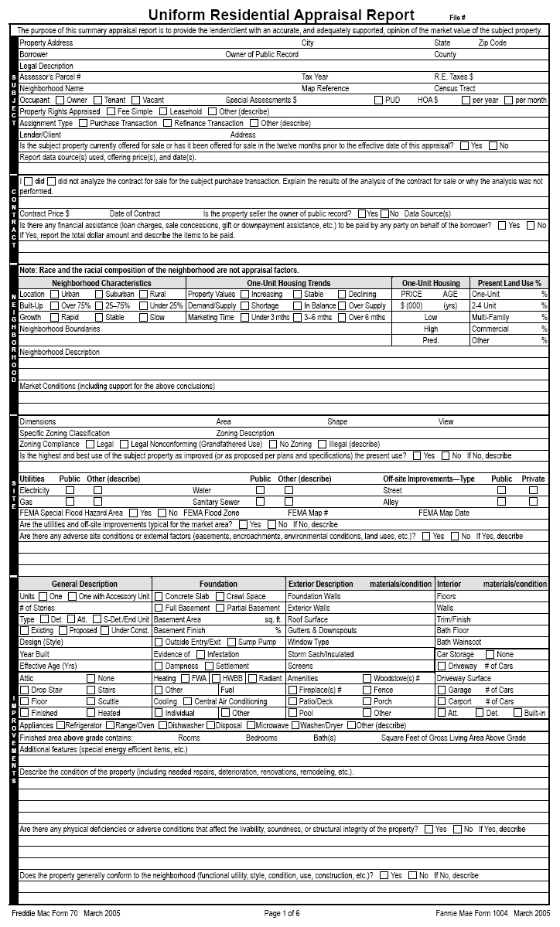

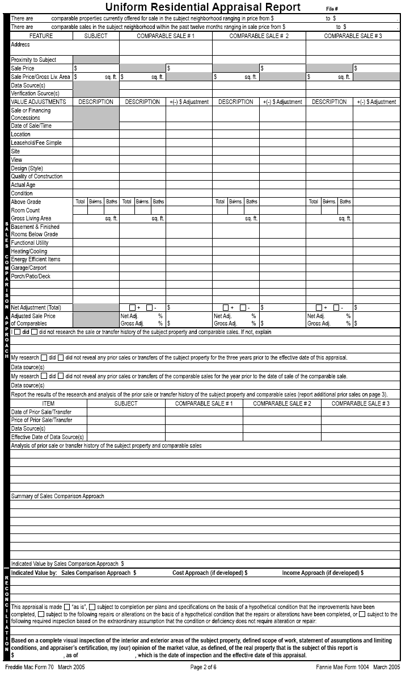
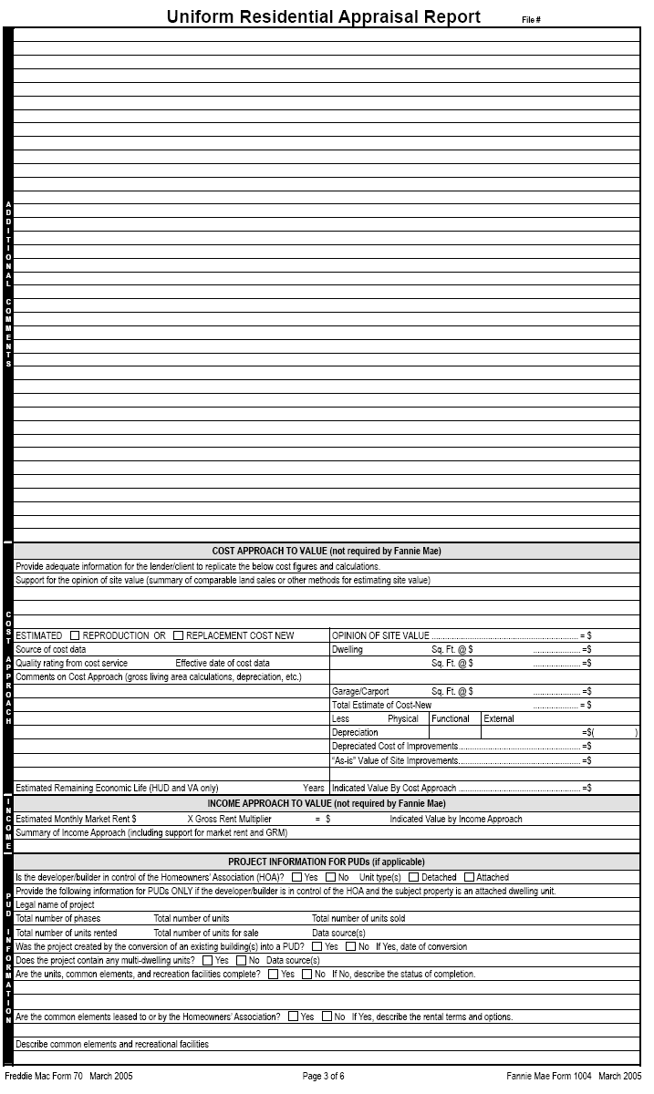
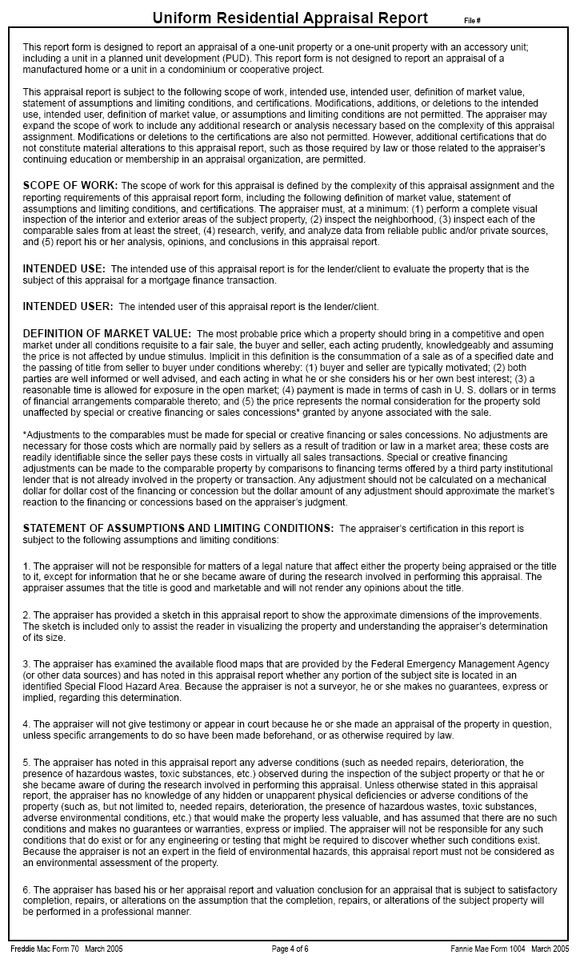
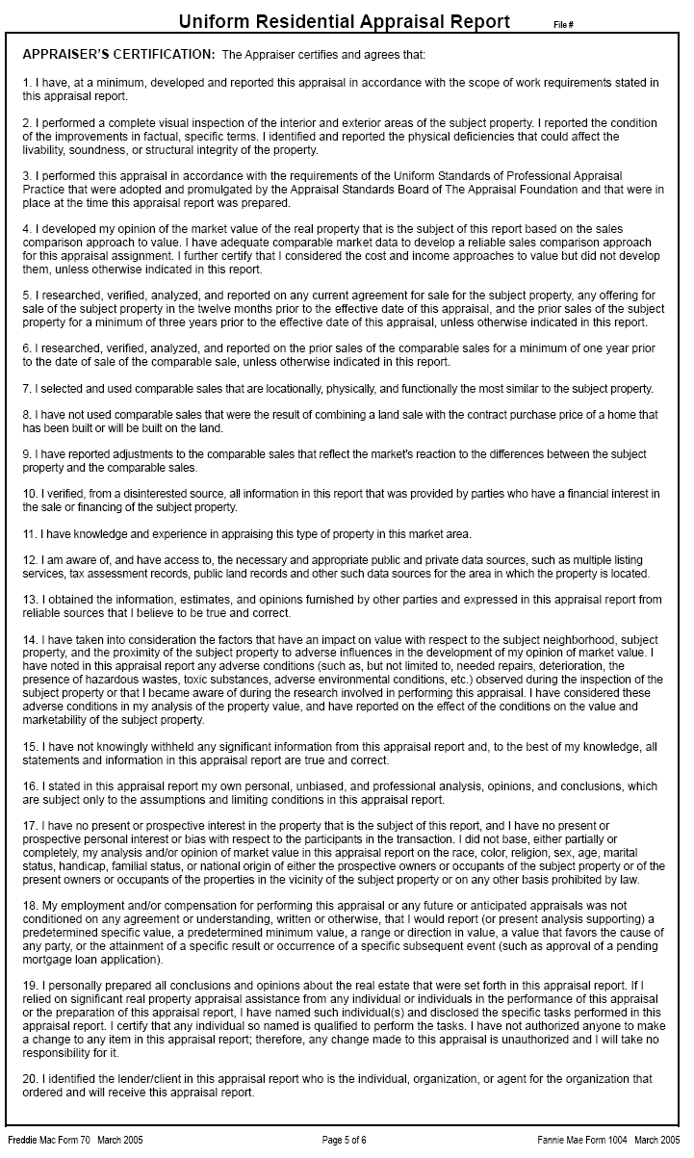
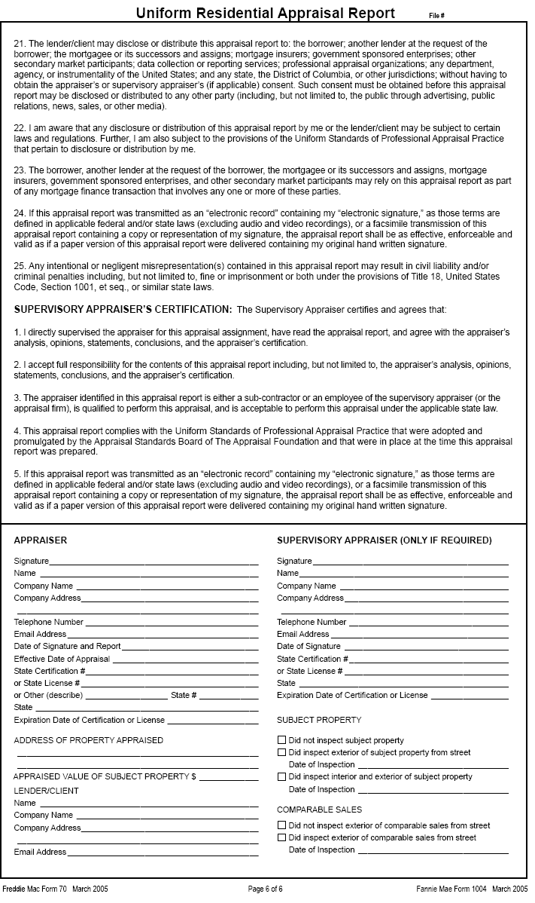

D-2 Manufactured Home Appraisal Report
This section provides specific instructions for completing the Manufactured Home Appraisal Report (Fannie Mae Form 1004C March 2005).

This report form is designed to report an appraisal of a one-unit manufactured home; including a unit in a planned unit development (PUD), based on an interior and exterior inspection of the subject property. This form is not designed to report an appraisal of a conventionally constructed “stick” or “site” built home or a unit in a condominium or cooperative project. Manufactured homes within a condominium regime or a cooperative project are not eligible as collateral for a FHA-insured loan.

A manufactured home is defined as a structure that is transportable in one or more sections. In the traveling mode, the home is eight feet or more in width and forty feet or more in length and is built on a permanent chassis and designed to be used as a dwelling when connected to the required utilities, which includes the plumbing, heating, air-conditioning and electrical systems contained therein. A manufactured home is designed and constructed to the Federal Manufactured Home Construction and Safety Standards (MHCSS) as evidenced by an affixed certification label. Manufactured homes may also be referred to as mobile homes, sectionals, multi-sectionals, double-wides, triple-wides or single wides. Modular housing is built to the local/state codes and is not to be considered manufactured housing. When erected on site, to be eligible for FHA insurance the manufactured home is:

- Built on or after June 15, 1976 based on MHCSS,
- At least 400 square feet in gross living area,
- Built and remains on a permanent chassis,
- Designed to be used as a dwelling with a permanent foundation which is designed and constructed to HUD/FHA criteria and,
- Have a HUD Certification Label/Seal affixed to the exterior of the home.

Appraisers are reminded to pay particular attention to Appraiser’s Certifications #8 and #11 of the Manufactured Home Appraisal Report and the Competency Rule of USPAP which addresses an appraiser’s familiarity with a specific property type.

Section 1 – Subject

This section provides the factual data to identify the property and the parties to the appraisal process. The *FHA case number together with *borrower and/or *property information will be supplied by the lender/client who engages the appraiser.
Field | Protocol
*File Number | • Insert the FHA Case Number at the top right corner of the page.  - The FHA appraisal may not be transmitted to the lender without a case number.
*Property Address | • Enter the property street number and name, city, state and zip code for the property. A post office box number is not acceptable. Enter the nearest intersection if a house number is not available.
*Borrower | - Enter the name of the borrower/mortgagor.
Owner of Public Record | - Enter the name of the owner as listed in public records. If the seller is not the owner of public record the appraiser must explain.
County | - Enter the name of the county in which the property is located. It further provides locational parameters. If not applicable enter “N/A”.
Legal Description | • Enter the legal description of the property. The four types of legal descriptions are: lot and block system, geodetic survey, government survey system and metes and bounds system. If the space provided is insufficient, enter this information with the heading “Legal Description” in the “Additional Comments” section of the form report or attach this information as an addendum.
Assessor’s Parcel # | - Enter the parcel number assigned by the local tax assessor. For those areas that do not have an assessor’s parcel number, enter the tax identification number.
Tax Year | - Enter the current tax year used by the locale, e.g. fiscal year or actual year.
R. E. Taxes $ | - Enter the dollar amount of the annual real estate taxes, including all relevant taxes (school district tax, fire district tax, etc.). Manufactured homes must be taxed as real estate to be eligible for Title II FHA insurance.
Neighborhood Name | - Enter the name of the subdivision, if applicable, or the commonly known local neighborhood designation. If the subject property is in a planned unit development or manufactured housing park, provide the name of the development.
Map Reference | - Enter location map reference, page number and coordinates, from source used. This reference should relate to the location maps most commonly used in the locale.
Census Tract | - Enter the census tract number. The census tract number must be provided.  - Census tract numbers have four digits and may have a two digit decimal suffix. Where the basic census tract number is less than four digits, the Census Bureau includes leading zeros except when displaying numbers on maps or printed reports. To uniquely identify a census tract, a two-digit state code and three-digit county code precede the four-or six-digit census tract number. The Census Bureau has an internet resource guide for locating census information. It can be found at URL: www.census.gov
Occupant | - Mark the box signifying the occupancy status at the time of the appraisal.  If vacant, the appraiser should note in the “Improvements” section under “condition of property” whether the utilities were on or off at the time of the appraisal. If off, condition the appraisal on a satisfactory re-inspection that the utility that was off at the time of the appraisal does not require alteration, repair or further inspection.
Special Assessments $ | - Report the dollar amount of special assessments for the subject property, if any, and provide a brief explanation for the assessment. Special assessments can include municipal bond debt for off-site improvements. Larger than typical special assessments may affect marketability. If not applicable enter “N/A”.
PUD HOA$ | • Enter the dollar amount of the HOA fee and mark the box indicating if the fees are paid “per year” or “per month”.
Property Rights Appraised | • Mark the appropriate box indicating the property rights appraised for the subject property as of the date of the appraisal. “Other” includes Land Trust.
Assignment Type | - Mark the appropriate box indicating the assignment type.
Lender/Client  Address | • Enter the name of the lender/client who ordered and will receive the appraisal report. After the client’s name add “its successors or assigns”.  - The use of the appraisal is to support FHA’s decision to provide mortgage insurance on the real property that is the subject of the appraisal; therefore, intended users include the lender/client and FHA.  - Enter the lender/client’s address.
Currently offered for sale or offered for sale in last 12 months. | - The appraiser’s certification states in part “I have researched, verified, analyzed and reported on any current agreement of sale of the subject property, any offering for sale of the subject property in the twelve months prior to the effect date of the appraisal…”  - Mark the appropriate box indicating whether the subject is currently offered for sale or has been offered for sale in the 12-month period prior to the effective date of the appraisal. If there are multiple actions, report each instance. Research may reveal an expired or withdrawn listing. The prior listing may provide a good indication of the upper limit of value.
Report data source(s) used, offering price(s), and date(s) | - Complete this field regardless of whether the property is currently offered for sale or has been for sale in the 12 months preceding the date of the appraisal.  - Identify source(s) used, price(s) and date(s) of current or prior listings.

Section 2 - Contract
This section must be completed when the appraisal assignment involves a purchase transaction, otherwise enter “N/A” for not applicable. FHA requires that the appraiser be provided with a complete copy of the ratified sales contract, including all addenda, for the subject property. It provides the agreed-on contract price (accepted offer), date of sale, and all financial terms implicit in the offer. If unable to obtain this information, the appraiser is to state what efforts were made to obtain it.
Field | Protocol
Analyze Contract of Sale | - Explain the results of the analysis (terms and conditions) of the contract of sale or why the analysis was not performed.  - The analysis may include a reference to the number of pages contained in the contract for sale provided.  - The analysis should include a description of any non-realty items included in the contract
Contract Price $ | • Enter the final agreed upon contract price  for purchase transaction.  - If the manufactured home is new construction, does the contract price include: all delivery, installation and setup costs.
Date of Contract | • Enter the date of the contract. This is the date when all parties have agreed to the terms of, and signed the contract.
Is The Property Seller The Owner of Public Record  Data Source(s) | • Mark the appropriate box indicating whether or not the seller is the owner of public record. The appraiser is instructed to contact the lender/client if the seller is someone other than the owner of record. The property may not be eligible for FHA financing if it involves flipping (resale in less than 90 days). The lender will make a determination for any exceptions to FHA’s Flipping Rule and advise the appraiser.  • Report where the information was obtained.
Sales Concessions Downpayment Assistance | - Mark the appropriate box indicating whether or not there is any financial assistance (loan charges, sales concessions, gift or down payment assistance, etc.) paid by any party on behalf of the borrower. If necessary, use the “Additional Comments” section of the appraisal reporting form or an addendum and enter the heading “Sales Concessions” completing the description.  - If yes, the appraiser is to report the total dollar amount and describe the items to be paid. If the sale involves personal property (e.g. above ground pool, lawn mower, furniture, etc.) it should be identified and excluded from the valuation.
Manufacturer’s  Invoice | - Applies only to new construction (initial sale from manufacturer). Mark the appropriate box and explain the results of the analysis (terms and conditions) of the manufacturer’s invoice or why the analysis was not performed.  - If the invoice is not available, the appraiser is to note the unavailability.
Retailer’s Name | - Applies only to new construction (initial sale from manufacturer). Provide name of retailer or distributor who sold unit.

Section 3 – Neighborhood

This section should reflect the area surrounding the subject property. The appraiser must observe neighborhood characteristics and surrounding properties to make determinations that will be incorporated into the valuation of the subject property. In all instances, the appraiser must mark the appropriate box for each line in neighborhood characteristics and housing trends. Failure to note conditions that may adversely affect the value of the property is poor appraisal practice and violates the Uniform Standards of Professional Appraisal Practice.

NOTE: Race and the racial composition of the neighborhood are not appraisal factors.
Neighborhood Characteristics
Field | Protocol
Location | • Enter the type of area surrounding the subject property.  Urban – relates to a city  Suburban – relates to an area adjacent to a city  Rural – relates to the country or beyond the suburban area
Built-up | • Enter the built-up percentage – the percentage of available land that has been improved. Land such as a state park would not be considered available land.
Growth | • Enter the growth rate. If many lots are available, the growth rate may be rapid, stable or slow, but if the neighborhood is fully developed, select the “stable” box.

Manufactured Housing Trends
Field | Protocol
Property Values | • Mark the box describing the current trend in property values for manufactured housing in the community. Comparing manufactured housing units that have been sold and resold in recent years is an effective way to determine market trends. Appraisers who use this method, however, should make sure to factor in any improvements or changes made to the property between sales.

Manufactured Housing Trends
Field | Protocol
Property Values | - If the subject property is one of few manufactured homes in the neighborhood, indicate this scarcity in market conditions, identify the most predominant housing type within neighborhood and address trends in value for that identified type.
Demand/Supply | • Mark the appropriate demand/supply trend. To determine the equilibrium status of supply and demand in the neighborhood, compare the number of houses sold to the number of houses listed for sale in a recent time period. The similarity or difference between the number of houses sold and listed, not the absolute numbers, should determine the demand/supply level.  - If the subject property is one of few manufactured homes in the neighborhood, indicate this scarcity under market conditions, identify the most predominant housing type within neighborhood and address trends in demand/supply for that identified type.
Marketing Time | • Mark the appropriate marketing time – the typical length of time a property most similar to the subject property would have to stay on the market before being sold at a price near its market value.

Manufactured Housing
Price Age | • Indicate the low and high neighborhood prices and ages as well as the predominant value and age of manufactured housing. The high and low for both price and age should exclude the extreme. If the subject property is one of few manufactured homes in the neighborhood, indicate this paucity under market conditions, identify the most predominant housing type/style within neighborhood and address prices and ages for that identified type.

Present Land Use %
One-Unit, 2-4 Unit, Multi-Family, Commercial, Other | • Estimate each type of land usage in the neighborhood. If there is no land in the neighborhood with one of the designated classifications, enter a “0”. If a portion of the land consists of parks or other unspecified classifications, enter the estimated percentages on the “Other” line and explain in the neighborhood description section.
Neighborhood Boundaries |  | • The appraiser must clearly define the boundaries – north, south, east and west – of the subject’s neighborhood. Providing a description of neighborhood boundaries by physical features such as streets, rail lines, other man-made barriers or well defined natural barriers (i.e. rivers, lakes, etc.) details the make up and understanding regarding neighborhood composition.

Neighborhood Narrative
Neighborhood Description | • Discuss factors that would attract residents or cause them to reject the neighborhood. These are typical factors important to discuss:  - Level of maintenance and condition of homes  - Housing styles, ages, sizes, etc.  - Land uses

Neighborhood Narrative
Neighborhood Description |  | - Proximity to employment and amenities, including travel distance and time to local employment sources and community amenities  - Employment stability, in terms of variety of employment opportunities and industries  - Overall appeal of the neighborhood as compared to competitive neighborhoods in the same market  - Convenience to shopping with respect to distance, time and required means of transportation  - Convenience to schools in terms of the distance and time for travel to school
Market Conditions (including support for the above conclusions) | - Provide relevant information in support of conclusions relating to trends in property values, demand/supply and marketing time.  - Provide a description of the prevalence and impact of sales and financing concessions and/or down payment assistance in the subject’s market area.  - Other areas of discussion may include days on market, list to sale price ratios, and/or financing availability.

Section 4 – Site

This information provides the description of the land underlying the subject property. Insert factual information on each of the lines provided and report the conclusions as directed. Consider all aspects of the physical description and reconcile them in the opinion of market value. This section of the appraisal requires the appraiser to consider any adverse site conditions or adverse external factors that may impact value.
Field | • Protocol
Dimensions | • List all dimensions of the site beginning with the frontage. If the shape of the site is irregular, show the boundary dimensions (85' X 150' X 195' X 250'), or attach a property survey, site plan or plat or legal description with the comment, “see attached .” Do not list site area on the dimensions line.
Area | • Enter the site area in square feet or acres. This entry must be consistent with the dimensions provided in the “Dimensions” field.
Shape | • Describe the shape of the site, e.g. triangular, square, rectangular, irregular, flag lot.
View | • Briefly describe the view from the property (None is not an acceptable response).  - Identify a view with a significant positive or negative influence on the value.  - Photographs are recommended for any negative or positive view influences affecting value or marketability.
Specific Zoning Classification | • Enter the specific zoning classification used by the local municipality or jurisdiction, e.g., R-1  - If none exists enter “None Exists”
Zoning Description | - Describe what the specific classification means. Include a general statement describing what the zoning permits. For example: R-1 = Residential-Single Family  - If “None Exists” describe the prevalent use of sites in the neighborhood.

Field | • Protocol
Zoning Compliance | • Determine whether the current use is in compliance with the zoning ordinances. Mark the box indicating whether the use is Legal, Legal Non-Conforming (Grandfathered Use), No Zoning, or Illegal Use.  • If the existing property does not comply with all of the current zoning regulations (use, lot size, improvement size, off street parking, etc.) but is accepted by the local zoning authority, enter “Legal Non-Conforming” and provide a brief explanation.  - If the use is not legal, the property is not eligible for FHA mortgage insurance.
Highest and  Best Use | • Mark the appropriate box. This entry represents the highest and best use of the site, as improved, in relation to the neighborhood and current market conditions.  • If current use represents the highest and best use, mark "yes".  • If it does not, mark "no" and provide a detailed explanation.
Utilities | • Mark either “Public” or "Other." If “Other" is marked, describe. Public utilities mean governmentally supplied and regulated. Public does not include any community systems sponsored, owned or operated by the developer or a private company not subject to government regulation or financial assistance.  • Note if there are mechanical chlorinators or water-flow that decreases noticeably while running simultaneous plumbing fixtures.  • Visually inspect the septic system and its surrounding area. If there are obvious or readily observable signs of system failure, “require inspection” to ensure that the system is in proper working order.  Note: The appraiser shall indicate whether a public water or sewage disposal system is available to the site. If available, connection must be made to public or community water/sewage disposal system if connection costs are reasonable. The lender will determine whether connection is feasible.
Off-site Improvements–Type | • Briefly describe the off-site improvements under "Type" and mark Public or Private. For example: "Street-Asphalt; Public", “Alley-None”  • Public refers to an improvement dedicated to and accepted by a unit of government – not including Home Owner's Associations.
FEMA Special Flood Hazard Area | • FEMA (Federal Emergency Management Agency) is responsible for mapping flood hazard areas. If the property is within a Special Flood Hazard Area, mark "YES". Otherwise, mark “NO”.  • Attach a copy of the flood map panel for properties located within an identified flood hazard area.  Note: To be eligible for FHA-insurance, the finished grade level beneath a manufactured home must be at or above the 100-year return frequency elevation. If the site supporting a manufactured home is within a FEMA designated flood hazard area, the lender should order a FEMA Elevation Certificate to determine whether the manufactured home qualifies for FHA-insurance.

Field | • Protocol
FEMA Flood Zone | • Enter the FEMA Zone designation. Only properties within Special Flood Hazard Areas, such as zones "A" a special flood hazard area and "V" a coastal area, require flood insurance. Zones "B" "C" and “X” do not.
FEMA Map # and FEMA Map Date | • Enter the FEMA Map number and map date. If it is not shown on any map, enter "Not Mapped."
Are utilities and off site improvements typical for the market area? | - Mark the appropriate box indicating whether the utilities and off-site improvements are typical for the market area.  - If “No” is marked, explain why the utilities and/or off site improvement are not typical.
Is site size, shape and topography conforming? | - Mark the appropriate box indicating whether the site size, shape and topography are generally conforming to and acceptable in the market area.  - If “no” is marked, explain why and its impact on value and/or marketability.
Vehicular access | - Mark the appropriate box indicating whether there is adequate vehicular access to the subject property.  - If “no” is marked, provide explanation.
Street maintenance | - Mark the appropriate box indicating whether the street is properly maintained.  - If “no” is marked, describe the condition of the street, lack of an all weather surface and/or adequacy maintenance.
Any adverse site conditions or external factors | • Mark the appropriate box indicating whether there are any adverse site conditions or external factors (easements, encroachments, environmental conditions, land uses, etc.).  - If “No” is marked, no comment is necessary, if “Yes” is marked, a detailed explanation is required.  - Describe any adverse site conditions or adverse factors. Consider easements affecting the functional utility of the property in the conclusions of both the highest and best use and market value. For example, discuss adverse easements, encroachments, slide areas, illegal or non-conforming zoning use, etc. Consider surface, sub-surface and overhead easements.  - List any adverse environmental conditions, including hazardous wastes, toxic substances and others.  - Explain all deficiencies that do not require repair (extreme slope, etc.) and consider them in the opinion of value.  • Discuss the observations with direct relationship to value and consider them in the approaches to value.

Section 5 – HUD Data Plate

The Federal Manufactured Home Construction and Safety Standards, Part 24 of the Code of Federal Regulations (CFR) 3280, requires that “each manufactured home shall bear a data plate affixed in a permanent manner near the main electrical panel or other readily accessible or visible location.” Typically, the HUD Data Plate is adjacent to the electric service panel, the utility room or within a cabinet in the kitchen. Over time, homeowners often remove this sheet and it is common for the data plate to be missing from a manufactured home.

Copies of the data plate are generally available only from the manufacturer of the home or the in-plant inspection agency responsible for inspecting the home prior to its shipment from the manufacturing plant. If the data plate is missing, locating a replacement or the specific data plate information from the manufacturer or in-plant inspection agency may be impractical or expensive. Some manufacturers are no longer in business or the in-plant inspection agency may no longer have the information.

The HUD Data Plate (Manufacturer’s Data Plate) provides information on:
- Name and address of the manufacturing plant where the home was constructed;
- Serial number, model designation and date of manufacture (date the certification label was applied to the home).
- Compliance statement;
- List of certification label(s) number(s);
- List of major factory installed equipment, and
- Roof zone and wind zone maps designating the zones for which the home has been constructed.

The heating/cooling certification and insulation maps may be on the data plate, or may be in separate documentation provided with the home. The data plate is not required to include the heating and cooling certification. Manufacturers and in-plant inspection agencies are not required to maintain the heating and cooling certification information.

The Certification Label (aka HUD Seal) is a 2 inch by 4 inch aluminum plate, permanently attached to the home, located at one end of each section of the home, approximately one foot up from the floor and one foot in from the road side, or as near that location on a permanent part of the exterior of the home as practicable. This Certification Label is often referred to as the HUD Label, or the HUD Tag. Etched on the Certification Label is the Certification Label Number, also referred to as the HUD Label Number. Label numbers are not required to be sequential on multi-section homes.

Verifications of the Certification Label Numbers are available from the manufacturer, the in-plant inspection agency, and HUD, sometimes at-cost. Contacts for the in-plant inspection agencies are available on HUD’s manufactured housing website. Information on requesting these verifications is available at the website for the manufactured housing program at http://www.hud.gov/offices/hsg/sfh/mhs/mhslabels.cfm.

Field | • Protocol
HUD Data Plate | • Mark the appropriate box to indicate if the Data Plate is attached. If the Data Plate is missing and/or the appraiser is unable to locate it, the appraiser only needs to report this fact and is not required to secure the Data Plate information from another source.
Certification Label  (aka HUD Seal) | • To be eligible for FHA-insured financing, the manufactured home must have a HUD Certification Label affixed to the tail-light end of each transportable section.  - If the appraiser is unable to locate the HUD Certification Label (HUD Seal), the lender must be notified.
Manufacturer’s Serial # or VIN # | • Enter the manufacturer’s serial number or VIN # which can be found on the HUD Data Plate. If the Data Plate is missing, the serial number is stamped on the foremost cross member of the supporting frame of the hitch-end of the manufactured home.
HUD Certification Label #(s) | - Enter the label #s for each section.
Field | • Protocol
Manufacturer’s Name, Trade/Model, and date of Manufacture | • Provide the manufacturer’s name, model name of the subject unit and date of manufacturer. This information can be found on the HUD Data Plate.
Wind, Roof Load and Thermal Zones | - The HUD Data Plate contains wind, roof load and thermal zone maps which designate the zone for which the home was constructed. Mark the appropriate box.  - Mark the appropriate box indicating whether the subject meets zone requirements for its location.  - Marked “no” if the zone map indicates the manufactured home was constructed for a geographic area different from where the home is located, the appraiser should note and highlight this discrepancy.  - Mark “no” if the Data Plate is missing. The appraiser should note: Date plate missing, unable to determine compliance with wind, roof load and thermal zones requirements.

Section 6 – Improvements

This section describes the subject improvements. Accurately report the conditions observed. Describe needed repairs, or the existence of any functional or external obsolescence. Enter factual information on each of the lines provided and report the conclusions. Consider all aspects of the physical description and reconcile them in the opinion of market value.

General Description
Field | Protocol
Units/Additions | • Mark the appropriate box. The Manufactured Home Appraisal Report is designed solely for the valuation of a one-unit manufactured home. The appraiser is to indicate if the original manufactured home (as delivered and installed) to the site has been altered or added on to by marking the box for additions.
# of Stories | • Enter the number of stories above grade, including half stories. Do not include the basement.
Design (Style) | • Enter a brief description of the house design style using historical or contemporary fashion. For example: Cape Cod, bi-level, split level, split foyer, colonial, town house, etc. Do not use builder's model name. Avoid generic descriptions such as Traditional or Conventional.
# of Sections | • Mark the appropriate box denoting the number of sections. Mark “Other” if subject made up of four or more sections.
Type | • Mark the box that identifies the type of dwelling, "Det." (Detached), “Att.” (Attached), "S-Det.” (Semi-Detached) or “End Unit” (End unit of a group of rowhouses or townhouses).
Stage of Construction | • Mark the box signifying the stage of construction, Existing, Proposed or New Construction (new construction would only apply to foundation).
Year Built | • If the manufactured home is less than one year old, include both the month and year completed.  • If it is over one year old, insert the year built.
Effective Age (Yrs) | • Enter the effective age of the improvements. A range is acceptable. The effective age reflects the condition of the property relative to similar competitive properties. The effective age may be greater than, less than or equal to the actual age.  • Note any significant difference between the actual and effective ages and explain in the “condition of property” comments section.

Attic – Enter the attic and observe the interior roofing for insulation, deficient materials, leaks or readily observable evidence of significant water damage, structural problems, previous fire damage, FRT sheathing, exposed and frayed wiring and adequate ventilation by vent, fan or window. If any of these deficiencies exist, condition the appraisal on their repair and prepare the appraisal “subject to repairs” and/or “subject to inspection”.

The attic must be entered, at a minimum, by head and shoulders, whether access is by pull-down stairway or scuttle. Size of the scuttle and accessibility of the attic dictate the level of entry.
Field | Protocol
None | Enter ‘X” if there is no attic.
Drop Stair | Enter “X” if this item exists.
Stairs | Enter “X” if this item exists.
Floor | Enter “X” if this item exists.
Scuttle | Enter “X” if this item exists.
Finished | Enter “X” if this item exists.
Heated | Enter “X” if the attic is heated.

Foundation
The appraiser is required to inspect the foundation and basement. The appraiser must address all visible deficiencies and may require a recommendation for an inspection. Consider deferred maintenance and physical deterioration in the valuation process.

Basement
Generally, may be partially or completely below grade (ground level). Do not count the basement in the finished gross living area at the grade level. The information provided must be consistent with the description in the Foundation section.
Foundation
Field | Protocol
Poured Concrete | - Mark this box if any part of the foundation system has a concrete slab.
Concrete Runners | - Mark this box if any part of the foundation system has concrete runners upon which the manufactured home rests in some fashion.
Block & Pier | • Mark this box if the manufactured home is supported by concrete/masonry blocks constructed on free standing piers or by a continuous perimeter enclosure.
Other-Att. Description | - Mark this box if the foundation supporting the manufactured home does not fall under the above types and describe the foundation supporting the manufactured home.
Full Basement | - Mark this box if there is a full basement.
Partial Basement | - Mark this box if there is a partial basement.  - For a dirt basement floor, determine whether such a property is typical for the area and is readily marketable. If so, it is not required that a concrete basement floor be installed. Mechanical equipment, however, must be located on a concrete pad.
Basement Area Sq Ft | - Enter the square footage of the basement area using exterior dimensions.
Basement Finish % | - Enter the percentage of basement (figure above) that is finished.
Outside Entry/Exit | - Mark this box only if there is an outside entry/exit, otherwise leave blank.  - In there is an entry, make sure door is operable.
Sump Pump | • Mark this box only if there is a sump pump, otherwise leave blank.
Evidence of  Infestation | - Mark this box if there is evidence of infestation, including the house and/or other structures within the legal boundaries of the property, otherwise leave blank.  • Examine the subject property for readily observable evidence of wood boring insects.  - Do not require a pest inspection based solely on the age of a property. Inspections are necessary whenever there is evidence of decay, pest infestation, suspicious damage or when it is customary to the area or required by state law.
Evidence of Dampness | - Basement or crawl space area must not have excessive dampness or ponding of water.  - If any of these inadequacies exist, condition the appraisal “subject to repairs” to correct the condition, or “subject to inspection” to determine the source of problem and corrective measures necessary by a qualified party.
Evidence of Settlement | • Mark this box if there is evidence of settlement, otherwise leave blank.  • Examine foundation for readily observable evidence of settlement.  - Hairline step-cracks are common, however, horizontal cracks, bulging walls or separation of sill plate from top of foundation wall are critical and require inspection.

Mechanical Systems
An appraiser must examine mechanical, plumbing and electrical systems of the subject property to ensure that they are in proper working order. This examination entails turning on the applicable systems and observing their performance. Electrical, plumbing and/or heating certifications may be called for by the appraiser when he/she cannot determine if one or all of these systems are working properly. An appraiser should not arbitrarily call for such certifications. However, they are still responsible for checking on the adequacy of these systems at the time of appraisal.

Heating and Cooling Systems
Field | Protocol
Heating | • Enter an “X” in the box indicating the type of heating system: FWA (forced warm air), HWBB (hot water baseboard), Radiant or “Other”. If “Other” is marked, provide a brief description, e.g. EBB (for electric baseboard).  - Turn on the furnace/heating system to test functionality, weather permitting, and that no unusual noises are heard, no odors or smoke are emitted indicating a defective unit, etc. However, do not operate the systems if doing so may damage equipment or when outside temperatures will not allow system to operate.  - Note significant holes/deterioration on the unit.  - Determine whether there is an installed heat or cool-air source in each room by using the system’s normal operating controls. It is not necessary to observe the uniformity of heat or cool-air to various rooms.  - Turn on the hot water to ensure that the water heater is operating appropriately.
Fuel | • Enter type of fuel used: coal, gas, oil, propane, electric, etc.
Cooling | - Enter an “X” in the box indicating the type of cooling system: Central Air Conditioning, Individual or Other. If “Other” is marked, provide a brief description, e.g. permanently affixed fans, zoned air-conditioning, etc.  - Turn on air conditioning system to test functionality, weather permitting, and that no unusual noises are heard, no odors or smoke are emitted indicating a defective unit, etc. However, do not operate the systems if doing so may damage equipment or when outside temperatures will not allow system to operate.  - Note significant holes/deterioration on the unit

Exterior Materials/Condition
Enter the types of Materials and rate the observed Condition of the Materials (Good, Average, Fair, and Poor). Make every effort to describe accurately and explain in detail "Fair" and "Poor" ratings and whether or not the item(s) described require repair, replacement or further inspection. The rating must relate to the habitability of the house given local standards (Photo documentation of property condition is always advisable).

Exterior Description materials/condition
Field | Protocol
Skirting | - If the manufactured home features skirting placed between the bottom of the home and the grade of the supporting ground, indicate the material type of the skirting. Note that FHA requires a properly enclosed crawl space (if crawl area with no basement) with a continuous perimeter enclosure of a permanent foundation-type construction i.e., poured concrete, block, brick, stone, treated wood, etc.) and rate the observed condition.  - If the manufactured home has a crawl space and lacks a continuous perimeter enclosure of a permanent nature, note and highlight this absence. Note whether enclosed crawl area has adequate access and ventilation.
Exterior Walls | • Enter the material type: aluminum, vinyl or wood siding, brick veneer, stucco, stone, etc.  - If a combination of materials, show the predominant portion first and rate the observed condition.
Exterior Description materials/condition
Field | Protocol
Roof Surface | - Enter the material type: composition shingle, asphalt shingle, wood, slate, clay tile, aluminum, built-up, etc. and rate the observed condition.  - View the roof from ground level to determine if the integrity of the roof is sufficient.  - Observe roof coverings, roof drainage systems, flashing, skylights, or chimneys for readily observable evidence of leakage or abnormal condensation on building components.  - Note any evidence of deterioration of roofing materials (missing tiles, shingles, flashing). Deteriorated roofing materials include those that are worn, cupped, or curled.  - If the roof is otherwise unobservable, look for telltale signs of roof problems on the interior, such as damage or water stains to the ceiling area of a room or closet.  - The appraiser must note in the appraisal that he/she could not adequately observe the entire roof area (state which area(s) were unobservable). Based on the information reported by the appraiser, the underwriter will determine whether or not a roofing inspection is required.
Gutters and Downspouts | • Enter the material type: galvanized, aluminum, plastic, vinyl, PVC, etc. and rate the condition observed.
Window Type | • Enter window type: Double Hung, Single Hung, Casement, Sliders, etc. and identify the window frame material: wood, aluminum, steel, vinyl, etc. Rate the condition observed.  - Bedroom windows with security bars require a quick release mechanism for emergency egress. If not so equipped, condition the appraisal on a “required repair”.
Storm Sash / Insulated | • Describe storm sash material or state if windows are double glazed, etc. or a combination of the two. Rate the condition observed. If none, so state.
Screens | - Describe style (full, half, none) and rate the condition observed.
Doors | - Describe exterior doors (type and material, i.e., wood, metal, fiberglass, etc.)

A brief description of an amenity may include its material type and/or size and/or dimensions.
Amenities
Field | Protocol
Woodstove # | - Enter “X” if this amenity exists and provide a specific number.
Fireplace(s) # | - Enter “X” if this amenity exists and provide a specific number
Fence | - Enter “X” if this amenity exists. Describe material/type in additional features
Patio/Deck | - Enter “X” if this amenity exists. Describe material/type in additional features
Porch | - Enter “X” if this amenity exists. Describe material/type in additional features
Pool | - Enter “X” if this amenity exists. Describe in additional features. Specify whether in-ground or above-ground. Above-ground pools are considered personal property and are not to be included in the value.
Other | - Enter “X” if this line is used to report another amenity or salient feature not listed above that has contributory value. Describe “Other” in additional features. Be sure to compare the subject and comparable sales in relation to that amenity or feature and make the appropriate adjustments.

Interior Materials/Condition
Enter the types of materials and rate the observed Condition of the Materials (Good, Average, Fair, and Poor) and whether or not the item(s) described require repair, replacement or further inspection. Make every effort to describe accurately and explain in detail "Fair" and "Poor" ratings. The rating must relate to the habitability of the house given local standards.
Interior materials/condition
Field | Protocol
Floors | - Enter material type — tile, hardwood, carpet, etc.— and rate condition observed
Walls | • Enter material type—plaster, drywall, paneled etc.— and rate condition observed
Trim/Finish | • Enter material type — wood, metal, vinyl, etc.— and rate condition observed
Bath Floor | • Enter material type—ceramic tile, vinyl, carpet,etc.— and rate condition observed
Bath Wainscot | • Enter material type that protects walls from moisture — ceramic tile, fiberglass, etc. — and rate condition observed.

Car Storage
Field | Protocol
None | - If the property does not have a garage, carport or driveway, mark "NONE".
Driveway # of Cars | - If applicable, mark this box and enter the number of cars that can be parked. A single lane driveway is considered to be a one-car driveway. It would be considered a two car driveway if either car can be moved without disturbing the other.
Driveway Surface | - Enter surface type: concrete, gravel, macadam, etc., if none so state.
Garage # of Cars | - Enter the number of cars the structure can accommodate.
Carport # of Cars | - Enter the number of cars the structure can accommodate.
Garage/Carport Type | - If there is a garage, designate whether it is “Attached”, “Detached” or “Built-in” and Enter an “X” in the box(es) indicating the style “Att.”, “Det., “Built-in”

Appliances
Make an entry [X] in the boxes to indicate that these items exist. An entry in a box means that the item was considered part of the real estate and is included in the value. If an item is personal property, put a "P" in the box and do not include it in the opinion of value.
Field | Protocol
Refrigerator | Enter “X” if this item exists. Enter “P” if personal property.
Range/Oven | Enter “X” if this item exists. Enter “P” if personal property.
Dishwasher | Enter “X” if this item exists. Enter “P” if personal property.
Disposal | Enter “X” if this item exists. Enter “P” if personal property.
Fan/Hood | Enter “X” if this item exists. Enter “P” if personal property.
Microwave | Enter “X” if this item exists. Enter “P” if personal property.
Washer/Dryer | Enter “X” if this item exists. Enter “P” if personal property.
Other | Enter “X” for existing item not listed above and describe. Do not include personalty.

Gross Living Area
Room design and count should reflect local custom. A dining area built as an L-shape off the kitchen may or may not be considered a room depending on the size. To determine whether one or two rooms should be counted, hypothetically insert a wall to separate the two areas that have been built as one: if the residents can use the resulting two rooms with the same or more utility without increased inconvenience, count the room as two. If the hypothetical wall would result in a lack of utility and increased inconvenience, count the room as one. The room count typically includes a living room (LR), dining room (DR), kitchen (KT), den (DN), recreation room (REC) and one or more bedrooms (BR). Typically, the foyer, bath and laundry room are not counted as rooms. A room is a livable area with a specific use.

Note: To be eligible for FHA financing, a manufactured home must have a gross living area of no less than 400 square feet.

Room Count and Gross Living Area
Field | Protocol
Finished area above grade contains | • To complete this section, enter the total number of above grade rooms, the total number of bedrooms above grade, and the total number of bathrooms above grade. Do not include foyers, basement finished rooms or unfinished attic space.  - Enter the total square footage of the gross living area above grade.

Narrative Comments Section
The completion of this section is critical to the opinion of market value. The appraiser must discuss all adverse conditions and observed physical and functional deficiencies noted. If necessary, use the Additional Comments section of the form report, or an addendum, for additional discussion or description.
Field | Protocol
Additions or modifications | • Describe any additions or modifications made to the manufactured home since its initial placement on the site. Any subsequent additions or modifications should not take the home out of compliance with the Manufactured Home Construction and Safety Standards (MHCSS). If the appraiser suspects that an addition or modification to the home poses a risk to the structural integrity of the home, the appraiser is to notify the lender.
Installer’s Name  Date Installed  Model Year | - If available, indicate the name of the person or company that installed the manufactured home, the date of installation and the model year of the manufactured home. If information not readily available, the appraiser is to note such.

Field | Protocol
Permanent Foundation System | - Mark the applicable box. To be eligible for a FHA-insured financing, the design of the permanent foundation must be in compliance with FHA criteria as evidenced by an engineer’s certification verifying such compliance.  - The appraiser should indicate if a copy of the required engineer’s certification of compliance of the design of the permanent foundation was provided.
Removal of towing hitch, wheels and axels | - Mark the appropriate box. The appraiser must inspect the underside of the manufactured home and determine if the towing hitch, running gear (wheels and axels) have been removed. If not removed, or unable to determine due to lack of access, the manufactured home is not eligible for FHA-insured financing and the lender must be notified.
Utility Connections | - Mark the appropriate box indicating whether the manufactured home is permanently connected to public water and sewer or well and septic and other utilities.  - If “no” is marked, the manufactured home is not eligible for FHA-insured financing and the appraiser must notify the lender.
Gross Living Area Acceptable to Market | - Mark the appropriate box indicating whether the living area of the manufactured home is in concert with market expectations for overall living size, room size and layout.  - If “no” is marked, an explanation is required. The analysis should reveal the living size and dimensions are not in keeping with market expectations for the neighborhood (substandard) and factor this deficiency in the opinion of value. If the gross living area of the manufactured home is less than 400 square feet, the home is not eligible for FHA-insured financing and the appraiser must notify the lender.
Additional Features | • Use this space to describe special energy efficient features such as solar energy or geothermal systems and/or to further describe the additional features,  • Please elaborate on any special or unusual aspects of items, e.g. gas fireplace or wood burning fireplace, 16’ X 32’ inground pool, etc.
Rate quality of construction | - Rate the quality of construction of the manufactured homes by marking the appropriate box and identify cost service used.  - Report the source of the rating determination, e.g. Nationally published cost services such as the N.A.D.A. Manufactured Housing Appraisal Guide or the Marshall & Swift Residential Cost Handbook
Condition of the property (including needed repairs, deterioration, renovations, remodeling, etc.) | • Describe any physical deterioration and/or functional or external depreciation noted at the property.  • Provide a conclusion as to the overall condition of the improvements that is supported by the previous descriptive sections.  - Describe needed repairs.

Field | Protocol
Physical deficiencies or adverse conditions | - Enter an “X “ in the applicable box indicating whether or not there are any physical deficiencies or adverse conditions that affect the livability, soundness, or structural integrity of the property. If the response is “No”, no explanation is required or needed. However, if the response is “Yes”, a full and detailed explanation is required and, if necessary, condition the appraisal on the “repair or alteration of the condition” or a “required inspection” by appropriately qualified individuals or entities, which may include professional engineers, tradespersons, HUD Fee Inspectors.  Lead-Based Paint Hazard  - If the manufactured home was built before 1978, this may indicate a lead paint hazard. For all FHA insured properties, correction is required to all defective paint in or on structures and/or property improvements built before January 1, 1978 in accordance with 24 CFR Part 35.  - Observe all interior and exterior surfaces, such as walls, stairs, deck porch, railing, windows or doors for defective (chipping, flaking or peeling) paint. (Exterior surfaces include surfaces on fences, detached garages, storage sheds and other outbuildings and appurtenant structures.). Note any areas affected (be specific) and condition the appraisal on their repair subject to the satisfaction of the condition.
Property conformity | - Enter an “X “ in the applicable box indicating whether or not the subject generally conforms to the neighborhood (functional utility, style, condition, use, construction, etc.). If the response is “Yes”, no explanation is required or needed. However, if the response is “No”, an explanation is required.

Section 7 – Cost Approach

The appraiser is only required to complete the cost approach if the manufactured home is new construction (initial sale from manufacturer). If the manufactured home is over one year old and the retailer’s invoice, stating the retail purchase price of the home, is available, a copy of the invoice should be appended to the appraisal report. If the manufactured home is new construction less than one year old but title has been re-conveyed after the initial sale or if the home is over a year old, the cost approach is not required by FHA. For cost estimates, the appraiser must rely upon a nationally published cost service such as the N.A.D.A. Manufactured Housing Appraisal Guide or the Marshall & Swift Residential Cost Handbook. The use of a nationally published cost service will enable a reader/reviewer of the appraisal to replicate the appraiser’s estimate.

If the manufactured home is new construction (an initial sale from manufacturer) and the retail purchase price, including delivery, installation and set up costs, of the home is available, the appraiser may rely upon the retail purchase price and exclude reliance upon a cost service. An opinion of value of the supporting site is still required. A copy of the invoice stating the retail purchase price and all delivery, installation and set up costs must be appended to the appraisal report. The validity and reliability of the value of the manufactured home derived by the cost approach must be discussed in the reconciliation section.

State the Remaining Economic Life as a single number or as a range. This line must be completed for every FHA appraisal whether or not the cost approach is completed. An explanation is required if the remaining economic life is less than 30 years.

Cost Approach To Value
Provide adequate information for the lender/client to replicate the below cost figures and calculations.
Field | Protocol
Support for opinion of site value | - Provide a summary of the comparable land sales or other methods (abstraction, allocation, land residual, extraction) of estimating site value in support of the opinion of site value.
Reproduction or Replacement Cost | - Mark the box indicating which cost estimating method was used  - Reproduction Cost – exact duplicate with all deficiencies and obsolescence  - Replacement Cost – cost at current prices with equivalent utility.
Source of Cost Data | - Provide the name of the cost service and reference page numbers of cost tables or factors. Reviewer or reader must be able to replicate. If retail purchase price is available, append a copy of the retail purchase price invoice, including all delivery, installation and set up costs, to the appraisal report.
Effective Date of Cost data | - Enter the edition and date of latest updates referenced
Quality Rating | - Enter the quality rating of the manufactured home derived from the cost service.
Opinion of Site Value | - Enter the Opinion Of Site Value based on recent comparable land sales provided above

Cost Approach using Marshall & Swift
Field | Protocol
Section (width)  Marshall & Swift | - Determine how many sections (single wide = one section, double wide = two sections, etc) make up the subject manufactured home.  - Based upon the selected quality rating of the manufactured home, choose the corresponding page of square foot costs for that quality rating. Compute the GLA (Gross Living Area) for home (width multiplied by length) and multiply by appropriate rate per square foot from the square foot costs table.  - Make any square foot or lump sum adjustments to reflect value of items of home that are above and beyond those detailed basic description for the selected quality square foot costs.
Subtotal | - Enter the total of the selected quality rating per square foot times the GLA and any square foot and lump sum adjustments
Cost Multiplier | - Enter the appropriate cost multiplier factor, if applicable.
Modified Cost Multiplier Subtotal | - Multiply the Cost Multiplier times the subtotal of the square foot cost new – enter result.
Physical Depreciation or Condition Modifier | - If applicable, enter the amount of estimated depreciation as a specific dollar amount.
Functional Obsolescence | - Enter the amount of estimated depreciation as a specific dollar amount. Provide an explanation in the “comments section” if functional obsolescence is present and adjusted for.
External Obsolescence | - Enter the amount of estimated depreciation as a specific dollar amount. Provide an explanation in the comments section if external obsolescence present and adjusted for.

Cost Approach using Marshall & Swift
Field | Protocol
Depreciated Modified Subtotal  (not shown on 1004C form) | - Add the total estimated physical, functional and external depreciation and subtract from the amount entered for Modified Cost Multiplier Subtotal
Delivery, Installation and Setup | - If applicable, enter the deliver, installation and setup costs and add to the cost new. Note: Marshall and Swift includes delivery, installation and setup cost in the square foot.
Other Depreciated Site Improvements | - Enter the depreciated value of any site improvement.
Market Value of Subject Site | - Enter value site value from as provided above.
Indicated Value by the Cost Approach | - Add any additional delivery, installation and setup costs from above together with the depreciated value of site improvements and the market value of the supporting site for a final indication of value by the Cost Approach.
NOTE: | - To property employ the Marshall & Swift Cost Guide, follow the Marshall & Swift instructions.
Economic Life | - State Remaining Economic Life as a single number or as a range.

Cost Approach using N.A.D.A. Appraisal Guide
Field | Protocol
Exterior Dimensions | - Determine the length and width of the subject manufactured home.
N.A.D.A Data Identification | - Enter the edition month(s) and year of the N.A.D.A Manufactured Housing Appraisal Guide
MH State | - Enter the state in which the manufactured home is located.
Region | - Based upon the state in which the manufactured home is located and using the Regional Code Map of the N.A.D.A Guide, enter the appropriate region.
Size | - Enter the exterior length and width of the manufactured home.
Gray Pages | - Using the region code in the Gray Pages section of the N.A.DA. Guide, find the Trade Name of the home. This will provide a page number.
White Pages Section (lists homes by manufacturer, model/trade name and by regional location | - Using the page number located in the Gray Pages section, go to that page number in the White Pages Section, Part 1 of the N.A.D.A. Guide and locate the Trade Name and find the page number listed for the Manufacturer’s Name, Model name for the listed width and Region Code.
Yellow Pages  (not listed in 1004C Cost Chart, provides current depreciated replacement value) | - Using the page number located in the White Pages section, go to that page number in the Value Chart found in the Yellow Pages Section of the N.A.D.A. Guide and, using the length and width of the subject manufactured home, determine the base retail book value.
Black SVS pg. | - Use the Black Pages SVS (Supplemental Value Section) section of the N.A.D.A. Guide when a home is not listed in the Gray or White Pages section.

Cost Approach using N.A.D.A. Appraisal Guide
Field | Protocol
Green Section  (not listed in 1004C Cost Chart, provides older home conversion chart, condition modifier, accessory values, etc. ) | - Use the Green Pages section of the N.A.D.A. Guide section of the N.A.D.A. Guide for older homes, to adjust for condition and add for components and accessories not addressed in the Yellow Pages Section.
NOTE: | - To property employ the N.A.D.A. Appraisal Guide, follow the N.A.D.A. instructions.
Indicated Value by the Cost Approach | - Add the value of the supporting site to final, modified value of the manufactured home for the final indication of value.
Economic Life | - State Remaining Economic Life as a single number or as a range.

Section 8 – Sales Comparison Approach

Comparable Data Pool

The appraiser is required to report the number of comparable properties currently offered for sale, as of the effective date of the appraisal, and the number of comparable sales in the subject neighborhood, within 12 months of the effective date of the appraisal, in this section. Unlike the neighborhood price data, which includes all sales, this section focuses only on those properties that are comparable to the subject, not the universe of sales.

If there was difficulty in locating comparable properties, i.e. the subject is a manufactured home and one or more of the similar style properties was a “stick or site built ” home, then for purposes of this section, all such properties in the subject’s neighborhood are to be treated as comparable and counted.

At least two of the comparable sale properties must be manufactured homes. It may be necessary to expand search parameters outside the immediate market area to locate truly comparable sales. If that is the case, an explanation is required and should be consistent with the neighborhood analysis provided.

Field | Protocol
Comparable properties offered for sale | - Enter the number of comparable properties currently offered for sale, including those under contract, within the subject neighborhood together with the price range.
Comparable sales | - Enter the number of comparable sales that occurred within the 12 month period preceding the effective date of the appraisal, and within the subject neighborhood, together with the price range.

Enter factual data in each field or line.
Field | Protocol
Address | • Enter the address that can be used to locate each property. Enter community, if needed, to identify property. For rural properties, list location by road name, nearest intersection and side road.
Proximity to Subject | • Enter proximity in straight-line distance and direction. For example, "1.5 miles NE" or “3 blocks south”. If comparable distance from the subject is more than a generally accepted distance, or located outside the defined neighborhood boundaries, be sure to explain why the sale is applicable in the "Summary of Sales Comparison Approach" section.
Sale Price | • Enter the purchase price (total paid) for the subject and each of the comparable sales. This means the closed or settled price of the comparable sale.  - If the appraisal involves a refinance of the subject, enter “Refi” as the subject’s sale price,  - If the assignment is for an REO appraisal, enter REO as the subject’s sales price.
Sale Price / Gross Liv. Area | • Enter price per square foot for the above grade living area for the subject, if a purchase transaction, and each comparable sale.
Manufactured Home | - Indicate whether the comparable sale is a manufactured home. At least 2 of the comparable sale properties must be manufactured homes.
Data Source(s) | - Enter data source(s) used for sales and property information.
Verification Source(s) | - Enter verification source(s). The document or organization from which the additional proof was obtained.  - Contacting someone with first-hand knowledge of the transaction (agent, broker, buyer, seller, etc.) especially where it involves confirmation of seller concessions, is the preferred method of verification.  - A single source may be used if the quality of data is such that sales data are confirmed and verified by settled transactions. Information provided should permit the reader of the report to locate the data from the sources cited.  - Do not use as market data sales that are not verified and adjusted to reflect the terms and conditions of sale.

Value Adjustments

Adjustments are made to the prices of the sale properties for price-influencing dissimilarities between each sale and the subject property. Not all dissimilarities require adjustment because not all dissimilarities achieve price differentials in the market. All adjustments must be extracted from the market and supported by the actions of the market.

For each adjustment item, enter the description of the adjustment and whether it is an upward or downward adjustment. Do not make an adjustment unless it has a material effect on value.

The value factors of Location, Site, View, Design, Quality of Construction, Age, Condition and Functional Utility are all subjective factors that require subjective adjustments. Be careful that adjustments are reasonable and not excessive. If a property is overvalued, there is a high probability that the reason can be traced to an excessive adjustment somewhere in this section. Make adjustments only if the dissimilarity has a noticeable effect on the value. Small differences do not usually require adjustments. Always explain subjective adjustments.

VALUE ADJUSTMENTS
Field | Protocol
Sales or Financing Concessions | - Report the type of financing such as Conventional, FHA or VA, etc.  - Report the type and amount of sales concession for each comparable sale listed. If no concessions exist, the appraiser must note “none.”  - The appraiser is required to make market-based adjustments to the comparable sales for any sales or financing concessions that may have affected the sales price. The adjustment for such affected comparable sales must reflect the difference between the sales price with the sales concessions and what the property would have sold for without the concessions.
Date of Sale / Time | • State month and year of settlement. Showing the contract date and settled date is also acceptable.  - Time adjustments, if any, must be supported by the market and consistent with the neighborhood market conditions noted. If this is the case, show both the contract date and settled date as any time adjustment should be calculated using the contract date (meeting of the minds) rather than the settled date. Explanation is required for any time adjustments.
Location | - Enter the name of the subdivision or PUD. If none is applicable enter the neighborhood name that is commonly used to refer to the property’s location or,  - Location adjustments may be warranted for positive or negative factors that influence sales price such as busy street versus quiet street.  - Explain any adjustments made in this area.
Leasehold / Fee Simple | • State whether the property was sold as Fee Simple or as a Leasehold Estate. An adjustment is required if the estate differs from the rights appraised for the subject property.
Site | • Enter the site size. Make adjustments only for measurable differences. Small differences in lot sizes do not usually call for an adjustment if the size is typical.  • If necessary, consider the possibility of excess or surplus land.
View | • Describe the view from the site, i.e. similar homes, commercial area, water view, scenic view, etc. Such terms as “Average” or “Good” are only to be used as adjuncts, i.e. “Residential/Average”, “Water view/Good”.  - Make adjustments only if the view is superior or inferior to the subject. If the subject has a superior view and adjustments are made, a photograph of the view amenity is recommended.
Design (Style) | • Enter the style according to a description used by local custom. Be consistent with improvement description.
Quality of Construction | • Enter "Good", "Average", "Fair", etc. using the quality rating from your cost service subscription or provider.  - Adjustments may also be warranted for interior construction quality and should be explained.
Actual Age | • Enter only the actual age of the subject and each comparable sale.
Condition | • Enter the condition of the subject and comparable sales.  - Only ratings to be used are: “New”, “Good”, “Average”, “Fair” and “Poor”  • Consider required repairs or alterations to the subject completed when determining the need for adjustments to the comparable sales.
Above Grade Room Count | • Enter room count, consistent with the description of improvements on the front of the appraisal form. Up to three adjustments may be entered:  - The first line is for bathroom count differences. A deficiency or surplus in the number of baths should be adjusted first.  - The second line adjustment is for room count.  - The third is for a difference in square footage.  • Explain any comparable property that has an adjustment in both square feet and room count.
Gross Living Area | • Enter the total square footage of the above grade living areas.
Basement & Finished Rooms Below Grade | • Provide total square footage of basement area and/or enter percentage of basement in relation to first floor area.  • Enter the type of rooms below grade: bedroom, recreation room, laundry, full bath, etc.  • Explain any special features or finishes in the “Summary of Sales Comparison Approach.”
Functional Utility | • Enter "Equal", "Superior" or "Inferior" as a total of the items rated in the Improvement Analysis compared to the subject. Use the "Summary of Sales Comparison Approach” to explain differences.  • Adjust for functional obsolescence observed in the subject, recorded on Page 1, and not found in the comparables.  - Floor plan of the subject is required when functional obsolescence is attributable to layout or poor floor plan.
Heating / Cooling | • Enter type of heating and cooling systems, e. g. Gas FWA C/Air.  - Any adjustment for differences in heating and cooling systems should be based on market expectations.
Energy Efficient Items | • Describe energy efficient items: storm windows and doors, solar installations, replacement windows, etc. and enter an adjustment for differences if warranted. If none, so state.
Garage / Carport | • Enter description of garage/carport used car storage. Calculate adjustments in accordance with market acceptance of carport value versus garage and size (one car, two cars, etc.).
Porch, Patio, Deck | • Enter these features for the subject and comparables if they exist. Base any adjustments on local market expectations.
Blank Lines | • Τhree blank lines are provided for the appraiser’s use to describe additional amenities, features or individual characteristics not listed or addressed elsewhere in the sales grid, e.g. woodstove, fireplace, fencing, pool or other.  - Enter appropriate adjustments. For example, a pool located in an area that expects pools might bring a dollar premium in comparison to a comparable without a pool.
Net Adjusted (Total) | • Mark either [+] or [-] box to indicate if the total net adjustments will increase or decrease the value and note by how much. If any adjustment is excessive, review the comparable sales to determine if the best ones were selected. If the total adjustments appear excessive in relation to the sale price; the appraiser should reexamine the comparability of that sale.  • Explain any adjustment that appears to be excessive.
Adjusted Sale Price of Comparables | • Total all of the adjustments and add them to or subtract them from the sales price of each comparable. Generally, adjustments should not exceed 10% for line items, 15% for net adjustments and 25% for gross adjustments. If any adjustments exceed stated guidelines an explanation must be provided including reasons for not using more similar comparable sales.
Research sale or transfer history of subject & comps | - Enter an “X “ in the applicable box indicating whether you “did” or “did not” research the sale or transfer history of the subject property and comparable sales. If not, provide explanation.
Prior sales or transfers of subject property | - Enter an “X “ in the applicable box indicating whether your research “did” or “did not” reveal any prior sales or transfers of the subject property for the three years prior to the effective date of this appraisal.
Data Source(s) | - Enter data source(s) used for sales and transfer information.  - Appraisers are to be familiar with the data source(s), e.g. how the data is gathered and how often it is updated  - Be familiar with the data source(s), i.e. how the data is gathered and how often it is updated, what is the publication date of the data, what is the effective date of the data.
Prior sales or transfers of comparable sales | - Enter an “X “ in the applicable box indicating whether your research “did” or “did not” reveal any prior sales of transfers of the comparable sales for the year prior to the date of sale of the comparable sale.
Data Source(s) | - Enter data source(s) used for sales and transfer information. Two sources are recommended for researching prior sales and transfers, local MLS and local public records at a minimum.  - Appraisers should be familiar with the data source(s), e.g. how the data is gathered and how often it is updated.

Report the results of the research and analysis of the prior sale or transfer history of the subject property and comparable sales (report additional prior sales in the “Additional Comments” section or an addendum).
Field | Protocol
Date of Prior Sale / Transfer | - Report the date(s) of prior sale(s) or transfer(s) of the subject that occurred within three years of the effective date of the appraisal.  - Report the date(s) of prior sale(s) or transfer(s) of each comparable sale for the year prior to the date of the comparable sale.
Price of Prior Sale /  Transfer | - Report the price of the prior sale(s) or transfer(s) of the subject that occurred within three years of the effective date of the appraisal.  - Report the price of the prior sale(s) or transfer(s) of each comparable for the year prior to the date of the comparable sale.
Data Source(s) | - Enter data source(s) used.
Effective Date of Data Source(s) | - Enter the date the data was published or updated by the source. For example, the local MLS may update their database multiple times during the week or month whereas property transfers at the local land records office may take six or eight weeks to be recorded. The property transfer records may have an effective date that is eight weeks earlier than the appraisal date and the MLS data is within one week of the appraisal date.

Narrative Comments
Field | Protocol
Analysis of prior sale or transfer history of subject and comparable sales | - Provide analysis of prior sale or transfer history of the subject and comparable sales.  - Analysis may address changes in property conditions between sale dates or verifying if prior sale was an arm’s-length transaction.
Summary of Sales Comparison Approach | - Explain comparable selection and any necessary explanation of adjustments.  - Explain any adjustments exceeding guidelines.  - Explain which comparable sale or sales is/are given most weight or consideration and why.
Indicated Value by Sales Comparison Approach | - Enter the Indicated Value

Section 9 – Reconciliation

The appraiser should consider all appropriate approaches to value and all information relevant to the subject property and the market conditions in the opinion of market value.

If there is insufficient space in the reconciliation section to list and describe the valuation conditions noted, then the appraiser is instructed to insert a reference in the reconciliation section “see Additional Comments section on the next page” and list and describe the items under the heading “Required Repairs/Inspections”. If necessary, due to space limitations, use an addendum with the same heading.

Field | Protocol
Indicated Value by: | - Enter the Indicated Value for each of the approaches to value developed. If the approach was not developed, enter “ND or “Not Dev” for not developed.  - Reconcile the three approaches to value with a brief description of the validity of each approach with respect to the appraisal assignment.

This appraisal is made
Field Protocol
Mark this box  “as is” | when:  - There is/are no Property Condition(s) noted.  - Establishing the “as is” value for a regular 203(k) when needed.  - The property is ineligible for FHA financing and is being rejected.

This appraisal is made
Mark this box  “per plans & specs” | when the appraisal involves:  - Proposed construction, or  - Under construction, less than 90% complete, or a  - 203(k) with a Plan Review and Specification of Repairs prepared by a 203(k) Consultant.

This appraisal is made
Mark this box  “subject to repairs or alterations” | when the appraisal involves existing housing, or new construction more than 90% complete with only buyer preference items remaining (floor coverings, appliances, landscaping packages (soil must be stabilized to prevent erosion)), requiring repairs or alterations to:  - Protect the health and safety of the occupants  - Protect the security of the property  - Correct physical deficiencies or conditions affecting structural integrity  - Complete buyer preference items for new homes, or to  - Complete repairs/improvements noted in work order or contractor estimates for the Streamline K  - Meet FHA Minimum Property Requirements
The appraiser must indicate the extent of repairs and note this in the appropriate section of the appraisal, or in the “additional comments” section, or in an addendum, under the heading of “Reconciliation – Required Repairs” listing the repairs noted together with an estimated cost to cure.

This appraisal is made
Field Protocol
Mark this box  “subject to a required inspection” | when the appraisal calls for a required inspection to:  - Certify the condition and/or status of a mechanical or structural element of the property  - Protect the health and safety of the occupants  - Protect the security of the property  - Meet FHA Minimum Property Requirements or Minimum Property Standards
More than one box may be marked depending on the assignment and property conditions.

The appraiser must indicate the reasoning for any required inspections and note this in the appropriate section of the appraisal, or in the “additional comments” section, or in an addendum, under the heading of “Reconciliation – Required Inspection ” listing the required inspections.

The value “subject to completion per plans and specifications”, “subject to the following repairs or alterations”, or “subject to the following required inspection” must be consistent with the subject property condition(s) described.
Opinion of Market Value | - Enter the opinion of Market Value
Final Reconciliation | • This entry should contain the appraiser's reasoning for arriving at the final value.
Date of Value | • Enter the date when the property was inspected.

More than one box may be marked in the reconciliation section depending on the assignment and property conditions.

Section 10 – Additional Comments

These comment lines provide additional space for the appraiser to fully describe any item, area or condition where the commentary exceeds the space provided in other sections of the report. It is recommended that any information carried forward to the additional comments section, or an addendum if needed, follow the sequence of the form with a proper heading identifying said section.

For example, the neighborhood “market conditions” comments exceed the space provided on the form. In that case, on page one in neighborhood market conditions enter “See additional comments”, in the “additional comments” section enter the heading “Neighborhood Market Conditions” and provide the narrative in this section. Follow the same procedure for any section of the report where commentary exceeds space provided. This will provide the reader with the proper identification and linkage of additional comments together with a logical flow of information in a standardized reporting format.

Section 11 – Income Approach

In a single-family residential property, the Income Approach is generally not recognized as a basis for buying by the market. The approach typically provides minimal applicability in the opinion of market value. Therefore, the Income Approach is not required for FHA appraisals completed on the Manufactured Home Appraisal Report, Fannie Mae Form 1004C.

Income Approach To Value (not required for FHA appraisals)
Field | Protocol
Income Approach | • Enter “N/A” in each blank field in this section of the report.

Section 12 – PUD Information

A PUD is a project that includes common property and improvements owned and maintained by an owners’ association for the use and benefit of the individual units in the subdivision. If not applicable, leave blank.

Project Information for PUDs (if applicable)
Field | Protocol
Developer/Builder in  control of HOA | • Enter an “X” in the box indicating whether or not the developer/builder is in control of the Home Owners’ Association (HOA).
Unit Type(s) | - Enter an “X” in the box indicating unit type, Detached or Attached.

Provide the following information for PUDs only if the developer is in control of the HOA and the subject property is an attached dwelling unit.

The information requested is self-explanatory. Appraisers may choose to answer the last question referencing common elements and recreational facilities in support of a location adjustment regardless of dwelling style.

Field | Protocol
Legal name of project
Total number of phases Total number of units Total number of units sold
Total units rented
Total units for sale
Data source(s) | - Provide source(s) of information, e.g. HOA board, management company, etc.
Was the project created by the conversion of an existing building(s) into a PUD? If Yes, date of conversion.
Does the project contain any multi-dwelling units? Yes No Data source(s)
Are the units, common elements, and recreation facilities complete? Yes No If no, describe the status of completion.
Describe common elements and recreational facilities.

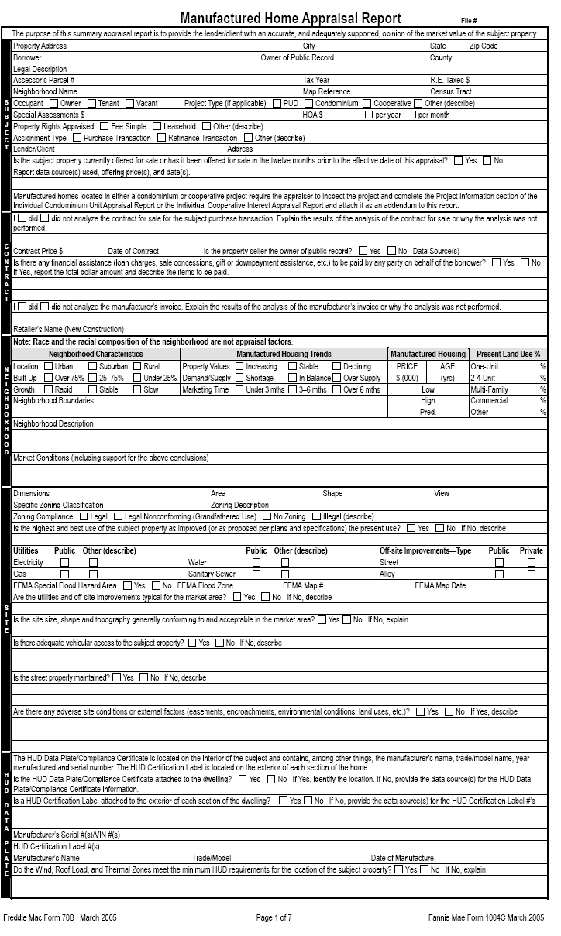

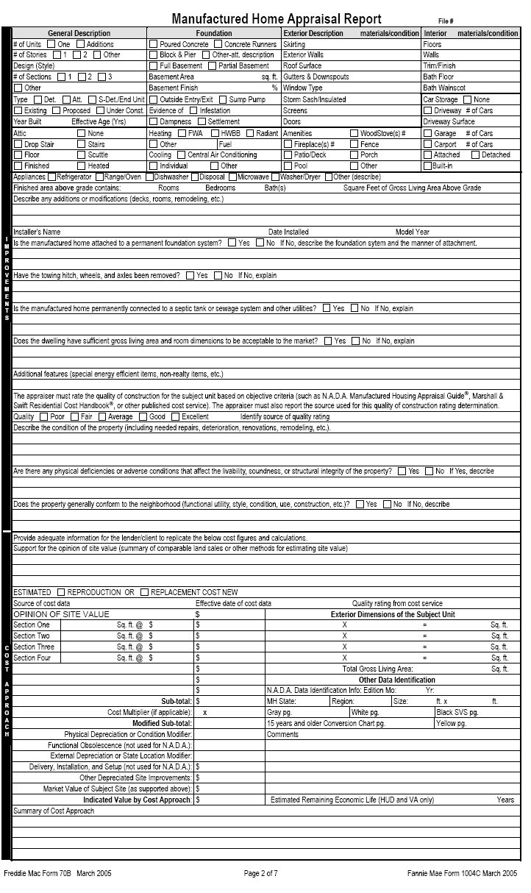

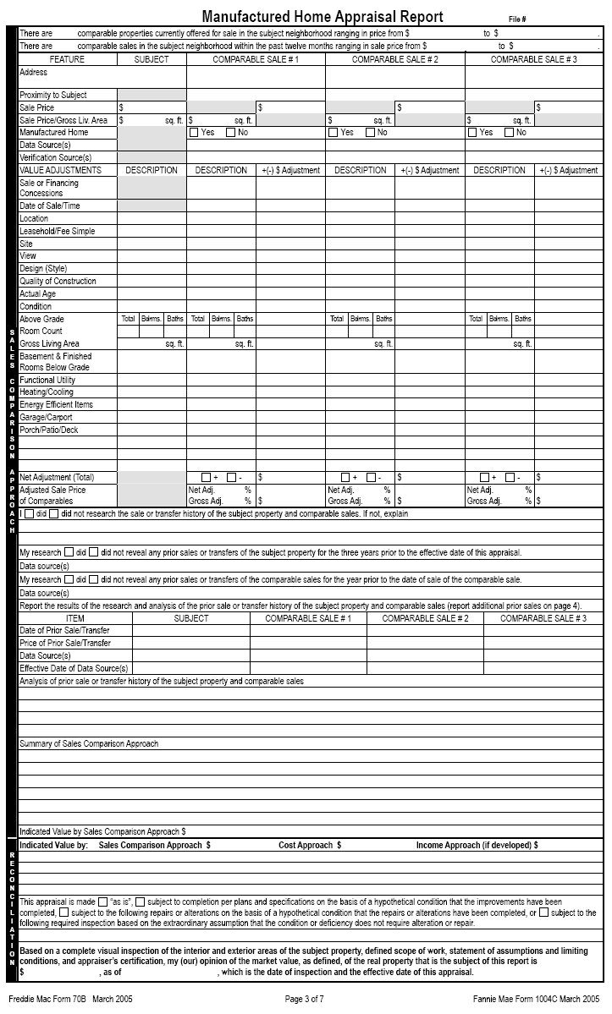

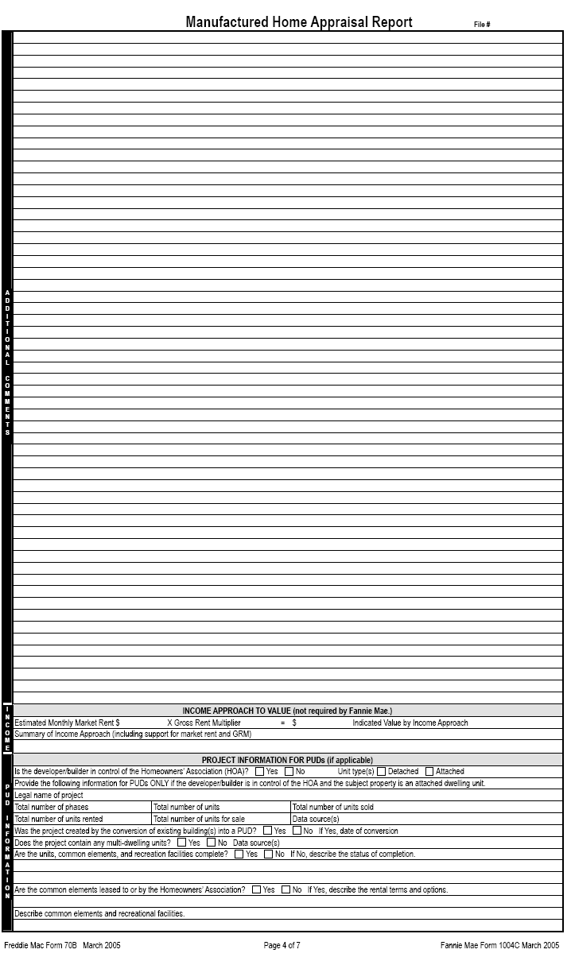

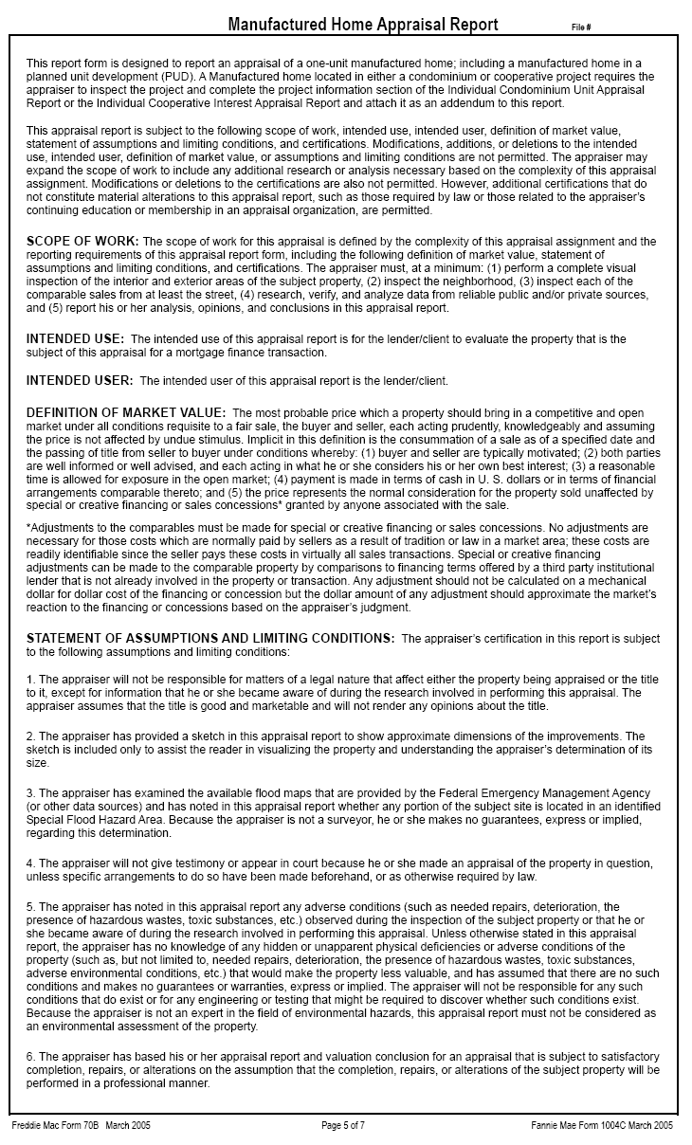

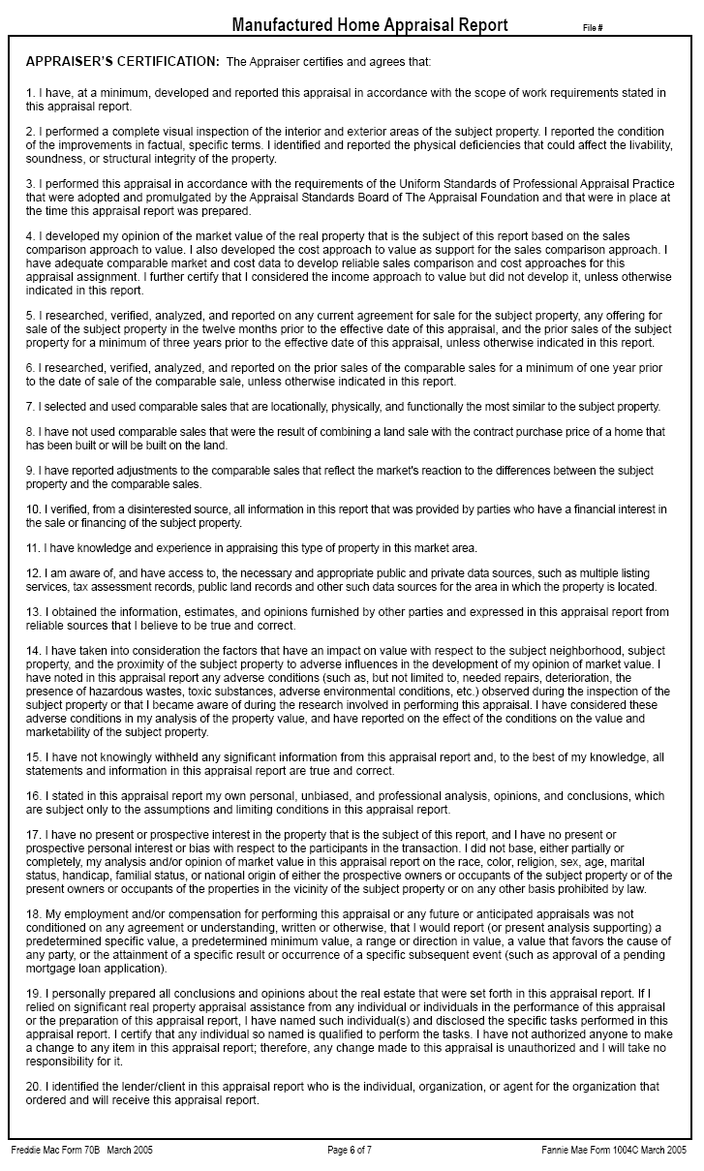

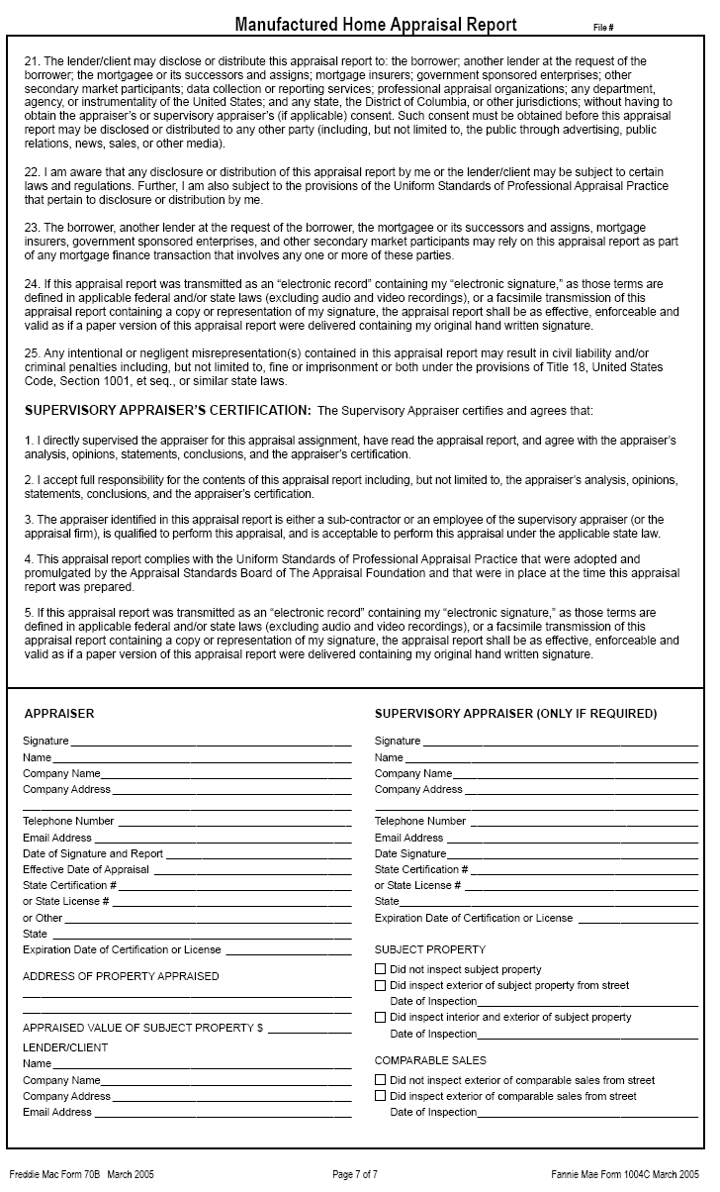

D-3 Individual Condominium Unit Appraisal Report

This section provides specific instructions for completing the Individual Condominium Unit Appraisal Report (Fannie Mae Form 1073 March 2005, Condo).

This report form is designed to report an appraisal of a unit in a condominium project or a condominium unit in a planned unit development (PUD) based on an interior and exterior inspection of the subject property. This form is not designed to report an appraisal of a manufactured home or a unit in a cooperative project.

Section 1 - Subject

This section provides the factual data to identify the property and the parties to the appraisal process. The *FHA case number together with *borrower and/or *property information will be supplied by the lender/client who engages the appraiser.

Field | Protocol
*File Number | • Insert the FHA Case Number at the top right corner of the page.  - The FHA appraisal may not be transmitted to the lender without a case number.
*Property Address | • Enter the property street number and name, city, state and zip code for the property. A post office box number is not acceptable.  - Enter Unit #
*Borrower | - Enter the name of the borrower/mortgagor.
Owner of Public Record | - Enter the name of the owner as listed in public records. If the seller is not the owner of public record the appraiser must explain.
County | - Enter the name of the county in which the property is located. It further provides locational parameters. If not applicable enter “N/A”.
Legal Description | • Enter the legal description of the property. The four types of legal descriptions are: lot and block system, geodetic survey, government survey system and metes and bounds system. If the space provided is insufficient, enter “see attached addendum” and create addendum with the heading “Legal Description” and complete the legal description.
Assessor’s Parcel # | - Enter the parcel number assigned by the local tax assessor. For those areas that do not have an assessor’s parcel number, enter the tax identification number.
Tax Year | - Enter the current tax year used by the locale, e.g. fiscal year or actual year.
R. E. Taxes $ | - Enter the dollar amount of the annual real estate taxes, including all relevant taxes (school district tax, fire district tax, etc.).
Project Name | - Enter the name of the condominium project. The name of the project can be obtained from the condominium documents or public records.
Phase # | - Enter the phase number of the subject, if applicable. Refer to condominium documents, public records or confirm through Management Company.
Map Reference | - Enter location map reference, page number and coordinates, from source used.  This reference should relate to the location maps most commonly used in the locale.
Census Tract | - Enter the census tract number. Census tract numbers must be provided.  - The Census Bureau has an internet resource guide for locating census information. It can be found at URL: www.census.gov
Occupant | - Mark the box signifying the occupancy status at the time of the appraisal.  If vacant, the appraiser should note in the “Unit Description” section under “condition of the property” whether the utilities were on or off at the time of the appraisal. If off, condition the appraisal on a satisfactory re-inspection that the utility that was off at the time of the appraisal does not require alteration, repair or further inspection.
Special Assessments $ | - Report the dollar amount of special assessments for the subject property, if any, and provide a brief explanation for the assessment. Special assessments can include municipal bond debt for off-site improvements. Larger than typical special assessments may affect marketability. If not applicable enter “N/A”.
HOA$ | • Enter the dollar amount of the HOA fee (Condo fee) and mark the box indicating if the fees are paid “per year” or “per month”.
Property Rights Appraised | • Mark the appropriate box indicating the property rights appraised for the subject property as of the date of the appraisal. “Other” includes Land Trust.
Assignment Type | - Mark the appropriate box indicating the assignment type.
Lender/Client  Address | • Enter the name of the lender/client who ordered and will receive the appraisal report. After the client’s name add “its successors or assigns”.  - The use of the appraisal is to support FHA’s decision to provide mortgage insurance on the real property that is the subject of the appraisal; therefore, intended users include the lender/client and FHA.  - Enter the lender/client’s address.
Currently offered for sale or offered for sale in last 12 months. | - The appraiser’s certification states in part “I have researched, verified, analyzed and reported on any current agreement of sale of the subject property, any offering for sale of the subject property in the twelve months prior to the effect date of the appraisal…”  - Mark the appropriate box indicating whether the subject is currently offered for sale or has been offered for sale in the 12-month period prior to the effective date of the appraisal. If there are multiple actions, report each instance. Research may reveal an expired or withdrawn listing. The prior listing may provide a good indication of the upper limit of value.
Report data source(s) used, offering price(s), and date(s) | - Complete this field regardless of whether the property is for sale or has been for sale in the 12 months preceding the date of the appraisal.  - Enter source(s) used, price(s) and date(s) of current or prior listings.

Section 2 - Contract

This section must be completed when the appraisal assignment involves a purchase transaction, otherwise enter “N/A” for not applicable. FHA requires that the appraiser be provided with a complete copy of the ratified sales contract, including all addenda, for the subject property. It provides the agreed-on contract price (accepted offer), date of sale, and all financial terms implicit in the offer. If unable to obtain this information, the appraiser is to state what efforts were made to obtain it.

Field | Protocol
Analyze Contract for Sale | - Explain the results of the analysis (terms and conditions) of the contract of sale or why the analysis was not performed.  - The analysis may include a reference to the number of pages contained in the contract for sale provided.
Contract Price $ | • Enter the final agreed upon contract price .
Date of Contract | • Enter the date of the contract. This is the date when all parties have agreed to the terms of, and signed the contract.
Is The Property Seller The Owner of Public Record  Data Source(s) | • Mark the appropriate box indicating whether or not the seller is the owner of public record. The appraiser is instructed to contact the lender/client if the seller is someone other than the owner of record. The property may not be eligible for FHA financing if it involves flipping (resale in less than 90 days). The lender will make a determination for any exceptions to FHA’s Flipping Rule and advise the appraiser.  • Report where the information was obtained.
Sales Concessions Downpayment Assistance | - Mark the appropriate box indicating whether or not there is any financial assistance (loan charges, sales concessions, gift or down payment assistance, etc.) paid by any party on behalf of the borrower. If necessary, use an addendum and enter the heading “Sales Concessions” completing the description.  - If yes, the appraiser is to report the total dollar amount and describe the items to be paid. If the sale involves personal property (e.g. above ground pool, lawn mower, furniture, etc.) is should be identified and excluded from the valuation.

Section 3 – Neighborhood

This section should reflect the area surrounding the subject property. The appraiser must observe neighborhood characteristics and surrounding properties to make determinations that will be incorporated into the valuation of the subject property. In all instances, the appraiser must mark the appropriate box for each line in neighborhood characteristics and housing trends. Failure to note conditions that may adversely affect the value of the property is poor appraisal practice and violates the Uniform Standards of Professional Appraisal Practice.

NOTE: Race and the racial composition of the neighborhood are not appraisal factors.
Neighborhood Characteristics
Field | Protocol
Location | • Enter the type of area surrounding the subject property.  Urban – relates to a city  Suburban – relates to an area adjacent to a city  Rural – relates to the country or beyond the suburban area
Built-up | • Enter the built-up percentage – the percentage of available land that has been improved. Land such as a state park would not be considered available land.

Neighborhood Characteristics
Field | Protocol
Growth | • Enter the growth rate. If many lots are available, the growth rate may be rapid, stable or slow, but if the neighborhood is fully developed, select the “stable” box.

Condominium Unit Housing Trends
Field | Protocol
Property Values | • Mark the box describing the current trend in property values for condominium units in the community. Comparing individual condominium units that have been sold and resold in recent years is an effective way to determine market trends. Appraisers who use this method, however, should make sure to factor in any improvements or changes made to the property between sales.
Demand/ Supply | • Mark the appropriate demand/supply trend. To determine the equilibrium status of supply and demand in the neighborhood, compare the number of condominium units sold to the number of condominium units listed for sale in a recent time period. The similarity or difference between the number of units sold and listed, not the absolute numbers, should determine the demand/supply level.
Marketing Time | • Mark the appropriate marketing time – the typical length of time a property similar to the subject property would have to stay on the market before being sold at a price near its market value.

Condominium Housing
Price Age | • Indicate the low and high neighborhood prices and ages as well as the predominant value and age. The high and low for both price and age should exclude the extreme.

Present Land Use %
One-Unit, 2-4 Unit, Multi-Family, Commercial, Other | • Estimate each type of land usage in the neighborhood. If there is no land in the neighborhood with one of the designated classifications, enter a “0”. If a portion of the land consists of parks or other unspecified classifications, enter the estimated percentages on the “Other” line and explain in the neighborhood description section.

Neighborhood Narrative
Neighborhood Boundaries | • The appraiser must clearly define the boundaries – north, south, east and west – of the subject’s neighborhood. Providing a description of neighborhood boundaries by physical features such as streets, rail lines, other man-made barriers or well defined natural barriers (i.e. rivers, lakes, etc.) details the make up and understanding regarding neighborhood composition.

Neighborhood Narrative
Neighborhood Description |  | • Discuss factors that would attract residents or cause them to reject the neighborhood. These are typical factors important to discuss:  - Level of maintenance and condition of homes  - Housing styles, ages, sizes, etc.  - Land uses  - Proximity to employment and amenities, including travel distance and time to local employment sources and community amenities  - Employment stability, in terms of variety of employment opportunities and industries  - Appeal to market regarding the overall appeal of the neighborhood as compared to competitive neighborhoods in the same market  - Convenience to shopping with respect to distance, time and required means of transportation  - Convenience to schools in terms of the distance and time for travel to school
Market Conditions (including support for the above conclusions) | - Provide relevant information in support of conclusions relating to trends in property values, demand/supply and marketing time.  - Provide a description of the prevalence and impact of sales and financing concessions and/or down payment assistance in the subject’s market area.  - Other areas of discussion may include days on market, list to sale price ratios, and/or financing availability.

Section 4 – Project Site

This information provides the description of the land underlying the subject project. Insert factual information on each of the lines provided and report the conclusions as directed. Consider all aspects of the physical description and reconcile them in the opinion of market value. This section of the appraisal requires the appraiser to consider any adverse site conditions or adverse external factors that may impact value.

Field | • Protocol
Topography | • Enter site topography, e.g. basically level, or it may be moderately sloping, strongly sloping, or steeply sloped, hilly, rolling, flat, etc. Provide an explanation regarding whether the topography affects marketability and/or value.
Size | • Enter the project site area in square feet if less than one acre. Enter the acreage only if more than one acre. How does size of subject compare to typical sites in market area?
Density | - Enter density classification as shown in zoning or other public records for unit per acre, i.e. low density may be town houses or garden style projects; high density may be mid-rise or high-rise projects.
View | • Briefly describe the view from the unit (None is not an acceptable response).  - Identify a view with a significant positive or negative influence on the value.  - Photographs are recommended for any negative or positive view influences affecting value or marketability.
Specific Zoning Classification | • Enter the specific zoning classification used by the local municipality or jurisdiction, e.g., R15, DR-3, etc.  - If none exists, enter “None Exists.”
Zoning Description | - Describe what the specific classification means. Include a general statement describing what the zoning permits. For example: R15 = Low Density Multi-Family Residential  - If “No Zoning” exists, describe the prevalent use of sites in the neighborhood.
Zoning Compliance | • Determine whether the current use is in compliance with the zoning ordinances. Mark the box indicating whether it is Legal, Legal Non-Conforming (Grandfathered Use), No Zoning, or Illegal Use.  • If the existing property does not comply with all of the current zoning regulations (use, lot size, improvement size, off street parking, etc.) but is accepted by the local zoning authority, enter “Legal Non-Conforming” and provide a brief explanation.  - Mark the appropriate box “yes” or “no” indicating that the zoning regulations permit rebuilding to current density.  - If the use is not legal, the property is not eligible for FHA mortgage insurance.
Highest and  Best Use | • Mark the appropriate box. This entry questions the categorization as the highest and best use of the site as improved or, as proposed and completed, in relation to the neighborhood and current market conditions.  • If current use represents the highest and best use, mark "yes".  • If it does not, mark "no" and provide an explanation.
Utilities | • Mark either “Public” or "Other." If “Other" is marked, describe. Public utilities mean governmentally supplied and regulated. Public does not include any community systems sponsored, owned or operated by the developer or a private company not subject to government regulation or financial assistance.  • Note if there are mechanical chlorinators or water-flow that decreases noticeably while running simultaneous plumbing fixtures.  • Visually inspect the septic system and its surrounding area. If there are obvious or readily observable signs of system failure, “require inspection” to ensure that the system is in proper working order.  Note: The appraiser shall indicate whether a public water or sewage disposal system is available to the site. If available, connection must be made to public or community water/sewage disposal system if connection costs are reasonable. The lender will determine whether connection is feasible.
Off-site Improvements–Type | • Briefly describe the off-site improvements by which the property is accessed.  - Under "Type", enter road surface material and mark Public or Private. For example: "Street-Asphalt; Public", “Alley-None”  • Public refers to an improvement dedicated to and accepted by a unit of government – not including Home Owner's Associations.
FEMA Special Flood Hazard Area | • FEMA (Federal Emergency Management Agency) is responsible for mapping flood hazard areas. If the property is within a Special Flood Hazard Area, mark "YES". Otherwise, mark “NO”.  • Attach a copy of the flood map panel for properties located within an identified flood hazard area.
FEMA Flood Zone | • Εnter the FEMA Zone designation. Only properties within Special Flood Hazard Areas, such as zones "A" a special flood hazard area and "V" a coastal area, require flood insurance, Zones "B" "C" and “X” do not.
FEMA Map # and FEMA Map Date | • Enter the FEMA Map number and map date. If it is not shown on any map, enter "Not Mapped."
Are utilities and off site improvements typical for the market area | - Mark the appropriate box indicating whether the utilities and off-site improvements are typical for the market area.  - If “No” is marked, explain what is typical.
Any adverse site conditions or external factors | • Mark the appropriate box indicating whether there are any adverse site conditions or external factors (easements, encroachments, environmental conditions, land uses, etc.).  - If “No” is marked, no comment is necessary, if “Yes” is marked, an explanation is required.  - Describe any adverse site conditions or adverse factors. Consider easements affecting the functional utility of the property in the conclusions of both the highest and best use and market value. For example, discuss adverse easements, encroachments, slide areas, illegal or non-conforming zoning use, etc. Consider surface, sub-surface and overhead easements.  - List any adverse environmental conditions, including hazardous waste, toxic substances and others.  - Explain all deficiencies that do not require repair (extreme slope, etc.) and consider them in the opinion of value.  • Discuss the observations with direct relationship to value and consider them in the final opinion of value.

Section 5 – Project Information

This section describes the subject condominium project information. Accurately report the conditions observed including the overall condition of the project and quality of construction. Enter factual information on each of the lines provided and report the conclusions. Consider all aspects of the project information and reconcile them in the opinion of market value.

Field | Protocol
Data source (s) for project information | - Enter the data source(s) for the project information, i.e. condo documents, public records, property management company, board or association officials, etc.
Project Description | - Mark the box that best identifies the type of project description. Some projects may contain more than one building type. In those cases, mark the appropriate boxes. If “other” is marked, enter a brief description for the project description.

General Description
Field | Protocol
# of Stories | • Enter the number of stories for the project property type, i.e. number of stories for garden, mid-rise, or high-rise projects, townhouse, etc.
# of Elevator(s) | • Enter the number of elevators. If none, enter “walk up”.
Stage of Construction | • Mark the box indicating the stage of construction, Existing, Proposed or Under Construction. Properties that are either Proposed or Under Construction require plans and specifications for the appraiser to review.
Year Built | • Enter the year built.
Effective Age (Yrs) | • Enter the effective age of the improvements. A range is acceptable. The effective age reflects the condition of the property relative to similar competitive properties. The effective age may be greater than, less than or equal to the actual age.  • Note any significant difference between the actual and effective ages and explain in the “condition of property” comments section.
Exterior Walls | - Enter the type of construction material: aluminum, vinyl, wood siding, brick veneer, stucco, etc. If a combination of materials, show the predominant portion first.

General Description
Field | Protocol
Roof Surface | - Enter material type used for roof covering: composition shingle, wood, slate, clay tile, gravel, built-up, etc.
Total # Parking | - Enter the total number of parking spaces for the condominium project.
Ratio (spaces/units) | - Enter the ratio, total number of parking spaces divided by the total number of units.
Type | - Enter the type of parking in the condominium project, such as open, garage, carport, or assigned.
Guest Parking | - Enter the number of guest, visitor, or non-assigned parking spaces in the condominium project.

Subject Phase
Field | Protocol
# of Units | - Enter the total number of units in the subject’s phase.
# of Units Completed | - Enter the number of units in the subject phase that have been completed.
# of Units for Sale | - Enter the number of units in the subject’s phase currently offered for sale.
# of Units Sold | - Enter the number of units in the subject’s phase that have been purchased.
# of Units Rented | - Enter the number of units in the subject’s phase that are rented.
# of Owner Occupied Units | - Enter the number of units in the subject’s phase that are owner occupied.

If Project Completed
Field | Protocol
# of Phases | - Enter the total number of phases of construction in the subject project.
# of Units | - Enter the total number of units in the subject project.
# of Units for Sale | - Enter the number for sale in the subject project.
# of Units Sold | - Enter the number of units sold in the subject project.
# of Units Rented | - Enter the number of units rented in the subject project.
# of Owner Occupied Units | - Enter the number of owner occupied units in the subject project.

If Project Incomplete
Field | Protocol
# of Planned Phases | - Enter the total number of planned phases for the subject project.
# of Planned Units | - Enter the number or planned units for the subject project.
# of Units for Sale | - Enter the number of units for sale in the subject project.
# of Units Sold | - Enter the number of units sold in the subject project.
# of Units Rented | - Enter the number of units rented in the subject project.
# of Owner Occupied Units | - Enter the number of owner occupied units in the subject project.

Field | Protocol
Project Primary Occupancy | - Mark the box indicating the occupancy type for the project, i.e. Principle Residence, Second Home or Tenant.
Is the developer/builder in control of the HOA | - Mark the box indicating whether or not the developer/builder is in control of the HOA.
Management Group | - Mark the box identifying the type of management group. If management agent is marked, provide name of management company and phone number.
Does any single entity own more than 10% of the total units in the project ? | - Enter an “X” in the applicable box indicating whether or not a single entity owns more that 10% of the total units in the project. If “yes”, provide the name of the entity and the number of units owned. It is possible to have multiple entities in this category.
Was the project created by conversion ? | - Enter an “X” in the applicable box indicating whether or not the project was created by a conversion. If “yes”, describe the original use and the date of conversion.
Are the units, common elements, and recreation facilities complete? | - Enter an “X” in the applicable box indicating whether or not the common elements and recreational facilities have been completed.  - If “no”, provide an explanation describing what remains to be completed.
Is there any commercial space in the project? | - Enter an “X” in the applicable box indicating whether or not there is commercial space in the project. If “yes” describe the commercial space and provide the overall percentage of commercial space.
Describe the condition of the project and quality of construction | - Describe the overall condition and maintenance of the project.  - Note any evidence of physical deterioration  - Rate the project’s condition (Good, Average, Fair, Poor).  - Rate the quality of construction giving consideration to the durability and quality of the materials and finish.
Describe the common elements and recreational facilities | - Describe common elements and recreational areas such as parking areas, pools, courts, club houses, fitness centers, etc.
Are any common elements leased to or by the HOA? | - Enter an “X” in the box indicating whether or not any of the common elements are leased to the HOA.  - If “yes” provide a description of the rental terms and options and comment on any effect on the marketability or value of the project.
Is the project subject to ground rent? | - Enter an “X” in the box indicating whether or not the project is subject to a ground rent.  - If “yes”, enter the dollar amount of the annual ground rent and describe the terms, restrictions, and conditions of the lease agreement and what effect, if any, it has on the marketability or value of the project.
Are the parking facilities adequate for the project size and type? | - Enter an “X” in the box indicating whether or not the parking facilities are adequate for the project size and type.  - If “no” describe and comment on the effect of value and marketability. For example, projects of similar size, type and quality have garage parking whereas the subject project has assigned open spaces.

Section 6 – Project Analysis

Field | Protocol
Analyze the Condominium Project Budget | - Explain the results of analysis of the condominium project budget or why the analysis was not performed.  - The analysis includes adequacy of the fees and reserves to meet operating expenses which may include: legal and accounting, utilities, trash removal, snow removal, repairs and maintenance, recreational areas maintenance and upkeep, gardening and yard maintenance, taxes, insurance, facility rentals, etc.
Are there any other fees for the use of the project facilities | - Enter an “X “ in the box indicating whether or not there are any fees other than the regular HOA fee for use of the project facilities.  - If “yes”, report the charges and describe.
Compared to other competitive projects | - Mark the box that best indicates the subject project’s unit charge comparability to competitive projects of similar quality and design.  - If either the “High” or “Low” box is marked, an explanation is required.
Are there any special or unusual characteristics of the project known to appraiser? | - Enter an “X” in the box indicating whether or not there are any special or unusual characteristics of the project known to the appraiser (information from condo documents, budget, HOA meetings, or other sources.  - If “yes”, describe and explain the effect on value and marketability. For example, condo increasing by 30% to cover major repair due to lack of adequate reserves for building maintenance.

Section 7 – Unit Description

Mechanical Systems
An appraiser must examine mechanical, plumbing and electrical systems of the subject property to ensure that they are in proper working order. This examination entails turning on the applicable systems and observing their performance. Do not operate the systems if doing so may damage equipment, or when outside temperatures will not allow the system to operate.

Field | Protocol
Unit Charge | - Enter the monthly condo/HOA fee, multiply by 12 and enter result per year.
Annual Assessment per Sq.Ft. of GLA | - Divide the annual assessment charge per year by the GLA to compute the assessment per square foot.
Utilities included in monthly assessment | - Enter an “X “ in the appropriate box or boxes identifying which utilities are included in the unit monthly assessment.  - It “other” is marked, please describe.

General Description
Field | Protocol
Floor # | - Enter the floor level location of the unit.
# of levels | - Enter the number of levels contained in the subject unit.
Heating Type | • Enter the type of heating system: FWA (forced warm air), HWBB (hot water baseboard), HWRad (hot water radiant) EBB (for electric baseboard), etc.  - Turn on the furnace/heating system to test functionality, weather permitting, and that no unusual noises are heard, no odors or smoke are emitted indicating a defective unit, etc. However, do not operate the systems if doing so may damage  - Turn on the hot water to ensure that the water heater is operating appropriately.  - Note any significant deterioration to heating system.
Fuel | - Enter type of fuel used: natural gas, oil, propane, electric, etc.
Cooling Type | - Enter an “X” in the box indicating the type of cooling system: Central Air Conditioning, Individual or Other. If “Other” is marked, provide a brief description, e.g. permanently affixed fans, zoned air-conditioning, etc.  - Turn on the air conditioning system to test functionality, weather permitting, and that no unusual noises are heard, no odors or smoke are emitted indicating a defective unit, etc. However, do not operate the systems if doing so may damage equipment or when outside temperatures will not allow system to operate.  - Note significant holes/deterioration on the unit
Interior Materials/Condition
Enter the types of Materials and the Condition of the Materials (Good, Average, Fair, and Poor). Make every effort to describe accurately and explain in detail "Fair" and "Poor" ratings. The rating must relate to the habitability of the house given local standards.
Interior materials/condition
Field | Protocol
Floors | - Enter floor type — tile, hardwood, carpet, etc. — and note the condition.
Walls | - Enter type of walls — plaster, drywall, paneled, etc. — and note the condition.
Trim/Finish | - Enter type of molding — wood, metal, vinyl, etc. — and note the condition.
Bath Wainscot | - Enter type that protects walls from moisture — ceramic tile, fiberglass, etc. — and note the condition.
Doors | - Enter door types — wood, metal, hollow core, etc. — and note the condition.

Amenities
Field | Protocol
Fireplace(s) # | - Enter “X” if this amenity exists and provide a specific number
Woodstove # | • Enter “X” if this amenity exists and provide a specific number
Deck/Patio | - Enter “X” if this amenity exists.
Porch/Balcony | - Enter “X” if this amenity exists.
Other | - Enter “X” in this box if applicable and describe amenity or feature.

Appliances
Make an entry [X] in the boxes to indicate that these items exist. An entry in a box means that the item was considered part of the real estate and is included in the value. If an item is personal property, put a "P" in the box and do not include it in the opinion of value. Treat non-functioning equipment as existing, but as deferred maintenance in the valuation process.
Field | Protocol
Refrigerator | Enter “X” if this item exists. Enter “P” if personal property.
Range/Oven | Enter “X” if this item exists. Enter “P” if personal property.
Disp / Microwave | Enter “X” if this item exists. Enter “P” if personal property.
Dishwasher | Enter “X” if this item exists. Enter “P” if personal property.
Washer/Dryer | Enter “X” if this item exists. Enter “P” if personal property.

Car Storage
Field | Protocol
None | - Mark "NONE" if there is no car storage space.
Type of Space | - Enter an “X” in the box or boxes signifying type of storage space, if applicable.
# of Cars | - Enter the number of cars the space can accommodate, if applicable.
Assigned or Owned | - Mark this box indicating whether, space(s) are assigned or owned, if applicable.
Parking Space # | - Enter the parking space #/

Gross Living Area
The appraiser must attach a sketch of the subject unit that indicates interior perimeter unit dimensions rather than exterior dimensions (include the calculations to show how you arrived at the estimated gross living area) or attach a copy of the floor plan (along with dimensions) provided in the condo documents which also lists the square footage.

Room Count, Gross Living Area and Heating and Cooling separately metered
Field | Protocol
Finished area above grade contains | • To complete this section, enter the total number of above grade rooms, the total number of bedrooms above grade, and the total number of bathrooms above grade. Do not include foyers, basement finished rooms or unfinished attic space.  - Enter the total square footage of the gross living area above grade.
Are heating and cooling separately metered? | - Enter an “X” in the box indicating whether or not the heating and cooling for the individual units separately metered? “  - If “No”, describe and comment on compatibility to other projects in the market area.

Narrative Comments Section

The completion of this section is critical to the opinion of market value. The appraiser must discuss all adverse conditions and observed physical and functional deficiencies noted. If necessary, use the Additional Comments section of the form report, or an addendum, for additional discussion or description.

Field | Protocol
Additional Features | • Use this space to describe special energy efficient features such as solar energy or geothermal systems and/or to further describe the additional features,  • Please elaborate on any special or unusual aspects of items, e.g. gas fireplace or wood burning fireplace.
Condition of the property (including needed repairs, deterioration, renovations, remodeling, etc.) | • Describe any physical deterioration and/or functional or external depreciation noted at the property.  • Provide a conclusion as to the overall condition of the improvements that is supported by the previous descriptive sections.  - Describe needed repairs.
Physical deficiencies or adverse conditions | - Enter an “X “ in the applicable box indicating whether or not there are any physical deficiencies or adverse conditions that affect the livability, soundness, or structural integrity of the property. If the response is “No”, no explanation is required or needed. However, if the response is “Yes”, a full and detailed explanation is required and, if necessary, condition the appraisal on the “repair or alteration of the condition” or a “required inspection” by appropriately qualified individuals or entities, which may include professional engineers, tradespersons, HUD Fee Inspectors.

Field | Protocol
Physical deficiencies or adverse conditions | Lead-Based Paint Hazard  - If the home was built before 1978, this may indicate a lead paint hazard. For all FHA insured properties, correction is required to all defective paint in or on structures and/or property improvements built before January 1, 1978 in accordance with 24 CFR Part 35.  - Observe all interior and exterior surfaces, such as walls, stairs, deck porch, railing, windows or doors for defective (chipping, flaking or peeling) paint. (Exterior surfaces include surfaces on fences, detached garages, storage sheds and other outbuildings and appurtenant structures.). Note any areas affected (be specific) and condition the appraisal on their repair subject to the satisfaction of the condition.
Property conformity | - Enter an “X “ in the applicable box indicating whether or not the subject generally conforms to the neighborhood (functional utility, style, condition, use, construction, etc.). If the response is “Yes”, no explanation is required or needed. However, if the response is “No”, an explanation is required.

Section 8 – Prior Sale History

Field | Protocol
Research sale or transfer history of subject & comps | - Enter an “X “ in the applicable box indicating whether you “did” or “did not” research the sale or transfer history of the subject property and comparable sales. If not, provide explanation.
Prior sales or transfers of subject property | - Enter an “X “ in the applicable box indicating whether your research “did” or “did not” reveal any prior sales or transfers of the subject property for the three years prior to the effective date of this appraisal.
Data Source(s) | - Enter data source(s) used for sales and transfer information. Two sources are recommended for researching prior sales and transfers, local MLS and local public records at a minimum.  - Be familiar with the data source(s), i.e. how the data is gathered and how often it is updated, what is the publication date of the data, what is the effective date of the data.
Prior sales or transfers of comparable sales | - Enter an “X “ in the applicable box indicating whether your research “did” or “did not” reveal any prior sales of transfers of the comparable sales for the year prior to the date of sale of the comparable sale.
Data Source(s) | - Enter data source(s) used for sales and transfer information. Two sources are recommended for researching prior sales and transfers, local MLS and local public records at a minimum.  - Be familiar with the data source(s), i.e. how the data is gathered and how often it is updated, what is the publication date of the data, what is the effective date of the data.

Report the results of the research and analysis of the prior sale or transfer history of the subject property and comparable sales (report additional prior sales in the “Additional Comments” section or an addendum).

Field | Protocol
Date of Prior Sale / Transfer | - Report the date(s) of prior sale(s) or transfer(s) of the subject that occurred within three years of the effective date of the appraisal.  - Report the date(s) of prior sale(s) or transfer(s) of each comparable sale for the year prior to the date of the comparable sale.
Price of Prior Sale /  Transfer | - Report the price of the prior sale(s) or transfer(s) of the subject that occurred within three years of the effective date of the appraisal.  - Report the price of the prior sale(s) or transfer(s) of each comparable for the year prior to the date of the comparable sale.
Data Source(s) | - Identify data source(s) used.
Effective Date of Data Source(s) | - Enter the date the data was published or updated by the source. For example, the local MLS may update their database multiple times during the week or month whereas property transfers at the local land records office may take six or eight weeks to be recorded. The property transfer records may have an effective date that is eight weeks earlier than the appraisal date and the MLS data is within one week of the appraisal date.
Analysis of prior sale or transfer history of subject and comparable sales | - Provide analysis of prior sale or transfer history of the subject and comparable sales.  - Analysis may address changes in property conditions between sale dates or verifying if prior sale was an arm’s-length transaction.

Section 9 – Sales Comparison Approach

Comparable Data Pool

The appraiser is required to report the number of comparable properties currently offered for sale, as of the effective date of the appraisal, and the number of comparable sales in the subject neighborhood, within 12 months of the effective date of the appraisal, in this section. Unlike the neighborhood price data, which includes all sales, this section focuses only on those properties that are comparable to the subject, not the universe of sales.

If there was difficulty in locating comparable properties, i.e. the subject is a “high-rise” and it is the only sale within the project in the past 12 months, and one or more of the comparable properties was a “mid-rise” or ”garden style”, then for purposes of this section, all such properties in the subject’s neighborhood are to be treated as comparable and counted.

Field | Protocol
Comparable properties offered for sale | Enter the number of comparable properties currently offered for sale, including those under contract, within the subject neighborhood together with the price range.
Comparable sales | Enter the number of comparable sales that occurred within the 12 month period preceding the effective date of the appraisal, and within the subject neighborhood, together with the price range.

Enter factual data in each field or line.
Field | Protocol
Address and unit # | • Enter the address and unit number for the subject and each comparable sale.
Project Name and Phase | - Enter the project name and phase number for the subject and each comparable sale.
Proximity to Subject | • Enter proximity in straight-line distance and direction. For example, "1.5 miles NE" or “3 blocks south”. If comparable distance from the subject is more than a generally accepted distance, or located outside the defined neighborhood boundaries, be sure to explain why the sale is applicable in the "Summary of Sales Comparison Approach" section.
Sale Price | • Enter the purchase price (total paid) for the subject and each of the comparable sales. This means the closed or settled price of the comparable sale.  - If the appraisal involves a refinance of the subject, enter “Refi” as the subject’s sale price.
Sale Price / Gross Liv. Area | • Enter price per square foot for the above grade living area for the subject, if a purchase transaction, and each comparable sale.
Data Source(s) | - Enter data source(s) used for sales information.
Verification Source(s) | - Enter verification source(s), the document or party from which the additional proof was obtained. MLS by itself is not considered a verification source.  - Contacting someone with first-hand knowledge of the transaction (agent, broker, buyer, seller, etc.) especially where it involves confirmation of seller concessions is the preferred method of verification.  - A single source may be used if the quality of data is such that sales data are confirmed and verified by settled transactions. Information provided should permit the reader of the report to locate the data from the sources cited.  - Do not use as market data sales that are not verified and adjusted to reflect the terms and conditions of sale.

Value Adjustments

Adjustments are made to the prices of the sale properties for price-influencing dissimilarities between each sale and the subject property. Not all dissimilarities require adjustment because not all dissimilarities achieve price differentials in the market. All adjustments must be extracted from and supported by the actions of the market.

For each adjustment item, enter the description of the adjustment and whether it is an upward or downward adjustment. Do not make an adjustment unless it has a material effect on value.

VALUE ADJUSTMENTS
Field | Protocol
Sales or Financing Concessions | - Report the type of financing such as Conventional, FHA or VA, etc.  - Report the type and amount of sales concession for each comparable sale listed. If no concessions exist, the appraiser must note “none.”  - The appraiser is required to make market-based adjustments to the comparable sales for any sales or financing concessions that may have affected the sales price.  - The adjustment for such affected comparable sales must reflect the difference between the sales price with the sales concessions and what the property would have sold for without the concessions.
Date of Sale / Time | • State month and year of the sale. Showing the contract date and settled date is also acceptable.  - Time adjustments, if any, must be supported by the market and consistent with the neighborhood market conditions noted. If this is the case, show both the contract date and settled date as any time adjustment should be calculated using the contract date (meeting of the minds) rather than the settled date.
Location | - Enter the name of the subdivision or PUD. If none is applicable enter the neighborhood name that is commonly used to refer to the property’s location.
Leasehold / Fee Simple | • State whether the property was sold as Fee Simple or as a Leasehold Estate. An adjustment is required if the estate differs from the rights appraised for the subject property, and the difference is recognized by the local market.
HOA Mo. Assessment | • Enter the monthly unit charges  - Any adjustments made for value differences should be explained.
Common Elements  And Rec. Facilities | - List the common elements and recreational facilities.  - Adjust for differences where and if warranted.
Floor Location | - Enter the floor location of the unit.  - Adjust for any differences attributable to floor location within a project if warranted.
View | • Describe the view from the unit, water view, skyline, etc. Such terms as “Average” or “Good” are only to be used as adjuncts, i.e. “Skyline/Average”, “Water view/Good”.  - Make adjustments only if the view is superior or inferior to the subject. If the subject has a superior view and adjustments are made, a photograph of the view amenity is recommended.
Design (Style) | • Enter the style according to a project description used. Be consistent with improvement description.
Quality of Construction | • Enter "Good", "Average", "Fair", etc. using the quality rating from your cost service subscription or provider.  - Adjustments may also be warranted for interior construction quality and should be explained and justified.
Actual Age | • Enter only the actual age of the subject and each comparable sale.
Condition | • Enter the condition of the subject and comparable sales.  - Only ratings to be used are: “New”, “Good”, “Average”, “Fair” and “Poor”  • Consider any assumed repairs or alterations to the structure and the roof when determining the need for adjustments to the comparable sales.
Above Grade Room Count | • Enter room count, consistent with the description of improvements on the front of the appraisal form. Up to three adjustments may be entered:  - The first line is for bathroom count differences. A deficiency or surplus in the number of baths should be adjusted first.  - The second line adjustment is for room count.  - The third is for a difference in square footage.  • Explain any property that has an adjustment in both square feet and room count.
Gross Living Area | • Enter the total square footage of the above grade living areas. Adjustments for differences in square footage should be market derived.
Basement & Finished Rooms Below Grade | • Show full or partial basement with basement finish percentage, i.e. Full 75%, Partial 50%.  • Enter the type of rooms below grade: bedroom, recreation room, laundry, full bath, etc.  - Include below grade improvements found in the subject property or comparable sales.  • Make appropriate adjustments to reflect differences between the comparable sales and the subject property.  • Explain any special features or finishes in the “Summary of Sales Comparison Approach.”  - If no basement enter N/A
Functional Utility | • Enter "Equal", "Superior" or "Inferior" as a total of the items rated in the Improvement Analysis compared to the subject. Use the "Summary of Sales Comparison Approach” to explain differences.  • Adjust for functional obsolescence observed in the subject noted in the unit description and not found in the comparable sales.  • Extract dollar adjustments from the market. For example, a poor floor design that includes two bedrooms so that the entrance to one is gained by passing through the other typically requires a negative adjustment for functional obsolescence.  - Floor plan of the subject is required when functional obsolescence is attributable to layout or poor floor plan.
Heating / Cooling | • Enter an adjustment for differences in heating and cooling systems. Any adjustment should be based on market expectations.
Energy Efficient Items | • Describe energy efficient items: storm windows and doors, solar installations, replacement windows, etc. and enter an adjustment for differences if warranted. If none, so state.
Garage / Carport | • Enter an adjustment for car storage. Calculate adjustments in accordance with market acceptance of carport value versus garage and size (one car, two cars, etc.).
Porch, Patio, Deck | • Enter an adjustment for these features. Base any adjustments on local market expectations.
Blank Lines | • Τhree blank lines are provided for the appraiser’s use to describe additional amenities, features or individual characteristics not listed or addressed elsewhere in the sales grid, e.g. woodstove, fireplace, fencing, other.  - Enter appropriate adjustments where warranted.
Net Adjusted (Total) | • Mark either [+] or [-] box to indicate if the total net adjustments will increase or decrease the value and note by how much. If any adjustment is excessive, review the comparable sales to determine if the best ones were selected. If the total adjustments appear excessive in relation to the sale price; the appraiser should reexamine the comparability of that sale.  • Explain any adjustment that appears to be excessive.
Adjusted Sale Price of Comparables | • Total all of the adjustments and add them to or subtract them from the sales price of each comparable. Generally, adjustments should not exceed 10% for line items, 15% for net adjustments and 25% for gross adjustments. If any adjustments exceed stated guidelines a detailed explanation must be provided including reasons for not using more similar comparable sales.
Summary of Sales Comparison Approach | - Use this section to explain comparable selection;  - Use this section to provide required explanations for subjective adjustments made in any of the following value factors: Location, Site, View, Design, Quality of Construction, Age, Condition and Functional Utility;  - Use this section to explain any adjustments exceeding guidelines;  - Use this section to explain which comparable sale or sales is/are given most weight or consideration and why.
Indicated Value by Sales Comparison Approach | - Enter the Indicated Value

Section 10 – Income Approach

In a single-family residential property, the Income Approach is generally not recognized as a basis for buying by the market. The approach typically provides minimal applicability in the opinion of market value; therefore, the Income Approach is not required for FHA appraisals completed on the Individual Condominium Unit Appraisal Report, Fannie Mae Form 1073. However, if adequate data is available, the Income Approach should be completed.

Income Approach To Value (not required for FHA appraisals)
Field | Protocol
Estimated Monthly  Market Rent | • Enter the subject’s estimated market rent and multiply it by the Gross Rent Multiplier (ratio between sales price and gross monthly rental income.
Summary of Income Approach | - Provide support for market rent and GRM if developed.

Section 11– Reconciliation

The appraiser should consider all appropriate approaches to value and all information relevant to the subject property and the market conditions in the opinion of market value.

If there is insufficient space in the reconciliation section to list and describe the “repairs, alterations or required inspections” noted, then the appraiser is instructed to insert a reference in the reconciliation section “see Attached Addendum” and list and describe the items under the heading “Repairs, Alterations, Required Inspections.”
Field | Protocol
Indicated Value by: | - Enter the Indicated Value for each of the approaches to value developed. If the approach was not developed, enter “ND or “Not Dev” for not developed.  - Reconcile the approaches to value with a brief description of the validity of each approach with respect to the appraisal assignment.

This appraisal is made
Field Protocol
Mark this box  “as is” | when:  - There is/are no Property Condition(s) noted.  - Establishing the “as is” value for a regular 203(k) when needed.

This appraisal is made
Mark this box  “per plans & specs” | when the appraisal involves:  - Proposed construction, or  - Under construction, less than 90% complete, or a  - 203(k) with a Plan Review and Specification of Repairs prepared by a 203(k) Consultant.

This appraisal is made
Mark this box  “subject to repairs or alterations” | when the appraisal involves existing housing, or new construction more than 90% complete with only buyer preference items remaining (floor coverings, appliances, landscaping packages (soil must be stabilized to prevent erosion)), requiring repairs or alterations to:  - Protect the health and safety of the occupants  - Protect the security of the property  - Correct physical deficiencies or conditions affecting structural integrity  - Complete buyer preference items for new homes, or to  - Complete repairs/improvements noted in work order or contractor estimates for the Streamline K  - Meet FHA Minimum Property Requirements
The appraiser must indicate the extent of repairs and note this in the appropriate section of the appraisal, or in the “additional comments” section, or in an addendum, under the heading of “Reconciliation – Property Conditions” listing the repairs noted together with an estimated cost to cure.

This appraisal is made
Field Protocol
Mark this box  “subject to a required inspection” | when the appraisal calls for a required inspection to:  - Certify the condition and/or status of a mechanical or structural element of the property  - Protect the health and safety of the occupants  - Protect the security of the property  - Meet FHA Minimum Property Requirements or Minimum Property Standards
More than one box may be marked depending on the assignment and property conditions.

The appraiser must indicate the reasoning for any required inspections and note this in the appropriate section of the appraisal, or in the “additional comments” section, or in an addendum, under the heading of “Reconciliation - Valuation Conditions” listing the required inspections.

Field Protocol
The value “subject to completion per plans and specifications”, “subject to the following repairs or alterations”, or “subject to the following required inspection” must be consistent with the subject property conditions described.
Opinion of Market Value | - Enter the opinion of Market Value
Final Reconciliation | • This entry should contain the appraiser's reasoning for arriving at the final value.
Date of Value | • Enter the date when the property was inspected.

Additional Comments - Addendum

It may become necessary to include commentary that carries beyond the provided space of the appraisal reporting form. The use of an addendum provides the additional space for the appraiser to fully describe any item, area or condition where the commentary exceeds the space provided in other sections of the report. It is recommended that any information carried forward to the addendum, if needed, follow the sequence of the form with a proper heading identifying said section.

For example, the neighborhood “market conditions” comments exceed the space provided on the form. In that case, on page one in neighborhood market conditions enter “See additional comments”, in the “additional comments” section enter the heading “Neighborhood Market Conditions” and provide the narrative in this section. Follow the same procedure for any section of the report where commentary exceeds space provided. This will provide the reader with the proper identification and linkage of additional comments together with a logical flow of information in a standardized reporting format.

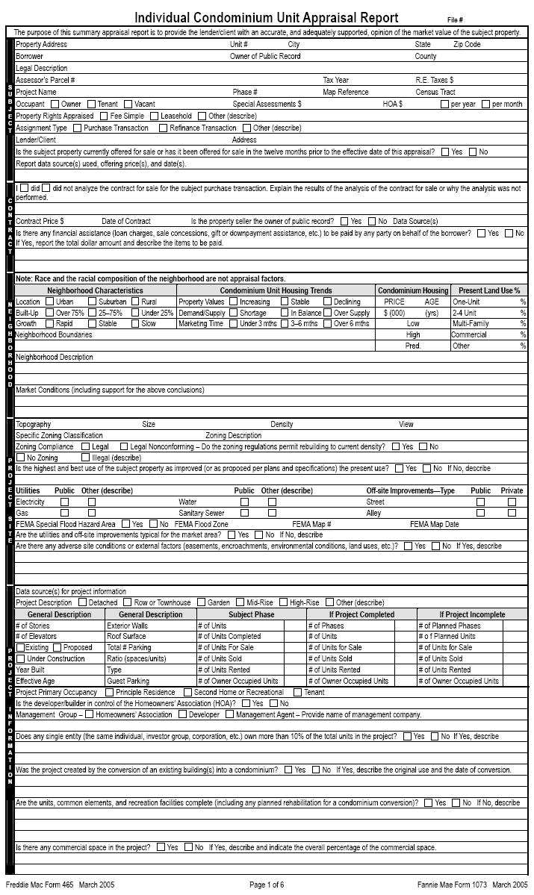

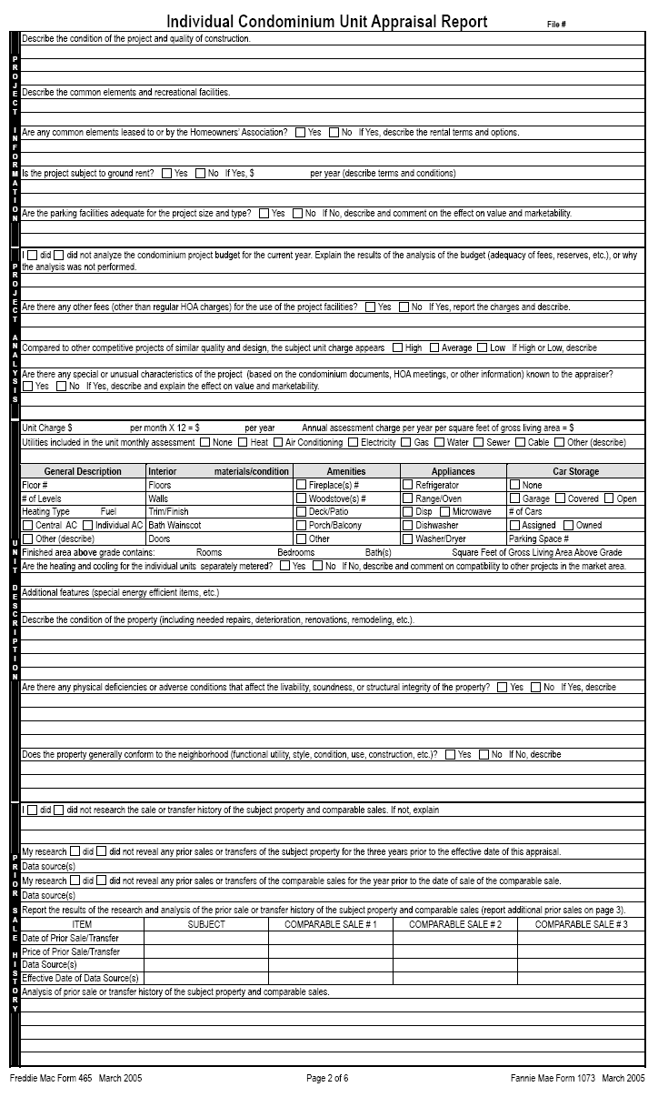

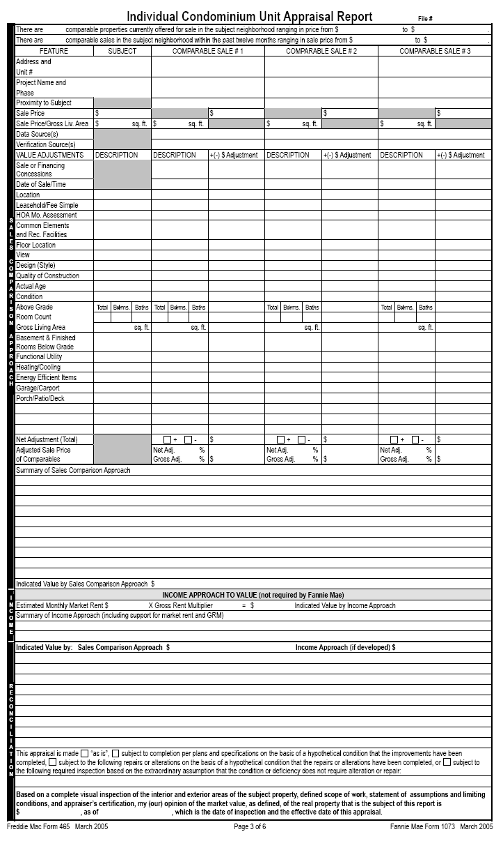

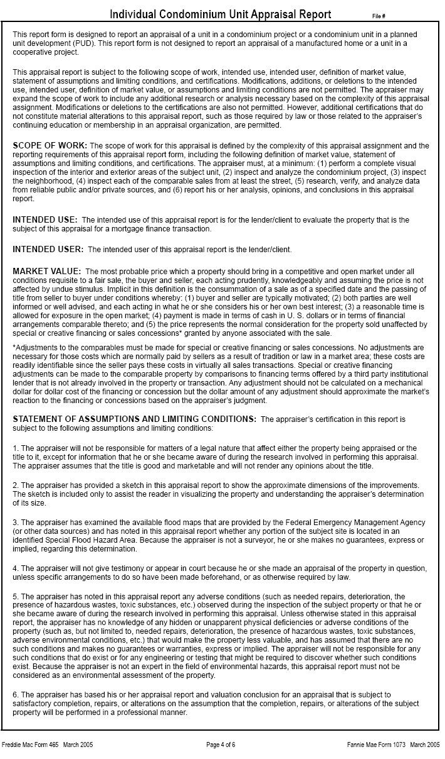
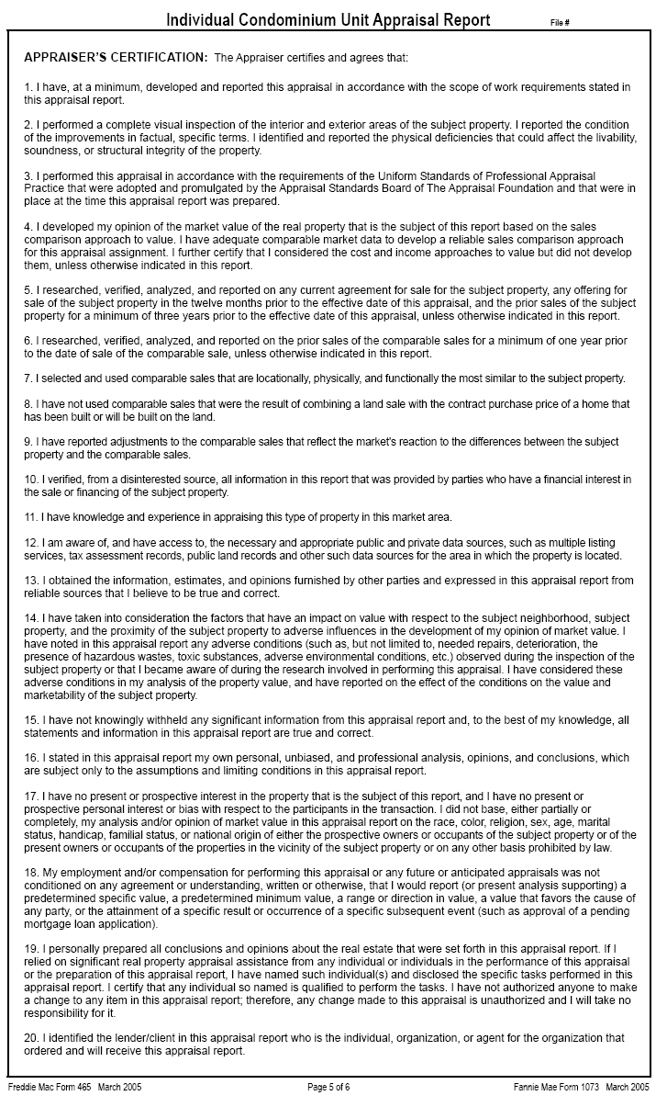

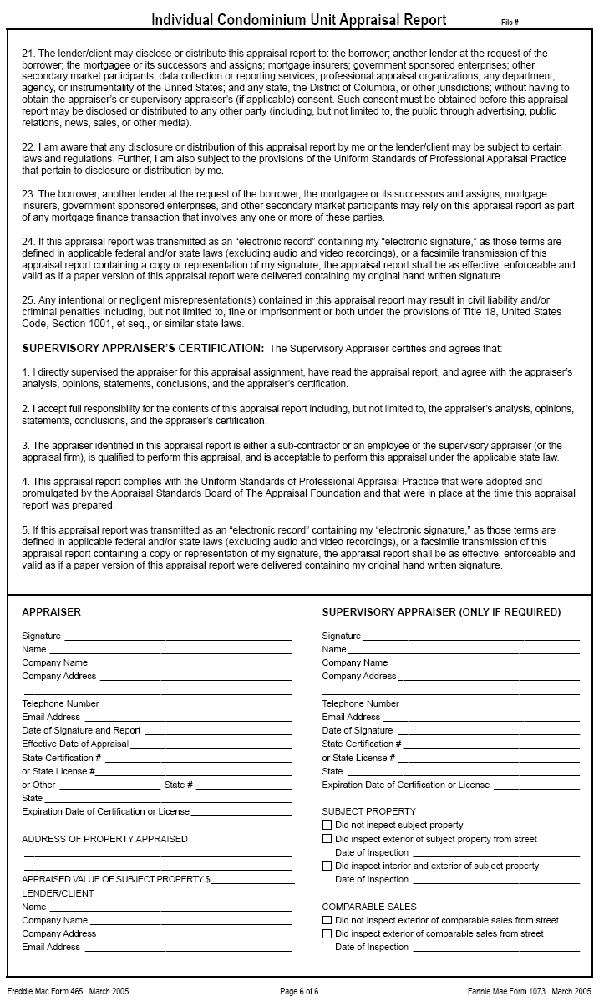

D-4 Small Residential Income Property Appraisal Report

This section provides specific instructions for completing the Small Residential Income Property Appraisal Report (Fannie Mae Form 1025 March 2005)

This report form is designed to report an appraisal of a two-four unit property, including a two-four unit property in a planned unit development (PUD), based on an interior and exterior inspection of the subject property. A two-four unit property located in a condominium project requires the appraiser to inspect the project and complete the project information section of the Individual Condominium Unit Appraisal Report. This form is not designed to report an appraisal of a manufactured home, therefore, where one or more of the units is a manufactured home, the appraiser is required to complete the following sections of the Manufactured Home Appraisal Report: HUD Data Plate and Improvements sections.

Section 1 - Subject

This section provides the factual data to identify the property and the parties to the appraisal process. The *FHA case number together with *borrower and/or *property information will be supplied by the lender/client who engages the appraiser.

Field | Protocol
*File Number | • Insert the FHA Case Number at the top right corner of the page.  - The FHA appraisal may not be transmitted to the lender without a case number.
*Property Address | • Enter the property street number and name, city, state and zip code for the property. A post office box number is not acceptable. Enter the nearest intersection if a house number is not available.
*Borrower | - Enter the name of the borrower/mortgagor.
Owner of Public Record | - Enter the name of the owner as listed in public records. If the seller is not the owner of public record the appraiser must explain.
County | - Enter the name of the county in which the property is located. It further provides locational parameters. If not applicable enter “N/A”.
Legal Description | • Enter the legal description of the property. The four types of legal descriptions are: lot and block system, geodetic survey, government survey system and metes and bounds system. If the space provided is insufficient, enter this information with the heading “Legal Description” in the “Additional Comments” section of the form report or attach this information as an addendum.
Assessor’s Parcel # | - Enter the parcel number assigned by the local tax assessor. For those areas that do not have an assessor’s parcel number, enter the tax identification number.
Tax Year | - Enter the current tax year used by the locale, e.g. fiscal year or actual year.
R. E. Taxes $ | - Enter the dollar amount of the annual real estate taxes, including all relevant taxes (school district tax, fire district tax, etc.).
Neighborhood Name | - Enter the name of the subdivision, if applicable, or the commonly known local neighborhood designation. If the subject property is in a planned unit development, provide the name of the development.
Map Reference | - Enter location map reference, page number and coordinates, from source used. This reference should relate to the location maps most commonly used in the locale.
Census Tract | - Enter the census tract number. The census tract number must be provided.  - The Census Bureau has an internet resource guide for locating census information. It can be found at URL: www.census.gov
Occupant | - Mark the box signifying the occupancy status at the time of the appraisal.  If vacant, the appraiser should note in the “Improvements” section under “condition of property” whether the utilities were on or off, for each of the units, at the time of the appraisal. If off, condition the appraisal on a satisfactory re-inspection that the utility that was off at the time of the appraisal does not require alteration, repair or further inspection.
Special Assessments $ | - Report the dollar amount of special assessments for the subject property, if any, and provide a brief explanation for the assessment. Special assessments can include municipal bond debt for off-site improvements. Larger than typical special assessments may affect marketability. If not applicable enter “N/A”.
PUD HOA$ | • Enter the dollar amount of the HOA fee and mark the box indicating if the fees are paid “per year” or “per month”.
Property Rights Appraised | • Mark the appropriate box indicating the property rights appraised for the subject property as of the date of the appraisal. “Other” includes Land Trust.
Assignment Type | - Mark the appropriate box indicating the assignment type.
Lender/Client  Address | • Enter the name of the lender/client who ordered and will receive the appraisal report. After the client’s name add “its successors or assigns”.  - The use of the appraisal is to support FHA’s decision to provide mortgage insurance on the real property that is the subject of the appraisal; therefore, intended users include the lender/client and FHA.  - Enter the lender/client’s address.
Currently offered for sale or offered for sale in last 12 months. | - The appraiser’s certification states in part “I have researched, verified, analyzed and reported on any current agreement of sale of the subject property, any offering for sale of the subject property in the twelve months prior to the effect date of the appraisal…”  - Mark the appropriate box indicating whether the subject is currently offered for sale or has been offered for sale in the 12-month period prior to the effective date of the appraisal. If there are multiple actions, report each instance. Research may reveal an expired or withdrawn listing. The prior listing may provide a good indication of the upper limit of value.
Report data source(s) used, offering price(s), and date(s) | - Complete this field regardless of whether the property is currently offered for sale or has been for sale in the 12 months preceding the date of the appraisal.  - Identify source(s) used, price(s) and date(s) of current or prior listings.

Section 2 - Contract

This section must be completed when the appraisal assignment involves a purchase transaction, otherwise enter “N/A” for not applicable. FHA requires that the appraiser be provided with a complete copy of the ratified sales contract, including all addenda, for the subject property.
It provides the agreed-on contract price (accepted offer), date of sale, and all financial terms implicit in the offer. If unable to obtain this information, the appraiser is to state what efforts were made to obtain it.
Field | Protocol
Analyze Contract for Sale | - Explain the results of the analysis (terms and conditions) of the contract of sale or why the analysis was not performed.  - The analysis may include a reference to the number of pages contained in the contract for sale provided.
Contract Price $ | • Enter the final agreed upon contract price.
Date of Contract | • Enter the date of the contract. This is the date when all parties have agreed to the terms of, and signed the contract.
Is The Property Seller The Owner of Public Record  Data Source(s) | • Mark the appropriate box indicating whether or not the seller is the owner of public record. The appraiser is instructed to contact the lender/client if the seller is someone other than the owner of record. The property may not be eligible for FHA financing if it involves flipping (resale in less than 90 days). The lender will make a determination for any exceptions to FHA’s Flipping Rule and advise the appraiser.  • Report where the information was obtained.
Sales Concessions Downpayment Assistance | - Mark the appropriate box indicating whether or not there is any financial assistance (loan charges, sales concessions, gift or down payment assistance, etc.) paid by any party on behalf of the borrower. If necessary, use the “Additional Comments” section of the appraisal reporting form or an addendum and enter the heading “Sales Concessions” completing the description.  - If yes, the appraiser is to report the total dollar amount and describe the items to be paid. If the sale involves personal property (e.g. above ground pool, lawn mower, furniture, etc.) is should be identified and excluded from the valuation.

Section 3 – Neighborhood

This section should reflect the area surrounding the subject property. The appraiser must observe neighborhood characteristics and surrounding properties to make determinations that will be incorporated into the valuation of the subject property. In all instances, the appraiser must mark the appropriate box for each line in neighborhood characteristics and housing trends. Failure to note conditions that may adversely affect the value of the property is poor appraisal practice and violates the Uniform Standards of Professional Appraisal Practice.

NOTE: Race and the racial composition of the neighborhood are not appraisal factors.
Neighborhood Characteristics
Field | Protocol
Location | • Enter the type of area surrounding the subject property.  Urban – relates to a city  Suburban – relates to an area adjacent to a city  Rural – relates to the country or beyond the suburban area
Built-up | • Enter the built-up percentage – the percentage of available land that has been improved. Land such as a state park would not be considered available land.
Neighborhood Characteristics
Field | Protocol
Growth | • Enter the growth rate. If many lots are available, the growth rate may be rapid, stable or slow, but if the neighborhood is fully developed, select the “stable” box.

Two-Four Unit Housing Trends
Field | Protocol
Property Values | • Mark the box describing the current trend in property values for Two-Four Unit single family homes in the community. If the subject property is the sole or one of only several 2-4 unit single family homes in the neighborhood or marketplace, indicate this scarcity under market conditions, identify the most predominate housing type in the neighborhood and address trends in value for that identified type. Comparing houses that have been sold and resold in recent years is an effective way to determine market trends. Appraisers who use this method, however, should make sure to factor in any improvements or changes made to the property between sales.
Demand/ Supply | • Mark the appropriate demand/supply trend. If the subject property is the sole or one of only several 2-4 unit single family homes in the neighborhood or marketplace, indicate this scarcity under market conditions, identify the most predominant housing type in the neighborhood and address trends in demand/supply for that identified type. To determine the equilibrium status of supply and demand in the neighborhood, compare the number of 2-4 unit properties sold to the number of 2-4 unit properties listed for sale in a recent time period. The similarity or difference between the numbers of houses sold and listed, not the absolute numbers, should determine the demand/supply level.
Marketing Time | • Mark the appropriate marketing time – the typical length of time a property similar to the subject property would have to stay on the market before being sold at a price near its market value.

Two-Four Unit Housing
Price Age | • Indicate the low and high neighborhood prices and ages as well as the predominant value and age. The high and low for both price and age should exclude the extreme.

Present Land Use %
One-Unit, 2-4 Unit, Multi-Family, Commercial, Other | • Estimate each type of land usage in the neighborhood. If there is no land in the neighborhood with one of the designated classifications, enter a “0”. If a portion of the land consists of parks or other unspecified classifications, enter the estimated percentages on the “Other” line and explain in the neighborhood description section.

Neighborhood Narrative
Neighborhood Boundaries |  | • The appraiser must clearly define the boundaries – north, south, east and west – of the subject’s neighborhood. Providing a description of neighborhood boundaries by physical features such as streets, rail lines, other man-made barriers or well defined natural barriers (i.e. rivers, lakes, etc.) details the make up and understanding regarding neighborhood composition.
Neighborhood Description |  | • Discuss factors that would attract investors or cause them to reject the neighborhood. Some typical factors important to discuss include:  - Vacancy / rent loss  - Level of maintenance and condition of homes  - Housing styles, ages, sizes, etc.  - Proximity to employment and amenities, including travel distance and time to local employment sources and community amenities  - Employment stability, in terms of variety of employment opportunities and industries  - Overall appeal of the neighborhood as compared to competitive neighborhoods in the same market  - Convenience to shopping with respect to distance, time and required means of transportation  - Convenience to schools in terms of the distance and time for travel to school
Market Conditions (including support for the above conclusions) | - Provide relevant information in support of conclusions relating to trends in property values, demand/supply and marketing time.  - Provide a description of the prevalence and impact of sales and financing concessions and/or down payment assistance in the subject’s market area.  - Other areas of discussion may include days on market, list to sale price ratios, and/or financing availability.

Section 4 – Site

This information provides the description of the land underlying the subject property. Insert factual information on each of the lines provided and report the conclusions as directed. Consider all aspects of the physical description and reconcile them in the opinion of market value. This section of the appraisal requires the appraiser to consider any adverse site conditions or adverse external factors that may impact value.

Field | • Protocol
Dimensions | • List all dimensions of the site beginning with the frontage. If the shape of the site is irregular, show the boundary dimensions (85' X 150' X 195' X 250') or attach a property survey or legal description of the site.
Area | • Enter the site area in square feet or acres. This entry must be consistent with the dimensions provided in the “Dimensions” field.
Shape | • Describe the shape of the site, e.g. triangular, square, rectangular, irregular, flag lot.
View | • Briefly describe the view from the property (None is not an acceptable response).  - Identify a view with a significant positive or negative influence on the value.  - Photographs are recommended for any negative or positive view influences affecting value or marketability.
Specific Zoning Classification | • Enter the specific zoning classification used by the local municipality or jurisdiction, e.g., R-3, R-5.  - If none exists enter “None Exists.”
Zoning Description | - Describe what the specific classification means. Include a general statement describing what the zoning permits. For example: R-3 = single family and two-family, up to 3 dwelling units per acre  - If “No Zoning” exists describe the prevalent use of sites in the neighborhood.
Zoning Compliance | • Determine whether the current use is in compliance with the zoning ordinances. Mark the box indicating whether it is a Legal, Legal Non-Conforming (Grandfathered Use), No Zoning, or an Illegal Use.  • If the existing property does not comply with all of the current zoning regulations (use, lot size, improvement size, off street parking, etc.) but is accepted by the local zoning authority, enter “Legal Non-Conforming” and provide a brief explanation.  - If the use is not legal, the property is not eligible for FHA mortgage insurance.
Highest and  Best Use | • Mark the appropriate box. This entry represents the highest and best use of the site, as improved, in relation to the neighborhood and current market conditions.  • If current use represents the highest and best use, mark "yes".  • If it does not, mark "no" and provide an explanation.
Utilities | • Mark either “Public” or "Other." If “Other" is marked, describe. Public utilities mean governmentally supplied and regulated. Public does not include any community systems sponsored, owned or operated by the developer or a private company not subject to government regulation or financial assistance.  • Note if there are mechanical chlorinators or water-flow that decreases noticeably while running simultaneous plumbing fixtures.  - Visually inspect the septic system and its surrounding area. If there are obvious or readily observable signs of system failure, “require inspection” to ensure that the system is in proper working order.  Note: The appraiser shall indicate whether a public water or sewage disposal system is available to the site. If available, connection must be made to public or community water/sewage disposal system if connection costs are reasonable. The lender will determine whether connection is feasible.
Off-site Improvements–Type | • Briefly describe the off-site improvements under "Type" and enter road surface material and mark Public or Private. For example: "Street-Asphalt; Public", “Alley-None”  • Public refers to an improvement dedicated to and accepted by a unit of government – not including Home Owner's Associations.
FEMA Special Flood Hazard Area | • FEMA (Federal Emergency Management Agency) is responsible for mapping flood hazard areas. If the property is within a Special Flood Hazard Area, mark "YES". Otherwise, mark “NO”.  • Attach a copy of the flood map panel for properties located within an identified flood hazard area.
FEMA Flood Zone | • Εnter the FEMA Zone designation. Only properties within Special Flood Hazard Areas, such as zones "A" a special flood hazard area and "V" a coastal area, require flood insurance. Zones "B" "C" and “X” do not.
FEMA Map # and FEMA Map Date | • Enter the FEMA Map number and map date. If it is not shown on any map, enter "Not Mapped."
Are utilities and off site improvements typical for the market area | - Mark the appropriate box indicating whether the utilities and off-site improvements are typical for the market area.  - If “No” is marked, explain why the utilities and/or off site improvement are not typical.
Any adverse site conditions or external factors | • Mark the appropriate box indicating whether there are any adverse site conditions or external factors (easements, encroachments, environmental conditions, land uses, etc.).  - If “No” is marked, no comment is necessary, if “Yes” is mark, an explanation is required.  - Describe any adverse site conditions or adverse factors. Consider easements affecting the functional utility of the property in the conclusions of both the highest and best use and market value. For example, discuss adverse easements, encroachments, slide areas, illegal or non-conforming zoning use, etc. Consider surface, sub-surface and overhead easements.  - List any adverse environmental conditions, including hazardous wastes, toxic substances and others.  - Explain all deficiencies that do not require repair (extreme slope, etc.) and consider them in the opinion of value.  • Discuss the observations with direct relationship to value and consider them in the approaches to value.

Section 5 – Improvements

This section describes the subject improvements. Accurately report the conditions observed. Describe needed repairs, or the existence of any functional or external obsolescence. Enter factual information on each of the lines provided and report the conclusions. Consider all aspects of the physical description and reconcile them in the opinion of market value.

General Description
Field | Protocol
Units | • Mark the appropriate box indicating number of units.
Accessory Unit | - A 2-4 unit dwelling with an accessory unit is ineligible for FHA financing.
# of Stories | • Enter the number of stories above grade, including half stories. Do not include the basement.
# of Buildings | - Enter number of buildings.
Type | • Mark the box that identifies the type of dwelling, "Det." (Detached), “Att.” (Attached), "S-Det.” (Semi-Detached) or “End Unit” (End unit of a group of rowhouses or townhouses).
Stage of Construction | • Mark the box signifying the stage of construction, Existing, Proposed or Under Construction. Properties that are either Proposed or Under Construction require plans and specifications for the appraiser to review.
Design (Style) | • Enter a brief description of the house design style using historical or contemporary fashion. For example: Cape Cod, bi-level, split level, split foyer, colonial, town house, rowhouse, etc. Do not use builder's model name. Avoid generic descriptions such as Traditional or Conventional.
Year Built | • If the property is less than one year old, include both the month and year completed.  • If it is over one year old, insert the year completed.
Effective Age (Yrs) | • Enter the effective age of the improvements. A range is acceptable. The effective age reflects the condition of the property relative to similar competitive properties. The effective age may be greater than, less than or equal to the actual age.  • Note any significant difference between the actual and effective ages and explain in the “condition of property” comments section.

Attic – Enter the attic and observe the interior roofing for insulation, deficient materials, leaks or readily observable evidence of significant water damage, structural problems, previous fire damage, FRT sheathing, exposed and frayed wiring and adequate ventilation by vent, fan or window. If any of these deficiencies exist, condition the appraisal on their repair and prepare the appraisal “subject to repairs” and/or “subject to inspection”.

The attic must be entered, at a minimum, by head and shoulders, whether access is by pull-down stairway or scuttle. Size of the scuttle and accessibility of the attic dictate the level of entry.
Field | Protocol
None | Enter ‘X” if there is no attic.
Drop Stair | Enter “X” if this item exists.
Stairs | Enter “X” if this item exists.
Floor | Enter “X” if this item exists.
Scuttle | Enter “X” if this item exists.
Finished | Enter “X” if this item exists.
Heated | Enter “X” if the attic is heated.

Foundation
The appraiser is required to inspect the foundation and basement. The appraiser must address all visible deficiencies and may require a recommendation for an inspection. Consider deferred maintenance and physical deterioration in the valuation process.

Basement
Generally, may be partially or completely below grade (ground level). Do not count the basement in the finished gross living area at the grade level. The information provided must be consistent with the description in the Foundation section. If basement is finished and has a grade walk out entrance, count square foot GBA.

Foundation
Field | Protocol
Concrete Slab | - Mark this box if any part of the foundation system has concrete slab.
Crawl Space | - Mark this box if any part of the foundation system has crawl space.  - Access to the space should be clear. Examine the crawl space for inadequate access (minimum entry of the head and shoulders).  - Check the distance from the bottom of floor joists to ground. Space should be adequate for maintenance and repair. A minimum distance of 18 inches from the ground to the bottom of the joists is highly recommended but not mandated.  - Check for insulation, and ventilation or for any structural problems. The support beams should be intact and of structural soundness.
Full Basement | - Mark this box if there is a full basement.
Partial Basement | - Mark this box if there is a partial basement.  - For a dirt basement floor, determine whether such a property is typical for the area and is readily marketable. If so, it is not required that a concrete basement floor be installed. Mechanical equipment, however, must be located on a concrete pad.
Basement Area Sq Ft | - Enter the square footage of the basement area using exterior dimensions.
Basement Finish % | - Enter the percentage of basement (figure above) that is finished.
Outside Entry/Exit | - Mark this box only if there is an outside entry/exit, otherwise leave blank.  - In there is an entry, make sure door is operable.
Sump Pump | • Mark this box only if there is a sump pump, otherwise leave blank.
Evidence of  Infestation | - Mark this box if there is evidence of infestation, including the house and/or other structures within the legal boundaries of the property, otherwise leave blank.  • Examine the subject property for readily observable evidence of wood boring insect.  - Do not require a pest inspection based solely on the age of a property. Inspections are necessary whenever there is evidence of decay, pest infestation, suspicious damage or when it is customary to the area or required by state law.
Evidence of Dampness | • Mark this box if there evidence of dampness, otherwise leave blank.  - Examine the foundation/basement for dampness or readily observable evidence of water damage. Signs of past water problems may include efflorescence, mold, mildew or stains on walls or mechanical equipment.  - Basement or crawl space area must not have excessive dampness or ponding of water.  - If any of these inadequacies exist, condition the appraisal “subject to repairs” to correct the condition, or “subject to inspection” to determine the source of problem and corrective measures necessary by a qualified party.
Evidence of Settlement | • Mark this box if there is evidence of settlement, otherwise leave blank.  • Examine foundation for readily observable evidence of settlement.  - Hairline step-cracks are common, however, horizontal cracks, bulging walls or separation of sill plate from top of foundation wall are critical and require inspection.

Mechanical Systems
An appraiser must examine the mechanical, plumbing and electrical systems of the subject property to ensure that they are in proper working order. This examination entails turning on the applicable systems and observing their performance. Electrical, plumbing and/or heating certifications may be called for by the appraiser when he/she cannot determine if one or all of these systems are working properly. An appraiser should not arbitrarily call for such certifications. However, the appraiser is still responsible for checking the functionality of these systems at the time of appraisal. Note the type of heating and cooling for each unit, if different.

Heating and Cooling Systems
Field | Protocol
Heating | • Enter an “X” in the box indicating the type of heating system: FWA (forced warm air), HWBB (hot water baseboard), Radiant or “Other”. If “Other” is marked, provide a brief description, e.g. EBB (for electric baseboard).  - Turn on the furnace/heating system to test functionality, weather permitting, and that no unusual noises are heard, no odors or smoke are emitted indicating a defective unit, etc. However, do not operate the systems if doing so may damage equipment or when outside temperatures will not allow system to operate.  - Note significant holes/deterioration on the unit.  - Turn on the hot water to ensure that the water heater is operating appropriately.
Fuel | • Enter type of fuel used: coal, gas, oil, propane, electric, etc.
Cooling | - Enter an “X” in the box indicating the type of cooling system: Central Air Conditioning, Individual or Other. If “Other” is marked, provide a brief description, e.g. permanently affixed fans, zoned air-conditioning, etc.

Heating and Cooling Systems
Field | Protocol
Cooling | - Turn on the air conditioning system to test functionality, weather permitting, and that no unusual noises are heard, no odors or smoke are emitted indicating a defective unit, etc. However, do not operate the systems if doing so may damage equipment or when outside temperatures will not allow system to operate.  - Note significant holes/deterioration on the unit

Exterior Materials/Condition

Enter the types of Materials and rate the observed Condition of the Materials (Good, Average, Fair, and Poor). Make every effort to describe accurately and explain in detail "Fair" and "Poor" ratings and whether or not the item(s) described require repair, replacement or further inspection. The rating must relate to the habitability of the house given local standards (Photo documentation of property condition is always advisable).

Exterior Description materials/condition
Field | Protocol
Foundation Walls | - Enter the material type: poured concrete, block, brick, stone, treated wood, etc. and rate the observed condition.
Exterior Walls | • Enter the material type: aluminum, vinyl or wood siding, brick veneer, stucco, stone, etc. If a combination of materials, show the predominant portion first and rate the observed condition.
Roof Surface | • Enter the material type: composition shingle, asphalt shingle, wood, slate, clay tile, aluminum, built-up, etc. and rate the observed condition.  - View the roof from ground level to determine if the integrity of the roof is sufficient.  - If the roof is otherwise unobservable, look for telltale signs of roof problems on the interior such as damage or water stains to ceiling area of a room or closet.  - Observe roof coverings, roof drainage systems, flashing, skylights, chimneys for readily observable evidence of leakage or abnormal condensation on building components.  - Note any evidence of deterioration of roofing materials (missing tiles, shingles,  flashing). Deteriorated roofing materials include those that are worn, cupped, or curled.  - The appraiser must note in the appraisal that he/she could not adequately observe the entire roof area (state which area(s) were unobservable). Based on the information reported by the appraiser, the underwriter will determine whether or not a roofing inspection is required.
Gutters and Downspouts | • Enter the material type: galvanized, aluminum, plastic, vinyl, PVC, etc. and rate the condition observed.

Exterior Description materials/condition
Field | Protocol
Window Type | • Enter window type: Double Hung, Single Hung, Casement, Sliders, etc. and identify the window frame material: wood, aluminum, steel, vinyl, etc. Rate the condition observed. Bedroom windows with security bars require a quick release mechanism for emergency egress. If not so equipped, condition the appraisal on a “required repair”.
Storm Sash / Insulated | • Describe storm sash material or state if windows are double glazed, etc. or a combination of the two. Rate the condition observed. If none, so state.
Screens | - Describe style (full, half, none) and rate the condition observed.

A brief description of an amenity may include its material type and/or size and/or dimensions.
Amenities
Field | Protocol
Fireplace(s) # | - Enter “X” if this amenity exists and provide a specific number.
Woodstove # | - Enter “X” if this amenity exists and provide a specific number.
Patio/Deck | - Enter “X” if this amenity exists. Describe material/type in additional features.
Fence | - Enter “X” if this amenity exists. Describe material/type in additional features.
Pool | - Enter “X” if this amenity exists. Describe in additional features. Specify whether in-ground or above-ground. Above-ground pools are considered personal property and are not to be included in the value.
Porch | - Enter “X” if this amenity exists. Describe material/type in additional features.
Other | - Enter “X” if this line is used to report another amenity or salient feature not listed above that has contributory value. Describe “Other” in additional features. Be sure to compare the subject and comparable sales in relation to that amenity or feature and make the appropriate adjustments.

Interior Materials/Condition

Enter the types of Materials and rate the observed Condition of the Materials (Good, Average, Fair, and Poor) and whether or not the item(s) described require repair, replacement or further inspection. Make every effort to describe accurately and explain in detail "Fair" and "Poor" ratings. The rating must relate to the habitability of the house given local standards (Photo documentation of property condition is always advisable). If the condition of materials varies significantly between the different units, address each unit separately. Use the Additional Comment section on page 4 if necessary.

Interior materials/condition
Field | Protocol
Floors | - Enter material type — tile, hardwood, carpet, etc. — and rate condition observed.
Walls | • Enter material type — plaster, drywall, paneled etc. — and rate condition observed.
Trim/Finish | • Enter material type — wood, metal, vinyl — and rate condition observed.

Interior materials/condition
Field | Protocol
Bath Floor | • Enter material type — ceramic tile, vinyl, carpet — and rate condition observed
Bath Wainscot | • Enter material type that protects walls from moisture — ceramic tile, fiberglass, etc. — and rate condition observed.

Car Storage
Field | Protocol
None | - If the property does not have a garage, carport or driveway, mark "NONE".
Driveway # of Cars | - If applicable, mark the box and enter the number of cars that can be parked. A single lane driveway is considered to be a one-car driveway. It would be considered a two car driveway if either car can be moved without disturbing the other.
Driveway Surface | - Enter surface type: concrete, gravel, macadam, etc., if none so state.
Garage # of Cars | - Enter the number of cars the structure can accommodate.
Carport # of Cars | - Enter the number of cars the structure can accommodate.
Garage/Carport Type | - If there is a garage, designate whether it is “Attached”, “Detached” or “Built-in” and Enter an “X” in the box(es) indicating the style “Att.”, “Det., “Built-in”

Appliances
Field | Protocol
Refrigerator | Enter the number of refrigerators, enter 0 if none.
Range/Oven | Enter the number of range/ovens, enter 0 if none.
Dishwasher | Enter the number of dishwashers, enter 0 if none.
Disposal | Enter the number of disposals, enter 0 if none.
Microwave | Enter the number of microwaves, enter 0 if none.
Washer/Dryer | Enter the number of washer/dryers, enter 0 if none.
Other | Enter “X” for any other appliances not listed above and describe. Do not include personalty. Enter “none” if applicable.

Gross Living Area
The gross living area is obtained by drawing an imaginary line on the outside perimeter walls of each unit (similar to the method used to measure a single family dwelling). Do not include attic or basement areas that may be assigned to a unit.

Gross Building Area
The gross building area is the total finished area (including common areas – hallways, interior stairways, etc.) of the improvements, above and below grade, based upon exterior measurements. Use same method for calculating GBA of comparable sales and rentals.

Room Count and Square Feet of Gross Living Area
Field | Protocol
To complete this section | - Enter, for each unit, the total number of rooms, the total number of bedrooms, and the total number of bathrooms.  - Enter the total square footage of the gross living area for each unit.  - If a unit is located in the basement but has a walk-out at grade entrance, included it in the gross building area.

Narrative Comments Section
The completion of this section is critical to the opinion of market value. The appraiser must discuss all adverse conditions and observed physical and functional deficiencies noted. If necessary, use the Additional Comments section of the form report, or an addendum, for additional discussion or description.

Field | Protocol
Additional Features | • Use this space to describe special energy efficient features such as solar energy or geothermal systems and/or to further describe the additional features,  • Please elaborate on any special or unusual aspects of items, e.g. gas fireplace or wood burning fireplace, in-ground pool, etc.
Condition of the property (including needed repairs, deterioration, renovations, remodeling, etc.) | • Describe any physical deterioration and/or functional or external depreciation noted at the property.  • Provide a conclusion as to the overall condition of the improvements that is supported by the previous descriptive sections.  - Describe needed repairs.
Physical deficiencies or adverse conditions | - Enter an “X “ in the applicable box indicating whether or not there are any physical deficiencies or adverse conditions that affect the livability, soundness, or structural integrity of the property. If the response is “No”, no explanation is required or needed. However, if the response is “Yes”, a full and detailed explanation is required and, if necessary, condition the appraisal on the “repair or alteration of the condition” or a “required inspection” by appropriately qualified individuals or entities, which may include professional engineers, tradespersons, HUD Fee Inspectors.  Lead-Based Paint Hazard  - If the home was built before 1978, this may indicate a lead paint hazard. For all FHA insured properties, correction is required to all defective paint in or on structures and/or property improvements built before January 1, 1978 in accordance with 24 CFR Part 35.  - Observe all interior and exterior surfaces, such as walls, stairs, deck porch, railing, windows or doors for defective (chipping, flaking or peeling) paint. (Exterior surfaces include surfaces on fences, detached garages, storage sheds and other outbuildings and appurtenant structures.). Note any areas affected (be specific) and condition the appraisal on their repair subject to the satisfaction of the condition.
Property conformity | - Enter an “X “ in the applicable box indicating whether or not the subject generally conforms to the neighborhood (functional utility, style, condition, use, construction, etc.). If the response is “Yes”, no explanation is required or needed. However, if the response is “No”, a full and detailed explanation is required.
Subject to Rent Control | - Enter an “X” in the applicable box indicating whether property is subject to rent control  - If yes, indicate ceilings on rent and any other pertinent controls.

Section 6 – Comparable Rental Data

The appraiser is required to report information on the subject and three comparable rental properties. Ideally, the properties used for comparable rentals will not be the same as those used in the Sales Comparison Analysis.

Enter factual data in each field or line.
The following properties represent the most current, similar, and proximate comparable rental properties to the subject property. The analysis is intended to support the opinion of market rent for the subject property.
Field | Protocol
Address | • Enter the address that can be used to locate each property. Enter community, if needed, to identify property. For rural properties, list location by road name, nearest intersection and side road.
Proximity to Subject | • Enter proximity in straight-line distance and direction. For example, "1.5 miles NE" or “3 blocks south”. If comparable distance from the subject is more than a generally accepted distance, or located outside the defined neighborhood boundaries, be sure to explain why the sale is applicable in the "Summary of Sales Comparison Approach" section.
Current Monthly Rent | • Enter current monthly rent for the subject and each of the comparable rentals.  .
Rent/Gross Bldg. Area | • Enter Rent/Gross Bldg Area for the subject and each of the comparable rentals.
Rent Control | - Enter an “X” in the applicable box indicating rent control or not
Data Source(s) | - Enter data source(s) used for sales and property information
Date of Lease(s) | - Enter the date of lease for each of the subject units as well as the comparable rentals.
Location | - Enter the neighborhood name that is commonly used to refer to the property’s location.  - Location adjustments may be warranted for positive or negative factors that influence market rent such as busy street versus a quiet street.  - Explain any adjustments made in this area.
Actual Age | - Enter only the actual age of the subject and each comparable rental.

Field | Protocol
Condition | - Enter the condition of the subject and comparable rental.  - Ratings to be used are: “New”, “Good”, “Average”, “Fair” and “Poor” or a combination if more accurate.  - Consider required repairs or alterations, to the subject, completed when determining the need for adjustments to the comparables rentals.
Gross Building Area | - Enter the total Gross Building Area for the subject and each comparable.
Unit Breakdown | - Enter total room count, number of bedrooms, number of baths and size for each unit in the subject.  - Enter total room count, number of bedrooms, number of baths, size in square feet, and the monthly rent for each unit in each of the three comparable rentals.  - Enter room count, total square footage and monthly rent for each of the comparable rentals.
Utilities included | - Indicate which utilities, if any, (electric, water, heat, etc.) are included in the rent for the subject and the comparable rentals.
Analysis of rental data and support for estimated market rents | - Provide analysis of rental data collected.  - Provide support for estimated market rents for the subject units.  - Discuss the adequacy of the comparable rentals.  - Address rental concessions if applicable.

Section 7 – Subject Rent Schedule

The appraiser is required to report information on the subject leases and provide an opinion of market rent.
Rent Schedule: The appraiser must reconcile the applicable indicated monthly market rents to provide an opinion of the market rent for each unit in the subject property.
Leases | - Provide the starting and termination dates of the leases for each unit of the subject.  - Provide comments on lease data, i.e. terms and conditions.
Actual Rent | - Enter the rent for each unit, unfurnished or furnished, and then the total rent.  - Enter the total actual monthly rent for all units  - Enter any other monthly income. Itemize this information in the comments section below.  - Enter the total actual monthly income.
Total Actual Rent
Other Income

Total Actual Income
Opinion of Market Rent | - Enter opinion of market rent for each unit, unfurnished and furnished, and then the total rent.  - Enter the total estimated market rent for all units.  - Enter any other monthly income. Itemize this information in the comments section below, e.g. coin operated washers and dryers, garage rented for storage, etc.  - Enter the total estimated monthly income.
Gross Monthly Rent
Other Income

Total Est. Income
Utilities included in estimated rents | - Enter an “X” in the box indicating the applicable utility items included in the rent.  - If the “other” box is marked, describe.
Comments on actual or estimated rents | - Provide comments on actual or estimated rents and other monthly income (including personal property) such as itemizing other monthly income; differences, or lack there of, between actual rent and market rent.

Section 8 – Prior Sale History

Field | - Protocol
Research sale or transfer history of subject & comps | - Enter an “X “ in the applicable box indicating whether you “did” or “did not” research the sale or transfer history of the subject property and comparable sales. If not, provide explanation.
Research prior sales or transfers of subject property | - Enter an “X “ in the applicable box indicating whether your research “did” or “did not” reveal any prior sales or transfers of the subject property for the three years prior to the effective date of this appraisal.
Data Source(s) | - Enter data source(s) used for sale and transfer information.  - Appraisers are to be familiar with the data source(s), e.g. how the data is gathered and how often it is updated
Research prior sales or transfers of comparable sales | - Enter an “X “ in the applicable box indicating whether your research “did” or “did not” reveal any prior sales of transfers of the comparable sales for the year prior to the date of sale of the comparable sale.
Data Source(s) | - Enter data source(s) used for sales and transfer information. Two sources are recommended for researching prior sales and transfers, local MLS and local public records at a minimum.  - Appraisers should be familiar with the data source(s), e.g. how the data is gathered and how often it is updated.

Report the results of the research and analysis of the prior sale or transfer history of the subject property and comparable sales (report additional prior sales in the “Additional Comments” section or an addendum).
Field | - Protocol
Date of Prior Sale/Transfer | - Report the date(s) of prior sale(s) or transfer(s) of the subject that occurred within three years of the effective date of the appraisal.  - Report the date(s) of prior sale(s) or transfer(s) of each comparable sale for the year prior to the date of the comparable sale.
Price or Prior Sale/Transfer | - Report the price of the prior sale(s) or transfer(s) of the subject that occurred within three years of the effective date of the appraisal.  - Report the price of the prior sale(s) or transfer(s) of each comparable for the year prior to the date of the comparable sale.
Data Source(s) | - Identify the data source(s) used.
Effective Date of Data Source(s) | - Enter the date the data was published or updated by the source for the subject and comparable sales. For example, the local MLS may update their database multiple times during the week or month whereas property transfers recorded at the local land records office may take six or eight weeks after settlement. The property transfer records may have an effective date that is eight weeks earlier than the appraisal date and the MLS data is within one week of the appraisal date.
Field | - Protocol
Analysis of prior sale or transfer history of subject and comparable sales | - Provide analysis of prior sale or transfer history of the subject and comparable sales.  - Analysis may address changes in property conditions between sale dates or verifying if prior sale was an arm’s-length transaction.

Section 9 – Sales Comparison Approach

The appraiser is required to report the number of comparable properties currently offered for sale, as of the effective date of the appraisal, and the number of comparable sales in the subject neighborhood, within 12 months of the effective date of the appraisal, in this section. Unlike the neighborhood price data, which includes all sales, this section focuses only on those properties that are comparable to the subject, not the universe of sales.

If there was difficulty in locating comparable properties, i.e. the subject is a four unit single family property and one or more of the comparable properties was a two or three unit single family property, etc., then for purposes of this section, all such properties in the subject’s neighborhood are to be treated as comparable and counted.

Field | Protocol
Comparable properties offered for sale | - Enter the number of comparable properties currently offered for sate, including those under contract, within the subject neighborhood together with price range
Comparable sales | - Enter the number of comparable sales that occurred within the 12 month period preceding the effective date of the appraisal, and within the subject neighborhood, together with the price range

Field | Protocol
Address | - Enter the address that can be used to locate each property. Enter community, if needed, to identify property. For rural properties, list location by road name, nearest intersection and side road.
Proximity to Subject | - Enter proximity in straight-line distance and direction. For example, “1.5 miles NE” or “3 blocks south”. If comparable distance from the subject is more than a generally accept distance, or located outside the defended neighborhood boundaries, be sure to explain why the sale is applicable in the “Summary of Sales Comparison Approach “ section.
Sale Price | - Enter the purchase (total paid) for the subject and each of the comparable sales. This means the closed or settled price of the comparable sale.  - If the appraisal involves a refinance of the subject, enter “Refi” as the subject’s sale price.
Sale Price/Gross Bldg. Area | - Enter price per square foot of the gross building area for the subject, if a purchase transaction, and each comparable sale.
Gross Monthly Rent | - Enter the Gross Monthly Rent for the subject property and each comparable sale.
Gross Rent Multiplier | - Enter the Gross Rent Multiplier for the subject property and each comparable sale.  A manual check on the software calculations is recommend to test for accuracy as the appraiser is responsible for data contained in the report (Sale price divided by gross monthly rent).
Price Per Unit | - Enter Price Per Unit for the subject property and each comparable.
Price Per Room | - Enter Price Per Room for the subject property and each comparable.
Price Per Bedroom | - Enter Price Per Bedroom for the subject property and each comparable.
Rent Control | - Enter an “X” in the box indicating whether or not there is Rent Control.
Data Source(s) | - Enter data source(s) used for sales and property information for each comparable.
Verification Source(s) | - Enter verification source(s), the document or party from which the additional proof was obtained. MLS by itself is not considered a verification source.  - Contacting someone with first-hand knowledge of the transaction (agent, broker, buyer, seller, etc) especially where it involves confirmation of seller concessions, is the preferred method of verification.  - A single source may be used if the quality of data is such that sales data are confirmed and verified by settled transactions. Information provided should permit the reader of the report to locate the data from the source cited.
Verification Source(s) | - Do not use as market data sales that are not verified and adjusted to reflect the terms and conditions of sale.

Value Adjustments
Adjustments are made to the price of the sale properties for price-influencing dissimilarities between each sale and the subject property. Not all dissimilarities require adjustment because not all dissimilarities achieve price differentials in the market. All adjustments must be extracted from and supported by the actions of the market.

For each adjustment item, enter the description of the adjustment and whether it is an upward or downward adjustment. Do not make an adjustment unless it has a material effect on value. Make adjustments only if the dissimilarity has a noticeable effect on the value. Small differences do not usually require adjustments.

VALUE ADJUSTMENTS
Field | Protocol
Sales or Financing Concessions | - Report the type of financing such as Conventional, FHA or VA, etc.  - Report the type and amount of sales concession for each comparable sale listed. If no concessions exist, the appraiser must note “none.”  - The appraiser is required to make market-based adjustments to the comparable sales for any sales or financing concessions that may have affected the sales price.  - The adjustment for such affected comparable sales must reflect the difference between the sales price with the sales concessions and what the property would have sold for without the concessions.
Date of Sale / Time | • State month and year of settlement. Showing the contract date and settled date is also acceptable.  - Time adjustments, if any, must be supported by the market and consistent with the neighborhood market conditions noted. If this is the case, show both the contract date and settled date as any time adjustment should be calculated using the contract date (meeting of the minds) rather than the settled date. Explanation is required for any time adjustments.
Location | - Enter the name of the subdivision or PUD. If none is applicable enter the neighborhood name that is commonly used to refer to the property’s location.  - Location adjustments may be warranted for positive or negative factors that influence sales price such as busy street versus quiet street.  - Explain any adjustments made in this area.
Leasehold / Fee Simple | • State whether the property was sold as Fee Simple or as a Leasehold Estate. An adjustment is required if the estate differs from the rights appraised for the subject property.
Site | • Enter the site size. Make adjustments only for measurable differences. Small differences in lot sizes do not usually call for an adjustment if the size is typical.  • If necessary, consider the possibility of excess or surplus land.
View | • Describe the view from the site, i.e. similar homes, commercial area, water view, scenic view, etc. Such terms as “Average” or “Good” are only to be used as adjuncts, i.e. “Residential/Average”, “Water view/Good”.  - Make adjustments only if the view is superior or inferior to the subject.  - If the subject has a superior view and adjustments are made, a photograph of the view amenity is recommended.
Design (Style) | • Enter the style according to a description used by local custom. Be consistent with improvement description.
Quality of Construction | • Enter "Good", "Average", "Fair", etc. using the quality rating from your cost service subscription or provider.  - Adjustments may be warranted for construction quality and should be explained.
Actual Age | • Enter only the actual age of the subject and each comparable sale.
Condition | • Enter the condition of the subject and comparable sales.  - Ratings to be used are: “New”, “Good”, “Average”, “Fair” and “Poor” or a combination if more accurate.  • Consider required repairs or alterations to the subject completed when determining the need for adjustments to the comparable sales.
Gross Building Area | • Enter the total Gross Building area for the subject and each comparable.
Unit Breakdown | - Enter room count per unit, consistent with the description of improvements on the front of the form.  - Enter room count for the units in each of the comparable sales and make adjustments where warranted.  - Explain adjustments in the Summary of Sales Comparison.
Basement Description | - Enter description of basement, total square footage of basement area and/or enter percentage of basement in relation to first floor area or enter full, partial, none.
Basement Finished Rooms | • Enter the type of rooms below grade: bedroom, recreation room, laundry, full bath, etc.  • Make sure any adjustment made here have not been duplicated in the GBA or elsewhere.
Functional Utility | • Enter "Equal", "Superior" or "Inferior" as a total of the items rated in the Improvement Analysis compared to the subject. Use the "Summary of Sales Comparison Approach” to explain differences.  • Adjust for functional obsolescence observed in the subject and not found in the comparables.
Heating / Cooling | • Enter type of heating and cooling systems, e. g. Gas FWA C/Air.  - Any adjustment for differences in heating and cooling systems should be based on market expectations.
Energy Efficient Items | • Describe energy efficient items: storm windows and doors, solar installations, replacement windows, etc. and enter an adjustment for differences if warranted. If none, so state.
Parking on/off Site | • Enter description of on/off site parting. Calculate adjustments in accordance with market acceptance of on/off site parting.
Porch, Patio, Deck | • Enter these features for the subject and comparable sales if they exist. Base any adjustments on local market expectations.
Blank Lines | • Τhree blank lines are provided for the appraiser’s use to describe additional amenities, features or individual characteristics not listed or addressed elsewhere in the sales grid, e.g. woodstove, fireplace, fencing, pool or other.  - Enter appropriate adjustments. For example, a pool located in an area that expects pools might bring a dollar premium in comparison to a comparable without a pool.
Net Adjusted (Total) | • Mark either [+] or [-] box to indicate if the total net adjustments will increase or decrease the value and note by how much. If any adjustment is excessive, review the comparable sales to determine if the best ones were selected. If the total adjustments appear excessive in relation to the sale price; the appraiser should reexamine the comparability of that sale.  • Explain any adjustment that appears to be excessive.
Adjusted Sale Price of Comparables | • Total all of the adjustments and add them to or subtract them from the sales price of each comparable. Generally, adjustments should not exceed 10% for line items, 15% for net adjustments and 25% for gross adjustments. If any adjustments exceed stated guidelines an explanation must be provided including reasons for not using more similar comparable sales.
Adjusted Price Per Unit | - Enter adjusted price per unit for each comparable sale (adjusted sale price divided by number of units).
Adjusted Price Per Room | - Enter adjusted price per room for each comparable sale (adjusted sale price divided by number of rooms).
Adjusted Price Per Bedroom | - Enter adjusted price per bedroom for each comparable sale (adjusted sale price divided by number of bedrooms).
Value Per Unit | - Enter adjusted price per unit and multiply by number of units = estimated value.
Value Per GBA | - Enter price per gross square foot of building area and multiply by gross square feet of building = estimated value
Value Per Room | - Enter adjusted price per room and multiply by number of rooms = estimated value.
Value Per Bedroom | - Enter adjusted price per bedroom and multiply by number of bedrooms = estimated value.
Summary of Sales Comparison Approach | - Explain comparable selection and any necessary explanation of adjustments.  - Explain any adjustments exceeding guidelines.  - The appraiser must reconcile the above value indicator(s) and comment which were given most consideration and why.
Indicated Value by Sales Comparison Approach | - Enter the indicated value by Sales Comparison Approach.

Section 10 – Income

Sale price divided by gross monthly rent = Gross Rent Multiplier

Gross Monthly Rent | - Enter the gross monthly rent developed in the Opinion of Market Rent.  - Multiply the gross monthly rent by the gross rent multiplier to arrive at the indicated value by the Income Approach.
Comments on Income Approach | - Provide comments on Income Approach including reconciliation of the GRM.  - Reconcile the multipliers developed in the sales comparison analysis  - Judge comparability and applicability of each  - Do not average, account for differences

Section 11 – Reconciliation

The appraiser should consider all appropriate approaches to value and all information relevant to the subject property and the market conditions in the opinion of market value.

If there is insufficient space in the reconciliation section to list and describe any “repairs, alterations or required inspections” noted, then the appraiser is instructed to insert a reference in the reconciliation section “see Additional Comments section on the next page” and then list and describe the items under the heading “Repairs, Alterations, Required Inspections”. If necessary, due to space limitations, use an addendum with the same heading.

Field | Protocol
Indicated Value by: | - Enter the Indicated Value for each of the approaches to value developed. If the approach was not developed, enter “ND or “Not Dev” for not developed.  - Reconcile the three approaches to value with a brief description of the validity of each approach with respect to the appraisal assignment.

This appraisal is made
Field Protocol
Mark this box  “as is” | when:  - There is/are no repair(s), alteration(s) or inspection condition(s) noted.  - Establishing the “as is” value for a regular 203(k) when needed.  - The property is ineligible for FHA financing and is being rejected.

This appraisal is made
Mark this box  “per plans & specs” | when the appraisal involves:  - Proposed construction, or  - Under construction, less than 90% complete, or a  - 203(k) with a Plan Review and Specification of Repairs prepared by a 203(k) Consultant.

This appraisal is made
Mark this box  “subject to repairs or alterations” | when the appraisal involves existing housing, or new construction more than 90% complete with only buyer preference items remaining (floor coverings, appliances, landscaping packages (soil must be stabilized to prevent erosion)), requiring repairs or alterations to:  - Protect the health and safety of the occupants  - Protect the security of the property  - Correct physical deficiencies or conditions affecting structural integrity  - Complete buyer preference items for new homes, or to  - Complete repairs/improvements noted in work order or contractor estimates for the Streamline K  - Meet FHA Minimum Property Requirements
The appraiser must indicate the extent of repairs and note this in the appropriate section of the appraisal, or in the “additional comments” section, or in an addendum, under the heading of “Reconciliation – Required Repairs” listing the repairs noted together with an estimated cost to cure.

This appraisal is made
Field Protocol
Mark this box  “subject to a required inspection” | when the appraisal calls for a required inspection to:  - Certify the condition and/or status of a mechanical or structural element of the property  - Protect the health and safety of the occupants  - Protect the security of the property  - Meet FHA Minimum Property Requirements or Minimum Property Standards
More than one box may be marked depending on the assignment and property conditions.

The appraiser must indicate the reasoning for any required inspections and note this in the appropriate section of the appraisal, or in the “additional comments” section, or in an addendum, under the heading of “Reconciliation – Required Inspection ” listing the required inspections.

Field Protocol
The value “subject to completion per plans and specifications”, “subject to the following repairs or alterations”, or “subject to the following required inspection” must be consistent with the subject property condition(s) described.
Opinion of Market Value | - Enter the opinion of Market Value
Final Reconciliation | • This entry should contain the appraiser's reasoning for arriving at the final value.
Date of Value | • Enter the date when the property was inspected.

Section 12– Additional Comments

These comment lines provide additional space for the appraiser to fully describe any item, area or condition where the commentary exceeds the space provided in other sections of the report. It is recommended that any information carried forward to the additional comments section, or an addendum if needed, follow the sequence of the form with a proper heading identifying said section.

For example, the neighborhood “market conditions” comments exceed the space provided on the form. In that case, on page one in neighborhood market conditions enter “See additional comments”, in the “additional comments” section enter the heading “Neighborhood Market Conditions” and provide the narrative in this section. Follow the same procedure for any section of the report where commentary exceeds space provided. This will provide the reader with the proper identification and linkage of additional comments together with a logical flow of information in a standardized reporting format.

Section 13 – Cost Approach

If the subject property is new construction (less than one year old), or the Cost Approach is recognized in the market as a basis for pricing, the appraiser may complete the Cost Approach; however, it is not required for an FHA appraisal. If, however, the subject is a unique property, has specialized improvements, is manufactured housing, or the client requests the Cost Approach be completed, then the Cost Approach is required and must be completed. The square foot method is to be used.

- State the Remaining Economic Life as a single number or as a range. This line must be completed for every FHA appraisal whether or not the cost approach is completed. An explanation is required if the remaining economic life is less than 30 years.

Cost Approach To Value
Provide adequate information for the lender/client to replicate the below cost figures and calculations.
Field | Protocol
Support for opinion of site value | - Provide a summary of the comparable land sales or other methods (abstraction, allocation, land residual, extraction) of estimating site value in support of the opinion of site value.
Reproduction or Replacement Cost | - Mark the box indicating which cost estimating method was used  - Reproduction Cost – exact duplicate with all deficiencies and obsolescence  - Replacement Cost – cost at current prices with equivalent utility.
Source of Cost Data | - Provide the name of the cost service and reference page numbers of cost tables or factors. Reviewer or reader must be able to replicate.
Provide adequate information for the lender/client to replicate the below cost figures and calculations.
Field | Protocol
Quality Rating | - Enter the quality rating of the cost tables or factors referenced.
Effective Date | - Enter the edition and date of latest updates referenced.
Comments | - Describe how physical depreciation was calculated  - Describe functional or external obsolescence,  - Gross living area calculations or refer to property sketch.
Economic Life | - Enter remaining economic life of improvements (required for all FHA appraisals).
Opinion of Site Value | - Enter the Opinion Of Site Value
Dwelling Sq. Ft. @ $ | - Enter the GLA, multiply it by the square foot factor – enter result.
Basement Sq. Ft. @ $ | - Enter basement square feet, multiply it by square foot factor – enter result.
Blank Line | - Use this line for lump sum adjustments for plumbing fixtures, dormers, fireplaces, built-in appliances, pools, etc. Add together – enter the sum.
Gar/Crprt Sq. Ft @ $ | - Enter the car storage square feet, multiply it by square foot factor – enter result.
Total Cost New | - Add the results of the first five lines together – enter the sum.
Less Depreciation | - Enter the amount of estimated depreciation as a specific dollar amount, as a percentage or as a combination of both. Entries made in either functional or external depreciation require explanation in the comments section. Add together all forms of depreciation – enter the sum and deduct this total from the total cost new.
Depreciated Cost | - Enter the difference from the total cost new less depreciation.
“As-is” Value of Site Improvements | - Enter the “as-is” value of site improvements
Blank Line | - Enter marketing costs here; generally averages 6%. Also, if applicable, identify and include impact fees.
Indicated Value | - Add together depreciated cost of improvements, “as-is” value of site improvements, marketing expense and/or impact fees – enter the total.

Section 14 – PUD Information

A PUD is a project that includes common property and improvements owned and maintained by an owners’ association for the use and benefit of the individual units in the subdivision. If not applicable, leave blank.

Project Information for PUDs (if applicable)
Field | Protocol
Developer/Builder in  control of HOA | • Enter an “X” in the box indicating whether or not the developer/builder is in control of the Home Owners’ Association (HOA).
Unit Type(s) | - Enter an “X” in the box indicating unit type, Detached or Attached.

Provide the following information for PUDs only if the developer is in control of the HOA and the subject property is an attached dwelling unit.

The information requested is self-explanatory. Appraisers may choose to answer the last question referencing common elements and recreational facilities in support of a location adjustment regardless of dwelling style.

Field | Protocol
Legal name of project
Total number of phases Total number of units Total number of units sold
Total units rented
Total units for sale
Data source(s) | - Provide source(s) of information, e.g. HOA board, management company, etc.
Was the project created by the conversion of an existing building(s) into a PUD? If Yes, date of conversion.
Does the project contain any multi-dwelling units? Yes No Data source(s)
Are the units, common elements, and recreation facilities complete? Yes No If no, describe the status of completion.
Describe common elements and recreational facilities.

