HUMAN RESOURCES
of the
FARM and Foreign Agricultural SERvices
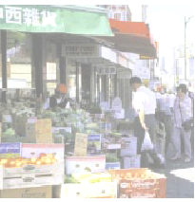


Human Capital PLAN
FY 2004 – FY 2009
(Revision 3 - NOV 04)
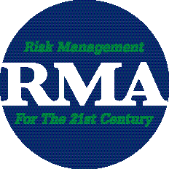




Table of Contents

- Message from the Human Resources Director

- “Our Job Is People” – Mission, Values and Vision

- The President’s Management Agenda

- USDA’s Mission, Strategic Goals and Objectives

- USDA Management Initiatives and Strategic Human Capital Plan

- The Missions and Strategic Goals of the Farm and Foreign Agricultural Services Mission Agencies (FSA, FAS, RMA) with HR Implications

- The supporting Strategic Goals and Strategies of FFAS Human Resources

- Agency Annual Performance Plans (Budget Performance), Program Performance Reports

Appendix

- Tools and Guides utilized in the development of the FFAS Human Capital Plan

- Human Resources Supporting Logic Model for the (FSA) Budget & Performance Management System

- USDA’s Workforce Restructuring Plan (FY 2003 – FY 2007) and COMPLETED supporting FFAS Initiatives

Message from the Human Resources Director

“Our Job Is People”. This is the key driver behind the Farm and Foreign Agricultural Services’ (FFAS) Human Capital Plan (HC Plan). The HR Teams in Washington and Kansas City are dedicated and determined to “help FFAS attract, motivate, develop, retain and reward its most valuable resource - employees.”

Our HC Plan incorporates the missions and goals of the USDA and those of the Farm and Foreign Agricultural Services’ mission areas, the Farm Service Agency (FSA), the Risk Management Agency (RMA) and the Foreign Agricultural Service (FAS). Our HC Plan also embraces the Government-wide Initiatives articulated in the President’s Management Agenda, especially the Strategic Management of Human Capital initiative.

Over the next five years, HR will continue to become increasingly involved with its customers, stakeholders and employees. We will be increasingly recognized as a valuable business partner to our clientele. In the Human Resources services role, we will implement new or improved programs and processes to ensure timely, efficient and state-of-the-art systems and services. We will ensure applicable policies, procedures and practices support the effective and efficient accomplishment of the Agencies’ mission; or we will change them.

In our Business Partner and Consultative role, we will provide the critical support and information essential to help our managers and employees make better and faster decisions; decisions that deal with the present and decisions that guide us into the future; decisions that ensure we accomplish the continual challenges of the mission areas.

This HC Plan aligns itself with the Human Capital Management criteria of OPM’s Human Capital Standards, OMB’s Standards for Success and GAO’s Model for Strategic Human Capital Management. As these documents strive for short and long-term results, so does FFAS Human Resources. The Strategic Goals and Objectives in the HC Plan are long reaching and resilient; yet, they provide the necessary vision to establish specific annualized results-driven plans, initiatives or projects. They will support the Agencies’ missions, strategic plans and annual performance plans by supporting workforce planning and deployment, by improving the acquisition and utilization of talent, by sustaining a learning environment and leadership continuity and improving the results-driven culture.

The HC Plan document is designed to be a working document, as well as a resource document for ready-access to vital statistics and information. It captures where HR has been and where it is going. It acts like a guide through the next five years and is entirely focused on effective and strategic Human Capital Management. Remember, “Our Job Is People.”

Patricia A. Farmer
Director, Human Resources

“Our Job Is People” – Mission, Values and Vision

The mission of Human Resources of the Farm and Foreign Agricultural Services is quite succinct, “OUR JOB IS PEOPLE. We help FFAS attract, motivate, develop, retain and reward its most valuable resource – employees.” We actively support the agencies in the mission area that are determined to ensure the well being of U.S. agriculture through delivery of commodity, credit, conservation, insurance, and export programs.

Located in Washington, D.C., the Human Resources Division (HRD) provides human resources services to FSA, FAS and RMA in the nation’s capital and partners with the Kansas City Personnel Department who provide HR services to the State and Field offices. Both areas provide HR services and consultation for over 17,000 federal and state employees in 50 states and over 80 countries. These services include:

- Foreign and Domestic Staffing and Operations
- Training & Development
- Performance Management, Benefits & Awards
- Employee and Labor relations
- Special Projects, Planning and Coordination

The main web site for the Human Resources Division in Washington, D.C. is:

FFAS Human Resources - Washington DC

Human Resources in Kansas City (KC HRD) provides services for federal and state employees located in FSA offices throughout the 50 States and Puerto Rico, including the Aerial Photography Field Office (APFO) employees in Salt Lake City, UT. KC HRD also provides HR services for FSA and RMA employees located in Kansas City and St. Louis, MO. The KC HRD web site is:

FFAS Human Resources - Kansas City

The Farm & Foreign Agricultural Services’ Human Resources Mission, Values and Vision acts to establish the parameters upon which Human Resources provides value to the agencies it serves. The HR Team-developed Mission, Values and Vision pictorial follows on the next page:

Human Resources Mission, Values and Vision

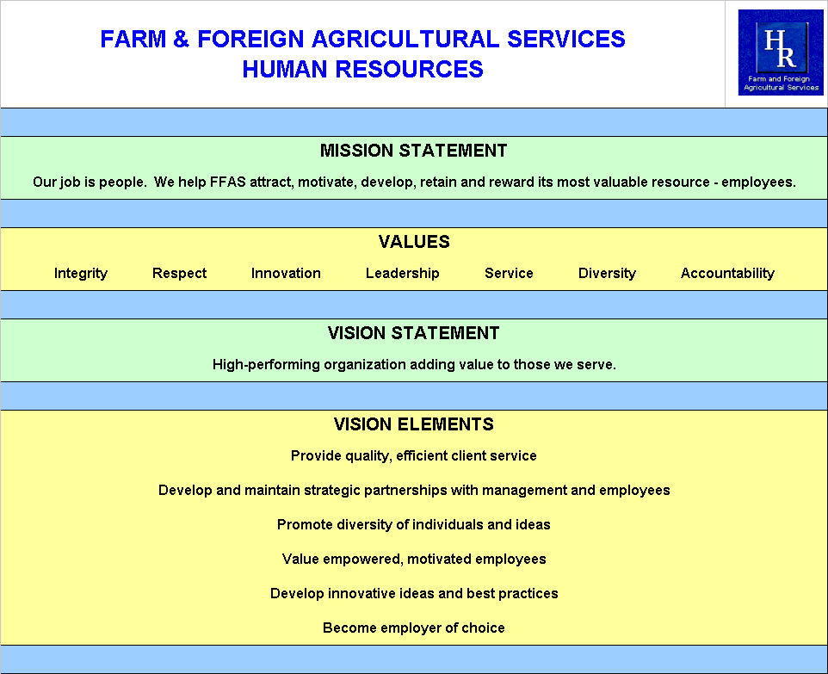

The President’s Management Agenda

A. The President's Management Agenda of FY 2002 has three visions for government reform. They are:

- Citizen-centered, not bureaucracy-centered;
- Results-oriented;
- Market-based, actively promoting rather than stifling innovation through competition.

- It also defines five government-wide goals or initiatives that set these visions into motion and defines the framework in which FFAS accomplishes its dominant missions. These initiatives directly influence the way Human Resources aligns itself to support the FFAS organization and its Agencies.

The Government-wide initiatives in the President’s Management Agenda are:

- Strategic Management of Human Capital
- Competitive Sourcing
- Improved Financial Performance
- Expanded Electronic Government
- Budget and Performance Integration

In February of 2004, a sixth initiative was implemented:

6. Federal Real Property Asset Management

- OMB's Standards For Success has been developed by the Office of Management & Budgets (OMB) to guide agencies in meeting these initiatives. A quarterly Executive Branch Management Scorecard tracks how well the departments and major agencies are executing the five government-wide management initiatives. FFAS Human Resources actively addresses the Strategic Management of Human Capital standard articulated in the Standard for Success to ensure Human Capital investments, activities and resources directly support agency accomplishment of organizational goals.

- OPM's Human Capital Standards focus leadership’s attention to one of the government’s core assets – people. Only through skilled and dedicated employees, can the various missions of the government’s branches meet the needs of the nation. FFAS Human Resources thoroughly applies the Office of Personnel Management (OPM) standards to ensure its short and long-term strategies and Human Capital Management Annual Performance Plans support agency accomplishment of organizational goals.

- Another vital source of credible information related to effective Human Capital Management and utilized by FFAS are the various and timely reports or testimonies produced by the General Accounting Office regarding Human Capital and the Performance and Accountability Series and High Risk Updates.

4. USDA’s Mission, Strategic Goals and Objectives

USDA STRATEGIC PLAN FY 2002 - 2007

USDA Mission: We provide leadership on food, agriculture, natural resources, and related issues based on sound public policy, the best available science, and efficient management.

STRATEGIC GOAL 1: ENHANCE ECONOMIC OPPORTUNITIES FOR AGRICULTURAL PRODUCERS

- Objective 1.1: Expand International Marketing Opportunities
- Objective 1.2: Support International Economic Development and Trade Capacity Building
- Objective 1.3: Expand Alternative Markets for Agricultural Products and Activities
- Objective 1.4: Provide Risk Management and Financial Tools to Farmers and Ranchers

STRATEGIC GOAL 2: SUPPORT INCREASED ECONOMIC OPPORTUNITIES AND IMPROVED QUALITY OF LIFE IN RURAL AMERICA

- Objective 2.1: Expand Economic Opportunities Through USDA Financing of
- Businesses
- Objective 2.2: Improve the Quality of Life Through USDA Financing of Quality Housing, Modern Utilities, and Needed Community Facilities

STRATEGIC GOAL 3: ENHANCE PROTECTION AND SAFETY OF THE NATION'S AGRICULTURE AND FOOD SUPPLY

- Objective 3.1: Reduce the Incidence of Foodborne Illnesses Related to Meat, Poultry, and Egg Products in the U.S.
- Objective 3.2: Reduce the Number and Severity of Agricultural Pest and Disease Outbreaks

STRATEGIC GOAL 4: IMPROVE THE NATION’S NUTRITION AND HEALTH

- Objective 4.1: Improve Access to Nutritious Food
- Objective 4.2: Promote Healthier Eating Habits and Lifestyles
- Objective 4.3: Improve Food Program Management and Customer Service

STRATEGIC GOAL 5: PROTECT AND ENHANCE THE NATION’S NATURAL RESOURCE BASE AND ENVIRONMENT

- Objective 5.1: Implement the President’s Healthy Forest Initiative and Other
Actions to Improve Management of Public Lands
- Objective 5.2: Improve Management of Private Lands

5. USDA Management Annual Performance Plans and Strategic Human Capital Plan

We are working to strengthen USDA’s management through vigorous execution of the President’s Management Agenda (PMA). Better management will result in more efficient program operations that offer improved customer service and more effective stewardship of taxpayer funds. We expect to:

- Ensure an efficient, high-performing, diverse, competitively sourced workforce, aligned with mission priorities and working cooperatively with USDA partners and the private sector.
- Enhance internal controls, data integrity, management information, and program and policy improvements as reflected by an unqualified audit opinion and a reduction of erroneous payments by USDA programs.
- Implement business processes and information technology needed to make our services available electronically.
- Link budget decisions and program priorities more closely with program performance, and recognize the full cost of programs.

Detailed plans are available for each of the PMAs. Here is a brief summary of USDA Human Capital Plans:

Improve Human Capital Management

The President has identified strategic management of human capital as a means to making government more citizen-centered and creating a high-performing workforce. We will manage our human capital according to a comprehensive plan that includes implementing Annual Performance Plans both within the agencies and from a corporate perspective. Our Human Capital Plan focuses on strategic workforce planning and maximizing employee performance. Because automation and process efficiency play a large role in achieving optimal performance of our employees, support systems for human resources, procurement, property management, and finance are critical for us to achieve our performance targets. Other human capital challenges include meeting the demand for cutting edge research talent, ensuring a responsive and effective workforce with technology, customer service and business skills, and supporting a broader scope of program responsibilities with the same or fewer staff.

In managing our human capital and in delivering our services to customers, USDA will continue to focus on ensuring civil rights and equal employment opportunity for everyone, regardless of race, color, national origin, gender, religion, age, sexual orientation, disability, marital or familial status, or any other factor. We are committed to continuous civil rights progress in the workplace, in program delivery, and in processing complaints in a timely and efficient manner.

USDA plans include:

- Linking human capital plans with business plans, and integrating the human capital impacts of Presidential initiatives such as competitive sourcing and e-Government.
- Using workforce planning and flexible tools to recruit, retain, and reward employees while developing a high-performing and accountable workforce.
- Ensuring employment opportunities for all members of the workforce, while implementing programs targeted at 1) critical occupations with projected skill gaps, and 2) underrepresented groups.
- Increasing the use of competitive sourcing.
- Ensuring timely resolution of program and employment civil rights complaints.

USDA Strategic Human Capital Plan

Goal 1. Strategic Workforce Planning and Alignment
USDA regularly assesses its current and future workforce requirements as a basis for human capital planning to assure strategic alignment with the USDA’s mission.

Goal 2. Learning and Leadership Development

USDA is committed to continual learning, knowledge transfer, and professional development to enhance the capabilities of our workforce.

Goal 3. Recruitment and Retention
USDA recruits, acquires, and retains a highly skilled, diverse workforce with the competencies needed to achieve its mission.

Goal 4. Performance Culture
USDA has a culture that is results-oriented, motivates employees to perform, and values diversity.

6. The Missions and Strategic Goals of the Farm and Foreign Agricultural Services Mission Agencies (FSA, FAS, RMA)

Farm Service Agency - FSA STRATEGIC PLAN (update in progress)

Mission: To equitably serve all farmers, ranchers, and agricultural partners through the delivery of effective, efficient agricultural programs for all Americans.

Farm Service Agency Goal 1: Promote Viable and Productive Farms and Ranches. (Supports USDA Strategic Goal 1: Enhance economic opportunities for agricultural producers.)

- Strategy 1: Improve Access to Capital
- Strategy 2: Mitigate Market Losses
- Strategy 3: Mitigate Losses from Natural Disasters
- Strategy 4: Expand Market Opportunities

Farm Service Agency Goal 2: Promote Secure and Affordable Food and Fiber Supply (Supports USDA Strategic Goal 1: Enhance economic opportunities for agricultural producers.)
- Strategy 1: Promote Domestic Agriculture
- Strategy 2: Provide Adequate and Secure Storage Capacity that Maintains Quality
- Strategy 3: Improve Purchase and Delivery of Food Aid

Farm Service Agency Goal 3: Conserve Natural Resources and Enhance the Environment (Supports USDA Strategic Goal 5: Protect and enhance the nation’s natural resource base and environment.)
- Strategy 1: Improve Conservation Practices on Farms and Ranches
- Strategy 2: Target Lands to Maximize Conservation Benefits
- Strategy 3: Mitigate Adverse Impacts from Agricultural Production

Human Capital Performance Goals cited in FSA Strategic Plan:
- Reduce cycle time to fill vacancies (on BPMS Scorecard)
- Reduce % of skills gaps in mission critical positions (on BPMS Scorecard)

Foreign Agricultural Service - FAS STRATEGIC PLAN (update in progress)

Mission: We serve U.S. agriculture’s international interests by working to expand international market opportunities for U.S. agricultural, fish, and forest products, and supporting international economic development and trade capacity building.

STRATEGIC GOAL I: EXPAND INTERNATIONAL MARKET OPPORTUNITIES FOR AGRICULTURAL, FISH, AND FOREST PRODUCTS (Supports USDA Strategic Goal 1: Enhance economic opportunities for agricultural producers.)

- Objective 1.1: Expand foreign market access for U.S. exporters of agricultural, fish, and forest products.
- Objective 1.2: Focus and expand foreign market development, promotion, and outreach activities to U.S. exporters and foreign buyers.
- Objective 1.3: Maintain foreign market intelligence services for U.S. agricultural interests.
- Objective 1.4: Focus financial assistance programs to meet evolving foreign market development needs.

STRATEGIC GOAL II: SUPPORT INTERNATIONAL ECONOMIC DEVELOPMENT AND TRADE CAPACITY BUILDING
- Objective 2.1: Organize and facilitate long-term market infrastructure development activities and projects that support economic development and trade capacity building.
- Objective 2.2: Administer foreign food aid and other assistance programs to meet international food security challenges and U.S. Government commitments.

STRATEGIC GOAL III: IMPLEMENT PRESIDENT’S MANAGEMENT AGENDA
- Objective 3.1: Ensure the development and implementation of human capital management in FAS.
- Objective 3.2: Improve financial management.
- Objective 3.3: Expand Electronic Government.
- Objective 3.4: Establish budget and performance integration

Human Capital Performance Goals cited in FAS Strategic Plan:
- Decrease number of critical occupations with significant skills gaps
- Meet workforce diversity goals

Risk Management Agency - RMA STRATEGIC PLAN (update in progress)

Mission: Promote, support, and regulate sound risk management solutions to strengthen and preserve the economic stability of American agricultural producers. (Supports USDA Strategic Goal 1: Enhance economic opportunities for agricultural producers.)

RMA STRATEGIC GOAL: Preserve and strengthen the economic stability of America’s agricultural producers by promoting and supporting the use of sound risk management tools among farmers and ranchers.

- Objective One: Increase the availability and effectiveness of risk management solutions.
- Objective Two: Improve and protect the soundness, safety, efficiency, and effectiveness of the risk management delivery system.
- Objective Three: Ensure that customers and stakeholders have knowledge and awareness of risk management tools and products to help strengthen the economic viability of farm and ranch production systems.
- Objective Four: Ensure effective oversight of the crop insurance industry and enhance deterrence and prosecution of fraud, waste, and abuse.
- Objective Five: Develop, acquire, and align activities, resources, and skills to efficiently achieve vision, mission, and strategic objectives.

Human Capital Performance Goals cited in RMA Strategic Plan:
- Reduce Mission Critical Occupations with skill gaps
- Increase the number of capable/leadership competency-trained SES employees
- Increase the percentage of SES, managers, and workforce with performance appraisal plans that link to the Agency mission, goal, and outcomes

7. The supporting Strategic Goals and Strategies of FFAS Human Resources

Mission: Our job is people. We help FFAS attract, motivate, develop, retain and reward its most valuable resource - employees.

HR STRATEGIC GOAL: Human Capital investments, activities and resources directly support agency accomplishment of organizational goals.

From the Strategic Management of Human Capital perspective, it is imperative to have the right employees with the right skills in the right place at the right time to effectively support agency accomplishment of programmatic goals.

Considering the projected retirement rate of the agencies’ skilled workforce (>33%) over the next five years, the resulting implications in providing effective and efficient programs and services to our citizens presents a major challenge - to ensure the competency and skills needs (or gaps) of mission critical occupations are effectively addressed through recruitment, development, diversity, retention, and related strategies
. With this in mind, our STRATEGIC GOAL is: Human Capital investments, activities and resources directly support agency accomplishment of organizational goals.

Accordingly, agency management will concentrate on effective workforce planning and organizational alignment, acquiring and developing staff whose size, skills, and deployment meet the agency’s needs, leadership continuity and succession planning, and creating a diverse, results-oriented culture.

By embracing the USDA Human Capital Plan and OPM’s Standards for Success in Human Capital, agency management and Human Resources will be able to systematically address its major human capital challenges and effectively utilize the available resources, investments and activities to support the agency’s long-term goals and objectives.

The intermediate strategies for Human Resources that will help meet the Human Capital Strategic Goal and those of the agencies are:

- Improve alignment of human capital initiatives to Agency mission and goals

- Support workforce planning & deployment
- Improve the Acquisition and Utilization of Talent

- Sustain the Learning Environment and increase Leadership Continuity

- Improve the Results-Driven Performance Culture

The systematic means to meet the intended outcomes of these strategies will include the development, implementation and maintenance of a rolling, 5-year workforce analysis and succession plan, updated annually. Assessed data from the workforce/succession plan will be used to identify mission critical occupations (including leadership positions), identify skill gaps, and project long-term recruitment / retention and training and development strategies, each with specific Annual Work Plans. Also, from this data and other agency-identified human capital needs, agency management and HR will identify annualized mission related Human Capital Management Annual Performance Plans (HCMAPP) intended to:

- Close identified skill needs (gaps) in Mission Critical Occupations
- Recruit the right people with the right skills at the right time
- Provide on-time training and development activities and tools
- Implement results-driven performance culture practices, policies or processes
- Provide high quality and efficient HR support and services to its customers

A rigorous quarterly progress review of the HCMAPP ensures the outcomes or results are progressing as planned and communicated to management and employees. Quarterly Reviews of the HCMAPP are available on the FFAS Intranet - FFAS Human Capital Management Annual Performance Plans.

An identical process for the out years, e.g., FY 2006, 2007, etc., will be conducted by the HR Team and coordinated with the Mission Areas’ Annual Performance Plan development and implementation schedule. This process is designed to maximize the HR alignment to the Agencies’ missions and to ensure HR’s integration with all the Government-wide initiatives of the President’s Management Agenda.

The specific HR Performance Goals and Indicators derived from each agency’s Strategic Plan are as follows:

FSA Performance Goals / Indicators* | FY 04 Baseline | FY 09 Target
Reduce cycle time to fill vacancies | 76 days | 65 days
Reduce skills gaps in mission critical occupations by: | 4.00% | 2.00%
* FSA Strategic Plan Scorecard items based on HR Logic Model (see Appendix B)

FAS Performance Goals & Indicators | FY 04 Baseline | FY 09 Target
Reduce mission critical occupations with skill gaps | 09 | 03
Meet workforce diversity goals (# of USDA-defined categories at or above overall employee profile) | 4 of 5 | 5 of 5

RMA Performance Goals & Indicators | FY 04 Baseline | FY 09 Target
Reduce Mission Critical Occupations with skill gaps | 07 | 02
Increase the number of capable/leadership competency-trained SES employees (# employees to each SES) | 1 to 1 | 3 to 1
Increase the percentage of SES, managers, and workforce with performance appraisal plans that link to the Agency mission, goal, and outcomes | 1% | 90%

8. Agency Annual Performance Plans (Budget Performance), Program Performance Reports

In support of the overall Strategic Plan for each Agency, Annual Performance Plans are developed and implemented. These plans define specific Strategic Goals, Outcomes, Performance Goals and Indicators for each Fiscal Year. Human Resources generally integrates its Human Capital Management strategies into the Agencies’ Annual Performance Plans.

FY 2003 Annual Performance Plans for the Mission Areas

- Farm Service Agency Annual Performance Plan

- Foreign Agricultural Service Annual Performance Plan

- Risk Management Agency Annual Performance Plan (future)

Annual Performance Plans for the Mission Areas will be added as they are completed and available.

The results of the Annual Performance Plans are prepared annually in the Agencies’ Annual Program Performance Reports where the results of the specific Human Capital Management Performance Plans are generally included. The Annual Program Performance reports are posted on the respective Agency web site.

- Farm Service Agency Annual Program Performance Report

- Foreign Agricultural Service Annual Program Performance Report

- Risk Management Agency Annual Program Performance Report (future)

Appendix A: Tools and Guides utilized in the preparation of the Human Resources Strategic Plan

USDA References

- The President’s Management Agenda
- USDA Strategic Plan
- USDA Human Capital Plan

OPM Tools and References

- OPM Human Capital Standards
- OPM HRM Accountability System Development Guide
- Guide to Senior Executive Qualifications
- OPM Workforce Planning Model
- Guide to Senior Executive Qualifications

OMB Tools and References

- OMB Standards for Success
- Executive Branch Management Scorecard
- The President’s Quality Award Program Criteria
- OMB Circular NO. A-11, Part 6 – Preparation and Submission of Strategic Plans, Annual Performance Plans, and Annual Program Performance Reports.
- OMB – PART (Program Assessment Rating Tool)
- OMB – Instructions for the Program Assessment Ratings Tools

GAO Tools and References

- GAO A Model of Strategic Human Capital Management
- GAO Human Capital – A Self-Assessment Checklist for Agency Leaders
- GAO High Risk Series – Strategic Human Capital Management

Human Resources Tools and References

- USDA/FFAS Workforce Planning & Succession Planning Guidance
- FFAS Workforce Planning Summary
- FFAS Recruitment Strategy and Agency Annual Recruitment Work Plans
- FFAS Training & Development Strategy and Agency Annual T&D Work Plans
- Human Resources Logic Model (Appendix B)
- FFAS Human Capital Management Annual Performance Plans

Appendix B: Human Resources Supporting Logic Model for the (FSA) Budget & Performance Management System
Note: The End Outcome Measures are an essential part of the FSA Strategic Plan - Scorecard

Appendix C USDA’s Workforce Restructuring Plan (FY 2003-2007), dated December 2001, and COMPLETED supporting FFAS Initiatives.

In addition to its five year Strategic Plan, USDA had also implemented a Workforce Restructuring Plan (FY2003-2007) in FY 2001 that directly supported the President’s first priority of Management Reform – to make the government citizen-centered. This is articulated within the President’s FY 2002 Budget Document.

The framework for USDA’s 5-Year Workforce Restructuring Plan identified specific organizational changes to:

- Reduce the number of managers, organizational layers and time it takes to make decisions
- Increase the span of control
- Redirect positions to ensure that the largest number of employees possible are in direct service delivery positions that interact with citizens
- Retrain and/or re-deploy employees as part of the restructuring efforts

USDA’s resulting major initiatives of the Workforce Restructuring Plan were:

- Create accountable organization to conduct and coordinate service center agencies’ modernization and restructuring plan.
- Office Consolidation
- Continue Modernizing Information Technology Infrastructure.
- Analyze Organization.
- Workforce Restructuring, Convergence, and Centralizing Services.
- Outsourcing

Teaming with the Human Resources offices of the Natural Resources Conservation Service (NRCS) and Rural Development (RD), HR (FSA) had completed an analysis of its Service Centers to support initiative, number 5 above.

That project was entitled Restructuring Administrative Functions; and it involved the following studies and initiatives completed or resolved in FY02, FY03 and FY04:

- Delegated Examining Unit - COMPLETED
- Benefits (Retirement Calculator) - COMPLETED
- Worker’s Compensation Administration - COMPLETED
- E-Learning – RESOLVED (under USDA initiative, e.g., AgLearn)
- Common T&A System - COMPLETED
- Automated Hiring System - COMPLETED

