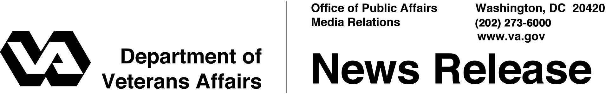

FOR IMMEDIATE RELEASE
November 9, 2007

VA Agrees to Buy Land for New National Cemetery
Veterans To Be Buried Near Historic Washington’s Crossing
WASHINGTON -- The Department of Veterans Affairs (VA) and Dolington Land LP, a subsidiary of real estate developer Toll Brothers Inc. and the owner of a 205-acre site in Bucks County, Pa., near Washington’s Crossing Historic Park, have signed an “offer to sell” agreement under which VA will purchase for $10.5 million the site for the construction of a new national cemetery.
“This is a key step forward in bringing a national shrine to veterans in southeastern Pennsylvania,” said VA’s Under Secretary for Memorial Affairs William F. Tuerk. “Building this cemetery is a priority for VA, and we are pleased to be moving forward with our plans.”
With this step taken, VA expects to complete the formal purchase of the property by March 2008. Once the purchase is finalized and the cemetery design is complete, initial construction will begin in mid 2008. Burials at the new national cemetery, which will serve more than 580,000 veterans and their families who live in the area, are expected to begin in late 2008. Indiantown Gap National Cemetery, the nearest open national cemetery in Pennsylvania, is 120 miles from the site of the new cemetery.
Veterans with a discharge other than dishonorable, their spouses and dependent children are eligible for burial in a national cemetery. Other burial benefits for eligible veterans include a burial flag, a Presidential Memorial Certificate and a government headstone or marker – even if they are not buried in a national cemetery.
In the midst of the largest cemetery expansion since the Civil War, VA operates 125 national cemeteries in 39 states and Puerto Rico, as well as 33 soldiers' lots and monument sites. More than 3.3 million Americans, including veterans of every war and conflict -- from the Revolutionary War to the current war in Iraq -- are buried in VA’s national cemeteries.

# # #

