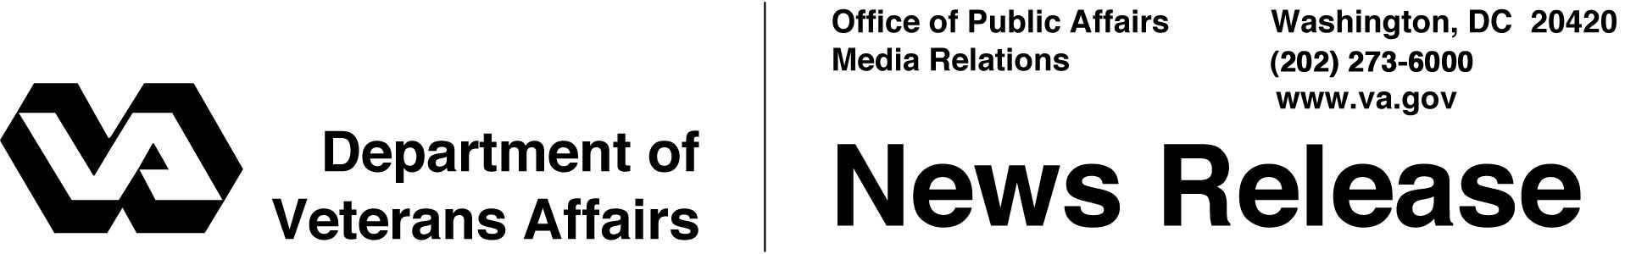

FOR IMMEDIATE RELEASE
May 7, 2004

VA Announces Changes for Wyoming Health Care Facilities
WASHINGTON – Maintaining the current mission of the Cheyenne VA Medical Center, studying the range of procedures performed there and contracting for some care are part of a comprehensive plan by the Department of Veterans Affairs (VA) to modernize its nationwide health care facilities.
"These changes will provide greater access to care for the veterans of Wyoming," said Secretary of Veterans Affairs Anthony J. Principi.
Nearly 23,000 of Wyoming's 57,000 veterans were treated last year in VA's health care facilities, up from about 17,200 in 2000. In 2003, VA spent $157 million in Wyoming, an increase from $119 million three years before.
Secretary Principi noted that about 80 percent of the health care provided by VA is outpatient care. He said the plan would allow the department to provide more of the outpatient care veterans want and use, while building upon VA's expertise in providing highly specialized inpatient care.
The changes are part of a comprehensive plan called CARES, short for "Capital Asset Realignment for Enhanced Services." The secretary's CARES report can be viewed in its entirety on VA's Web site at http://www.va.gov/CARES.
Briefly, the secretary's announcement included the following for Wyoming:
- Maintain current mission at the Cheyenne VA Medical Center;
- Study the range of procedures provided at small and rural facilities;
- Contract for care in Wyoming to improve access to hospital and tertiary care; and
- Increase use of telemedicine to provide mental health care and specialty services to veterans in Wyoming.

- More -
Wyoming CARES 2/2/2/2

CARES is a plan to modernize and improve VA's health care system. Among the elements of the Secretary’s CARES decision are more than 150 new community based outpatient clinics, potential creation of four new - and expansion of five existing - spinal cord injury centers, two new blind rehabilitation centers, and expansions throughout VA’s healthcare system that will enhance veterans’ access to VA care.
In July 1999, a General Accounting Office study found that VA was diverting a million dollars a day – or $3.6 billion during a decade – from veterans' health care to maintenance on unneeded or unused facilities. The average age of VA's more than 4,900 buildings is more than 50 years, and the need to reduce vacant space and unneeded buildings has been the focus of several reports by the General Accounting Office.
This approach to facility's management means the dollars once wasted on old and vacant buildings can be used to enhance services in the communities where health care is provided.
"CARES modernizes VA’s 74-year old health care system," said Principi. "I want to emphasize that no veteran will lose health care as a result of CARES, nor will there be any gaps in their health care services."
The CARES plan was reviewed by an independent commission, which received more than 212,000 comments and held 81 site visits to VA and Department of Defense medical facilities, and State Veterans Homes, 38 public hearings and 10 formal meetings. The commission submitted its recommendations to Secretary Principi in mid-February.

# # #

People wishing to receive e-mail from VA with the latest news releases and updated fact sheets can subscribe at the following Internet address:
http://www.va.gov/opa/pressrel/opalist_listserv.cfm

