

Representing the National Center for Environmental Prediction / Aviation Weather Center (NCEP/AWC) Graphical Area Forecast (GFA) Data in BUFR

Version 1.0

November 2005

Table of Contents

Document Identification Sheet
DOCUMENT DESCRIPTION

Document title: Representing AWC Graphical Area Forecast (GFA) Data in BUFR.

Document Reference Number | Issue : DRAFT 1.0
 | Date Of Issue : 9/2005
Abstract

This document provides guidelines for the correct depiction of AWC GFA data from BUFR code.

Keywords: GFA BUFR

Disk Reference/ File Name

Contact : C. Wallace  Aviation Weather Center  Kansas City, Missouri | Tel:  (816) 584-7248 | E-mail:  Clinton.Wallace@noaa.gov

Document Change Record
Issue | Date | Reason for Change | Section Pages Affected

- The BUFR Format

  - Introduction

BUFR stands for Binary Universal Form for the Representation of meteorological data. It is a standard developed by the World Meteorological Organization (WMO; see WMO Manual 306 Part B for technical specification, which can be procured via the WMO web site - http://www.wmo.ch/index-en.html) for the efficient storage of meteorological features in a machine independent form, where all the information to describe the features are contained within the data.

This document has been prepared by the Aviation Weather Center (AWC) for the purpose of providing guidance to software developers who have the task of constructing Graphical Area Forecast (GFA) BUFR visualization software. The document is designed to assist developers in the construction of compliant visualization software that receives its data input from text files obtained from BUFR decoding software supplied by the AWC

The AWC has produced this document with the intention of circulating it to all interested parties. If additional guidance or advice in regard to any of the items included in this document is required, then users, software manufacturers and State Authorities are invited to contact the AWC. A consultancy service is available to assist these users. Please contact Clinton Wallace for further information: - E-mail: Clinton.Wallace@noaa.gov Tel: (816) 584-7248.

  - Scope of Document

  - Concepts

To produce a BUFR file two elements are needed: 1) A file of raw data and 2) a set of tables containing descriptors. When the raw data is encoded each data value is attached to a descriptor which defines what that data represents. The decoding process reads the BUFR file, looks up the descriptor in the relevant table and writes out the information in whatever format is needed.

    - BUFR Tables

The binary BUFR files contain a set of tables’ descriptors and data values. To be able to understand what the values represent the descriptors need to be decoded from a set of common tables that sit on the local machine. This format means that the BUFR messages are very small and are machine independent. They can be understood and decoded by any BUFR decoder which has the latest tables available.

    - Representation

Data held in the BUFR format is completely independent of the way in which the data is depicted on GFA charts. Only the information that describes the feature is encoded. For example, an area of aircraft icing is a list of points with the height of the base and top. There is nothing in the BUFR bulletin about how the icing area should be drawn, or how the attributes are to be displayed. This depiction is arbitrary, and is determined by the graphical display program. This document has been produced to assist in this regard. It is recommended that the overall aim of BUFR visualization, as stated in section 1.1, should be carefully considered.

    - Standards

Although no information is given in BUFR on how to visually represent the data, rules have been laid down by the International Civil Aviation Organization (ICAO) and WMO. The ICAO requirements are laid out in Annex 3, Meteorological Service for International Air Navigation in the International Standards and Recommended Practices document. WMO Manual 306 Part B should be the standard used for the BUFR code itself.

    - Open and Closed Areas

The boundaries of areas of some of the GFA elements are described as being either “open” or “closed”. Closed areas are defined as regions that have identical first and last coordinates. Open areas have different start and end coordinates. Both open and closed areas are used in the GFA.

    - Unit Conversions

    - WMO Message Header Ids

- Header Representation

A BUFR message will always be packaged between the characters ‘BUFR’ and ‘7777’. Before the data representing the features appears, a header is always found that details where the message has come from, the date and valid times, regional information, and ICAO information.

  - Message Header for Graphical AIRMET (Tango, Sierra, and Zulu)
  - Message Header for Graphical Area Forecast

- Features Represented

  - Graphical AIRMET Sierra

Graphical AIRMET Sierra consists of the following phenomena:

- IFR Ceiling
- IFR Visibility
- Mountain Obscuration

  - Graphical AIRMET Tango

Graphical AIRMET Tango consists of the following phenomena:

- Moderate Turbulence
- Sustained Strong Surface Winds (> 30 knots)
- Low Level Wind Shear

  - Graphical AIRMET Zulu

Graphical AIRMET Zulu consists of the following phenomena:

- Moderate Icing
- Freezing Levels
- Multiple Freezing Levels

  - Other Graphical Area Forecast Elements

The GFA consists of all of the above phenomena in addition to:

- Thunderstorms
- Mountain Wave Turbulence
- Pressure Centers and Fronts
- Tropical Storms
- Precipitation
- Volcanic Eruption
- MVFR Visibility
- Towering Cumulus Clouds
- Clouds

- Graphical AIRMET Sierra

  - IFR Ceiling Representation

IFR CIG is represented on a G-AIRMET Sierra chart as an area drawn with a line. IFR CIG will depict areas of cloud ceilings with bases less than 1000 feet above ground level (AGL). The appropriate text label is located at the center of the hazard area polygon. There is no symbol associated with areas of IFR CIG.

    - BUFR Sequence

Table 1 shows the BUFR sequence for IFR CIG. In BUFR, how the data is depicted is not specified. Only the points describing the area and the attributes associated with that area are held.

 |  | GFA IFR CIG and Visibility
3 16 054 | 1 12 000 | Replicate 12 descriptors (Number of replications = Number of areas of IFR CIG)
 | 0 31 001 | Replication count
 | 0 08 007 | Dimensional significance, 2=Area
 | 0 20 006 | Flight rules, 1=IFR
 | 2 04 001 | Add associated field
 | 0 31 021 | Associated field significance, 21: 0=original value, 1=substituted/corrected value
 | 3 01 027 | Description of feature
 | 0 20 008 | Cloud distribution for aviation, 3=Broken, 4=Overcast
 | 0 20 014 | Height of top of cloud
 | 0 20 001 | Horizontal visibility (m)
 | 0 03 042 | Description of feature, 1=ABV/AOA, 3=BLW/AOB,  7=Missing
 | 2 04 000 | Add associated field, Cancel
 | 0 08 007 | Dimensional significance, Missing=Cancel
Table 1: G-AIRMET Sierra IFR CIG BUFR Sequence

    - Feature Header

IFR CIG Type of feature
1 Number of areas of IFR CIG in the list

    - Feature Data

1st row = heights of CIG base and top in meters, 2nd row =
number of points in area. These are followed by two columns containing latitude and longitude data. The numbers in the last row indicate the flight rules (1=IFR) and the cloud distribution for aviation (3=BROKEN, 4=OVERCAST)).

  - IFR Visibility Representation

IFR visibility is represented on a G-AIRMET Sierra chart as an area drawn with a line. IFR visibility will depict areas where the prevailing visibility is less than 3 statute miles. The appropriate text label is located at the center of the hazard area polygon. There is no symbol associated with areas of IFR visibility
.
    - BUFR Sequence

BUFR sequence for IFR VIS is shown in Table 1. In BUFR, how the data is depicted is not specified. Only the points describing the area and the attributes associated with that area are held.

    - Feature Header

IFR VIS Type of feature
1 Number of areas of IFR VIS in the list

    - Feature Data

  - Mountain Obscuration Representation

Mountain obscuration is represented on a G-AIRMET Sierra chart as a single line. The appropriate label for mountain obscuration (Figure 1) is located at the center of the hazard area polygon.

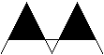
Figure 1: Mountain obscuration label

    - BUFR Sequence

Table 3 shows the BUFR sequence for mountain obscuration. In BUFR, how the data is depicted is not specified. Only the points describing the line and the attributes associated with that line are held.

 |  | GFA Mountain Obscuration
3 16 055 | 1 08 000 | Replicate 8 descriptors (Number of replications = Number of areas of mountain obscuration)
 | 0 31 001 | Replication count
 | 0 08 007 | Dimensional significance, 2=Area
 | 0 20 025 | Obscuration, 14=Mountain
 | 2 04 001 | Add associated field
 | 0 31 021 | Associated field significance, 21: 0=original value, 1=substituted/corrected value
 | 3 01 027 | Description of feature
 | 0 08 011 | Meteorological feature, 12=Cloud, 63=Missing
 | 2 04 000 | Add associated field, Cancel
 | 0 08 007 | Dimensional significance Missing=Cancel
Table 2: G-AIRMET Sierra Mountain Obscuration BUFR Sequence

    - Feature Header

MT OBSC Type of feature
1 Number of lines of mountain obscuration in the list

    - Feature Data

1st row = number of points on the line. These are followed by two columns containing latitude and longitude data. A single number in the last row indicates the type of obscuration (14=MOUNTAIN).

- Graphical AIRMET Tango

  - Moderate Turbulence Representation

Moderate turbulence is represented on a G-AIRMET Tango chart as an area drawn with a line. The appropriate intensity label is located at the center of the hazard area polygon. The base and top of the turbulence layer (100’s feet AMSL or FL) will be included in the drawn area

Please note that open and closed boundaries are used for encoding turbulence information – see section 1.3.4.

    - BUFR Sequence

Table 4 shows the BUFR sequence for turbulence. In BUFR, how the data is depicted is not specified. Only the points describing the area and the attributes associated with that area are held.

 |  | GFA Turbulence
3 16 056 | 1 09 000 | Replicate 9 descriptors (Number of replications = Number of areas of CAT and/or mountain wave turbulence)
 | 0 31 001 | Replication count
 | 0 08 007 | Dimensional significance, 3=Volume
 | 2 04 001 | Add associated field
 | 0 31 021 | Associated field significance, 21: 0=original value, 1=substituted/corrected value
 | 3 01 027 | Description of feature
 | 0 08 011 | Meteorological feature, 13=Turbulence, 23=Mountain wave
 | 0 11 031 | Degree of turbulence, 6=Moderate, 7=Severe
 | 0 08 011 | Meteorological feature, Missing=Cancel
 | 2 04 000 | Add associated field, Cancel
 | 0 08 007 | Dimensional significance, Missing=Cancel
Table 3: G-AIRMET Tango Moderate Turbulence BUFR Sequence

    - Feature Header

Contains the type of data to follow and the number of features in the list.

TURB Type of feature
2 Number of turbulence areas in the list

    - From Line and Example

60E BIS TO 60SE DLH TO 50WNW PXV TO 50E HLC TO 50SW RAP TO 60E BIS

20SW END TO 50SSW ARG TO 50SW VUZ TO 30ENE BTR TO 50SSE AUS TO 50WSW ABI TO 20SW END

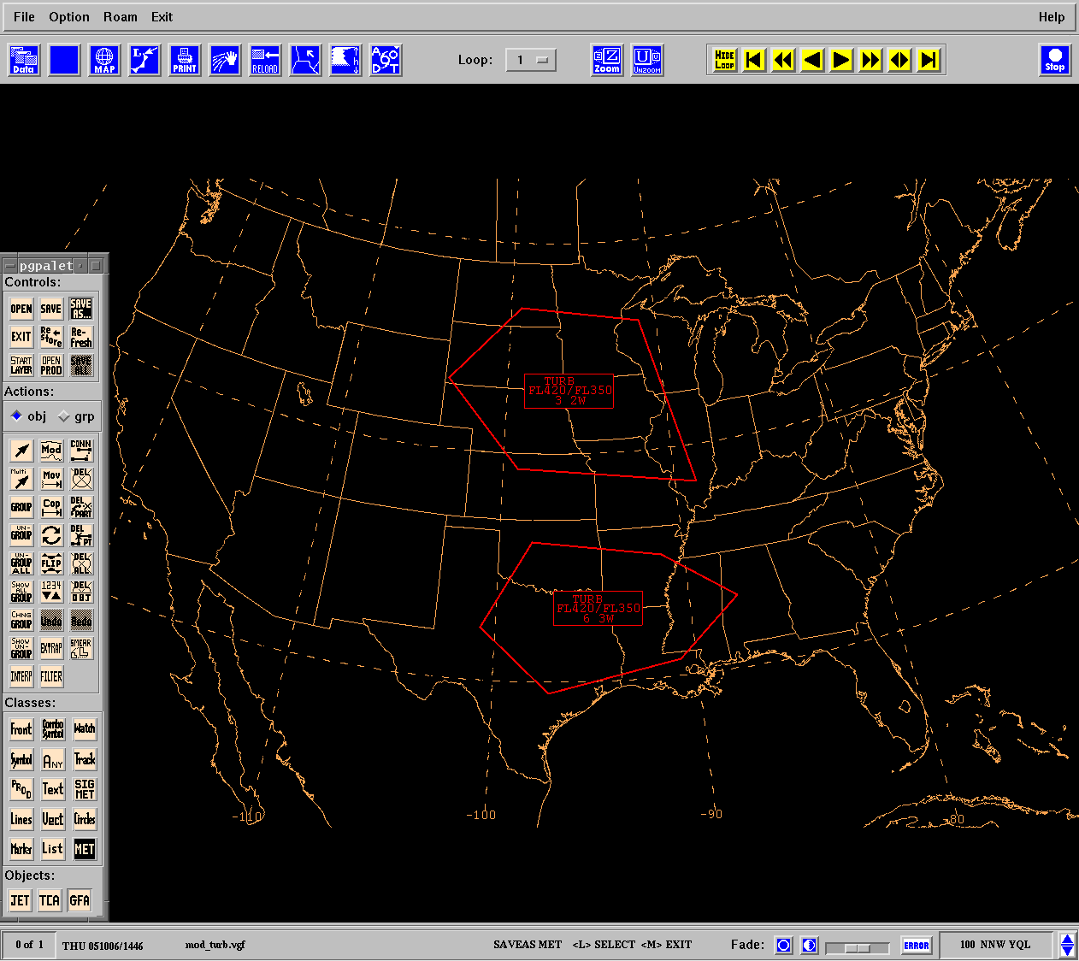

    - Feature Data

1st row = heights of moderate turbulence base and top in meters, 2nd row = number of points in area. These are followed by two columns containing latitude and longitude data. The numbers in the last row indicate the meteorological feature (13=TURBULENCE) and the degree of turbulence (6=MODERATE).

  - Sustained Strong Surface Winds Representation

Areas where the sustained surface winds are in excess of 30 knots specified at 10 meters above the ground are represented on a G-AIRMET Tango chart as an area drawn with a line. The appropriate speed in knots will be delineated on a label located in the center of the hazard area polygon.

Please note that open and closed boundaries are used for encoding turbulence information – see section 1.3.4.

    - BUFR Sequence

Table 5 shows the BUFR sequence for sustained strong surface winds. In BUFR, how the data is depicted is not specified. Only the points describing the area and the attributes associated with that area are held.

 |  | GFA Strong Surface Winds
3 16 057 | 1 09 000 | Replicate 9 descriptors (Number of replications = Number of areas of surface wind speed)
 | 0 31 001 | Replication count
 | 0 08 007 | Dimensional significance, 2=Area
 | 2 04 001 | Add associated field
 | 0 31 021 | Associated field significance, 21: 0=original value, 1=substituted/corrected value
 | 1 01 000 | Replicate 1descriptor
 | 0 31 001 | Replication count
 | 3 01 023 | Latitude, longitude
 | 0 11 012 | Wind speed at 10 m
 | 2 04 000 | Add associated field, Cancel
 | 0 08 007 | Dimensional significance, Missing=Cancel
Table 4: G-AIRMET Tango Sustained Strong Surface
Winds BUFR Sequence

    - Feature Header

Contains the type of data to follow and the number of features in the list.

SFCWIND Type of feature
1 Number of areas of sustained strong surface winds in the list

    - From Line and Example

30N YOW TO 30E MPV TO 30ESE ALB TO 30NNE HTO TO 30WNW HAR TO 40S JHW TO 20WNW BUF TO 50SSW YOW TO 30N YOW

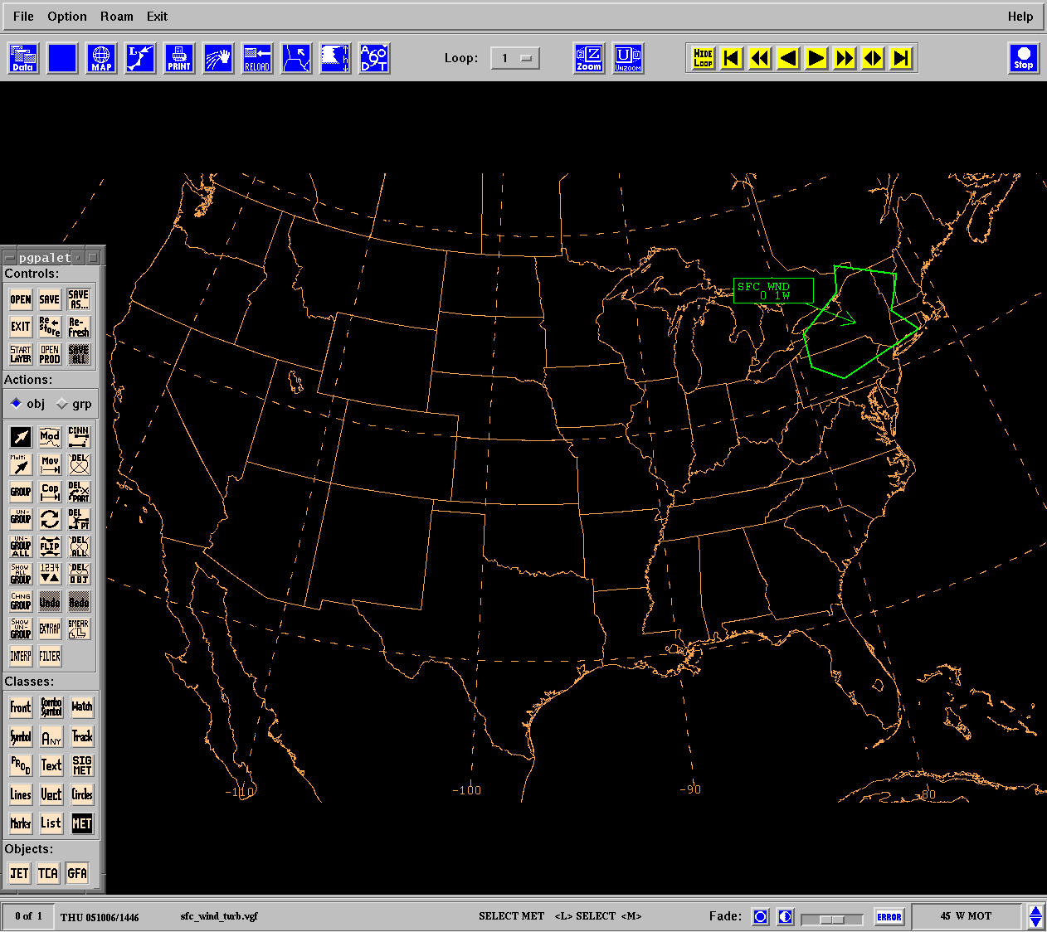

    - Feature Data

1st row = number of points in area. These are followed by two columns containing latitude and longitude data. A single number in the last row indicates the wind speed in knots at 10 meters.

  - Low Level Wind Shear Representation

Areas of wind shear, other than that which is convectively induced, that exceed 10 knots per 100 feet below 2000 feet AGL are represented on a G-AIRMET Tango chart as an area. A text box with ‘LLWS’ inside it is associated with the area.

    - BUFR Sequence

Table 6 shows the BUFR sequence for low level wind shear. In BUFR, how the data is depicted is not specified. Only the points describing the line and the attributes associated with that line are held.

 |  | GFA Low Level Wind Shear
3 16 058 | 1 08 000 | Replicate 8 descriptors (Number of replications = Number of areas of low level wind shear)
 | 0 31 001 | Replication count
 | 0 08 007 | Dimensional significance, 2=Area
 | 2 04 001 | Add associated field
 | 0 31 021 | Associated field significance, 21: 0=original value, 1=substituted/corrected value
 | 1 01 000 | Replicate 1descriptor
 | 0 31 001 | Replication count
 | 3 01 023 | Latitude, longitude
 | 0 07 007 | Height (m)
 | 0 11 063 | Wind shear
 | 2 04 000 | Add associated field, Cancel
 | 0 08 007 | Dimensional significance, Missing=Cancel
Table 5: G-AIRMET Tango Low Level Wind Shear BUFR Sequence

    - Feature Header

LLWS Type of feature
1 Number of areas of low level wind shear

    - From Line and Example

30WSW MOT TO 20SW BJI TO 30NNW FOD TO 30SE ANW TO 60NNW
RAP TO 30WSW MOT

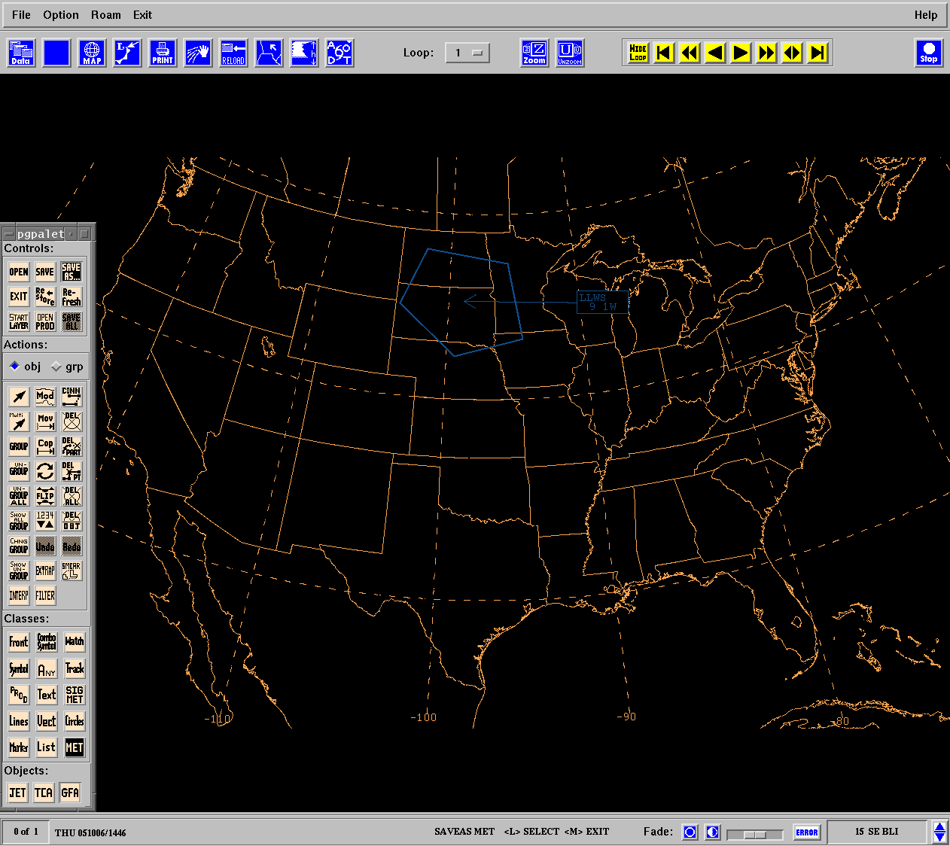

    - Feature Data

1st row = number of points on the line. These are followed by two columns containing latitude and longitude data. The numbers in the last row indicate height in meters and the wind shear.

- Graphical AIRMET Zulu

  - Moderate Icing Representation

Moderate icing is represented on a G-AIRMET Zulu chart as an area drawn with a line. The appropriate intensity label is located at the center of the hazard area polygon. The base and top of the icing layer (100’s feet AMSL or FL) will be included in the drawn area.

Please note that open and closed boundaries are used for encoding icing information – see section 1.3.4.

    - BUFR Sequence

Table 7 shows the BUFR sequence for moderate icing. In BUFR, how the data is depicted is not specified. Only the points describing the line and the attributes associated with that line are held.

 |  | GFA Icing
3 16 059 | 1 09 000 | Replicate 9 descriptors (Number of replications = Number of areas of icing)
 | 0 31 001 | Replication count
 | 0 08 007 | Dimensional significance, 2=Area
 | 0 08 011 | Meteorological feature, 15=Airframe Icing
 | 2 04 001 | Add associated field
 | 0 31 021 | Associated field significance, 21: 0=original value, 1=substituted/corrected value
 | 3 01 027 | Description of feature
 | 0 20 041 | Airframe icing, 4=Moderate Icing, 7=Severe Icing
 | 2 04 000 | Add associated field, Cancel
 | 0 08 011 | Meteorological feature, Missing=Cancel
 | 0 08 007 | Dimensional significance, Missing=Cancel
Table 6: G-AIRMET Zulu Moderate Icing BUFR Sequence

    - Feature Header

Contains the type of data to follow and the number of features in the list.

ICING Type of feature
1 Number of icing areas in the list

    - From Line and Example

40WNW GSO TO 40NW ILM TO 40W CRG TO 30S ABY TO 20NNW ATL TO
40WNW GSO

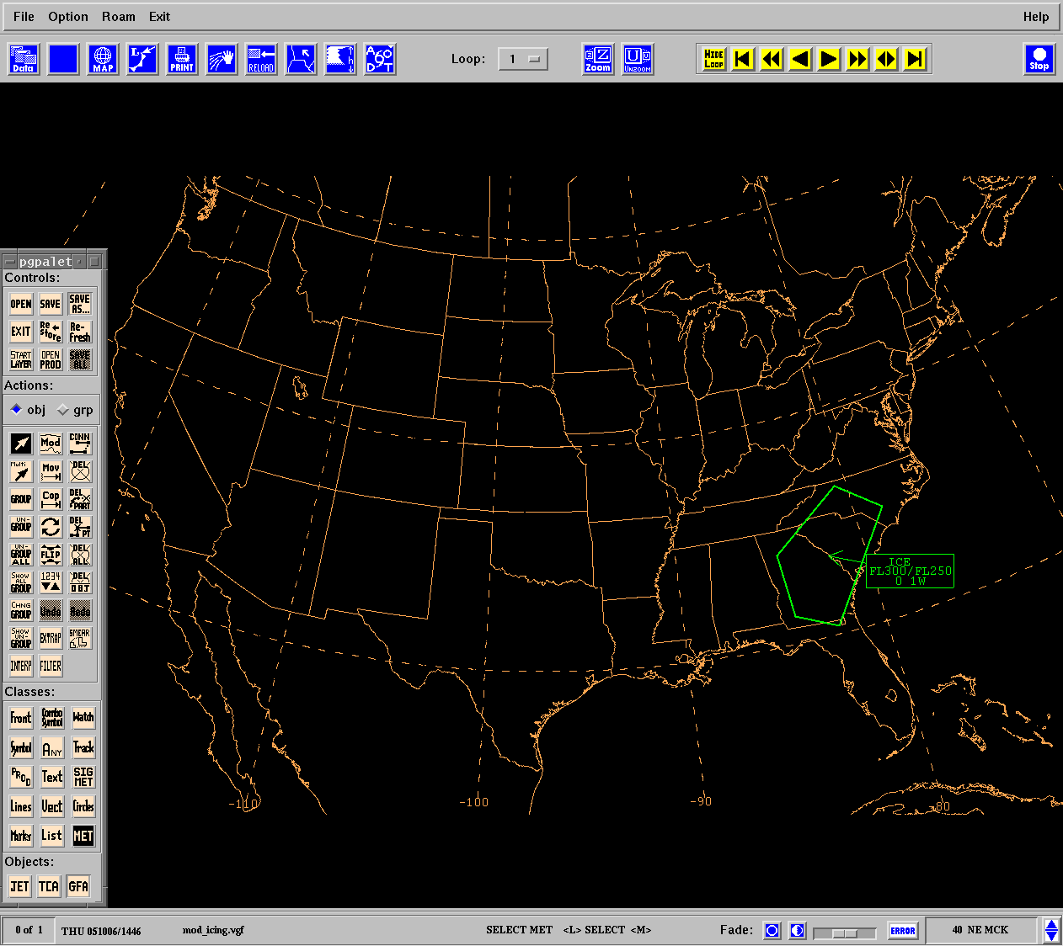

    - Feature Data

1st row = heights of aircraft icing base and top in meters, 2nd row = number of points in area. These are followed by two columns containing latitude and longitude data. A single number in the last row indicates the degree of aircraft icing (4=MODERATE).

  - Freezing Level Representation

The freezing level heights are delineated by a single line on the GFA chart at 4000 feet AMSL intervals. A text box which details the height of the lowest freezing level (in hundreds of feet AMSL or SFC) is associated with each freezing level.

    - BUFR Sequence

Table 8 shows the BUFR sequence for freezing level heights. In BUFR, how the data is depicted is not specified. Only the points describing the line and the attributes associated with that line are held.

 |  | GFA Freezing Level(s)
3 16 060 | 0 08 040 | Flight level significance, 13=Zero degrees Celsius crossing
 | 1 06 000 | Replicate 6 descriptors (Number of replications = Number of areas of freezing levels)
 | 0 31 001 | Replication count
 | 0 08 007 | Dimensional significance, 1=Line
 | 2 04 001 | Add associated field
 | 0 31 021 | Associated field significance, 21: 0=original value, 1=substituted/corrected value
 | 3 01 027 | Description of feature
 | 2 04 000 | Add associated field, Cancel
 | 0 08 007 | Dimensional significance, Missing=Cancel
 | 0 08 040 | Flight level significance, Missing = Cancel
Table 7: GFA Freezing Level(s) BUFR Sequence

    - Feature Header

FZLVL Type of feature
1 Number of freezing levels

    - Feature Data

1st row = number of points on the line. These are followed by two columns containing latitude and longitude data. A single number in the last row indicates the flight level significance (13=ZERO DEGREES CELSIUS CROSSING).

  - Multiple Freezing Levels Representation

Multiple freezing level heights are delineated by single lines on the GFA chart at 4000 feet AMSL intervals. A text box which details the height of the lowest freezing level (in hundreds of feet AMSL or SFC) is associated with each freezing level.

    - BUFR Sequence

The BUFR sequence described in section 6.2.1 can be used for multiple freezing levels.

    - Feature Header

FZLVL Type of feature
3 Number of freezing levels

    - Feature Data

1st row = number of points on the line. These are followed by two columns containing latitude and longitude data. A single number in the last row indicates the flight level significance (13=ZERO DEGREES CELSIUS CROSSING).

- Other Graphical Area Forecast Elements

  - Thunderstorm Representation

Thunderstorms are represented on a GFA chart as an area or volume drawn with a line, that is not included in an active SIGMET. The appropriate label is located at the center of the hazard polygon. The label will include the following information:

- Optional modifiers
  - OBSC (occasional)
  - EMBD (embedded)
- Frequency or coverage
  - ISOL (isolated)
  - OCNL (occasional)
  - FRQ (frequent)
- Optional hail indicator
- Height of max cloud top
- Height of cloud base
    - BUFR Sequence

Table 9 shows the BUFR sequence for thunderstorms. In BUFR, how the data is depicted is not specified. Only the points describing the line and the attributes associated with that line are held.

 |  | GFA Thunderstorms
3 16 061 | 3 16 050 | GFA Header
 | 0 08 011 | Meteorological feature, 21=Thunderstorm
 | 1 10 000 | Replicate 10 descriptors (Number of replications = Number of areas of forecast thunderstorms)
 | 0 31 001 | Replication count
 | 0 08 007 | Dimensional significance, 2=Area
 | 0 20 021 | Type of precipitation, 14=Hail
 | 2 04 001 | Add associated field
 | 0 31 021 | Associated field significance, 21: 0=original value, 1=substituted/corrected value
 | 3 01 027 | Latitude, longitude, flight level (base and top)
 | 0 20 008 | Cloud distribution for aviation, 8=Isolated, 10=Occasional, 12=Frequent, 15=Obscured, 16=Embedded
 | 0 20 013 | Height of base of cloud
 | 0 20 014 | Height of top of cloud
 | 2 04 000 | Add associated field, Cancel
 | 0 08 007 | Dimensional significance Missing=Cancel
 | 0 08 011 | Meteorological feature, Missing=Cancel
Table 8: GFA Thunderstorms BUFR Sequence

    - Feature Header

TSTM Type of feature
2 Number of thunderstorms

    - Feature Data

1st row = heights of thunderstorms base and top in meters, 2nd row = number of points in area. These are followed by two columns containing latitude and longitude data. The numbers in the last row indicate the meteorological feature (21=THUNDERSTORM), the type of precipitation (14=HAIL), and the cloud distribution for aviation (8=ISOLATED, 10=OCCASIONAL, 12=FREQUENT, 15=OBSCURED, or 16=EMBEDDED).

  - Mountain Wave Representation

Mountain waves are represented on a GFA chart as an area drawn with a line. The appropriate intensity label is located at the center of the hazard area polygon. The base and top of the turbulence layer (100’s feet AMSL or FL) will be included in the drawn area.

Please note that open and closed boundaries are used for encoding turbulence information – see section 1.3.4.

    - BUFR Sequence

The BUFR sequence described in section 4.1.1 can be used for mountain waves.

    - Feature Header

Contains the type of data to follow and the number of features in the list.

MTW Type of feature
2 Number of mountain wave areas in the list

    - Feature Data

1st row = heights of mountain wave base and top in meters, 2nd row = number of points in area. These are followed by two columns containing latitude and longitude data. The numbers in the last row indicate the meteorological feature (23=MOUNTAIN WAVE) and the degree of turbulence (6=MODERATE, 7=SEVERE).

  - Pressure Centers and Fronts Representation

    - BUFR Sequence

Table 10 shows the BUFR sequence for pressure centers and fronts. In BUFR, how the data is depicted is not specified. Only the points describing the line and the attributes associated with that line are held.

 |  | GFA Pressure Centers and Fronts
3 16 062 | 3 16 050 | GFA Header
 | 1 09 000 | Replicate 9 descriptors Number of replications = Number of tropical storms)
 | 0 31 001 | Replication count
 | 0 08 007 | Dimensional significance, 0=Point
 | 0 19 001 | Type of synoptic feature, 2=Tropical Storm
 | 2 04 001 | Add associated field
 | 0 31 021 | Associated field significance, 21: 0=original value, 1=substituted/corrected value
 | 3 01 023 | Latitude, longitude
 | 0 19 005 | Direction of motion
 | 0 19 006 | Speed of motion of feature
 | 2 04 000 | Add associated field, Cancel
 | 0 08 007 | Dimensional significance, Missing=Cancel
 | 1 09 000 | Replicate 9 descriptors (Number of replications = Number of pressure centers)
 | 0 31 001 | Replication count
 | 0 08 007 | Dimensional significance, 0=Point
 | 2 04 001 | Add associated field
 | 0 31 021 | Associated field significance, 21: 0=original value, 1=substituted/corrected value
 | 3 01 023 | Latitude, longitude
 | 0 07 004 | Pressure (Pa)
 | 0 19 005 | Direction of motion
 | 0 19 006 | Speed of motion of feature
 | 2 04 000 | Add associated field, Cancel
 | 0 08 007 | Dimensional significance, Missing=Cancel
 | 1 12 000 | Replicate 12 descriptors (Number of replications = Number of fronts)
 | 0 31 001 | Replication count
 | 0 08 007 | Dimensional significance, 1=Line
 | 2 04 001 | Add associated field
 | 0 31 021 | Associated field significance, 21: 0=original value, 1=substituted/corrected value
 | 0 08 011 | Front, 0=Quasi Stationary front at the surface, 2=Warm front at the surface, 4=Cold front at the surface, 6=Occlusion, 26=Trough
 | 1 01 000 | Replicate one descriptor
 | 0 31 001 | Replication count
 | 3 01 023 | Latitude, longitude
 | 0 19 005 | Direction of motion
 | 0 19 006 | Speed of motion of feature
 | 0 08 011 | Front, Missing=Cancel
 | 2 04 000 | Add associated field, Cancel
 | 0 08 007 | Dimensional significance, Missing=Cancel
Table 9: GFA Pressure Centers and Fronts BUFR Sequence

    - Feature Header
    - Feature Data

  - Tropical Storms Representation
    - BUFR Sequence

The BUFR sequence described in section 7.3.1 can be used for tropical storms.

    - Feature Header
    - Feature Data

  - Precipitation Representation

    - BUFR Sequence

Table 11 shows the BUFR sequence for precipitation. In BUFR, how the data is depicted is not specified. Only the points describing the line and the attributes associated with that line are held.

 |  | GFA Precipitation
3 16 062 | 3 16 050 | GFA header
 | 1 10 000 | Replicate 10 descriptors (Number of replications = Number of areas of precipitation)
 | 0 31 001 | Replication count
 | 0 08 007 | Dimensional significance, 2=Area
 | 2 04 001 | Add associated field
 | 0 31 021 | Associated field significance, 21: 0=original value, 1=substituted/corrected value
 | 3 01 023 | Latitude, longitude
 | 0 20 021 | Type of Precipitation, 2=Liquid precipitation not freezing, 3=Liquid freezing precipitation, 6=Solid precipitation, 7=Snow
 | 0 20 022 | Character of precipitation, 1=Continuous, 2=Intermittent
 | 0 20 025 | Obscuration, 8=Haze, 11=Dust, 12=Sand,
 | 0 20 024 | Intensity of phenomena, 1=Light, 2=Moderate, 3=Heavy, 4=Violent
 | 2 04 000 | Add associated field, Cancel
 | 0 08 007 | Dimensional significance, Missing=Cancel
Table 10: GFA Precipitation BUFR Sequence

    - Feature Header
    - Feature Data

  - Volcanic Eruption(s) Representation

The location of active volcanic eruption(s), including the name of the volcano and its coordinates are represented with a symbol (Figure 3) on the GFA chart.

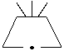
Figure 3: Volcanic eruption symbol

    - BUFR Sequence

Table 12 shows the BUFR sequence for volcanic eruptions. In BUFR, how the data is depicted is not specified. Only the points describing the line and the attributes associated with that line are held.

 |  | GFA Volcanic Eruption(s)
3 16 063 | 3 16 050 | GFA header
 | 0 08 011 | Meteorological feature, 17=Volcano
 | 1 07 000 | Replicate 7 descriptors (Number of replications = Number of areas of volcanic ash activity)
 | 0 31 001 | Replication count
 | 0 08 007 | Dimensional significance, 0=Point
 | 2 04 001 | Add associated field
 | 0 31 021 | Associated field significance, 21: 0=original value, 1=substituted/corrected value
 | 3 01 023 | Latitude, longitude
 | 0 01 022 | Name of feature
 | 2 04 000 | Add associated field, Cancel
 | 0 08 007 | Dimensional significance, Missing=Cancel
 | 0 08 011 | Meteorological feature, Missing=Cancel
Table 11: GFA Volcanic Eruption(s) BUFR Sequence

    - Feature Header

VA Type of feature
2 Number of volcanic eruptions

    - Feature Data

1st row = two columns containing latitude and longitude data. The numbers in the last row indicate the meteorological feature (17=VOLCANO) and the name of the volcano.

  - MVFR Visibility Representation

    - BUFR Sequence

Table 13 shows the BUFR sequence for MVFR visibility. In BUFR, how the data is depicted is not specified. Only the points describing the line and the attributes associated with that line are held.

 |  | GFA MVFR Visibility
3 16 064 | 3 16 050 | GFA Header
 | 1 11 000 | Replicate 11 descriptors (Number of replications = Number of areas of MVFR)
 | 0 31 001 | Replication count
 | 0 08 007 | Dimensional significance, 2=Area
 | 0 20 006 | Flight rules, 2=MVFR
 | 0 20 025 | Obscuration, 1=Fog
 | 2 04 001 | Add associated field
 | 0 31 021 | Associated field significance, 21: 0=original value, 1=substituted/corrected value
 | 1 01 000 | Replicate 1 descriptor
 | 0 31 001 | Replication count
 | 3 01 023 | Latitude, longitude
 | 0 20 003 | Present weather
 | 2 04 000 | Add associated field, Cancel
 | 0 08 007 | Dimensional significance, Missing=Cancel
Table 12: GFA MVFR Visibility BUFR Sequence

    - Feature Header
    - Feature Data

  - Towering Cumulus Cloud Representation

    - BUFR Sequence

Table 14 shows the BUFR sequence for towering cumulus clouds. In BUFR, how the data is depicted is not specified. Only the points describing the line and the attributes associated with that line are held.

 |  | GFA Towering Cumulus Clouds
3 16 065 | 3 16 050 | GFA header
 | 1 11 000 | Replicate 11 descriptors (Number of replications = Number of areas of TCU)
 | 0 31 001 | Replication count
 | 3 01 023 | Latitude, longitude
 | 0 08 007 | Dimensional significance, 3=Volume
 | 0 20 012 | Cloud type, 32=Towering Cumulus
 | 2 04 001 | Add associated field
 | 0 31 021 | Associated field significance, 21: 0=original value, 1=substituted/corrected value
 | 3 01 027 | Description of feature
 | 0 20 008 | Cloud distribution for aviation, 10=occasional, 12=Frequent
 | 0 20 013 | Height of base of cloud
 | 0 20 014 | Height of top of cloud
 | 2 04 000 | Add associated field, Cancel
 | 0 08 007 | Dimensional significance, Missing=Cancel
Table 13: GFA Towering Cumulus Clouds BUFR Sequence

    - Feature Header
    - Feature Data

  - Cloud Representation

    - BUFR Sequence

Table 15 shows the BUFR sequence for clouds. In BUFR, how the data is depicted is not specified. Only the points describing the line and the attributes associated with that line are held.

 |  | GFA Clouds
3 16 066 | 3 16 050 | GFA header
 | 1 12 000 | Replicate 12 descriptors (Number of replications = Number of areas of clouds)
 | 0 31 001 | Replication count
 | 3 01 023 | Latitude, longitude
 | 0 08 007 | Dimensional significance, 3=Volume
 | 2 04 001 | Add associated field
 | 0 31 021 | Associated field significance, 21: 0=original value, 1=substituted/corrected value
 | 1 01 000 | Replicate 1 descriptor
 | 0 31 001 | Replication count
 | 3 01 027 | Description of feature
 | 0 20 008 | Cloud distribution for aviation, 3=Broken, 4=Overcast
 | 0 20 013 | Height of base of cloud
 | 0 20 014 | Height of top of cloud
 | 2 04 000 | Add associated field, Cancel
 | 0 08 007 | Dimensional significance, Missing=Cancel
 | 0 08 021 | Time significance, Missing=Cancel
Table 14: GFA Clouds BUFR Sequence

    - Feature Header
    - Feature Data

- Contact Details

The Aviation Weather Center can provide a consultancy service to assist individual clients in the construction of GFA visualization software that is fully compliant with ICAO Annex 3 and the software criteria that have been constructed by the ICAO SADIS Operations Group. Please contact the Aviation Weather Center via the contact details below for further information.

Clinton E. Wallace
Chief, Aviation Support Branch
Aviation Weather Center (NOAA/NWS/NCEP)
7220 NW 101st Terrace, Room 101
Phone: 816.584.7248
Fax: 816.880.0650
Email: Clinton.Wallace@noaa.gov

