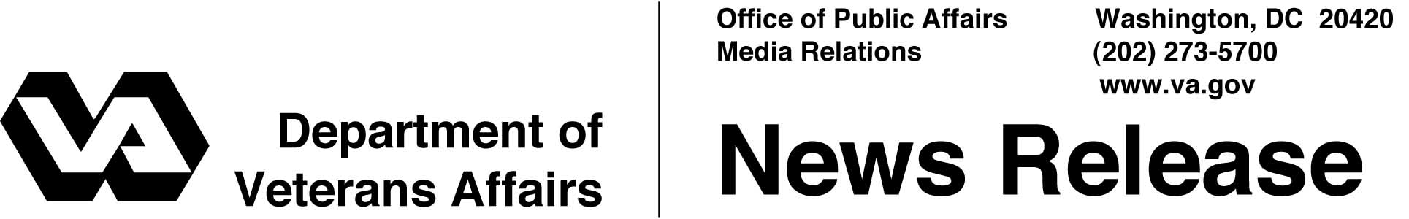

FOR IMMEDIATE RELEASE
February 12, 2002

Distribution Center for Homeless Vets Reaches Milestone
WASHINGTON -- As winter winds pierce America’s cities, the homeless huddle near open fires in Detroit, sleep above subway vents in New York City and crowd soup kitchens in Washington, D.C. Although the cities may change, the stories of substance abuse, mental health disorders, and hopelessness remain the same.
The Department of Veterans Affairs (VA) is working to rewrite that story and provide an opportunity for America's estimated 250,000 homeless veterans to get off the streets and on the road to self-sufficiency.
VA operates the nation’s largest integrated network of homeless programs. One of them, the Excess Property for Homeless Veterans Initiative, Operation New Hope, has distributed more than $100 million in clothing and other items to homeless veterans since its inception in 1994. What makes Operation New Hope unique is not the amount of clothing distributed, but rather, how it’s distributed.
Former homeless veterans who are enrolled in the VA’s New Jersey Health Care System’s Compensated Work Therapy program distribute the clothing from the Somerville Asset Management Service, a VA facility in Hillsborough, N.J. Aside from receiving job training in warehousing, shipping and distribution management, veterans enrolled in the program have an opportunity to experience the therapeutic value of work.
The therapeutic value of work is not a new concept; it’s just something many take for granted. But for homeless veterans, work provides a daily purpose, a mission. It fosters pride, self-esteem and a sense of accomplishment, and is often the first step toward recovery.

- More -
Operation New Hope 2-2-2-2

Under Operation New Hope, the distribution center obtains clothing, footwear, sleeping bags, blankets, personal hygiene items and other materials for homeless veterans. Most of the items are excess military clothing collected from the Department of Defense (DoD), but donations of "civilian” clothing from corporations have steadily increased. Civilian clothing is especially useful as homeless veterans seek stable housing and employment.
VA’s Office of Acquisition and Materiel Management started the program and coordinates it, working closely with the General Services Administration and DoD. Individual VA facilities across the nation, working with community and faith-based organizations, and state and local governments, distribute the clothing and other items to homeless veterans through their outreach activities.
For information on how to make donations to the distribution center, contact Allen Taylor at (202) 273-6350, or e-mail allen.taylor@mail.va.gov.

# # #

