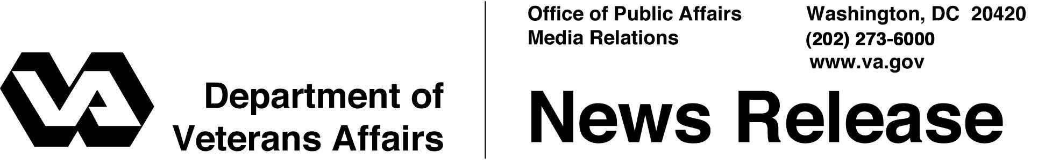

FOR IMMEDIATE RELEASE
January 27, 2004

VA Teaches Disabled Veterans To Ski
WASHINGTON – Approximately 350 disabled military veterans will ski the Rocky Mountains at the 18th National Disabled Veterans Winter Sports Clinic in Snowmass Village at Aspen, Colo., April 4 to April 9.
This rehabilitation program is open to all U.S. military veterans with spinal cord injury or disease, certain neurological conditions, orthopedic amputations, visual impairments or other disabilities, who receive care at any Department of Veterans Affairs (VA) facility.
This year, for the first time, veterans from the current combat operation in Iraq will attend. Veterans from operations in Afghanistan, who have participated in earlier Winter Clinics, will also participate.
Sponsored by VA and the Disabled American Veterans (DAV), the clinic is hosted by the Grand Junction (Colo.) VA Medical Center and VA’s Rocky Mountain Network.
At the clinic, disabled veterans will learn adaptive Alpine and Nordic skiing and will be introduced to a variety of other adaptive activities and sports, such as rock climbing, scuba diving, handcycling, horseback riding, snowmobiling and sled hockey. The U.S. Secret Service will also teach self-defense.
“VA's national rehabilitation special events help veterans to reach their full potential and achieve independence,” said Secretary of Veterans Affairs Anthony J. Principi. “We are honored to welcome Iraqi Freedom veterans to this year’s event.”
The National Disabled Veterans Winter Sports Clinic shows that the lives of disabled veterans can be changed forever when they discover the extraordinary challenges they can overcome. This experience has been described by participants as “miracles on a mountainside.”
- More -
Winter Sports Clinic 2/2/2/2

“The Disabled American Veterans is proud to have co-sponsored the National Disabled Veterans Winter Sports clinic since 1991,” said DAV National Commander Allan W. Bowers. “The clinic is a wonderful example of DAV’s ongoing commitment to the brave men and women disabled in service to our nation. It is also an excellent example of partnering with VA to deliver the services disabled veterans have earned, and to support their rehabilitation efforts.”
VA is a recognized leader in rehabilitation, with recreational therapy programs at each of its 162 hospitals. DAV is a nonprofit, congressionally chartered veterans service organization, with a membership of more than one million wartime disabled veterans.

For further information about the Clinic, contact Annie Tuttle, VA Public Affairs Coordinator, at (909) 422-3193, or Jim Hall, DAV Communications, at (877) 426-2838, ext. 2048.

# # #

People wishing to receive e-mail from VA with the latest news releases and updated fact sheets can subscribe at the following Internet address:
http://www.va.gov/opa/pressrel/opalist_listserv.cfm

