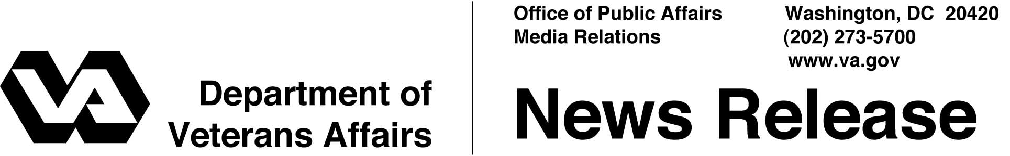

FOR IMMEDIATE RELEASE
October 3, 2003

Veterans Showcase Talent at National Veterans Creative Arts Festival
WASHINGTON, D.C. – Veterans from across the country will be in Oklahoma City, Oct. 6-12, for the 2003 National Veterans Creative Arts Festival. The festival is the culmination of a year-long fine arts competition open to all veterans receiving care at Department of Veterans Affairs (VA) medical facilities.
“The National Veterans Creative Arts Festival demonstrates that healing goes well beyond a person’s physical recovery. Creative arts therapy plays an important role in the rehabilitation of the mind as well as the spirit,” said Secretary of Veterans Affairs Anthony J. Principi.
“VA is proud to give veterans the opportunity to develop their artistic talents, while improving their overall health and well-being,” Principi said. “Helping them live rich, fulfilling and meaningful lives after trauma or disease is what this Festival is all about.”
At the 2003 Festival, more than 120 talented veterans, first-place winners selected from nearly 3,000 competitors nationwide, will be in Oklahoma City for a week of workshops and rehearsals. The week will culminate on Sunday, Oct. 12, with a stage show and art exhibit at the Rose State College Performing Arts Center in Midwest City, Okla. Beginning at 2 p.m., the music, drama and dance performers will showcase their talent at the stage show, accompanied by a professional orchestra. Artists will exhibit their work in the lobby of the Rose State College Performing Arts Center after the show.

- More -
Creative Arts 2/2/2/2

Film actress Bo Derek, honorary chairperson for VA’s National Rehabilitation Special Events will be in attendance and available for interviews before the show.
The festival is co-sponsored by VA, the American Legion Auxiliary and Help Hospitalized Veterans, and hosted by the Oklahoma City VA Medical Center.
For further information during the event, contact Kim Byers, public affairs coordinator for the National Veterans Creative Arts Festival, at (405) 815-6044. After October 14, call (734) 761-7824. Additional information is available on the Festival’s website: www.va.gov/vetevent/caf/2003.

# # #

People wishing to receive e-mail from VA with the latest news releases and updated fact sheets can subscribe at the following Internet address:
http://www.va.gov/opa/pressrel/opalist_listserv.cfm

