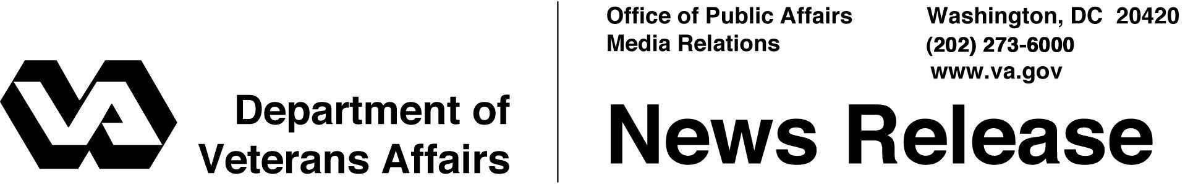

FOR IMMEDIATE RELEASE
August 19, 2004

VA Assists Floridians in Recovery
WASHINGTON – Secretary of Veterans Affairs Anthony J. Principi has ordered his department to offer "whatever assistance necessary" to Floridians in the aftermath of Hurricane Charley.
"These are our neighbors, and as in the past, we are there for them now," Principi said.
The efforts underway by the Department of Veterans Affairs (VA) include:
- Augmenting local hospitals with about 50 VA health care workers;
- Working with lenders to establish a moratorium on foreclosures in the affected areas for veterans with GI Bill home loan guarantees;
- Making VA home loan representatives available to provide financial counseling to veterans affected by the hurricane; and
- Offering foreclosed properties in Florida to the Federal Emergency Management Administration (FEMA) to temporarily house hurricane victims.
In Florida, employees at VA facilities are also pitching in to help victims of the hurricane by collecting donations for disaster area residents, including non-perishable food, personal hygiene items and gift certificates to local businesses.
Among VA medical facilities in the area, the Port Charlotte outpatient clinic has been closed because of roof damage, and VA officials are considering the temporary transfer of 56 patients from Port Charlotte state veterans' nursing home to other facilities in the region because of electrical problems.

- More -
Hurricane Charley 2/2/2/2

"Our National Acquisitions Center is standing by to assist with the purchase of medical supplies and equipment as necessary," Principi said.
Through the local news media, VA is also reaching out to victims by providing them with information about VA benefits and services available to veterans and their families during this difficult time.
In Florida this year, VA expects to spend $4.4 billion this year providing health care, disability compensation and other benefits to nearly 2 million veterans plus their family members.

# # #

People wishing to receive e-mail from VA with the latest news releases and updated fact sheets can subscribe at the following Internet address:
http://www.va.gov/opa/pressrel/opalist_listserv.cfm

