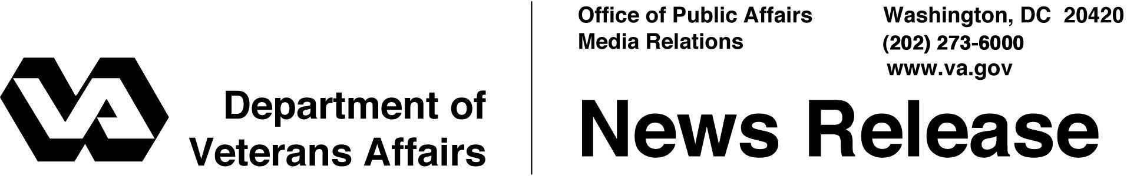

FOR IMMEDIATE RELEASE
August 27, 2004

No Specific Threats to VA Facility, VA Secretary Says
WASHINGTON – The Department of Veterans Affairs (VA) is unaware of any information indicating a specific terrorist threat to any VA facility in our national health care system, according to Secretary of Veterans Affairs Anthony J. Principi.
"We are operating as usual," Principi said. "No VA services have been affected by the recent information bulletin issued by the Department of Homeland Security."
The Department of Homeland Security (DHS) regularly distributes information outlining a variety of protective measures to increase awareness and provide guidance to law enforcement, state and local officials, as well as the private sector, about potential terrorist threats.
The recent "information bulletin" issued by DHS was cautionary in nature. DHS and the Federal Bureau of Investigation stressed in the bulletin that no "credible information" exists about threats to a specific VA facility.
VA operates the nation's largest integrated medical system, with 158 hospitals and nearly 860 outpatient clinics.

# # #

People wishing to receive e-mail from VA with the latest news releases and updated fact sheets can subscribe at the following Internet address:
http://www.va.gov/opa/pressrel/opalist_listserv.cfm

