CRUISE REPORT
Cruise Number: KM03-05, Leg 1

Vessel: R/V KILO MOANA – University of Hawaii UNOLS

Area of Operation: Gulf of Alaska, Kodiak to Seward

Itinerary: 18 April, 2003 Depart Kodiak Alaska
27 April, 2003 Arrive Kodiak Alaska

Participating Organizations: NOAA/PMEL/FOCI
NOAA/AFSC/FOCI
Scripps Institute of Oceanography

Cruise Objectives: To deploy and/or recover surface and subsurface oceanographic instrumentation moorings in the Gulf of Alaska. To complete CTD casts at the mooring locations and to release Argos tracked drifter buoys along our trackline.

Chief Scientist: William Floering, NOAA/PMEL/OERD2
206-526-6480
William.Floering@noaa.gov

Personnel: Dr. Calvin Mordy M/USA NOAA/PMEL
Carol DeWitt F/USA NOAA/PMEL
Earl Roskie M/USA NOAA/PMEL
Steve Smith M/USA NOAA/PMEL
Rick Miller M/USA NOAA/PMEL
Lisa Munger F/USA Scripps Institute of Oceanography

Summary of Operations and Samples Collected:

CTD Casts 22
Salinity Samples 11
Nutrient Samples 12
Underway Thermosalinograph N/A
Dragging operations for “lost” moorings 24 hours
Argos Drifter Buoys Deployed 6
Recovered Moorings 11
Deployed Moorings 16

Narrative:

KILO MOANA departed the U.S. Coast Guard Base Kodiak, Alaska at 1500 hrs 18 April, 2003. Shortly after leaving port we recovered and deployed the AFSC CB-1 mooring in Chiniak Bay. We steamed southeast from Chiniak to a depth of approximately 800 meters where we deployed a marine mammal haruphone mooring for Scripps Institute of Oceanography and the Seattle National Marine Mammal Laboratory.

Next we traveled east to the FATE surface mooring location. On a pervious cruise we discovered that the FATE surface mooring had broken free from its anchor and was adrift somewhere in the Gulf of Alaska. The acoustic release was still on station, beyond that we had no way to determine how much of the mooring remained at this site in 2400 meters of water. Over the next 12-14 hours we attempted to recover the mooring by dragging a wire with large grapple hooks attached. We paid out 4800 meters of wire (2 to 1 scope) and tried to encircle the mooring and/or drag across what may remain on the bottom. In that kind of depth with no marker on your drag hooks it’s extremely difficult to know where the end of your wire is or to place the hooks on what may be a very small target. We didn’t have any luck dragging for what remains of the FATE surface mooring.

We proceeded to mooring site GBP-12 for a mooring recovery and deployment. Next was a recovery only at mooring site GB-11. An Argos tracked drifter buoy was deployed as we were leaving site GB-11. Next stop was mooring site GB-5 for another subsurface mooring recovery and deployment. The nitrate meter scheduled to be deployed at this site was leaking oil on the bench. A substitute nitrate meter was prepared and deployed at site GB-5. An Argos tracked drifter Buoy was deployed at GB-5. From here we proceeded to mooring site GB-4. This mooring could not be recovered. The acoustic release signal indicated that the release was lying horizontal on the ocean bottom.

The weather was picking up and the weather prediction was for 35 knots of wind. We left site GB-4, hoping to recover the surface mooring at GB-3 before the winds and seas increased and the conditions for mooring operations became unsafe. We launched the ship’s rescue boat and attached a line to the surface mooring to recover it. As the wind and seas continued to increase we recovered the surface mooring GBM-3 and deployed the subsurface mooring GBP-3. As we were finishing our work at site GBP-3 the winds were blowing 35-40 knots. Due to weather we halted operations at approximately 2000 hours Monday evening.

By Tuesday morning the winds had subsided; we deployed subsurface mooring GB-4 and deployed an Argos tracked drifter buoy. As the day progressed the wind increased to 35 to 40 knots and the seas were such that we did not attempt a CTD cast following this deployment. We tried to steam north to site GB-2 but the wind was blowing 50 knots and sea spray was getting inside the fresh air vents for the engine room, depositing salt water on the electrical controls for the engines and generators. We adjusted our course and speed to keep water out of the engine room and slowly steamed for site GB-1.

By Wednesday morning the storm had passed; we attempted to recover mooring GB-1 but the release was lying horizontal on the ocean bottom. A new mooring GB-1 was deployed nearby and we steamed to site GB-2. The situation at site GB-2 was similar to GB-1. The release was lying on the bottom, the mooring could not be recovered, and a new GB-2 was deployed nearby. After leaving site GB-2 we steamed back to mooring site GB-3 and successfully deployed the surface mooring at this site. This mooring is equipped with a new solar powered flashing warning light and a second Argos position transmitter. Argos tracked drifter buoys were deployed at GB-1, GB-2, and GB-3.

Steaming northwest we started work on the Gore Point line first thing Thursday morning. We recovered and re-deployed mooring GPP-36 then recovered GP-34 and GP-32 to ensure we would not run out of daylight for recoveries. Working our way back off shore we deployed subsurface moorings GP-32 and GP-34.

Had we followed the original cruise plan, after completing our work on the Gore Point Line we were scheduled to steam west to Shelikof Strait. The lack of success in recovering the moorings at GB-1, GB-2, GB-3 and GB-4 raised several new concerns. After consulting with the Seattle PMEL/FOCI office, it was decided to return to those sites, attempt to recover the “lost” moorings with a grapple drag and recover/re-deploy 2 of the moorings at a depth closer to 10 meters below the surface instead of 5 meters. We steamed back to mooring site GB-4 and began dragging operations on Friday. Two circle drags at GB-4 were tried with no success. The newly deployed GB-4 mooring was recovered, modified and re-deployed with a top float depth of 14 to 15 meters.

We tried a circle drag for the iron meter mooring at site GB-3 with no luck. During the night we steamed inshore to site GB-1. The newly deployed mooring at GB-1 was recovered, modified and re-deployed with a new depth to top float of 15 meters. Later in the day we attempted a circle drag for the “lost” mooring at site GB-2 however we had no success in snagging what remained of that mooring.

Historically we have had some luck with dragging operations in depths to 250 meters. Due to reasonable concerns the vessel captain took a conservative approach to dragging and that may have impacted our ability to snag these moorings. KILO MOANA had $30,000 of new wire on its winch, a wire that will be used for a number of projects besides our mooring dragging efforts. In addition, the ship does not have a tension meter on the system to tell when they’ve hung up on the bottom. To avoid damage to the wire and the crane/block, we were limited to the bare minimum amount of wire we could lay on the bottom for a circle type drag.

Following the dragging operations at mooring site GB-2 we headed west for the Kodiak U.S. Coast Guard Base, arriving at 1200 on April 27, 2003.

KILO MOANA draws a minimum of 25 feet of water. This limits which pier the ship can tie up to, and when the ship can transit the channel in and out of Kodiak. The local pilot advised that the ship not transit the channel at low tide. Waiting for high tide had some impact on scheduling our arrival and departure.

Summary of Cruise:

Days lost due to weather - 12 hours
Days lost due to equipment failure - 0 hours

Considerations for future cruises:

As mentioned above, the vessel has a minimum draft of 25 feet, uncharacteristically deep for a 190 foot ship. The draft presents some limitations on where the ship can safely travel and tie up.

There were a number of sounders available on the ship but there was some question as to which ones were corrected for speed of sound, which were corrected for hull depth, and not all the sounders were available for viewing on the ship-wide monitor screens. I suspect some of these issues will be resolved as people become more familiar with the layout and limitations of the new vessel.

There was a 3000 lb pull general purpose winch that we used extensively for mooring operations. This winch met most of our requirements but if the opportunity presents itself, a 5000-6000 lb winch would add to the ship’s capabilities.

For future mooring operations, a hull mounted EGG acoustic release transducer is recommended.

Space on the aft deck is limited. We staged for 16 mooring deployments including one surface mooring, not a large cruise by FOCI standards. If we were planning two surface mooring deployments and 15 or so moorings, we would not have sufficient space to store and secure all the necessary equipment. There is an area forward on the port side that is designed to accommodate two- 20 foot containers. Having one or two 20 foot flats in that area would greatly increase the deck space needed to secure the anchors, floats, spools, etc. necessary for mooring operations.

The current vessel computer navigation program is limited and will not provide a printout of the display screen nor allow the vessel to use its dynamic positioning system. This computerized navigation system is scheduled to be replaced in the near future.

Acknowledgments:

As Chief Scientist I would like to thank the Captain and crew of KILO MOANA for the assistance and cooperation that helped make this cruise successful. The pre-cruise communications with the Captain and support staff at the University of Hawaii was also extremely beneficial in matching the ship’s capabilities to our requests and requirements.

I would also like to thank the members of the scientific party for remaining flexible and determined as plans changed and the work day wore on.

Attachments:

Table 1: Station Summary KM03-05

CTD CASTS: KILO MOANA 0305
CTD # | DATE | TIME | LAT N | LONG W | DEPTH M
1 | 19-Apr | 2:50 | 57 43.53 | 152 18.14 | 153
2 | 19-Apr | 7:27 | 57 43.70 | 152 18.10 | 142
3 | 20-Apr | 16:16 | 58 41.03 | 148 50.39 | 204
4 | 20-Apr | 19:45 | 58 40.69 | 148 50.55 | 197
5 | 20-Apr | 21:48 | 58 55.28 | 148 38.05 | 257
6 | 21-Apr | 0:21 | 59 02.80 | 148 41.60 | 191
7 | 21-Apr | 4:05 | 59 02.27 | 148 41.10 | 201
8 | 21-Apr | 5:43 | 59 08.05 | 148 46.71 | 145
9 | 21-Apr | 19:30 | 59 18.39 | 148 58.99 | 143
10 | 23-Apr | 14:34 | 59 41.53 | 149 21.67 | 239
11 | 23-Apr | 19:39 | 59 41.57 | 149 19.02 | 228
12 | 23-Apr | 21:07 | 59 34.14 | 149 12.15 | 219
13 | 24-Apr | 2:12 | 59 31.85 | 149 10.21 | 210
14 | 24-Apr | 9:47 | 59 17.48 | 148 57.56 | 182
15 | 24-Apr | 11:22 | 59 07.81 | 148 46.39 | 144
16 | 24-Apr | 15:09 | 59 06.72 | 150 05.27 | 159
17 | 24-Apr | 19:43 | 58 45.16 | 150 52.38 | 174
18 | 24-Apr | 22:33 | 58 44.65 | 150 51.68 | 179
19 | 24-Apr | 0:10 | 58 57.54 | 150 55.80 | 148
20 | 25-Apr | 2:43 | 59 06:13 | 151 00.13 | 158
21 | 25-Apr | 6:00 | 59 06.92 | 150 59.15 | 168
22 | 25-Apr | 9:13 | 58 57.54 | 150 55.43 | 154
ARGOS DRIFTERS
DRIFT # | DATE | TIME | LAT N | LONG W | DEPTH M
37485 | 20-Apr | 23:22 | 58 55.74 | 148 38.15 | 255
37484 | 21-Apr | 4:36 | 59 02.30 | 148 41.60 | 200
37512 | 21-Apr | 18:01 | 59 08.32 | 148 47.92 | 144
37509 | 23-Apr | 19:50 | 59 41.38 | 149 18.88 | 221
37487 | 24-Apr | 2:32 | 59 31.78 | 149 10.16 | 210
37490 | 24-Apr | 10:04 | 59 17.42 | 148 57.15 | 182

Mooring Locations: KM-03-05
 |  | MOORING | LAT N | LONG W
 |  | FATE | 58 16.51 | 147 41.21
 |  | 02CB-1C | 57 43.33 | 152 17.65
 |  | 03GB-1A | 58 41.67 | 149 19.91
 |  | 03GB-2A | 59 32.00 | 149 10.95
 |  | 03GBM-3 | 59 18.00 | 148 58.20
 |  | 03GB-4A | 59 07.69 | 148 45.65
 |  | 03GBP-5 | 59 02.58 | 148 41.66
 |  | 02GBP-11 | 58 55.28 | 148 37.18
 |  | 03GBP-12 | 58 41.00 | 148 50.92
 |  | 03GBP-13 | 59 06.56 | 150 04.90
 |  | 02GP-32A | 59 06.26 | 150 59.51
 |  | 03GP-34A | 58 57.77 | 150 55.97
 |  | 03GPP-36 | 58 45.00 | 150 51.99

Figure 1: Mooring Positions

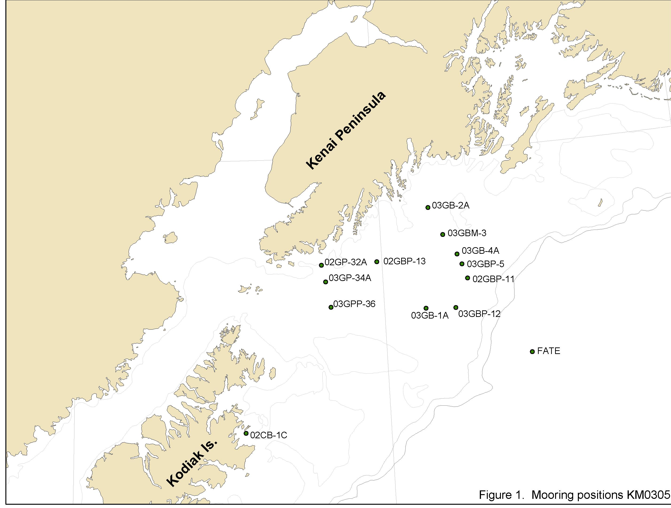

Figure 2: CTD and Drifter Positions

