Cruise Plan for Bering Ecosystem Study Project (BEST) on U.S.C.G. Cutter Healy (HLY0701); April 10 through May 12, 2007

Feb. 23, 2007 version

R. Sambrotto
Lamont-Doherty Earth Observatory
61 Rt. 9W
Palisades, NY 10964
Phone: 845-365-8402
Email: sambrott@ldeo.columbia.edu

Introduction and Overview
The initial cruise of the NSF sponsored Bering Ecosystem Study (BEST) project will take place April-May 2007 aboard the USCG cutter Healy (hereafter HLY0701). Similar ice-breaker cruises are planned in the following years. BEST is part of a larger, multi-agency, integrated effort that addresses ecosystem research in the eastern Bering Sea. Further information on this broader context can be found at http://www.arcus.org/bering/. The more specific major scientific goals of the BEST project and the general approach to their accomplishment can be found in the BEST Science Plan on-line at http://www.fish.washington.edu/research/best/. Briefly, BEST is concerned with understanding the ecosystem level responses to the changes in ice extent and seasonal distribution in the eastern Bering Sea. The availability of an icebreaker with the capabilities of the Healy provides one of the first opportunities to sample extensively in the marginal ice zone (MIZ) of this biologically productive marine system.

The science efforts aboard HLY0701 consist of several groups of researchers who will address various aspects of hydrography, nutrient chemistry, plankton production and distribution, marine mammal populations and bird surveys (Table 1). Cruise planning meetings were held in September, 2006 in Washington DC and December, 2006 at the University of Washington. The latter planning also included meetings with the Coast Guard and a tour of the Healy. Based on these meetings and further additional communications within the group, a sampling plan was developed that covers most of the non-Russian waters in the eastern Bering Sea (Fig. 1). The cruise track will begin and end in Dutch Harbor, Alaska for the 33 day period from April 10 to May 12, 2007. Fig. 1 depicts the four major cross-shelf lines: SL, MN, PN and CN. These lines are crossed by an extensive long-shelf section along the 70m isobath (the 70m line).

An important factor in the planning of HLY0701 is the contemporaneous sampling of the NOAA ship Miller Freeman in the region. This sampling has been incorporated into the HLY0701 cruise plan and will impact upon it in two basic ways. We plan joint sampling of the Healy and Miller Freeman in the region of the residual southernmost MIZ front. Here the UTOW package carried by the Freeman can map the frontal region. Also, we expect that the Miller Freeman can sample most of the CN line, thus leaving the Healy more time in the MIZ. For planning purposes, the overall cruise plan has been sub-divided into 11 phases. The goals and sampling of each of these phases is detailed in the following section.

Table 1. Science components and their major sampling activities during HLY0701.
Component, PIs | Sampling activities
1) Hydrography and circulation - Phyllis Stabeno; NOAA PMEL | CDT cast; drifter releases
2) Nutrient and oxygen fields – Cal Mordy; NOAA PMEL. | Water sampling with Niskin bottles.
3) Nitrogen productivity and isotopic budget – Ray Sambrotto; LDEO & Dan Sigman; Princeton | Water sampling with Niskin bottles, incubations, ice sampling
4) Iron distribution - Jingfeng Wu; UAF | Water sampling with trace metal clean bottles, ice sampling
5) Productivity, sediment fluxes and benthos - Al Devol; UW & David Shull; UWW | Water sampling with Niskin bottles, multicorer deployments
6) Zooplankton & meroplankton – Jeff Napp; NOAA PMEL | Plankton net hauls
7) Ice Seal Project – P. Boveng, M. Cameron, NOAA | Bearded, spotted, ringed, and ribbon seals - aerial shipboard surveys; satellite tagging
8) Bird observations – Kathy Kuletz; Fish and Wildlife Service | Observations from ship & ice
9) Walrus observations; Carleton Ray; UVA | Observations from ship, helicopter and ice
10) Underway bottom profile measurements - D. Chayes; LDEO | Multibeam acoustic system
11) Echo location and estimation of fish and krill - Chris Wilson & Alex De Robertis; NOAA | simrad EK60 scientific echosounders
12) Additional cruise operations | Helicopter surveys of ice field, collection of samples for carbonate system, teachers at sea.

Phase 1 – Initial stations from Bering Canyon to Unimak Pass
Healy currently is scheduled to arrive in Dutch Harbor on 4/9/07. The remaining loading that has not been done in Seattle will be done by the following day and Healy departs the dock after dinner on 4/10/07 at 18:00. Four stations follow within the next 13 hrs. that are intended to sample various source waters for the eastern shelf including the slope water in the Bering Canyon, the North Aleutian Shelf Current (NASC), Unimak Pass and a station close to to sample the Alaskan Coastal Current (ACC).
BEST stn# | addl. Info | Spd (kts) | Transit (hrs) | Water Depth (m) | CTD Time (min) | Prod Time (min) | Multi core Time (min) | AFSC net time (min) | Fe cast (min) | Other - Ice, Helo (min) | Arrive Local Date/Time | Depart Local Date/Time | Cruise day (at end)
Dutch |  |  |  |  |  |  |  |  |  | 1080 | 4/10/07 0:00 | 4/10/07 18:00 | 1
1 | Bering Canyon | 11 | 3.4 | 2000 | 60 |  |  |  | 60 |  | 4/10/07 21:23 | 4/10/07 23:23 | 1
2 | NASC | 11 | 1.4 | 70 | 25 |  |  | 45 |  |  | 4/11/07 0:45 | 4/11/07 1:55 | 2
3 | Unimak Pass | 11 | 1.1 | 80 | 30 |  |  | 45 |  |  | 4/11/07 3:01 | 4/11/07 4:16 | 2
4 | ACC | 11 | 1.3 | 70 | 26 | 60 |  |  |  |  | 4/11/07 5:31 | 4/11/07 6:57 | 2

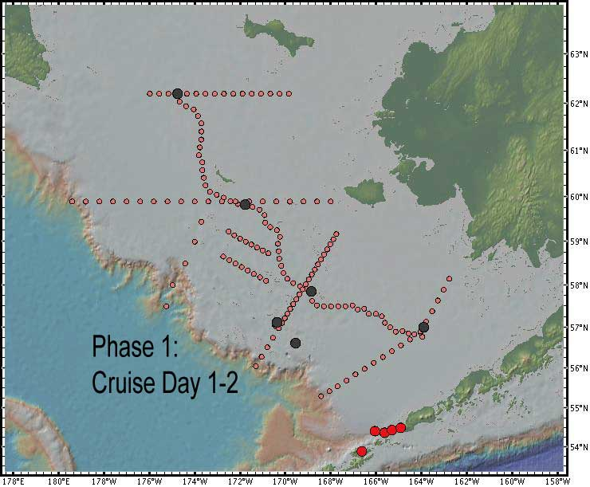
Phase 2 - Initial sampling of Bristol Bay

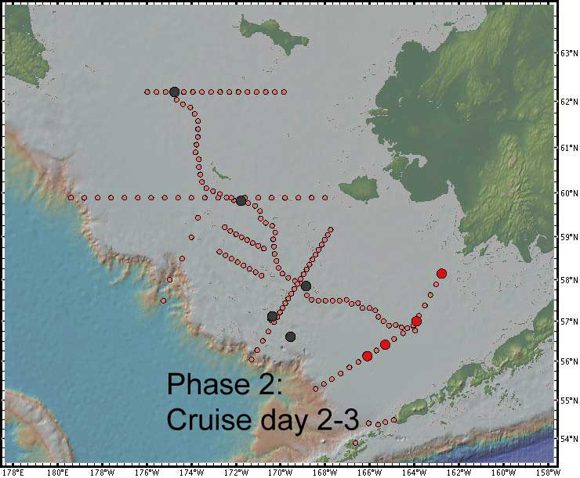

Phase 3 - Long shelf section along 70 m (expected 1st entry into ice)

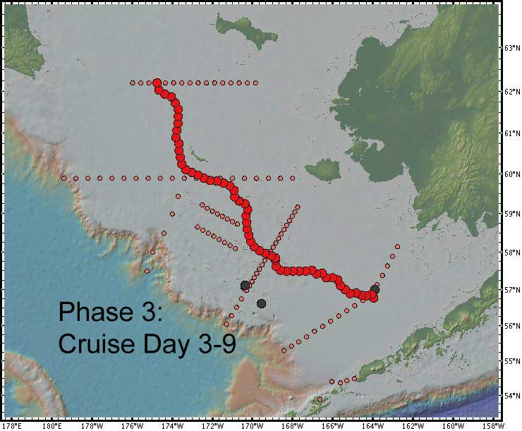

Phase 4 - Northern-most cross shelf section (SL)

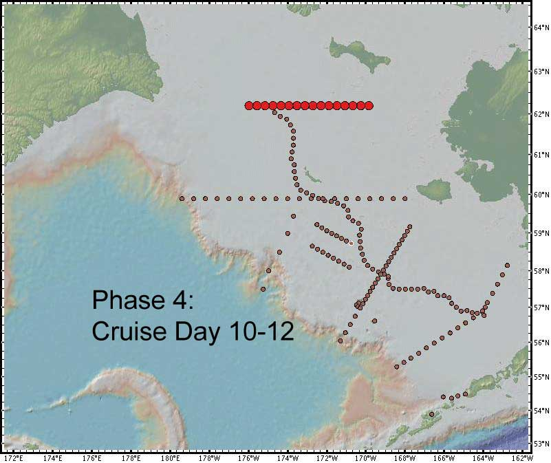

Phase 5 - St. Matthew – Nunivak cross shelf section (SN)

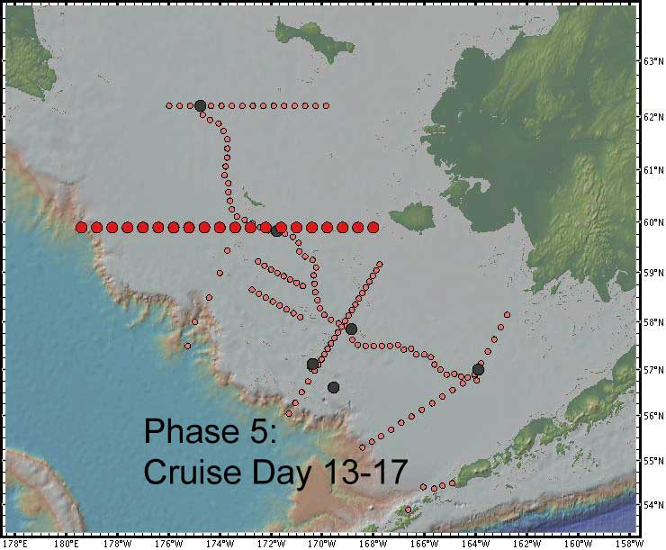

Phase 6 - Nunivak Pribilof line (partial)

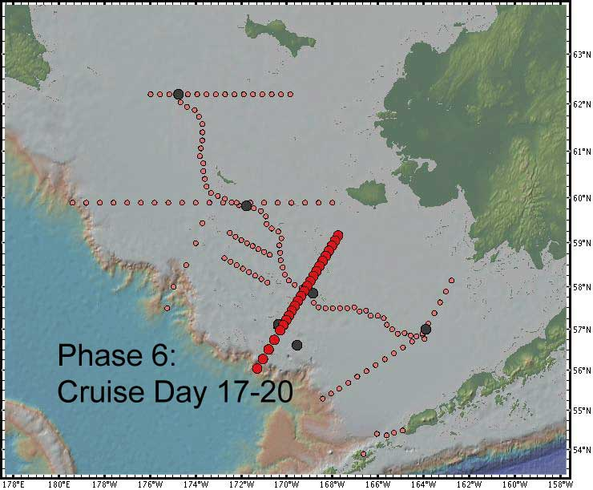

Phase 7 - Exchange of personnel and equipment on St. Paul and education & outreach activities in St. George

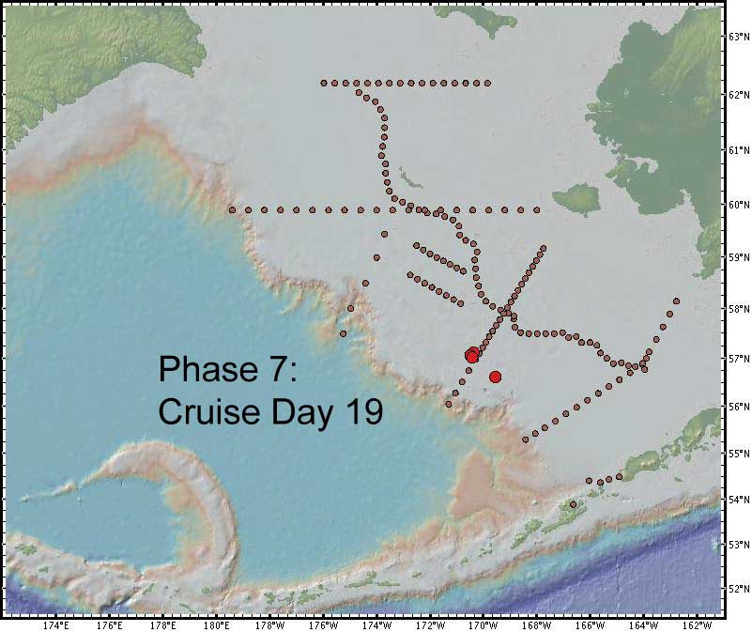

Phase 8 – Joint sampling with Miller Freeman

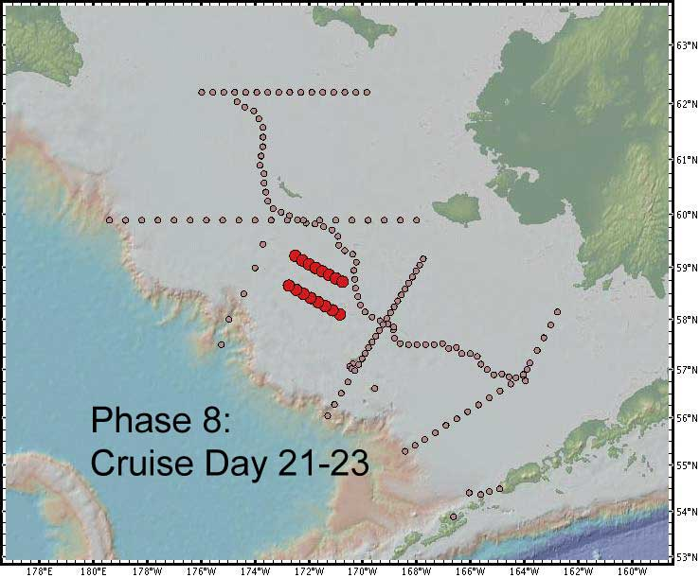

Phase 9 - Reoccupy WOCE P14 stations through Zemchung Canyon

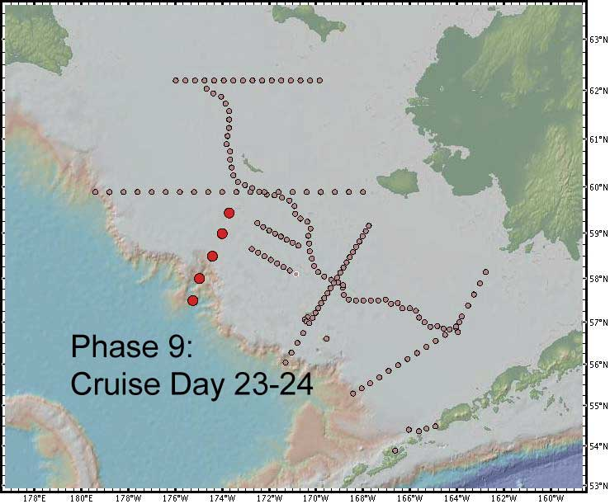

Phase 10 – Work in ice along St. Matthew – Nunivak cross shelf section (SN)

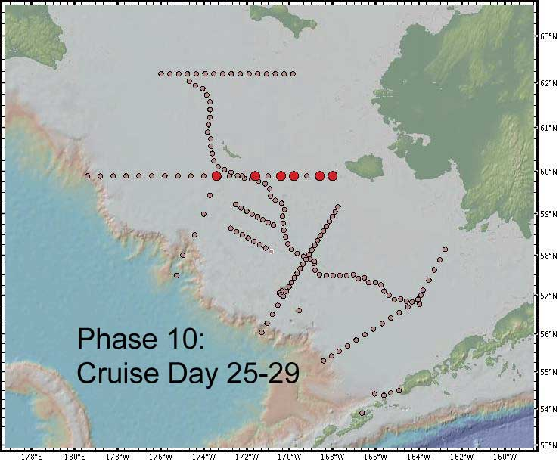

Phase 11 – Work as north as time allows on 70 m line

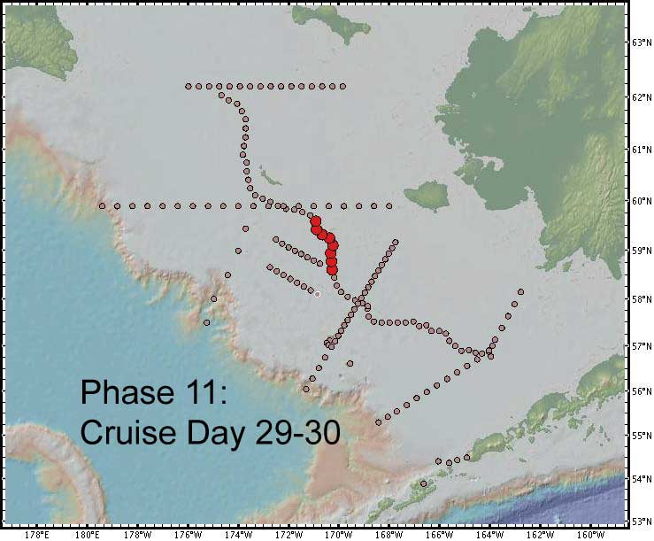

Phase 12 - Southern-most cross shelf sampling along CN line (Note: Miller Freeman may do this and free us for more time in the ice).

