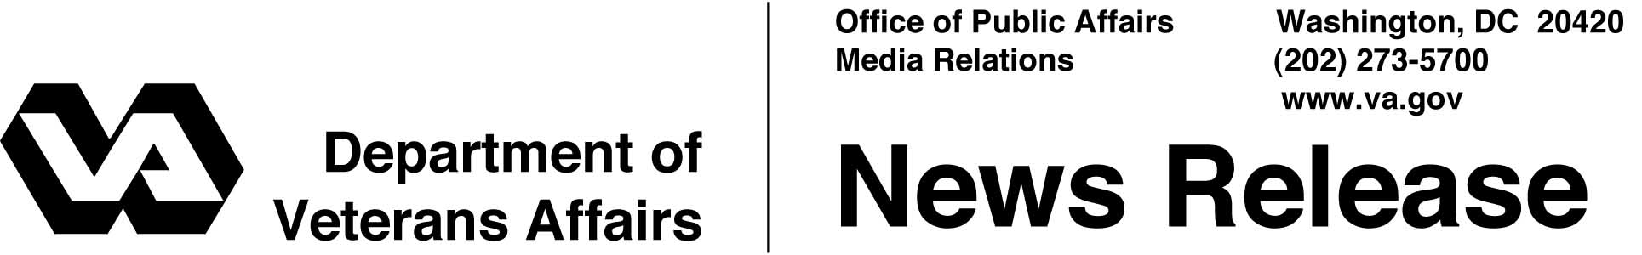

FOR IMMEDIATE RELEASE
May 23, 2001

VA Facilities Plan Memorial Day Observances
WASHINGTON -- Veterans Affairs (VA) facilities throughout the country will observe Memorial Day on May 28 with ceremonies recognizing service members who have given their lives for their country.
Secretary of Veterans Affairs Anthony J. Principi will join President Bush as the president places a wreath at the Tomb of the Unknowns at Arlington National Cemetery to honor those who have died in all of America’s wars.
Principi also called on Americans to pause at 3 p.m. for a National Moment of Remembrance.
"Our strength, our greatness, and our future have been secured by Americans who sacrificed their lives to defend a cause -- a belief larger than themselves, a legacy of freedom," Principi said. "Individually, and as a nation, we are indebted to them and to all who wore the uniforms of our armed services."
Veterans and visitors to VA medical centers, regional offices and national cemeteries will be asked to participate in the National Moment of Remembrance at
3 p.m. local time on Memorial Day. Designed to encourage people to reflect for one minute on the sacrifices of those who died in service for the nation, the observances will feature playing "Taps" on public address systems at many VA facilities.
The National Moment of Remembrance was recognized by an act of Congress to put the "memorial" back in Memorial Day and reclaim its original purpose of honoring America’s fallen heroes. The time was chosen because the mid-afternoon is when many Americans are enjoying the freedoms ensured by those who fought to preserve them.

- More -

Memorial Day 2/2/2/2

Memorial Day ceremonies open to the public are planned at VA national cemeteries around the country. Some will include national, state and local leaders or veterans group officials along with color guards, decorated veterans, bands and choirs.
Many of VA's 119 national cemeteries will have special activities ranging from historical ceremonies, the flying of the Avenue of Flags along the main roads of many national cemeteries and the placement of individual gravesite flags.
Among the day’s significant activities, the Dayton, Ohio, National Cemetery will host a traveling replica of the Vietnam Veterans Memorial; the Postal Service will unveil a new 34-cent flag stamp labeled "Honoring Veterans" at Florida National Cemetery and Indiantown Gap National Cemetery in Pennsylvania; and a flyover of World War II vintage planes at Los Angeles National Cemetery will be part of a ceremony that includes World War II veteran and actor Ernest Borgnine.
More than 8 million people visit VA's national cemeteries each year to pay tribute to some of the nearly 900,000 Americans who have died while in military service. To honor its continuing commitment to veterans, VA is planning six new national cemeteries. Four new state veterans cemeteries are opening over the next few months.
Veterans with an "other than dishonorable" discharge are entitled to burial in a VA national cemetery or, if buried in a private cemetery, VA will provide a headstone or marker for unmarked graves. Funeral homes can help survivors arrange for a burial flag, military funeral honors and a Presidential Memorial Certificate bearing the signature of the president recognizing a veteran's service to the country.
In addition, survivors of those veterans who were receiving VA payments at the time of death may be eligible for one of several types of reimbursements for certain burial expenses.
More information is available from the VA at 800-827-1000 or on the Web at http://www.cem.va.gov.
# # #

