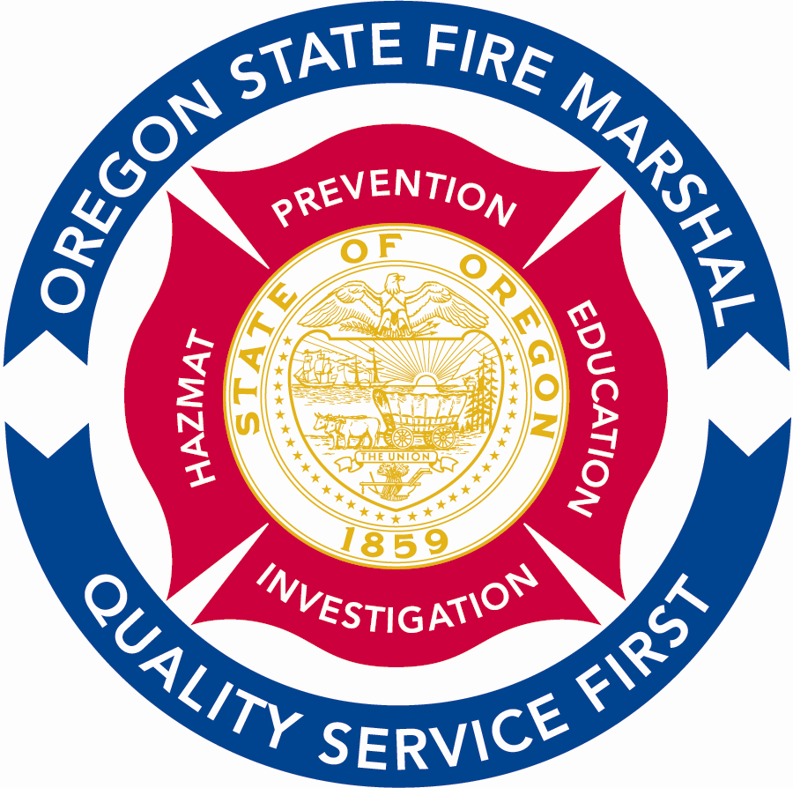
Office of Homeland Security

Office of State Fire Marshal
4760 Portland Road NE
Salem, OR 97305-1760
(503) 378-3473
Fax (503) 373-1825 fax
TTY (503) 390-4661
E-mail: Oregon.sfm@state.or.us
www.sfm.state.or.us
OREGON
Theodore R. Kulongoski, Governor

May 22, 2006

For Immediate Release
Contact: Donna Disch, Public Information Officer (503) 373-1540, ext. 275
(503) 945-0329, pager

Unit Citation awarded to Governance Board of Urban Search and Rescue Task Force

Oregon Fire Chiefs Association (OFCA) President Chief Jay Lilly of McMinnville awarded an OFCA Unit Citation to the Governance Board of the Oregon State Fire Marshal Urban Search and Rescue (USAR) Task Force during the 2006 Oregon Fire Service Meritorious Awards on May 19th at the Portland Metropolitan Exposition Center in Portland.

The USAR Task Force is a critical response element designed to assist with structural collapse rescue services resulting from either terrorist or natural disasters. They fill the void between initial response of local individual fire agencies responding first to an emergency scene and federal USAR services responding from outside the state. The nearest federal response services are in the Puget Sound area of Washington, Salt Lake City, Utah and in Sacramento, California.

The task force operates under an ORS 190 agreement and established the governance board to develop response capability standards and procedures. Through their leadership a $1.2 million federal Homeland Security grant secured specialized equipment and established three mobile equipment caches strategically located around the state. The board coordinated classes to train more than 200 fire service personnel in structural collapse specialty operations and management of technical rescue. Additionally they obtained funding and equipment for personal protective gear and communications devices to ensure safer effective operations.

The task force is mobilized by the Governor and sent to any place in the state needing advanced technical rescue services.

(continued)
The OFCA Unit Citation recognizes two or more individuals, functioning as a group working toward a common goal and awards performance of exceptional quality, professional performance and dedication to duty by the unit as a whole. USAR Task Force Governance Board members include:
Captain John Oliver, Clackamas County Fire District #1

Engineer Ben Meigs, Eugene Fire & EMS

Operations Chief Mike Burnett, Hillsboro Fire Department

Training Chief Sam Phillips, Hillsboro Fire Department

Special Ops Chief Don Schallberger, Hillsboro Fire Department

Battalion Chief Ed Fitzgerald, Portland Fire & Rescue

Battalion Chief Scott Parker, Salem Fire Department

Retired Chief Deputy of Operations Dennis Shew, Springfield Fire and Life Safety

Captain John McDowell, Springfield Fire and Life Safety

Division Chief Mike Duyck, Tualatin Valley Fire & Rescue

Captain Milt Villegas, Tualatin Valley Fire & Rescue

####

