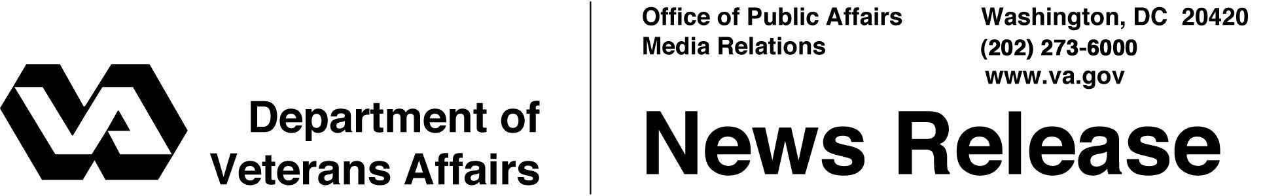

FOR IMMEDIATE RELEASE
June 12, 2003

VA Establishes Energy Conservation Program
WASHINGTON – The Department of Veterans Affairs (VA) is developing an agency-wide program to improve energy efficiency and conservation in the department’s facilities.
Existing energy program initiatives will be brought under the umbrella of the Office of Management, which will establish and coordinate department-wide energy policies and programs.
"VA will, for the first time, have a systematic, department-wide approach to energy conservation," said Deputy Secretary of Veterans Affairs Dr. Leo S. Mackay, Jr. "In addition to being a good steward of the environment, VA will save money that can be used to improve the lives of our veterans."
The energy conservation program will promote efficiency in building design and operations, energy consumption, water conservation and use of new advances in energy conservation technologies.
In June 2003, VA began an energy pilot program to test the department’s new approach to contracting for energy investments in VA medical facilities in Pennsylvania, West Virginia, New Jersey, California and Nevada, as well as at the Riverside National Cemetery.
Goals of the energy conservation program include:
- Reducing greenhouse gas emissions by 30 percent in 2010, as compared to FY 1990 emission levels;
- Reducing energy consumption per square foot by 35 percent in 2010, as compared to FY 1985;
- Expanding the use of renewable energy within VA facilities;
- More -
Energy 2/2/2/2

- Reducing the use of petroleum within VA facilities;
- Reducing overall water consumption in VA facilities and completing a water management plan in 80 percent of facilities by 2010;
- Promoting energy-efficient construction and building design for VA facilities; and
- Using Energy Star and other energy-efficient equipment within VA facilities.

VA will roll out its energy conservation program at an Energy Industry Forum on June 17 at the Washington Convention Center. For details regarding the forum, as well as additional information on VA’s energy conservation program, visit the VA Web site at http://www.va.gov/budget/capital/energy/.

# # #

People wishing to receive e-mail from VA with the latest news releases and updated fact sheets can subscribe at the following Internet address:
http://www.va.gov/opa/pressrel/opalist_listserv.cfm

