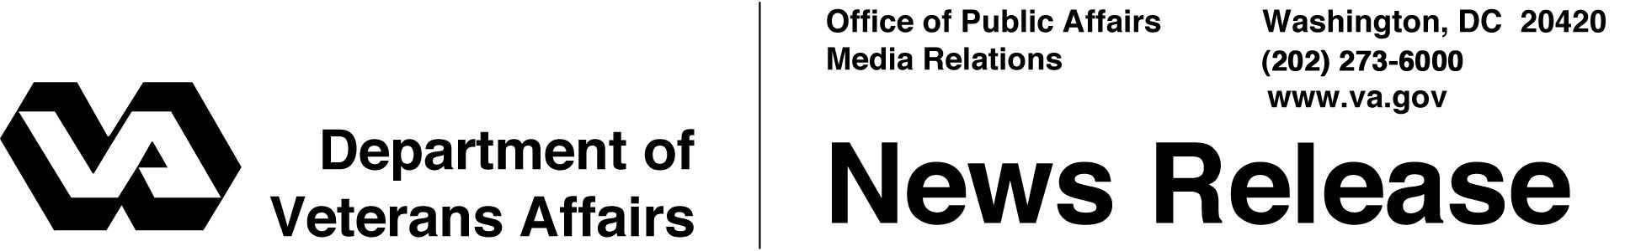

FOR IMMEDIATE RELEASE
August 9, 2002

VA Grant To Improve New Hampshire State Cemetery
WASHINGTON -- Secretary of Veterans Affairs Anthony J. Principi today announced the award of a $2.6-million grant to New Hampshire for improvements at the New Hampshire State Veterans Cemetery in Boscawen.
The project will provide for construction of an administration building, add more than 1,500 columbarium niches for cremated remains and provide for additional road, drainage and irrigation improvements.
"This award, and an increasing number like it for state veterans' cemeteries, recognize the contribution of America's aging veterans," said Principi. "I appreciate President Bush's leadership in supporting a 28-percent boost in next year's VA budget for state veterans' cemeteries."
The facility, established with the assistance of a grant from the Department of Veterans Affairs (VA) in 1998, is on Route 3 in Boscawen about 10 miles north of the state capital in Concord.
The New Hampshire cemetery provided 220 burials to veterans and eligible family members last year. The 104-acre cemetery is also scheduled to become the site of a memorial to New Hampshire’s military veterans who served in the armed forces from colonial times to the present.
A not-for-profit corporation, the New Hampshire Veterans Cemetery Association, is overseeing fundraising and design of an historical walkway that will be integrated into the overall cemetery design. Plans call for completion of the project in 2003.

- More -
New Hampshire cemetery grant 2/2/2

As a complement to VA’s system of national cemeteries, the state cemetery grants program has helped establish, expand or improve 48 operational state veterans cemeteries. Seven additional cemeteries are under construction. The state veterans cemeteries provided 15,409 burials in 2001. Since the program began in 1980, VA has awarded 120 grants for more than $138 million to 28 states, plus Guam.
Information about the grants program is available by contacting VA’s State Cemetery Grants Service at (202) 565-6801. Eligibility for burial in the New Hampshire State Veterans Cemetery is open to all veterans on the same basis as eligibility for burial in a VA national cemetery. Information can be obtained from the cemetery website on the Internet at http://www.state.nh.us/adjgeneral/cemetery.htm. Details may be obtained by calling the New Hampshire State Veterans Cemetery at (603) 227-1592.
Information on VA burial benefits can be obtained from national cemetery offices, from VA web sites on the Internet at http://www.va.gov or http://www.cem.va.gov or by calling VA regional offices toll-free on 1-800-827-1000.

# # #

