LIMIT EXCEEDED MESSAGES
These messages warn that one of the card limits has been exceeded.
USER MESSAGE
One of the following:
  - “Purchases exceed transaction dollar limit per transaction”
  - “Purchase exceed number of transactions per day”
  - “Purchases exceed gallons per transaction day”
  - “Eight or more Fleet card transactions per day for pool or equipment charges”
  - “Ten or more Fleet Card transactions in the thirty days per Fleet Card account”
ACTION
Review cardholder transactions to determine whether card should be withdrawn. Consult with management regarding possible disciplinary action. Note results and describe actions in the COMMENTS field of the User Messages window.
MULTIPLE TRANSACTIONS ON SAME DATE TO SAME VENDOR USER MESSAGE
This alert is generated when a cardholder has multiple transactions on the same date to the same vendor where combined transaction amounts exceed the single purchase limit.
USER MESSAGE
“More than one Fleet card transaction for the same vendor.”
ACTION
Review transaction details. Follow up with cardholder to determine legitimacy of multiple transactions to same vendor on same date. Consider whether transaction should be reviewed according to exceeded limits guidelines. Note results in the COMMENTS field of the User Messages window.

STATISCTICAL SAMPLING MESSAGE
This message identifies records chosen for inclusion in a statistical sampling survey.
USER MESSAGE
“This transaction has been selected for statistical sampling.”
ACTION
Review the transaction details from the User Messages screen in PCMS and answer the statistical sampling questions. Describe the actions taken in the COMMENTS field of the Audit Statistical Sampling screen.

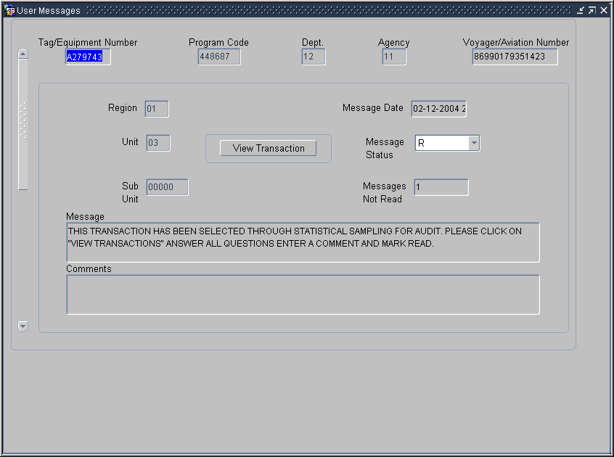

FLEET PCMS USER MESSAGES/ALERTS AND STATISTICAL SAMPLING REFERENCE GUIDE

Originated: August 2004



Prepared by:
Office of Procurement and Property Management
Procurement Systems Division

PURPOSE
This is a reference guide for AFHC\LFPCs when responding to alert system messages in the User Messages window in PCMS. Included is a description of each message, the text of the message and actions necessary to resolve the alert. The PCMS Fleet alert system is an integral tool for oversight of the Program and deter against fraud, waste, and abuse. USDA policy states that use of the Fleet and\or Aviation card is for official government business purposes only. See DR5400-6 Fleet Credit Card, for complete policy details.

ACTION
Following are the general steps an LFPC should follow when a User Message is received:
- Contact the person holding the Fleet card and discuss the reason the alert was generated.
- Update Comments with a description of the steps taken.
- Change Message Status to Read in PCMS Fleet User Message and Save User Message.

PROFILE ACCOUNTING MESSAGE
This message warns that accounting data has been changed more than twice a month.
USER MESSAGE
“Profile Accounting changed more than twice in the month.”
ACTION
Contact the person holding the Fleet card for an explanation. Review the accounting details in the Fleet Profile Accounting window in PCMS and ensure that the information is accurate. Note results of review and describe the actions taken in the COMMENTS field of the User Messages screen.

HOLIDAY PURCHASE MESSAGE
This message warns of potential non-business purchases.
USER MESSAGE
“Purchase made on a holiday”
ACTION
Contact the person holding the Fleet card for an explanation. Note results in the COMMENTS field of the User Messages window.

DISPUTED TRANSACTION MESSAGE
This alert warns the LFPC of a disputed transaction that has not been resolved within 45 days of the dispute date.
USER MESSAGE
“Transaction in dispute 45 days. All dispute documentation must be sent to the bank within 60 days from purchase date.”
ACTION
Review the transaction details from the User Messages screen in PCMS. Note results of review and describe the actions taken in the COMMENTS field of the User Messages screen. Be sure that all documentation has been sent to the bank.

SUSPICIOUS PRODUCT CODE MESSAGE
This message identifies transactions involving suspicious product codes.
USER MESSAGE
“Invalid product code”
ACTION
Review transaction details. Follow up with the person holding the Fleet card to discuss any discrepancies and review legitimacy of the purchase. Note results and describe actions in the COMMENTS field of the User Messages window.

LOST OR STOLEN CARD MESSAGE
This message warns that a card has been lost or stolen 3 or more times.
USER MESSAGE
“Card has been reported lost or stolen 3 or more times.”

ACTION
Investigate circumstances of loss or theft to determine if fraud has occurred. Consult with management regarding possible disciplinary action. Note results and describe actions in the COMMENTS field of the User Messages window.

UNRECOGNIZED TAG NUMBER MESSAGE
This message indicates that the vehicle tag number is not entered in the system.
USER MESSAGE
“Tag Number xxxxxxxx is not in PROP. Please enter Tag Number into PROP.”
ACTION
Verify legitimacy of tag number and add to system. Contact the person holding the Fleet card for explanation if tag number is not legitimate. Note results in the COMMENTS field of the User Messages window.

FUEL OTHER THAN PRODUCT CODES 25 AND 27 FOR AIRCRAFT MESSAGE
This message indicates an incorrect type of fuel was charged to an aircraft card.
USER MESSAGE
“Charges to aircraft for fuel other than product codes 25 and 27 which are AV gas and Jet Fuel for an aircraft card.”
ACTION
Contact the person holding the Fleet card to determine whether incorrect card or incorrect code was used. Correct accounting information accordingly. Note results in the COMMENTS field of the User Messages window.

