

Lesson 6: Fleet Card Setup

Lesson Description

In Lesson 6 LFPCs and AFHCs will learn how to create and maintain Fleet credit card accounts in PCMS. This lesson assumes participants have the ability to navigate PCMS and an understanding of the purpose of creating and maintaining Fleet accounts.

Training Objectives

At the conclusion of this lesson, PCMS LFPC’s and AFHC’s will be able to:

- Create, maintain, and query Fleet card accounts in FAMS.
- Delete, and replace Fleet cards.

Methodology

This lesson will be delivered using a combination of lecture and presentation, and discussion. Group discussion and trainee interaction will be used to stimulate recall of policy information and establish a knowledge base on which to build in subsequent lessons.

References

None

Enclosures

(1) Fleet PCMS User’s Guide, USDA\PMT, June 2006;
- Fleet PCMS Quickguide, USDA\PMT, October 2000;

- Fleet Card Setup Overview

Please turn off your monitor and give your attention to the instructor.

  - Workflow

The Fleet Card Setup window is used to setup Fleet card accounts for vehicles and equipment, establish specific vehicle\equipment profile information, and replace or delete Fleet cards.

The LFPC enters Fleet card details in PCMS. This information is then downloaded to the Bank by ACFS\FO on a nightly basis. After receiving the Fleet card details, the bank sends PCMS an acknowledgment in response to each account setup or maintenance request. The Fleet card account number is also issued at this point.

Notes:

  - Fleet Card Window
To access the Fleet Card window, click Fleet Card on the main menu and select Fleet Card Setup.

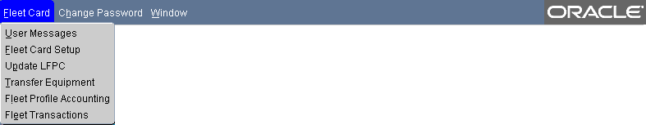

Enter details in the fields to create or modify Fleet card accounts.

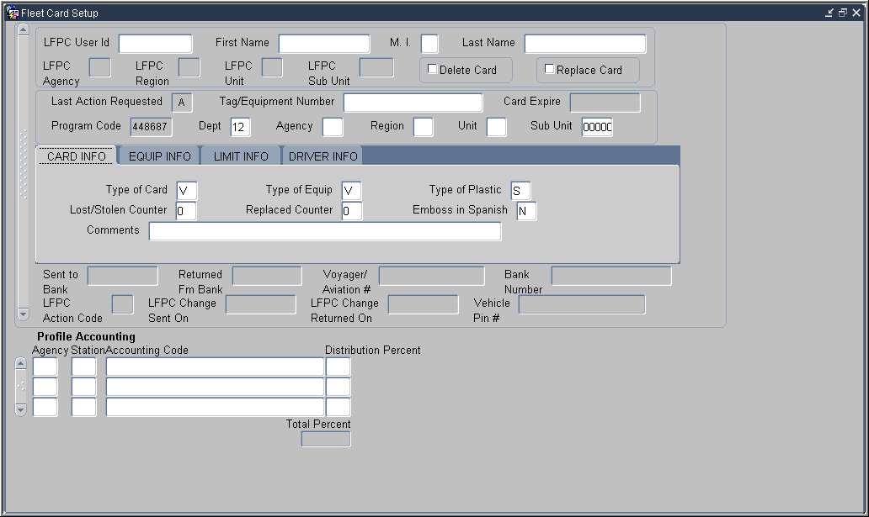

Notes:

  - LFPC Details

The following is a brief description of each LFPC field in the Fleet Card Setup screen.

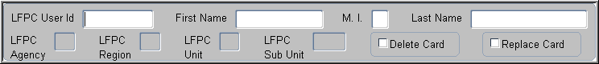
Fields:
Fieldname | Description
LFPC User ID  (Required field) | The PCMS user identification number of the LFPC assigned to the fleet card to either be added to or retrieved from PCMS. (Query field.)
First Name  (Required field) | The LFPC’s first name.
M. I.  (Required field) | The LFPC’s middle initial.
Last Name  (Required field) | The LFPC’s last name.
 | The LFPC’s organizational structure\hierarchy.  (Non-entry fields)
  LFPC Agency
  LFPC Region
  LFPC Unit
  LFPC Sub Unit
Delete Card | Use to delete a fleet card record at the bank.  Note: Cards cannot be deleted if Last Action Requested = A.
Replace Card | Use to replace a fleet card. Check this box to replace a card that has been damaged.  Note: Cards cannot be deleted if Last Action Requested = A.

All fields lock when you select either Delete Card or Replace Card

- Hierarchy Details

Fields:
Fieldname | Description
Last Action Requested  (Non-entry field) | When a card record is completed and saved, the Last Action Requested field is programmatically assigned one of the following values:  A - add, M - modify, D - delete, L - LFPC Information Changed,  R -replacement, T - transfer of equipment, and U - update.
Tag/Equipment Number  (Query field.) | Equipment identification number.
Card Expire  (Non-entry field) | Card expiration date.  Populated by the system when the record is returned from the bank.
Program Code  (Non-entry field) | The program code for each equipment record is hard coded into the system.
Dept  (Required field) | Contains the default value of 12 for USDA. This value can be changed.
Agency  (Required field) | The agency where the fleet card will reside.
Region  (Required field) | The region where the fleet card will reside.
Unit  (Required field) | The unit where the fleet card will reside.
Sub Unit  (Required field) | The sub-unit where the fleet card will reside.  Default is 00000.

Setup \ Maintenance Information
The setup\maintenance information is contained in the center of the Fleet Card Maintenance window, beginning with Card Information. It is organized into four tabs: Card Info, Equip Info, Limit Info and Driver Info. Click on the tab header to navigate between sections.

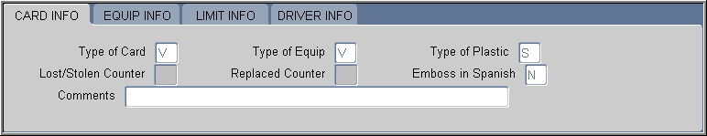
Card Info Tab

Fields:
Fieldname | Description
Type of Card  (Required Field) | Valid values are:  N = Neither D = Driver V = Vehicle
Type of Equip  (Required Field) | Valid values are:  A = Aircraft E = Equipment V = Vehicle  B = Boat P = Pool  Type of Card vs. Type of Equipment  - If the Type of Card = D, the Type of Equipment can only be V.  - If the Type of Card = V, the Type of Equipment can only be V.  - If the Type of Card = N, the Type of Equipment can be A, B, E, or P.  Type of Equipment vs. Tag/Equipment Number  - If the Type of Equipment = A, the Tag/Equipment Number must begin with N.  - If the Type of Equipment = P, the Tag/Equipment Number must begin with P.
Type of Plastic | Valid values are:  Q = Quasi-Generic – non-government/government card  S = Standard – government card
Lost/Stolen Counter  (Non-entry field) | Displays the number of times the card has been reported as lost or stolen.
Replaced Counter  (Non-entry field) | Displays the number of times the card has been replaced.
Emboss in Spanish  (Required Field) | Valid values are:  Y = Yes or N = No  Changing this field will generate a new Voyager account number and a new fleet card.
Comments  (Not Required) | User field for comments.

Notes:

Equip Info Tab
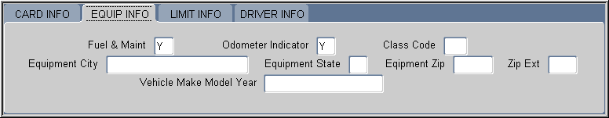

Fields:
Fieldname | Description
Fuel & Maint  (Required Field) | Valid values are:  Y = Yes or N = No
Odometer Indicator  (Required Field) | Valid values are:  Y = Yes or N = No  If the Type of Card is “V,” the Odometer Indicator is “Y” and no changes will be allowed.  If the Type of Card is “N” or “D,” the Odometer Indicator is “N.”
Class Code  (Optional Field) | Values for this field are yet to be determined. Field describes equipment size (e.g., medium sedan; light, medium, or heavy truck).
Equipment City | The city where the equipment will reside.  (Required if Type of Card is Vehicle or Neither.)
Equipment State | The state where the equipment will reside.  (Required if Type of Card is Vehicle or Neither.)
Equipment Zip | The zip code where the equipment will reside.  (Required if Type of Card is Vehicle or Neither.)
Zip Ext  (Not required.) | The zip extension of where the equipment will reside.  (Not required.)
Vehicle/ Make/Model/Year  (Not required.) | The vehicle’s make, model, and year.  Valid only when Type of Card is Vehicle or Driver.

Notes:

Limit Info Tab
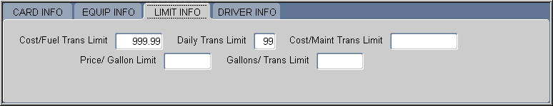

Fields:
Fieldname | Description
Cost/Fuel Trans Limit  (Required Field) | Fuel costs per transaction limit. Field defaults to all 9’s (999.99) unless individual agencies reset. Individual agencies determine their own limits.
Daily Trans Limit  (Required Field) | Transaction limit per day. Field defaults to all 9’s (99) unless individual agencies reset. Individual agencies determine their own limits.
Cost/Maint Trans Limit  (Required Field) | Maintenance cost per transaction limit. Field defaults to all 9’s (999999.99) unless individual agencies reset. Individual agencies determine their own limits.
Price/Gallon Limit  (Required Field) | Price per gallon limit. Field defaults to all 9’s (999.99) unless individual agencies reset. Individual agencies determine their own limits.
Gallons/Trans Limit  (Required Field) | Gallons per transaction limit. Field defaults to all 9’s (9999.99) unless individual agencies reset. Individual agencies determine their own limits.

Notes:

Driver Info Tab
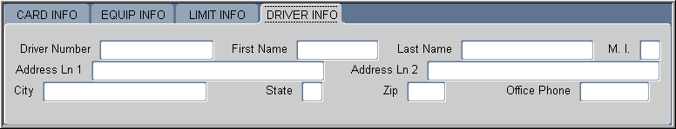
The Driver Information is only required when the Type of Card is Driver.

This window is not used by USDA at this time.

Fields:
Fieldname | Description
Driver Number | USDA’s driver identification (license) number.
First Name  (Required Field) | Driver’s first name.
Last Name  (Required Field) | Driver’s last name.
M.I.  (Required Field) | Driver’s middle initial.
Address Ln1  (Required Field) | Driver’s Department/Agency.
Address Ln2 | Driver’s address information.
City  (Required Field) | The driver’s office city.
State  (Required Field) | The driver’s office state.
Zip  (Required Field) | The driver’s office zip.
Office Phone  (Required Field) | Driver’s office phone number.

Notes:

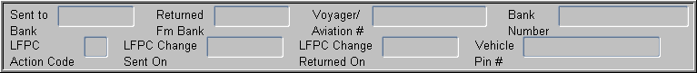

Bank \ LFPC Information

Fields:
Fieldname | Description
Note: These fields are informational only; they cannot be updated from this window.
Sent to Bank | Date that a new or updated fleet record was sent to the bank.
Returned Fm Bank | Date the fleet record was returned from the bank.
Voyager/Aviation # | The Fleet Card Voyager/Aviation account number.
Bank Number | The Fleet Card’s bank ghost account number.
LFPC Action Code | Valid values are:  Blank = no updates have been made or L = LFPC information changed.
LFPC Change Sent on | Date that the updated LFPC information was sent to the bank.
LFPC Change Returned on | Date the updated LFPC information was returned from the bank.
Vehicle Pin # | The vehicle pin number. (Must be used when making purchases).

Notes:

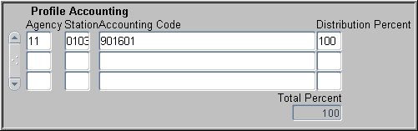
Profile Accounting

One or more lines of profile accounting information for the vehicle can be entered here.
Fieldname | Description
Agency  (Required Field) | The agency code that the purchase is to be charged against.
Station | The accounting station code that the purchase is to be charged against.
Accounting Code  (Required Field) | The accounting code against which this portion of the transaction is charged.*
Distribution Percent  (Required Field) | The percentage of this account to be applied to the transaction amount.
Total Percent  (Non-entry Field) | The total percentage to be applied to the transaction amount. This field must equal 100 percent.

Update Profile accounting details through the Profile Accounting window.

Notes:

- Query Fleet Card Records

Please turn off your monitor and give your attention to the instructor.

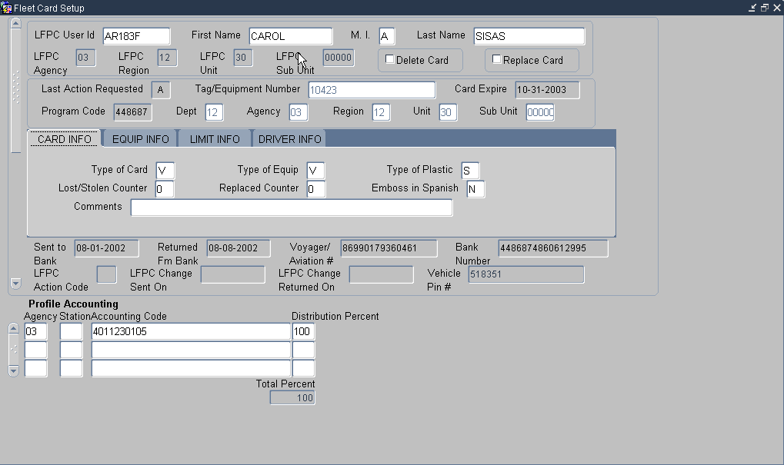

  - Query ALL records
- Click on the command bar to clear all fields
- Click again to generate a list of all records associated to the LFPC currently logged on
- Use the vertical scroll bar to navigate between vehicle\equipment records or click Record on the command menu and select Next or Previous.

  - Query specific records
- Click on the command bar once
- Enter the search value in a query field and click
- The query results display
- The “%” wildcard can be used
- Use the vertical scroll bar to navigate between vehicle\equipment records or click Record on the command menu and select Next or Previous.
- There are several lists available to select values from, such as: “LFPC User ID”;

The List of values option is available for the following fields:

Main Window
- LFPC User ID

Card Info Tab
- Type of Card
- Type of Equipment
- Type of Plastic
- Emboss in Spanish

Equipment Info Tab
- Fuel & Maint
- Odometer Indicator
- Equipment State

It may be quicker to run queries using the Discoverer tool. (Discoverer training is available in a separate training course).

Notes:

PRACTICAL EXERCISE

      - Query all vehicle\equipment records attached to the current LFPC User ID.

      - Query all records that have card plastic type value of “S”.

3. Query all records that have an Equipment State of California (CA) or Arizona (AZ).

- Fleet Card Maintenance

Please turn off your monitor and give your attention to the instructor.

  - Fleet Card Setup
To set up a new Fleet Card account, follow the steps below.

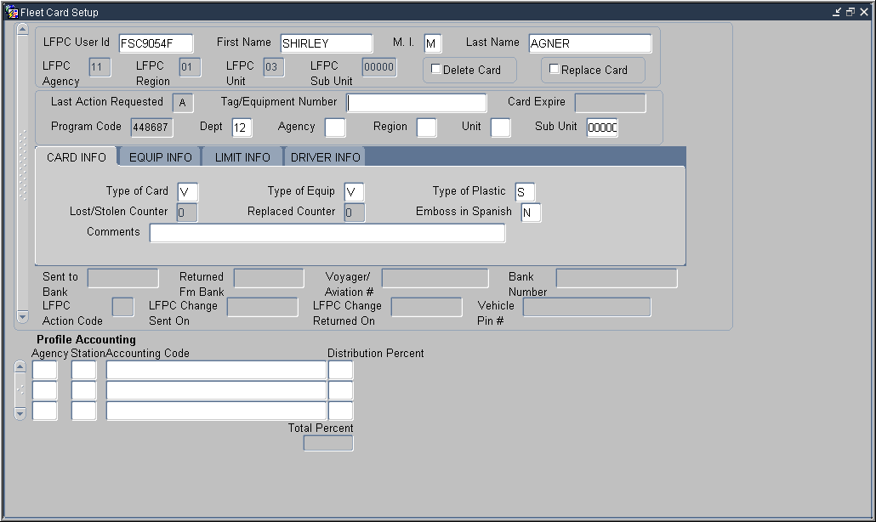
      - Enter the User ID in the LFPC User ID field and hit Tab on the keyboard.
The LFPC User ID fields populate.

Verify the LFPC populate, and that following fields are populated with these values
- Last Action Requested = A
- Depth = 12
- Sub Unit = 00000
These fields must be populated to be able to add the record.

      - Enter the account details:
- Tag\Equipment Number
- Cardholder’s hierarchy (e.g. Agency, Region, Unit, etc)

It is important to enter the correct Tag Number. If an incorrect Tag Number is sent to the Bank a new Tag number will have to be assigned to the vehicle and a new account will need to be created.

      - Enter the setup\maintenance details:
- Card INFO (e.g. Type of Plastic, Type of Card)
- Equip INFO (e.g. Fuel and maintenance, Odometer Indicator)
- Limit INFO (e.g. Cost\Fuel Trans Limit, Daily Trans Limit)

      - Enter the Profile Accounting details.
- Accounting entered during Fleet Card Setup is the default accounting for the Fleet Card.
- Profile Accounting can be updated through the Profile Accounting window.

      - Save the record by clicking on the command bar.
- The Date sent to the Bank field is populated after the data is downloaded to the Bank.
- Accounting can only be changed if the record has not yet been sent to the Bank.
- A record can only be removed if it has not yet been sent to the Bank. Click then on the command bar.

Make sure the Tag Number is correct before clicking .

Notes:

  - Copying a Fleet Card Record
When there are several new Fleet Cards to set up in PCMS that have similar details, the first record entered can be copied and modified so the LFPC does not have re-enter information un-necessarily. Use the following steps:
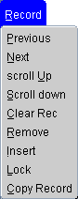
- Enter the first record and click on the command bar.
- Click Record on the menu bar and select Copy Record
- Change any unique setup\maintenance details.
- Click .
- Repeat steps 2 through 4 as necessary.

  - Modifying a Fleet Card Account

To modify a Fleet Card account
- Query a Fleet Card record
- Verify that Last Action Requested does NOT display “A” and Sent to Bank and Returned from Bank fields are populated.
- Change setup\maintenance details as necessary.
- Click .

Guidelines to modifying a Fleet Card account
- All fields in Fleet Card Setup can be modified prior to a record being sent to the Bank.
    - Last Action Code = A, Date Sent To Bank is blank.
- No modifications can be made to a record that has been sent to but not yet returned form the bank.
    - Last Action Code = A, M, T or R
    - Date Sent To Bank is not blank
    - Date Returned From Bank field is blank
- Most fields can be modified once a record has returned from the Bank.
    - Last Action Code = A, M, T or R
    - Date Sent To Bank is not blank
    - Date Returned Fm Bank is not blank
- Updates to Profile Accounting can be done through Fleet Card Setup only if it is a new Fleet Card record and the record has not yet been sent to the Bank.
- New cards will only be issued when information in the magnetic strip or information embossed upon the card changes.

PRACTICAL EXERCISES

    - Create a new Fleet Card record using the following information:
- Tag\Equipment Number: A11374
- Cost Limits: Fuel = $100.00, Daily trans = 03, Maint Trans = $500, Gallon limit = 40, Gallon Trans Limit = $50
- Card is to be used by a Vehicle for fuel and maintenance.
- Card should be a standard plastic.
- Equipment City: Rockville.
- Equipment State: MD
- Equipment Zip Code: 20850
- Codes: Program 448687 \ Dept 12 \ Agency 99 \ Region 01 \ Unit 02 \ Sub Unit 00000
- Station: 0110
- Accounting code: 7010101915
- Distribution % = 100

    - Copy the new Fleet Card record and create a second record using the following unique field values:
- Tag\Equipment Number: A287622
- Cost Limits: Fuel = $100.00, Daily trans = 03, Maint Trans = $500, Gallon limit = 40, Gallon Trans Limit = $50
- Card is to be used by a Vehicle, for fuel and maintenance.
- Card should be a standard plastic.
- Equipment City: Beltsville.
- Equipment State: MD
- Equipment Zip Code: 20705
- Codes: Program 448687 \ Dept 12 \ Agency 99 \ Region 01 \ Unit 02 \ Sub Unit 00000
- Station: 0110
- Accounting code: 7010101915
- Distribution % = 100

- Replacing and Deleting Fleet Cards

Please turn off your monitor and give your attention to the instructor.

  - Last Action Codes
Fleet Card Setup uses the following codes to indicate what action should be taken. Only one code per day can be processed for a Fleet Card record, unless the code is “U”:

U = Update | A = Add | M = Modify | T = Transfer | R = Replace | D = Delete

  - Lost and Stolen Cards

It is the Fleet Card user’s responsibility to report a lost or stolen card to Voyager. However, an LFPC has the authority to do so if the Fleet Card user has not reported it.

- Voyager sets up a new account for the vehicle\equipment.
- ACFS\FO creates a new account in PCMS.
- Verify Last Action Code for the new account displays “A”
- Enter the existing Tag\Equipment Number.
- The system updates the Voyager\Aviation Number and the Lost\Stolen Counter fields.
- ACFS\FO changes the Last Action Code of the old record to “D”.
- The system populates the Comments field with the name of the person who reported the card lost\stolen and the date it was reported.
- Both the old and new records will be available when the LFPC queries a Fleet card in PCMS. Use the scroll bar to navigate between records.

  - Replacement Cards
Over time, cards become damaged and need to be replaced. Follow these steps to request a replacement card.
- Verify the record can be edited.
- Last Action Code = M, T, or R
- Date Sent to Bank is not blank
- Date Returned from bank is not blank
- Check the Replace Card box and click on the Command Bar.
- The record is sent to the bank with an action code of “R”
- The system generates a duplicate card based on the card’s current details in the Fleet Card Setup window. (e.g., Tag\Equipment Number, hierarchy, Card information, etc.).

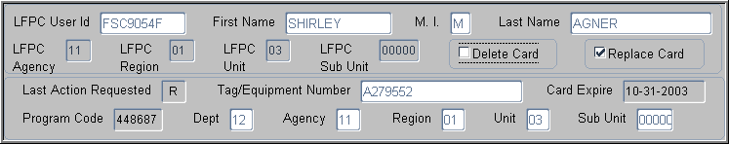

  - Delete a Card
When a vehicle\equipment is taken out of service, it needs to be flagged as deleted in PCMS.
- Verify the record can be edited.
- Last Action Code = M, T, or R
- Date Sent to Bank is not blank
- Date Returned from bank is not blank
- Check the Delete Card box and click on the Command Bar.
- The record is sent to the bank with an action code of “D,” notifying the bank the card is no longer valid.
- ACFO/FS updates the Return from Bank field in PCMS.
- PCMS will not allow any modifications to records with a Last Action Code of “D.”
- Once a tag\equipment number is deleted, the number can not be re-used.

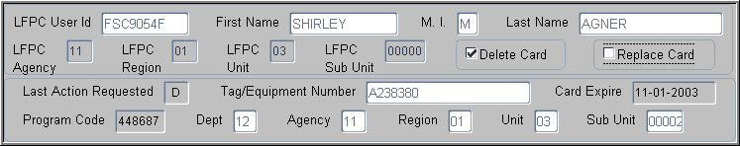

PRACTICAL EXERCISES

- Query the following record, and request a replacement card:
- Tag\Equipment: A010214

- Query the following record, and delete the card:
- Tag\Equipment: A010210

Notes:

- Update LFPC

Please turn off your monitor and give your attention to the instructor.

  - Window Overview
To access the window, click Fleet Card on the main menu and select Update LFPC.

Update the record as necessary.

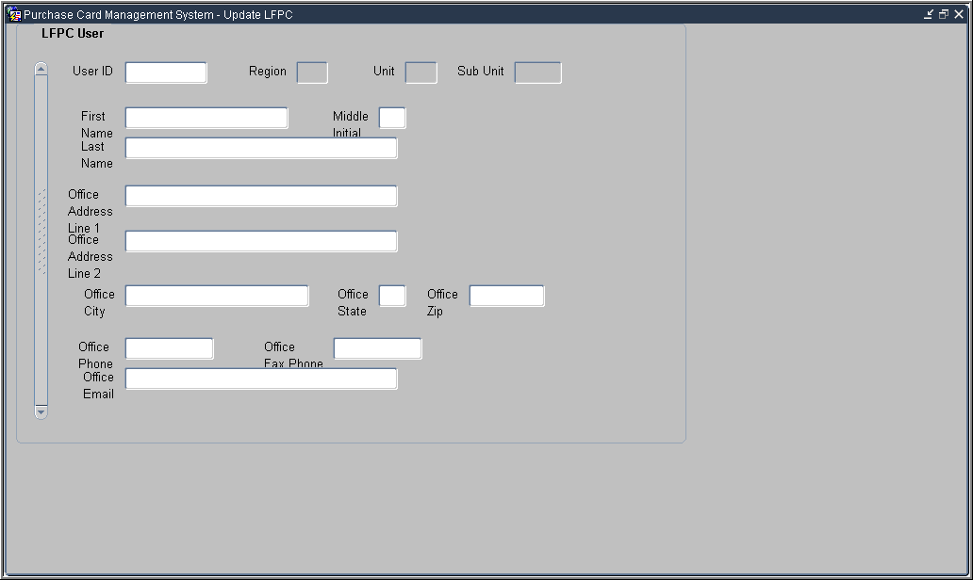

Notes:

  - Updating an LFPC
When updating this information in PCMS contact the AFHC to have SAMS information updated as well.

Fields:
Fieldname | Description
User ID | The PCMS user identification number of the LFPC.  (Required, alphanumeric, maximum 20 positions)
Region | The LFPC’s organizational structure/hierarchy.  (Non-entry fields.)
Unit
Sub Unit
First Name | The LFPC’s first name.  (Required, alphanumeric, maximum 12 positions)
Middle Initial | The LFPC’s middle initial.  (Required, alphanumeric, 1 position)
Last Name | The LFPC’s last name. (Query field.)  (Required, alphanumeric, maximum 20 positions)
Office Address Ln 1 | The LFPC’s office address.  (Required, alphanumeric, maximum 36 positions)
Office Address Ln 2 | Additional LFPC address information as needed.  (Alphanumeric, maximum 36 positions)
Office City | The LFPC’s office city.  (Required, alphanumeric, maximum 25 positions)
Office State | The LFPC’s office state.  (Required, alpha, 2 positions)
Office Zip | The LFPC’s office zip code.  (Required, numeric, 5 positions
Office Phone | The LFPC’s office work phone.  (Required, alphanumeric, 10 positions)
Office Fax Phone | The LFPC’s office fax phone number.  (Required, alphanumeric, 10 positions)
Office Email | The LFPC’s email address.  (Required, alphanumeric, maximum 50 positions)

Updating New LFPC details
When an LFPC is initially given access to PCMS, only the user id, name, office phone, and hierarchy appear in PCMS. Before you can add a fleet card record to a new LFPC you need to complete the LFPC information (e.g., address, phone, etc.) located on the Update LFPC window

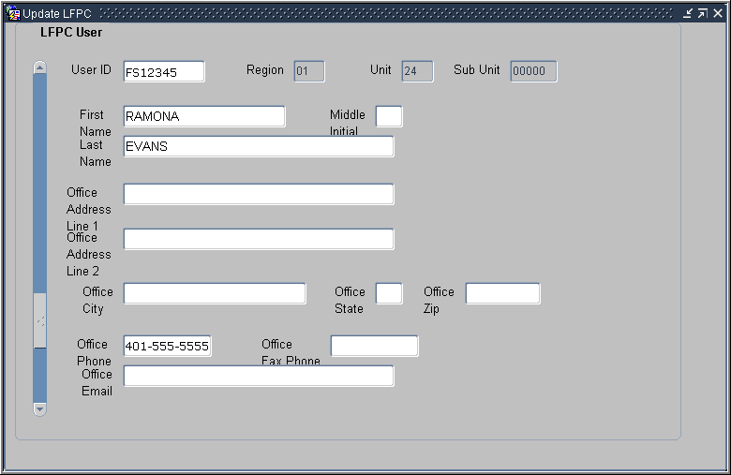
- Click Fleet Card on the main menu and select Update LFPC.
The Update LFPC window opens.
- Enter the User ID and click on the command bar.
The LFPC User record displays.
- Enter all appropriate LFPC information and click on the command bar.
- Click Action on the menu and select Exit to return to the main window.

Updating Existing LFPC details
The steps below describe the process to update information for LFPCs whose records have previously been completed in they system.

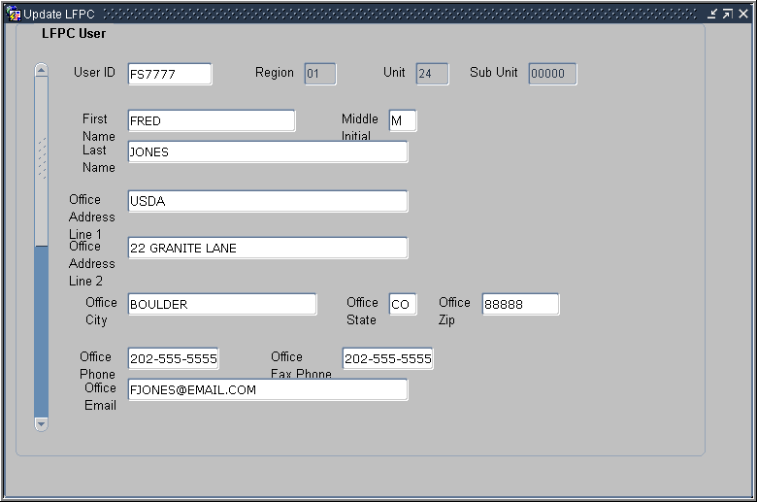
- Click Fleet Card on the main menu and select Update LFPC.
The Update LFPC window opens.
- Enter the User ID and click on the command bar.
The LFPC User record displays.
Or, click twice to retrieve all user records and scroll through the results to find the desired record.
- Enter all appropriate LFPC information and click on the command bar.
- Click Action on the menu and select Exit to return to the main window.
The system will make the following updates in the Fleet Card Setup window:
- LFPC Action Code will display an L (LFPC Information Change) in each record tied to that LFPC to indicate LFPC changes were made.
- LFPC Change Sent On date will be updated when the data is processed by ACFS\FO.
- LFPC Change Returned On date will be updated with the date the bank acknowledgement is received.
The “L” action code and date fields allow LFPC information to be changed without preventing additional modifications to the equipment records. If both a change to the LFPC information and a change to any equipment record for that LFPC are made, the addition, deletion, modification, replacement, or transfer will be sent for processing with the updated LFPC information. All equipment records for this LFPC will be sent to the bank, with an LFPC Action Code of “L” and with the appropriate action code of A, D, M, R, or T, depending if additional actions were taken on the record.

Notes:

- Summary and Review.

Please turn off your monitor and give your attention to the instructor.

- What are the main functions the LFPC performs using Fleet Card Setup?

- What are the steps for an LFPC when setting up a new Fleet Card account? (Walk the instructor through the steps)

- What would prevent a new Fleet Card record from being modified in Fleet Card Setup?

- If a Cardholder has a damaged purchase card how do they obtain a replacement?

Lesson 7: Transfer Equipment

Lesson Description

In Lesson 7 LFPCs and AFHCs will learn how to transfer equipment records to other LFPC accounts in PCMS. This is the concluding lesson in the Fleet PCMS training course.

Training Objectives

At the conclusion of this lesson, PCMS LFPC’s and AFHC’s will be able to:

- Query and transfer equipment records.

Methodology

This lesson will be delivered using a combination of lecture and presentation, and discussion. Group discussion and trainee interaction will be used to stimulate recall of policy information and establish a knowledge base on which to build in subsequent lessons.

References

None

Enclosures

  - Fleet PCMS User’s Guide, USDA\PMT, June 2006;
  - Fleet PCMS Quickguide, USDA\PMT, October 2000;

- Transfer Equipment Overview

Please turn off your monitor and give your attention to the instructor.

  - Transfer Equipment Window
To access the Transfer Equipment window, click Fleet Card on the main menu and select the Transfer Equipment.

Enter details in the fields to initiate a request to transfer equipment between LFPCs.

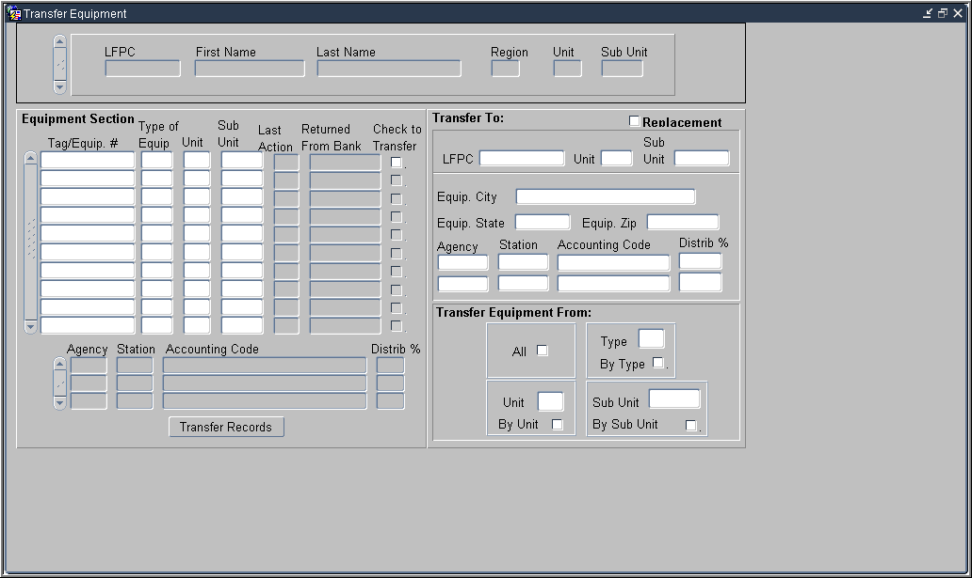

Notes:

  - Fields
The following is a brief description of each field in the Transfer Equipment window.

LFPC Details

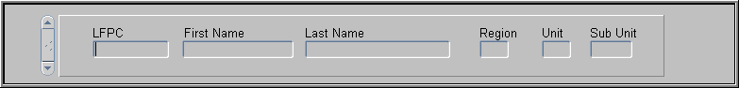

Fieldname | Description
LFPC  (Required field) | The LFPC user identification number.  (Query field.)
First Name  (Required field) | The LFPC’s first name.  (Query field.)
Last Name  (Required field) | The LFPC’s last name.
Region | The region where the Fleet card will reside.  (Query field.)
Unit | The unit where the Fleet card will reside.  (Query field.)
Sub-Unit | The sub-unit where the Fleet card will reside.  (Query field.)

Notes:

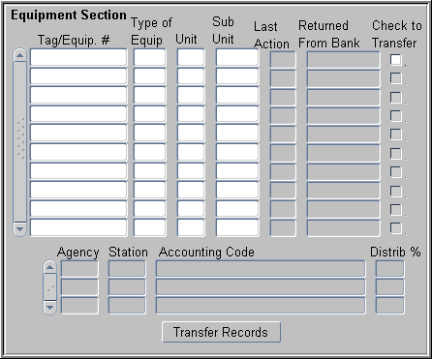
Equipment

The following fields detail the equipment attached to the current LFPC:

Fieldname | Description
Tag\Equipment #  (Query field) | The tag\equipment number as it appears on the Fleet card.
Type of Equip  (Query field) | The type of equipment:  A = Aircraft  B = Boat  E = Equipment  P = Pool Card  V = Vehicle
Unit  (Query field) | The unit where the equipment resides.
Sub Unit  (Query field) | The sub-unit where the equipment resides.
Last Action  (Non-entry field) | Indicates the last action performed on the record.  A - add, M - modify, D - delete, L - LFPC Information Changed,  R -replacement, T - transfer of equipment, and U - update.
Returned From Bank  (Non-entry field) | Date the fleet record was returned from the bank.
Check to Transfer  (Non-entry field) | Click in this box to indicate the equipment to transfer.
Agency | The agency code the transactions are charged against.
Station  (Non-entry field) | The accounting station code the transactions are charged against.
Accounting Code  (Non-entry field) | The accounting code the transactions are charged against.
Distrib %  (Non-entry field) | Enter the percentage to be applied to the transaction amount.

Notes:

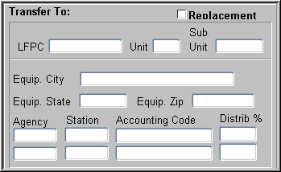
Transfer To

The following fields are optional depending on the type of transfer:
Fieldname | Description
Replacement | Check the box to transfer all equipment from the previous LFPC to the replacement LFPC. When this box is checked, only the LFPC ID is updated; all other fields in this section remain blank. The system will automatically mark all equipment for transfer to the replacement LFPC.
LFPC  (Required field) | LFPC user id that the equipment is to be transferred to.
Unit | The unit where the equipment will reside.
Sub Unit | The sub-unit where the equipment will reside.
Equip. City | The city where the equipment will reside.
Equip. State | The state where the equipment will reside.
Equip. Zip | The zip where the equipment will reside.
Agency | The agency code against which transactions are charged.
Station | The accounting station code against which transactions are charged.
Accounting Code | The accounting code against which transactions are charged.
Distrib % | The percentage to be applied to the transaction amount.

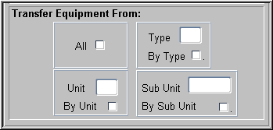

Transfer Equipment From

If you are transferring all of the records or just specific records from those listed in the Equipment Section, use the following fields to aid your selection of records for transfer:

Fieldname | Description
All | Check this box to have the system automatically mark all equipment for transfer.
Type\By Type | Enter the value for the type of equipment you wish to transfer in the Type box and check By Type to have system automatically mark all equipment of that type for transfer.
Unit\By Unit | Enter the unit in the Unit box and check By Unit to have system automatically mark all equipment from that unit for transfer.
Sub Unit\By Sub Unit | Enter the sub unit in the Sub Unit box and check By Sub Unit to have system automatically mark all equipment from that sub unit for transfer.

Notes:

- Querying Equipment

Please turn off your monitor and give your attention to the instructor.

Queries are performed based on LFPC. That is, to query for equipment you must first retrieve the LFPC associated with that equipment and then query the equipment information.

- Query equipment by LFPC or Group
- Click on the command bar to obtain all vehicle\equipment records attached to the LFPC UserID you logged on with.
Or
Enter the LFPC ID number to search by LFPC or the Region, Unit or Sub Unit to search by group and click on the command bar.
- Use the scroll bar to navigate between vehicle\equipment records. You can scroll through records for LFPCs or equipment within the same LFPC.

- Query by equipment
- Follow the instructions above to query by LFPC.
- Place the cursor in one of the Equipment fields and click on the command bar to clear all fields.
- Enter a search value in a field in the equipment section of the window.
- Click to perform the query.

- Tips
- The % wildcard can be used.
- The List of Values option is available for the LFPC User ID field.

Notes:

PRACTICAL EXERCISE

      - Query all vehicle\equipment records attached to the LFPC UserID you logged on with.

      - Query all vehicle\equipment records in the Region “01”.

- Rules for Transferring Equipment

Please turn off your monitor and give your attention to the instructor.

- Overview
When transferring equipment, the AFHC and LFPC must be aware that the LFPC and the equipment record can have a differing hierarchy/SAC (security access control) as it is possible for either of these to be changed by the AFHC or LFPC depending upon the transfer desired. For example, LFPC’s SAC is 11 01 02 00000, equipment transferred is 11 01 02 00001 and 11 01 02 00002. The equipment record SAC and accounting record SAC are always the same.

- Rules
Apply the following rules when transferring:

- The AFHC\LFPC can only transfer equipment that is within their SAC scope of authority. Meaning that:
- LFPCs whose SAC stops at the unit level may only transfer equipment to a sub-unit with the unit.
- AFHCs whose SAC stops at the region level may only transfer equipment to units or sub units within the region.
- AFHCs whose SAC stops at the department or agency level may transfer equipment to any unit or sub-unit within the department or agency respectively.

- A transfer results in the fleet equipment being moved to a new LFPC, new unit, or sub-unit. In addition to one of these moves, the equipment’s physical location and accounting code may also be changed.
- If the equipment’s physical location is changed, you must enter an entire location change (i.e., City, State, Zip and Profile Accounting).
- If the equipment’s profile accounting is changed, you must enter a value in Agency, Accounting Code, and Distribution Percent.

Notes:

- If a transfer is taking place because the LFPC is being replaced, check the Replacement box and enter the UserID of the LFPC that the equipment is being transferred to. All of the equipment records will automatically be marked for transfer when Replacement is checked.
When a Replacement transfer is made, the new LFPC’s address must be entered using Update LFPC before any of the transferred records will be sent to the bank.

- Equipment records that do not have Returned Fm Bank dates cannot be transferred and the system will generate a User Message to monitor the record field. When Returned Fm Bank is populated, the equipment record can then be queried and transferred.
- Changes to the accounting on a piece of equipment need to be made before making the transfer.
When completing transfers between sub units, do not try to update the equipment’s profile accounting unless Return Fm Bank is populated, otherwise the system will process the transfer record improperly.

Notes:

- To Transfer an Equipment Record

Please turn off your monitor and give your attention to the instructor.

- Transferring Equipment
To transfer an equipment record:

- Query an LFPC and the associated equipment records

- Use one of the following options to select the equipment records to be transferred:
- Check the Check to Transfer box at the end of desired record(s)
- Select an option in the Transfer Equipment From section
- Check the Replacement box to transfer all records when an LFPC is being replaced

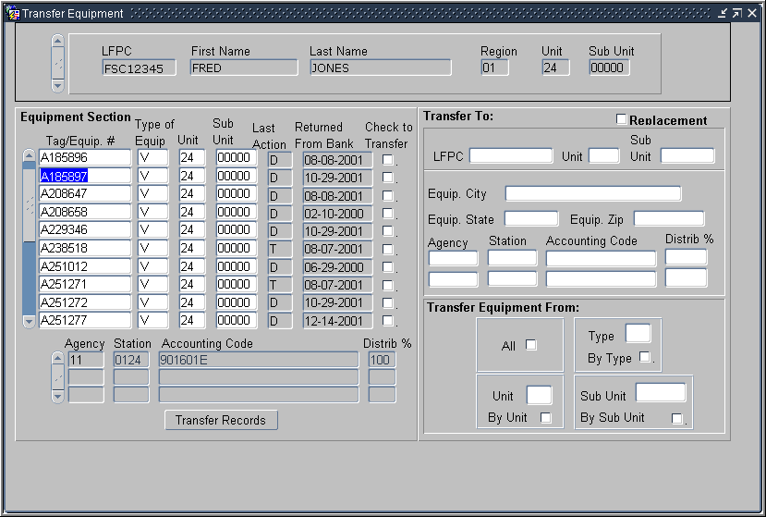

- Enter all of the values in the Transfer to section
- Required fields must have values
- When replacing an LFPC only the LFPC UserID must be entered, all other fields will be locked

- Click at the bottom of the Equipment section of the window.
  - When the transfer is complete, the list of equipment updates. Contact the LFPC to whom the equipment is being transferred to verify the transfer has completed.
  - A User Message will be generated if the transfer cannot be completed.
  - If the record has not returned from the Bank, a User Message will be generated and sent to the LFPC indicating the record needs to be monitored.
  - An equipment record that has been modified as a result of transfer will have a Last Action Code of “T”
If equipment is being transferred because an LFPC is leaving, the LFPC cannot be dropped in SAMS until ALL equipment has been transferred from his/her account. (See SAMS training)

PRACTICAL EXERCISES

- Query the LFPC you logged on with.

- Select all records with a Type V and transfer them to the trainee LFPC sitting to your right.

- Query your LFPC again.

- Transfer ALL records to a replacement LFPC, the trainee LFPC to your left.

Notes:

- Summary and Review.

Please turn off your monitor and give your attention to the instructor.

- What are the steps an LFPC takes to transfer equipment? (Walk the instructor through the steps)

- What would prevent a transfer from being completed?

- What is the Replacement check box for? When would it be used?

- How do you transfer equipment between groups? (Walk the instructor through the steps)

Final Assessment

Assessment Description

The final assessment requires the AFHC\LFPC to apply the knowledge learned in Lessons 1-7 of the Fleet PCMS training.

Assessment Objectives

At the conclusion of this assessment, LFPCs and AFHCs will be able to demonstrate their ability to:

- Access both the PCMS training and production databases
- Change their PCMS production password
- Navigate PCMS
- Set up a new Fleet Card account
- Transfer Equipment

Methodology

Trainees will individually undertake the assessment exercises. The instructor will be available to answer questions.

Exercise 1
  - Log on to the Production database with the UserID and password provided by your Instructor.

  - Change your password.

  - Review your Profile Accounting details.

  - Log off PCMS.

Exercise 2
- Log onto the training database, using the trainee UserID and password provided by the instructor.

- Set up a new Fleet Card account using the following information:
- Tag\Equipment Number: A268467
- Cost Limits: Fuel = $100.00, Daily trans = 03, Maint Trans = $500, Gallon limit = 40, Gallon Trans Limit = $50
- Card is to be used by a Vehicle for fuel and maintenance
- Card should be a standard plastic
- Equipment City: Rockville
- Equipment State: MD
- Equipment Zip Code: 20850
- Codes: Program 448687 \ Dept 12 \ Agency 99 \ Region 01 \ Unit 02 \ Sub Unit 00000
- Station: 0110
- Accounting code: 7010101915
- Distribution % = 100

Exercise 3
- Logged on to the training database transfer Fleet equipment using the following information:
- Transfer all Boats
- Recipient: LFPC seated to your right
- Location: Beltsville, MD, 20705
- Profile Accounting: Agency = 99, Station = 0110, Accounting Code = 901601, Distribution % = 100

