

CONTENTS

- Instructor Planning Guide
- Instructor Planning Checklists
- Fleet PCMS Course Pacing Guide
- Lesson 1 – Introduction
- Lesson 2 – Accessing and Navigating PCMS
- Lesson 3 – Profile Accounting
- Lesson 4 – Fleet Transactions
- Lesson 5 – Messages
- Lesson 6 – Fleet Card Setup
- Lesson 7 – Transfer Equipment
- Lesson 8 - SAMS
- Final Assessment
- Course Evaluation
- Course Report
- Quick Guides
- Fleet PCMS Users Guide

CONTENTS

- Fleet PCMS Course Pacing Guide
- Lesson 1 – Introduction
- Lesson 2 – Accessing and Navigating PCMS
- Lesson 3 – Profile Accounting
- Lesson 4 – Fleet Transactions
- Lesson 5 – Messages
- Lesson 6 – Fleet Card Setup
- Lesson 7 – Transfer Equipment
- Lesson 8 - SAMS
- Final Assessment
- Quick Guides
- Fleet PCMS Users Guide

Pacing Guide – Fleet PCMS Training

The table below contains a Pacing Guide for delivery of the PCMS LFPC\AFHC Course using the materials provided. The Pacing Guide is intended to serve as a planning tool for instructors, to assist in scheduling your training activities. It is constructed around an 8-hour training day, including breaks and a meal hour. Instructors should alter time intervals to accommodate students, facility limitations or any other relevant factors.

Day 1

Topic / Event | Duration | Begin | End
Course Introduction & Orientation | :10 | 9:00 | 9:10
Ice Breaker | :20 | 9:10 | 9:30
Lesson 1 | :60 | 9:30 | 10:30
Break | :10 | 10:30 | 10:40
Lesson 2 | :50 | 10:40 | 11:30
Lesson 3 | :50 | 11:30 | 12:20
Lunch | :60 | 12:20 | 1:20
Lesson 4 | :50 | 1:20 | 2:10
Break | :10 | 2:10 | 2:20
Lesson 5 | :60 | 2:20 | 3:20
Break | :10 | 3:20 | 3:30
Lesson 6 | :90 | 3:30 | 5:00

Day 2

Topic / Event | Duration | Begin | End
Course Introduction & Orientation | :10 | 9:00 | 9:10
Ice Breaker | :20 | 9:10 | 9:30
Lesson 7 | :90 | 9:30 | 11:00
Break | :10 | 11:00 | 11:10
Lesson – SAMS * | :90 | 11:10 | 12:40
Lunch | :60 | 12:40 | 1:40
Lesson – SAMS * | :90 | 1:40 | 3:10
Break | :10 | 3:10 | 3:20
Final Assessment | :40 | 3:20 | 4:00

* SAMS Training is to be attended by AFHCs only.

Lesson 1: PCMS Web Introduction

Lesson Description

The Introductory lesson is intended to provide PCMS LFPCs and AFHCs with background information regarding PCMS processes. This information will help trainees understand how different roles contribute in the procurement workflow, expectations for their own roles, and how to identify sources of help if necessary. This lesson will establish the basis of knowledge on which to build in subsequent lessons.

Training Objectives

At the conclusion of this lesson, PCMS LFPCs and AFHCs will be able to:

- Describe how LFPC and AFHC responsibilities contribute to the Purchase Card Management workflow.
- State the consequences of card misuse.
- Discuss in broad terms the functions performed by LFPCs and AFHCs.
- Identify where self-help information is located.

Methodology

This lesson will be delivered using a combination of lecture and presentation, and discussion. Group discussion and trainee interaction will be used to stimulate recall of policy information and establish a knowledge base on which to build in subsequent lessons.

References

(A) Departmental Regulation 5400-6, USDA, February 2002

Enclosures

(1) Fleet PCMS User’s Guide, USDA\PMT, June 2006
- Fleet PCMS Quickguide, USDA\PMT, October 2000

- Overview of PCMS
  - What is PCMS
The Purchase Card Management System (PCMS) is the application through which the Bank of America and the USDA communicate to manage and pay procurement transactions. To streamline the purchasing process, GSA has authorized The Bank of America to issue fleet cards to designated USDA vehicles and equipment.

ACFO\FS downloads purchase card transaction data from the bank. Automated transaction transfers are made to the Federal Foundation Information System (FFIS), where the payment process commences by processing account information. Payment files are then sent from FFIS to the Treasury, from which payments are made to the Bank for purchases billed.

  - Fleet Card Program Hierarchal Structure

DFPC (System)
- Manages the USDA Fleet Credit Card program system. Establishes AFHCs.
- Provides training and guidance to AFHCs.

DFPC (Policy)
- Issues Fleet PCMS policy.
AFHC
- Oversees the Fleet management program.
- Establishes LFPCs, and provides training as need.
- Liaison with the DFPC.
LFPC
- Maintains Fleet Card program daily operations at each agency site.
- Establishes and updates Fleet credit cards in PCMS.
- Provides oversight of fleet management.

Notes:

- LFPC Role and Responsibilities

  - Workflow
Below is a depiction of the procurement workflow as it involves the LFPC.

  - LFPC Role and responsibilities
        - Establish and update Fleet credit cards in PCMS;;
        - Monitor day to day operations of the Fleet Credit Card Program at each agency site;
        - The LFPC will work with the Fleet credit card users and the AFHC to resolve transaction issues;
        - Notify the Bank of any billing discrepancies, by lodging a dispute against the transaction;
        - The LFPC will perform audits on transactions if they receive notification of possible incorrect or inappropriate use of a fleet card;
        - Change Fleet cards limits if necessary;
        - Report fraud, waste and abuse in accordance with agency procedures;
        - Notify Voyager regarding any lost, stolen, or damaged Fleet credit cards;

Notes:

- AFHC Role and Responsibilities

  - Workflow
Below is a depiction of the procurement workflow as it involves the AFHC.

  - AFHC Role
What can the LFPC expect from their AFHC?
- Training, guidance and support;
- Reset PCMS passwords;
- The AFHC will work with the LFPC, and PSD to resolve transaction issues;
- In the absence of an LFPC the AFHC will lodge disputes;
- The AFHC will notify the LFPC of program non-compliance issues and will assist the LFPC in enforcing non-compliance measures;

  - Other Responsibilities
- Responsible for managing and overseeing the Fleet credit card program in their designated agency within the USDA;
- Establish and maintain agency-wide communications;
- Establish agency-unique fleet policies and procedures when necessary;
- Conduct agency-wide oversight of the fleet program;
- Establish LFPCs;
- Provide training and guidance to LFPCs;
- Reset LFPC passwords in SAMS;
- Serve as primary contact for LFPCs and as the liaison with the DFPC;
- Develop program literature and materials, and distribute to LFPCs;
- May identify Fleet PCMS application problems or possible enhancements, and submits Change Requests (CR) to PSD for consideration and implementation;
- Drive future programs applications and enhancements;

Notes:

- DFPC Role

  - DFPC System Role
What can the AFHC expect from their DFPC?
- Training, guidance and support;

  - Other Responsibilities
- Manages the PCMS system that supports the USDA Fleet Credit Card Program;
- Establishes AFHCs;
- Resets passwords for AFHCs;
- Provide training and guidance to AFHCs;
- Issues Bulletin Board messages;
- Assist in defining priorities and oversee PCMS fleet configuration management;
- Develop and recommend USDA policy and procedures for the department-wide Fleet Credit Card program;
- Develops fleet card program literature and materials for department-wide use;
- Drive future programs applications and enhancements;

Notes:

- Information Sources

  - User manuals
The Fleet PCMS User Manual is available for download on the USDA website at:
http://www.usda.gov/procurement/card/pcms/training.htm#afhcreference under the ‘AFHC/LFPC Reference Materials’ section.

  - Quick guides
Quick guide to assist AFHCs and LFPCs with specific Fleet PCMS issues are available for download on the USDA website at:
http://www.usda.gov/procurement/card/pcms/training.htm#afhcquick under the ‘AFHC\LFPC Quick Guides’ section.

  - DR 5400-6
The Departmental Regulation regarding Fleet Credit Card policy is available for download at:
http://www.usda.gov/procurement/card/pcms/training.htm#afhcreference under the ‘AFHC\LFPC Reference Materials’ section.

  - FAQ’s
Fleet card frequently asked questions and answers can be found on the USDA website at:
http://www.usda.gov/procurement/card/pcms/faqs.htm

  - AFHC
Your AFHC should always be the LFPC’s first point of contact. They will escalate an issue if necessary, and contact the helpdesk, or DFPC if required.

Your area AFHC is:
Contact details:

- Summary and Review.

Please turn off your monitor and give your attention to the instructor.

Lesson 2: Accessing and Navigating PCMS

Lesson Description

Lesson 2 will equip AFHCs and LFPCs with knowledge and information necessary to successfully access PCMS and navigate the menus and screens. Becoming familiar with the PCMS screens and layout will provide the AFHC\LFPC with a foundation on which to build specific knowledge in subsequent lessons.

Training Objectives

At the conclusion of this lesson, PCMS LFPCs and AFHCs will be able to:

- Demonstrate accessing PCMS and maintaining passwords.
- Navigate PCMS using menus and tools.

Methodology

This lesson will be delivered using a combination of lecture, demonstration and Instructor-led exercises. Practical exercises and testing will be utilized to measure the level of individual and group achievement of the Training Objectives outlined above and the overall effectiveness of this training program.

References

None.

Enclosures

- Fleet PCMS User’s Guide, USDA\PMT, June 2006
- Fleet PCMS Quickguide, USDA\PMT, October 2000

  - Logging On\Off PCMS

Please turn off your monitor and give your attention to the instructor.

  - Opening the PCMS Application
The PCMS application is web based. To open the application, open an Internet Explorer browser and access the USDA PCMS web page at http://www.nfc.usda.gov/corporate/PCMS.htm.

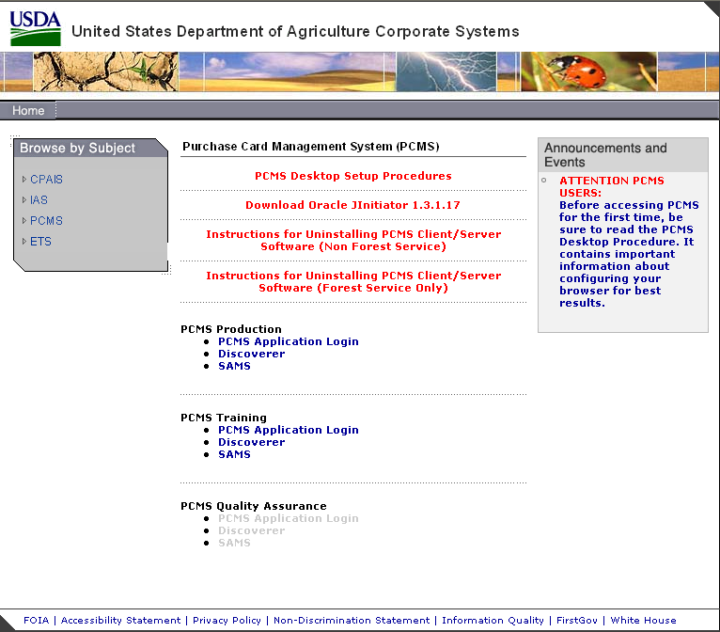

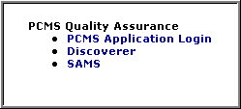
            - Click the active PCMS Application Login link at the bottom of the page.

An Oracle Forms Runtime window will open in another browser.

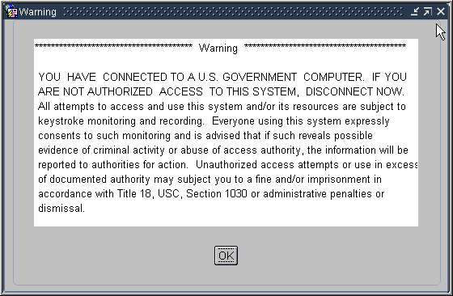
            - Click on the security message.

The Logon dialog box opens.

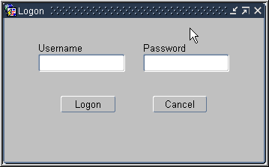

In production you will use the PCMSv5 Prod database. In training you will use the PCMSv5 Training Database.

You must be logged onto the network to access the transaction data on the server.

If the application cannot be opened:
      - LFPCs should inform their AFHC;
      - AFHCs should contact IT support directly;
      - If IT support determines the issues lies with the PCMS software they will contact the PCMS Helpdesk;

  - Logging ON
LFPCs will receive their PCMS user ID and password to the production database from their AFHC, and AFHCs will receive their user ID and password from the DFPC system coordinator at the completion of Fleet PCMS training. For training purposes please use the training ID and password provided by your instructor to log on to the training database.

            - Enter your username and password in the logon dialog box and click .

The Main Window opens.

If you experience problems logging on to PCMS:
      - Check your UserID and Password are correct
      - The LFPC should contact their AFHC
      - The AFHC should contact the PCMS helpdesk

  - Logging OFF
To exit PCMS, click .
or
Click the ‘X’ in the top right hand corner of Internet Explorer browser.

Clicking the ‘X’ on the main window will not close the application.

Notes:

- Passwords

Please turn off your monitor and give your attention to the instructor.

  - How to change a system password.
Click Change Password on the PCMS main menu at the top of the screen. The change password dialog box opens with your username displayed.
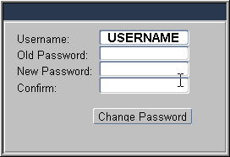

Type your old password and then your new one. Type the new password once again to confirm you've entered it correctly. Note that the passwords will appear as asterisks. Click . Your new password will be in effect the next time you log on to PCMS.

The following are password requirements:
- A password must be at least 6 alphanumeric characters in length
- Must start with a letter
- Must include at least one number
- Cannot contain spaces
- Must be different by at least 3 characters from the previous password

Every 90 days your password expires and must be changed. If your password is within five days of expiring, a notification message will appear every time you log in to PCMS until the expiration date.

  - Troubleshooting tips.
If you experience problems logging on please refer to the troubleshooting tips below to try to resolve the problem or determine the likely cause and contact the appropriate person.

Error Message | Explanation | Resolution
Password must be at least 6 characters and include one numeric value. | - UserID or Password may have been entered incorrectly.  - May be a problem with your user account | a. Check you have entered the information correctly. Re-enter details and try to log on again.  b. LFPCs contact your AFHC, AFHCs contact ACFO\FS helpdesk, to determine if there is a problem with your account.
Please enter a valid UserID\password. | - Username and password entered three times unsuccessfully, as a result the account has been locked out.  - The PCMS system is down. | a. LFPCs contact your AFHC, to remove the locked status. If AFHC is not available the LFPC can contact PSD.  b. LFPCs contact your AFHC. AFHC’s contact the PCMS Helpdesk.
Password not changed. | The 90 days has expired and you didn't change your password. You will not be able to log onto the system as your old password is no longer valid | LFPCs contact your AFHC, to reset your password. If AFHC is not available the LFPC can contact PSD.
Password cannot be reused. | The new password is the same as the previous password. | a. Try to change the password again ensuring the new password has at least 3 characters different from the previous password.  b. LFPC’s contact your AFHC to determine if there is a problem with the account.

  - Password Security
- Select a password you will remember and keep it secure
- DO NOT give your PCMS password to any other person
- If you suspect someone may have access to your password change it
- Account lockouts occur to prevent people from trying to guess your password
- Unique passwords are required to keep your password more secure

Notes:

PRACTICAL EXERCISE

1. Log on to PCMS Training Database using the trainee UserID and Password provided to you by your instructor.

2. After logging on change your password to: trainee

3. Log out of PCMS.

4. Log on to PCMS again using your new password.

- Menus
Please turn off your monitor and give your attention to the instructor.

    - Main Window

This is the main Window in PCMS. The bulletin board located in the center of the window provides up-to-date news about PCMS. You will read more about the bulletin board and user messages in a subsequent lesson.

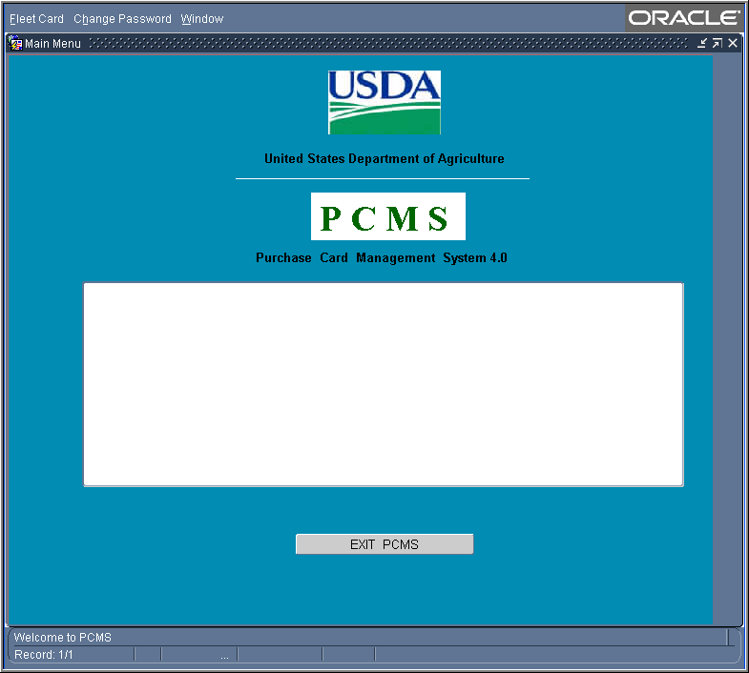

Fleet Card | 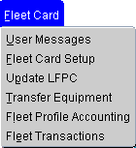 | Provides options for PCMS LFPCs and AFHCs to create and maintain Fleet credit cards and perform related functions, such as changing profile accounting, reading user messages and transferring equipment.
Change Password | 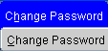 | Change PCMS passwords.
Window | 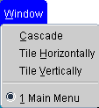 | Customize the Window display.  Note: The Window feature does not apply in PCMS.
  - Navigation Quick Guide

Main Window
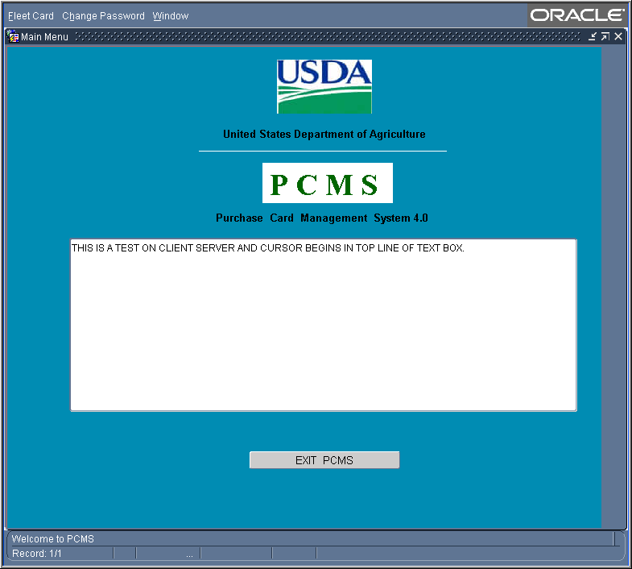
Main Menu. Provides access to main functions in PSMC.

Bulletin Board. Displays news and messages about PCMS.

Exit Button. Closes application

Status Bar. Displays messages about the status of the current window.

Form Window
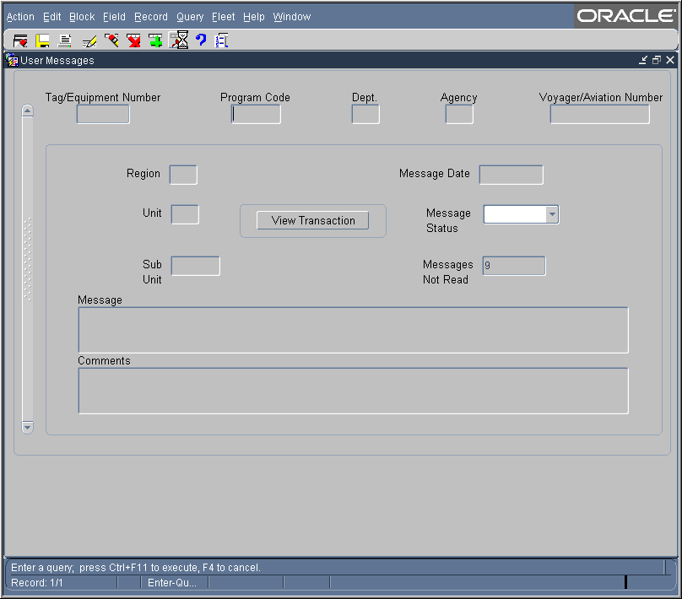
Form Sub-Menu. Appears when you open a window from the main menu.
Command Bar. Provides buttons to initialize or confirm actions.

Busy Signal. Line scrolls across the right side of the status bar when the system is retrieving data.
Status Bar. Provides messages about the status of the current window.
  - Sub-Menu

The sub-menu appears when you select one of the options from the Fleet Card menu. This menu provides options for performing data query and data entry functions.

Action | 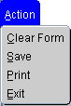 | Options to take action on a transaction, such as save data or print.
Edit |  | Options to edit text in the selected field.
Block | 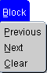 | Options to move between major sections of the window.
Field | 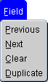 | Options to move the cursor between fields.
Record | 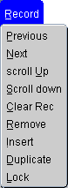 | Options to navigate and manipulate transactions.
Query | 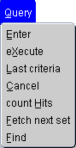 | Options to query the data and find records matching search criteria
Fleet |  | Lists the same options as the Fleet Card Menu. Allows movement between screens without having to back out of each one.
Help | 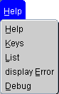 | Options for help and program shortcuts.  Note: The Help function is not available at this time.
Window | 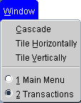 | Options to change how the windows are displayed.

Notes:

- Tools

  - Command Bar

The command bar appears on every window for the Fleet Card menu options. The command bar contains a row of command buttons that are used to initialize or confirm actions in PCMS.

Clear Form |  | Clears all data in the form.
Save |  | Saves changes to the database.
Print |  | Prints the screen.
Edit |  | Edit a field.
Clear |  | Removes the transaction information from the screen. Any unsaved changes will be lost. A cleared record is not deleted from the database.
Remove |  | Removes a line of accounting in the Profile Accounting screen.
Insert |  | Inserts a new record after the current record.
Find |  | Search functions.
Help |  | Displays a brief message about the current field.  Note: The Help function is not available at this time.
List |  | Opens a dialog box for selecting valid field entries. The text, “List of Values” appears in the status bar at the bottom of the screen when your cursor is in a field that accepts list values.

  - Navigation

There are several options for navigating through information in the PCMS windows.

Moving From Record to Record:
- Click Record on the main menu and select Next or Previous to move between records
- Use the scroll bar on the left of the screen.
- Scrollbars only become active when there is more information than the field can display.

Moving From Field to Field:
- Click Field on the main menu and select Next or Previous
- Use the Tab button on your keyboard
- Click in the field using the mouse

  - Executing a Query

Retrieving information from the database is called executing a query. You can enter a query using the steps described below.

Retrieving All Records:
- Click on the Command bar twice to query all records attached to the current user ID

Retrieving Specific Records:
- Click on the Command bar once
- Type the values you want to match in the appropriate fields
- Click again
- Follow instructions above to navigate through records and fields

Wildcard (%):

The wildcard allows you to search for a partial value. For instance, if you are not certain how a name is spelled when searching on Merchant Name, use the wild card to replace single or multiple letters or numbers.

For example, when searching for the Merchant Name “Toshiba” replace “oshiba” with the % to return all records beginning with “T”. You can query with the wildcard three different ways, for example: %oshiba, Tos%, or %osh%. The window will populate with all records matching your search criteria.

  - Lists
Some fields in the PCMS entry windows have lists from which the user may select valid field entries. If <List of Values> is displayed in the status bar at the bottom of the window, a list of values is available for the current field. To access the list, click on the command bar. A dialog box opens displaying the choices for the specific field. Scroll to highlight the item you want to select and click . The dialog box closes and the value appears in the applicable field.

Notes:

- Summary and Review
The following questions are to be answered in an instructor led group exercise and review session:

Please turn off your monitor and give your attention to the instructor.

      - Which menu bar item is used to customize the window display?

      - What are the steps to changing a password? (Class walks the instructor through the steps)

      - Where can you query Fleet Transactions? (Class walks the instructor through the steps)

      - Where are print options located if I want to print a screen? (Class walks the instructor through the steps)

