
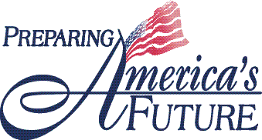

U.S. Department of Education

Office of Vocational and Adult Education
Fact Sheet Series

Adult Basic and Literacy Education

Transitioning English Language Learners (TELL)
The OVAE Fact Sheet Series highlights efforts currently underway at the Office of Vocational and Adult Education (OVAE) to support the principles of the President’s No Child Left Behind Act of 2001. The principle(s) supported by this effort are checked.

- Increase Accountability and Raise Academic Achievement
- Increase Options and Involvement for Parents and Students
- Increase Flexibility and Reduce Bureaucracy
- Focus on What Works

Background

Little is known about the instructional, programmatic, or policy practices that support adult advanced English language learners’ (ELLs’) transitions from federally funded English as a second language (ESL) services into Adult Basic Education (ABE) and Adult Secondary Education (ASE) programs, where they can attain a high school equivalency credential. Even less is known about the extent to which the effectiveness of these transitions is being measured.

Overview

The Transitioning English Language Learners project will expand knowledge regarding effective strategies for transitioning adult ELLs from ESL to ABE and ASE programs. The American Institutes for Research (AIR), under contract with the Office of Vocational and Adult Education, will identify ten adult education programs in three states that offer evidence of successful strategies for transitioning ELLs from ESL to other adult education services. AIR will observe and document these strategies as well as interview students, teachers and staff. The resulting data-rich descriptions will be summarized in a final report.

Outcomes and Products

- An environmental scan that documents instructional and programmatic strategies that help adult ELLs transition from ESL to ABE and ASE programs
- A report with recommendations for next steps to promote the transition of adult English language learners to ABE and ASE programs where they can attain a high school equivalency credential and be prepared for postsecondary education and the demands of the 21st century workforce

Timeline

- July 2008 to July 2010

Contact

Lynn.Spencer@ed.gov

