Poster
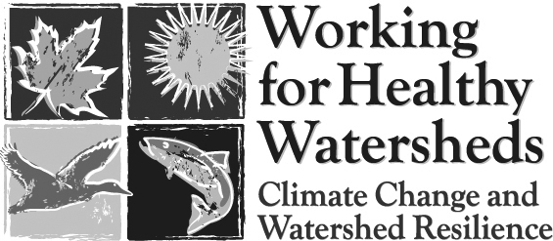
Session
Sign-up

Be a part of the Conference Poster Session – an opportunity to show what is happening on the ground, in the classroom, or in the lab to benefit watersheds, water quality and quantity, or fish and wildlife and their habitats. This session will give all conference attendees a chance to see your poster.

The poster session will be held in conjunction with a conference reception Wednesday evening, 5:30 - 6:30 p.m., November 5, in the Eugene Hilton. Tables will be available for poster session set up at 5:00 p.m.

Each poster session participant will have an assigned table area or floor space for an easel to display and discuss their exciting project or idea. Tri-fold boards or other self-standing display boards work best.

NAME

ORGANIZATION

MAILING ADDRESS

CITY/STATE/ZIP

DAY PHONE

E-MAIL

TITLE OF POSTER

DISPLAY NEEDS:
__ RESERVE TABLE SPACE FOR ME (__ FULL TABLE __ HALF TABLE)
Tables are eight feet long.
__ PROVIDE AN EASEL FOR ME
__ I WILL BRING MY OWN EASEL (THANK YOU! THIS SAVES US $$)

SPECIAL NEEDS? Call or e-mail Bill Hastie, OWEB Conference Poster Session Coordinator, at 503-585-3525 or hastiestuff@mac.com.

Submit completed forms to Bill BY MONDAY OCTOBER 20.

