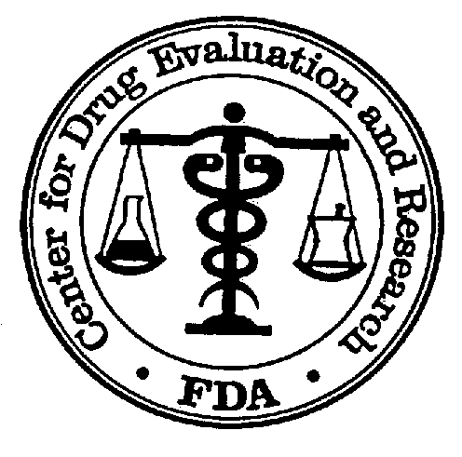_____________________________________________________________________
Questions
Pravastatin/ASA
18 July 2002
DEPARTMENT OF HEALTH AND HUMAN SERVICES
Public Health Service
Food and Drug Administration
Cardio-Renal Advisory Committee

The Cardio-Renal Advisory Committee is asked reconsider the co-packaged product of pravastatin and ASA, based on the additional materials and references provided by the sponsor.
This product was previously presented to the Advisory Committee on 18 January 2002. At that meeting there was general agreement that a population could be defined for which the co-packaged product would be indicated. There was also general agreement that the sponsor’s meta-analysis of the five lipid lowering studies in a secondary prevention population (PLAC I, PLAC II, REGRESS, LIPID and CARE) demonstrated that both pravastatin and aspirin individually contributed to the beneficial cardiovascular outcomes seen in the separate trials. The Advisory Committee also endorsed the choice of the two doses of aspirin (81 and 325 mg).

The Advisory Committee, however, felt that the risk/benefit ratio of marketing the co-packaged product was adverse based on the following considerations:

- The potential for excessive bleeding should the product not be discontinued prior to a surgical procedure.
- The potential for inappropriate discontinuation of the pravastatin should the patient need to temporarily discontinue aspirin.
- The use of the single fixed dose of the 40-mg pravastatin dose, where a higher or lower dose of pravastatin would be more appropriate for the individual.
- The potential for use of this co-packaged product in an inappropriate population such as for primary prevention of cardiovascular events.

Not all members of the advisory committee applied equivalent weight to each of the above concerns.

The sponsor amended their application by a response addressing aspects of these concerns, including the following:
- A proposal to include in the pravastatin/aspirin co-packaged product two new doses of pravastatin 20 and 80 mg in addition to the originally proposed 40 mg dose, to be co-packaged with the 81 and 325 mg doses of aspirin.
- Submission of numerous publications.

- To what extent has the sponsor’s submission addressed your concern regarding…
  - … the potential for excessive bleeding should the pravastatin/aspirin not be discontinued prior to surgery?
  - … the potential for inappropriate discontinuation of pravastatin during times when aspirin is temporarily discontinued?
  - … the inappropriate use of a lower or higher dose of pravastatin than is necessary or safe for a given patient?
  - … the inappropriate use of the co-packaged product in a non-indicated population?

- Do you recommend the approval of the co-packaged pravastatin/aspirin as therapy for patients for whom both products are indicated?

