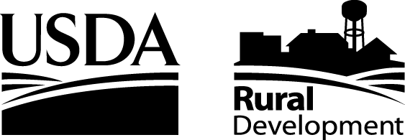 NEWS RELEASE
United States Department of Agriculture • Rural Development
101 South Main • Suite 102 • Temple, TX 76501
Phone: (254) 742-9756 • Fax: (254) 742-9709 • TDD: (254) 742-9700 • Web: http://www.rurdev.usda.gov/tx

Date: April 2, 2007 Contact Name: Scooter Brockette
Release Number TX 179.06 Telephone Number: 254-742-9700
Email: scooter.brockette@tx.usda.gov

USDA RURAL DEVELOPMENT ADDS AMERICAN SOUTHWEST MORTGAGE CORPORATION TO THE TEXAS GUARANTEED UNDERWRITING SYSTEM PILOT

TEMPLE, TEXAS, April 2, 2007 – Bryan Daniel, Texas State Director of USDA Rural Development announced today that American Southwest Mortgage Corporation now has the ability to underwrite USDA Rural Development Guaranteed Rural Housing Loans using the new Guaranteed Underwriting System (GUS). GUS was developed by USDA Rural Development to automate a manual underwriting process, which considers loan applications for approval. A unique GUS feature is that it determines a borrower’s income and a property’s eligibility for the Single Family Housing Guaranteed Loan Program.

“The Guaranteed Rural Housing Program not only provides decent and affordable housing, but is an important component of USDA’s economic development efforts,” said Bryan Daniel, Texas State Director of USDA Rural Development. “The availability of affordable housing is often a key element in whether a business decides to locate or remain in a rural community.”

GUS enables American Southwest Mortgage Corporation to receive faster loan decisions, streamlined documentation requirements, better quality loans, more consistency in program delivery, and will fulfill legal requirements under the Government Paperwork Elimination Act and the Freedom to E-File Act. American Southwest Mortgage Corporation has been successfully test piloting GUS in Oklahoma, Tennessee and Ohio for the past 6 months. Texas USDA Rural Development is excited to be partnering with them in bringing more efficient homeowner opportunities to rural Texans.

Guaranteed Rural Housing Loans are made to qualifying low- and moderate-income families to purchase homes in rural areas. The loans are made by mortgage lenders, such as banks, credit unions and mortgage companies.

The USDA Rural Development local office that serves your area can be located at http://www.rurdev.usda.gov/tx/officeinfo.htm, or call the State Office Housing Programs at
(254) 742-9700. American Southwest Mortgage Corporation can be reached at 16479 North Dallas Parkway, Addison, Texas 75001, (972) 380-4200, or at www.amswmtg.com.

#

Committed to the future of rural communities.

“USDA is an equal opportunity provider, employer and lender.”
To file a complaint of discrimination write USDA, Director, Office of Civil Rights, Room 326-W, Whitten Building, 14th and
Independence Avenue, SW, Washington, DC 20250-9410 or call (202) 720-5964 (voice or TDD).

